**KPMG Employee Homepage Content Placement**

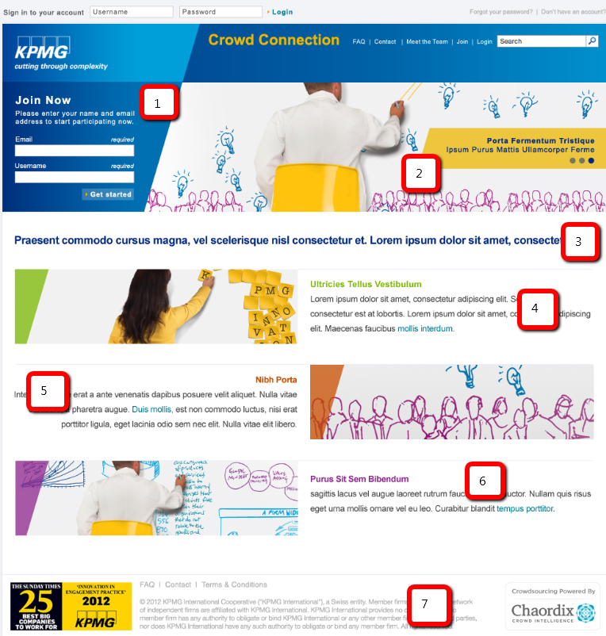

**Homepage**

**(1) Join Now**To join the community, please fill in the following fields. In the Display Name field, you can use whatever name you wish to be displayed to other community members.

(2) Slide 1 Have your voice heard.

(2) Slide 2 Shape the future of KPMG.

(2) Slide 3 Share your experiences.

**(3) We created this community for you to share your thoughts, opinions and ideas to help our clients succeed.**

(4) **Have your voice heard.** Crowd Connection is an invite only initiative that will influence how we work. As part of this effort, we are seeking direct insights from people like you. **Let’s innovate together.**

(5) **Vote, discuss, share and participate.** As a member of the community, you’ll have the opportunity to engage in activities that interest you. **Submit your ideas, vote and comment.**

(6) **Share your experiences**. Collaborate with other KPMG employees, share your experiences and insights, and help our clients do what they do - better. **Join now.**

(7) *footer terms note – not needed. Please remove from design*