**KPMG Employee Homepage Content Placement**

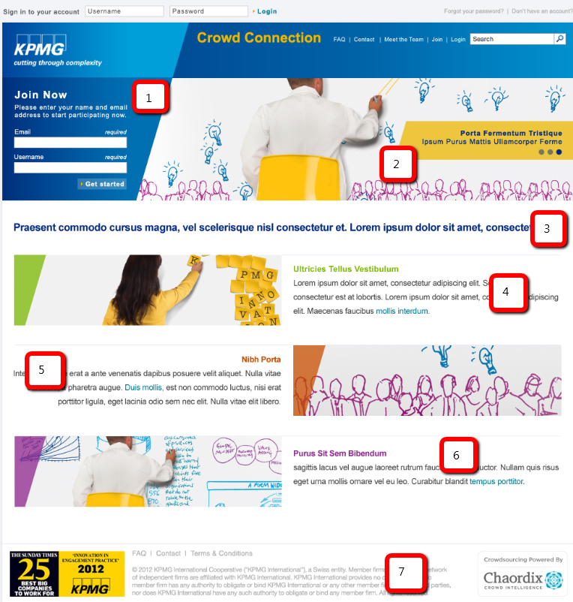

**Homepage**

**(1) Join Now**To join the community, please fill in the following fields. In the Display Name field, you can use whatever name you wish to be displayed to other community members.

(2) Slide 1 Have your voice heard.

(2) Slide 2 Shape the future of KPMG.

(2) Slide 3 Share your experiences.

**(3) We created this community for you to share your thoughts, opinions and ideas to help our clients succeed.**

(4) **Have your voice heard.** Crowd Connection is an invite only initiative that will influence how we work. As part of this effort, we are seeking direct insights from people like you. **Let’s innovate together.**

(5) **Vote, discuss, share and participate.** As a member of the community, you’ll have the opportunity to engage in activities that interest you. **Submit your ideas, vote and comment.**

(6) **Share your experiences**. Collaborate with other KPMG employees, share your experiences and insights, and help our clients do what they do - better. **Join now.**

(7) *footer terms note – not needed. Please remove from design*

**How It Works** *(available only when logged in)*

We created this community for you to share your thoughts, opinions and ideas to help us improve what we do. At regular intervals we will invite you to join in new sets of activities.

The community is available to invited members only and is accessible through a password-protected site. As a valued employee, you have been selected and invited to join this community. We will invite you to new activities that we think will be of interest to you over the coming weeks, and we'll reward you for your efforts.  
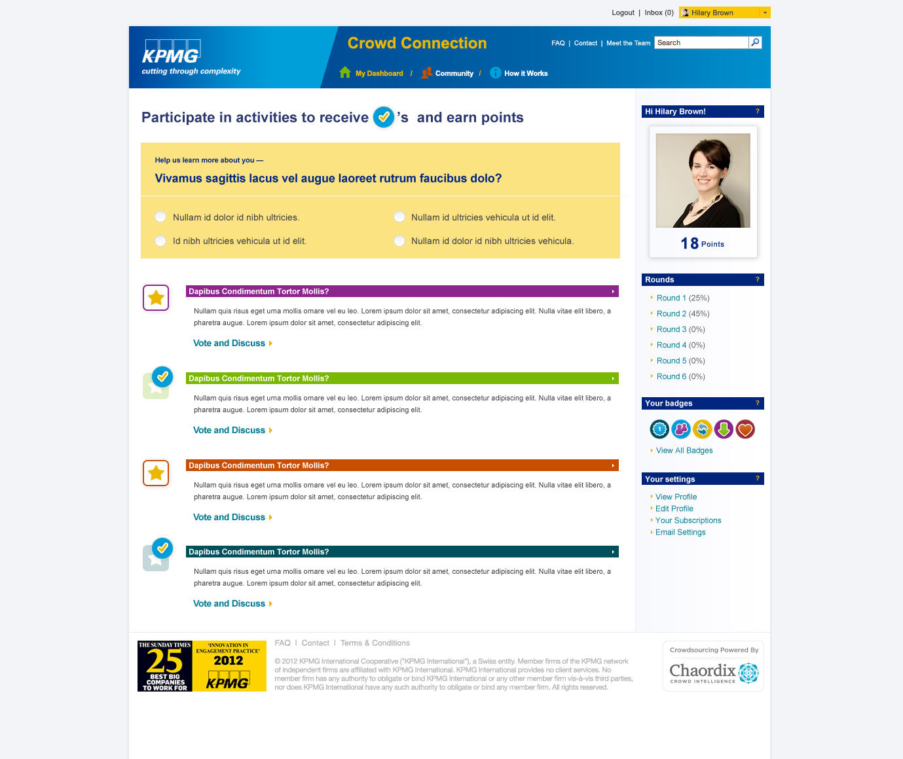

Activities are displayed under the Dashboard. You can also find out what is happening (and keep up with these discussions) from your Dashboard where you can find out who has commented on what, and when.

* Activities will be posted on the My Dashboard page
* Click on an activity underway
* Make comments and vote on other participants' submissions
* Share your ideas on the topic at hand by making a submission that will be shared with other Community members for their comments.

**It's quick and easy to participate in the activities -**

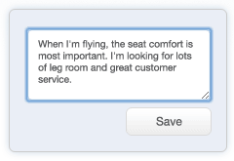

Lorem ipsum dolorsit amet, consectetuer adipiscing elit,

sed diam.

## Submit

Share your ideas and join discussions.

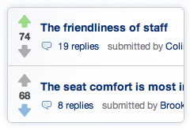

## Vote

Vote on ideas that matter to you.

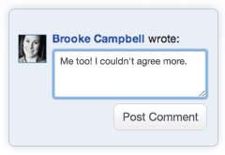

## Comment

Weigh-in on other members’ ideas.

## Get Recognized

Participating earns you entries into grand prize draws! Learn more about Rewards.

**Need More Information?**

Our Help page contains frequently asked questions and contact information. View Help section.

**Rewards** *(available only when logged in)*

**We'll make it worth your while – Win an iPad or a tablet!**

Everyone who participates is eligible for a chance to win fantastic prizes. The more involved you are the more chances you have to win!

**Reward Structure**

The more you join in discussions and participate in the community, the more entries you'll receive. Over the next 4 weeks, there will be ample opportunity to participate to earn rewards.

**Grand Prize Draw**

Here’s how you’ll earn entries into a draw for an iPad and a runner up draw for a tablet:

* 1 entry for signing up and completing the minimum level of participation in the first round of activities
* 1 additional entry for completing a minimum level of participation in each of the remaining two rounds of activities
* 1 additional entry for reaching 1,500 points and 1 more additional entry for reaching 3,000 points
* Each participant can earn up to 5 entries in total

**Top participation**

*(insert visual)*

The top 2 participants (based on points (link to points page)) within the community will receive a tablet as recognition for their participation!

Learn more about how you can earn points (link to points page)!

**Help** *(available only when logged in)*

**What is the KPMG Crowd Connection Community and how will it be used?**

The KPMG Crowd Connection Community was created for you to share your thoughts, opinions and ideas to help our clients do what they do - better. The Community is an online research tool available to invited members only and is accessible through a password-protected site on the public Internet. Employees who agree to participate will be volunteering their time to be involved in moderated, Customer-related discussions and activities over the course of the Community engagement.

**Why have I been invited to participate in the KPMG Crowd Connection Community?**

As an employee of KPMG, your thoughts and opinions will be incredibly valuable for helping to shape the way we work with our clients – helping us and our clients do our jobs more efficiently and effectively.  The Community will only be available to a select group of employees like yourself.

**What's in it for me?**

This is your opportunity to have a voice and share your thoughts, opinions and ideas on a number of topics. It is a chance to contribute to and take part in shaping the future of KPMG and our relationships with our partners. For your ongoing participation, you’ll earn entries towards draws for great rewards as a token of appreciation for your assistance and will also recognize the top two participants based on overall participation. Visit the Rewards Page to learn more.

**How do I use the KPMG Crowd Connection Community?**

Each invited member will have a limited, personal profile displayed that members of the Community can see. You will be able to contact other members of the community and see comments, discussions and ideas from other people. Similarly, your contributions will be visible to every other member of the community.

There will be trained, third-party moderators in the Community. They will be able to talk to members, see their contributions and provide assistance to participants.

New activities will be added each week. Participants will be notified by email as activities become available and will be prompted to provide their thoughts, opinions and ideas. All activities will remain active and accessible in the community for at least two weeks.

Badges of recognition can be earned by all members and reflect different levels of contribution. Other incentives will also be awarded for a high level of participation in the Community. To learn more about incentives, visit the Rewards Page.

**What if I forget my log-in information?**

Not to worry, if you've forgotten your login, it's really easy to reset it. Click login and then click on "forgot password" in the bottom right hand corner and follow the steps to reset your password.

**How long does the Community run for?**

There will be activities available in the Community every week, and ongoing participation is requested for approximately 3 months. As a Community participant, we will send you an email when new activities are posted.

**What if I want to stop participating in the Community?**

If you wish to be removed from the Community, please email us at support@communityname.com with the subject line: Unsubscribe: KPMG Crowd Connection Community.

**How much time will it take?**

Throughout the 4 week, you are encouraged to provide as much content as possible. New activities will be added weekly and we will prompt you to share your thoughts, opinions and ideas. For regular participation, we expect this will require roughly 3 hours in total over a 4 week period, if you participate in all of the activities. You are encouraged to participate as much as possible, as your feedback is extremely valuable.

**Will the information I enter to be visible to others?**

The Community is intended to provide an engaging experience to all participants, with collaboration, discussion and idea sharing at its core. Each invited member will have a limited, personal profile displayed that other members of the Community can see. You will be able to contact other members of the community within the Community interface and see comments, discussions and ideas from other Community participants. Your comments, discussions and ideas will also be accessible to other Community participants. Access to the Community is limited to invited participants and moderators only and content within the Community will not be searchable on the Internet. Some of this content may be used to help inform initiatives at KPMG, but will not be associated or attributed back to a personally identifiable individual.

For more information on site regulations, please visit the Terms of Service and Privacy Policy.

If you have technical questions, please contact support@sitename.

**The Challenge***(available only when logged in)*

**Big Data**

During our initial challenge, we will be addressing “big data”. How can we and our clients use and manage data sets so large that they become a burden?

We're all using big data, even if we aren't aware of it. Big data has been a loosely-defined term used to describe data sets that become very difficult to manage with standard tools.

Any challenges around small data sets are magnified when it comes to big data. Correlations become very challenging. Often times, big data leads to challenges around capturing valid (quality) data, storing and searching this information, as well as providing access to, analyzing and visualizing the information required to do one's job.

We’ll be running a series of activities around this challenge throughout the next few weeks. You can participate in a variety of ways after joining. We’ll also keep you up-to-date as we add new topics and opportunities to participate.

**Meet the Team** *(available only when logged in)*

**Invite Email**

Subject: Have Your Voice Heard - Join the KPMG Crowd Connection Community

[screenshot of homepage]

**Have your voice heard, and get an iPad.**

As a valued KPMG employee, we’d like to invite you to be part of an invite only online community that will influence the future of KPMG and our clients. Those who participate will be entered into a draw for an iPad and a tablet!

Now is your chance to help our clients do what they do – better. **Join** the discussions underway. Share your ideas, and interact with other valued employees.

**The challenge**

During our initial challenge, we will be addressing “big data”. How can we and our clients use and manage data sets so large that they become a burden? We’ll be running a series of activities around this challenge throughout the next few weeks. You can participate in a variety of ways after joining. We’ll also keep you up-to-date as we add new topics and opportunities to participate.

**Join Now**

We thank you for your time and appreciate your efforts.

Best regards,

*[signature]*

**Welcome Email**

Subject: Welcome to KPMG Crowd Connection

**Welcome to the KPMG Crowd Connection Community, Thanks for Joining Us!**

Thanks so much for accepting our invitation to join the KPMG Crowd Connection. Your email address has been verified and we look forward to collaborating with you. In fact, you can get started right now!

**Join discussions underway**

If you would like to learn more about the Community, please visit How it Works.

If you need help don’t hesitate to contact a moderator on the Help Page

Sincerely,

Community Moderator  
KPMG Crowd Connection

# Privacy Statement

The KPMG Crowd Connection Community website falls under the KPMG Privacy Policy. [View the KPMG Privacy Policy.](http://www.kpmg.com/Global/en/Pages/privacy.aspx)