**Reckitt Benckiser “Health & Home” CrowdExchange Content**

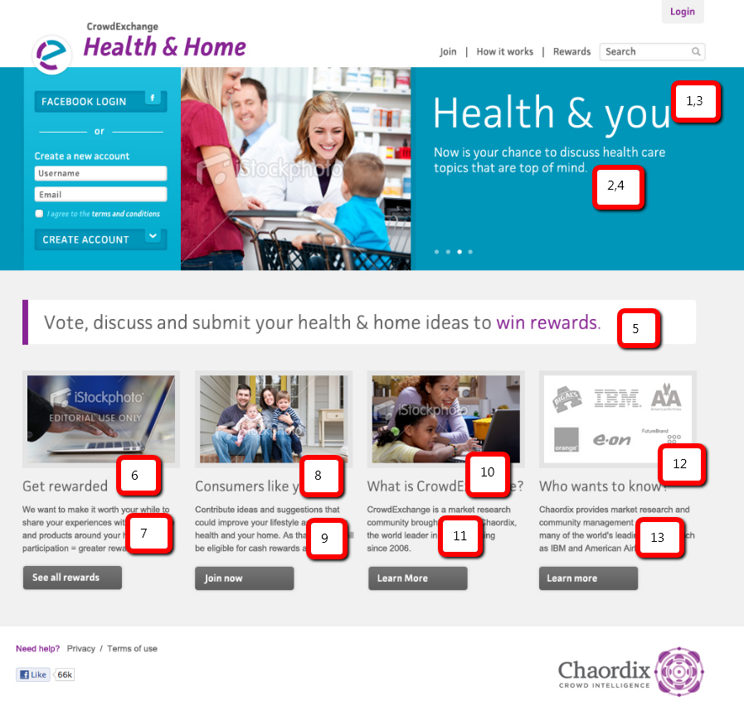

**(1) Healthy living**

(2) Join the conversation about health care topics that affect you and your family.

**(3) Home sweet home**

(4) Now is your chance to discuss how you make your home your own.

(7) Vote, discuss and submit your views on your health and home to win rewards.

**(8) Get rewarded**

(9) We want to make it worth your while to share your experiences with health care and products around your home. More participation = greater rewards. **Get rewarded** (link to rewards page)

**(10) Consumers like you**

(11) Contribute ideas and suggestions that could improve your lifestyle around your health and your home. As thanks, you will be eligible for rewards and prizes! **Join now** (link to join page)

**(12) What is CrowdExchange**

(13) CrowdExchange is a market research community brought to you by Chaordix, the world leader in crowdsourcing since 2006. **Learn more** (link to chaordix.com)

**(14) Who wants to know?**

(15) Chaordix provides market research and community management services for many of the world's leading brands, such as IBM and American Airlines. **Learn more** (link to chaordix.com)