Anacott Steel

Personal Logo

Table of contents:

3. Discovery

3. Idea

3. User Stories

4. Design

4. Story Boards

4. Wireframes

Discovery

Idea:

When stocks/commodities/currencies etc.. go up/down there is an underlying reason as to why. Usually more than one. I am talking about contemporary phenomenon’s besides the basic theory of economics. For example, if you ask every Natural Gas trader what moves the price of natural gas, they will all agree on the consensus of weather. How the weather in interpreted or analyzed is up to the trader and that is one of the main factors as to what drives the price.

My question is simple…what drives the price of cryptocurrencies? What IF ANY factors contribute to the buying AND selling of a crypto? I plan on using many contemporary phenomenon’s and data to see if you can forecast the movement of cryptos so there is one or many concrete factual answers to this question based on statistical data.

User Stories:

A trader wants to compare the price of bitcoin to ‘x’. x is the variable of the many contemporary phenomenon’s that will have some correlation to the price of bitcoin. First the user must login. (need to come up with my own logo)

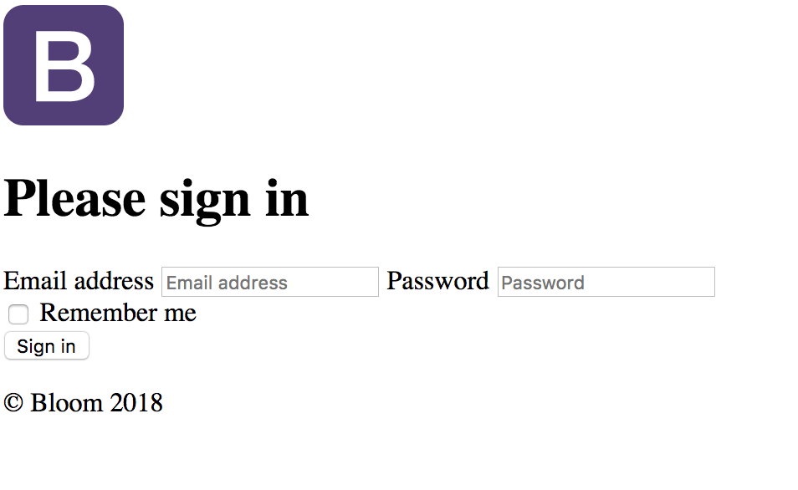

The User will see a homepage. The top will be updated “last price” as of “time” on main indexes….

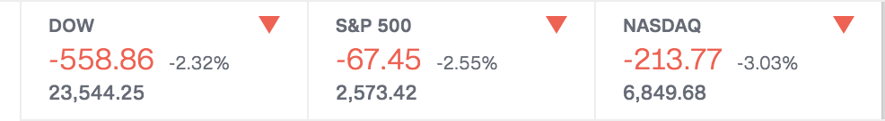

The trader will decide:

1. The crypto(s) out of a check list.

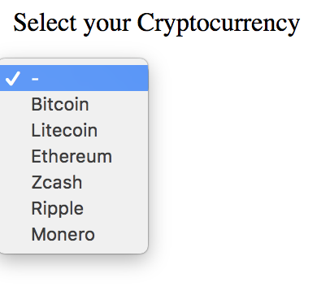

1. The contemporary phenomenon from a list; also explaining how the data is compiled using that phenomenon

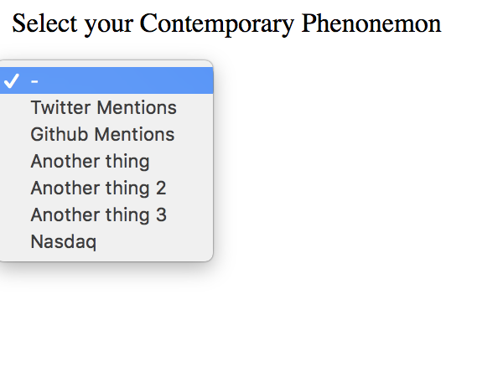

1. The time span (yearly,monthly,weekly,daily etc…)

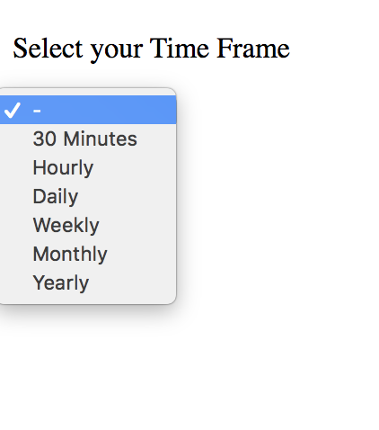

1. THEN based on the time frame they will have an option to chose how often they want the data shown over that time frame… ie Yearly, over 1,3,5 years...monthly over 3,6,12 months...weekly, 2 week, 4 weeks, 8 weeks...daily, course of 1 week, 2 weeks, month...hourly, 1 hour, 6 hour, 24 hour....minutes...15,30,60 -->



The user will then see a graph based on what they chose.

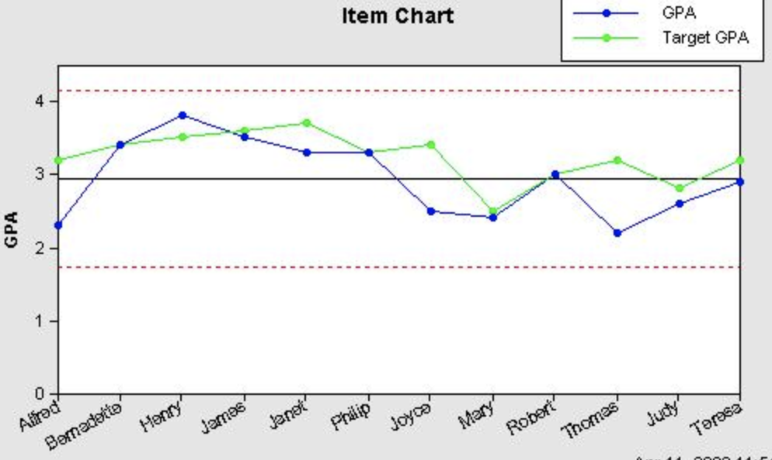

The user will then have the option to print out the graphs and/or export certain data sets to excel spreadsheets

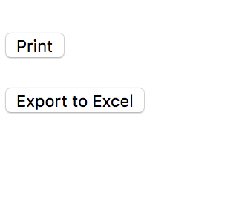

There will also be a dictionary explaining where all the data came from with the contemporary phenomenon’s and explaining what everything means. I do not know where/how I am going to implement this exactly yet.