## In the Bag Management documentation

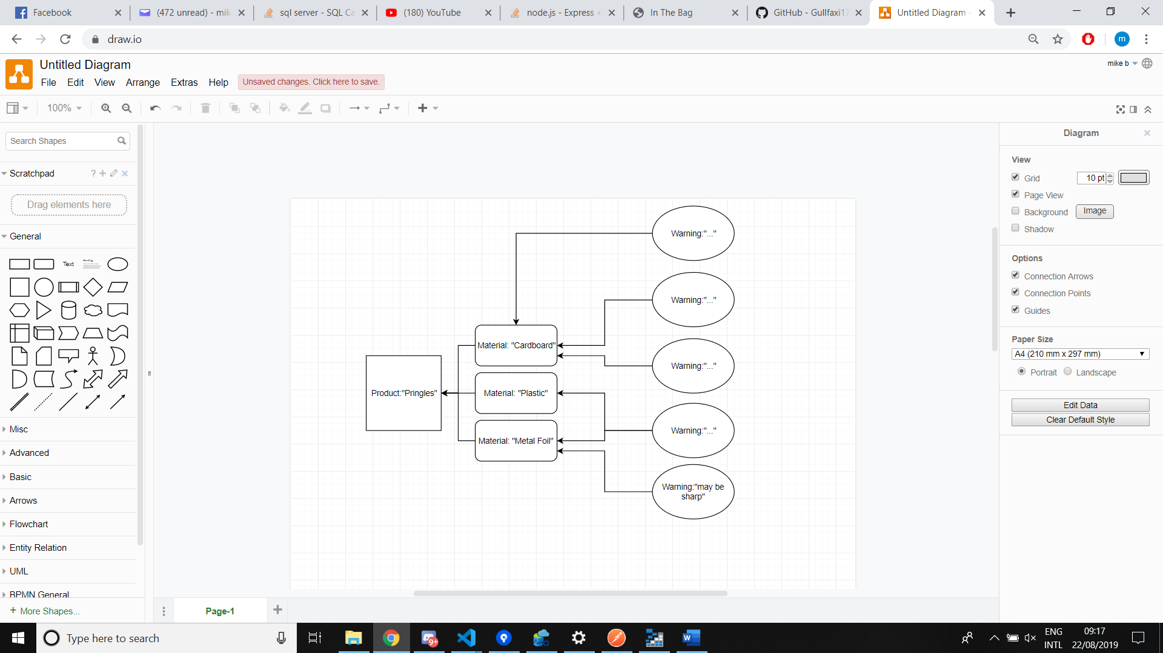Overall abstract schema

Materials, products and warnings are all unique. One product can be assigned many materials with each material having multiple warnings. A material can also be assigned to more than one product.

*Note that updating a Material and Warning will change that object for all its references!*

Using the web Server

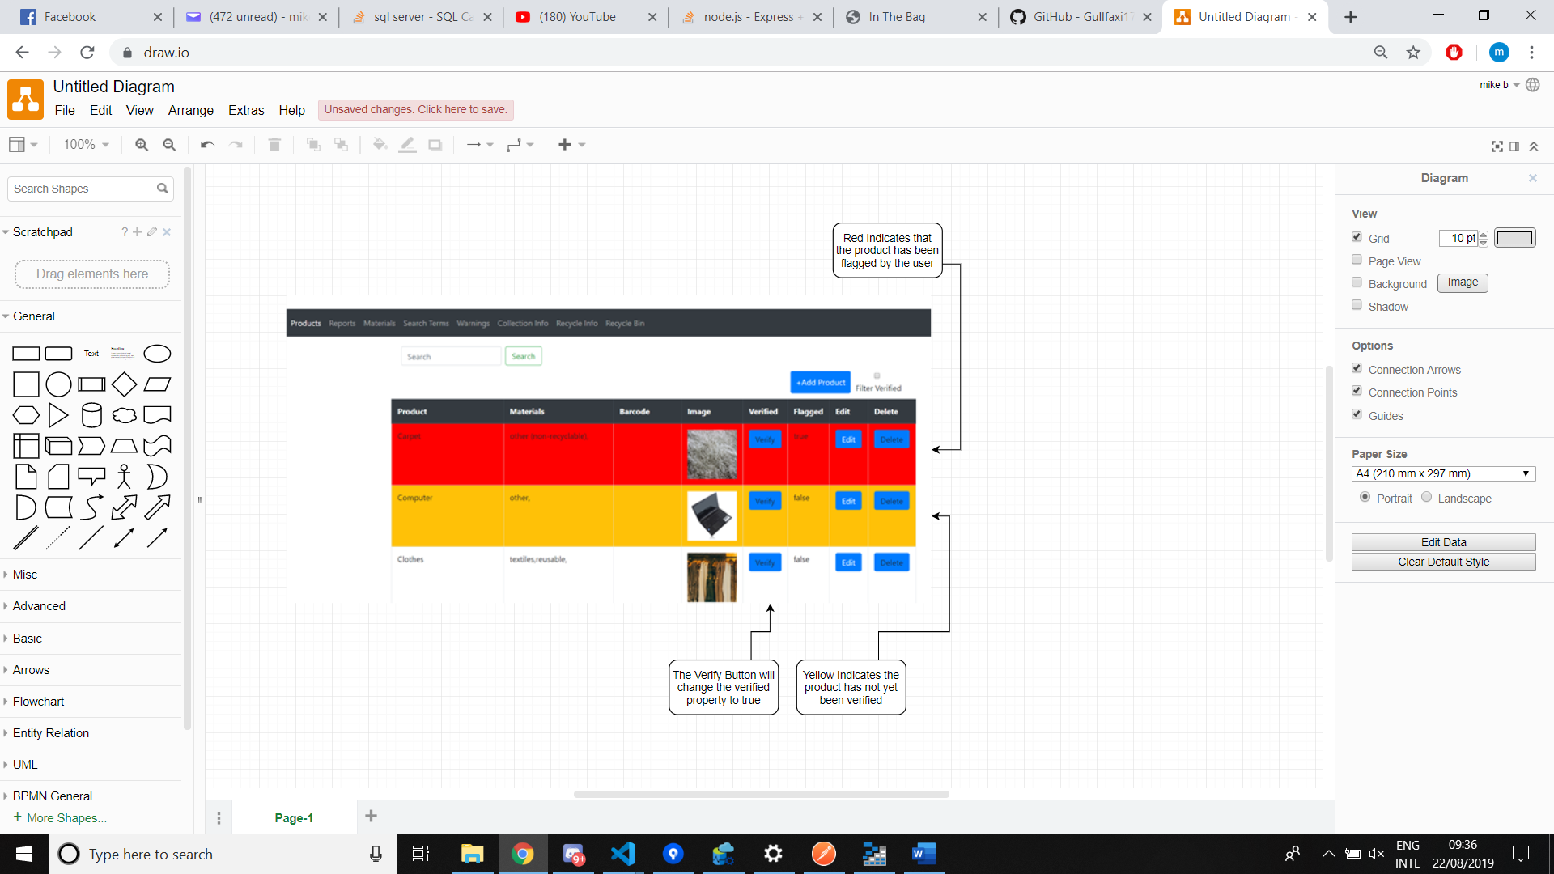Products Page:

The Flagged property can be switched to false in the edit page, however the app side does not display any flagged property.

Once verified a product cannot be unverified. It must either be deleated or edited to the correct standard.

**Editing a products name on the edit page will add a new product to the database, be sure to deleate the old product.(if the products name is not changed it will just edit the product)**

Reports Page:

A report can only be solved or deleted.

Reports are displayed by most relevent. This is calculated based on the number of searches for certain words. Hence the top report will be the one most searched for.

Materials Page:

A material can only be edited, this is because to deleate a material would break the database as products are linked to materials.

SearchTerms:

This page simply shows every search made and how many times said search is made.