Neo4j Installation
Download: Neo4j 2026 and Windows zip https://neo4j.com/deployment-center/ (Community)

System Requirements and OracleJDK https://neo4j.com/docs/operations-manual/current/installation/requirements/ https://www.oracle.com/java/technologies/downloads/#jdk21-windows
Install (Instructions Used are Below) https://neo4j.com/docs/operations-manual/current/installation/windows/
AuraDB (not used) https://neo4j.com/product/auradb/

Neo4j Operations Manual — Windows Installation
Before you install Neo4j on Windows, check System Requirements to see if your setup is suitable. If it is not already installed, get OracleJDK 21 or ZuluJDK 21. Java 25 is also supported.
Install and start Neo4j
You can install Neo4j on Windows either by downloading and extracting a ZIP archive, by running it as a Windows service, or by using the Windows PowerShell module.
Install Neo4j using a zip archive
- Download the Windows Executable 2026.03.1 (zip) release from Neo4j Deployment Center.
- Right-click the downloaded file and select Extract All to extract the contents of the archive.
- Place the extracted folder/files in a permanent home on your server and set the environment variable NEO4J_HOME to point to the extracted directory, for example (command prompt):
setx NEO4J_HOME "C:\neo4j\neo4j-community-2026.03.1"

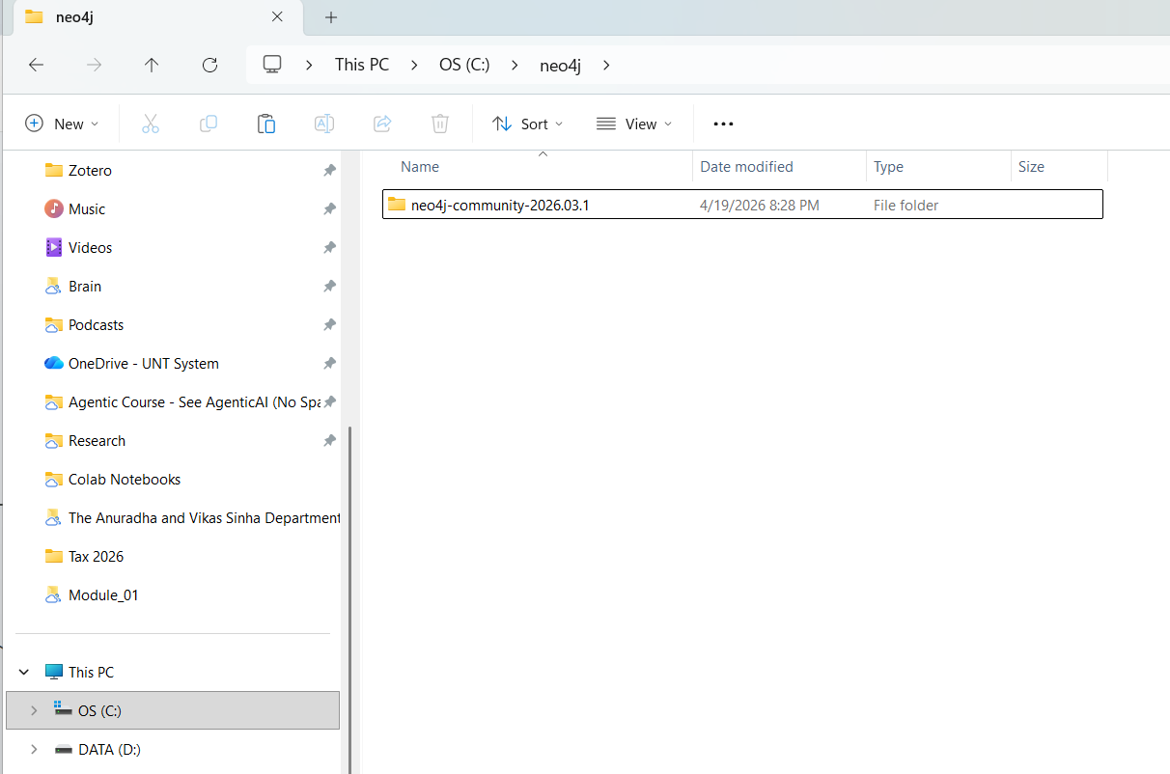

- Close, Reopen, or restart, your command prompt so %NEO4J_HOME% is initiated
- Start Neo4j as a console application by running %NEO4J_HOME%\bin\neo4j console in your command prompt:
C:\neo4j\neo4j-community-2026.03.1\bin\neo4j console

- Then go to: http://localhost:7474/browser/

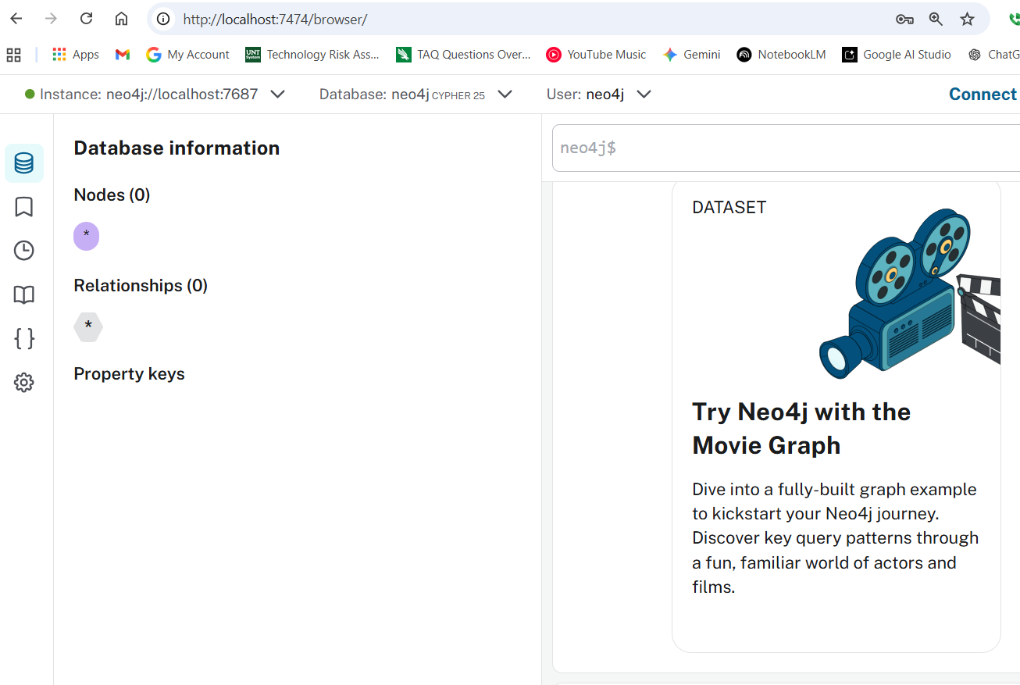
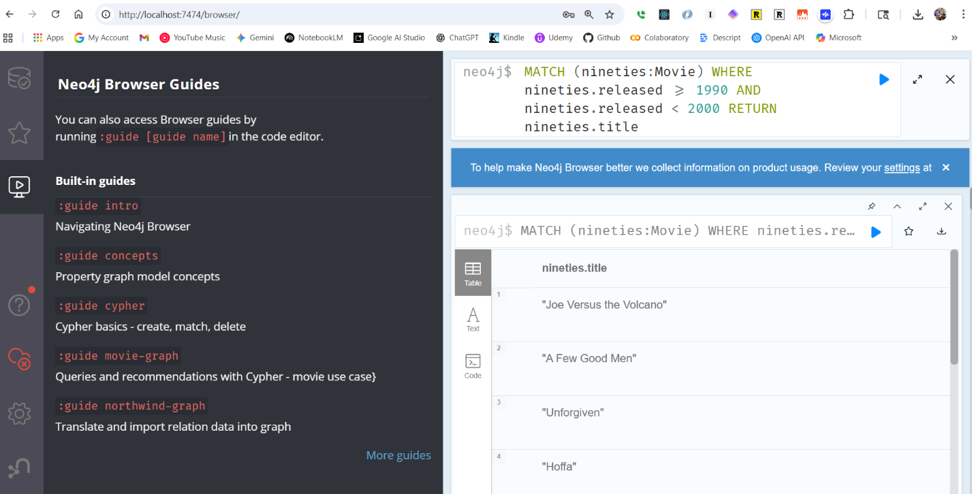

Example code from movie graph walkthrough

CREATE (TheMatrix:Movie {title:'The Matrix', released:1999, tagline:'Welcome to the Real World'})
CREATE (Keanu:Person {name:'Keanu Reeves', born:1964})
CREATE (Carrie:Person {name:'Carrie-Anne Moss', born:1967})
CREATE (Laurence:Person {name:'Laurence Fishburne', born:1961})
CREATE (Hugo:Person {name:'Hugo Weaving', born:1960})
CREATE (LillyW:Person {name:'Lilly Wachowski', born:1967})
CREATE (LanaW:Person {name:'Lana Wachowski', born:1965})
CREATE (JoelS:Person {name:'Joel Silver', born:1952})
CREATE
(Keanu)-[:ACTED_IN {roles:['Neo']}]->(TheMatrix),
(Carrie)-[:ACTED_IN {roles:['Trinity']}]->(TheMatrix),
(Laurence)-[:ACTED_IN {roles:['Morpheus']}]->(TheMatrix),
(Hugo)-[:ACTED_IN {roles:['Agent Smith']}]->(TheMatrix),
(LillyW)-[:DIRECTED]->(TheMatrix),
(LanaW)-[:DIRECTED]->(TheMatrix),
(JoelS)-[:PRODUCED]->(TheMatrix)

CREATE (Emil:Person {name:"Emil Eifrem", born:1978})
CREATE (Emil)-[:ACTED_IN {roles:["Emil"]}]->(TheMatrix)

CREATE (TheMatrixReloaded:Movie {title:'The Matrix Reloaded', released:2003, tagline:'Free your mind'})
CREATE
(Keanu)-[:ACTED_IN {roles:['Neo']}]->(TheMatrixReloaded),
(Carrie)-[:ACTED_IN {roles:['Trinity']}]->(TheMatrixReloaded),
(Laurence)-[:ACTED_IN {roles:['Morpheus']}]->(TheMatrixReloaded),
(Hugo)-[:ACTED_IN {roles:['Agent Smith']}]->(TheMatrixReloaded),
(LillyW)-[:DIRECTED]->(TheMatrixReloaded),
(LanaW)-[:DIRECTED]->(TheMatrixReloaded),
(JoelS)-[:PRODUCED]->(TheMatrixReloaded)

CREATE (TheMatrixRevolutions:Movie {title:'The Matrix Revolutions', released:2003, tagline:'Everything that has a beginning has an end'})
CREATE
(Keanu)-[:ACTED_IN {roles:['Neo']}]->(TheMatrixRevolutions),
(Carrie)-[:ACTED_IN {roles:['Trinity']}]->(TheMatrixRevolutions),
(Laurence)-[:ACTED_IN {roles:['Morpheus']}]->(TheMatrixRevolutions),
(Hugo)-[:ACTED_IN {roles:['Agent Smith']}]->(TheMatrixRevolutions),
(LillyW)-[:DIRECTED]->(TheMatrixRevolutions),
(LanaW)-[:DIRECTED]->(TheMatrixRevolutions),
(JoelS)-[:PRODUCED]->(TheMatrixRevolutions)

CREATE (TheDevilsAdvocate:Movie {title:"The Devil's Advocate", released:1997, tagline:'Evil has its winning ways'})
CREATE (Charlize:Person {name:'Charlize Theron', born:1975})
CREATE (Al:Person {name:'Al Pacino', born:1940})
CREATE (Taylor:Person {name:'Taylor Hackford', born:1944})
CREATE
(Keanu)-[:ACTED_IN {roles:['Kevin Lomax']}]->(TheDevilsAdvocate),
(Charlize)-[:ACTED_IN {roles:['Mary Ann Lomax']}]->(TheDevilsAdvocate),
(Al)-[:ACTED_IN {roles:['John Milton']}]->(TheDevilsAdvocate),
(Taylor)-[:DIRECTED]->(TheDevilsAdvocate)

CREATE (AFewGoodMen:Movie {title:"A Few Good Men", released:1992, tagline:"In the heart of the nation's capital, in a courthouse of the U.S. government, one man will stop at nothing to keep his honor, and one will stop at nothing to find the truth."})
CREATE (TomC:Person {name:'Tom Cruise', born:1962})
CREATE (JackN:Person {name:'Jack Nicholson', born:1937})
CREATE (DemiM:Person {name:'Demi Moore', born:1962})
CREATE (KevinB:Person {name:'Kevin Bacon', born:1958})
CREATE (KieferS:Person {name:'Kiefer Sutherland', born:1966})
CREATE (NoahW:Person {name:'Noah Wyle', born:1971})
CREATE (CubaG:Person {name:'Cuba Gooding Jr.', born:1968})
CREATE (KevinP:Person {name:'Kevin Pollak', born:1957})
CREATE (JTW:Person {name:'J.T. Walsh', born:1943})
CREATE (JamesM:Person {name:'James Marshall', born:1967})
CREATE (ChristopherG:Person {name:'Christopher Guest', born:1948})
CREATE (RobR:Person {name:'Rob Reiner', born:1947})
CREATE (AaronS:Person {name:'Aaron Sorkin', born:1961})
CREATE
(TomC)-[:ACTED_IN {roles:['Lt. Daniel Kaffee']}]->(AFewGoodMen),
(JackN)-[:ACTED_IN {roles:['Col. Nathan R. Jessup']}]->(AFewGoodMen),
(DemiM)-[:ACTED_IN {roles:['Lt. Cdr. JoAnne Galloway']}]->(AFewGoodMen),
(KevinB)-[:ACTED_IN {roles:['Capt. Jack Ross']}]->(AFewGoodMen),
(KieferS)-[:ACTED_IN {roles:['Lt. Jonathan Kendrick']}]->(AFewGoodMen),
(NoahW)-[:ACTED_IN {roles:['Cpl. Jeffrey Barnes']}]->(AFewGoodMen),
(CubaG)-[:ACTED_IN {roles:['Cpl. Carl Hammaker']}]->(AFewGoodMen),
(KevinP)-[:ACTED_IN {roles:['Lt. Sam Weinberg']}]->(AFewGoodMen),
(JTW)-[:ACTED_IN {roles:['Lt. Col. Matthew Andrew Markinson']}]->(AFewGoodMen),
(JamesM)-[:ACTED_IN {roles:['Pfc. Louden Downey']}]->(AFewGoodMen),
(ChristopherG)-[:ACTED_IN {roles:['Dr. Stone']}]->(AFewGoodMen),
(AaronS)-[:ACTED_IN {roles:['Man in Bar']}]->(AFewGoodMen),
(RobR)-[:DIRECTED]->(AFewGoodMen),
(AaronS)-[:WROTE]->(AFewGoodMen)

CREATE (TopGun:Movie {title:"Top Gun", released:1986, tagline:'I feel the need, the need for speed.'})
CREATE (KellyM:Person {name:'Kelly McGillis', born:1957})
CREATE (ValK:Person {name:'Val Kilmer', born:1959})
CREATE (AnthonyE:Person {name:'Anthony Edwards', born:1962})
CREATE (TomS:Person {name:'Tom Skerritt', born:1933})
CREATE (MegR:Person {name:'Meg Ryan', born:1961})
CREATE (TonyS:Person {name:'Tony Scott', born:1944})
CREATE (JimC:Person {name:'Jim Cash', born:1941})
CREATE
(TomC)-[:ACTED_IN {roles:['Maverick']}]->(TopGun),
(KellyM)-[:ACTED_IN {roles:['Charlie']}]->(TopGun),
(ValK)-[:ACTED_IN {roles:['Iceman']}]->(TopGun),
(AnthonyE)-[:ACTED_IN {roles:['Goose']}]->(TopGun),
(TomS)-[:ACTED_IN {roles:['Viper']}]->(TopGun),
(MegR)-[:ACTED_IN {roles:['Carole']}]->(TopGun),
(TonyS)-[:DIRECTED]->(TopGun),
(JimC)-[:WROTE]->(TopGun)

CREATE (JerryMaguire:Movie {title:'Jerry Maguire', released:2000, tagline:'The rest of his life begins now.'})
CREATE (ReneeZ:Person {name:'Renee Zellweger', born:1969})
CREATE (KellyP:Person {name:'Kelly Preston', born:1962})
CREATE (JerryO:Person {name:"Jerry O'Connell", born:1974})
CREATE (JayM:Person {name:'Jay Mohr', born:1970})
CREATE (BonnieH:Person {name:'Bonnie Hunt', born:1961})
CREATE (ReginaK:Person {name:'Regina King', born:1971})
CREATE (JonathanL:Person {name:'Jonathan Lipnicki', born:1996})
CREATE (CameronC:Person {name:'Cameron Crowe', born:1957})
CREATE
(TomC)-[:ACTED_IN {roles:['Jerry Maguire']}]->(JerryMaguire),
(CubaG)-[:ACTED_IN {roles:['Rod Tidwell']}]->(JerryMaguire),
(ReneeZ)-[:ACTED_IN {roles:['Dorothy Boyd']}]->(JerryMaguire),
(KellyP)-[:ACTED_IN {roles:['Avery Bishop']}]->(JerryMaguire),
(JerryO)-[:ACTED_IN {roles:['Frank Cushman']}]->(JerryMaguire),
(JayM)-[:ACTED_IN {roles:['Bob Sugar']}]->(JerryMaguire),
(BonnieH)-[:ACTED_IN {roles:['Laurel Boyd']}]->(JerryMaguire),
(ReginaK)-[:ACTED_IN {roles:['Marcee Tidwell']}]->(JerryMaguire),
(JonathanL)-[:ACTED_IN {roles:['Ray Boyd']}]->(JerryMaguire),
(CameronC)-[:DIRECTED]->(JerryMaguire),
(CameronC)-[:PRODUCED]->(JerryMaguire),
(CameronC)-[:WROTE]->(JerryMaguire)

CREATE (StandByMe:Movie {title:"Stand By Me", released:1986, tagline:"For some, it's the last real taste of innocence, and the first real taste of life. But for everyone, it's the time that memories are made of."})
CREATE (RiverP:Person {name:'River Phoenix', born:1970})
CREATE (CoreyF:Person {name:'Corey Feldman', born:1971})
CREATE (WilW:Person {name:'Wil Wheaton', born:1972})
CREATE (JohnC:Person {name:'John Cusack', born:1966})
CREATE (MarshallB:Person {name:'Marshall Bell', born:1942})
CREATE
(WilW)-[:ACTED_IN {roles:['Gordie Lachance']}]->(StandByMe),
(RiverP)-[:ACTED_IN {roles:['Chris Chambers']}]->(StandByMe),
(JerryO)-[:ACTED_IN {roles:['Vern Tessio']}]->(StandByMe),
(CoreyF)-[:ACTED_IN {roles:['Teddy Duchamp']}]->(StandByMe),
(JohnC)-[:ACTED_IN {roles:['Denny Lachance']}]->(StandByMe),
(KieferS)-[:ACTED_IN {roles:['Ace Merrill']}]->(StandByMe),
(MarshallB)-[:ACTED_IN {roles:['Mr. Lachance']}]->(StandByMe),
(RobR)-[:DIRECTED]->(StandByMe)

CREATE (AsGoodAsItGets:Movie {title:'As Good as It Gets', released:1997, tagline:'A comedy from the heart that goes for the throat.'})
CREATE (HelenH:Person {name:'Helen Hunt', born:1963})
CREATE (GregK:Person {name:'Greg Kinnear', born:1963})
CREATE (JamesB:Person {name:'James L. Brooks', born:1940})
CREATE
(JackN)-[:ACTED_IN {roles:['Melvin Udall']}]->(AsGoodAsItGets),
(HelenH)-[:ACTED_IN {roles:['Carol Connelly']}]->(AsGoodAsItGets),
(GregK)-[:ACTED_IN {roles:['Simon Bishop']}]->(AsGoodAsItGets),
(CubaG)-[:ACTED_IN {roles:['Frank Sachs']}]->(AsGoodAsItGets),
(JamesB)-[:DIRECTED]->(AsGoodAsItGets)

CREATE (WhatDreamsMayCome:Movie {title:'What Dreams May Come', released:1998, tagline:'After life there is more. The end is just the beginning.'})
CREATE (AnnabellaS:Person {name:'Annabella Sciorra', born:1960})
CREATE (MaxS:Person {name:'Max von Sydow', born:1929})
CREATE (WernerH:Person {name:'Werner Herzog', born:1942})
CREATE (Robin:Person {name:'Robin Williams', born:1951})
CREATE (VincentW:Person {name:'Vincent Ward', born:1956})
CREATE
(Robin)-[:ACTED_IN {roles:['Chris Nielsen']}]->(WhatDreamsMayCome),
(CubaG)-[:ACTED_IN {roles:['Albert Lewis']}]->(WhatDreamsMayCome),
(AnnabellaS)-[:ACTED_IN {roles:['Annie Collins-Nielsen']}]->(WhatDreamsMayCome),
(MaxS)-[:ACTED_IN {roles:['The Tracker']}]->(WhatDreamsMayCome),
(WernerH)-[:ACTED_IN {roles:['The Face']}]->(WhatDreamsMayCome),
(VincentW)-[:DIRECTED]->(WhatDreamsMayCome)

CREATE (SnowFallingonCedars:Movie {title:'Snow Falling on Cedars', released:1999, tagline:'First loves last. Forever.'})
CREATE (EthanH:Person {name:'Ethan Hawke', born:1970})
CREATE (RickY:Person {name:'Rick Yune', born:1971})
CREATE (JamesC:Person {name:'James Cromwell', born:1940})
CREATE (ScottH:Person {name:'Scott Hicks', born:1953})
CREATE
(EthanH)-[:ACTED_IN {roles:['Ishmael Chambers']}]->(SnowFallingonCedars),
(RickY)-[:ACTED_IN {roles:['Kazuo Miyamoto']}]->(SnowFallingonCedars),
(MaxS)-[:ACTED_IN {roles:['Nels Gudmundsson']}]->(SnowFallingonCedars),
(JamesC)-[:ACTED_IN {roles:['Judge Fielding']}]->(SnowFallingonCedars),
(ScottH)-[:DIRECTED]->(SnowFallingonCedars)

CREATE (YouveGotMail:Movie {title:"You've Got Mail", released:1998, tagline:'At odds in life... in love on-line.'})
CREATE (ParkerP:Person {name:'Parker Posey', born:1968})
CREATE (DaveC:Person {name:'Dave Chappelle', born:1973})
CREATE (SteveZ:Person {name:'Steve Zahn', born:1967})
CREATE (TomH:Person {name:'Tom Hanks', born:1956})
CREATE (NoraE:Person {name:'Nora Ephron', born:1941})
CREATE
(TomH)-[:ACTED_IN {roles:['Joe Fox']}]->(YouveGotMail),
(MegR)-[:ACTED_IN {roles:['Kathleen Kelly']}]->(YouveGotMail),
(GregK)-[:ACTED_IN {roles:['Frank Navasky']}]->(YouveGotMail),
(ParkerP)-[:ACTED_IN {roles:['Patricia Eden']}]->(YouveGotMail),
(DaveC)-[:ACTED_IN {roles:['Kevin Jackson']}]->(YouveGotMail),
(SteveZ)-[:ACTED_IN {roles:['George Pappas']}]->(YouveGotMail),
(NoraE)-[:DIRECTED]->(YouveGotMail)

CREATE (SleeplessInSeattle:Movie {title:'Sleepless in Seattle', released:1993, tagline:'What if someone you never met, someone you never saw, someone you never knew was the only someone for you?'})
CREATE (RitaW:Person {name:'Rita Wilson', born:1956})
CREATE (BillPull:Person {name:'Bill Pullman', born:1953})
CREATE (VictorG:Person {name:'Victor Garber', born:1949})
CREATE (RosieO:Person {name:"Rosie O'Donnell", born:1962})
CREATE
(TomH)-[:ACTED_IN {roles:['Sam Baldwin']}]->(SleeplessInSeattle),
(MegR)-[:ACTED_IN {roles:['Annie Reed']}]->(SleeplessInSeattle),
(RitaW)-[:ACTED_IN {roles:['Suzy']}]->(SleeplessInSeattle),
(BillPull)-[:ACTED_IN {roles:['Walter']}]->(SleeplessInSeattle),
(VictorG)-[:ACTED_IN {roles:['Greg']}]->(SleeplessInSeattle),
(RosieO)-[:ACTED_IN {roles:['Becky']}]->(SleeplessInSeattle),
(NoraE)-[:DIRECTED]->(SleeplessInSeattle)

CREATE (JoeVersustheVolcano:Movie {title:'Joe Versus the Volcano', released:1990, tagline:'A story of love, lava and burning desire.'})
CREATE (JohnS:Person {name:'John Patrick Stanley', born:1950})
CREATE (Nathan:Person {name:'Nathan Lane', born:1956})
CREATE
(TomH)-[:ACTED_IN {roles:['Joe Banks']}]->(JoeVersustheVolcano),
(MegR)-[:ACTED_IN {roles:['DeDe', 'Angelica Graynamore', 'Patricia Graynamore']}]->(JoeVersustheVolcano),
(Nathan)-[:ACTED_IN {roles:['Baw']}]->(JoeVersustheVolcano),
(JohnS)-[:DIRECTED]->(JoeVersustheVolcano)

CREATE (WhenHarryMetSally:Movie {title:'When Harry Met Sally', released:1998, tagline:'Can two friends sleep together and still love each other in the morning?'})
CREATE (BillyC:Person {name:'Billy Crystal', born:1948})
CREATE (CarrieF:Person {name:'Carrie Fisher', born:1956})
CREATE (BrunoK:Person {name:'Bruno Kirby', born:1949})
CREATE
(BillyC)-[:ACTED_IN {roles:['Harry Burns']}]->(WhenHarryMetSally),
(MegR)-[:ACTED_IN {roles:['Sally Albright']}]->(WhenHarryMetSally),
(CarrieF)-[:ACTED_IN {roles:['Marie']}]->(WhenHarryMetSally),
(BrunoK)-[:ACTED_IN {roles:['Jess']}]->(WhenHarryMetSally),
(RobR)-[:DIRECTED]->(WhenHarryMetSally),
(RobR)-[:PRODUCED]->(WhenHarryMetSally),
(NoraE)-[:PRODUCED]->(WhenHarryMetSally),
(NoraE)-[:WROTE]->(WhenHarryMetSally)

CREATE (ThatThingYouDo:Movie {title:'That Thing You Do', released:1996, tagline:'In every life there comes a time when that thing you dream becomes that thing you do'})
CREATE (LivT:Person {name:'Liv Tyler', born:1977})
CREATE
(TomH)-[:ACTED_IN {roles:['Mr. White']}]->(ThatThingYouDo),
(LivT)-[:ACTED_IN {roles:['Faye Dolan']}]->(ThatThingYouDo),
(Charlize)-[:ACTED_IN {roles:['Tina']}]->(ThatThingYouDo),
(TomH)-[:DIRECTED]->(ThatThingYouDo)

CREATE (TheReplacements:Movie {title:'The Replacements', released:2000, tagline:'Pain heals, Chicks dig scars... Glory lasts forever'})
CREATE (Brooke:Person {name:'Brooke Langton', born:1970})
CREATE (Gene:Person {name:'Gene Hackman', born:1930})
CREATE (Orlando:Person {name:'Orlando Jones', born:1968})
CREATE (Howard:Person {name:'Howard Deutch', born:1950})
CREATE
(Keanu)-[:ACTED_IN {roles:['Shane Falco']}]->(TheReplacements),
(Brooke)-[:ACTED_IN {roles:['Annabelle Farrell']}]->(TheReplacements),
(Gene)-[:ACTED_IN {roles:['Jimmy McGinty']}]->(TheReplacements),
(Orlando)-[:ACTED_IN {roles:['Clifford Franklin']}]->(TheReplacements),
(Howard)-[:DIRECTED]->(TheReplacements)

CREATE (RescueDawn:Movie {title:'RescueDawn', released:2006, tagline:"Based on the extraordinary true story of one man's fight for freedom"})
CREATE (ChristianB:Person {name:'Christian Bale', born:1974})
CREATE (ZachG:Person {name:'Zach Grenier', born:1954})
CREATE
(MarshallB)-[:ACTED_IN {roles:['Admiral']}]->(RescueDawn),
(ChristianB)-[:ACTED_IN {roles:['Dieter Dengler']}]->(RescueDawn),
(ZachG)-[:ACTED_IN {roles:['Squad Leader']}]->(RescueDawn),
(SteveZ)-[:ACTED_IN {roles:['Duane']}]->(RescueDawn),
(WernerH)-[:DIRECTED]->(RescueDawn)

CREATE (TheBirdcage:Movie {title:'The Birdcage', released:1996, tagline:'Come as you are'})
CREATE (MikeN:Person {name:'Mike Nichols', born:1931})
CREATE
(Robin)-[:ACTED_IN {roles:['Armand Goldman']}]->(TheBirdcage),
(Nathan)-[:ACTED_IN {roles:['Albert Goldman']}]->(TheBirdcage),
(Gene)-[:ACTED_IN {roles:['Sen. Kevin Keeley']}]->(TheBirdcage),
(MikeN)-[:DIRECTED]->(TheBirdcage)

CREATE (Unforgiven:Movie {title:'Unforgiven', released:1992, tagline:"It's a hell of a thing, killing a man"})
CREATE (RichardH:Person {name:'Richard Harris', born:1930})
CREATE (ClintE:Person {name:'Clint Eastwood', born:1930})
CREATE
(RichardH)-[:ACTED_IN {roles:['English Bob']}]->(Unforgiven),
(ClintE)-[:ACTED_IN {roles:['Bill Munny']}]->(Unforgiven),
(Gene)-[:ACTED_IN {roles:['Little Bill Daggett']}]->(Unforgiven),
(ClintE)-[:DIRECTED]->(Unforgiven)

CREATE (JohnnyMnemonic:Movie {title:'Johnny Mnemonic', released:1995, tagline:'The hottest data on earth. In the coolest head in town'})
CREATE (Takeshi:Person {name:'Takeshi Kitano', born:1947})
CREATE (Dina:Person {name:'Dina Meyer', born:1968})
CREATE (IceT:Person {name:'Ice-T', born:1958})
CREATE (RobertL:Person {name:'Robert Longo', born:1953})
CREATE
(Keanu)-[:ACTED_IN {roles:['Johnny Mnemonic']}]->(JohnnyMnemonic),
(Takeshi)-[:ACTED_IN {roles:['Takahashi']}]->(JohnnyMnemonic),
(Dina)-[:ACTED_IN {roles:['Jane']}]->(JohnnyMnemonic),
(IceT)-[:ACTED_IN {roles:['J-Bone']}]->(JohnnyMnemonic),
(RobertL)-[:DIRECTED]->(JohnnyMnemonic)

CREATE (CloudAtlas:Movie {title:'Cloud Atlas', released:2012, tagline:'Everything is connected'})
CREATE (HalleB:Person {name:'Halle Berry', born:1966})
CREATE (JimB:Person {name:'Jim Broadbent', born:1949})
CREATE (TomT:Person {name:'Tom Tykwer', born:1965})
CREATE (DavidMitchell:Person {name:'David Mitchell', born:1969})
CREATE (StefanArndt:Person {name:'Stefan Arndt', born:1961})
CREATE
(TomH)-[:ACTED_IN {roles:['Zachry', 'Dr. Henry Goose', 'Isaac Sachs', 'Dermot Hoggins']}]->(CloudAtlas),
(Hugo)-[:ACTED_IN {roles:['Bill Smoke', 'Haskell Moore', 'Tadeusz Kesselring', 'Nurse Noakes', 'Boardman Mephi', 'Old Georgie']}]->(CloudAtlas),
(HalleB)-[:ACTED_IN {roles:['Luisa Rey', 'Jocasta Ayrs', 'Ovid', 'Meronym']}]->(CloudAtlas),
(JimB)-[:ACTED_IN {roles:['Vyvyan Ayrs', 'Captain Molyneux', 'Timothy Cavendish']}]->(CloudAtlas),
(TomT)-[:DIRECTED]->(CloudAtlas),
(LillyW)-[:DIRECTED]->(CloudAtlas),
(LanaW)-[:DIRECTED]->(CloudAtlas),
(DavidMitchell)-[:WROTE]->(CloudAtlas),
(StefanArndt)-[:PRODUCED]->(CloudAtlas)

CREATE (TheDaVinciCode:Movie {title:'The Da Vinci Code', released:2006, tagline:'Break The Codes'})
CREATE (IanM:Person {name:'Ian McKellen', born:1939})
CREATE (AudreyT:Person {name:'Audrey Tautou', born:1976})
CREATE (PaulB:Person {name:'Paul Bettany', born:1971})
CREATE (RonH:Person {name:'Ron Howard', born:1954})
CREATE
(TomH)-[:ACTED_IN {roles:['Dr. Robert Langdon']}]->(TheDaVinciCode),
(IanM)-[:ACTED_IN {roles:['Sir Leight Teabing']}]->(TheDaVinciCode),
(AudreyT)-[:ACTED_IN {roles:['Sophie Neveu']}]->(TheDaVinciCode),
(PaulB)-[:ACTED_IN {roles:['Silas']}]->(TheDaVinciCode),
(RonH)-[:DIRECTED]->(TheDaVinciCode)

CREATE (VforVendetta:Movie {title:'V for Vendetta', released:2006, tagline:'Freedom! Forever!'})
CREATE (NatalieP:Person {name:'Natalie Portman', born:1981})
CREATE (StephenR:Person {name:'Stephen Rea', born:1946})
CREATE (JohnH:Person {name:'John Hurt', born:1940})
CREATE (BenM:Person {name: 'Ben Miles', born:1967})
CREATE
(Hugo)-[:ACTED_IN {roles:['V']}]->(VforVendetta),
(NatalieP)-[:ACTED_IN {roles:['Evey Hammond']}]->(VforVendetta),
(StephenR)-[:ACTED_IN {roles:['Eric Finch']}]->(VforVendetta),
(JohnH)-[:ACTED_IN {roles:['High Chancellor Adam Sutler']}]->(VforVendetta),
(BenM)-[:ACTED_IN {roles:['Dascomb']}]->(VforVendetta),
(JamesM)-[:DIRECTED]->(VforVendetta),
(LillyW)-[:PRODUCED]->(VforVendetta),
(LanaW)-[:PRODUCED]->(VforVendetta),
(JoelS)-[:PRODUCED]->(VforVendetta),
(LillyW)-[:WROTE]->(VforVendetta),
(LanaW)-[:WROTE]->(VforVendetta)

CREATE (SpeedRacer:Movie {title:'Speed Racer', released:2008, tagline:'Speed has no limits'})
CREATE (EmileH:Person {name:'Emile Hirsch', born:1985})
CREATE (JohnG:Person {name:'John Goodman', born:1960})
CREATE (SusanS:Person {name:'Susan Sarandon', born:1946})
CREATE (MatthewF:Person {name:'Matthew Fox', born:1966})
CREATE (ChristinaR:Person {name:'Christina Ricci', born:1980})
CREATE (Rain:Person {name:'Rain', born:1982})
CREATE
(EmileH)-[:ACTED_IN {roles:['Speed Racer']}]->(SpeedRacer),
(JohnG)-[:ACTED_IN {roles:['Pops']}]->(SpeedRacer),
(SusanS)-[:ACTED_IN {roles:['Mom']}]->(SpeedRacer),
(MatthewF)-[:ACTED_IN {roles:['Racer X']}]->(SpeedRacer),
(ChristinaR)-[:ACTED_IN {roles:['Trixie']}]->(SpeedRacer),
(Rain)-[:ACTED_IN {roles:['Taejo Togokahn']}]->(SpeedRacer),
(BenM)-[:ACTED_IN {roles:['Cass Jones']}]->(SpeedRacer),
(LillyW)-[:DIRECTED]->(SpeedRacer),
(LanaW)-[:DIRECTED]->(SpeedRacer),
(LillyW)-[:WROTE]->(SpeedRacer),
(LanaW)-[:WROTE]->(SpeedRacer),
(JoelS)-[:PRODUCED]->(SpeedRacer)

CREATE (NinjaAssassin:Movie {title:'Ninja Assassin', released:2009, tagline:'Prepare to enter a secret world of assassins'})
CREATE (NaomieH:Person {name:'Naomie Harris'})
CREATE
(Rain)-[:ACTED_IN {roles:['Raizo']}]->(NinjaAssassin),
(NaomieH)-[:ACTED_IN {roles:['Mika Coretti']}]->(NinjaAssassin),
(RickY)-[:ACTED_IN {roles:['Takeshi']}]->(NinjaAssassin),
(BenM)-[:ACTED_IN {roles:['Ryan Maslow']}]->(NinjaAssassin),
(JamesM)-[:DIRECTED]->(NinjaAssassin),
(LillyW)-[:PRODUCED]->(NinjaAssassin),
(LanaW)-[:PRODUCED]->(NinjaAssassin),
(JoelS)-[:PRODUCED]->(NinjaAssassin)

CREATE (TheGreenMile:Movie {title:'The Green Mile', released:1999, tagline:"Walk a mile you'll never forget."})
CREATE (MichaelD:Person {name:'Michael Clarke Duncan', born:1957})
CREATE (DavidM:Person {name:'David Morse', born:1953})
CREATE (SamR:Person {name:'Sam Rockwell', born:1968})
CREATE (GaryS:Person {name:'Gary Sinise', born:1955})
CREATE (PatriciaC:Person {name:'Patricia Clarkson', born:1959})
CREATE (FrankD:Person {name:'Frank Darabont', born:1959})
CREATE
(TomH)-[:ACTED_IN {roles:['Paul Edgecomb']}]->(TheGreenMile),
(MichaelD)-[:ACTED_IN {roles:['John Coffey']}]->(TheGreenMile),
(DavidM)-[:ACTED_IN {roles:['Brutus "Brutal" Howell']}]->(TheGreenMile),
(BonnieH)-[:ACTED_IN {roles:['Jan Edgecomb']}]->(TheGreenMile),
(JamesC)-[:ACTED_IN {roles:['Warden Hal Moores']}]->(TheGreenMile),
(SamR)-[:ACTED_IN {roles:['"Wild Bill" Wharton']}]->(TheGreenMile),
(GaryS)-[:ACTED_IN {roles:['Burt Hammersmith']}]->(TheGreenMile),
(PatriciaC)-[:ACTED_IN {roles:['Melinda Moores']}]->(TheGreenMile),
(FrankD)-[:DIRECTED]->(TheGreenMile)

CREATE (FrostNixon:Movie {title:'Frost/Nixon', released:2008, tagline:'400 million people were waiting for the truth.'})
CREATE (FrankL:Person {name:'Frank Langella', born:1938})
CREATE (MichaelS:Person {name:'Michael Sheen', born:1969})
CREATE (OliverP:Person {name:'Oliver Platt', born:1960})
CREATE
(FrankL)-[:ACTED_IN {roles:['Richard Nixon']}]->(FrostNixon),
(MichaelS)-[:ACTED_IN {roles:['David Frost']}]->(FrostNixon),
(KevinB)-[:ACTED_IN {roles:['Jack Brennan']}]->(FrostNixon),
(OliverP)-[:ACTED_IN {roles:['Bob Zelnick']}]->(FrostNixon),
(SamR)-[:ACTED_IN {roles:['James Reston, Jr.']}]->(FrostNixon),
(RonH)-[:DIRECTED]->(FrostNixon)

CREATE (Hoffa:Movie {title:'Hoffa', released:1992, tagline:"He didn't want law. He wanted justice."})
CREATE (DannyD:Person {name:'Danny DeVito', born:1944})
CREATE (JohnR:Person {name:'John C. Reilly', born:1965})
CREATE
(JackN)-[:ACTED_IN {roles:['Hoffa']}]->(Hoffa),
(DannyD)-[:ACTED_IN {roles:['Robert "Bobby" Ciaro']}]->(Hoffa),
(JTW)-[:ACTED_IN {roles:['Frank Fitzsimmons']}]->(Hoffa),
(JohnR)-[:ACTED_IN {roles:['Peter "Pete" Connelly']}]->(Hoffa),
(DannyD)-[:DIRECTED]->(Hoffa)

CREATE (Apollo13:Movie {title:'Apollo 13', released:1995, tagline:'Houston, we have a problem.'})
CREATE (EdH:Person {name:'Ed Harris', born:1950})
CREATE (BillPax:Person {name:'Bill Paxton', born:1955})
CREATE
(TomH)-[:ACTED_IN {roles:['Jim Lovell']}]->(Apollo13),
(KevinB)-[:ACTED_IN {roles:['Jack Swigert']}]->(Apollo13),
(EdH)-[:ACTED_IN {roles:['Gene Kranz']}]->(Apollo13),
(BillPax)-[:ACTED_IN {roles:['Fred Haise']}]->(Apollo13),
(GaryS)-[:ACTED_IN {roles:['Ken Mattingly']}]->(Apollo13),
(RonH)-[:DIRECTED]->(Apollo13)

CREATE (Twister:Movie {title:'Twister', released:1996, tagline:"Don't Breathe. Don't Look Back."})
CREATE (PhilipH:Person {name:'Philip Seymour Hoffman', born:1967})
CREATE (JanB:Person {name:'Jan de Bont', born:1943})
CREATE
(BillPax)-[:ACTED_IN {roles:['Bill Harding']}]->(Twister),
(HelenH)-[:ACTED_IN {roles:['Dr. Jo Harding']}]->(Twister),
(ZachG)-[:ACTED_IN {roles:['Eddie']}]->(Twister),
(PhilipH)-[:ACTED_IN {roles:['Dustin "Dusty" Davis']}]->(Twister),
(JanB)-[:DIRECTED]->(Twister)

CREATE (CastAway:Movie {title:'Cast Away', released:2000, tagline:'At the edge of the world, his journey begins.'})
CREATE (RobertZ:Person {name:'Robert Zemeckis', born:1951})
CREATE
(TomH)-[:ACTED_IN {roles:['Chuck Noland']}]->(CastAway),
(HelenH)-[:ACTED_IN {roles:['Kelly Frears']}]->(CastAway),
(RobertZ)-[:DIRECTED]->(CastAway)

CREATE (OneFlewOvertheCuckoosNest:Movie {title:"One Flew Over the Cuckoo's Nest", released:1975, tagline:"If he's crazy, what does that make you?"})
CREATE (MilosF:Person {name:'Milos Forman', born:1932})
CREATE
(JackN)-[:ACTED_IN {roles:['Randle McMurphy']}]->(OneFlewOvertheCuckoosNest),
(DannyD)-[:ACTED_IN {roles:['Martini']}]->(OneFlewOvertheCuckoosNest),
(MilosF)-[:DIRECTED]->(OneFlewOvertheCuckoosNest)

CREATE (SomethingsGottaGive:Movie {title:"Something's Gotta Give", released:2003})
CREATE (DianeK:Person {name:'Diane Keaton', born:1946})
CREATE (NancyM:Person {name:'Nancy Meyers', born:1949})
CREATE
(JackN)-[:ACTED_IN {roles:['Harry Sanborn']}]->(SomethingsGottaGive),
(DianeK)-[:ACTED_IN {roles:['Erica Barry']}]->(SomethingsGottaGive),
(Keanu)-[:ACTED_IN {roles:['Julian Mercer']}]->(SomethingsGottaGive),
(NancyM)-[:DIRECTED]->(SomethingsGottaGive),
(NancyM)-[:PRODUCED]->(SomethingsGottaGive),
(NancyM)-[:WROTE]->(SomethingsGottaGive)

CREATE (BicentennialMan:Movie {title:'Bicentennial Man', released:1999, tagline:"One robot's 200 year journey to become an ordinary man."})
CREATE (ChrisC:Person {name:'Chris Columbus', born:1958})
CREATE
(Robin)-[:ACTED_IN {roles:['Andrew Marin']}]->(BicentennialMan),
(OliverP)-[:ACTED_IN {roles:['Rupert Burns']}]->(BicentennialMan),
(ChrisC)-[:DIRECTED]->(BicentennialMan)

CREATE (CharlieWilsonsWar:Movie {title:"Charlie Wilson's War", released:2007, tagline:"A stiff drink. A little mascara. A lot of nerve. Who said they couldn't bring down the Soviet empire."})
CREATE (JuliaR:Person {name:'Julia Roberts', born:1967})
CREATE
(TomH)-[:ACTED_IN {roles:['Rep. Charlie Wilson']}]->(CharlieWilsonsWar),
(JuliaR)-[:ACTED_IN {roles:['Joanne Herring']}]->(CharlieWilsonsWar),
(PhilipH)-[:ACTED_IN {roles:['Gust Avrakotos']}]->(CharlieWilsonsWar),
(MikeN)-[:DIRECTED]->(CharlieWilsonsWar)

CREATE (ThePolarExpress:Movie {title:'The Polar Express', released:2004, tagline:'This Holiday Season... Believe'})
CREATE
(TomH)-[:ACTED_IN {roles:['Hero Boy', 'Father', 'Conductor', 'Hobo', 'Scrooge', 'Santa Claus']}]->(ThePolarExpress),
(RobertZ)-[:DIRECTED]->(ThePolarExpress)

CREATE (ALeagueofTheirOwn:Movie {title:'A League of Their Own', released:1992, tagline:'Once in a lifetime you get a chance to do something different.'})
CREATE (Madonna:Person {name:'Madonna', born:1954})
CREATE (GeenaD:Person {name:'Geena Davis', born:1956})
CREATE (LoriP:Person {name:'Lori Petty', born:1963})
CREATE (PennyM:Person {name:'Penny Marshall', born:1943})
CREATE
(TomH)-[:ACTED_IN {roles:['Jimmy Dugan']}]->(ALeagueofTheirOwn),
(GeenaD)-[:ACTED_IN {roles:['Dottie Hinson']}]->(ALeagueofTheirOwn),
(LoriP)-[:ACTED_IN {roles:['Kit Keller']}]->(ALeagueofTheirOwn),
(RosieO)-[:ACTED_IN {roles:['Doris Murphy']}]->(ALeagueofTheirOwn),
(Madonna)-[:ACTED_IN {roles:['"All the Way" Mae Mordabito']}]->(ALeagueofTheirOwn),
(BillPax)-[:ACTED_IN {roles:['Bob Hinson']}]->(ALeagueofTheirOwn),
(PennyM)-[:DIRECTED]->(ALeagueofTheirOwn)

CREATE (PaulBlythe:Person {name:'Paul Blythe'})
CREATE (AngelaScope:Person {name:'Angela Scope'})
CREATE (JessicaThompson:Person {name:'Jessica Thompson'})
CREATE (JamesThompson:Person {name:'James Thompson'})

CREATE
(JamesThompson)-[:FOLLOWS]->(JessicaThompson),
(AngelaScope)-[:FOLLOWS]->(JessicaThompson),
(PaulBlythe)-[:FOLLOWS]->(AngelaScope)

CREATE
(JessicaThompson)-[:REVIEWED {summary:'An amazing journey', rating:95}]->(CloudAtlas),
(JessicaThompson)-[:REVIEWED {summary:'Silly, but fun', rating:65}]->(TheReplacements),
(JamesThompson)-[:REVIEWED {summary:'The coolest football movie ever', rating:100}]->(TheReplacements),
(AngelaScope)-[:REVIEWED {summary:'Pretty funny at times', rating:62}]->(TheReplacements),
(JessicaThompson)-[:REVIEWED {summary:'Dark, but compelling', rating:85}]->(Unforgiven),
(JessicaThompson)-[:REVIEWED {summary:"Slapstick redeemed only by the Robin Williams and Gene Hackman's stellar performances", rating:45}]->(TheBirdcage),
(JessicaThompson)-[:REVIEWED {summary:'A solid romp', rating:68}]->(TheDaVinciCode),
(JamesThompson)-[:REVIEWED {summary:'Fun, but a little far fetched', rating:65}]->(TheDaVinciCode),
(JessicaThompson)-[:REVIEWED {summary:'You had me at Jerry', rating:92}]->(JerryMaguire)

WITH TomH as a
MATCH (a)-[:ACTED_IN]->(m)<-[:DIRECTED]-(d) RETURN a,m,d LIMIT 10;

