**Effects of amputation on blade growth in the bull kelp *Nereocystis luetkeana***

by

Michael Chung

A report submitted in partial fulfillment of the requirements of

DIRECTED STUDIES AND APPLIED DATA ANALYSIS

at

Bamfield Marine Science Centre

Instructors: Dr. Sara Wuitchik and Daniel Wuitchik

Teaching Assistant: Jenna Fleet

©Michael Chung, 12/2021

Home University: The University of British Columbia

**Abstract**

Different tissues of primary producers have varying photosynthetic abilities that may represent trade-offs with functions of support. While this has been widely observed in terrestrial species, the extent of these trade-offs remains poorly understood in macroalgae. Here, I examine how these trade-offs are represented in the Bull kelp *Nereocystis luetkeana* by looking at the growth of blades with varying levels of non-blade tissue amputation. Since non-blade tissue functions mainly for structural support, according to these trade-offs, the blades should grow more with increased levels of amputation because these tissues will act as carbon sinks. Individuals of *N. luetkeana* were grown in boat slips and it was found that increased levels of non-blade tissue amputation resulted in greater blade growth after 6.5 days. Additionally, healthy tissues grew more than damaged ones. It was concluded that non-blade tissue in *N. luetkeana* acts as carbon sinks, and that tissue health is another factor contributing to blade growth. This supplements the idea that there are trade-offs between photosynthetic ability and structural support in the tissues of primary producers which may represent biophysical constraints on tissue types. With climate change predicted to increase storm severity and frequency, *N. luetkeana* might direct energetics to structural support, which may inhibit overall fitness due to interactive effects of physiological stress from shifting oceanic conditions As an ecologically and economically important habitat forming species, *N. luetkeana* needs to be the target of future research and conservation efforts.

**Keywords**  
Bull kelp, growth, stipes, carbon sink/source, photosynthetic trade-offs

**Introduction**

Kelps (Order: Laminariales) are a subset of macroalgae that form marine ecosystems whose productivity rivals tropical rainforests (Krumhansl et al., 2016). They are habitat forming species that create complex three-dimensional structures that facilitate the settlement of other organisms and support high levels of biodiversity (Christie et al., 2009, Krumhansl et al., 2016; Teagle et al., 2017). Furthermore, these habitats support diversity not only nurseries and refuge for other species, but they provide feeding grounds for predators as well (Springer et al., 2006). Their biomass can provide food for immediate grazers and detritivores, as well as other ecosystems when they dislodge and drift vast distances (Springer et al., 2006).

A particularly important species of kelp is *Nereocystis luetkeana* (K. Mertens, 1840), commonly known as the bull kelp. This species is found along the west coast of North America from the Aleutian Islands down to California (Brietzke et al., 2016) and creates a large forest-like habitat from the substrate to the surface of the water (Springer et al., 2006). Individuals fix carbon rapidly and can grow up to 25 cm per day (Duncan and Foreman, 1980) making it an important species in aquaculture (Springer et al., 2006).

Like other primary producers, photosynthesis facilitates growth for structural, photosynthetic, and reproductive components in *N. luetkeana* (Springer et al., 2006). The general morphological components of an alga are i) the holdfast which attaches the alga to the substrate, ii) the central stem-like stipe, iii) the gas-filled floats that, if present, are known as pneumatocysts, and iv) leaf-like blades that are the primary site of photosynthesis (Gonzales, 2018; Springer et al., 2006). The pneumatocyst of *N. luetkeana* has a prominent head referred to as the “bulb” while the body of the pneumatocyst tapers towards the stipe (Springer et al., 2006). Meanwhile the stipes themselves serve mainly structural support purposes to allow the blades to reach the surface and help to withstand hydrodynamic forces in *N. luetkeana* (Denny et al., 1997).

Due to their primary function of structural support, the stipes may overall act as a sink for photosynthetic resources. The leaf economic spectrum describes the trade-off between photosynthetic capacity and structural longevity in terrestrial plants; it notes that tissues which have more defense compounds, whether anti-herbivory or structural, have less photosynthetic capacities (Wright et al., 2004). There are some parallels to this spectrum in macroalgae with some algae replacing photosynthetic tissue with non-pigmented tissue to increase biomechanical stiffness (Rodrigues et al., 2016; Demes et al., 2011). While evolutionarily distinct from each other, the convergences of structures between terrestrial plants and macroalgae are striking, and examinations of the leaf economic spectrum trade-offs with respect to macroalgae remains largely understudied (Rodrigues et al., 2016; Drobnitch et al., 2015).

In *N. luetkeana*, the primary function of the stipe is to structurally support and connect the thallus (Denny et al., 1997). However, Luning (1969) suggests that stipes serve diverse functions, and these functions may draw energetic resources from other areas of the thallus when they studied *Laminaria hyperborea*. Similarly, Buggeln (1977) proposed that stipes can secondarily act as a source of organic materials during the beginning of the growing season, or as a sink to store material in to prepare for the winter for *Alaria esculenta*. Ultimately, the stipe requires a carbon investment for it to be reaped in the future. Carbon allocation to the stipe therefore appears to be a key feature in kelps that remains poorly explored.

Moreover, there are differences in growth patterns between the stipes and blades of *N. leutkeana*. In *N. luetkeana*, blade growth increases with blade size whereas stipes show a comparatively slower growth rate (Kain, 1987). Individuals with shorter stipes also showed greater growth rates (Kain, 1987). This suggests that the presence of the stipe inhibits growth. While Kain et al. (1987) observed increased blade growth in *N. luetkeana* when stipes were amputated, the degree to which this noted pattern has been observed has not yet been quantified. Additionally, as Kain et al. (1987) observed this difference in growth during dark exposure and this difference has not yet been examined with regular photoperiod.

Here I set out to answer the question: How does the presence of non-blade biomass affect blade growth in *N. luetkeana* with regular photoperiod? This builds on the work of Kain et al. (1987) where blade growth in the dark seemed to be stunted by presence of the stipe. I hypothesize that blade growth will increase with greater amounts of biomass amputation due to the non-blade biomass acting as a carbon sink as it functions primarily for structural support, corresponding with the leaf economic spectrum trade-offs. Alternatively, if non-blade biomass structures were carbon sources, then it would be expected that abscission of these structures would inhibit blade growth as the carbon they would be supplying if they were attached would not be transported.

**Methods**

Collection and experimental design

The methods were adapted from Kain (1987) and modified to work with our location at the Bamfield Marine Sciences Centre (BMSC; 48°50'6.94" N, 125°08'7.80" W) located on the west coast of Vancouver Island within Barkley Sound, British Columbia, Canada. Boat slips were used as they provided a protected area from stormy weather to avoid detachment while maintaining sufficient water flow to keep individuals of *N. luetkeana* alive for the experimental timeline. *N. luetkeana* (*n* = 37) were collected by pulling them from the surface by hand from a boat. They were held in net-covered, outdoor aquaria with flowing water channeled from the Bamfield Inlet at 8 -10 °C. Following similar methods of measuring growth rate in *N. luetkeana* from Kain (1987) and Kain et al. (1987), individuals had all blades trimmed to 40 cm and hole-punched 10 cm from the top of the pneumatocyst. The hole-punch is used as a physical identifier to track growth rate as growth occurs at the base of the blades (Kain, 1987).

The initial wet mass and length of each individual was then recorded to be used as a baseline measurement for biomass and length amputation, respectively. Individuals were divided into three groups with treatment groups being cut at approximately the same points along the length of the thallus. Points of abscission could be denoted as: the middle the bulb, 1.5 m below the base of the bulb, with one group remaining fully intact and having no amputation at all. Henceforth, these will be referred to as the extreme, the intermediate, and the control treatments respectively. The amputated parts had their lengths and masses measured to be calculated as a percent of their total respective metric.

Additionally, a qualitative damage rating was noted for the portions of individuals that were to be suspended in the boat slips. Ratings were noted as follows: 0 being a healthy individual, 1 as having minimal blemishes in the blades, 2 is rated as having some blades tattered or discoloured, 3 is notable discolouration, decay, or dentation, and 4 is noted as heavy damage with large amounts of rotting or dentation.

Boat slip cleats at BMSC were fitted with nylon cordage as a tying point and cordage was tied to hang *N. luetkeana* individuals in a 4 x 4 grid between the boat slips; a smaller boat slip was also used with a similar arrangement to fit 5 individuals. The blade possessing portions were then attached via cordage by the base of the blades and suspended in a grid between boat slips. 75 ± 5 cm of spacing was given to account for blade overlap between individuals during growth (Fig. 1). Placement within the boat slip plots was randomized and a weighted string was attached on suspending cordage to attach individuals to. This weighted attachment was to help prevent overexposure to air and sun which had caused rotting in a pilot experiment. Individuals remained in the plots for 6.5 days, after which growth was measured.

Lab measurements and statistical analyses

Using the hole-punches as markers, five intact blades from each individual were haphazardly selected and had their change in length recorded from the initial 10 cm hole-punch. Several *N. luetkeana* individuals had all their blades completely rot away during the growth phase of the experiment. Therefore, their data could not be recorded with regards to blade growth. There were five from the control treatment that rotted, two from the intermediate treatment, and one from the extreme treatment (*ncontrol* = 7, *nintermediate*= 10, *nextreme* = 12). A total of 29 individuals were studied across all treatments.

To check for distribution fitting, a fitDist test was used (Delignette-Muller and Dutang, 2015). Data was transformed using the Gaussianize function (Goerg, 2011). To model the data and examine effects of amputation and damage on growth, a full GAMLSS model using average growth as the response variable and the following terms as explanatory, i.e. average growth ~ treatment + health + treatment:health + initial mass + initial length + amputated mass + amputated length + mass remaining + length remaining + percent of amputated mass + percent of amputated length + holdfast presence or absence (Rigby and Stasinopoulos, 2005). Lastly, the individual itself and the plot it was in were both treated as random effects in this full GAMLSS model (Rigby and Stasinopoulos, 2005).

From here a backwards stepwise approach was used and the resultant, reduced model had the following as notable explanatory variables: percent of amputated mass + percent of amputated length + length remaining + treatment + health. To examine differences between the intermediate and extreme treatments an ANOVA and Tukey HSD was used using only treatment as an explanatory variable, i.e average growth ~ treatment (Chambers et al., 1992; Miller, 1981). R 4.1.1 (R Core Team, 2021) was used for all statistical analyses.

**Results**

From the reduced backwards model selections, the explanatory variables of interest were treatment + health + length remaining + percent of amputated mass + percent of amputated length. There were significant effects of amputation on blade growth compared to the control treatment, which itself had an average growth of 2.39 cm (Table 1). The intermediate treatment had an increase in average blade growth compared to the control with an average of 3.36 cm (p = 0.01161; Fig. 1; Table 1). The extreme treatment also had an increase in average blade growth compared to the control with an average of 3.55 cm (p = 0.04193; Fig. 1; Table 1). Individuals with higher damage ratings had comparatively slower growth than those with lower damage ratings (p= 0.01039; Fig. 2; Table 2). Damage rating of 0 had an average growth of 3.56 cm, and this decreased through the damage scale to the individual with a damage rating of 3 having 0.66 cm of average growth (p = 0.01039; Table 2). The individual with a damage rating of 4 had 4.08 cm of average blade growth (Table 2). Individuals that had less remaining length, as measured from the top of the bulb, showed greater average blade growth, but this was not significant (p = 0.5378; Fig. 3). When amputation was measured as a percentage of mass or length of the entire individual, a greater percent amputation for both mass (p = 0.02609) and length (p= 0.00386) resulted in greater average blade growths as well (Fig. 4). From the Tukey HSD, there was no difference between the intermediate and the extreme amputation treatments (p = 0.9133). Additionally, the interaction between damage rating and treatment group was not significant enough to be included in the reduced GAMLSS model. All other parameters in the full GAMLSS model had statistically insignificant effects on average blade growth.

**Discussion**

When greater amounts of non-blade tissue were removed, the blades of *N. luetkeana* grew more (Fig. 2, Fig. 4, Fig. 5; Table 1). This was consistently observed whether removal was based on the amount of tissue remaining (Fig. 4), as a percentage of the initial specimen’s measurements (Fig. 5), or as a flat amount (Fig. 2). This is consistent with the initial hypotheses that non-blade tissues of *N. luetkeana* act as carbon sinks. Interestingly, blade health was another indicator of growth abilities. Individuals that had higher damage going into the experiment consequently showed less blade growth than healthier ones (Fig. 3; Table 2). As tissue health was rated qualitatively, the visible decay in colour from brown to green and softening of the blades is indicative of declining photosynthetic pigment abundances. This may explain the observed decrease in blade growth as fewer pigments results in a decline in photosynthetic capacity and therefore a decrease in ability to fix carbon.

The results of amputation on growth suggests that the amputation of carbon sink structures in *N. luetkeana* can increase growth of non-sink tissues. Without the stipe and pneumatocyst to intake carbon, growth seems to be focused on carbon source tissues, namely the blades in this case. Furthermore, increasing amounts of amputation resulted in increased blade growth (Fig. 5). These results are supported by the observations found in Kain et al. (1987), where amputation of the stipe resulted in increased blade growth when held in dark conditions. It is further supplemented here with the quantification of amputation and a natural photoperiod. This contrasts some of the findings of Luning (1969) where stipe presence in *L. hyperborea* enhanced blade growth at the start of the season, or when grown in the darkness. The stipe may not only serve several functions as a structure, but these functions may vary depending on species and life history strategies between kelps; *N. luetkeana* is an annual species that would not need to invest over-winter storage materials into its stipe while *L. hyperborea* is a perennial species and may need this storage function to jumpstart growth in the next season. This is further connected by Buggeln (1977) who’s study showed that in the perennial species *A. esculenta*, stipe presence inhibited blade growth during August-September which was thought to be when storage of organic materials began.

While there appear to be differences in carbon allocation between life history strategies, there are similarities between perennial kelps and *N. luetkeana* with regards to comparing stipe and blade functions. The differences in structure and function of the stipe compared to the blades may also help explain the results of this study, with stipes acting as carbon sinks and blades being the carbon source. There is literature that suggests stipes are specialized for functions of structural support, blades are specialized for photosynthesis, and that there are trade-offs involved. For example, the stipes of *N. luetkeana* may change diameter morphology in accordance with hydrodynamic forces, further supporting the idea that their primary function is for attachment (Johnson and Koehl, 1994). A similar observation is made in *Laminaria setchellii* cell walls to withstand winter storms and in *Laminaria digitata* it is suggested that energy is directed towards strengthening cells rather than blade growth in response to increased hydrodynamic forces (Kregting et al., 2016; Starko et al., 2018). Moreover, the blades in *N. luetkeana* and *Egregia menziesii* may also change in cell structure to withstand greater hydrodynamic forces, the response has been observed to decrease intrinsic photosynthetic capacity due to a proportionally lower number of pigmented cells in red algae (Kraemer and Chapman, 1991; Coleman and Martone, 2020; Demes et al., 2011). In comparison to other species, the blades in *Macrocystis pyrifera* and *L. digitata* have the greatest photosynthetic abilities compared to the holdfasts or stipes, which again, primarily serve as structural support systems in these other species (Arnold and Manley, 1985; Gevaert et al., 2011). Furthermore, the blades of algae are generally flexible and can reconfigure to reduce drag in response to hydrodynamic forces while stipe and holdfast size are associated with tolerating the brunt of hydrodynamic drag forces (Martone et al., 2012; Starko and Martone, 2016). This flexibility may also allow the blades to stay attached while maintaining optimal compositions of photosynthetic tissues. I propose that in correspondence with the leaf economic spectrum in terrestrial plants, a similar trade-off between structural integrity and photosynthetic capacity exists in macroalgae.

As the key primary producers in marine environments, comparing the structural properties and photosynthetic capacity in algae may shed light on ecological trade-offs in other primary producers. This trade-off has been notably present in terrestrial plants. The leaf economic spectrum describes the trade-off between longer lived leaves investing more into defense and support and having a comparatively lower photosynthetic rate per unit mass than shorter lived leaves (Wright et al. 2004; Edwards et al., 2014). There is also evidence that similar trade-offs are present in other plant tissues (Reich, 2014). Rodriguez et al. (2016) examined this spectrum in *M. pyrifera* and found consistent predictions of leaf life-span and nutrient content, with shorter lived blades being grown to optimize light availability. However, Rodriguez et al. (2016) also note inconsistencies with the generalization as *M. pyrifera* pigment concentrations were lower in areas with less light availability which would not have been predicted otherwise. However, in support of the leaf economic spectrum, greater mass in the leaf cell walls of terrestrial plants is associated with lower nitrogen content for photosynthetic proteins and lower inner leaf CO2 diffusion rates (Onoda et al., 2017). Likewise, in red macroalgae (Order: Rhodophyta), the presence of non-pigmented medullary cells may enhance tissue strength at an initial metabolic cost, but they may otherwise compensate for lower photosynthetic rates through optimizing light exposure (Demes et al., 2011). Nevertheless, it is interesting to see the parallels between terrestrial plants and these examples of macroalgae despite their evolutionary differences. The results presented here appear to support the leaf economic spectrum, as the stipe and pneumatocyst act as structural components which have been shown by this study to act as carbon sinks in *N. luetkeana*. From these authors observations, supplemented by this paper’s findings, I suggest that a tissue may therefore not be able to have both high photosynthetic capacities while also having strong structural properties; in part due to the distinct evolutionary histories of macroalgae and terrestrial plants, these trade-offs may be a result of biophysical constraints of tissue types. Organisms must therefore balance carbon allocation between photosynthetic tissue and structural components in their dynamic environments.

Additionally, healthier tissues seem to be more productive and have better growth abilities. While health was rated qualitatively, there may be physiological stress associated with these ratings that are another cause for differences in blade growth. Most notably, the qualitative rating was largely based on colouration which could have been indicative of photosynthetic pigment content, stress, or most likely, cell death. While these specific mechanisms of action cannot be concluded as causal due to the qualitative nature of this parameter, these were taken to be signs that general physiological health likely inhibited blade growth as well as the amputation treatments.

Limitations of this study include a smaller sample size in the control treatments due to rotting. Another limitation is the natural variability that pneumatocysts had on keeping individuals afloat in the intermediate and control treatments. This kept the blades at the surface and partially exposed to the air which led to more cases of rotting. In comparison, individuals in the extreme treatment naturally flipped and had their blades submerged in the water. While healthier individuals showed greater blade growth, the small sample size for damaged individuals with high damage ratings could be considered outliers. Moreover, because this experiment was conducted in November, the differences in blade growth resulting from amputation or damage would likely be amplified by ideal growing conditions. Most notably, these ideal conditions would be an increase in sun exposure and to some degree, higher temperatures that would be present in the summer months.

In the face of a changing climate, there are a multitude of environmental factors that may shift kelp distributions (Teagle and Smale, 2018). In relation to hydrodynamics, Anthropogenic climate change is projected to increase storm severity and frequency (Greenough et al., 2001; Tillotson, 2004). Additionally, the Anthropocene has resulted in rapidly shifting environmental stressors such as increased temperatures may increase the vulnerability of *N. luetkeana* (Supratya et al., 2020; Schiltroth, 2021). The findings of this paper may suggest that with increasing storm severity and frequency, macroalgae may require to invest more resources into structural reinforcement that would have otherwise been invested into primary production and reproduction. Additionally, I speculate that there may be interactive effects of the increases in hydrodynamic forces in tandem with physiological stressors of temperatures, among other conditions, that will contribute to greater losses of *N. luetkeana*. This may in turn detrimentally affect other species that rely on kelp forests and the biodiversity they can support.

An interesting direction that warrants further investigation would be to examine carbon allocation in a comparative analysis of perennial and annual species of kelp, as *N. luetkeana* may not need to invest as much carbon into structural support due to its shorter lifespan, the total carbon transported from blade to stipe tissues could be explored as part of a comparative analyses of these different life histories strategies. Further research should aim to compare and quantify the photosynthetic capacity and biomechanical properties of other algae to determine if there really are trade-offs between photosynthetic capacity and structural support. Similar methods to the ones presented here may be adapted to other primary producers to examine the structure and function of tissue types. Additionally, the effects of physiological stress on growth should also be investigated to see how *N. luetkeana* growth rates and reproductive abilities would be affected by anthropogenic changes to their environments, namely interactive effects of temperature and hydrodynamic forces. These findings should also investigate how this might impact the ecologically and economically important systems that rely upon their habitat forming abilities. Here, I emphasize the need for a more holistic approach to understanding tissue structure and function trade-offs by considering life history strategies and analyzing biophysical constraints among evolutionarily distinct phyla.

Conclusions

It was found that non-blade tissues in *N. luetkeana* have been shown to act as carbon sinks in this study as greater amounts of stipe amputation resulted in greater blade growth. Healthier tissues also had greater growth which may be indicative of the effects of physiological stress on growth. Coinciding with the leaf economic spectrum, trade-offs between structural support and photosynthetic ability of algal tissue may be restricted by biophysical limitations as there are comparable trade-offs in terrestrial plants. With storms projected to increase in frequency and severity due to climate change kelps may be required to allocate more carbon to structural reinforcement which may in turn reduce their overall productivity. This, in combination with other environmental changes associated with the Anthropocene, can result in physiological stress levels that may result in greater losses of habitat forming kelps such as *N. luetkeana* and detriment the ecosystems they create.

**Acknowledgements**

This project was by no means an independent effort. I would like to first and foremost thank the instructors Sara, Dan, and Jenna for their incredible support, patience, and feedback in this process. I would also like to thank Patrick Martone for suggesting this project idea. Additionally, I thank Liam Coleman and Patrick Martone both, for their responsive inputs and consults for my methodology and analyses. I would like to extend a gratuitous amount of gratitude to Carter, Lauren, Hazel, and Lyubava for aiding in the big day of data collection, of which, I do not wish to imagine how it would have gone without their help. Thank you to Sammie, Lucy, Hannah, Lauren (once again), Mara, and Andrew for their peer reviews in the editing process. Also, a massive shout out to Siobhan and Heather for coming to (k)help collect my organisms in the hail. Thank you to the cougar for sparing everyone. Thank you to Nootka, for bringing me true joy. Lastly, thank you to the Fall Program class of 2021 and all the staff at BMSC for a wonderful semester in a truly incredible place.

**References**

Arnold, K. E., & Manley, S. L. (1985). Carboallocation in *Macrocystis pyrifera* (Phaeophyta): Intrinsic variability in photosynthesis and respiration. *Journal of Phycology, 21*(1), 154–167.<https://doi.org/10.1111/j.0022-3646.1985.00154.x>

Brietzke, C., Fretwell, K., & Starzomski, B. (2016). Bull Kelp • *Nereocystis Luetkeana.* Biodiversity of the Central Coast. Retrieved October 29, 2021, from <https://www.centralcoastbiodiversity.org/bull-kelp-bull-nereocystis-luetkeana.html>.

Buggeln, R. G. (1977). Physiological investigations on *Alaria esculenta* (Laminariales, Phaeophyceae). II. role of translocation in Blade Growth. *Journal of Phycology, 13*(3), 212–218.<https://doi.org/10.1111/j.1529-8817.1977.tb02918.x>

Chambers, J. M., Freeny, A and Heiberger, R. M. (1992) *Analysis of variance; designed experiments.* Chapter 5 of *Statistical Models in S* eds J. M. Chambers and T. J. Hastie, Wadsworth & Brooks/Cole.

Christie, H., Norderhaug, K. M., & Fredriksen, S. (2009). Macrophytes as habitat for Fauna. *Marine Ecology Progress Series, 396*, 221–233.<https://doi.org/10.3354/meps08351>

Coleman, L. J., & Martone, P. T. (2020). Morphological plasticity in the kelp *Nereocystis luetkeana* (Phaeophyceae) is sensitive to the magnitude, direction, and location of mechanical loading. *Journal of Phycology*, *56*(6), 1414–1427.<https://doi.org/10.1111/jpy.13043>

Delignette-Muller ML, Dutang C (2015). “fitdistrplus: An R Package for Fitting Distributions.” *Journal of Statistical Software*, 64(4), 1–34. <https://www.jstatsoft.org/article/view/v064i04>.

Demes, K. W., Carrington, E., Gosline, J., & Martone, P. T. (2011). Variation in anatomical and material properties explains differences in hydrodynamic performances of foliose red macroalgae (rhodophyta)1. *Journal of Phycology*, *47*(6), 1360–1367. <https://doi.org/10.1111/j.1529-8817.2011.01066.x>

Denny, M., & Cowen, B. (1997). Flow and flexibility. II. the roles of size and shape in determining wave forces on the Bull Kelp *Nereocystis Luetkeana*. *Journal of Experimental Biology*, *200*(24), 3165–3183. <https://doi.org/10.1242/jeb.200.24.3165>

Drobnitch, S. T., Jensen, K. H., Prentice, P., & Pittermann, J. (2015). Convergent evolution of vascular optimization in Kelp (Laminariales). *Proceedings of the Royal Society B: Biological Sciences*, *282*(1816), 20151667. <https://doi.org/10.1098/rspb.2015.1667>

Duncan, M. J., & Foreman, R. E. (1980). Phytochrome-mediated stipe elongation in the kelp *Nereocystis* (Phaeophyceae)1. *Journal of Phycology*, *16*(1), 138–142.<https://doi.org/10.1111/j.1529-8817.1980.tb03008.x>

Edwards, E. J., Chatelet, D. S., Sack, L., & Donoghue, M. J. (2014). Leaf life span and the leaf economic spectrum in the context of whole plant architecture. *Journal of Ecology*, *102*(2), 328–336. <https://doi.org/10.1111/1365-2745.12209>

Gevaert, F., Delebecq, G., Menu, D., & Brutier, L. (2011). A fully automated system for measurements of photosynthetic oxygen exchange under immersed conditions: An example of its use in *laminaria digitata* (heterokontophyta: Phaeophyceae). *Limnology and Oceanography: Methods*, *9*(9), 361–379. <https://doi.org/10.4319/lom.2011.9.361>

Goerg, G.M. (2011). “Lambert W Random Variables - A New Family of Generalized Skewed Distributions with Applications to Risk Estimation”. Annals of Applied Statistics, 5(3), 2197-2230. <https://arxiv.org/abs/0912.4554>.

Gonzales, J. (2018). *The inside scoop on giant kelp*. Geological Oceanography Lab. Retrieved October 24, 2021, from<https://mlml.sjsu.edu/geooce/2016/12/11/the-inside-scoop-on-giant-kelp/>.

Greenough, G., McGeehin, M., Bernard, S. M., Trtanj, J., Riad, J., & Engelberg, D. (2001). The potential impacts of climate variability and change on health impacts of extreme weather events in the United States. *Environmental Health Perspectives*, *109*(suppl 2), 191–198. <https://doi.org/10.1289/ehp.109-1240666>

Johnson, A., & Koehl, M. (1994). Maintenance of dynamic strain similarity and environmental stress factor in different flow habitats: Thallus allometry and material properties of a giant kelp. *Journal of Experimental Biology*, *195*(1), 381–410. <https://doi.org/10.1242/jeb.195.1.381>

Kain, J. M. (1987). Patterns of relative growth in *Nereocystis luetkeana* (Phaeophyta). *Journal of Phycology*, *23*(1), 181–187.<https://doi.org/10.1111/j.0022-3646.1987.00181.x>

Kain, J. M., Norton, T. A., & Montegut, A. E. (1987). Growth of blades of *Nereocystis luetkeana* (Phaeophyta) in darkness. *Journal of Phycology*, *23*(3), 464–469.<https://doi.org/10.1111/j.1529-8817.1987.tb02533.x>

Kim, J. K., Stekoll, M., & Yarish, C. (2019). Opportunities, challenges and future directions of open-water seaweed aquaculture in the United States. *Phycologia, 58*(5), 446–461.<https://doi.org/10.1080/00318884.2019.1625611>

Kraemer, G. P., & Chapman, D. J. (1991). Effects of tensile force and nutrient availability on carbon uptake and cell wall synthesis in blades of juvenile *Egregia menziesii* (turn.) Aresch. (Phaeophyta). *Journal of Experimental Marine Biology and Ecology*, *149*(2), 267–277.<https://doi.org/10.1016/0022-0981(91)90049-3>

Kregting, L., Blight, A. J., Elsäßer, B., & Savidge, G. (2016). The influence of water motion on the growth rate of the Kelp *Laminaria digitata*. *Journal of Experimental Marine Biology and Ecology*, *478*, 86–95. <https://doi.org/10.1016/j.jembe.2016.02.006>

Krumhansl, K. A., Okamoto, D. K., Rassweiler, A., Novak, M., Bolton, J. J., Cavanaugh, K. C., Connell, S. D., Johnson, C. R., Konar, B., Ling, S. D., Micheli, F., Norderhaug, K. M., Pérez-Matus, A., Sousa-Pinto, I., Reed, D. C., Salomon, A. K., Shears, N. T., Wernberg, T., Anderson, R. J., … Byrnes, J. E. (2016). Global patterns of Kelp Forest change over the past half-century. *Proceedings of the National Academy of Sciences, 113*(48), 13785–13790.<https://doi.org/10.1073/pnas.1606102113>

Luning, K. (1969). Growth of amputated and dark-exposed individuals of the brown alga *Laminaria hyperborea*. *Marine Biology, 2*(3), 218–223.<https://doi.org/10.1007/bf00351143>

Martone, P. T., Kost, L., & Boller, M. (2012). Drag reduction in wave‐swept macroalgae: Alternative strategies and new predictions. *American Journal of Botany*, *99*(5), 806–815. <https://doi.org/10.3732/ajb.1100541>

Miller, R. G. (1981) Simultaneous Statistical Inference. Springer.

Onoda, Y., Wright, I. J., Evans, J. R., Hikosaka, K., Kitajima, K., Niinemets, Ü., Poorter, H., Tosens, T., & Westoby, M. (2017). Physiological and structural tradeoffs underlying the leaf economics spectrum. *New Phytologist*, *214*(4), 1447–1463. <https://doi.org/10.1111/nph.14496>

R Core Team (2021). R: A language and environment for statistical computing. R Foundation for Statistical Computing, Vienna, Austria. [https://www.R-project.org/](https://www.r-project.org/).

Reich, P. B. (2014). The world-wide ‘fast-slow’ plant economics spectrum: A traits manifesto. *Journal of Ecology*, *102*(2), 275–301. <https://doi.org/10.1111/1365-2745.12211>

Rigby RA, Stasinopoulos DM (2005). “Generalized additive models for location, scale and shape, (with discussion).” *Applied Statistics*, 54, 507-554.

Rodriguez, G. E., Reed, D. C., & Holbrook, S. J. (2016). Blade life span, structural investment, and nutrient allocation in giant kelp. *Oecologia*, *182*(2), 397–404.   
<https://doi.org/10.1007/s00442-016-3674-6>

Schiltroth, B. (2021). *Effects of climate change on two species of foundational brown algae, Nereocystis luetkeana and Fucus gardneri, within the Salish Sea* (thesis). Simon Fraser University, Vancouver.

Springer, Y., Hays, C., Carr, M., & Mackey, M. (2006). (rep.). Ecology and Management of the Bull Kelp, *Nereocystis luetkeana*: A Synthesis with Recommendations for Future Research. Lenfest Ocean Program. Retrieved from <https://www.researchgate.net/publication/228379251_Ecology_and_Management_of_the_Bull_Kelp_Nereocystis_Luetkeana_A_Synthesis_with_Recommendations_for_Future_Research>.

Starko, S., & Martone, P. T. (2016). Evidence of an evolutionary-developmental trade-off between drag avoidance and tolerance strategies in wave-swept intertidal kelps (Laminariales, Phaeophyceae). *Journal of Phycology*, *52*(1), 54–63. <https://doi.org/10.1111/jpy.12368>

Starko, S., Mansfield, S. D., & Martone, P. T. (2018). Cell wall chemistry and tissue structure underlie shifts in material properties of a perennial kelp. *European Journal of Phycology*, *53*(3), 307–317. <https://doi.org/10.1080/09670262.2018.1449013>

Supratya, V. P., Coleman, L. J. M., & Martone, P. T. (2020). Elevated temperature affects phenotypic plasticity in the bull kelp (*Nereocystis luetkeana*, Phaeophyceae). *Journal of Phycology*, *56*(6), 1534–1541. <https://doi.org/10.1111/jpy.13049>

Teagle, H., Hawkins, S. J., Moore, P. J., & Smale, D. A. (2017). The role of kelp species as biogenic habitat formers in coastal marine ecosystems. *Journal of Experimental Marine Biology and Ecology, 492*, 81–98.<https://doi.org/10.1016/j.jembe.2017.01.017>

Teagle, H., & Smale, D. A. (2018). Climate-driven substitution of habitat-forming species leads to reduced biodiversity within a temperate marine community. *Diversity and Distributions*, *24*(10), 1367–1380. <https://doi.org/10.1111/ddi.12775>

Vettori, D., & Nikora, V. (2017). Morphological and mechanical properties of blades of *Saccharina Latissima*. *Estuarine, Coastal and Shelf Science*, *196*, 1–9. <https://doi.org/10.1016/j.ecss.2017.06.033>

Wright, I. J., Reich, P. B., Westoby, M., Ackerly, D. D., Baruch, Z., Bongers, F., Cavender-Bares, J., Chapin, T., Cornelissen, J. H., Diemer, M., Flexas, J., Garnier, E., Groom, P. K., Gulias, J., Hikosaka, K., Lamont, B. B., Lee, T., Lee, W., Lusk, C., … Villar, R. (2004). The Worldwide Leaf Economics Spectrum. *Nature*, *428*(6985), 821–827. <https://doi.org/10.1038/nature02403>

**Tables and Figures**

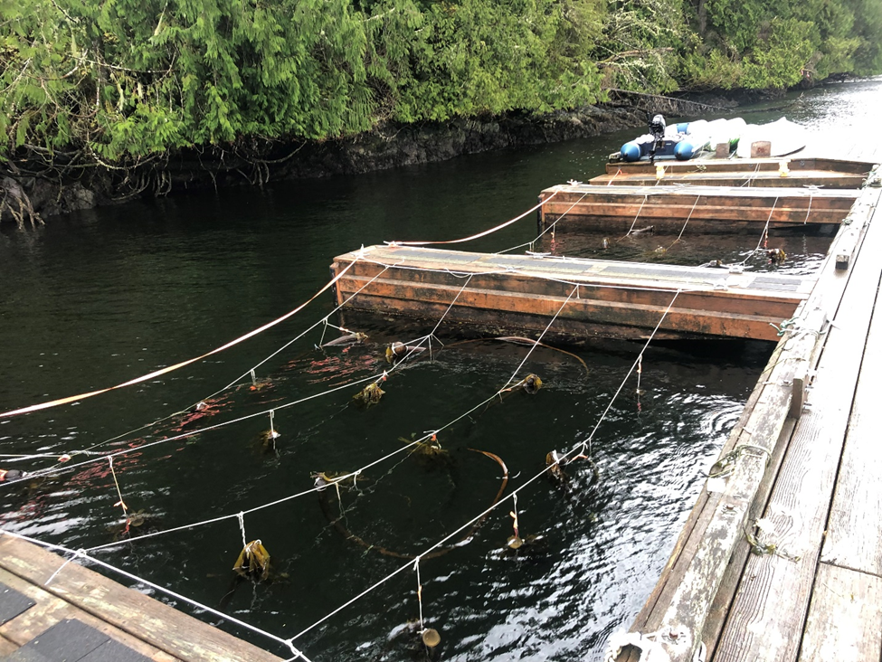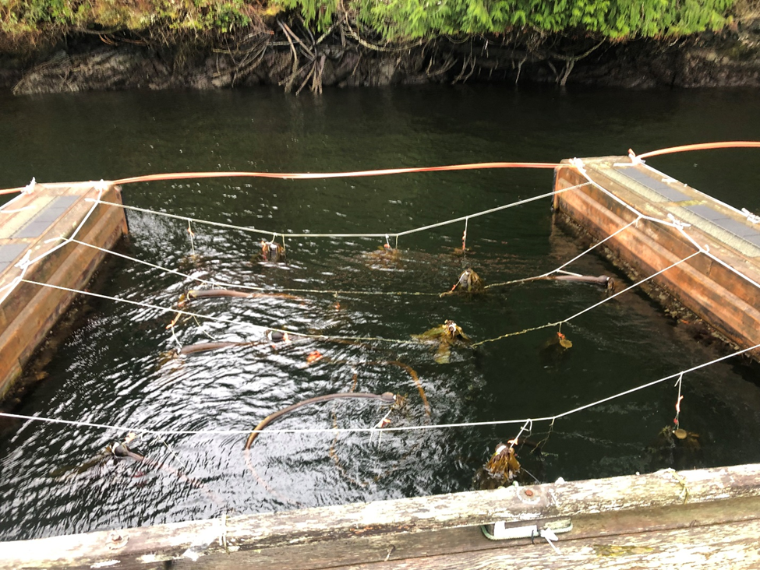

**Fig. 1.** Displayed is the experimental set-up for growing individuals of *Nereocystis luetkeana* in the BMSC boat slips. Nylon cordage is tethered along boat cleats, and more nylon cordage is tethered across to suspend individuals in an ordered arrangement. Individuals are suspended by nylon cordage tied to the base of the blades. Spacing of 75 ± 5 cm was given to individuals to prevent blade overlap during growth.

**Fig. 2.** A comparison of amputation treatments and average blade growth of individuals of *Nereocystis luetkeana*. The control treatment has no amputation (*n* = 7), the intermediate treatment is cut 1.5 m from the base of the bulb (*n* = 10; p = 0.01161), and the extreme treatment is cut in the middle of the bulb (*n* = 12; p = 0.04193). p-values compare the differences in growth of treatments using the control as the base reference.

**Fig. 3.** Damage rating and average blade growth of individuals of *Nereocystis luetkeana* (p = 0. 01039). Ratings are as follows: 0 is a healthy individual (*n* = 13), 1 is rated as having minimal blemishes in the blades (*n* = 10), 2 is rated as having some blades tattered or discoloured (*n* = 4), 3 is notable discolouration, decay, or dentation (*n* = 1), and 4 is noted as heavy damage with large amounts of rotting or dentation (*n* = 1). These ratings were applied only to the portions of individuals suspended in the water and are not necessarily representative of the entire specimen.

**Fig. 4.** Average blade growth of individuals of *Nereocystis luetkeana* plotted against the length of the individual remaining which was measured from the top of the bulb as the reference point.The red line is the slope of best fit using a linear model. The gray shaded area shows the 95% confidence interval. The effects of length remaining on average blade growth were not statistically significant (*n* = 29; p = 0.05378; R2 = -0.395).

**Fig. 5.** The comparison of percent amputation rates of length and mass on average blade growth blades of individuals of *Nereocystis luetkeana*. Blue lines show the line of best fit using a linear model. The gray shaded area shows the 95% confidence interval. Percent of amputated length has a significant effect on average blade growth (*n* = 29; p = 0.00386; R2 = 0.371). The percent of amputated mass also has a significant effect on average blade growth as well (*n* = 29; p = 0.02609; R2 = 0.358).

**Table 1.** Average growth by treatment group of individuals of *Nereocystis luetkeana*. The control treatment had no cut applied to it, the intermediate treatment was amputated at 1.5 m from the base of the bulb, and the extreme treatment was amputated in the middle of the bulb. The p-value listed compares the average growth of the treatment to the average growth of the control. Asterisks denote significant effects of the treatment on growth.

|  |  |  |  |
| --- | --- | --- | --- |
| **Treatment** | **Average Growth (cm)** | **Sample size (n)** | **p-value** |
| Control | 2.39 | 7 | N/a |
| Intermediate* | 3.36 | 10 | 0.01161* |
| Extreme* | 3.55 | 12 | 0.04193* |

**Table 2.** Average growth according to damage rating of individuals of Nereocystis luetkeana. There was a significant effect of damage rating on average blade growth, with higher damage ratings corresponding to lower amounts of growth (p = 0.01039). Ratings are as follows: 0 is a healthy individual, 1 is rated as having minimal blemishes in the blades, 2 is rated as having some blades tattered or discoloured, 3 is notable discolouration, decay, or dentation, and 4 is noted as heavy damage with large amounts of rotting or dentation. These ratings were applied only to the portions of individuals suspended in the water and are not necessarily representative of the entire specimen.

|  |  |  |
| --- | --- | --- |
| **Damage rating** | **Average Growth (cm)** | **Sample size** |
| 0 | 3.56 | 13 |
| 1 | 3.15 | 10 |
| 2 | 2.58 | 4 |
| 3 | 0.66 | 1 |
| 4 | 4.08 | 1 |

**Supplementary**

**Table S1.** Mu coefficients for outputs of the reduced GAMLSS model. Outputs are factors that have a relationship with average blade growth in *Nereocystis luetkeana*. Asterisks indicate significance.

|  |  |  |  |  |
| --- | --- | --- | --- | --- |
| **Output** | **Estimate** | **Std. Error** | **t-value** | **p-value** |
| Intercept* | 4.422 | 0.709 | 6.229 | 2.87 e-05* |
| Percent of amputated length* | -7.501 | 2.145 | -3.496 | 0.00386* |
| Percent of amputated mass* | 3.337 | 1.332 | 2.505 | 0.02609* |
| Length remaining | -0.001 | 0.0008 | -2.117 | 0.05378 |
| Extreme treatment* | 3.946 | 1.752 | 2.253 | 0.04193 |
| Intermediate treatment* | 4.316 | 1.474 | 2.928 | 0.01161 |
| Damage rating* | -0.499 | 0.167 | -2.985 | 0.01039 |

.