PrestaSOAP
- Enable PHP_CURL and PHP_SOAP modules
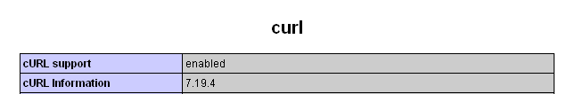
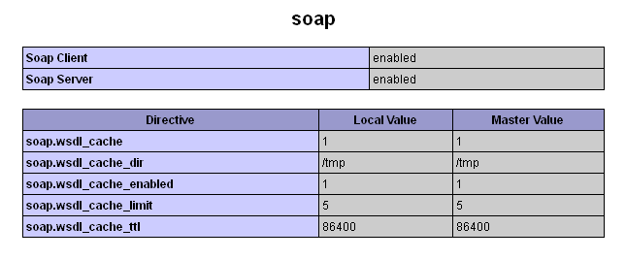
- Edit config.php file
- Enable PrestaShop REST Webservices
http://doc.prestashop.com/display/PS14/Chapter+1+-+Creating+Access+to+Back+Office
- Use REST Key for SOAP Request
<loginInfo>
<key>LFKSDLFSDFKLSDFMSDF</key>
</loginInfo>
- web services list
http://<hostname>/<installdir>/modules/prestasoap/index.php?type=wsdl
- Test Webservices with SOAPui
- Download SOAPui here: http://www.soapui.org/
- Make new project with WSDL
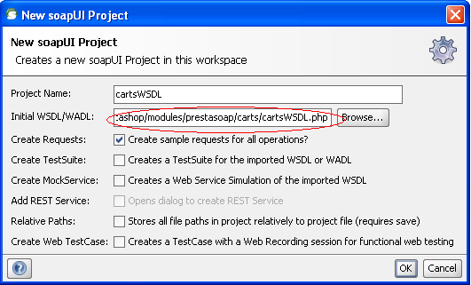
- Enter KEY and ID and execute SOAP request
