G1

Joana Faith C. Aradillos Mini Task # 2

9- St. Raymond

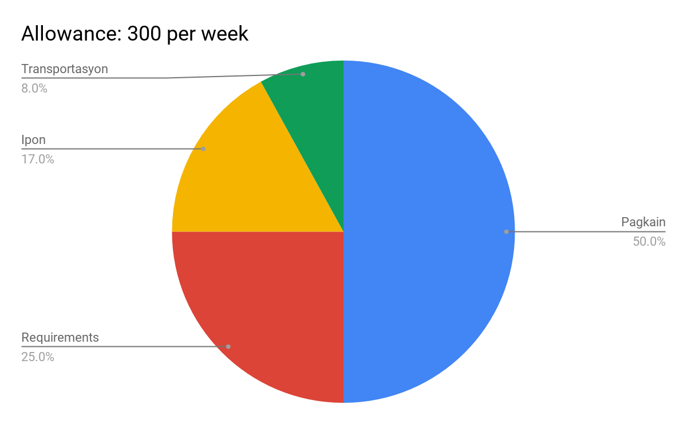

Week 1- 4

|  |  |  |  |  |
| --- | --- | --- | --- | --- |
| DAY 1 | DAY 2 | DAY 3 | DAY 4 | DAY 5 |
| 1. 60 | 70 | 90 | 120 | 160 |
| 2. 210 | 270 | 340 | 420 | 510 |
| 3. 610 | 720 | 840 | 970 | 1110 |
| 4. 1160 | 1220 | 1290 | 1370 | 1460 |