Created By: Mike Grue

Last Edited: 2/9/18

Fire Damage Assessment

DASHBOARD: How To

# Navigate to the Damage Assessment Dashboard

The below How-To will give you a quick tutorial on navigating to and using the Damage Assessment ArcGIS Online (AGOL) Dashboard.

1. On a computer that is connected to the internet, click <http://arcg.is/1CnLXz>.
2. Enter the username and password, if prompted. *This is the same username and password you use for Survey123*: 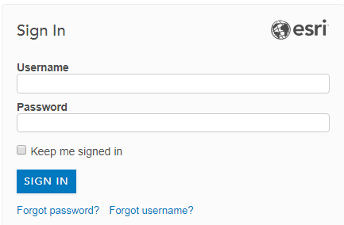
   1. *If you forgot your password, and your username includes your name (i.e. “jsmith_pds”), then you can retrieve your own password by clicking “Forgot password?” and following the instructions*.
   2. *If you are using a generic username (i.e. “da_team1”), then you cannot retrieve this password and you will need to contact LUEG-GIS for the password.*

# Notes on Data Last Updated:

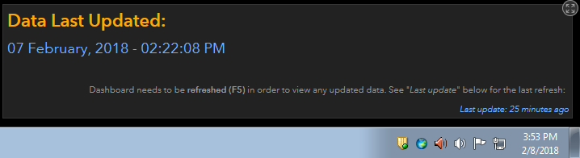

1. In the above scenario, the “**Data Last Updated**” means that the raw Survey123 data was downloaded, processed, and made available to the Dashboard via a processing script on Feb 7, 2018 at 2:22:08 PM.
2. The “*Last update: 25 minutes ago*” means that the Dashboard itself (not the data) was last refreshed 25 minutes ago (or Feb 8, 2018 at 3:28 PM). The Dashboard will only look for newly updated data when **refreshed**.
3. This is important, because users will not see the newest data until they hit F5 to refresh the Dashboard.

# Dynamic Buttons

1. The buttons at the top right of the Dashboard can be used to single out structure type(s) in the map, and the tabs: “Extent of Damage (Structure)”, and “Report List”.
2. In the “Report List” tab, click on a report to have the map pan to that report. 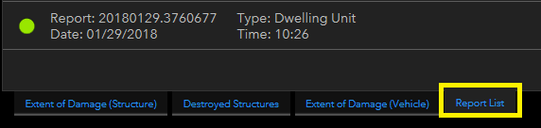
3. In the top right corner of the map, you can select bookmarks, see layers that are available in the map, and change the basemap. 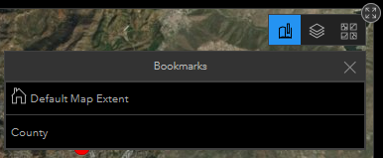
4. Click on a point to display all the tabular information about that report. 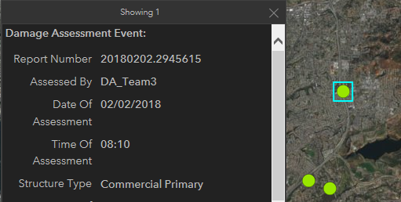

# Editing

1. There is no way to edit this data. If there is an error, or changes need to be made:
   1. Log onto the Damage Assessment web map located at: <http://arcg.is/8vKaa>.
   2. Make the edits to the raw data.
   3. Have LUEG-GIS run the processing script to process the raw data and load it into the database the Dashboard uses.