Created By: Mike Grue

Last Updated: 10/4/2018

How To Export AGOL Data to Excel

Fire Damage Assessment

**WARNING! Exporting AGOL data to Excel may be a good way to see a snapshot of the data as it exists in AGOL at the time of export, but it does not offer a way to incorporate any changes made in the Excel export back into the AGOL database. The Excel export should be considered ‘read-only’. *Any changes you want to make to the data should be done through the appropriate Web Map, NOT the Excel export, and NOT in the Feature Service itself.***

In order to get an Excel extract of the AGOL data located at the Feature Service (FS):

* **Fire Damage Assessment PROD v2**

Please follow the below instructions:

1. Click [here](http://sdcounty.maps.arcgis.com/home/item.html?id=2ef15bee2d8f4ee8bff2a8649a3b1eae) to navigate to the Feature Service (FS).
2. Sign in using an account with permission to view the FS.
3. Click **Export Data** > **Export to Excel** 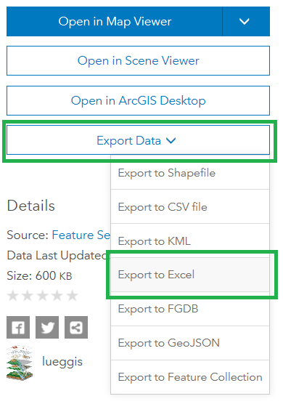
4. **Add a Tag** so you can search for the data if you need to, keep the rest of the defaults, click **Export**. 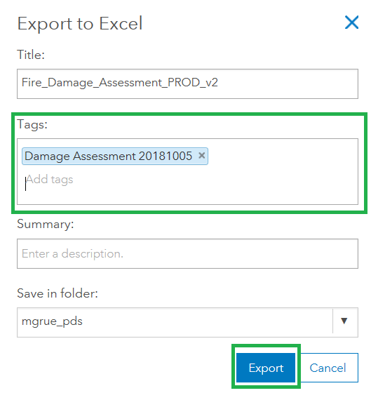
5. *You will be taken to the splash page of the Excel file you just created. This excel file is saved in your home folder on AGOL (“mgrue_pds” in the example above).* In order to download the Excel file to your computer: Click **Download** > **Save as**.

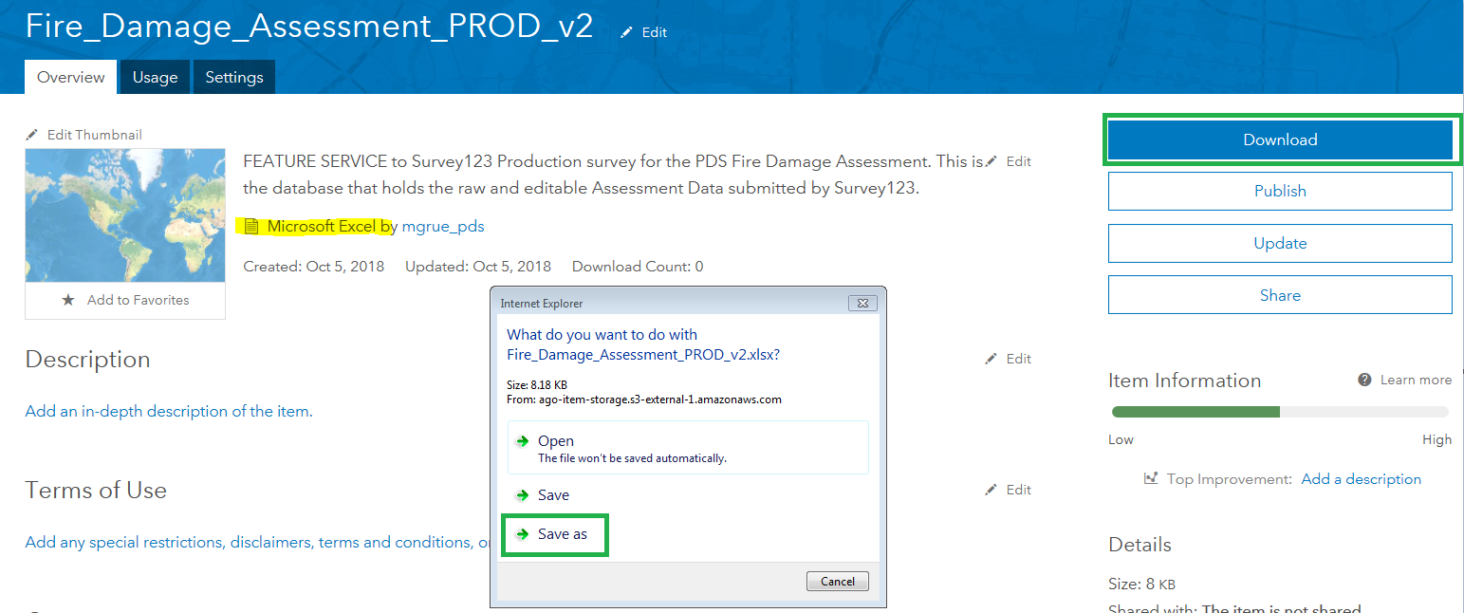

1. After downloading to your computer, you should delete the Excel file that is saved on AGOL:
2. Click **Content** (**A**) > **My Content** (**B**) > Your_Home_Folder (**C**) > The checkbox next to the Excel file (**D**) > **Delete** (**E**). 