Created By: Mike Grue

Last Updated: **6/21/2019**

BLUE Version*

Fire Damage Assessment (DA) Explained

Application Process

**\*This document is the current documentation for LUEG-GIS to use should a fire start (before the County ITO has supported this application) and LUEG-GIS needs to support the DA efforts w/o ITO support.**

**The documentation that the ITO was supplied is now named “FIRE_DAMAGE_ASSESSMENT_EXPLAINED_old_county_version.docx”.**

**This document is meant for LUEG-GIS staff in order to help them support the Fire Damage Assessment Application.**

Contents

Executive Summary 3

How To Run the Processing Scripts 5

Run the Scripts 5

Verify Scripts Ran Successfully 5

DA Flow Chart 6

Survey123 7

Downloading a Survey to User Devices 7

Editing an Existing Survey 7

ArcGIS Online (AGOL) Items 9

Navigate To AGOL Items 9

Live (Raw) Data Items 10

Processed Data Items 10

Scripts 12

File Structure of Root Folder on BLUE Net 12

File Structure of PDS Share Folder on CountyNet (CoSD) 13

Processing 13

Inputs 14

Outputs 15

Pre-event Checklist (work-in-progress) 17

DA Team Responsibilities 17

LUEG-GIS Responsibilities 17

Post-event Checklist (work-in-progress) 18

DA Team Responsibilities 18

LUEG-GIS Responsibilities 18

# Executive Summary

The Fire Damage Assessment (DA) App was built to:

1. Give DA personnel a **digital method to collect DA data** in the field and in the office.
2. Enable a way for DA managers to **view and edit** the live, incoming data from the field.
3. Provide a Dashboard for upper management to be **kept informed of the latest DA data**.

The designed workflow during a DA event is:

1. **Survey123** is installed on smart phones, tablets, laptops (& desktops), and is the data collection method for the field (& office) staff.
   1. **Navigate** **to**: Download Survey123 software to your device, sign in and download the Fire Damage Assessment PROD v2 survey.
2. **ArcGIS Online (AGOL) Web Map** is used by DA managers to view (and edit if needed) the raw field data.
   1. **Navigate** **to**: Click [here](http://sdcounty.maps.arcgis.com/home/webmap/viewer.html?webmap=52db3e5a2e1f4471bba2bfb63c38cde5) or see [ArcGIS Online (AGOL) Items](#_ArcGIS_Online_(AGOL)) below.
3. **Processing Scripts** download the raw data from the raw database to a local FGDB on the BLUE Network, process it, archive the processed data, update the 2 GIS Feature Classes (FC) in a FGDB (on BLUE) with the processed data (One FC holds only the current data, while the other holds both the past events and the current data), then upload the current processed data to a separate AGOL database for the Dashboard to use.
   1. **Navigate to:** See How To Run the Processing Scripts below
   2. **Navigate to FGDB:** P:\Damage_Assessment_GIS\Fire_Damage_Assessment\PROD_v2_as_on_BLUE\PROD_v2\Data\PRODUCTION_DATA.gdb
4. **PDS Info Folder** contains exports from the Processing Scripts (Excel files of the processed data, pictures from the field, QA/QC files) and an import file (which tells the Processing Scripts which reports belong with any stacked parcels).
   1. **Navigate to:** P:\Damage_Assessment_GIS\Fire_Damage_Assessment\PROD_v2_as_on_BLUE\PDS_Info
5. **SDE Databases SDEP2 (Workspace)** contains the processed GIS Feature Class (FC) for the current event, and one FC for all the previous events & the current events combined. These FC’s are in the Feature Dataset “SDEP2.SANGIS.PDS” on the County Network. Since processing now needs to be on BLUE, these FC’s will be **manually** **updated** on COSD as needed by LUEG-GIS staff.
   1. **Navigate to:** 
      1. SDEP2.SANGIS.PDS\SDEP2.SANGIS.PDS_DAMAGE_ASSESSMENT_FIRE_CURRENT
      2. SDEP2.SANGIS.PDS\SDEP2.SANGIS.PDS_DAMAGE_ASSESSMENT_FIRE_HISTORICAL
6. **AGOL Dashboard** uses the processed data on the AGOL database to report various high-level statistics about the DA data.
   1. Navigate to: Click [here](http://sdcounty.maps.arcgis.com/home/item.html?id=82cdd3ad03b44c81813aa07169567345) or see [ArcGIS Online (AGOL) Items](#_ArcGIS_Online_(AGOL)) below.

# How To Run the Processing Scripts

## Run the Scripts

**This section is to quickly inform the reader how to run the Processing Scripts and how to verify that they ran successfully.**

**Copy File from COSD to BLUE**

1. From a computer on the County Network (COSD), navigate to:
   1. *S:\GIS\Damage_Assessment_PDS\Fire\PROD_v2\PDS_Info\Stacked_Parcels_Input*
2. Without deleting the file “**DA_Match_Report_To_APN.txt**”, transfer that file (via email or flash drive) to BLUE Network. The file should be saved to the path below -- overwrite the existing file:
   1. *P:\Damage_Assessment_GIS\Fire_Damage_Assessment\PROD_v2_as_on_BLUE\PDS_Info\Stacked_Parcels_Input*

**Ensure the scripts are not currently being run by another LUEG-GIS staffer**

1. From a computer on the BLUE Network, navigate to:
   1. *P:\Damage_Assessment_GIS\Fire_Damage_Assessment\PROD_v2_as_on_BLUE\PROD_v2\Scripts\Logs\DA_Fire_BatchFile_PROD_v2.log*
2. Scroll to the bottom of the file and confirm that the process is not in progress:
   1. For example, below shows that the last run finished at 3:53pm on 6/26/19: 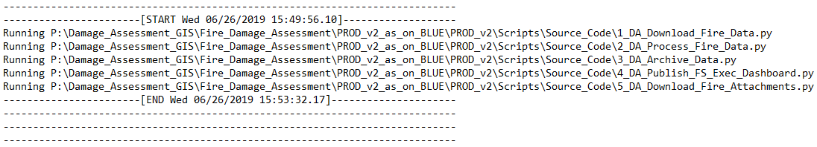
   2. Below shows that the process is currently being run: 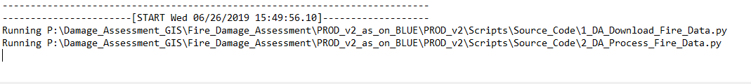

**Launch batch file**

1. From a Computer on the BLUE Network, navigate to:
   1. *P:\Damage_Assessment_GIS\Fire_Damage_Assessment\PROD_v2_as_on_BLUE\PROD_v2\Scripts*
2. Click **DA_Fire_Batch_File_PROD_v2.bat** to run all the processing scripts. These scripts can take anywhere from about 5 – 30 min to run (depending on the amount of data and the connection speeds).

## Verify Scripts Ran Successfully

1. In order to tell if the scripts ran successfully, check the files located at:
   1. *P:\Damage_Assessment_GIS\Fire_Damage_Assessment\PROD_v2_as_on_BLUE\PROD_v2\Scripts\Source_Code\Success_Error*
2. This folder will contain a SUCCESS or ERROR file for each script that was run by the batch file. There should be **5 files** in this folder by the time the batch file is finished calling scripts (Hopefully all 5 are named **SUCCESS_running_<name of script>.txt**). Make sure that you pay attention to the **Date modified** for each file to ensure that all files have been recently created.
   1. If you find any ERROR files, there was a problem running that script. You can check the **log files** at: *P:\Damage_Assessment_GIS\Fire_Damage_Assessment\PROD_v2_as_on_BLUE\PROD_v2\Scripts\Logs*
3. In order to check the processed GIS data:
   1. Check the **Excel file** that is created in folder at: *P:\Damage_Assessment_GIS\Fire_Damage_Assessment\PROD_v2_as_on_BLUE\PDS_Info\Processed_Assessments_Excel_Exports*
   2. This Excel file is an extract of the FC in the PRODUCTION_DATA.gdb. **PDS_DAMAGE_ASSESSMENT_FIRE_CURRENT**.
4. In order to check the Dashboard, type <http://arcg.is/111faf> into a web browser. Log in with your own AGOL account (or use ‘lueggis’ if you don’t have one).

# DA Flow Chart

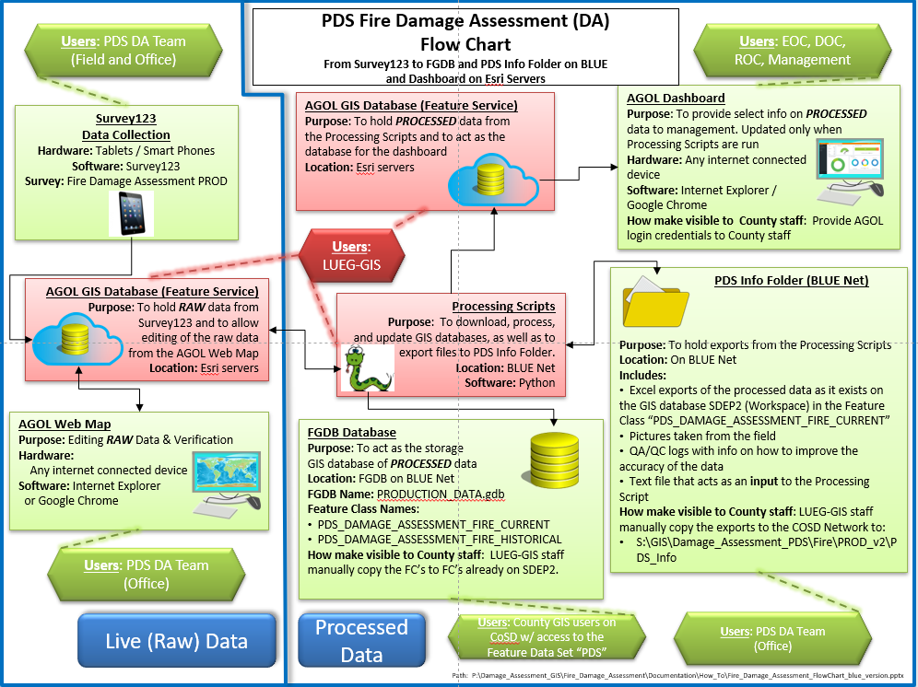

# Survey123

## Downloading a Survey to User Devices

1. A user needs to have the Survey123 app downloaded to their device from the appropriate app store.
2. The user then needs to have a Tier 2 AGOL account that is in the AGOL group **Damage Assessment (Editor)**. This group should have permission to 1) access the “Fire Damage Assessment” survey and 2) write to the AGOL database that has the same name as the survey.
3. The user signs onto Survey123 on their device and chooses to download the survey.
4. The new survey is now ready to be filled out and sent to the AGOL database.

## Editing an Existing Survey

**WARNING! Editing an existing survey has potential consequences. It is highly recommended that the existing Production survey not be edited during an event. The risk of affecting the whole process in an unforeseen way is high, especially during the stress and unpredictability during an event.**

**It is also highly recommended to not edit an existing Production survey, but to create a new version (v3, v4, etc.) and use the current Production survey as a template to build the new one.**

For LUEG-GIS to edit the existing survey, a desktop computer and appropriate software is needed.

1. The Fire DA App was created by downloading to a computer and using ESRI software: **Survey123 Connect for ArcGIS**. 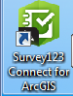
2. Once Survey123 Connect for ArcGIS is downloaded, logging in on the Survey123 Connect splash page should allow you to download any already published survey *that is owned by the account you signed in with (in this case “lueggis”)*.
3. Folders and files used to create the survey:
   1. 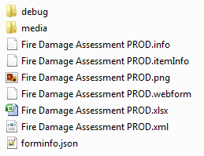
   2. The .xlsx file is the main interface used to change the AGOL Form and the AGOL database. If an edit only changes the form (i.e. adding or editing a domain), this change can be published to AGOL w/o deleting and recreating the AGOL database. However, changes to the survey that would require changes to the *schema of the AGOL Database* **would** require a deletion and recreation of the AGOL Database. The software will do this automatically, and it will warn you first that the data may be lost if you proceed with publishing.
   3. **WARNING! If you do make a change to the survey that requires a schema change (i.e. Add a field, Change a field’s name, or the data type for an existing field), you will have to:**
      1. **Save the existing data to a temp FGDB.**
      2. **Proceed with the publishing.**
      3. **Append the saved data from the temp FGDB to the newly created Feature Service (FS).**
   4. **Any scripts/maps that look at that AGOL FS will also need to be repointed since the FS will have received a new service name (i.e. the highlighted portion below is the name of a FS created by Survey123.**

# ArcGIS Online (AGOL) Items

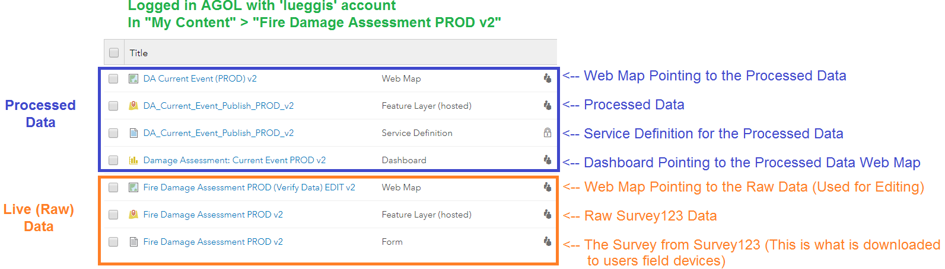

The above items represent the AGOL items that are used by the Fire DA Application.

Three items are pre-processing (before the scripts are run): The Survey123 **Form** that is downloaded to a users device, the **Feature Layer/Service (FS)** that holds the Survey123 data, and the **Web Map** that is used to edit the raw data.

Four items are post-processing (after the scripts are run): The **FS** and **Service Definition** that is overwritten by the script “DA_Publish_FS_Exec_Dashboard.py” which contains the processed data, the **Web Map** that consumes that FS, and the **Dashboard** which consumes the Web Map.

## Navigate To AGOL Items

1. The AGOL items that are a part of the Fire DA App are owned by the AGOL user account **lueggis**. This means that all the items are found when signed into <https://www.arcgis.com/home/index.html> as **lueggis** and click on the **My Content** tab. 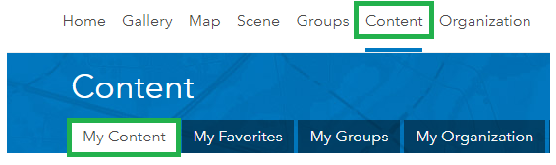
2. The folders that contain the items are found in the **Fire Damage Assessment PROD** folders (choose the most recent version): 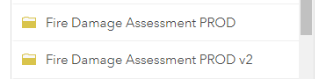

## Live (Raw) Data Items

These items are used to collect, and edit the raw data before the scripts are run to process, store, and report on the data.

1. The Form **Fire Damage Assessment PROD v2 – Form** is created by Survey123 Connect when the survey is published. This is the form that is downloaded to a users device. It contains the rules and customizations that were set in Survey123 Connect.
   1. This must be shared with the correct group in order for a user to *DOWNLOAD*a new survey to Survey123.
2. The FS **Fire Damage Assessment PROD v2 – Feature Layer (hosted)** is the FS that is created by Survey123 Connect when the survey is published. This is the online database that receives the raw data from the user’s device.
   1. This must be shared with the correct group in order for a user to *UPLOAD*a record to this AGOL database. It must also be shared with the correct group in order for the script to *DOWNLOAD* the raw data in order to process it.
3. The Web Map **Fire Damage Assessment PROD (Verify Data) EDIT v2** is the Web Map that looks at the *raw* survey data (Fire Damage Assessment PROD – Feature Layer (hosted)) and allows the user to view and edit the raw Assessments before they are processed. This web map allows editing of the location, some attributes, and allows for Assessments to be deleted.

## Processed Data Items

All of these items exist only for the purposes of being used by the Dashboard. These are much less critical than the Pre-processing items above. There is no data editing done in these services.

1. The FS **DA_Current_Event_Publish_PROD v2 – Feature Layer (hosted)** is the FS that is created by publishing the *processed* data via a MXD that is pointing to the processed data on Workspace.
   1. Since there is no editing allowed on this FS, any changes need to be first made to the raw data. The processing scripts will then update this data when they are run.
   2. This must be shared with the correct group in order for a user to be able to view the Dashboard.
2. Web Map **DA Current Event (PROD) v2** is pointing to the *processed* survey data (DA_Current_Event_Publish_PROD v2 – Feature Layer (hosted)). The primary use of this web map is to be consumed by the Dashboard.
   1. This must be shared with the correct group in order for a user to be able to view the Dashboard.
3. The Dashboard **Damage Assessment: Current Event PROD v2** is used to display processed data.
   1. This must be shared with the correct group in order for a user to be able to view the Dashboard.

## Users in AGOL Groups

The below people are in the group "Damage Assessment (Editor)" that can add new data as well as edit the Raw data in AGOL. This list may grow/shrink as needed.

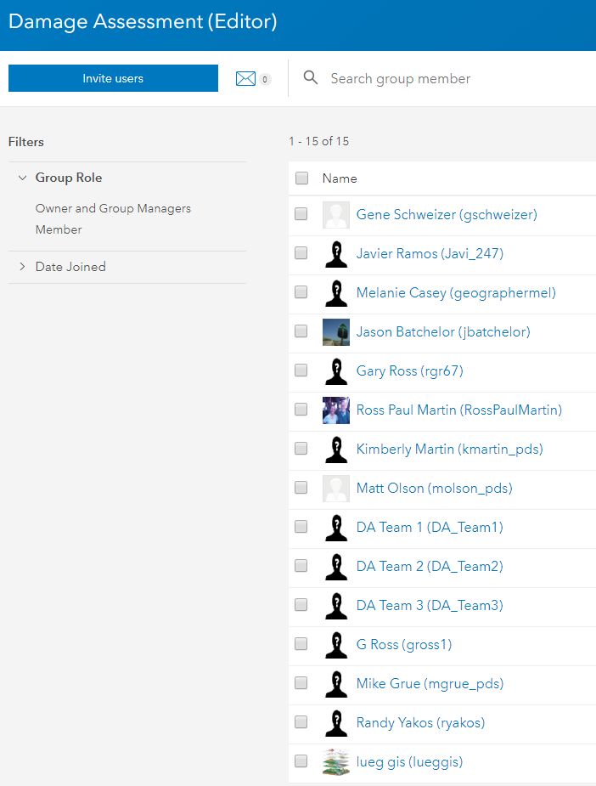

The below people are in the view only group "Damage Assessment (Viewer)".  This is the group that we would add people to if you wanted them to only be able to see the Dashboard.  It is OK if users in the (Editor) group aren't on this list.  Everyone on the (Editor) list above can see the dashboard too This list may grow/shrink as needed.:

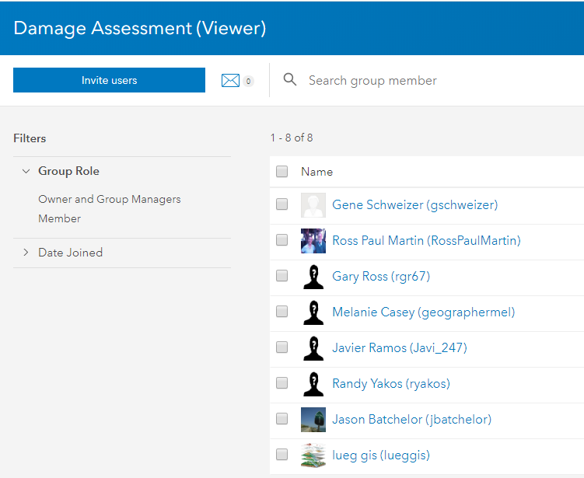

# Scripts

## File Structure of Root Folder on BLUE Net

Path to **Root Folder** on BLUE that is the **Production environment**:

*P:\Damage_Assessment_GIS\Fire_Damage_Assessment*

* **Archived** (*Contains old items that should be able to be deleted*)
* **Documentation** (*Contains* d*ocumentation about this app*)
* **Prod_v2_as_on_BLUE** (*Contains the second version of the production application, which is the replacement for the first version)*
  + **PROD_v2**
    - **Data** (C*ontains all the working FGDBs created by the scripts*)
    - **MXD** (*Contains the MXD that is used to publish the processed data to AGOL*)
    - **Scripts:** (*Contains any script related items*)
      * **Config_Files** (*Contains a template of the .ini file used to pass variables to the scripts. The .ini file the scripts actually use is on the desktop of the user on 395 because it has passwords we don’t want everyone to have access to*)
      * **Connection_Files** (*Contains* *SDE connection files to GIS SDE databases: Workspace and Warehouse*)
      * **Logs** (*Contains* *logs from every script*)
      * **Source_Code:** (*Contains all the python scripts*)
        + **Control_Files** (*Contains CSV files that pass variables to the processing script, i.e. new fields to add or fields to calculate*)
        + **Success_Error** (*Contains files named based on the successful run—or not—of each script*)
      * **DA_Fire_BatchFile_PROD_v2.bat** (*The batch file that runs all the scripts*)
  + **PDS_Info** (*Folder that the DA team uses to send/receive data to/from the scripts*)
    - **Field_Pics_Exports** (*Contains the pictures submitted by field staff via Survey123 are stored by the scripts*)
    - **Processed_Assessments_Excel_Exports** (*Contains Excel file extracts of the database of the current event on Workspace on CoSD*)
    - **QA_QC_Logs_Exports** (*Contains a log file with info for DA team and LUEG-GIS to help correct and improve the raw data*)
    - **Stacked_Parcels_Input** (*Contains a text file that the DA team fills out to tell the script which parcel a report should be tied to if that report is on a stacked parcel*)

## File Structure of PDS Share Folder on CountyNet (CoSD)

Path to the **Shared Folder** that PDS DA Team has access to on CoSD. This is the location on COSD that LUEG-GIS staff would update after the scripts are run on BLUE.

S:\GIS\Damage_Assessment_PDS\Fire

* **PROD_v2** (*Contains the PDS_Info folder*)
  + **PDS_Info** (*Folder that the DA team uses to send/receive data to/from the scripts*)
    - **Field_Pics_Exports** (*Contains the pictures submitted by field staff via Survey123 are stored by the scripts*)
    - **Processed_Assessments_Excel_Exports** (*Contains Excel file extracts of the database of the current event on Workspace on CoSD*)
    - **QA_QC_Logs_Exports** (*Contains a log file with info for DA team and LUEG-GIS to help correct and improve the raw data*)
    - **Stacked_Parcels_Input** (*Contains a text file that the DA team fills out to tell the script which parcel a report should be tied to if that report is on a stacked parcel*)

## Processing

Processing is currently happening on BLUE. 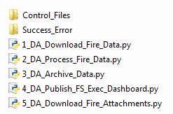

1. Double-clicking on the batch file (**DA_Fire_BatchFile_PROD_v2.bat**) will call each script in correct order. The process can be described as:
   1. Download the raw data (submitted by field users using Survey123) and stored on AGOL.
   2. Process the raw data.
      1. Confirm that the Download script ran successfully.
      2. Make a copy of the original downloaded AGOL data, but don't copy any features where "ReportNumber is NOT NULL or ReportNumber <> ''".
      3. Join the raw data (w/o any NULL ReportNumbers) to the PARCELS_ALL database (to get APN info for each report).
      4. Look for reports on ‘stacked’ parcels. If found, either delete the duplicates created by the join and nullify the APN info *or* keep the report with the correct APN if this pair was specified in the file ‘DA_Match_Report_To_APN.txt’ (mentioned in “Inputs” section below).
      5. Add fields that were not created by Survey123, but are still needed.
      6. Calculate various fields.
      7. QA/QC the working data. Write a log file that can be used by PDS DA Team to ensure the accuracy of their data.
      8. Backup the Production DA data in the FGDB PRODUCTION_DATA.gdb.
      9. Write the newly processed data to PRODUCTION_DATA.gdb.
      10. Export the newly processed data to an Excel file that PDS DA Team can use (after LUEG-GIS moves the data from BLUE to COSD.
      11. Update some fields in the raw AGOL data:
          1. Update any Report Number where “Quantity is NULL” to have a “Quantity = 1”.
          2. Update all features in raw data with their “Estimated Replacement Cost” that may have been calculated by the process.
      12. Write a “Success” or “Error” file depending on if the script was successful or not. This will let the publish script below know if it should be run or not.
   3. Archive (backup) the CURRENT processed data into a HISTORICAL Feature Class in PRODUCTION_DATA.gdb. This HISTORICAL FC contains not only the data that was just processed, but also the processed data of previous fires/events. *This is in contrast to the backup (BAK) that happens in the Processing script above, that backup is only a backup of the data that is in the CURRENT FC and does not contain any data from previous fires/events.*
   4. Publish the CURRENT processed data via an MXD to a second AGOL FS for the Dashboard to use.
   5. Download any attachments (pictures) from the raw Survey123 database.

## Inputs

There are really only a few inputs that LUEG-GIS needs to be aware of: a config file that stores variables the scripts need, 2 CSV files, a Success/Error file for each script, and a text file maintained by the PDS DA team.

1. **Fire Damage Assessment PROD v2 – Feature Layer (hosted)** – Is the AGOL database that holds the raw Survey123 field data.
2. **DA_Main_Config_File_v2.ini** –(Stored on BLUE) –Each of the 4 scripts looks to a config file that is used to pass a number of variables to the scripts. *This config file has the lueggis password stored in it.*
3. **FieldsToAdd.csv** – (Stored in Control_Files folder) – Tells the script which fields to add.
4. **FieldsToCalculate.csv** – (Stored in Control_Files folder) – Tells the script which fields to calculate – and how.
5. **Success_Error** – (Stored in Source_Code folder) – Folder contains the files that are created by the scripts that are used to tell other scripts if they were run correctly or if they had errors. Sometimes we do not want a script to run if the preceding script had errors in it. For example, if the processing data failed, we do not want to overwrite correctly processed data that is on already on AGOL with partially processed data.
   1. **NOTE**: This is a useful folder to verify that every script ran successfully.
6. **DA_Match_Report_To_APN.txt** – (Stored in “PDS_Info\Stacked_Parcels_Input”folder) – The ‘DA_Process_Fire_Data.py’ script uses this text file to get the list of Report Numbers and which APN they should be associated with. This file is maintained by the PDS DA team. It exists so that if an assessment happened on a parcel that is ‘stacked’ (multiple APN’s on one Parcel footprint), the script would know which APN info belongs to that Report Number.
7. **PARCELS_ALL**

## Outputs

There are a variety of outputs that the script produces. The GIS outputs are put into the “Data” folder. But most of the final outputs go to **PDS_Info** folder where a PDS user logged onto CoSD will be able to access the output tables and files (once LUEG-GIS puts the newly created files from BLUE to COSD). On BLUE, the **PDS_Info** folder is located at: **P:\Damage_Assessment_GIS\Fire_Damage_Assessment\PROD_v2_as_on_BLUE\PDS_Info**. On COSD, the **PDS_Info** folder is located at:: **S:\GIS\Damage_Assessment_PDS\Fire\PROD_v2\PDS_Info**

1. Data for PDS DA Team (PDS_Info):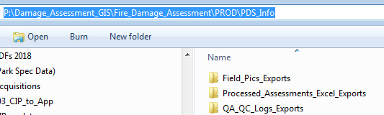
   1. **Field_Pics_Exports** folder is the directory where any pictures taken with Survey123 are kept. The script will put the pictures here automatically as long as the config file is pointing to the correct path to the PDS_Info folder.
   2. **Processed_Assessments_Excel_Exports** folder is the directory where the Excel export of the Assessment data is kept. Each run of the script “DA_Process_Fire_Data.py” will place a new Excel file here with a timestamp of when the data was downloaded from AGOL.
   3. **QC_QC_Logs_Exports** folder is the directory where the QA/QC log files are kept. Each run of the “DA_Process_Fire_Data.py” and “DA_Archive_Data.py” scripts will produce a QA/QC log file with a timestamp that will go over a variety of checks and will give information on how to fix the data. The QA/QC log files are intended for use by PDS DA Team *and* LUEG-GIS to help ensure accuracy of the data.
2. **Log files** that record the general running of the script are housed in the ‘Scripts’ folder and are intended for LUEG-GIS to debug scripts. A log file is created for each script that is run, plus one log file for the batch file that gets updated at each run.
3. **GIS Data** is updated in a ‘production’ FGDB located on BLUE named “PRODUCTION_DATA.gdb” each time the scripts are run. This is the GIS data that can be used to update the FC’s on COSD.
4. **GIS Data** is updated on Workspace (**manually** by LUEG-GIS staff) at:
   1. **SDEP2.SANGIS.PDS\SDEP2.SANGIS.PDS_DAMAGE_ASSESSMENT_FIRE_CURRENT**
   2. **SDEP2.SANGIS.PDS\SDEP2.SANGIS.PDS_DAMAGE_ASSESSMENT_FIRE_CURRENT_BAK**
   3. **SDEP2.SANGIS.PDS\SDEP2.SANGIS.PDS_DAMAGE_ASSESSMENT_FIRE_HISTORICAL**
5. **DA_Current_Event_Publish_PROD v2 – Feature Layer (hosted)** is the AGOL FS that gets completely overwritten and holds the processed data that the Dashboard uses.

# Pre-event Checklist (work-in-progress)

## DA Team Responsibilities

1. Maintain Damage Assessment Devices (iPad 6th Gen):
   1. Keep devices charged.
   2. Store devices in IT closet.
   3. Keep devices logged into COSD PDS Apple ID and enrolled in Airwatch Agent.
   4. Ensure Survey123 app is downloaded with latest version of Fire Damage Assessment survey.
2. Maintain GPS receivers (Bad Elf GPS PRO+):
   1. Keep devices charged.
   2. Store devices in IT closet.
   3. Pair GPS with Damage Assessment Device using Bluetooth.
3. Document login information for:
   1. Apple ID.
   2. Airwatch Agent.
   3. ArcGIS accounts DA_Team1, DA_Team2, DA_Team3, DA_Team4.
   4. iPad passcodes.
4. Deliver Damage Assessment Devices, GPS, and accessories .
5. Ensure Initial Damage Assessment Report paper form (PDS 810) is consistent with latest version of Damage Assessment survey.

## LUEG-GIS Responsibilities

1. Test the Processing Scripts. Test the Processing Scripts by submitting test data and running the scripts. Clean up the test data afterwards.
2. Documentation of DA Application. Ensure that any staff that may be responsible for supporting the DA application has access to this “*FIRE_DAMAGE_ASSESSMENT_EXPLAINED_blue_version.docx*” document.

# Post-event Checklist (work-in-progress)

## DA Team Responsibilities

1. Ensure all features in the CURRENT FC have a Quantity of 1. *Except for ‘Vehicles’, which can have more than 1 in the Quantity field*.
   1. During an event, it is OK for a point to have multiple structures associated with it in order to save time (i.e. 1 point for a mobile home park where 30 DU’s were destroyed). But when the event is winding down, this ‘stacked point’ should be split out into one point per structure.
2. Make sure there are no “Vehicles – Damaged” in the data. Vehicles should only be included in the data if they are Destroyed.
3. Confirm the QA/QC file has all “OK!’s”.

## LUEG-GIS Responsibilities

1. Delete the features in the AGOL Feature Services. *After an event has been resolved and there are going to be no more changes to the RAW data, and the PROCESSED data is no longer needed, the two AGOL FS’s should have their features deleted (do not delete the FS themselves). We will delete the features in the RAW Survey123 FS as well as the PROCESSED data FS:*
   1. Ensure that the PDS DA team is done using the AGOL Feature Service with the RAW Survey123 data.
   2. Ensure that PDS DA team and any other department that is using the AGOL Feature Service with the PROCESSED data is done using the data.
   3. In order to delete the features in the features in an AGOL FS can be done in a few ways.
   4. By using an AGOL Web Map to click on each feature > edit > delete. This can take a long time, but it is easy to do.
   5. By using ArcMap: Add Data from ArcGIS Online > Sign in > (Enter credentials for ‘lueggis’) > Add Feature Service “Fire Damage Assessment PROD vX” > Edit Features > Create Local Copy for Editing > (Delete all features) > Save Edits > Synchronize Local Edits with Server.
   6. By using a script that will programmatically delete every feature in a FS, but will leave the FS intact. This script is not written, but it could be in the future.
2. Delete the features in the “CURRENT” FC. *The “CURRENT” FC is supposed to only hold features from an active event. Once an event has been resolved, the FC in SDEP2 (Workspace) should have all the features deleted. But there are a few steps to take first:*
   1. Ensure that the features from the most recent event in Workspace in **PDS_DAMAGE_ASSESSMENT_FIRE_CURRENT** match the features from the most recent event in **PDS_DAMAGE_ASSESSMENT_FIRE_HISTORICAL**. It is possible that there will be features in the Historical database that were later intentionally deleted in the CURRENT database. If so, it would make sense to delete these features from the HISTORICAL database too.
   2. Delete the features in **PDS_DAMAGE_ASSESSMENT_FIRE_CURRENT**. Any future changes to the GIS data will now be made in the HISTORICAL database.
3. Standardize the Incident Names. *Make sure all the recent incidents have correctly named Incident Names and that they are all consistent (i.e. West* ***F****ire vs. West* ***f****ire)*.
   1. One way to do this is to add the HISTORICAL FC to a MXD and get the unique values for any recently added features and make sure they are consistent. Change the incident names if needed.
4. Confirm the QA/QC file has all “OK!’s”.
5. Append the new features in from HISTORICAL FC to HISTORICAL_BAK FC **manually**. This backup is maintained manually and provides a fail-safe against any accidental scripting deletions in the HISTORICAL FC.
6. Clear out the DA_Match_Report_To_APN.txt. *To give the next event a clean slate.*
   1. Delete all of the pairs in the text file, however do not remove any of the instructions, or delete the text file itself.
7. Move all exported files from BLUE’s “PDS_Info” folder to the COSD’s “PDS_Info” folder. Once transferred, remove the files from BLUE’s “PDS_Info” folder to keep duplication and confusion to a minimum.