**Section 1: Introduction**

Bookworm’s World

Software Design Specifications

**1.1 Describe the purpose of this document**

The purpose of the document is to give a clear plan for a web design project to people involved in the project, like teachers, students, and other people working on it. It will explain what the project is for, what it will do, and what rules and limits the project needs to follow.

The document will help the people working on the project understand what they need to do and what rules they need to follow. Teachers will use it to make sure the project is good for learning. Students will use it to understand what they need to do. And everyone working on the project will use it to work together and fix any problems that come up.

The goal is to make sure the project is done well and everyone is happy with it. The document will help everyone work together and ensure the project meets its goals.

**1.2 Describe the scope of this document**

This document outlines what the website should be capable of doing. It should allow users to create accounts, add and remove books, rate and comment on books, and log in and out of their accounts. This is the second version of the website, and this document covers everything that has been done so far. Some of the website's features include a search function to help users find items quickly, a favorites feature to let users save what they like, and the ability to rate and comment on items to share their opinions with others. This document helps the team understand what they need to do and how to make the website work as intended.

**1.3 Describe this document's intended audience**

The intended audience for this document is for teachers, students, and faculty. This document describes the requirements and goals for the project. The team would use this document as a guide to meet the requirements.

**1.4 Identify the system/product using any applicable names and/or version numbers.**

This document explains what the project should be. The website is under version 2 and lets users do things like search for books, log in and out, comment and rate books, and add or remove books from their accounts. The website has three main features: finding books, managing books, and letting users interact with each other through comments and ratings. This document helps the team know what they need to do and how to make the website work correctly.

**1.5 Provide references for any other pertinent documents such as:**

Reference: N/A

Related and/or companion documents: None

Prerequisite documents: None

Document which provide background and/or context for this document: N/A

Documents that result from this document: N/A

**1.6 Define any important terms, acronyms, or abbreviations**

**Section 2: System Overview**

This project consists of a book website where users access all types of features. To begin, the project's name is “Bookworm’s World.” In total, there are five features we have worked on. We have added an “About us” section about the project's members. The “Search” feature lets the user find the information they are looking for. A “Comment” feature where the users can speak their mind about a book. “Favorites” for users who want to save their favorite webpages and get to them quickly. The last feature is “Rating” so users can give their opinions on books.

**Section 3: Design Considerations**

**3.1 Assumptions and Dependencies**

**Assumptions:**

1. Users have access to web browsers and the internet.

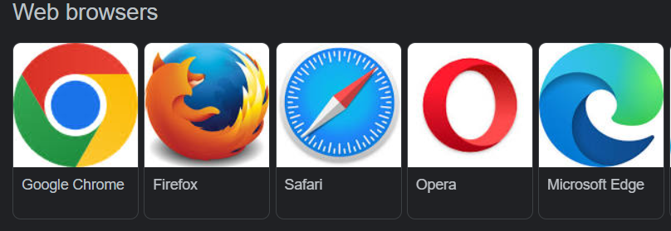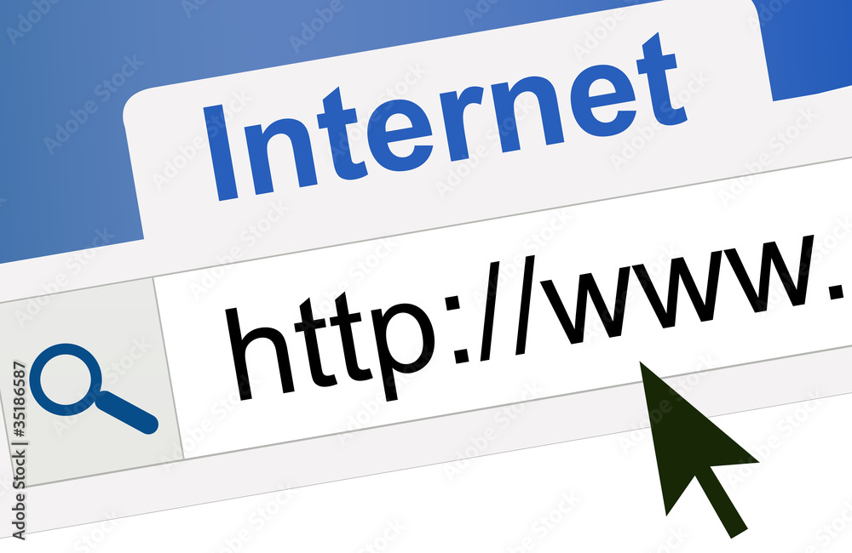

1. Users have skills to navigate website

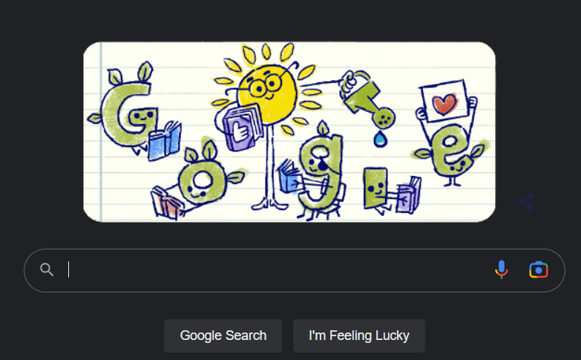

1. The website will have books in a specific language

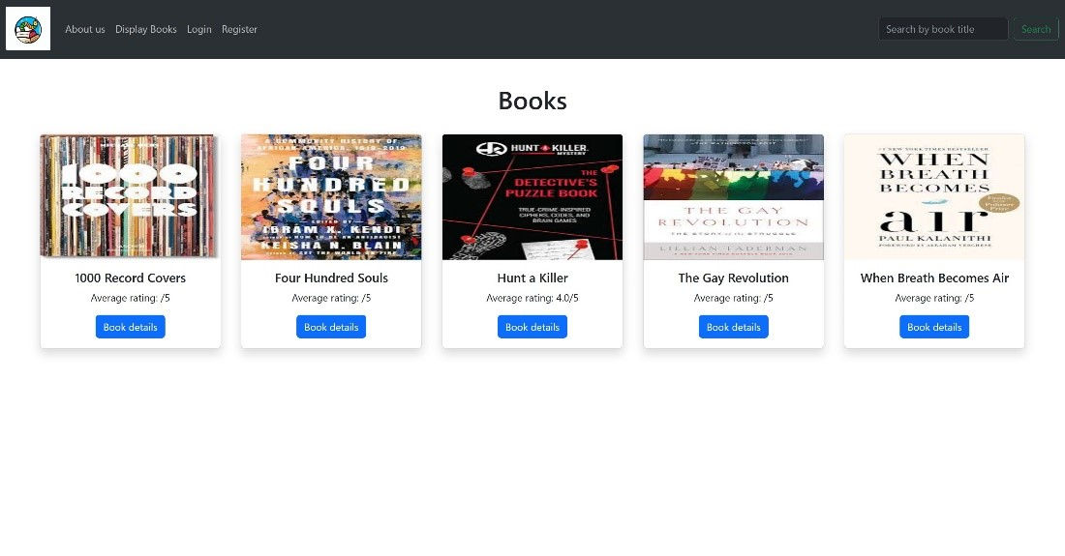

1. The website will have a search bar to help users find specific books
2. The website will have a review/rating for each book
3. The website will show the book detail page not logged in.
4. Users can delete comments
5. This website allows users to add their favorite books.

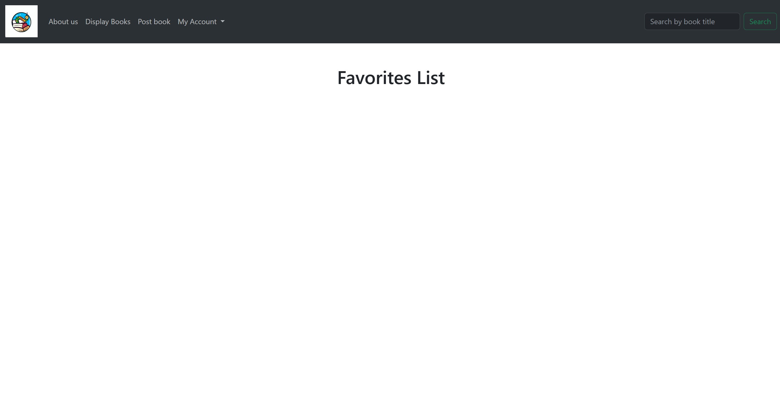

1. The website will show books that users have posted.

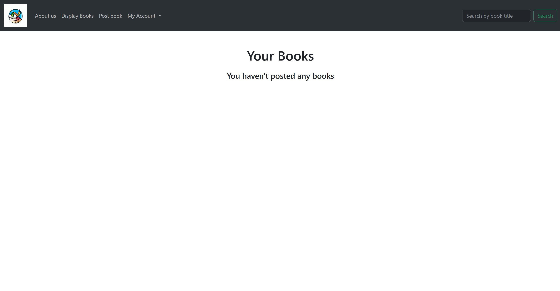

**Dependencies:**

1. The website will depend on a secure host to make it accessible to users.
2. The website will depend on a management system to retrieve and store book information
3. The website will depend on user feedback to improve functionality

**3.2 General Constraints**

1. Budget: Development, maintenance, and hosting is all dependent on budget
2. Time: There is a constrain because of the deadline to meet
3. Technical limits: There may be constraints with website capabilities
4. Needs: The website must meet the needs of the users
5. Accessibility: The accessibility of the website must be reliable despite users' disabilities.
6. Security: User data must be protected from unauthorized personnel.

**3.3 Goals and Guidelines**

**Goals:**

1. Give users a variety of books to choose from
2. Have a user-friendly website
3. Give the best recommendation to users based on their picks
4. Get user feedback to improve user experience
5. Maintain and improve the website’s functionality

Guidelines:

1. Ensure that the website is optimized for all devices
2. Keep books up to date to ensure users have access to the most current information.
3. Have quality images and book showcase

**3.4 Development Methods**

Rapid Application Development (RDA): We want to focus on speed and flexibility for the development of the website. Having preexisting components helps the development of the website. Allowing us to quickly develop and deploy the website.

**Section 4: ArchitecturaI Strategies**

**4.1** Use of a particular type of product (programming language, database, library, etc.)

- For this project, we used a combination of programming languages such as Python, HTML, CSS, and Bootstrap. To implement these languages, we are using the Django library.

**4.2** Reuse of existing software components to implement various parts/features of the system

- In this project, we utilized the preexisting structure of the class software. We then incorporated our own features and altered the design

**4.3** Future plans for extending or enhancing the software

- We are planning to include a search bar, a comment section, a favorites list, and a rating system to enhance our website.

**4.4** User interface paradigms (or system input and output models)

- We have developed different input and output models for system interfaces, which include a search bar, a comment section, and a rating system.

**4.5** Hardware and/or software interface paradigms

1. Web browser Interface: Used for the users to interact with website
2. Mobile Interface: Useful for increase mobile device usage
3. Content management System: To allow for easier way to manage website content
4. Database Management System: This helps maintain books on website
5. Search Engine: Tool for users to find the books they are looking for.

**4.6** Error detection and recovery

1. Validating user input: Ensure that user input meets criteria for access
2. Automated Testing: To help detect errors in code
3. Backups: To help with potential loss of data
4. Automatic Recovery: Help minimize the impact of errors on the website

**4.7** Memory management policies

1. Garbage Collection: To help free up memory no longer in use by website
2. Caching: To help store information that is constantly accessed
3. Memory Allocation: To determine how memory will be stored on the website

**4.8** External databases and/or data storage management and persistence

1. Relational Database: The database will store the book and user information. This could be the user’s username and password. For the books it would be the title or description
2. File Storage: The file storage will be used for large files like multimedia files or book covers.
3. Cloud Storage: Cloud storage allows for cost-effective sharing and storing of data.
4. Data Backup: In case of a disaster, having data backed up will help in the recovery.
5. Data Migration: Data migration is critical for scalability, performance, and reliability of the website.

**4.9** Distributed data or control over a network

1. Load balancing: Having traffic balanced between multiple servers will prevent one from being overloaded.
2. Clustering: To have reliability, connecting different servers as one will help.
3. Partitioning: Another strategy that helps scalability and reliability is dividing data across different servers.
4. Content Delivery Network: With CDN the performance of the website by improving the load time for the website’s content.

**4.10** Generalized approaches to control

1. Monitoring: Having alerts for potential system failures and network congestion will help with the performance of the website by assuring everything is working properly.
2. Configuration Management: Making sure that the website’s configuration is working properly. For example, the servers, network, and software.

**4.11** Concurrency and synchronization:

1. The Django Framework will handle the concurrency and synchronization of the website.

**4.12** Communication mechanisms

1. Remote Procedure Call: RPC will be used to handle procedures that are too complicated and resource demanding.
2. Representational State Transfer: REST will use HTTP to get to the servers and access data.
3. WebSocket: The websocket will establish the connection between the user’s device and the servers.

**Section 5: System Architecture**

This section should provide a high-level overview of how the functionality and responsibilities of the system were partitioned and then assigned to subsystems or components.

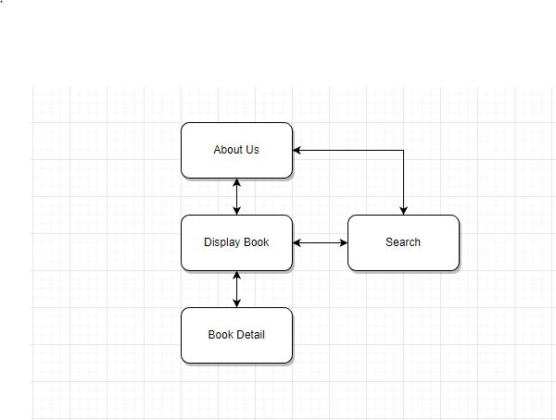

Level 0

To access membership features in Book Worm, a login verification is required. Without registering, the user would be limited to certain features.

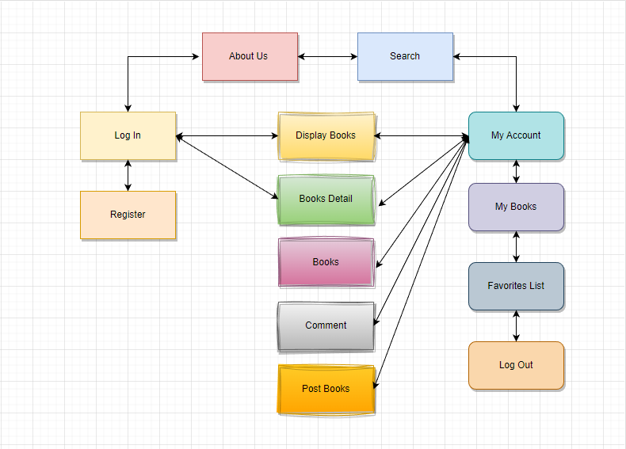

Level 1

**5.1** About Page- This Page is Built to introduce the team and give a brief overview of what our website will be about.

**5.2** Display Books- This Page shows all available books starting with title and giving book detail option to see further details of said books

**5.3** Register - This Page is for new incoming users who want to sign up to favorite their favorite books, rate or comment on their opinions on the books

**5.4** Log In- This log in page is used for existing user coming back to log in and view their saved books, view previously made comments or just look at their profile

.

5.n component-n (subsystem-n) name or description

**Section 6: Detailed System Design**

**6.1 Search -** This is designed to help users find books faster and access content easier rather than scrolling through the books.

**6.2 Comment**- Allows users to give feedback on what they thought about the book for a more detailed rating on said product.

**6.3 Favorite** – This Feature allows signed in user to add books to their favorites making it easier on the user to find their favorite books and giving signing up more purpose.

**6.4 Security Log in** – The log in page can secure sensitive information like passwords and payment information or any personal data the user has provided

**6.5 Rating**- This will allow signed in users to give feedback on their favorite or not so favorite books, this will give the books a visual rating for users who do not want to read paragraphs of comment reviews.

• **Definition**

The specific purpose and semantic meaning of the component. This may need to

refer back to the requirements specification.

• **Responsibilities**

The primary responsibilities and/or behavior of this component. What does this

component accomplish? What roles does it play? What kinds of services does it provide to its clients? For some components, this may need to refer back to the requirements specification.

• **Constraints**

Any relevant assumptions, limitations, or constraints for this component. This

should include constraints on timing, storage, or component state, and might include rules for interacting with this component (encompassing preconditions, postconditions, invariants, other constraints on input or output values and local or global values, data formats and data access, synchronization, exceptions, etc.)

• **Composition**

A description of the use and meaning of the subcomponents that are a part of this

component.

• **Uses/Interactions**

A description of this component collaboration with other components. What other

components is this entity used by? What other components does this entity use (this would include any side-effects this entity might have on other parts of the system)? This concerns the method of interaction as well as the interaction itself.

• **Resources**

A description of any and all resources that are managed, affected, or needed by

this entity. Resources are entities external to the design such as memory, processors, printers, databases, or a software library. This should include a discussion of any possible race conditions and/or deadlock situations, and how they might be resolved.

• **Processing**

A description of precisely how this component goes about performing the duties

necessary to fulfill its responsibilities. This should encompass a description of any algorithms used; changes of state; relevant time or space complexity;

concurrency; methods of creation, initialization, and cleanup; and handling of exceptional conditions.

• **Interface/Exports**

The set of services (resources, data, types, constants, subroutines, and exceptions)

that are provided by this component. The precise definition or declaration of each such element should be present, along with comments or annotations describing the meanings of values, parameters, etc. .... For each service element described, include (or provide a reference) in its discussion a description of its important software component attributes (Classification, Definition, Responsibilities, Constraints, Composition, Uses, Resources, Processing, and Interface).

**Section 7: Graphical User Interface Design**

**GUI Design. Picture copy/paste**

Home / About us Page:

The about us page contains the members/contributors of the project. It is also the home page of the website.

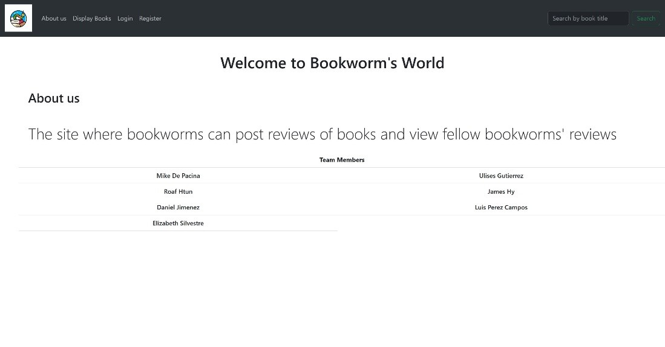

Display Books Page:

The display books page is where you can find all available books offered. Here users will be provided with the cover of each book and their rating.



Book Detail Page:

Book detail page is where users can get more information regarding the book they selected. This page will provide them with the name, author, publish date, price, rating, and comment sections. The comment section will let the users give their opinion regarding the book.

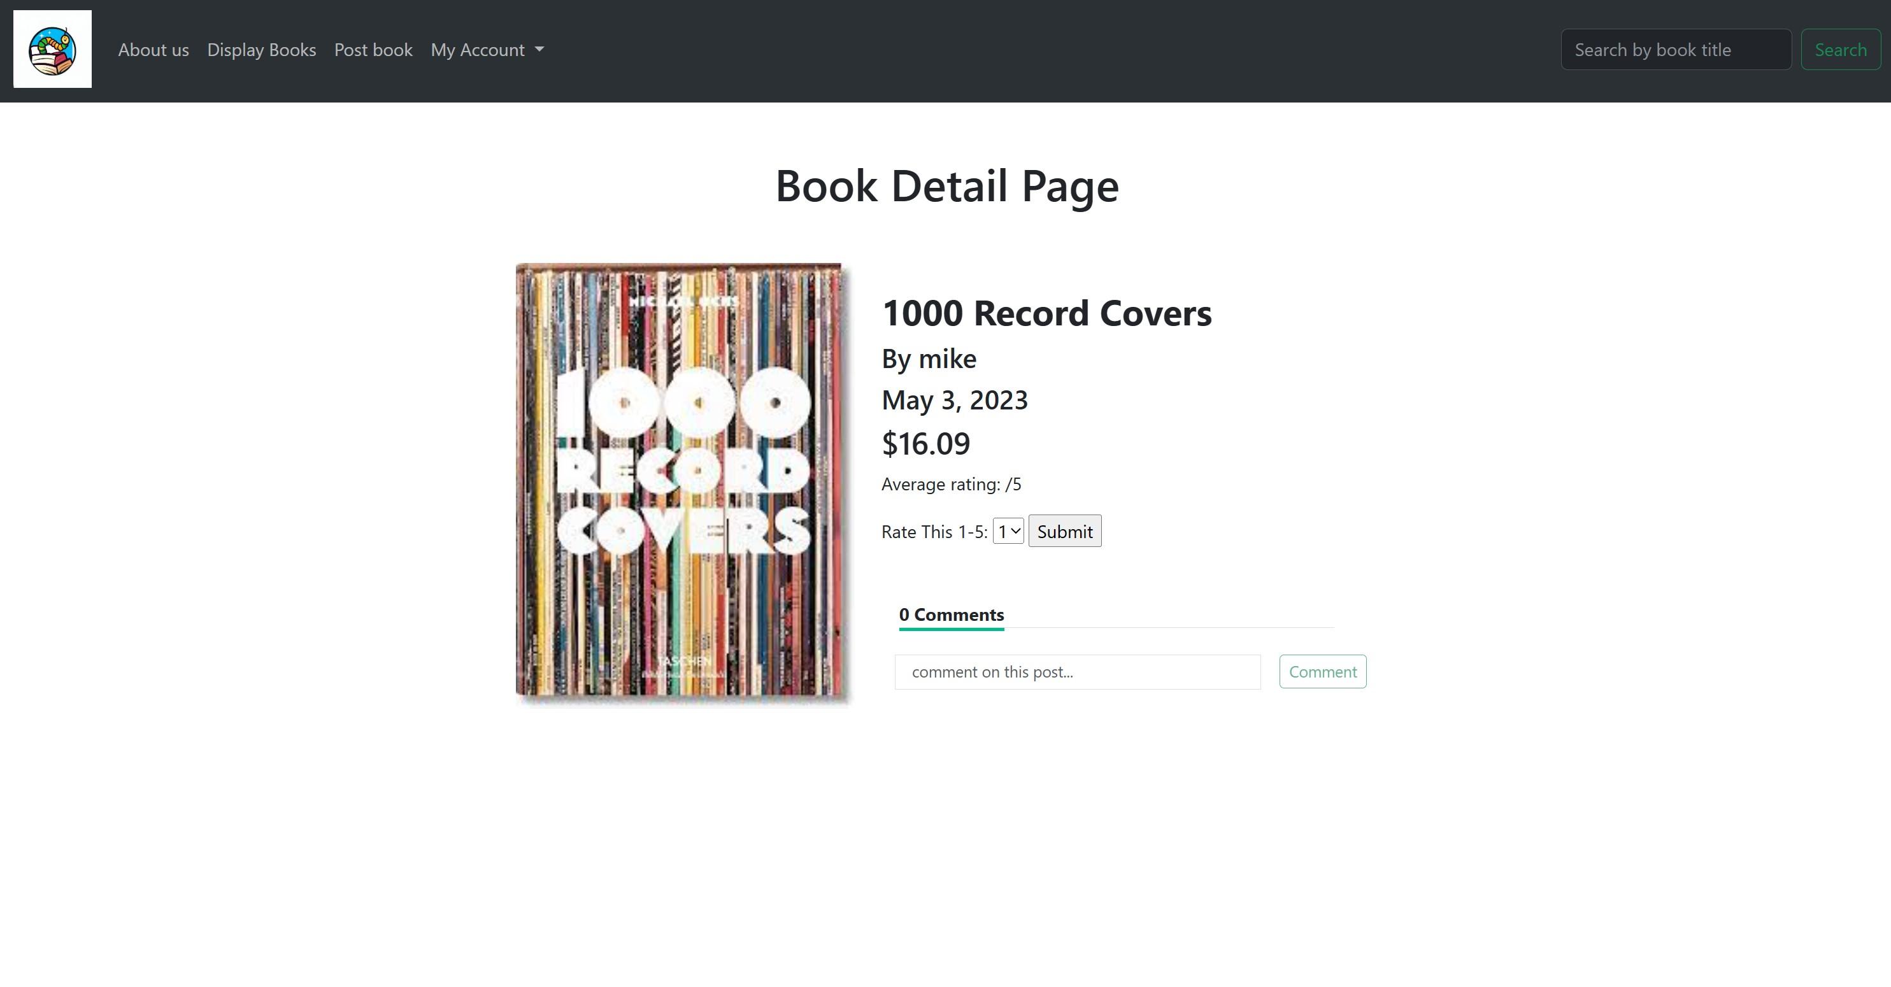

Post Book Form:

The Post Book page will let users post their book and the details of it. Details such as the name, price, and the cover of the book. The post-book form is only accessible if you are a registered user.

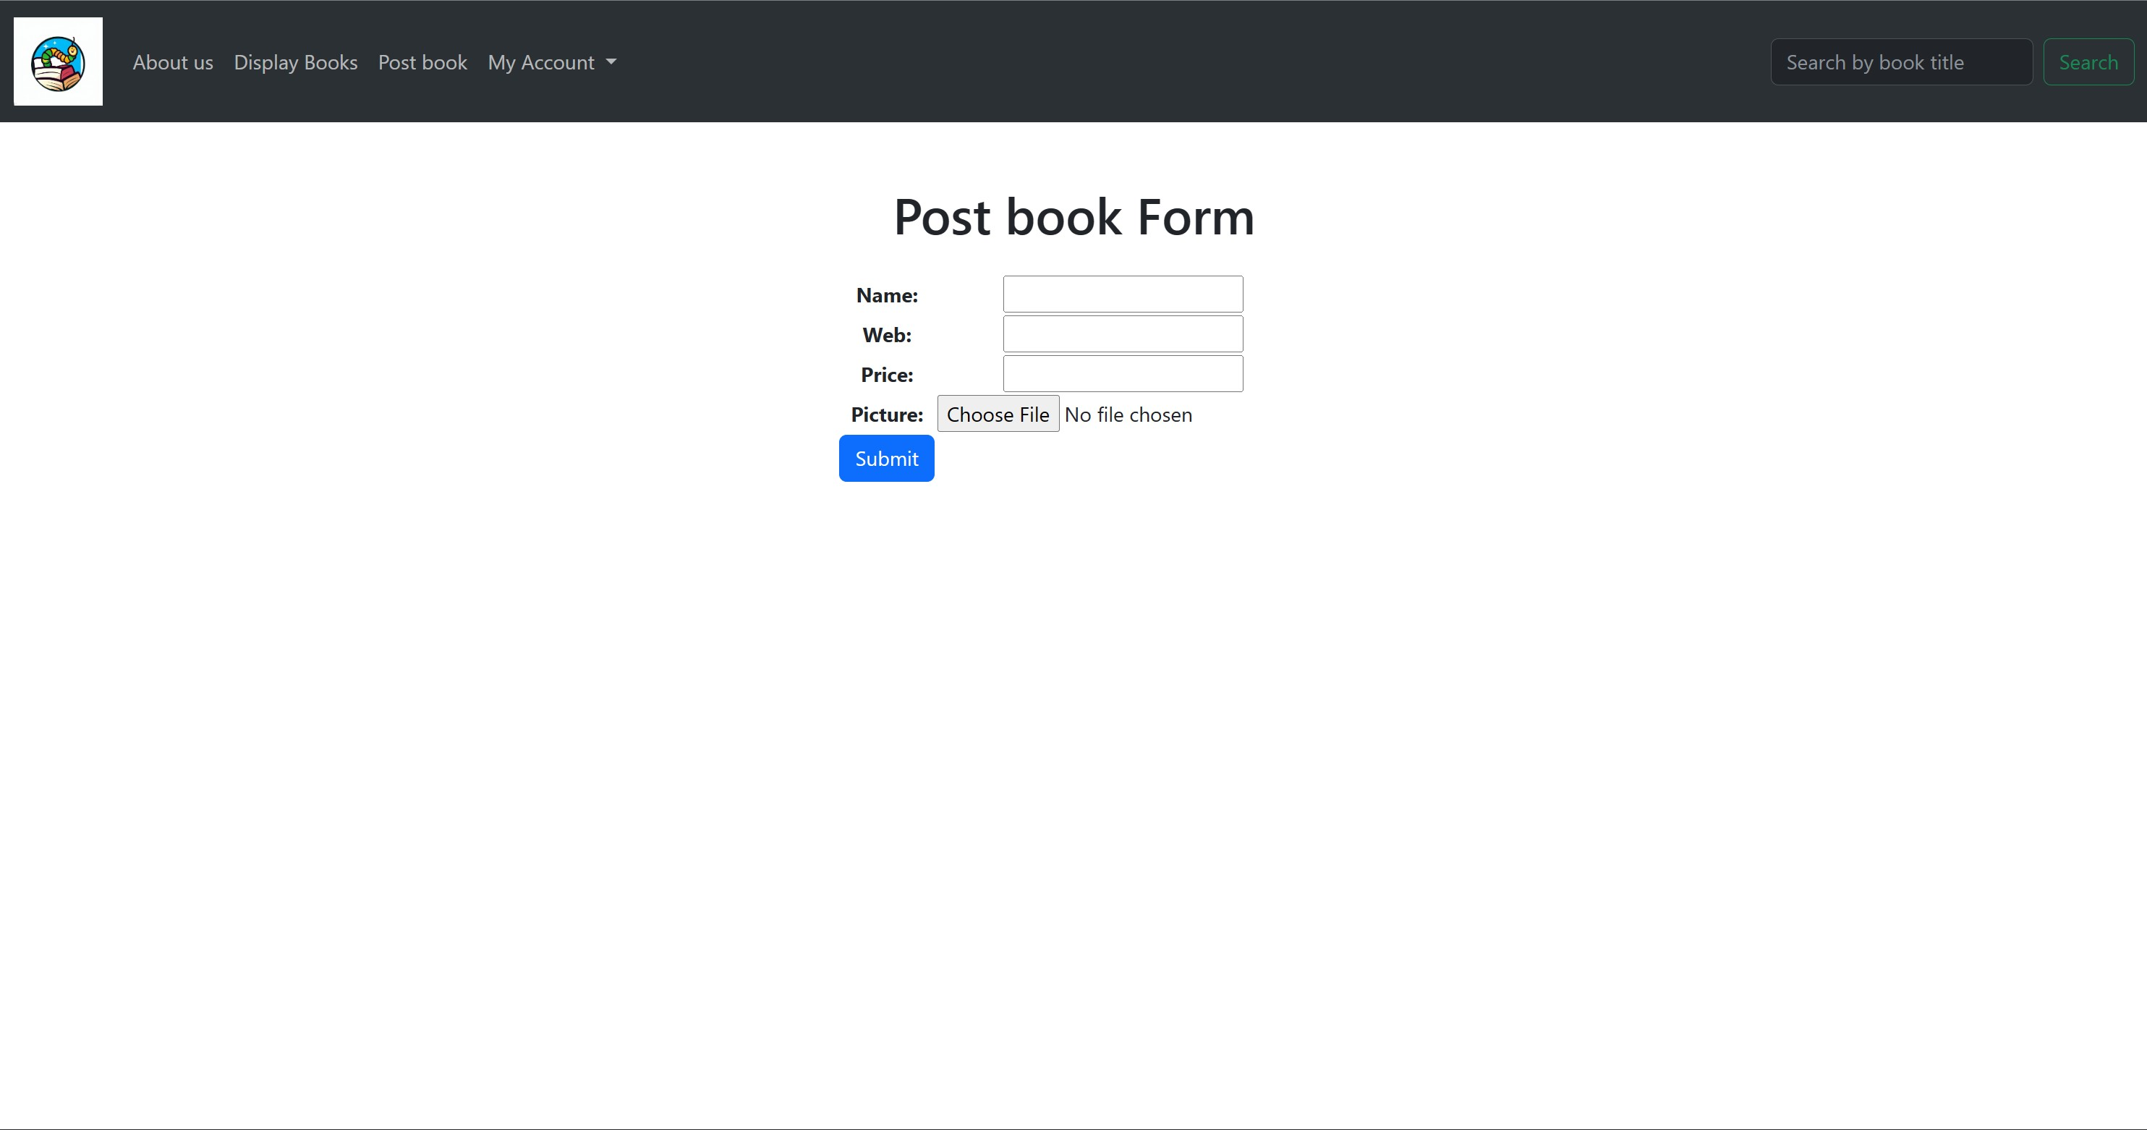

Your Books Page:

In the book’s pages, you will be able to find different books. The books displayed on this page are the ones posted by the account holder.



Favorite List Page:

The favorites list page allows users to save the books they love. Users can always come back when they want, log out and jump back in to find their book.



**Section S: Glossary**

An ordered list of defined terms and concepts used throughout the document.

1. Python: An interpreted, object-oriented, high-level programming language with dynamic semantics.
2. Django: Django is a high-level Python web framework that encourages rapid development and clean, pragmatic design.
3. HTML: HTML is the standard markup language for Web pages.
4. CSS: CSS is the language we use to style an HTML document.
5. Bootstrap: This is an open-source front-end development framework for the creation of websites and web apps.