**Software Requirements Specification**

**for**

**Bookworm’s World**

**Version 4 approved**

**Prepared by Mike Allen De Pacina, Ulises Gutierrez, Roaf Htun, James Hy, Daniel Jimenez, Luis Perez Campos, Elizabeth Silvestre**

**May 8, 2023**

# Table of Contents

Table of Contents................................................................................................................... 2

Revision History..................................................................................................................... 3

1. Introduction................................................................................................................ 4
   1. Purpose........................................................................................................... 4
   2. Intended Audience and Reading Suggestions................................................ 4
   3. Product Scope................................................................................................ 5
   4. Definitions, Acronyms, and Abbreviations .................................................. 5
   5. References......................................................................................................5
2. Overall Description.................................................................................................... 6
   1. System Analysis........................................................................................ 6
   2. Product Perspective........................................................................................ 6
   3. Product Functions...........................................................................................7
   4. User Classes and Characteristics....................................................................8
   5. Operating Environment.................................................................................. 9
   6. Design and Implementation Constraints........................................................ 10
   7. User Documentation...................................................................................... 11
   8. Assumptions and Dependencies.................................................................... 11
   9. Apportioning of Requirements...................................................................... 11
3. External Interface Requirements............................................................................... 12
   1. User Interfaces............................................................................................... 12
   2. Hardware Interfaces....................................................................................... 14
   3. Software Interfaces........................................................................................ 14
   4. Communications Interfaces........................................................................... 15
4. Requirements Specification....................................................................................... 16
   1. Functional Requirements............................................................................... 16
   2. External Interface Requirements................................................................... 16
   3. Logical Database Requirements.................................................................... 17
   4. Design Constraints......................................................................................... 17
5. Other Nonfunctional Requirements........................................................................... 18
   1. Performance Requirements............................................................................ 19
   2. Safety Requirements...................................................................................... 19
   3. Security Requirements................................................................................... 19
   4. Software Quality Attributes........................................................................... 19
   5. Business Rules............................................................................................... 20
6. Other Requirements................................................................................................... 21

Appendix A: Glossary............................................................................................................ 22

Appendix B: Analysis Models............................................................................................... 23

Appendix C: To Be Determined List......................................................................................24

# Revision History

|  |  |  |  |
| --- | --- | --- | --- |
| **Name** | **Date** | **Reason For Changes** | **Version** |
| Rough Draft | 4/17/2023 | First attempt at the document before the planned features are added | 1 |
| Rough Draft | 5/03/2023 | Second attempt at the document | 2 |
| Revision | 5/05/2023 | Revisions | 3 |
| Final Draft | 5/08/2023 | Final Draft | 4 |

# 1. Introduction

Our upcoming software project aims to provide a comprehensive solution for book enthusiasts to browse, search, rate, comment, add and remove books from their personal collections. The software will be designed with an intuitive and user-friendly interface incorporating modern web design to provide a seamless browsing experience.

Users will have the ability to search for books based on keywords. They will be able to rate and comment on books as well as view the ratings and comments of other users. Additionally, users will have the ability to add books and remove books that are no longer desired.

Our goal is to provide a platform for book enthusiasts to connect and engage with one another while also simplifying the process of managing their book collections. We look forward to delivering a high-quality product that meets the users’ needs.

## 

## 1.1 Purpose

This document specifies the software requirements for a web-based platform that allows users to add, remove, rate, and comment on books. The software product being developed is version 1.0; this document covers all aspects of the software. At the platform’s core, the software includes the ability to search for books based on criteria, add books to a personal collection, rate and comment on books and view the ratings and comments of other users. Overall, this document serves as a blueprint for the team to understand the project goals and objectives and how the software should be designed and implemented to meet those requirements.

## 1.2 Intended Audience and Reading Suggestions

This SRS document is intended for those who will be involved in the web design project.

For students, this document can provide an example of how a software requirement is structured and organized. They can study different sections and understand how each section contributes to the overall understanding of the project.

For other peers, this document can serve as a useful reference when working on similar projects. They can use this document as a guide to understand a system’s functionalities and the non-functions that should be considered. They can also use this document as a reference when developing their own software specifications.

Professors who teach software engineering or other related courses can use this document as a teaching aid to demonstrate the best practice in engineering. They can use this document to show how to identify certain requirements, how to model the system’s architecture and user interface, and how to useability requirements.

## 1.3 Product Scope

The software is designed to be user-friendly that enable users to easily navigate through the various functions of the site. Once released, the software will provide users to discover new books, share their opinions, and comment with other readers. Users will be able to search for

books based on various criteria, such as title, and author. They will also be able to rate books and write reviews with other users. Overall, the software will enable users to have a

better reading experience and will provide a valuable resource for readers and book enthusiasts alike.

## 1.4 Definitions, Acronyms, and Abbreviations

Refer to Appendix A

## 1.5 References

Title: Django QuerySet API Reference – Django Documentation

Author: Django Software Foundation

Date: Last updated on April 20, 2023

Source: <https://docs.djangoproject.com/en/3.2/topics/db/queries/>

Title: CSS Navigatoin Bar Tutorial – W3Schools

Author: W3Schools

Date: Last updated on April 18, 2023

Source: <https://www.w3schools.com/css/css_navbar.asp>

# 2. Overall Description

The web design project we are creating allows users to add, delete, rate, comment on books, search for books, and add books to their favorite list. To accomplish these functions, the program will have to be designed with the user in mind. The interface should be user-friendly, with clear instructions to guide users through various site functions. The software must also be secure to protect users’ personal information.

To allow users to search for books and add them to their favorites list, the software will need to have a database that can store all the book information and users’ preferences. It will be important that the database is well organized and easily searchable to provide users with quick and relevant results.

Overall, the project’s outcome will depend on how well the requirements are defined and how effectively they are implemented in the final product. The software should allow for future growth and changes to the system and should handle future traffic and usage over time.

## 2.1 System Analysis

We were given a program that had basic functions for storing book information. Our task was to enhance the program’s efficiency by creating several new features. The first three features include “About Us” to introduction to our group, a search bar to locate a specific book, and improving the website appearance. For the remaining features, the group had to opportunity to exercise our own creativity. We chose to implement a comment section to allow users to express their opinions and give feedback on the details books page, A rating features that allows users to rate books using a rating system from 1 to 5, and a favorites list that enables users to save books they like when logged in to their account.

## 2.2 Product Perspective

Bookworm’s World is a standalone product that does not rely on other services to function. The concept is similar to other services that manage books like Barnes & Noble or Amazon as they all give users the opportunity to comment, favorite and rate books. The key difference is that Bookworm’s World serves as a hub for readers to sell, trade, and see other books. Users have an opportunity to interact with other users and discuss about books.

## 2.3 Product Functions

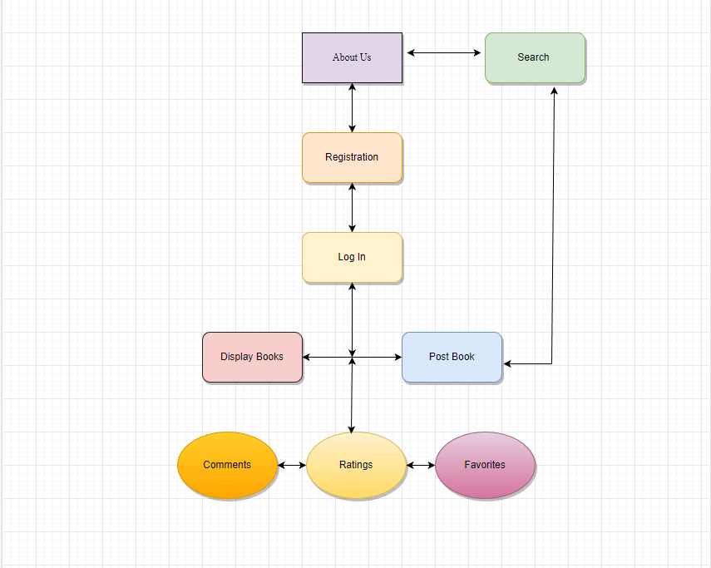

A search bar is a function that allows the user to search for books by inputting a test regardless of capital letters; the results should show what the user is searching for. The book detail page is where the comment section will be located. The comment interface allows users to comment on the books they like or dislike. The rating will be located above the comment section, allowing users to rate the book from 1 less desirable to 5 most desirable books - also, the favorite list will allow users to create a favorite list when logged into their account. When logged in, users can add their favorite books to find them easily the next time they visit the website.

## 2.4 User Classes and Characteristics

End Users

* Characteristics: The end consumers of the web design project may range in technical proficiency from beginner to advanced. This applies to the instructor, the application's developers, and every other user who uses it. They are probably dedicated readers who enjoy learning about new books and communicating with other people.
* Goals: The users of the websites should be able to quickly search for books, post books, add them to lists of favorites, rate them, and leave comments. One of the main goals is the ability to converse with other users and exchange opinions about each posted book.
* Needs: The software for the web design project must be user-friendly and provide clear instructions to guide users through the site functions. The software should be secure, to protect their private data.
* Environment: The end users can use the application from a range of devices including desktops, laptops, tablets, and smartphones.

Developers

* Characteristics: Developers of the web application are most likely to have some level of expertise in web development, including front-end and back-end development.
* Goals: Developers must be able to build and maintain a scalable, secure, and high-performing web application.
* Needs: The software must have clear instructions and procedures for development in the documentation. Additionally, the software must be simple to modify and maintain.
* Environment: Developers will work in a development environment that includes an ide such as PyCharm.
* Interactions: Developers will interact with the software by building and maintaining the web application, testing and debugging code, and collaborating with other developers.

## 2.5 Operating Environment

The application is run online, so any device that has access to the internet and a web browser should be able to run the application. For this reason, the application can run on any operating system including Windows, macOS, and Linux. The application could be affected on performance based on how old the device is or the speed of the internet connection.

## 2.6 Design and Implementation Constraints

1. Usability: the user interface should be easy to use, with clear navigation and functionality.

2. Performance: The search bar, comment, rating, and favorite section should be responsive and load quickly to ensure a good user experience.

3. Security: The software should be designed to protect user data and prevent unauthorized access.

4. Accessibility: The software should be designed to be accessible to all users.

Items that will influence the ability of the software developers to implement the product:

1. Regulatory policies within the organization that may affect the development of the software:

The program should follow any rules and guidelines that apply to it, such as laws that protect people’s personal information.

2. Hardware limitations:

The program should be able to work on different types of computers.

3. Interface with other applications:

The software should be able to connect with other apps, like social media or third-party tools.

4. Parallel operation:

The software should be able to work with multiple processes at the same time.

5: Higher-order language requirements:

The software should be designed to use different programming languages.

6. Reliability requirements:

The software should be made to not break down, even if there are errors.

7. Safety and security considerations:

The software should be created with protection in mind, so people’s information is kept safe.

## 2.7 User Documentation

Currently, no other documents will be delivered along with this software.

## 2.8 Assumptions and Dependencies

* Users are expected to have a basic understanding on how to navigate a web page.
* The users' devices are expected to have modern web browsers installed.
* The users' devices are expected to have a stable internet connection.
* The database management system should be capable of handling large volumes of data.
* The software will rely on third-party libraries such as bootstrap and frameworks to provide specific functionality, such as authentication and database connectivity.
  + Software Engineers must use the following prompts when setting the software up
    - pip install django-comments-dab
    - python manage.py makemigrations
    - python manage.py migrate

## 2.9 Apportioning of Requirements

Requirements such as comments or favorites will be delayed for the upcoming version.

# 

# 3. External Interface Requirements

## 3.1 User Interfaces

When users open the application, they are welcomed by an “About Us” welcome page, see Figure 1. Users can log in if they are registered; see Figure 2. They can register if they do not have an account, see Figure 3. Users can view books that can be exchanged; see Figure 4. Users

can add their own books to the system; see Figure 5. Users can view the books they added; see Figure 6.

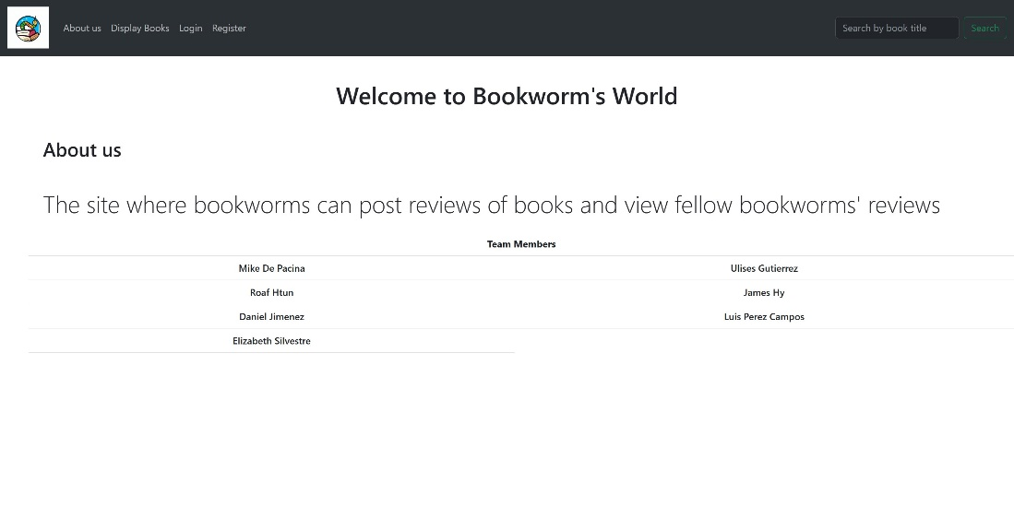

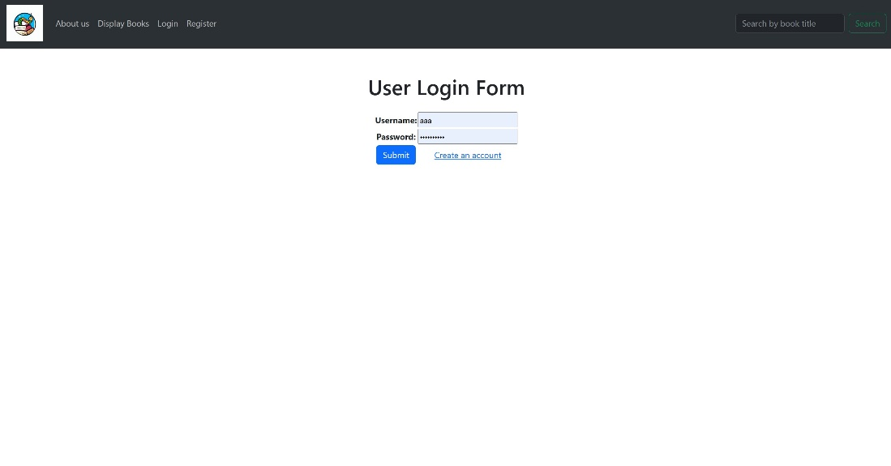

Figure 1 – Welcome Page Figure 2 – Login Page

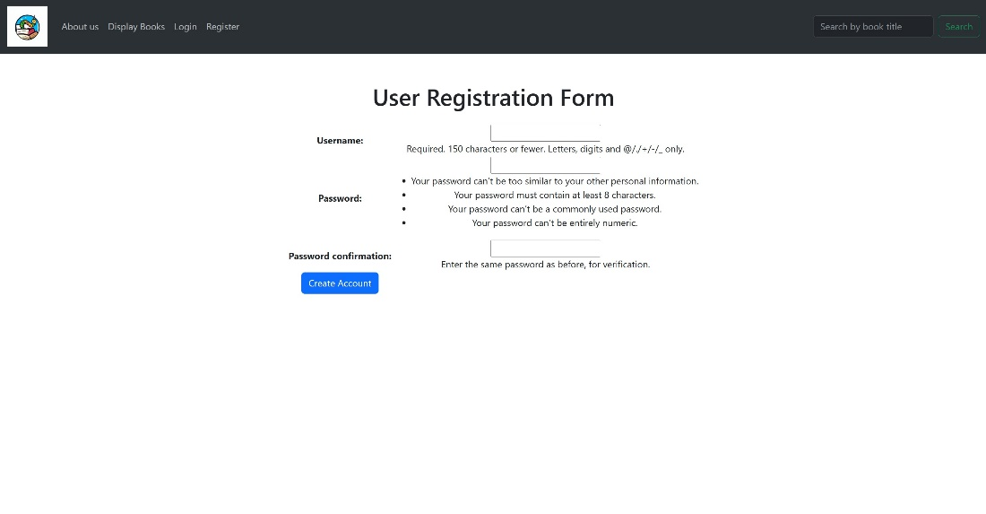

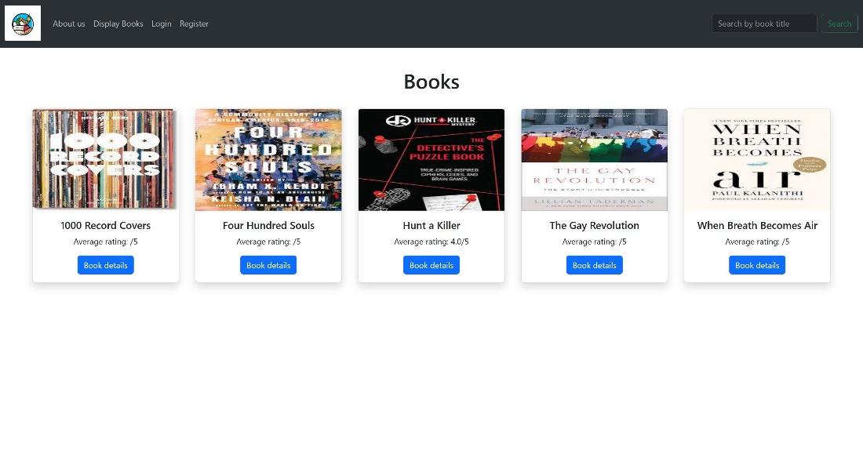

Figure 3 – User Registration Figure 4 – Book Exchange

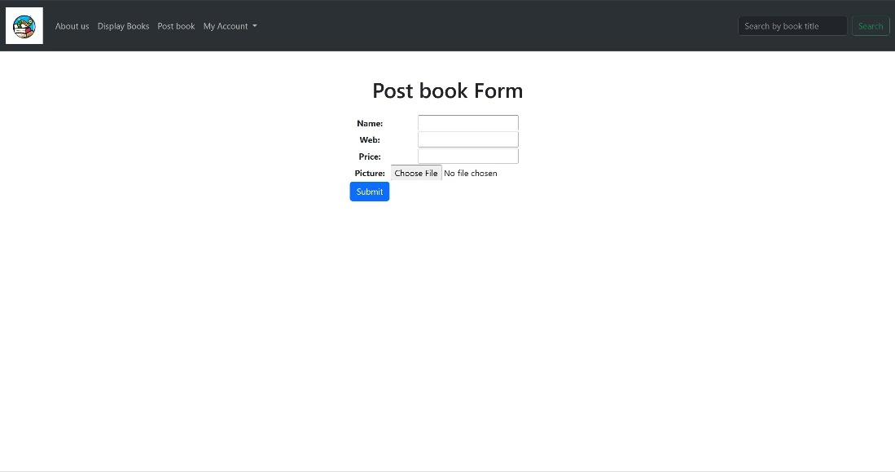

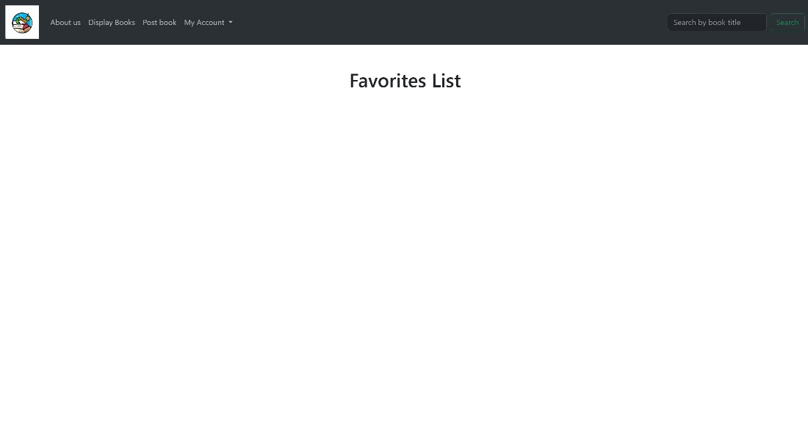

Figure 5 – Post Book Figure 6 – User Books

## 3.2 Hardware Interface

Our application or website does not have any designated hardware; it does not have any direct hardware interfaces. All the process is internal.

## 3.3 Software Interfaces

Our entire project was done in PyCharm version 2023.1 from the JetBrains website. In addition, we used Anaconda3 version 2021.11. from the Anaconda website to install Python. Using Anaconda, Django version 3.2.6 was installed onto the project. This software is what gives our project its functionality. Using Python, we code the backend of the project on PyCharm. The website comes as a result of programming. Here is where users can add/edit/view the data (in our case books). All data will be saved in a DB.sqlite3 file

## 3.4 Communications Interfaces

Our product creates a server where our Book Exchange HTTP website can run. Here users can edit/manipulate the data (books in our case). Any data manipulated from the browser is then sent to the SQLite3 file where it is stored and sent back to the server.

# 

# 4. Requirements Specification

## 4.1 Functional Requirements

1.) User Account Management

* Users should be able to create an account with a unique username and password.
* Users should be able to log in to their account and log out when finished

2.) Book Management

* Users should be able to add a new book including its title, price, website, cover image, and other relevant information.
* Users should be able to delete a book from their collection
* Users should be able to search for books by title
* Users should be able to view detailed information about a book, including its rating, comments

3.) Rating and Comment Management

* Users should be able to rate a book on a scale of 1-5 stars.
* Users should be able to write comments about a book.
* Users should be able to view all the comments and ratings associated with a book.

4.) Favorites List Management

* Users should be able to add a book to their favorites list.
* Users should be able to remove a book from their favorites list.
* Users should be able to view their favorites list.

## 4.2 External Interface Requirements

User Interface

* Credentials
  + Password must be hidden when typed, for example ( *****).
* HTML and CSS to create the GUI

Communication Interface

* The website shall grant GET access to the user so that they can access the website

## 4.3 Logical Database Requirements

Password

* The Passwords must contain at least 8 characters

Username

* The Username must accept 150 characters or less and accepts letters, digits, and @/./+/-/_ only.

Book

* Title
  + Title must accept 150 characters or less and accepts letters, digits, and @/./+/-/_ only.
* Price
  + Price must accept only numbers in this format “$0.00”
* Website
  + Website must be a working link to the book
* Picture
  + Picture must accept any image file

Rate

* The rating system shall be out of five stars and the user picks what they believe the book deserves

Comment

* The comments must accept 200 characters or less and accepts letters, digits, and @/./+/-/_ only.

## 4.4 Design Constraints

Easy to use on all devices

* The project must be easy to use regardless of what device the user uses

Easy to run

* The project must be easy to use for weak/poor internet connections.

Effective

* Data must be effectively displayed to the users

Backend

* Python
  + Python is responsible for all the functionality of the website like search, favorite, rate, and comment
* Django
  + Framework responsible of the visual side of the project
* HTML
  + Responsible for the visual appearance of the website
* CSS
  + Responsible for the visual appearance of the website

# 5. Other Nonfunctional Requirements

## 5.1 Performance Requirements

1. The search bar should return a search result in under 3 seconds for up to 100 pages of content. 2. the comment section should be able to handle up to 100 comments per page and load up within 10 seconds.

3. The rating system should be able to handle up to 100 ratings per day. On average, it should take at least 3 seconds.

4. The favorite feature should be able to save up to 500 items per user and load the list within 3 seconds.

5. The login and logout process should take no longer than 10 seconds to complete.

## 5.2 Safety Requirements

This product is safe to use freely and can not cause the user any damage. We designed that so that it can be easy to use without worrying about any sort of harm as a result of using it,

## 5.3 Security Requirements

Accounts are protected by password and username, without those a third party can not access the user’s account. No personal user data is stored so the user is safe to use the product freely,

## 5.4 Software Quality Attributes

This product is both easy to use and easy to learn. We wanted to create a product that anyone can pick up and know what is going on. That is exactly what we created. Users can easily create accounts and manage their books. No complex curriculum is needed, simply make an account and the rest is easy. Descriptions on the pages on how to do the tasks provide more clarity and make it easier for newcomers.

## 5.5 Business Rules

Guests can view the available books and are not able to manage books. Registered users can manage books and add their own books to the website. This was done so that unregistered users are encouraged to make an account and become registered users for Bookworm’s World

# 

# 

# 6. Legal and Ethical Considerations

There are two main ethical issues involved in our project. Our first issue is we do not have a form moderation set up for the comments. We have no way of moderating what users put in the comments. This is an issue because users could leave false comments about books and discourage users from the book. In addition, we cannot moderate foul language if any is used. The second issue is review bombing, this is when groups of people organize a group to leave bad reviews on a book on purpose to make it look bad. We do not have a way of controlling this and can lead to books being rated lower than they should

# Appendix A: Glossary

Software Requirements Specification (SRS): Document describing all functions of the system and the constraint under what it operates.

Platform: A group of technologies that are used as a base for other applications.

Python: An interpreted, object-oriented, high-level programming language with dynamic semantics.

Anaconda: A distribution of the Python and R programming languages for scientific computing, that aims to simplify package management and deployment.

Django: Django is a high-level Python web framework that encourages rapid development and clean, pragmatic design.

PyCharm: PyCharm is an integrated development environment used for programming in Python.

SQLite: SQLite is a C-language library that implements a small, fast, self-contained, high-reliability, full-featured, SQL database engine.

HTML: HTML is the standard markup language for Web pages.

CSS: CSS is the language we use to style an HTML document.

Bootstrap: This is an open-source front-end development framework for the creation of websites and web apps.

HTTPS: Hypertext Transfer Protocol Secure is an extension of the Hypertext Transfer Protocol. It uses encryption for secure communication over a computer network and is widely used on the Internet.

GET request: is a way for you to grab data from a data source with the help of the internet

GUI: Graphical User Interface

# Appendix B: Analysis Models

Login Diagram

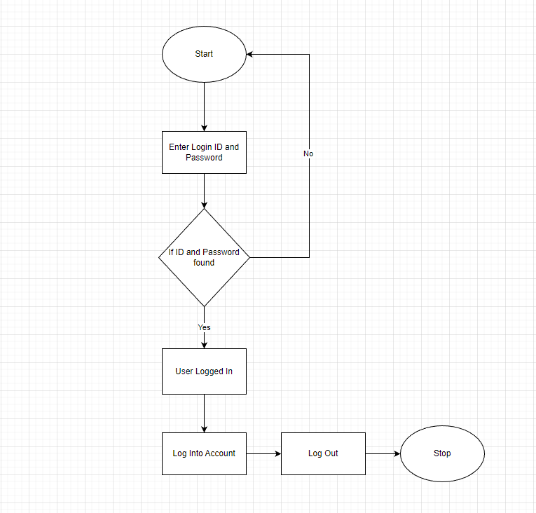

Accessing Diagram

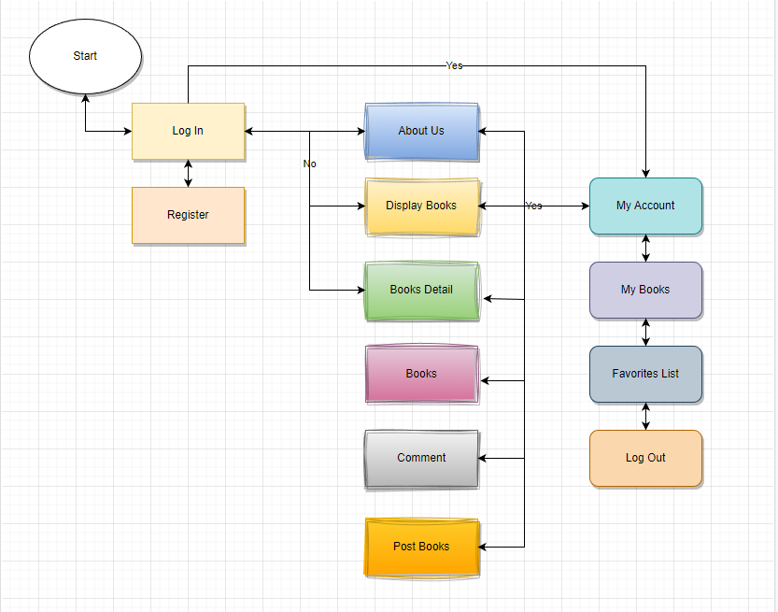

# Appendix C: To Be Determined List

* Update the pictures for user interfaces after we have finished the UI
* Once website is done, revisit this document to see if anything need to be added

**General Template Directions:**

* This page should not appear in the final document.
* Replace any **<Insert x here...>** placeholders with the actual text. Yes this also means replacing the angle <> brackets as well. Your document should not have ANY **blue** text in it. If the text had any kind of formatting (bold, italics, font size) keep the same formatting. DO change the font color to black.
* Remove any **<green text>** placeholders. These are descriptions about what to write in each section and may also provide examples of what to write. Do not simply copy / adapt the wording to fit your project. All green text should be replaced with your own text or removed completely in some cases.
* **DO NOT** change the formatting of the document this includes:
  + font sizes
  + font weights
  + italics NOT in angle brackets
  + margins
  + spacing
  + adding or removing sections of the document.
* Each major numbered section (1, 2, 3 etc.) should start on a new page.
* When the document is finished, update the table of contents with the correct page numbers, and make sure the numbers are properly aligned to the right.