Pentru code standards, am ales urmatoarele:

- am respectatlimita de 79 de caractere pe linie

- am folosit blank lines in functiipentruseparareadiverselorsectiuni din cod

- am scris

import pygame

import sqlite3

import gc

import random

ci nu :

import pygame, sqlite3, gc, random

- de asemeneaestecorectsi :

from tkinter import *

from PIL import ImageTk, Image

from datetime import datetime

- am evitatsapunemspatiiunde nu eraunecesare:

ex:

volumeLevels = [0.1, 0.2, 0.3, 0.4, 0.5, 0.6, 0.7, 0.8, 0.9]

self.resizable(0, 0)

frame.grid(row=0, column=0, sticky="nsew")

nr += s[i]

i += 1

- pentru naming style am folositmixedCase:

initialVolumeIndex, imgBtnBack, imgBtnArteDark

- iarpentruclase am folositCapitalizedWords:

class TopScore(Frame), class CategorySuggest(Frame), class SuggestForm(Frame)

- mereu am folosit "self" ca un prim argument a uneiinstante a uneimetode:

self.backgroundImage, self.btn1.bind, self.backgroundLabel

- am folosit UPPERCASE pentrucomenzisi lowercase pentruvalori (baza de date)

self.c.execute("SELECT username, max_score

FROM userinfo

WHERE max_score IS NOT NULL

ORDER BY max_score DESC")

Am folosit Code Refactoring pentru ca standardele de mai sus sa fie respectatesaupentru ca anumiteparti de cod trebuiaumodificate:

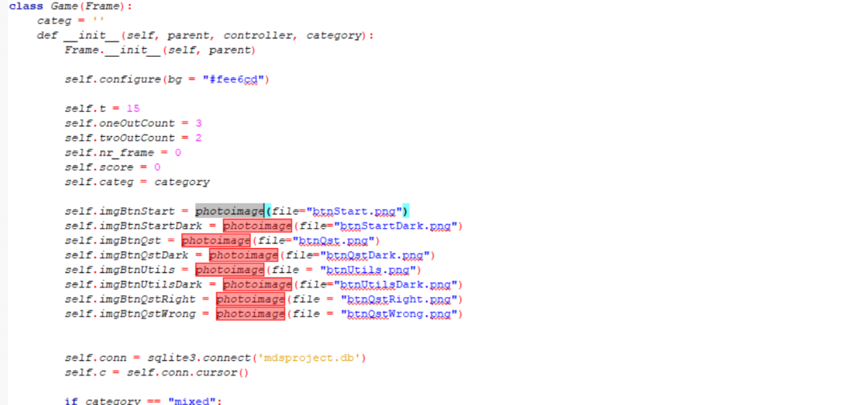

Modificat in:

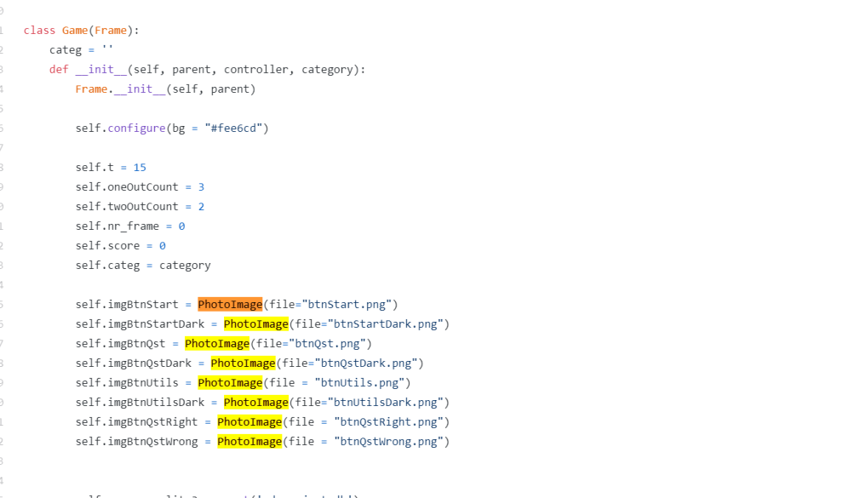

Sau:

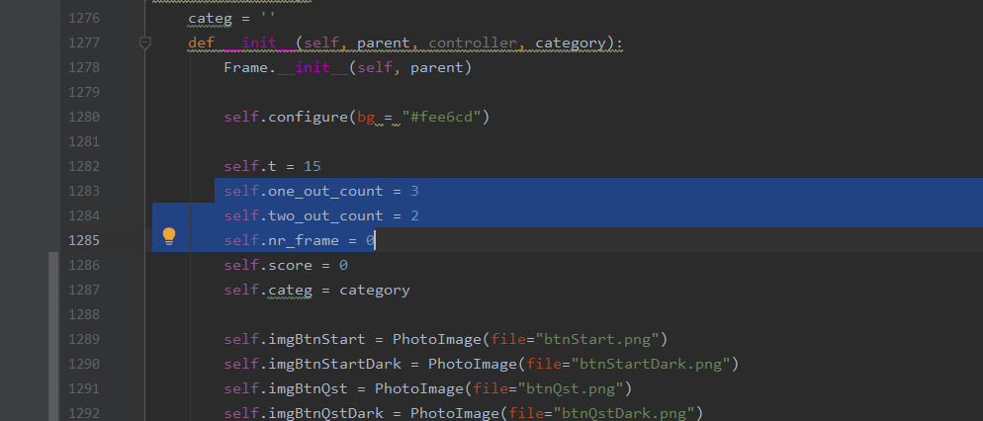

Modificat in:

