Mike Eberhart

CIS-267

Homework01 Endless Runner Readme

https://meberhart.itch.io/alien-invaders

***Alien Invaders***

Starting out the player is thrown into the middle of an alien invasion. With nothing but their fighter jet they player must survive as long as they can. Dodging storm clouds and enemy fire while trying to shoot down UFOs and collect points. So long as don’t stay still and keep shooting down UFOs you’ll have a better chance of survival. Below is a more detailed explanation of a few items from above.

**Player Controls and Key bindings**

* ‘W-A-S-D’ -> Used to move the player jet around in all directions.
* ‘Left Mouse Click’ -> Used to fire the main gun of the player jet.
* ‘F’ -> Used to fire a missile
* ‘R’ -> Used to active the shields.
* ‘ESC’ -> Used to pause the game and bring up the menu.

**Player collectables and power ups**

**Star Collectable**:

* Worth 1000 points
* spawns every 60 seconds

**Coin Collectable**:

* Worth 100 points and drops from above every 5 seconds.
* As the game continues the spawn rate increases.

**Missile Power Up**:

* A rocket with fire coming out of it

  AI-generated content may be incorrect.Each power up gives the player +2 missiles to fire. There is also a 5 second cooldown timer in between shots.
* Spawns every 6 seconds

**Shield Power Up**:

* A blue shield in a circle

  AI-generated content may be incorrect.Equips the player with a shield they can be activated by pressing the ‘R’ key.
* The player can also have 2 shields at once. One activated and one equipped.
* Spawns every 24 seconds

**Missile/Bullet**:

* + - The bullet is the main projectile fire from the player jets main gun. It does 1 damage to UFOs. The missile is a one hit kill weapon, so its best used on high level UFOs.

**Spawning Buildings:**

* The spawn order for the buildings is random. After 60 seconds the spawn rate for the buildings is increased for the duration of the game.

*All UFOs fire a plasma shot in the direction of the player every few seconds.

**Bronze UFO:**

* Health: 4
* Point Value: 10
* Spawns within the range of 2.0 to 3.0 seconds

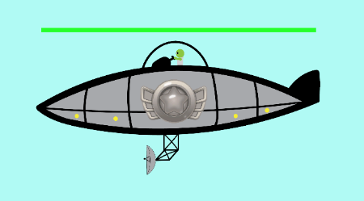**Silver UFO:**

* Health: 6
* Point Value: 25
* Spawns within the range of 12 to 18 seconds

**Gold UFO:**

* Health: 10
* Point Value: 50
* Spawns within the range of 22 to 32 seconds

**Plasma Shot:**

* Fired from the alien UFO in the last known position of the player jet.

**Storm Cloud:**

* On contact this will destroy the player jet or their shields (if active).
* Travels in a wave pattern through the level
* Doesn’t start spawning in until after 30 seconds

After thoughts: I feel I could’ve done a better job at organizing my code. Making better use of ‘ObjectData’ scripts and maybe a few more global scripts. I used one to control the increasing spawn rates, but each induvial spawner could’ve just as easily had the code in their spawner scripts too. The increased spawn rates are used to make the game a bit harder over time. Which it does get harder to dodge the alien plasma shots once their spawn rates are maxed out. I was going to add sound but had to deal with errors so didn’t get time too. It would have been a neat feature though.