The Director General’s Clock

August 2020

Overview

In normal operation, the clock will run from the internal battery-backed realtime clock with very good accuracy for many years. Unfortunately the mechanism is old, and it does occasionally “slip” resulting in the hands being mis-timed. A simple user interface exists inside the unit to allow the hands to be reset easily.

The clock also has a red light – this can display useful information about the clock’s mode:

* Normally, the light will illuminate for one minute at 10PM for the BBC News bulletin
* If the clock is stopped, the light will be on continuously
* If the clock is “double stepping” to catch up with real time, the light will flash

# User interface

The internal user interface comprises a small display and two small buttons:

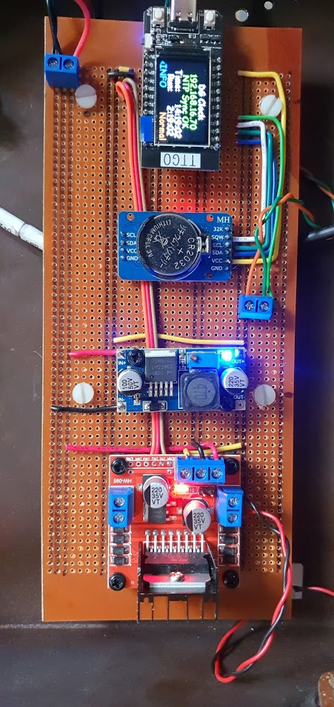

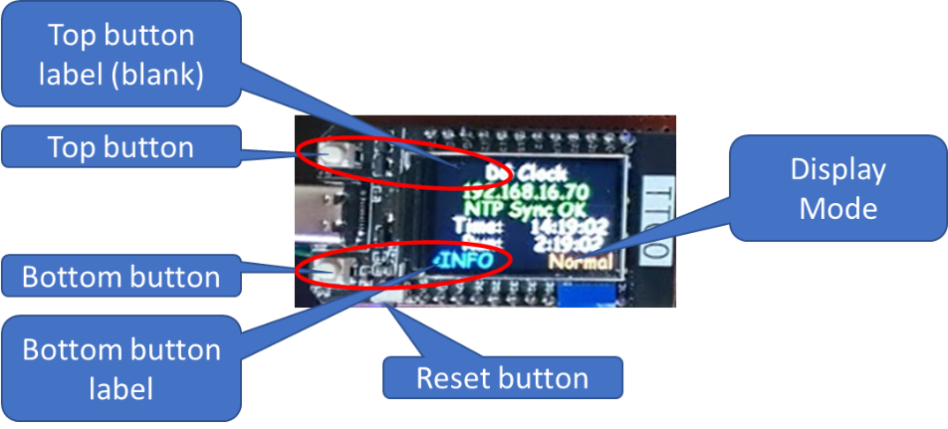



## Normal Mode

In normal mode, the internal display will show the current time and the time it thinks is displayed on the hands of the clock, as well as whether the hands are in Run, Wait or Fast mode.

If the WiFi has been configured, it will also show the unit’s IP address and whether it has been able to synchronise with a Network Time Protocol (NTP) server.

* The top button does nothing in the “Normal” mode.
* The bottom button well take you to the “Set” mode.

## Set Mode

In Set mode, the display will remind you of the current position of the hands, and tell you the first step to adjusting the hands, namely to stop them.

* The top button takes you back to the “Normal” mode.
* The bottom button takes you to “Stop” mode, and stops the hands. The clock continues to run behind the scenes.

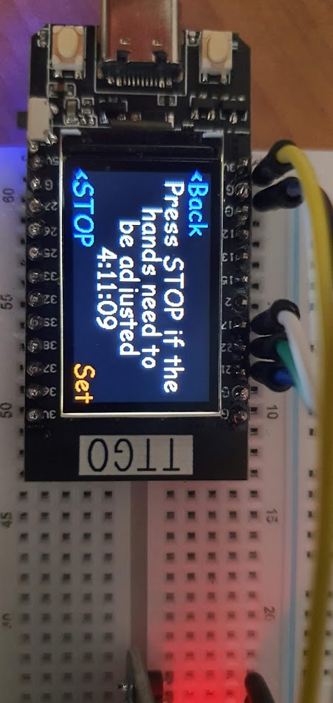

## Stop Mode

Stop mode is very similar to Set mode, except that the hands will be stationary. This allows the hands to be adjusted more easily.

* The top button allows you to set the hands to “Other” values in the “Adjust” mode
* The bottom button takes you back to “Normal” mode

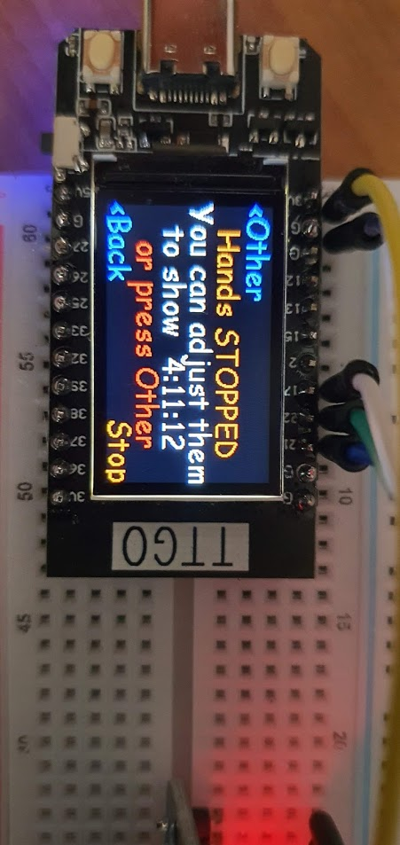

## Adjust Mode

Adjust mode allows you to select other times to set the hands to in order to make setting easier.

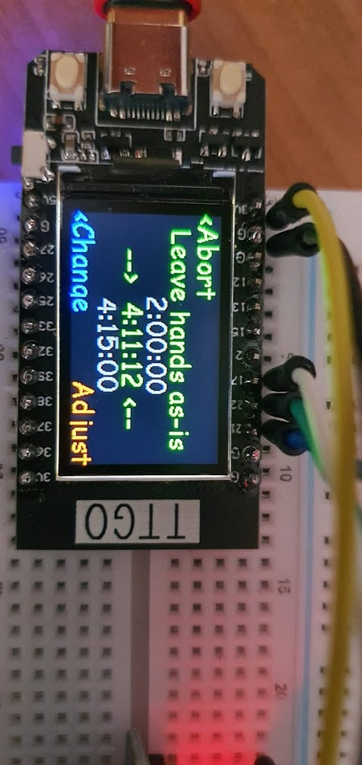

* Pressing the top button tells the clock that the hands are in the highlighted position, 04:11:12 in the example above. The default position is always where the clock thinks the hands are anyway.
* Pressing the bottom button moves down the list of recommended hand positions. The sequence will always be:
  + The current hand position (unless the hands have slipped, of course)
  + The next round multiple of five minutes after the current time of day
  + The next round hour
  + Each subsequent hour in turn until you loop around to the current hand position

Pressing the top button when the hand position is other than the current position is warned by changing the text to red. If you accidentally tell the clock to move the hands, keep pressing the bottom button (“Change”) until the text goes green again, then press the top button (“Abort”).

## Moving the hands

Moving the hands can be done in small steps by sweeping the second hand using the second hand adjuster, or in larger steps by moving just the hour and minute hands with a separate adjuster. The second adjuster is very stiff, and a small pair of pliers is recommended. Looking at the back of the clock face, the adjusters are shown below:

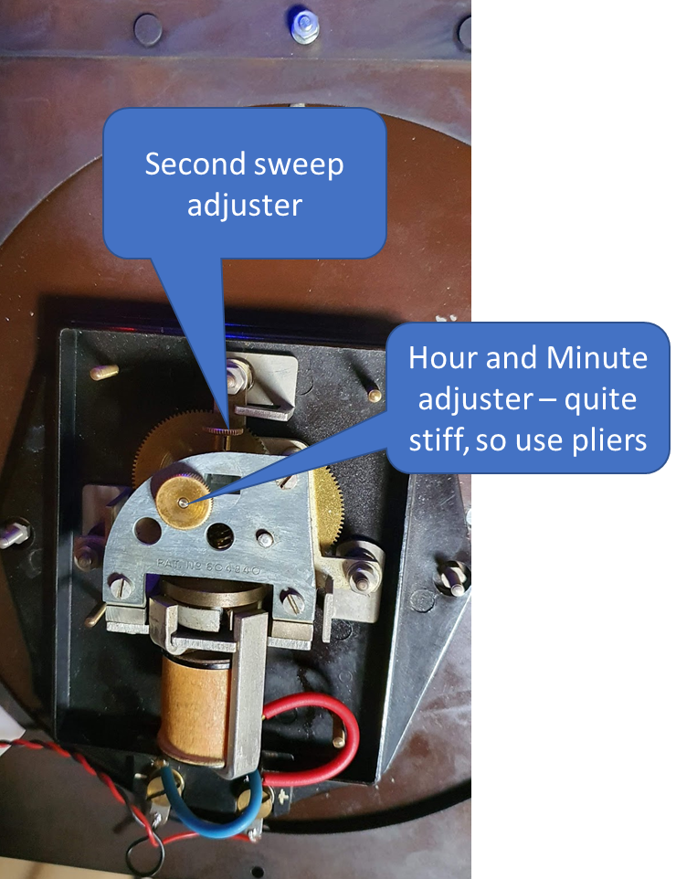

Full design documentation for the electronics including the source code (in Loboris MicroPython) can be found at https://github.com/MikeEllis-T67M/DGclock