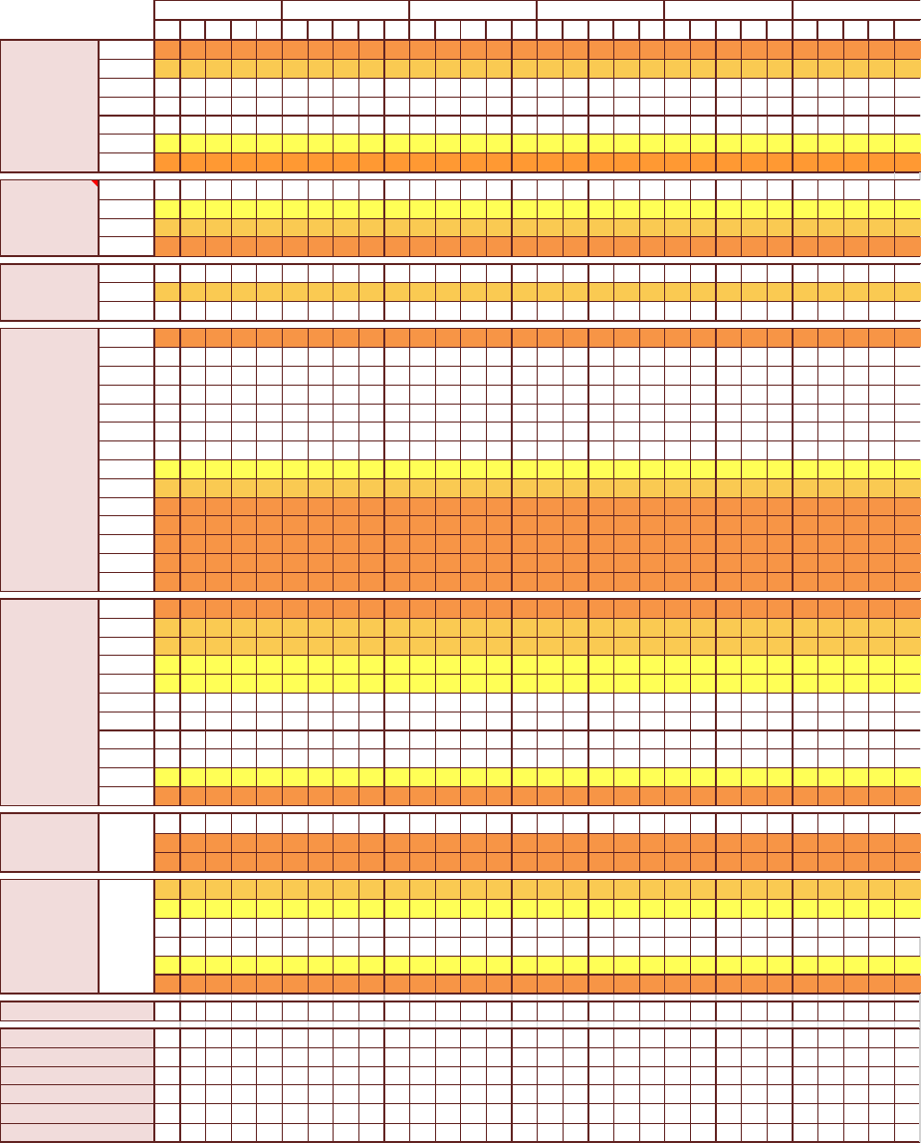
OFFICIAL SENSITIVE – MEDICAL INCONFIDENCE (When Complete)
FMED 13
08/21
OBSERVATION CHART - ADULT
NEWS key
Name
Hospital No.
0 1 2 3
DoB
Rank
Service No.
Date:
Time:
A + B  Respirations  Breaths/min | ≥25
A + B  Respirations  Breaths/min | 21-24
A + B  Respirations  Breaths/min | 18-20
A + B  Respirations  Breaths/min | 15-17
A + B  Respirations  Breaths/min | 12-14
A + B  Respirations  Breaths/min | 9-11
A + B  Respirations  Breaths/min | ≤8
A + B  SpO₂ | ≥96
A + B  SpO₂ | 94-95
A + B  SpO₂ | 92-93
A + B  SpO₂ | ≤91
Air or Oxygen | A= Air
Air or Oxygen | O₂ L/min
Air or Oxygen | Device
C  Blood  Pressure  mmHg  Score uses  systolic BP only | ≥220
C  Blood  Pressure  mmHg  Score uses  systolic BP only | 201-219
C  Blood  Pressure  mmHg  Score uses  systolic BP only | 181-200
C  Blood  Pressure  mmHg  Score uses  systolic BP only | 161-180
C  Blood  Pressure  mmHg  Score uses  systolic BP only | 141-160
C  Blood  Pressure  mmHg  Score uses  systolic BP only | 121-140
C  Blood  Pressure  mmHg  Score uses  systolic BP only | 111-120
C  Blood  Pressure  mmHg  Score uses  systolic BP only | 101-110
C  Blood  Pressure  mmHg  Score uses  systolic BP only | 91-100
C  Blood  Pressure  mmHg  Score uses  systolic BP only | 81-90
C  Blood  Pressure  mmHg  Score uses  systolic BP only | 71-80
C  Blood  Pressure  mmHg  Score uses  systolic BP only | 61-70
C  Blood  Pressure  mmHg  Score uses  systolic BP only | 51-60
C  Blood  Pressure  mmHg  Score uses  systolic BP only | ≤50
C  Pulse  Beats/min | ≥131
C  Pulse  Beats/min | 121-130
C  Pulse  Beats/min | 111- 120
C  Pulse  Beats/min | 101-110
C  Pulse  Beats/min | 91-100
C  Pulse  Beats/min | 81-90
C  Pulse  Beats/min | 71-80
C  Pulse  Beats/min | 61-70
C  Pulse  Beats/min | 51-60
C  Pulse  Beats/min | 41-50
C  Pulse  Beats/min | ≤40
D  Consciousness | Alert  Confusion  VPU
E  Temperature  °C | ≥39.1° 38.1-39° 37.1-38° 36.1-37° 35.1-36°  ≤35°
NEWS 2 TOTAL
Pain score
Bowels open Y/N
Waterlow score
Monitoring frequency
Escalation of care Y/N *
Intials

* Record escalation of care in patients notes. See NICE CG50 (Jul 07) and QS161 (Sep 17)
OFFICIAL SENSITIVE – MEDICAL INCONFIDENCE (When Complete)
FMED 13
08/21
PATIENT CONTINUOUS ASSESSMENT
NATIONAL EARLY WARNING SCORE 2 (NEWS 2) PARAMETERS - ADULT ¹
Physiology | 3 | 2 | 1 | 0 | 1 | 2 | 3
Respiratory Rate (per minute) | ≤ 8 |  | 9 - 11 | 12 - 20 |  | 21 -24 | ≥ 25
SpO₂ % | ≤ 91 | 92 - 93 | 94 - 95 | ≤ 96
Air or oxygen? |  | Oxygen |  | Air
Systolic Blood Pressure (mmHg) | ≤90 | 91 - 100 | 101 - 110 | 111 - 219 |  |  | ≥ 220
Pulse (per minute) | ≤40 |  | 41 - 50 | 51 - 90 | 91 - 110 | 111 - 130 | ≥131
AVPU (Level of Consciousness) |  |  |  | Alert |  |  | V,P or U
Temperature (°C) | ≤35 |  | 35.1 - 36 | 36.1 - 38 | 38.1 - 39 | ≥39.1
CLINICAL RESPONSE TO NEWS TRIGGER THRESHOLDS
Score of 0 | Score of 1 - 4 |  | Score of 5 or more (or 3 in one parameter) |  |  | Score of 7 or more
- Monitor 12 hourly as minimum | - Monitor 4 - 6 Hourly as minimum |  | - Monitor 1 hourly minimum |  |  | - Provide continuous monitoring of vital signs
- Continue Routine NEWS | - Inform registered nurse who must assess |  | - Registered nurse to immediately inform the medical |  |  | - Registered nurse to immediately inform the medical
monitoring | the patient |  | team team caring for the patient |  |  | team caring for the patient
 | - Registered nurse to decide if increased |  | - Registered nurse to request urgent assessment by a |  |  | - Emergency assessent by a team with critical care
 | frequency of monitoring and/or escalation |  | o clinician or team with core competencies in the care |  |  | competencies, including practitioner(s) with advanced
 | clinical care is required |  | of acutely ill patients |  |  | airway management skills.
 |  |  | - Provide clinical care in an environment with |  |  | - Consider transfer of clinical care to higher dependecy u
 |  |  | monitoring facilities |  |  | or ITU with monitoring facilities

PAIN SCORE (AT REST AND ON MOVEMENT)
0 | 1 | 2 | 3
No pain | Mild | Moderate | Severe

LEVEL OF CONSCIOUSNESS ASSESSMENT - ACVPU

If Concious level is anything other than ALERT (C,V,P, or U) consider Neuro Observations - FMed 290
A | Alert | C | Confusion (New onset) | V | Responds to Voice | P | Responds to Pain | U | Unresponsive

WATERLOW SCALE: To be completed within 6hrs of admission and repeated every 24hrs²
TOTAL SCORE: 10+ AT RISK; 15+ HIGH RISK; 20+ VERY HIGH RISK
Build/Weight sub-total |  | Continence sub-total |  | Appetite sub-total |  | Special Risks sub-total
Average | 0 | Completed or catheterised | 0 | Average | 0 | Tissue Malnutrition |  |  | Major Surgery Trauma
Above average | 1 | Occasional  incontinence | 1 | Poor | 1 E.g. Terminal cachexia |  |  | 8 | Orthopaedic - below waist, spinal | 5
Obese | 2 | Incontinent faeces | 2 | NG feeds & fluids | 2 Cardiac failure |  |  | 5 | On table > 2 hours | 5
Below average | 3 | Doubly incontinent | 3 | NBM or anorexic | Peripheral Vascular  3  Disease |  |  | 5
 |  |  |  |  | Anaemia |  |  | 2
 |  |  |  |  | Smoking |  |  | 1
Skin Type sub-total |  | Mobility sub-total |  | Sex/Age sub-total |  | Neuro Deficit sub-total |  |  | Medication sub-total
Healthy | 0 | Full | 0 | Male | 1 | eg Diabetes, MS,  CVA, Motor or  sensory deficit  paraplegia |  | 6 | Cytotoxics | 4
Tissue paper | 1 | Restless | 1 | Female | 2
Dry | 1 | Apathetic | 2 | 14 - 49 | 1 |  |  | 6 | Steroids | 4
Oedematous | 1 | Restricted | 3 | 50-64 | 2
Clammy/temp  increased | 1 | Bedbound | 4 | 65 - 74 | 3 |  |  | 6 | High dose anti - inflammatory | 4
Discoloured | 2 | Chairbound | 5 | 75 - 80 | 4
Broken/spot | 3 |  |  | 81+ | 5 |  |  | 6 | TOTAL SCORE
RECOMMENDATIONS
10+ AT RISK |  |  | 15+ HIGH RISK |  |  |  | 20+ VERY HIGH RISK
- Inspect skin at least twice a day.  - Encourage/assist patient to stand, mobilise or reposition 4-6 hourly  - Commence repositioning chart.  - Consider use of pressure relieveing devices/ barrier creams  - To not exceed 4 hours siting out.  - Maintain adequate nutrician and hydration |  |  | - Inspect skin 4-6 hourly  - Encourage/assist patient to stand,mobilise or reposition 4 hourly  - Commence repositioning chart  - Impliment appropriate presure relieveing devices/ barrier creams  - To not exceed 2 hours siting out  - Maintain adequate nutrician and hydration, start food and fluid chart |  |  |  | - Inspect skin 2-4 hourly  - Encourage/assist patient to stand,mobilise or reposition 2-4 hourly  - Commence repositioning chart  - Impliment appropriate presure relieveing devices/ barrier creams  - Consider MDT consultation from dietician, skin specialist, & physio.  - Maintain adequate nutrician and hydration, start food and fluid chart

MALNUTRITION UNIVERSAL SCREENING TOOL (MUST)
Step 1 | BMI Score | BMI kg/m2: > 20 = 0 18.5 - 20 = 1 <18.5 = 2
Step 2 | Unplanned weight loss in 3-6 months | <5% = 0 5 - 10% = 1 >10% = 2
Step 3 | Acute Disease Effect Score | If patient is acutely ill there has been or is likely to be no nutritional intake >5 days : Score 2
Step 4 | Overall Risk of Malnutrition | Add Scores together to calculate overall risk of malnutrition: Score 0 Low Risk Score 1 Medium Risk Score 2 or more High Risk
Step 5 | Management Guidelines | 0 Low Risk - Routine Clinical Care  1 Medium Risk - Observe  2 or more High Risk - Treat |  |  |  | Repeat screening weekly in hospital. Document dietary intake for 3 days, if  adequate repeat screening weekly or set goals and improve intake.  Refer to reachback dietician for advice.  Set goals and improve intake, monitor and review weekly.
¹ htps://www.rcplondon.ac.uk/projects/outputs/national-early-warning-score-news-2
² NICE QS89, Jun 15

