M05 Tutorial – Django Deploy and Views

1. Server is Running

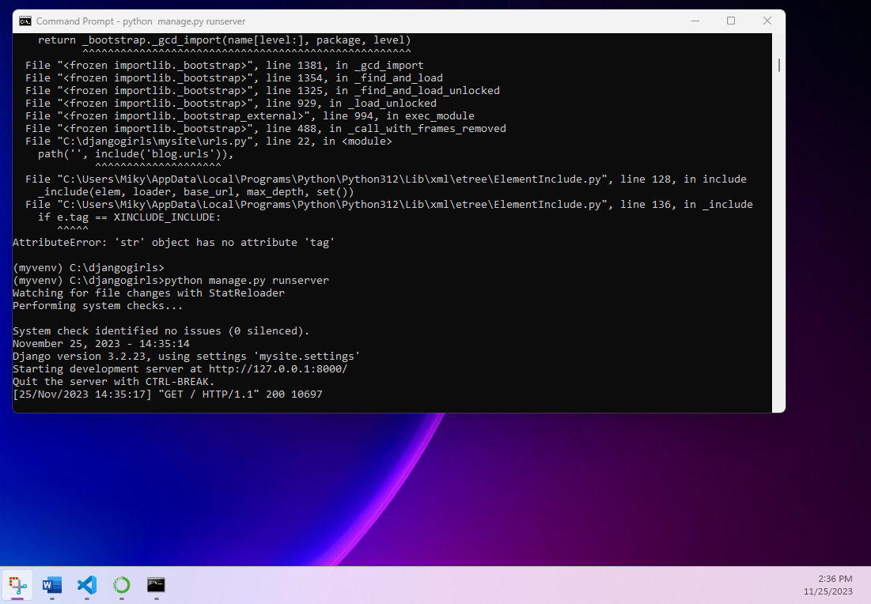

1. 127.0.0.1:8000

1. HTML Django Girls

