Assignment 4

Removing GUI components.

Submitted by: Mike LeBlanc

Contents

Introductions: 3

Screenshot proving updates have been installed! 3

Research the Linux directory structure and write in the path that best describes the following locations: 3

What is the current alias for **ls** on your VM and what does it do? 4

What are the default owner, groups, and other permissions for files created with the **touch** command? 4

**Linux: Files and Permissions** 4

What metadata is displayed with the **stat** command? 4

What command would you use to list all files that are *not* .txt or .bin files? 4

Use the **sort** command to sort contacts by last name and redirect the output into a file named **lastnamesort** located into your **/Documents** folder. 4

Answer the following questions in your professional Document: 5

What are the maximum initial permissions for files and directories? 5

What does the execute permission mean on a directory? 5

What does the SUID bit do? 5

How many groups can own a directory? 5

**Understanding Computer Hardware**. 5

What is the name of the Linux mascot? 5

In the **/proc/cpuinfo** file, what does the **vmx** flag indicate? 5

What are the main differences between **MBR** and **GPT**? 5

What command will unmount an optical disk? 5

Gold copy and snapshot 5

Conclusions 6

# Introductions:

Here we are, facing assignment 4 of our journey into Linux. On this episode, we ditch the disgusting GUI for the nice, clean, refreshing world of the command line interface! Our hero’s finally find respite and take a breather before getting back into the action!

## Screenshot proving updates have been installed!

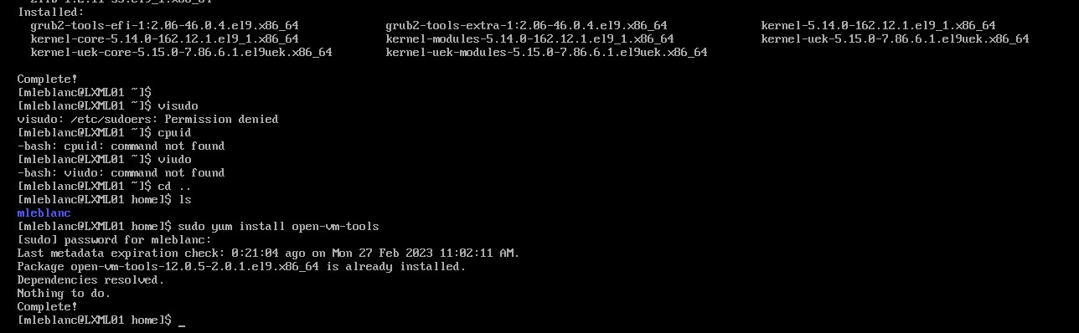

Figure : updates ready for action!

## Research the Linux directory structure and write in the path that best describes the following locations:

|  |  |
| --- | --- |
| **/home/username** | Your own home directory |
| /bin | Executable programs like cat and tar |
| /sbin | Executable programs used for administration such as fdisk |
| /boot | Boot-up processes including the Linux kernel |
| /media | Mount directory for removable devices |
| /var/run | Information about running processes such as pid |
| /dev | Device file for the first IDE hard drive |
| /etc/psswd | Passwords of system users |
| /sys/devices/cpu | CPU information |
| /var/boot.log | Log of messages produced by the syslog daemon at boot |
| /usr/share/man | Man pages |
|  |  |

## What is the current alias for **ls** on your VM and what does it do?

“ls” is still ls. On my VM it lists all files and folders that are in the current directory

## What are the default owner, groups, and other permissions for files created with the **touch** command?

Default permissions are read and write for user, and read for group and others.

# **Linux: Files and Permissions**

## What metadata is displayed with the **stat** command?

The stat command shows file size, permissions, creation and modification times, and device information.

## What command would you use to list all files that are *not* .txt or .bin files?

We would use the command ls -I “*.txt” -I “*.bin” to list all files while ignoring .txt and .bin files.

# Use the **sort** command to sort contacts by last name and redirect the output into a file named **lastnamesort** located into your **/Documents** folder.

`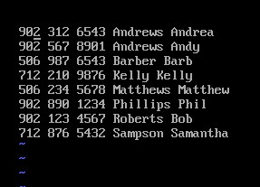

Figure :Sort completed successfully!

# Answer the following questions in your professional Document:

## What are the maximum initial permissions for files and directories?

The maximum initial permissions for files are 777 for folders and 644 for files as a root user.

## What does the execute permission mean on a directory?

The execute permission on a directory allows users to cd into that directory.

## What does the SUID bit do?

The SUID bit sets its permissions to the owner, instead of the user who launched it.

## How many groups can own a directory?

Only 1 (one) group may own a directory.

# **Understanding Computer Hardware**.

## What is the name of the Linux mascot?

The name of the adorable Linux mascot is Tux! He’s quite the penguin.

## In the **/proc/cpuinfo** file, what does the **vmx** flag indicate?

The vmx flag is supposed to indicate whether an INTEL CPU has hardware support for VMs. This does not apply to me specifically where I am on AMD’s Ryzen platform for CPU’s.

## What are the main differences between **MBR** and **GPT**?

MBR partitions use the standard BIOS partition tables where GUID Partition Tables (GPT) uses UEFI. With GPTs you can have more than 4 (four) partitions on each disk. GPT is also required for disks larger than 2 (two) terabytes.

## What command will unmount an optical disk?

To unmount a optical disk (cdrom) we would type unmount/cdrom into the CLI

# Gold copy and snapshot

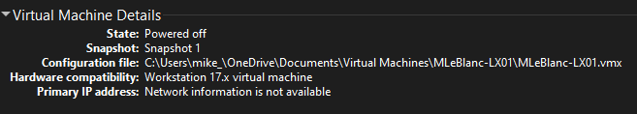

Figure :Snapshot!

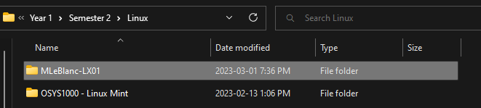

Figure : Good little nestled gold copies.

# Conclusions

With our first foray into a GUI-less CLI having been completed, we can now safely say our heroes are settling in to their new digs.

The no GUI CLI was a little uncomfortable at first, but with the training that we had earlier in the year has proven valuable.

The VMX question was discussed in class, but I do not recall what was said. And not being able to find the vmx flag, I researched using the endless knowledge that google can point us to.

This ends our episode of CLI heroes. Goodnight.