Assignment 1
  - Final Project

SAAD 1001
Mike LeBlanc

SWOT Analysis
Strengths:
- Convenient location: The polling station is in a central area that is easily accessible to most voters.
- Efficient staff: The polling station is staffed by experienced and efficient personnel who are well-trained in managing the voting process.
- Adequate resources: The polling station has sufficient resources such as voting booths, ballot papers, and other equipment to ensure a smooth and efficient voting process.
- Clear instructions: The instructions for voters are clear and easy to understand, reducing the likelihood of confusion or mistakes.
Weaknesses:
- Limited parking: The polling station has limited parking, which may make it difficult for some voters to find a place to park and vote.
- Small space: The polling station is small and may become overcrowded during peak voting hours, leading to longer wait times and potential safety concerns.
- Limited accessibility: The polling station may not be easily accessible for people with disabilities, making it difficult for them to vote.
- Technology limitations: The polling station may not have the latest technology to facilitate a smooth voting process, leading to delays or errors.
Opportunities:
- Increased outreach: The polling station could engage in more outreach efforts to increase voter turnout and encourage more people to vote.
- Online registration: The polling station could explore online registration options to make it easier for people to register to vote and avoid long lines on election day.
- Volunteer recruitment: The polling station could recruit more volunteers to help manage the voting process and reduce wait times.
- Diversification of services: The polling station could consider offering additional services such as language assistance or childcare to make it easier for people to vote.
Threats:
- Voter suppression: There may be efforts to suppress voter turnout or intimidate voters at the polling station.
- Cybersecurity threats: The polling station may be vulnerable to cyberattacks that could compromise the integrity of the voting process.
- COVID-19: The ongoing pandemic may create challenges for the polling station, such as reduced staffing levels or increased health and safety concerns.
- Weather conditions: Inclement weather may discourage some voters from going to the polling station, reducing overall turnout.

SDLC/Project Planning
- Requirements gathering: This phase involves gathering and documenting the requirements of the system from the stakeholders, including the polling station staff, voters, and election commission officials. The requirements may include features such as voter registration, ballot management, vote counting, and reporting.
- Design: In this phase, the system design is created based on the requirements gathered in the previous phase. This includes defining the system architecture, data model, user interface, and integration with other systems.
- Development: In this phase, the actual coding of the software is done based on the design specifications. This involves writing, testing, and debugging the code, as well as integrating third-party libraries or APIs.
- Testing: In this phase, the software is tested to ensure that it meets the functional and non-functional requirements. This includes testing for usability, performance, security, and compatibility.
- Deployment: In this phase, the software is deployed to the polling station systems and integrated with other election systems. This includes setting up the necessary hardware, software, and network infrastructure, as well as testing the system in a live environment.
- Maintenance: In this phase, the system is maintained and updated to ensure that it continues to function effectively and efficiently. This includes fixing bugs, updating security patches, and adding new features or functionalities.

Test Case Scenario
Test Case Description: This test case verifies that the voter registration feature of the polling station system is working as expected.
Test Steps:
- Navigate to the voter registration panel on the polling station software.
- Enter valid voter name.
- Verify that the system displays a confirmation message indicating that the voter has been successfully registered.
- Verify that the voter's information is stored correctly in the system database.
- Attempt to register the same voter with the same information again.
- Verify that the system displays an error message indicating that the voter is already registered.
- Attempt to register a voter with invalid or missing information.
- Verify that the system displays appropriate error messages for each invalid or missing field.
Expected Results:
- The voter registration page should load without errors.
- The voter information should be valid and complete.
- The voter registration form should be submitted without errors.
- The confirmation message should be displayed, and the voter should receive a registration confirmation.
- The voter's information should be stored correctly in the system database.
- The system should prevent the same voter from registering multiple times with the same information.
- The system should display an error message indicating that the voter is already registered.
- The system should prevent the voter from registering with invalid or missing information.
- The system should display appropriate error messages for each invalid or missing field.
Test Environment: The test environment should include a test instance of the polling station system, a test database, and sample voter data for testing purposes.

Use Case Diagram
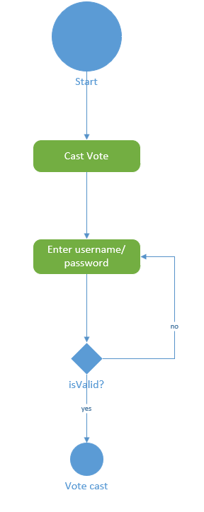

UML Diagram
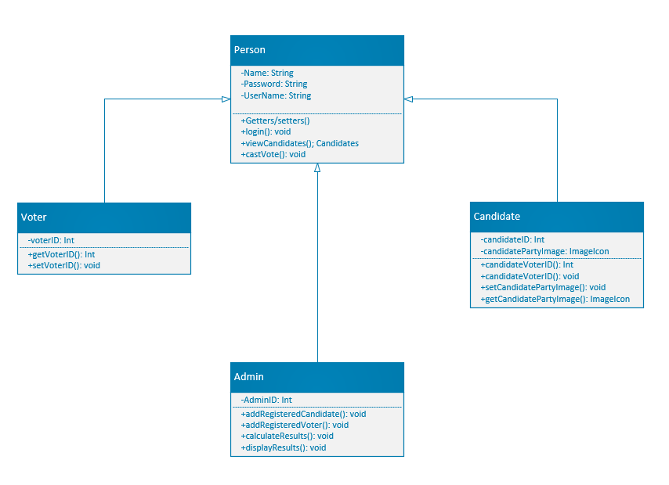

Sequence Diagrams
