**Analysis Report**

Trends and Projections in Workforce Headcounts

**Prepared for:**

Director and Senior Executive Team Meeting

**Prepared by:**

DA Team

**Date:** XX/XX/2023

Contents

1.Executive Summary: 2

2.Introduction 2

3.Methodology 2

4.Findings 2

4.1Trends over time in male and female employment, including any notable changes. 2

4.2. The current representation of part time employees in the sector and in each Cluster 3

4.3. The current representation of male and female part time employees as a proportion of the respective male and the female workforce in the sector and in each cluster 3

4.4. Change in these two above statistics over the last 4 years. 3

4.5. Projection of what the representation will be by 2025 if the current trends continue. 4

5.Conclusion: 4

6.Recommendations: 4

# 1.Executive Summary:

This report presents an analysis of trends in workforce headcounts from 2014 to 2018 and projections for the year 2025. The analysis focused on different clusters, including Education, Family & Community Services, Finance, Services & Innovation, Health, Industry, Justice, Planning & Environment, Premier & Cabinet, Transport, and Treasury. It reveals that the projected growth varies significantly across different clusters and genders.

# 2.Introduction

Workforce headcount is a critical metric in assessing an organization's growth and future staffing needs. This report presents an analysis of past trends and future projections of workforce headcounts in various clusters of our organization.

# 3.Methodology

The analysis was carried out using Python, a powerful tool for data manipulation and analysis. The historical data from 2014 to 2018 was used to build a linear regression model, which was then used to project the headcounts for the year 2025.

Code: https://github.com/MikeJR111/NSW-data-analysis/blob/main/Task1%20Data%20Analysis%20Case%20Study.ipynb

# 4.Findings

## 4.1Trends over time in male and female employment, including any notable changes.

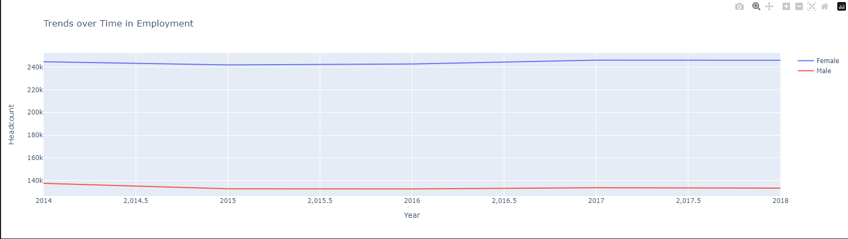

## 4.2. The current representation of part time employees in the sector and in each Cluster

## 4.3. The current representation of male and female part time employees as a proportion of the respective male and the female workforce in the sector and in each cluster

## 4.4. Change in these two above statistics over the last 4 years.

## 4.5. Projection of what the representation will be by 2025 if the current trends continue.

# 5.Conclusion:

Our projections indicate that there will be changes in workforce headcounts across various clusters by 2025. The trend suggests an overall increase in the female workforce in Education and Health clusters and a decrease in Family & Community Services and Industry clusters. For the male workforce, similar trends can be observed. These insights can guide the strategic planning for workforce management.

# 6.Recommendations:

The clusters predicted to experience a decrease in workforce headcounts should assess their hiring policies, workforce retention, and development programs. It is also recommended to carry out a deeper analysis to understand the reasons behind these projections and to formulate suitable strategies accordingly.