Preliminary analysis - Martha dataset

Table of Contents

# Suicidal ideation

## Network graph

We included a total of 44 studies in the analysis of this outcome. We had a total of 101 events in placebo and 159 events in drugs.

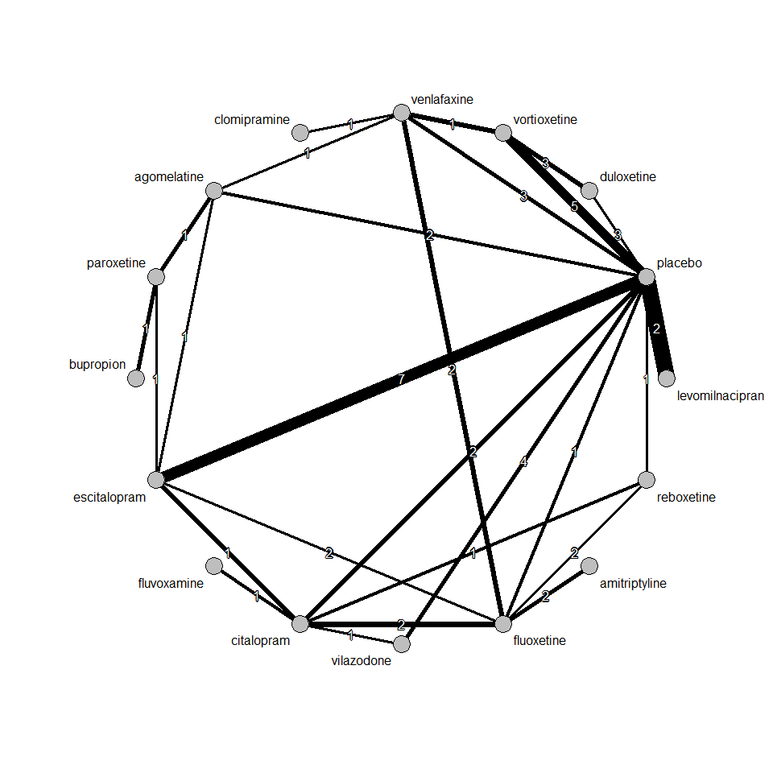

## Pairwise meta-analysis

After grouping all drugs under one node, we performed a pairwise meta-analysis between drugs vs placebo. We used Mantel-Haenszel method to synthesize odds ratios. We found a very small effect size with large uncertainty, i.e. an OR 1.07 [0.82, 1.38], favouring placebo. The random effects model gave almost identical results.

Number of studies combined: k = 40  
  
 OR 95%-CI z p-value  
Fixed effect model 1.07 [0.82; 1.38] 0.49 0.62  
Random effects model 1.02 [0.78; 1.35] 0.17 0.86  
  
Quantifying heterogeneity:  
tau^2 = 0; H = 1.00 [1.00; 1.00]; I^2 = 0.0% [0.0%; 0.0%]  
  
Test of heterogeneity:  
 Q d.f. p-value  
 23.06 39 0.9801  
  
Details on meta-analytical method:  
- Mantel-Haenszel method  
- DerSimonian-Laird estimator for tau^2  
- Continuity correction of 0.5 in studies with zero cell frequencies

We present contour-enhanced funnel plot. We don’t see asymmetry in the funnel plot. Thus, we can conclude that there is no publication bias in this study.

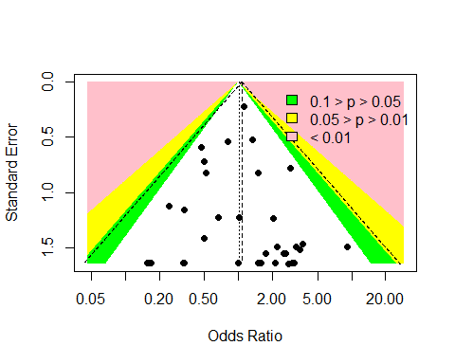

## Mantel-Haenszel network meta-analysis

We performed a Mantel-Haenszel NMA. Results are summarized in the forest plot below. Odds ratio smaller than 1 indicate that a drug reduced suicidal ideation as compared to placebo. All estimates come with large uncertainty; thus, no firm conclusion can be drawn for any of the drugs.

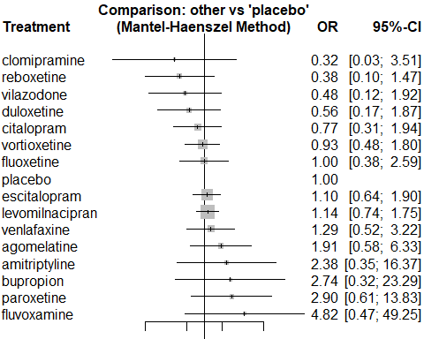

## Inverse variance network meta-analysis

The estimates found by using inverse variance method for both fixed and random effects model closely match the result we found in Mantel-Haenszel NMA. There are more treatments included in this NMA since a continuity correction (adding 0.5 to no event arms) has been used. Fixed and random effects NMA gave identical results, because heterogeneity was estimated to be zero.

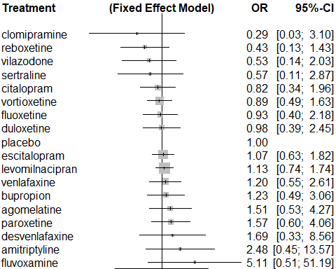

# Nausea

## Network graph

We included a total of 181 studies in the analysis of this outcome. We had a total of 1997 events in placebo and 8040 events in drugs.

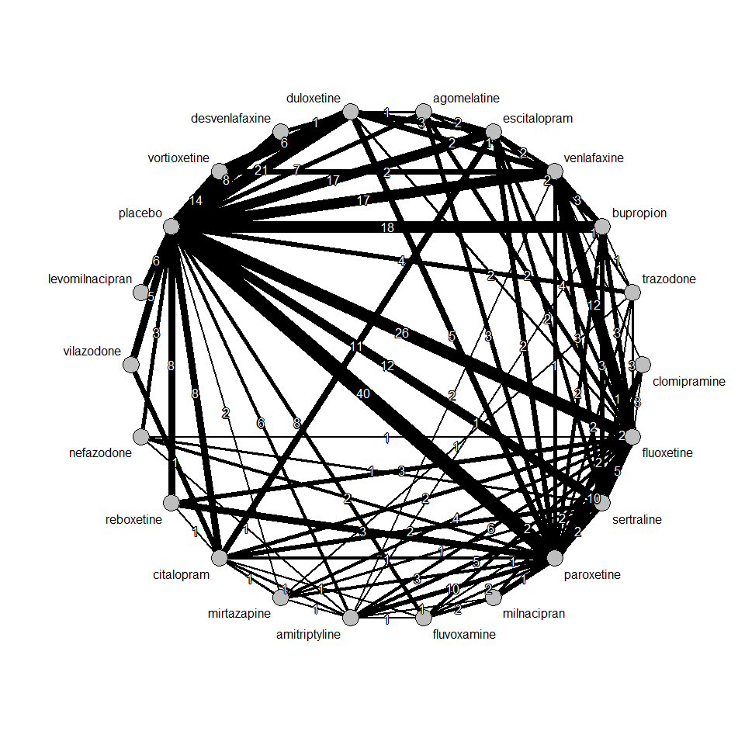

## Pairwise meta-analysis

After grouping all drugs under one node, we performed a pairwise meta-analysis between drugs vs placebo. We used Mantel-Haenszel method to synthesize odds ratios. We found a very **large** effect size with small uncertainty, i.e. an OR 2.59 [2.46, 2.74], favouring placebo.

Number of studies combined: k = 181  
  
 OR 95%-CI z p-value  
Fixed effect model 2.59 [2.46; 2.74] 34.61 < 0.01  
Random effects model 2.53 [2.32; 2.75] 21.35 < 0.01  
  
Quantifying heterogeneity:  
tau^2 = 0.1625; H = 1.46 [1.34; 1.59]; I^2 = 53.2% [44.6%; 60.5%]  
  
Test of heterogeneity:  
 Q d.f. p-value  
 384.88 180 < 0.0001  
  
Details on meta-analytical method:  
- Mantel-Haenszel method  
- DerSimonian-Laird estimator for tau^2  
- Continuity correction of 0.5 in studies with zero cell frequencies

We present contour-enhanced funnel plot below. We don’t see asymmetry in the funnel plot. Thus, we can conclude that there is no publication bias in this study.

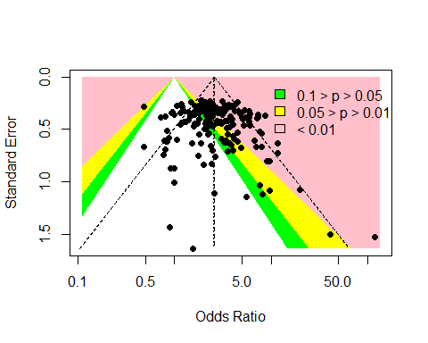

## Random effects network meta-analysis

We performed a random effects NMA. Results are summarized in the forest plot below. Odds ratio smaller than 1 indicate that a drug reduced nausea as compared to placebo. Odds ratios are much greater than 1 with small uncertainty; thus, we can infer that drug may be developing nausea for some patients.

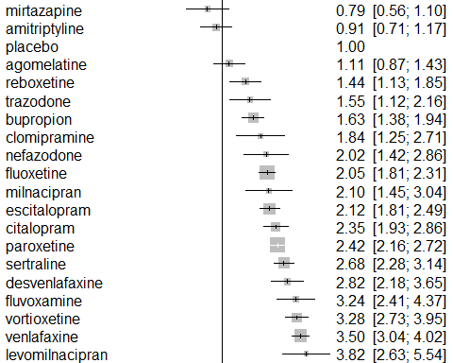

# Agitation

## Network graph

We included a total of 42 studies in the analysis of this outcome. We had a total of 262 events in placebo and 501 events in drugs.

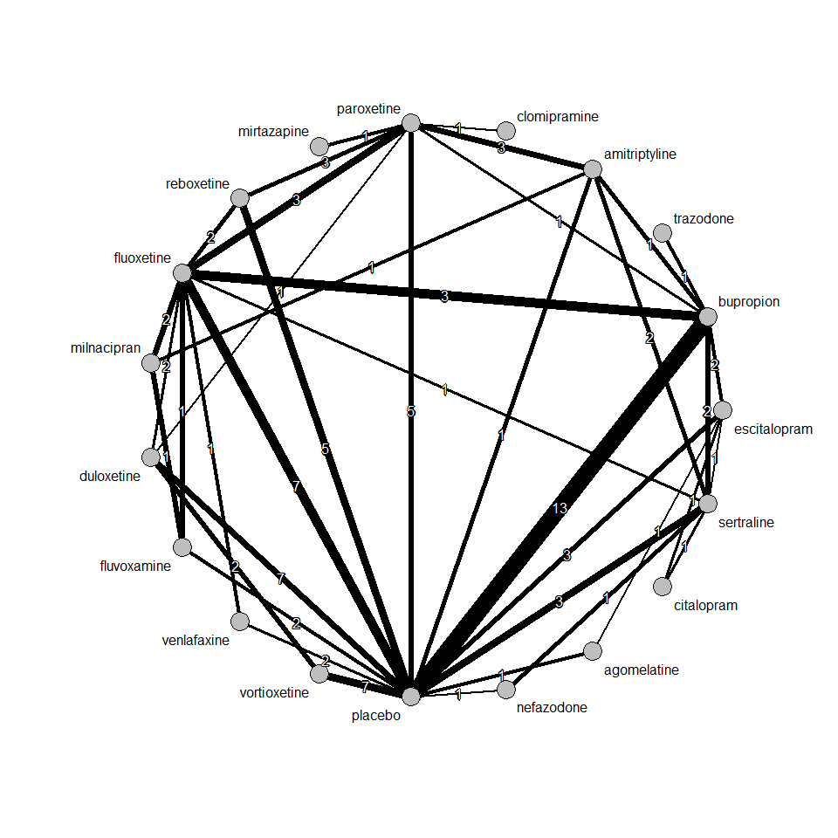

## Pairwise meta-analysis

After grouping all drugs under one node, we performed a pairwise meta-analysis between drugs vs placebo. We used Mantel-Haenszel method to synthesize odds ratios. We found a small effect size with moderate uncertainty, i.e. an OR 1.17 [0.99, 1.40], favouring placebo.

Number of studies combined: k = 42  
  
 OR 95%-CI z p-value  
Fixed effect model 1.17 [0.99; 1.40] 1.81 0.07  
Random effects model 1.13 [0.90; 1.41] 1.04 0.30  
  
Quantifying heterogeneity:  
tau^2 = 0.1150; H = 1.14 [1.00; 1.39]; I^2 = 23.4% [0.0%; 48.1%]  
  
Test of heterogeneity:  
 Q d.f. p-value  
 53.56 41 0.0904  
  
Details on meta-analytical method:  
- Mantel-Haenszel method  
- DerSimonian-Laird estimator for tau^2  
- Continuity correction of 0.5 in studies with zero cell frequencies

We present contour-enhanced funnel plot below. We don’t see asymmetry in the funnel plot. Thus, we can conclude that there is no publication bias in this study.

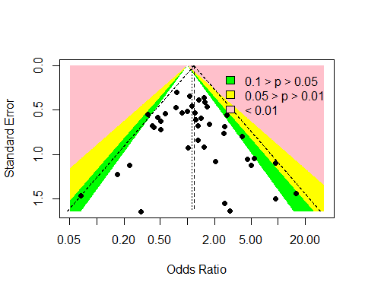

## Random effects network meta-analysis

We performed a random effects NMA. Results are summarized in the forest plot below. Odds ratio smaller than 1 indicate that a drug reduced agitation as compared to placebo. All estimates come with large uncertainty; thus, no firm conclusion can be drawn for any of the drugs.

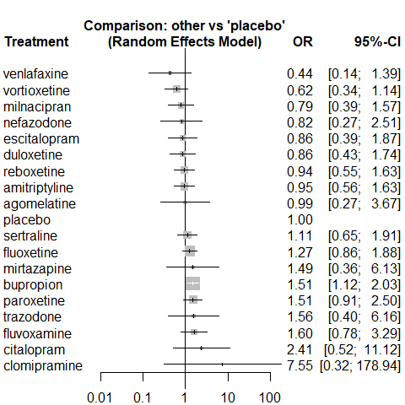

# Tremor

## Network graph

We included a total of 74 studies in the analysis of this outcome. We had a total of 128 events in placebo and 950 events in drugs.

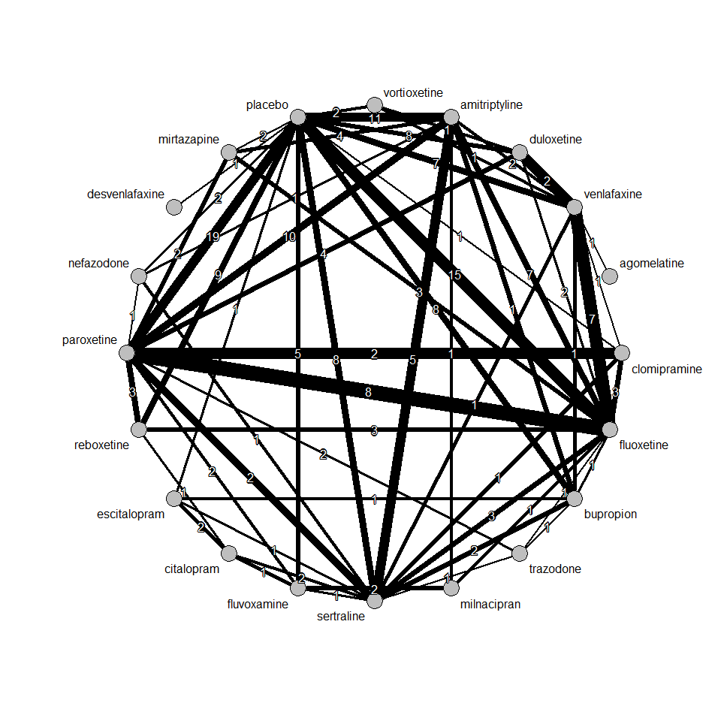

## Pairwise meta-analysis

After grouping all drugs under one node, we performed a pairwise meta-analysis between drugs vs placebo. We used Mantel-Haenszel method to synthesize odds ratios. We found a large effect size with small uncertainty, i.e. an OR 4.22 [3.50, 5.10], favouring placebo.

Number of studies combined: k = 73  
  
 OR 95%-CI z p-value  
Fixed effect model 4.22 [3.50; 5.10] 14.93 < 0.01  
Random effects model 3.56 [2.93; 4.34] 12.69 < 0.01  
  
Quantifying heterogeneity:  
tau^2 = 0; H = 1.00 [1.00; 1.10]; I^2 = 0.0% [0.0%; 17.8%]  
  
Test of heterogeneity:  
 Q d.f. p-value  
 63.04 72 0.7655  
  
Details on meta-analytical method:  
- Mantel-Haenszel method  
- DerSimonian-Laird estimator for tau^2  
- Continuity correction of 0.5 in studies with zero cell frequencies

We present contour-enhanced funnel plot below. There might be a publication bias since studies with low precision are not spread evenly on both sides of the average.

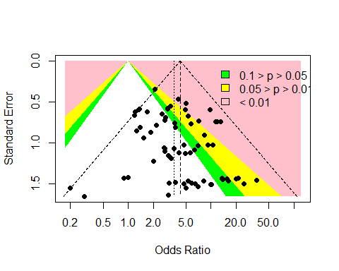

## Random effects network meta-analysis

We performed a random effects NMA. Results are summarized in the forest plot below. Odds ratio smaller than 1 indicate that a drug reduced tremor as compared to placebo. Odds ratio are large with small uncertainty; thus, we can infer that drug may be developing tremor for some patients.

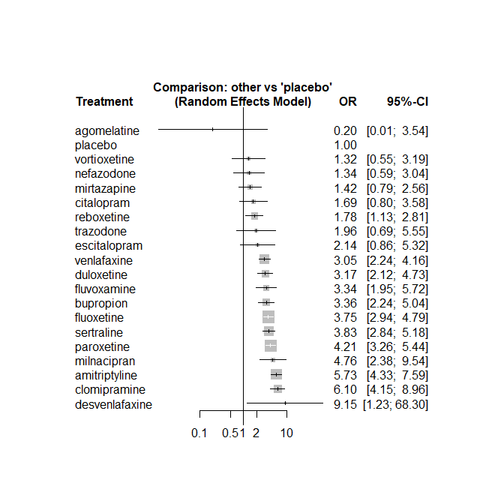

League table (fixed effect model):  
   
 agomelatine . .  
 0.03 [0.00; 0.62] amitriptyline 1.67 [0.77; 3.59]  
 0.06 [0.00; 1.08] 1.71 [1.13; 2.59] bupropion  
 0.12 [0.01; 2.29] 3.39 [1.58; 7.27] 1.98 [0.88; 4.45]  
 0.03 [0.00; 0.59] 0.94 [0.63; 1.40] 0.55 [0.33; 0.92]  
 0.02 [0.00; 0.73] 0.63 [0.08; 4.77] 0.37 [0.05; 2.85]  
 0.06 [0.00; 1.12] 1.81 [1.18; 2.79] 1.06 [0.63; 1.80]  
 0.09 [0.00; 1.89] 2.68 [1.07; 6.74] 1.57 [0.62; 3.96]  
 0.05 [0.00; 0.94] 1.53 [1.16; 2.01] 0.90 [0.59; 1.36]  
 0.06 [0.00; 1.11] 1.72 [0.98; 3.03] 1.01 [0.53; 1.92]  
 0.04 [0.00; 0.80] 1.20 [0.60; 2.41] 0.70 [0.33; 1.53]  
 0.14 [0.01; 2.61] 4.02 [2.26; 7.16] 2.36 [1.20; 4.63]  
 0.15 [0.01; 2.93] 4.27 [1.89; 9.62] 2.50 [1.03; 6.04]  
 0.05 [0.00; 0.84] 1.36 [1.03; 1.80] 0.80 [0.52; 1.22]  
 0.20 [0.01; 3.54] 5.73 [4.33; 7.59] 3.36 [2.24; 5.04]  
 0.11 [0.01; 2.04] 3.22 [1.96; 5.27] 1.88 [1.05; 3.37]  
 0.05 [0.00; 0.93] 1.50 [1.12; 2.00] 0.88 [0.57; 1.34]  
 0.10 [0.00; 2.15] 2.93 [1.03; 8.34] 1.72 [0.59; 4.98]  
 0.06 [0.00; 1.14] 1.88 [1.33; 2.64] 1.10 [0.70; 1.73]  
 0.15 [0.01; 2.99] 4.34 [1.76; 10.69] 2.54 [0.98; 6.57]  
   
 . . .  
 . . .  
 . . .  
 citalopram . .  
 0.28 [0.12; 0.62] clomipramine .  
 0.18 [0.02; 1.58] 0.67 [0.09; 5.16] desvenlafaxine  
 0.53 [0.23; 1.22] 1.93 [1.18; 3.14] 2.89 [0.37; 22.44]  
 0.79 [0.31; 1.99] 2.85 [1.09; 7.46] 4.28 [0.47; 38.88]  
 0.45 [0.21; 0.96] 1.63 [1.15; 2.31] 2.44 [0.32; 18.48]  
 0.51 [0.24; 1.09] 1.83 [0.98; 3.41] 2.74 [0.34; 21.98]  
 0.36 [0.14; 0.91] 1.28 [0.60; 2.72] 1.92 [0.23; 16.12]  
 1.19 [0.47; 2.99] 4.28 [2.27; 8.09] 6.43 [0.79; 52.15]  
 1.26 [0.43; 3.72] 4.54 [1.90; 10.83] 6.81 [0.78; 59.59]  
 0.40 [0.19; 0.86] 1.45 [1.05; 1.99] 2.17 [0.29; 16.49]  
 1.69 [0.80; 3.58] 6.10 [4.15; 8.96] 9.15 [1.23; 68.30]  
 0.95 [0.42; 2.13] 3.42 [1.99; 5.88] 5.13 [0.65; 40.30]  
 0.44 [0.21; 0.93] 1.59 [1.07; 2.36] 2.39 [0.31; 18.22]  
 0.87 [0.25; 3.04] 3.12 [1.07; 9.09] 4.68 [0.49; 45.02]  
 0.55 [0.25; 1.21] 2.00 [1.32; 3.02] 3.00 [0.39; 22.91]  
 1.28 [0.41; 4.01] 4.61 [1.81; 11.74] 6.92 [0.77; 62.12]  
   
 . . .  
 . . 3.16 [1.79; 5.59]  
 . 2.21 [0.54; 9.02] 0.67 [0.11; 4.14]  
 . 0.97 [0.32; 2.93] .  
 . . 1.24 [0.60; 2.56]  
 . . .  
 duloxetine . 0.85 [0.18; 3.94]  
 1.48 [0.56; 3.92] escitalopram .  
 0.84 [0.58; 1.23] 0.57 [0.23; 1.43] fluoxetine  
 0.95 [0.50; 1.81] 0.64 [0.24; 1.72] 1.12 [0.65; 1.96]  
 0.66 [0.31; 1.44] 0.45 [0.15; 1.35] 0.79 [0.40; 1.57]  
 2.22 [1.15; 4.31] 1.50 [0.52; 4.34] 2.63 [1.50; 4.63]  
 2.36 [0.97; 5.72] 1.59 [0.48; 5.29] 2.79 [1.22; 6.36]  
 0.75 [0.51; 1.12] 0.51 [0.20; 1.27] 0.89 [0.72; 1.10]  
 3.17 [2.12; 4.73] 2.14 [0.86; 5.32] 3.75 [2.94; 4.79]  
 1.78 [1.01; 3.13] 1.20 [0.45; 3.21] 2.10 [1.33; 3.32]  
 0.83 [0.53; 1.28] 0.56 [0.22; 1.39] 0.98 [0.73; 1.32]  
 1.62 [0.55; 4.80] 1.09 [0.28; 4.24] 1.92 [0.68; 5.40]  
 1.04 [0.75; 1.44] 0.70 [0.27; 1.79] 1.23 [0.94; 1.60]  
 2.39 [0.99; 5.77] 1.62 [0.46; 5.68] 2.84 [1.17; 6.85]  
   
 . . .  
 . 0.35 [0.10; 1.21] 3.66 [1.36; 9.83]  
 . . .  
 0.39 [0.13; 1.15] . .  
 . . .  
 . . .  
 . . .  
 . . .  
 . 0.86 [0.25; 2.93] 2.37 [0.94; 5.98]  
 fluvoxamine 1.26 [0.52; 3.06] .  
 0.70 [0.35; 1.39] milnacipran .  
 2.34 [1.09; 5.04] 3.34 [1.40; 7.99] mirtazapine  
 2.48 [0.95; 6.46] 3.54 [1.24; 10.09] 1.06 [0.40; 2.81]  
 0.79 [0.46; 1.38] 1.13 [0.56; 2.27] 0.34 [0.19; 0.59]  
 3.34 [1.95; 5.72] 4.76 [2.38; 9.54] 1.42 [0.79; 2.56]  
 1.87 [0.96; 3.66] 2.67 [1.20; 5.95] 0.80 [0.39; 1.62]  
 0.87 [0.49; 1.53] 1.24 [0.61; 2.53] 0.37 [0.20; 0.68]  
 1.71 [0.54; 5.40] 2.43 [0.71; 8.31] 0.73 [0.23; 2.33]  
 1.09 [0.61; 1.97] 1.56 [0.76; 3.22] 0.47 [0.25; 0.86]  
 2.52 [0.91; 6.99] 3.60 [1.19; 10.87] 1.08 [0.38; 3.03]  
   
 . . .  
 2.31 [0.55; 9.78] 1.95 [1.16; 3.27] 6.33 [3.94; 10.15]  
 . . 4.03 [2.18; 7.43]  
 . . .  
 . 1.31 [0.90; 1.91] 25.16 [1.33; 476.43]  
 . . 9.15 [1.23; 68.30]  
 . 0.68 [0.31; 1.48] 3.62 [1.49; 8.78]  
 . . 1.39 [0.23; 8.43]  
 . 1.04 [0.78; 1.39] 3.91 [2.71; 5.65]  
 . 0.61 [0.16; 2.31] 2.20 [0.96; 5.02]  
 . . .  
 . 0.27 [0.11; 0.70] 1.95 [0.16; 23.69]  
 nefazodone 0.09 [0.00; 1.78] 1.22 [0.26; 5.71]  
 0.32 [0.14; 0.73] paroxetine 4.02 [2.61; 6.21]  
 1.34 [0.59; 3.04] 4.21 [3.26; 5.44] placebo  
 0.75 [0.30; 1.88] 2.36 [1.50; 3.72] 0.56 [0.36; 0.88]  
 0.35 [0.16; 0.79] 1.10 [0.82; 1.47] 0.26 [0.19; 0.35]  
 0.69 [0.19; 2.52] 2.15 [0.77; 6.02] 0.51 [0.18; 1.45]  
 0.44 [0.19; 1.03] 1.38 [1.01; 1.88] 0.33 [0.24; 0.45]  
 1.02 [0.31; 3.33] 3.18 [1.31; 7.76] 0.76 [0.31; 1.82]  
   
 . . .  
 . 0.97 [0.63; 1.48] .  
 . 0.81 [0.37; 1.75] 5.17 [0.59; 45.63]  
 0.45 [0.09; 2.14] 1.42 [0.40; 5.05] .  
 . 3.13 [1.24; 7.92] .  
 . . .  
 . . .  
 . 1.77 [0.41; 7.71] .  
 1.51 [0.63; 3.59] 0.96 [0.44; 2.12] 13.44 [0.74; 243.82]  
 . 0.56 [0.13; 2.49] .  
 . . .  
 . . .  
 . 0.29 [0.08; 1.09] .  
 2.75 [1.35; 5.57] 1.82 [1.07; 3.09] 1.62 [0.36; 7.25]  
 0.67 [0.35; 1.27] 0.19 [0.10; 0.34] .  
 reboxetine . .  
 0.47 [0.28; 0.77] sertraline 0.33 [0.03; 3.30]  
 0.91 [0.30; 2.77] 1.96 [0.69; 5.55] trazodone  
 0.58 [0.35; 0.97] 1.26 [0.88; 1.79] 0.64 [0.22; 1.84]  
 1.35 [0.51; 3.57] 2.90 [1.17; 7.19] 1.48 [0.38; 5.69]  
   
 0.06 [0.00; 1.14] .  
 1.40 [0.43; 4.60] .  
 0.47 [0.16; 1.41] .  
 . .  
 6.95 [0.81; 60.01] .  
 . .  
 1.04 [0.71; 1.53] 2.04 [0.50; 8.27]  
 . .  
 1.29 [0.93; 1.79] .  
 . .  
 . .  
 . .  
 . .  
 . .  
 0.32 [0.18; 0.58] 0.92 [0.27; 3.09]  
 . .  
 0.90 [0.31; 2.63] .  
 . .  
 venlafaxine 2.28 [0.68; 7.63]  
 2.31 [0.97; 5.48] vortioxetine  
  
League table (random effects model):  
   
 agomelatine . .  
 0.03 [0.00; 0.62] amitriptyline 1.67 [0.77; 3.59]  
 0.06 [0.00; 1.08] 1.71 [1.13; 2.59] bupropion  
 0.12 [0.01; 2.29] 3.39 [1.58; 7.27] 1.98 [0.88; 4.45]  
 0.03 [0.00; 0.59] 0.94 [0.63; 1.40] 0.55 [0.33; 0.92]  
 0.02 [0.00; 0.73] 0.63 [0.08; 4.77] 0.37 [0.05; 2.85]  
 0.06 [0.00; 1.12] 1.81 [1.18; 2.79] 1.06 [0.63; 1.80]  
 0.09 [0.00; 1.89] 2.68 [1.07; 6.74] 1.57 [0.62; 3.96]  
 0.05 [0.00; 0.94] 1.53 [1.16; 2.01] 0.90 [0.59; 1.36]  
 0.06 [0.00; 1.11] 1.72 [0.98; 3.03] 1.01 [0.53; 1.92]  
 0.04 [0.00; 0.80] 1.20 [0.60; 2.41] 0.70 [0.33; 1.53]  
 0.14 [0.01; 2.61] 4.02 [2.26; 7.16] 2.36 [1.20; 4.63]  
 0.15 [0.01; 2.93] 4.27 [1.89; 9.62] 2.50 [1.03; 6.04]  
 0.05 [0.00; 0.84] 1.36 [1.03; 1.80] 0.80 [0.52; 1.22]  
 0.20 [0.01; 3.54] 5.73 [4.33; 7.59] 3.36 [2.24; 5.04]  
 0.11 [0.01; 2.04] 3.22 [1.96; 5.27] 1.88 [1.05; 3.37]  
 0.05 [0.00; 0.93] 1.50 [1.12; 2.00] 0.88 [0.57; 1.34]  
 0.10 [0.00; 2.15] 2.93 [1.03; 8.34] 1.72 [0.59; 4.98]  
 0.06 [0.00; 1.14] 1.88 [1.33; 2.64] 1.10 [0.70; 1.73]  
 0.15 [0.01; 2.99] 4.34 [1.76; 10.69] 2.54 [0.98; 6.57]  
   
 . . .  
 . . .  
 . . .  
 citalopram . .  
 0.28 [0.12; 0.62] clomipramine .  
 0.18 [0.02; 1.58] 0.67 [0.09; 5.16] desvenlafaxine  
 0.53 [0.23; 1.22] 1.93 [1.18; 3.14] 2.89 [0.37; 22.44]  
 0.79 [0.31; 1.99] 2.85 [1.09; 7.46] 4.28 [0.47; 38.88]  
 0.45 [0.21; 0.96] 1.63 [1.15; 2.31] 2.44 [0.32; 18.48]  
 0.51 [0.24; 1.09] 1.83 [0.98; 3.41] 2.74 [0.34; 21.98]  
 0.36 [0.14; 0.91] 1.28 [0.60; 2.72] 1.92 [0.23; 16.12]  
 1.19 [0.47; 2.99] 4.28 [2.27; 8.09] 6.43 [0.79; 52.15]  
 1.26 [0.43; 3.72] 4.54 [1.90; 10.83] 6.81 [0.78; 59.59]  
 0.40 [0.19; 0.86] 1.45 [1.05; 1.99] 2.17 [0.29; 16.49]  
 1.69 [0.80; 3.58] 6.10 [4.15; 8.96] 9.15 [1.23; 68.30]  
 0.95 [0.42; 2.13] 3.42 [1.99; 5.88] 5.13 [0.65; 40.30]  
 0.44 [0.21; 0.93] 1.59 [1.07; 2.36] 2.39 [0.31; 18.22]  
 0.87 [0.25; 3.04] 3.12 [1.07; 9.09] 4.68 [0.49; 45.02]  
 0.55 [0.25; 1.21] 2.00 [1.32; 3.02] 3.00 [0.39; 22.91]  
 1.28 [0.41; 4.01] 4.61 [1.81; 11.74] 6.92 [0.77; 62.12]  
   
 . . .  
 . . 3.16 [1.79; 5.59]  
 . 2.21 [0.54; 9.02] 0.67 [0.11; 4.14]  
 . 0.97 [0.32; 2.93] .  
 . . 1.24 [0.60; 2.56]  
 . . .  
 duloxetine . 0.85 [0.18; 3.94]  
 1.48 [0.56; 3.92] escitalopram .  
 0.84 [0.58; 1.23] 0.57 [0.23; 1.43] fluoxetine  
 0.95 [0.50; 1.81] 0.64 [0.24; 1.72] 1.12 [0.65; 1.96]  
 0.66 [0.31; 1.44] 0.45 [0.15; 1.35] 0.79 [0.40; 1.57]  
 2.22 [1.15; 4.31] 1.50 [0.52; 4.34] 2.63 [1.50; 4.63]  
 2.36 [0.97; 5.72] 1.59 [0.48; 5.29] 2.79 [1.22; 6.36]  
 0.75 [0.51; 1.12] 0.51 [0.20; 1.27] 0.89 [0.72; 1.10]  
 3.17 [2.12; 4.73] 2.14 [0.86; 5.32] 3.75 [2.94; 4.79]  
 1.78 [1.01; 3.13] 1.20 [0.45; 3.21] 2.10 [1.33; 3.32]  
 0.83 [0.53; 1.28] 0.56 [0.22; 1.39] 0.98 [0.73; 1.32]  
 1.62 [0.55; 4.80] 1.09 [0.28; 4.24] 1.92 [0.68; 5.40]  
 1.04 [0.75; 1.44] 0.70 [0.27; 1.79] 1.23 [0.94; 1.60]  
 2.39 [0.99; 5.77] 1.62 [0.46; 5.68] 2.84 [1.17; 6.85]  
   
 . . .  
 . 0.35 [0.10; 1.21] 3.66 [1.36; 9.83]  
 . . .  
 0.39 [0.13; 1.15] . .  
 . . .  
 . . .  
 . . .  
 . . .  
 . 0.86 [0.25; 2.93] 2.37 [0.94; 5.98]  
 fluvoxamine 1.26 [0.52; 3.06] .  
 0.70 [0.35; 1.39] milnacipran .  
 2.34 [1.09; 5.04] 3.34 [1.40; 7.99] mirtazapine  
 2.48 [0.95; 6.46] 3.54 [1.24; 10.09] 1.06 [0.40; 2.81]  
 0.79 [0.46; 1.38] 1.13 [0.56; 2.27] 0.34 [0.19; 0.59]  
 3.34 [1.95; 5.72] 4.76 [2.38; 9.54] 1.42 [0.79; 2.56]  
 1.87 [0.96; 3.66] 2.67 [1.20; 5.95] 0.80 [0.39; 1.62]  
 0.87 [0.49; 1.53] 1.24 [0.61; 2.53] 0.37 [0.20; 0.68]  
 1.71 [0.54; 5.40] 2.43 [0.71; 8.31] 0.73 [0.23; 2.33]  
 1.09 [0.61; 1.97] 1.56 [0.76; 3.22] 0.47 [0.25; 0.86]  
 2.52 [0.91; 6.99] 3.60 [1.19; 10.87] 1.08 [0.38; 3.03]  
   
 . . .  
 2.31 [0.55; 9.78] 1.95 [1.16; 3.27] 6.33 [3.94; 10.15]  
 . . 4.03 [2.18; 7.43]  
 . . .  
 . 1.31 [0.90; 1.91] 25.16 [1.33; 476.43]  
 . . 9.15 [1.23; 68.30]  
 . 0.68 [0.31; 1.48] 3.62 [1.49; 8.78]  
 . . 1.39 [0.23; 8.43]  
 . 1.04 [0.78; 1.39] 3.91 [2.71; 5.65]  
 . 0.61 [0.16; 2.31] 2.20 [0.96; 5.02]  
 . . .  
 . 0.27 [0.11; 0.70] 1.95 [0.16; 23.69]  
 nefazodone 0.09 [0.00; 1.78] 1.22 [0.26; 5.71]  
 0.32 [0.14; 0.73] paroxetine 4.02 [2.61; 6.21]  
 1.34 [0.59; 3.04] 4.21 [3.26; 5.44] placebo  
 0.75 [0.30; 1.88] 2.36 [1.50; 3.72] 0.56 [0.36; 0.88]  
 0.35 [0.16; 0.79] 1.10 [0.82; 1.47] 0.26 [0.19; 0.35]  
 0.69 [0.19; 2.52] 2.15 [0.77; 6.02] 0.51 [0.18; 1.45]  
 0.44 [0.19; 1.03] 1.38 [1.01; 1.88] 0.33 [0.24; 0.45]  
 1.02 [0.31; 3.33] 3.18 [1.31; 7.76] 0.76 [0.31; 1.82]  
   
 . . .  
 . 0.97 [0.63; 1.48] .  
 . 0.81 [0.37; 1.75] 5.17 [0.59; 45.63]  
 0.45 [0.09; 2.14] 1.42 [0.40; 5.05] .  
 . 3.13 [1.24; 7.92] .  
 . . .  
 . . .  
 . 1.77 [0.41; 7.71] .  
 1.51 [0.63; 3.59] 0.96 [0.44; 2.12] 13.44 [0.74; 243.82]  
 . 0.56 [0.13; 2.49] .  
 . . .  
 . . .  
 . 0.29 [0.08; 1.09] .  
 2.75 [1.35; 5.57] 1.82 [1.07; 3.09] 1.62 [0.36; 7.25]  
 0.67 [0.35; 1.27] 0.19 [0.10; 0.34] .  
 reboxetine . .  
 0.47 [0.28; 0.77] sertraline 0.33 [0.03; 3.30]  
 0.91 [0.30; 2.77] 1.96 [0.69; 5.55] trazodone  
 0.58 [0.35; 0.97] 1.26 [0.88; 1.79] 0.64 [0.22; 1.84]  
 1.35 [0.51; 3.57] 2.90 [1.17; 7.19] 1.48 [0.38; 5.69]  
   
 0.06 [0.00; 1.14] .  
 1.40 [0.43; 4.60] .  
 0.47 [0.16; 1.41] .  
 . .  
 6.95 [0.81; 60.01] .  
 . .  
 1.04 [0.71; 1.53] 2.04 [0.50; 8.27]  
 . .  
 1.29 [0.93; 1.79] .  
 . .  
 . .  
 . .  
 . .  
 . .  
 0.32 [0.18; 0.58] 0.92 [0.27; 3.09]  
 . .  
 0.90 [0.31; 2.63] .  
 . .  
 venlafaxine 2.28 [0.68; 7.63]  
 2.31 [0.97; 5.48] vortioxetine