Michael Shear
2/6/2023
CST 325
Journal 1 Vectors

The first big take away I got from this assignment was how much math goes into vectors that create all of the 3d generated content we see today. There were functions I didn't even realize existed such as normalize, multiply scalar, and project vector. I did realize that a lot of these functions could be used by implementing other functions inside of them which is an example just how interconnected vector math is.
The resources that I used were class slides and looked up clarification of formulas and their mathematical symbols online. However my biggest help was visiting the office hours and talking with the ta. The TA helped me with referencing slides and explained to me why we used specific mathematical operations to achieve desired results. I think the one thing I would like clarification on is how does the computer know how to use the math to display all these vectors, what kind of processing does it go through?
My biggest challenges was understanding the syntax of java script and using git hub repository.
I did a lot of online research and looked up function libraries as wall as talk to the TA. I attempted to solve the problems by myself first being successful by solving some in a quick manner, while others required more patience and contacting Jaden during his office hours. With Git hub I struggled with simple things such as file organization, creating a folder, and uploading a file through a specified folder. Plenty of tutorials and asking a lot of questions I was finally able to organize my git hub and upload files where they needed to be.

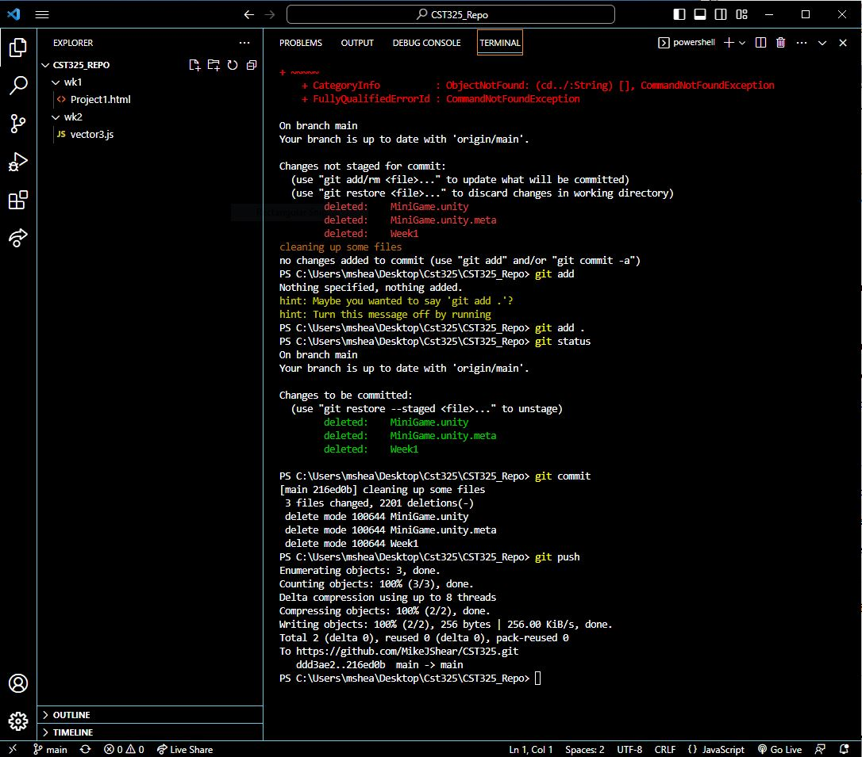
Learning to use Git with console commands in Visual Studio Code

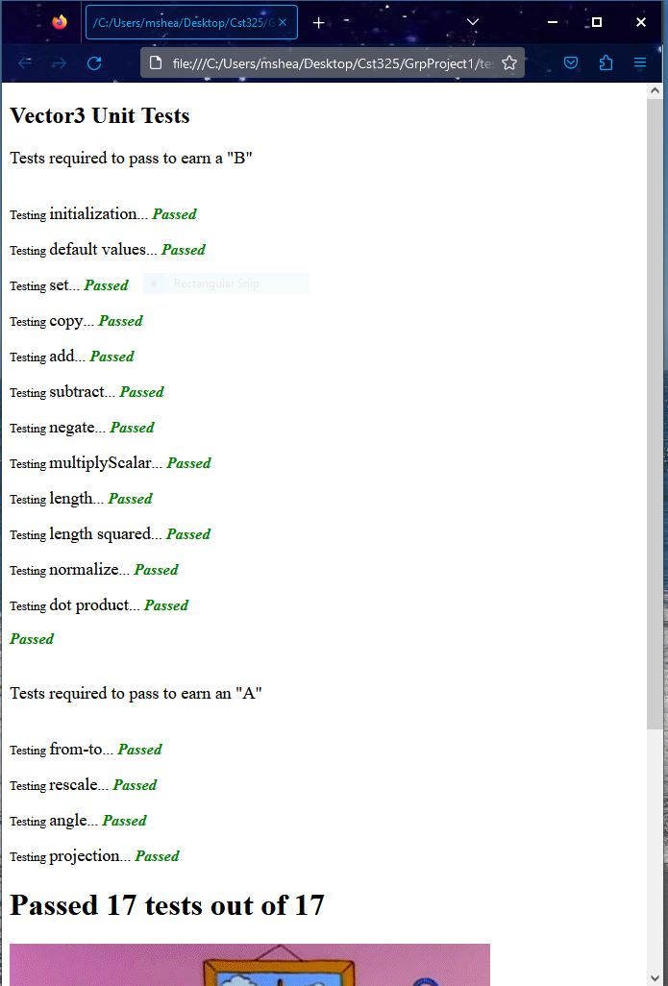
Successful test runs of all java script vector functions

