Michael Shear

2/26/2023

Cst 325

Journal 3

Ray Tracing

Throughout this project the first concept that I learned was without light and shading the object in this case the sphere appears to be 2d, even though it has 3 dimenssions. What surprised me was how many variables were needed to get just the light working. These variables included light position,the dot product result of that light hitting an object and finally setting the pixel color. With all the math that goes into creating 3d objects I have a whole new appreciation for those that do so for a living.

It is easy to get lost in the math and have a hard time visualizing what is actually going on. When my group ran into an obstacle we first attempted to collaborate together outside of campus through zoom meetings. If we still had difficulty figuring out what to do we would consult Jaden who would point us in the right dirrection. Jaden was a big help with better clarifying concepts and what specific formulas required to make them work, as well as go into depth of why those equations did what they did.

My biggest challenge was visualizing the math into an image and being sure I was using the correct syntax. As a team we worked together to solve some of the more minor issues such as how to properly declare a sphere and its radius. With more complicated issues such as getting the light set up and understanding the shadows we attended office hours as a group to help us all understand the assignment better.

The visual aids within the instructions were also very helpful as they gave more of a visual representation of the math instead of just variables and numbers. I'm getting a better understanding of using the console within the web browser to detect errors, and using the terminal to execute git commands to upload and change files into directories. 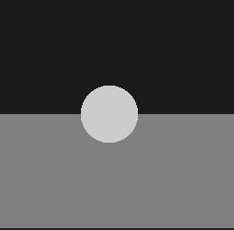

A 2d appearence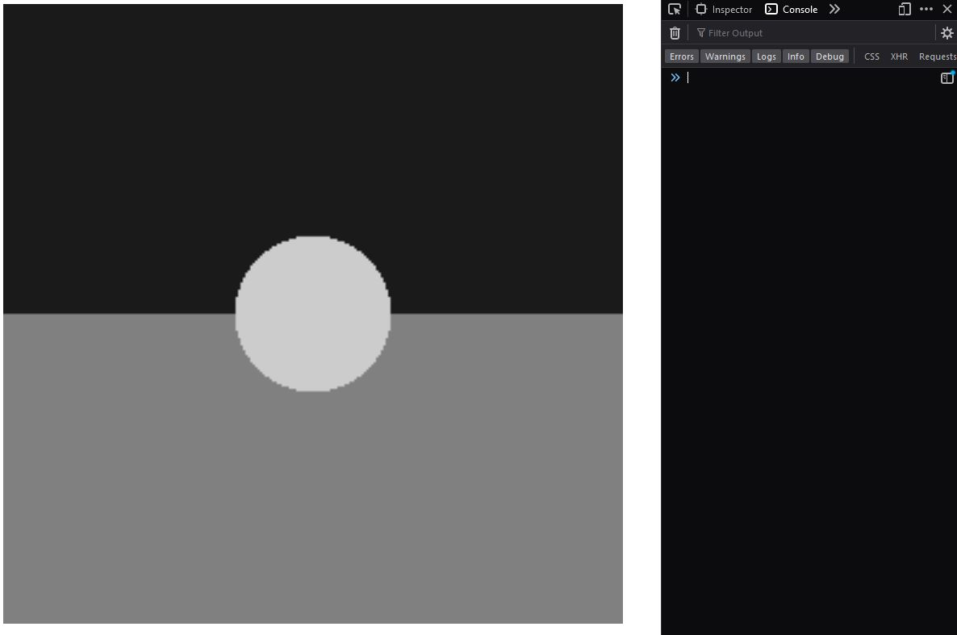

No errors but no changes

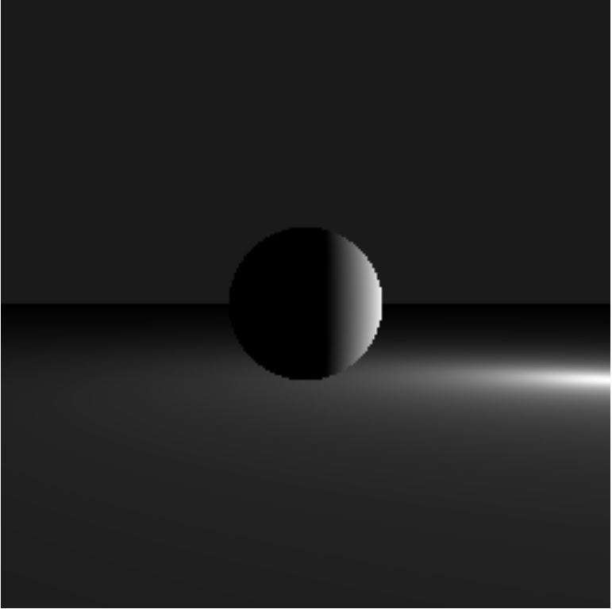

we got Light

