Michael Shear

2/26/2023

Cst 325

Journal WebGL

Introduction to WebGL and the Graphics pipeline

The first concept that stood out to me was the use of triangles in graphics design, and that the more triangles the smoother the object appears. Triangles are used to help group pixels together and reduce the amount of computations that are needed. Which saves system resources and time while attempting to produce the best graphics results possible. The lines that make up these triangles are grouped together as vectors in a set of matrices. The amount of detailed math that goes into a computer game has significantly increased since graphics processing first came to the scene.

Something else that came as a surprise to me was just how recent graphics programming began, roughly 20 years ago, when we were able to write code directly to a gpu to affect video output. I have also learned that based on the type of view perspective the origin of the scene could change, for example origin of object space and world space could be anywhere. Whereas the origin of view space is at the eye or camera. While writing the code for this week’s assignment I did have to view these concepts several times to help me better understand how to properly implement these concepts.

The issues that I had were mainly visualization of the math and how different operations affect the field of view. I thought it was really neat how the manipulation of mathematics acting upon can change an image in a subtle or drastic manner. For example our team had issues with being able to view the line grid. It turned out that because of a mathematical error the grid was behind the camera and out of view.

To combat these challenges our group met on zoom and constantly worked out the project issues together. When we were stuck we reviewed lecture slides and did some online research. When we still couldn't figure out a concept we consulted Jaden who helped us work through the issues we were having with our project. Office hours have been very helpful with better understanding of some of the concepts I have struggled with, whereas group work has helped me become a better communicator among my team mates. 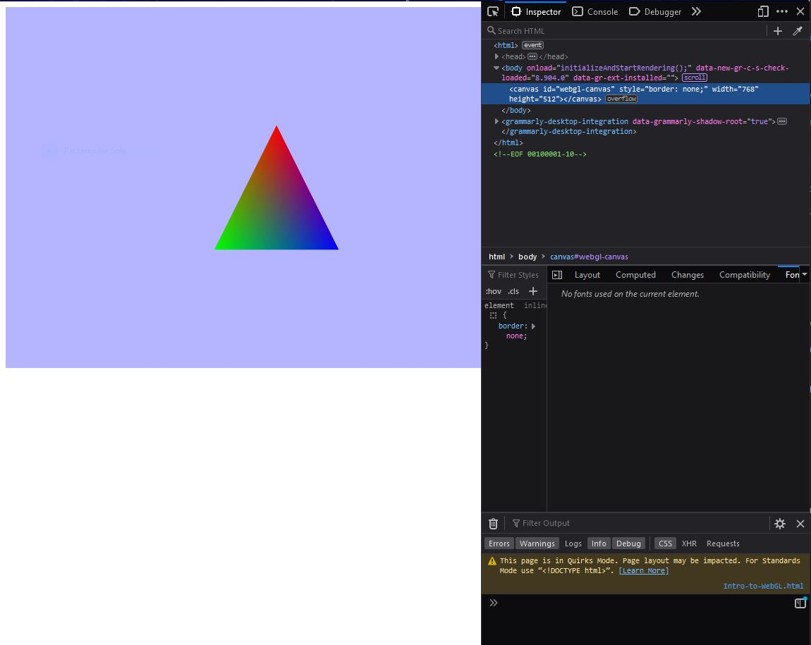

Doing Some debugging in console

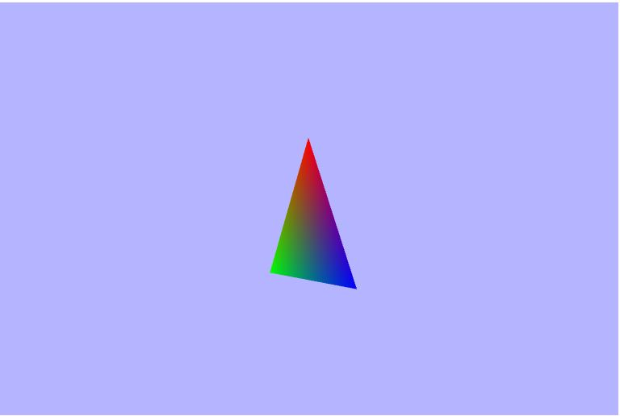

Triangle Mid Rotation