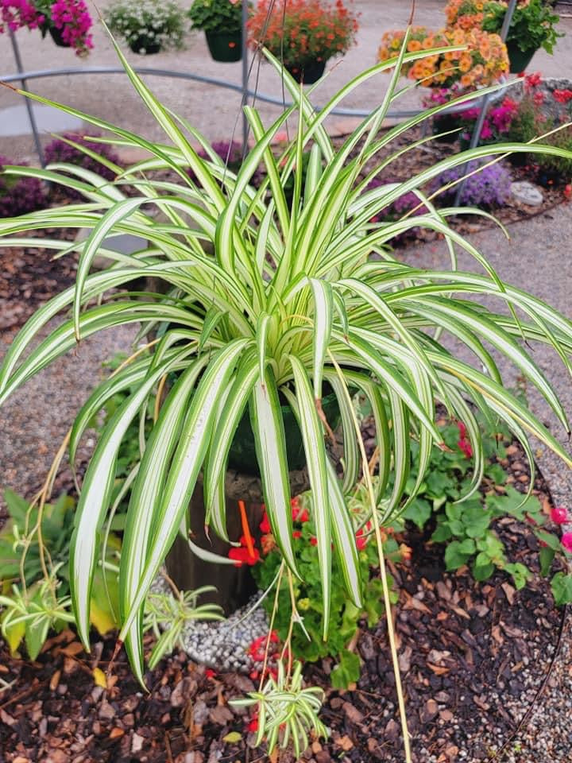

Spider Plant

Photo Cred: Pooler Plant Pick-Up Station

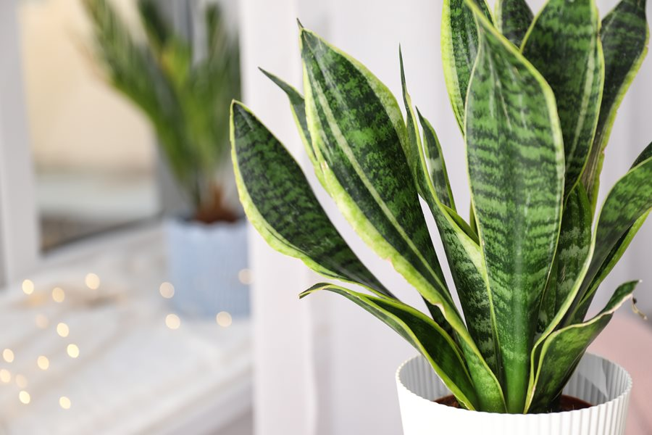

Snake Plant

Photo Cred: Garden Design

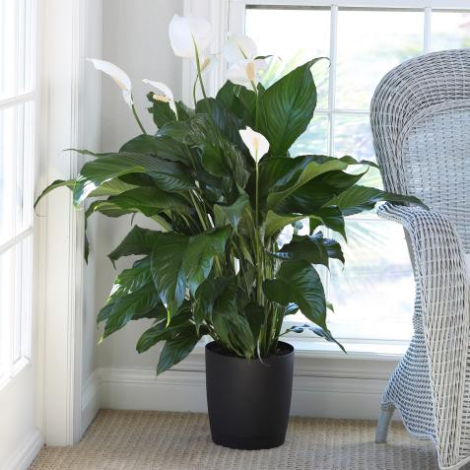

Peace Lily

Photo Cred: HGTV

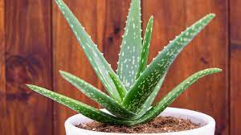

Aloe Vera

Photo Cred: The Old Farmers Almanac

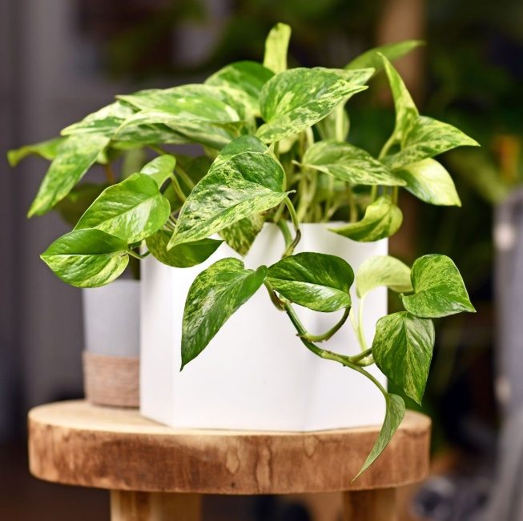

Pothos

Photo Cred: Country Living Magazine

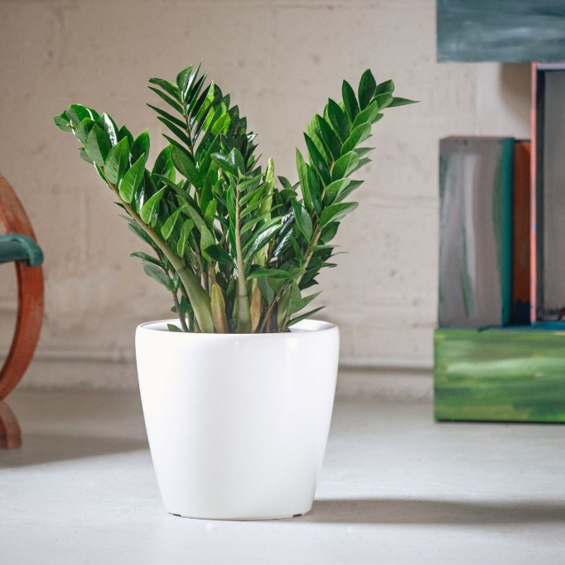

ZZ Plant

Photo Cred: My City Plants

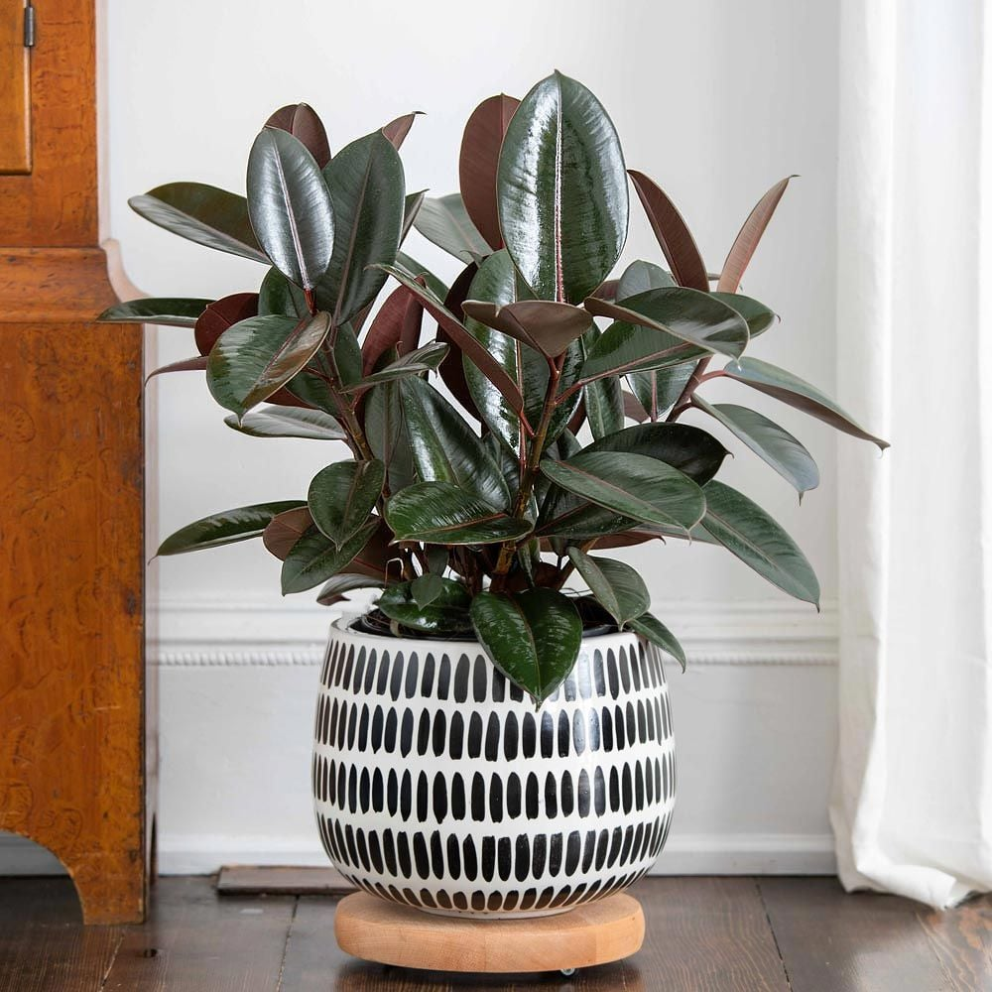

Rubber Plant

Photo Cred: White Flower Farm

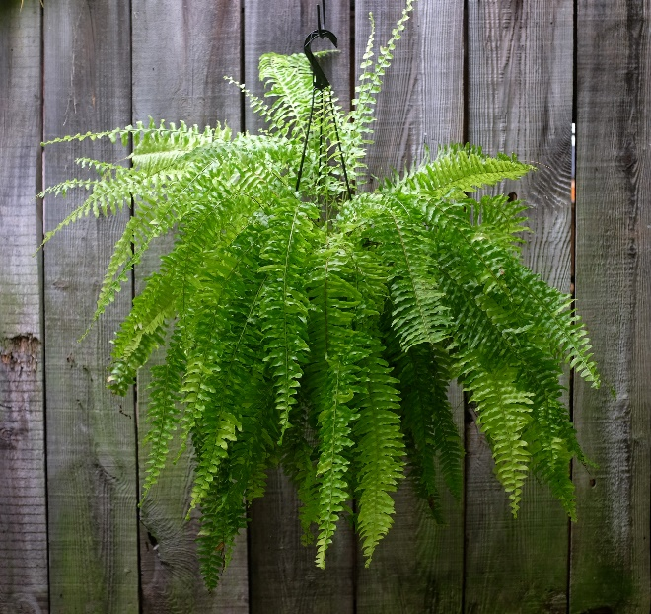

Boston Fern

Photo Cred: Michler’s Florist

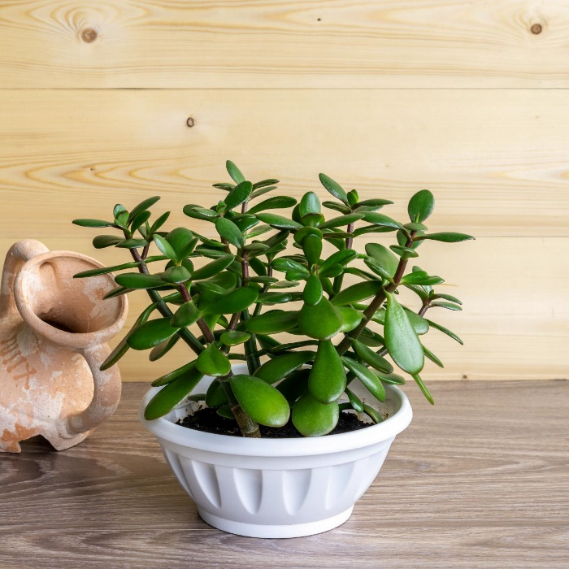

Jade Plant

Photo Cred: HGTV

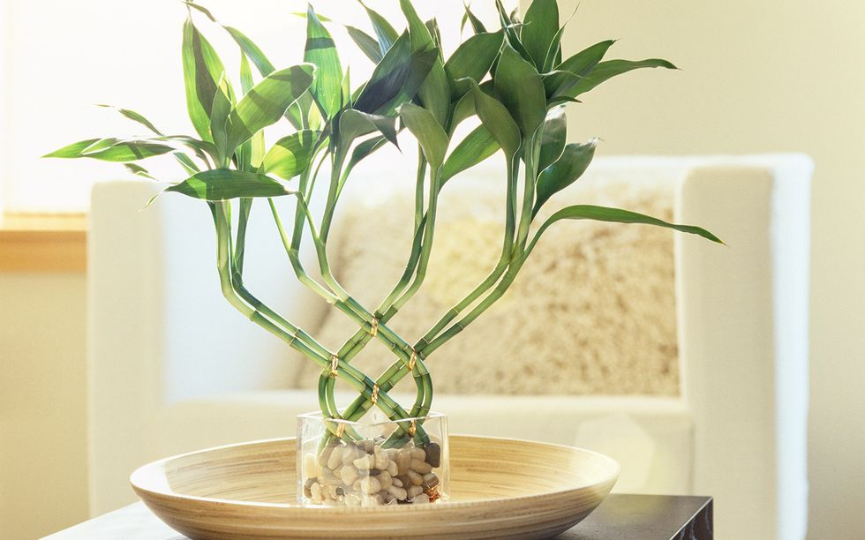

Bamboo

Photo Cred: Country Living Magazine

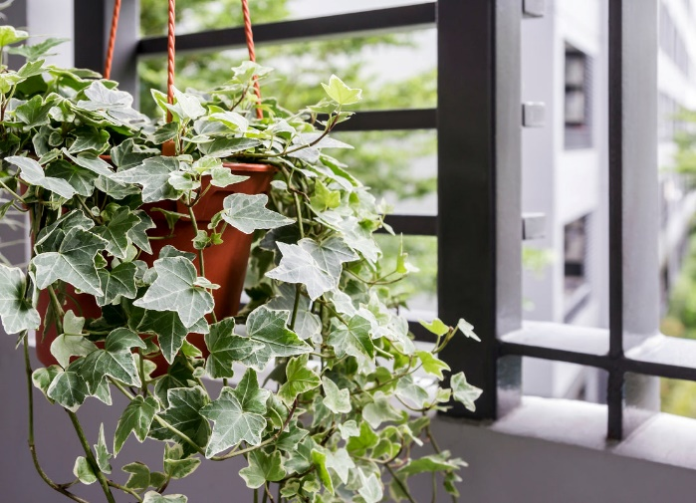

English Ivy

Photo Cred: Ugaoo

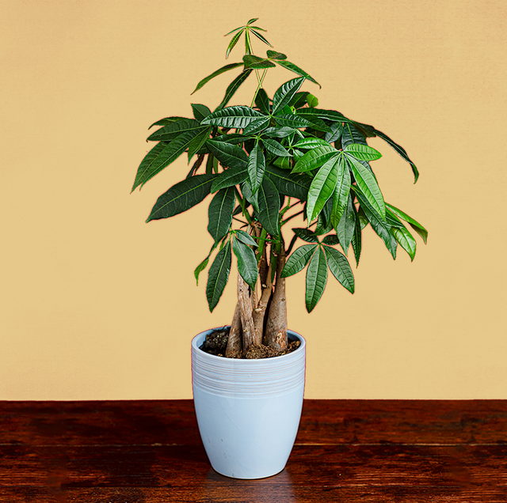

Money Plant

Photo Cred: Cosmopolitan

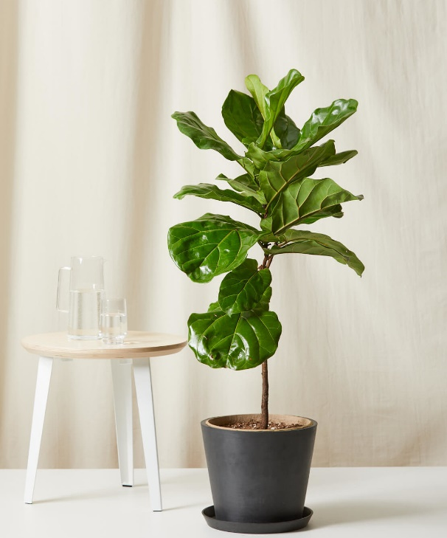

Fiddle Fig Leaf

Photo Cred: Bloomscape

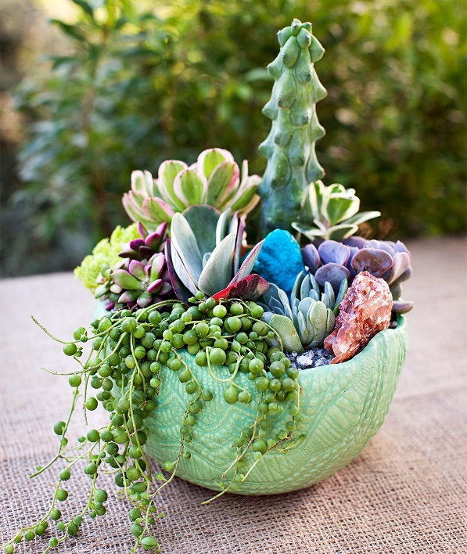

Succulents

Photo Cred: Better Homes & Gardens

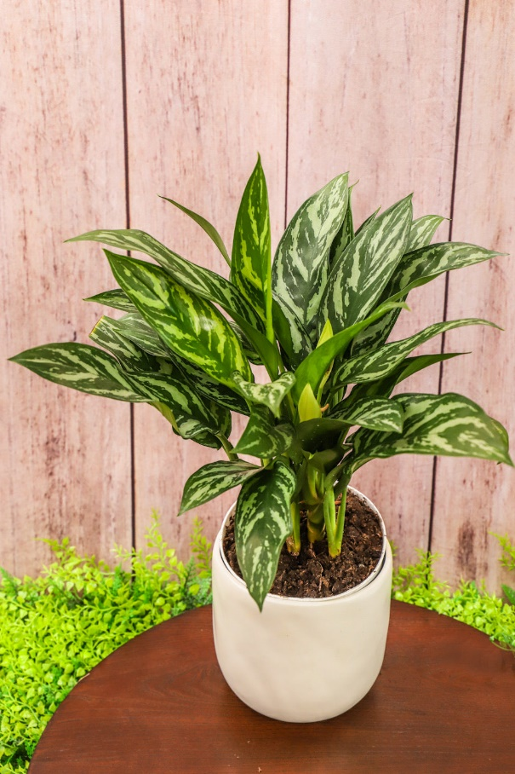

Chinese Evergreen

Photo Cred: ShopTansy

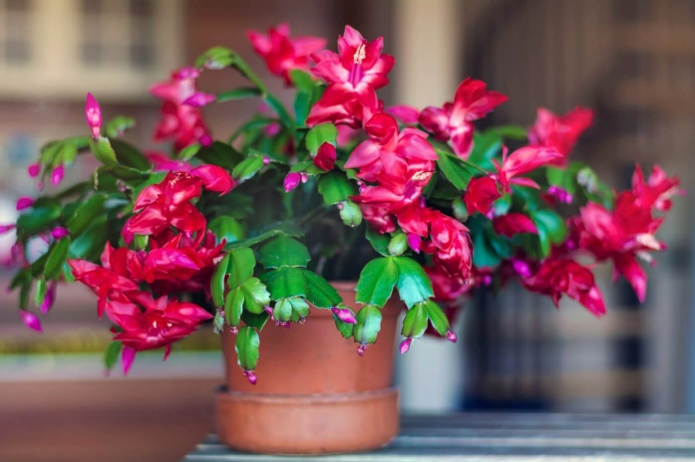

Christmas Cactus

Photo Cred: Frost Protek

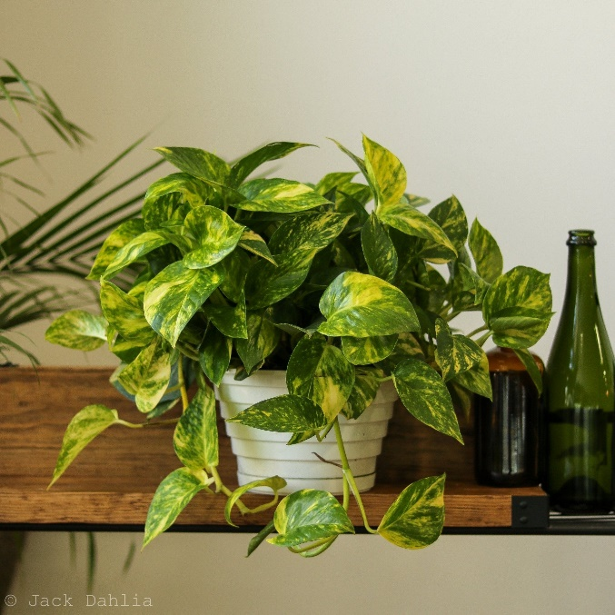

Golden Pothos

Photo Cred: Ed’s Plant Shop

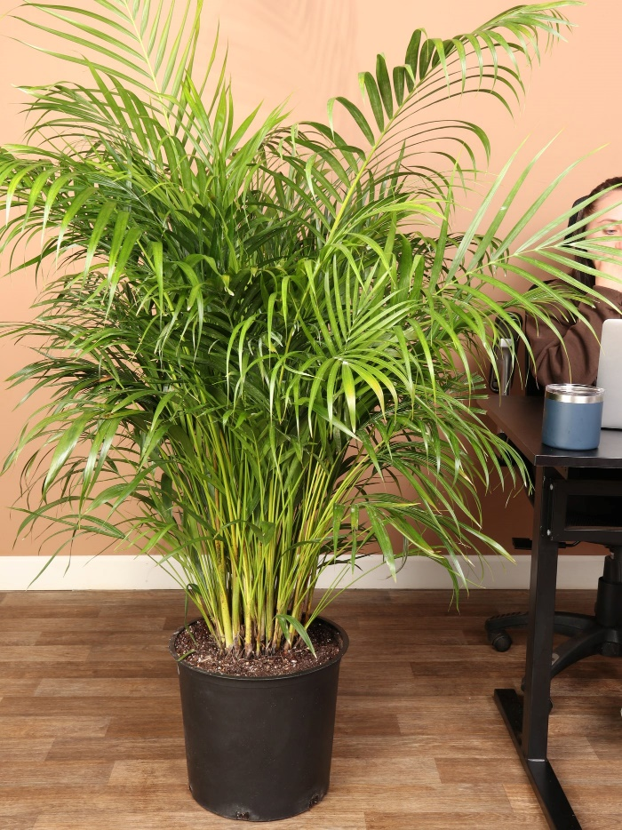

Areca Plam

Photo Cred: Dahing Plants

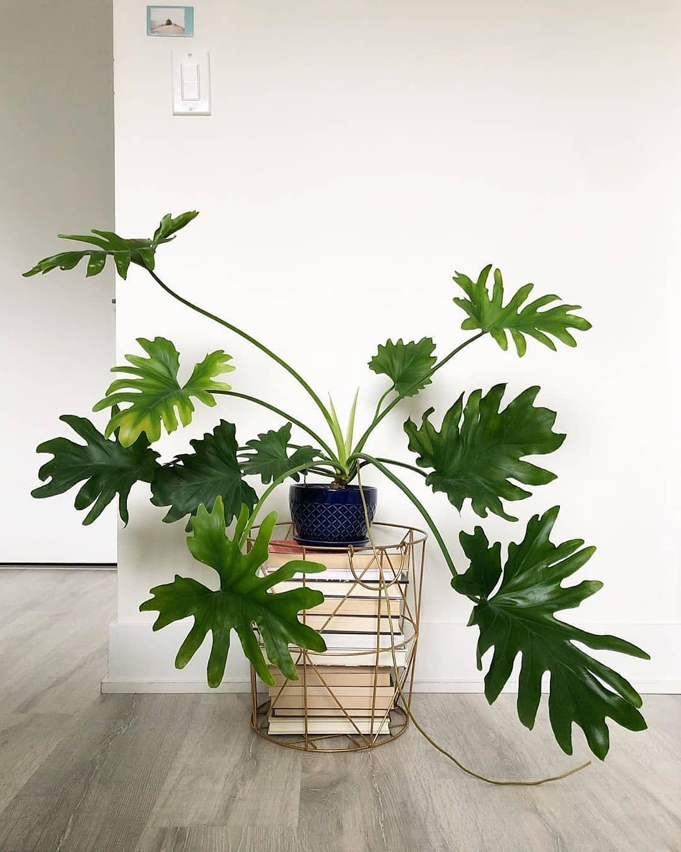

Philodendron

Photo Cred: Thursd

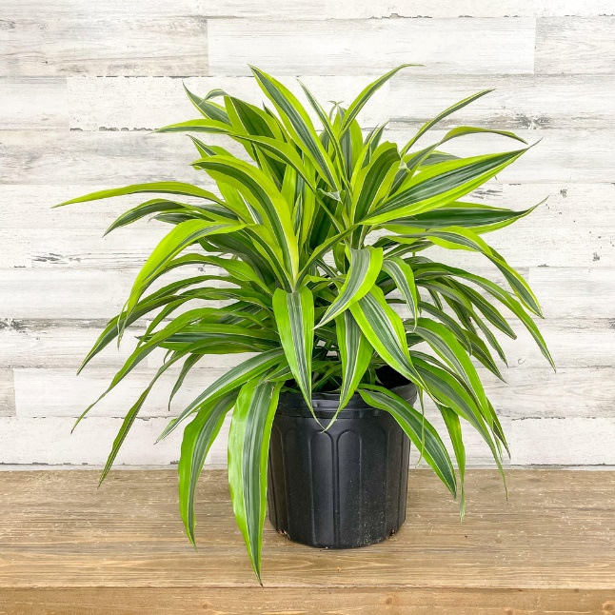

Dracaena

Photo Cred: Hicks Nurseries