Error Analysis: PD vs Noise Detection with PatchCore
Field test set, 229 measurements · 24 September 2026

Summary
PatchCore reaches 0.853 image-level AUROC on the field test set and clearly outperforms EfficientAD and the One-Class SVM. However, a date-level bootstrap shows it is statistically indistinguishable from a simple 5-nearest-neighbour classifier on the 256-dimensional mean/max feature. The error analysis identifies one mechanism behind most of the failures.
Main finding: errors concentrate on quiet measurements — files with few discharge pulses. These produce near-empty time windows that are well represented in both memory banks, so the distance difference that drives the decision collapses toward zero. The file lands on the decision threshold, where the random seed decides its label.
Supporting evidence: missed PD files contain nine times fewer pulses than correctly detected PD files (3,787 against 34,086), lie four times closer to the threshold, and the gap between the two memory banks falls from 0.925 to 0.152 (p = 1×10⁻⁶). Only 10 of 229 files are misclassified under all three random seeds.

1. Quantitative breakdown of errors
The model is trained on all laboratory data plus 70% of the field data; validation and test are field-only, drawn from measurement dates never seen during training. The test set holds 75 PD and 154 Noise files from 35 dates. The decision threshold is selected on the validation set.
 | seed 42 | seed 43 | seed 44
Errors (of 229 files) | 61 | 30 | 54
False alarms (Noise called PD) | 43 | – | –
Missed PD (PD called Noise) | 18 | – | –
Wrong under all three seeds | 10
Wrong under exactly one seed | 53

The direction of error depends on the operating point. At the validation-selected threshold the model over-calls PD (43 false alarms against 18 missed PD); at the F1-optimal threshold it becomes conservative (4 false alarms against 32 missed PD). The ranking of files is stable; the threshold is not.

Statistical resolution of the test set
Bootstrap resampling of measurement dates (2,000 resamples; dates rather than files, because files recorded on one date share an environment):
Method | Test AUROC | 95% confidence interval
PatchCore (WideResNet-50, K=8) | 0.864 | [0.730, 0.965]
kNN-5 on the 256-D feature | 0.867 | [0.750, 0.948]
EfficientAD | 0.737 | [0.552, 0.869]
One-Class SVM | 0.611 | [0.379, 0.864]

- PatchCore vs EfficientAD: +0.128, P(PatchCore better) = 0.91
- PatchCore vs One-Class SVM: +0.243, CI [0.006, 0.485], P = 0.98
- PatchCore vs kNN-5: −0.007, CI [−0.127, +0.151], P = 0.46 — no measurable difference
The confidence intervals are about ±0.12 wide. An improvement smaller than roughly 0.1 AUROC cannot be demonstrated on a test set of this size.

2. Where the errors occur
Three measurement dates account for 64% of all errors, and the two largest contributors are pure field-noise dates that the model had never seen:
Date | Files | PD files | Errors | Missed PD | False alarms
20250217 | 32 | 0 | 20 | 0 | 20
20250213 | 24 | 0 | 12 | 0 | 12
20220427 | 17 | 17 | 7 | 7 | 0
20231023 | 6 | 6 | 5 | 5 | 0

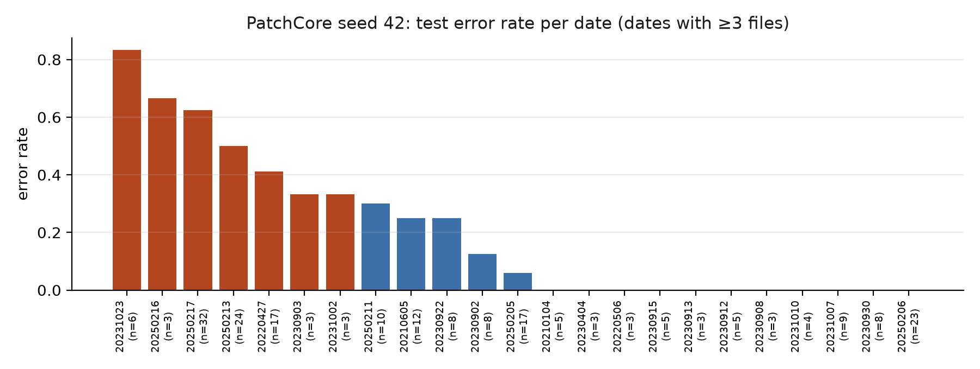
Figure 1. Test error rate per measurement date (dates with at least three files). Errors are not spread evenly: two unfamiliar field-noise environments dominate.
The other detectors fail on largely different files. Of the files PatchCore misclassifies, only 16 are also wrong for EfficientAD and 29 for the One-Class SVM. The failures are therefore specific to the method rather than a property of intrinsically difficult measurements.

3. Failure modes

3.1 Over-sensitivity: noise classified as PD (43 files)
- 32 of these come from the two unseen field-noise dates listed above.
- 21 of the 43 sit in a feature-space neighbourhood that is majority PD, so they are genuinely PD-like rather than merely borderline.
- Median pulse count 4,334, against 18,747 for correctly classified noise.

3.2 Under-sensitivity: PD classified as noise (18 files)
- Median pulse count 3,787, against 34,086 for correctly detected PD — a factor of nine.
- By fault type at the F1-optimal threshold: Corona 6 of 6 missed, Void 23 of 51 missed, Floating 15 of 17 correctly detected.
- Every missed PD file contains at least one window scoring on the PD side — but so do noise files, which is why increasing window sensitivity does not help (Section 5.1).

3.3 Relationship to the decision threshold
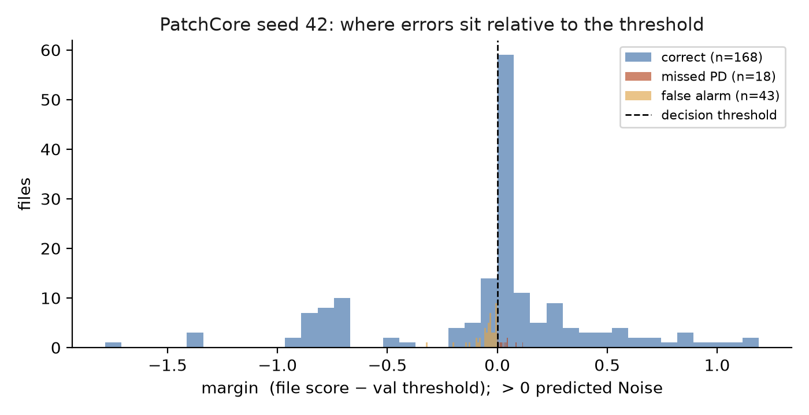
Figure 2. Distance from the decision threshold. Errors cluster at the threshold while correctly classified files sit further away. Median absolute margin: 0.035 for errors against 0.131 for correct files.
The half of the test files closest to the threshold carries a 40% error rate; the far half carries 13%.

4. Visual analysis of the raw 2D patterns
Each case figure shows three views of one misclassified measurement: the φ-q-n PRPD pattern (phase against amplitude, colour = pulse count — the conventional representation in the partial-discharge literature), the phase-resolved pulse sequence actually consumed by the model (128 phase bins × 3,600 cycles), and the 28 per-window scores that are averaged into the file decision.
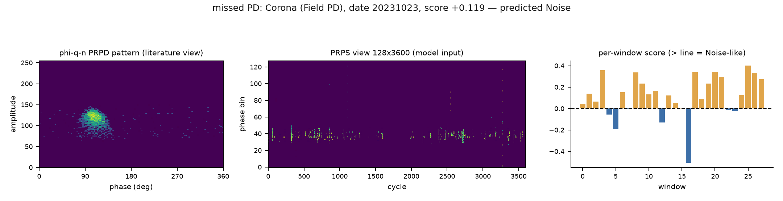
Figure 3. Missed PD — Field Corona, 20231023. Discharge activity is sparse, most windows carry little structure, and the averaged score falls on the noise side of the threshold. This file is misclassified under all three seeds.
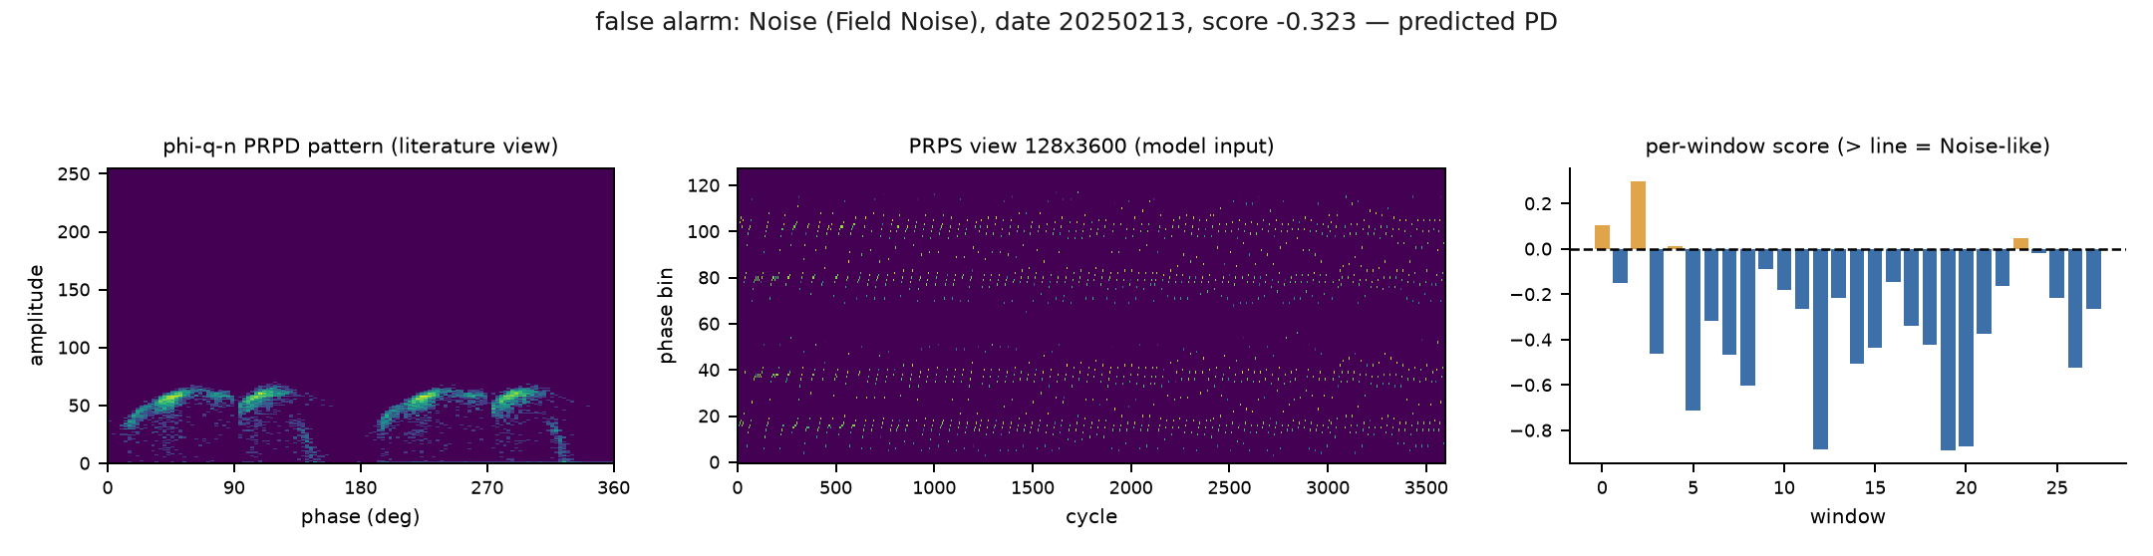
Figure 4. False alarm — Field Noise, 20250213. A structured, phase-correlated interference pattern that resembles discharge activity in feature space, from a noise environment absent from the training data.
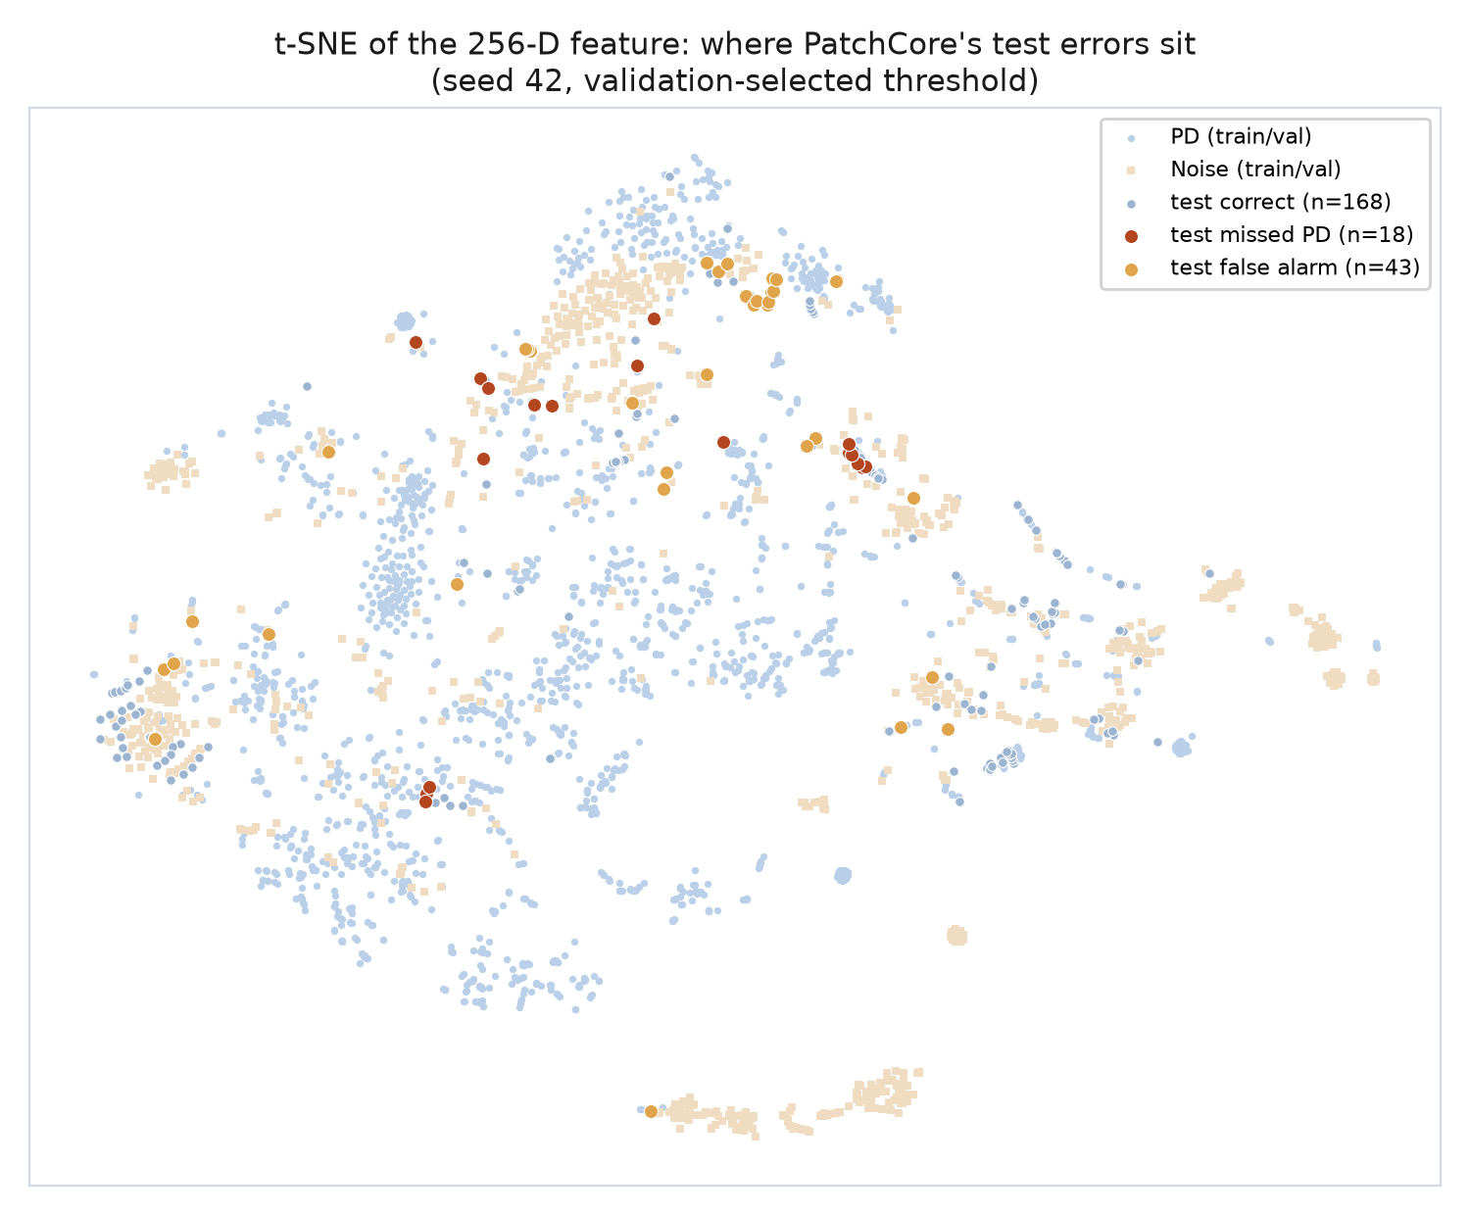
Figure 5. t-SNE projection of the 256-dimensional feature for all measurements. Blue = PD, beige = Noise (training and validation); red = missed PD, orange = false alarms. The errors do not form one cluster: they lie along the boundary regions between the classes.

5. Root cause
PatchCore performs no training in the conventional sense: a frozen ImageNet backbone extracts patch features, a greedy coreset retains 1% of them, and classification is a nearest-neighbour distance comparison. Two memory banks are built, one from PD and one from Noise, and the file score is the difference between the two distances. Four candidate causes were tested.

5.1 Rejected: window aggregation
The hypothesis that averaging 28 windows dilutes bursty discharge was tested by replacing the mean with the minimum, the maximum, the 90th percentile, and rules of the form “PD if at least k of 28 windows look PD-like”. Every alternative is worse on validation (mean 0.959 AUROC; minimum 0.916; “at least three windows” 0.752, with 124 false alarms). Noise files also contain PD-like windows, so raising window sensitivity is counter-productive.

5.2 Rejected: coreset compression
The possibility that subsampling discards rare but legitimate variation was tested across compression ratios: 0.1% gives 0.748 validation AUROC, 1% gives 0.954, and 5% gives 0.957. Performance saturates, so memory-bank capacity is not the limiting factor.

5.3 Confirmed: the PD bank is dominated by laboratory data
The memory banks were rebuilt so that each bank entry records the training window it came from, which allows every decision to be traced back to the specific training data it matched.
PD files | Files | Laboratory share of matches | Distance to PD bank | Distance to Noise bank | Gap
Correctly detected | 57 | 0.2 | 1.787 | 2.828 | 0.925
Missed | 18 | 0.8 | 1.628 | 1.733 | 0.152

Missed PD files predominantly match laboratory training windows, whereas correctly detected PD files match field windows (mean 0.70 against 0.31, p = 6×10⁻⁵). The PD bank holds 1,435 laboratory files against only 348 field files, which makes it a poor reference for field measurements.

5.4 The underlying mechanism: bank ambiguity on quiet measurements
The same table refutes the intuitive explanation. Missed PD files are not far from the PD bank — they are in fact slightly closer to it than correctly detected files (1.628 against 1.787). What collapses is the difference between the two banks: the gap falls from 0.925 to 0.152 (p = 1×10⁻⁶), and false alarms show the mirror image with a slightly negative gap.
Quiet measurements produce near-empty windows, and near-empty windows are well represented in both memory banks. Both distances shrink, their difference collapses toward zero, the file lands at the decision threshold, and the seed or the threshold determines the outcome.
This single mechanism accounts for the other observations: errors are quiet (Section 3), lie at the threshold (Figure 2), are unstable across seeds (Section 1), and differ between methods (Section 2).
Measure | Correct PD | Missed PD
Median pulse count | 34,086 | 3,787
Median distance to threshold | 0.131 | 0.035
Gap between the two memory banks | 0.925 | 0.152
Share of matches from laboratory data | 0.2 | 0.8

6. Label quality
Ten files are misclassified under all three seeds. All are missed PD, they come from two dates, and they divide into two distinct groups:
Group | n | Analyzer suspect score | Interpretation
Corona, 20231023 | 3 | 434 / 375 / 358 | Above the 95th-percentile cut (210)
Void, 20220427 | 7 | 7.8 – 17.2 | Typical for their class (percentile 0.6–20%)

- The three Corona files are independently flagged as atypical by the Analyzer's label-quality check, which uses a different method (pooled shrinkage Mahalanobis distance on the 256-D feature). They are candidates for expert re-examination of the original PRPD patterns. No labels were changed.
- The seven Void files are textbook examples of their class by that same measure, yet PatchCore misses all of them. These represent a genuine model failure rather than a labelling problem.

7. Conclusions and next steps
- Report the comparison as measured. On this dataset an ImageNet-based memory bank does not outperform a 5-nearest-neighbour classifier on the hand-crafted 256-dimensional feature. It does outperform EfficientAD and the One-Class SVM by a statistically significant margin.
- Stop tuning against this test set. The bootstrap confidence interval (±0.12 AUROC) is wider than any effect measured during model selection. Date-grouped cross-validation across all field dates should replace the single 15% split before further model work.
- Improve the data rather than the model. Two unseen noise environments cause half the errors, and 690 field measurements are currently excluded from validation and test only because their dates cannot be parsed from the filenames. Most of those filenames contain Unix timestamps, so the dates are recoverable. This is likely to matter more than any hyperparameter.
- Rebalance the PD memory bank toward field data. This is the best-supported model-side change (Section 5.3): more windows per field file, or a field-only PD bank for comparison.
- Submit the three Corona files for expert review, and treat the seven Void files as the documented model-failure case.

Appendix: method and reproducibility
- Dataset: 3,118 measurements (Lab PD 1,435, Lab Noise 156, Field PD 498, Field Noise 1,029); synthetic files excluded. Each measurement is 128 phase bins × 3,600 cycles of 8-bit peak amplitudes.
- Split by measurement date: no date appears in two splits, all laboratory data is in training, and validation and test are field-only (230 and 229 files).
- Model: WideResNet-50 (ImageNet, frozen), features from layers 2 and 3, 128×128 windows resized to 224, 1% greedy coreset, 8 windows per training file, three seeds (42/43/44).
- Pixel-level AUROC is not reported: the dataset has no pixel-level ground truth. Window-level AUROC (0.811) is reported in its place.
- Code and outputs: github.com/MikeJoester/prpd-analyzer — Comparison/error_analysis.py, error_figures.py, nn_audit.py; results in Results/patchcore/error_analysis/ and Plans/PatchCore_error_analysis_results.md.

