Missed PD Cases: Complete Figure Atlas
All 18 cases · PatchCore two-bank · seed 42, validation-selected threshold (+0.0011) · 2 October 2026
Every figure in Results/patchcore/error_analysis/missed18/, one page section per case, grouped by failure cause. Data for each case comes from missed_pd_cases.csv. The analytical discussion is in the companion report, PatchCore_Missed_PD_Cases_Report.docx.

How to read each case figure
Panel | What it shows
Left: φ-q-n PRPD pattern | Phase (0–360°) against pulse amplitude, colour = pulse count on a log scale. The conventional diagnostic view used in the PD literature.
Middle: PRPS view | The raw 128 × 3,600 matrix the model consumes: phase bin on y, AC cycle on x, colour = peak amplitude. One minute of recording.
Right: per-window scores | The file is tiled into 28 windows of 128 cycles, each scored separately; their mean is the file score. Bars below the dashed line scored as PD.

“Missed in n/10” counts how many of the ten training seeds (42–51) misclassify the file. 10/10 means a systematic failure; 4/10 means the file sits on the decision boundary.

Overview of all 18
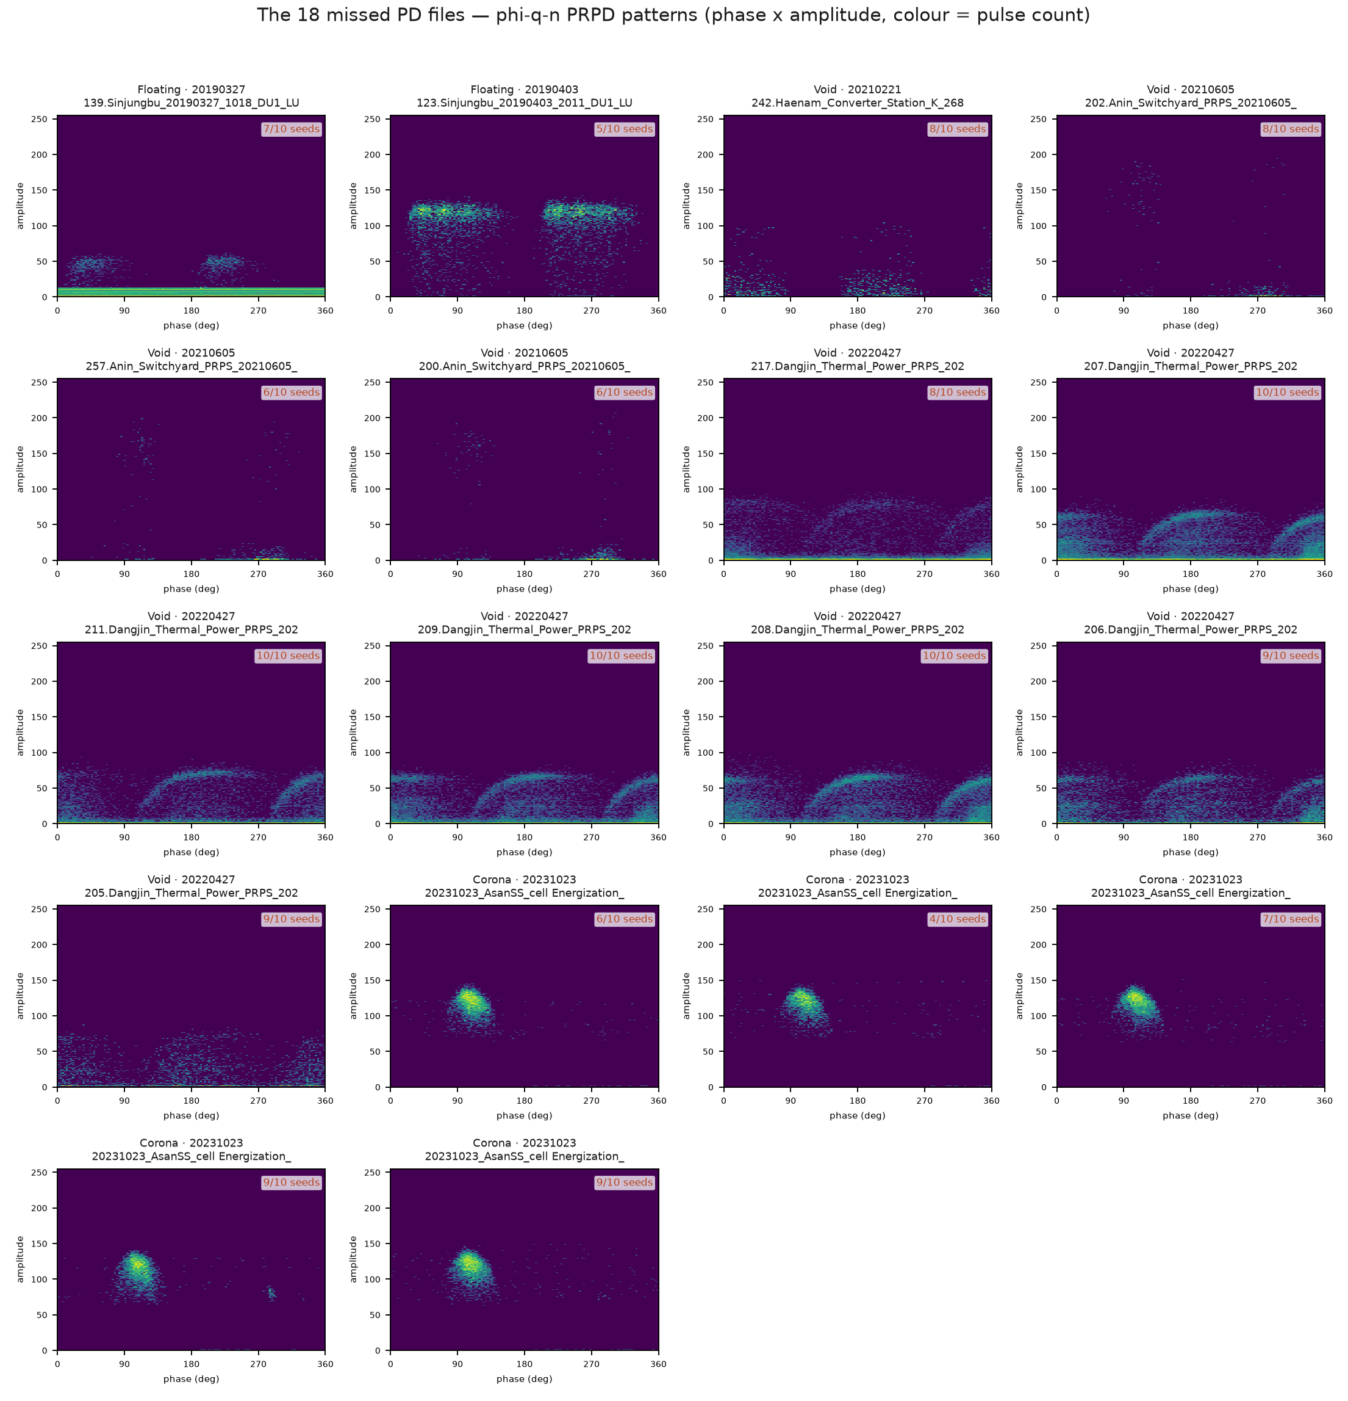
Figure 1. The 18 missed files as φ-q-n patterns, grouped by date. The three failure groups are visually distinct.
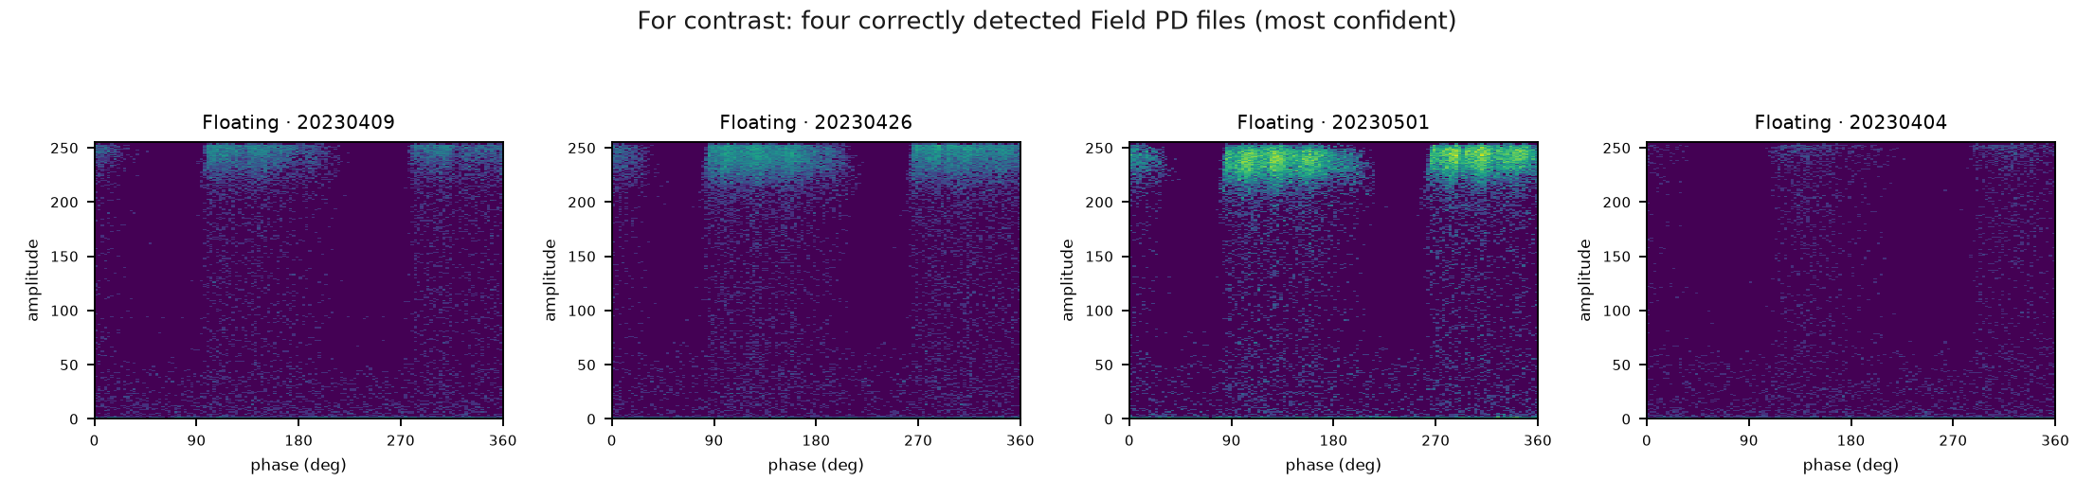
Figure 2. For contrast: the four Field PD files the model detects most confidently.

Group summary
Group | Files | Missed (median) | Pulses (median) | Suspect score | Lab match | Bank gap
A — Dangjin Void (textbook) | 7 | 10.0/10 | 17,970 | 8.9 | 0.8 | 0.129
B — Asan Corona (post-mitigation) | 5 | 7.0/10 | 3,568 | 425.6 | 1.0 | 0.505
C — Sparse / low activity | 6 | 6.5/10 | 569 | 143.1 | 0.6 | 0.187
Detected Field PD (57 files) | 57 | — | 34,086 | — | 0.2 | 0.925

Suspect score is the Analyzer's independent label-quality measure (95th-percentile review cut = 210). Bank gap is distance to the Noise bank minus distance to the PD bank: larger means a more confident PD decision.

Group A — Dangjin Void: textbook patterns, missed anyway
Seven Void measurements from 20220427. The phi-q-n patterns show the paired half-cycle clusters typical of void discharge and the Analyzer rates them as highly typical of their class (suspect score 7.8-17.2, far below the 210 review cut). They are missed in 8-10 of 10 seeds: the clearest model failure in the test set.

Case 7 — Void, 20220427
217.PD_04_Dangjin_Thermal_Power_PRPS_20220427_1710_DU0_LU17_CH1.dat
Missed in | Margin | Pulses | PD windows | Suspect | Lab match | Bank gap
8/10 seeds | +0.002 | 17,970 | 15/28 | 8 | 0.8 | 0.132

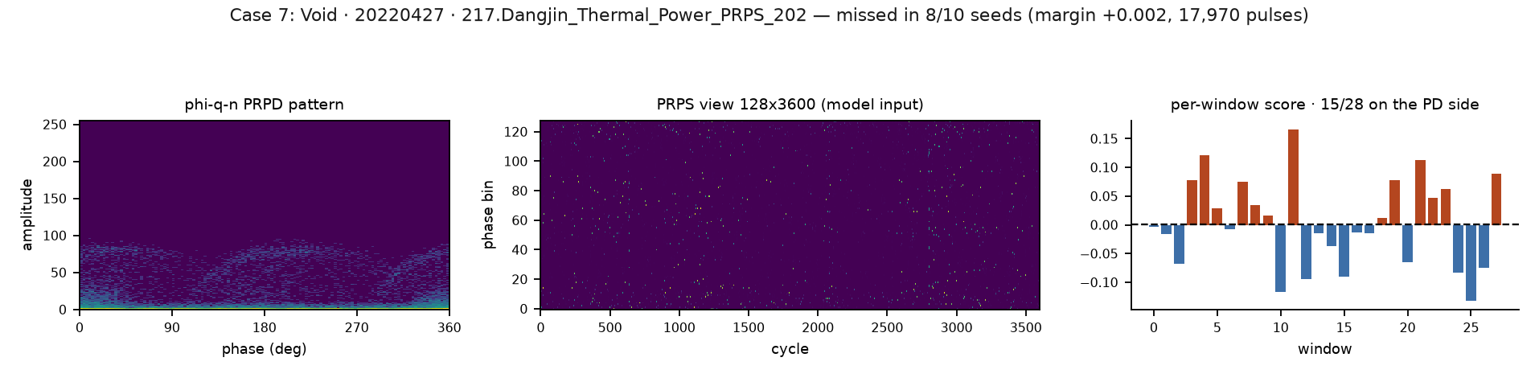

Case 8 — Void, 20220427
207.PD_04_Dangjin_Thermal_Power_PRPS_20220427_1146_DU0_LU17_CH1.dat
Missed in | Margin | Pulses | PD windows | Suspect | Lab match | Bank gap
10/10 seeds | +0.004 | 20,740 | 14/28 | 9 | 0.2 | 0.144

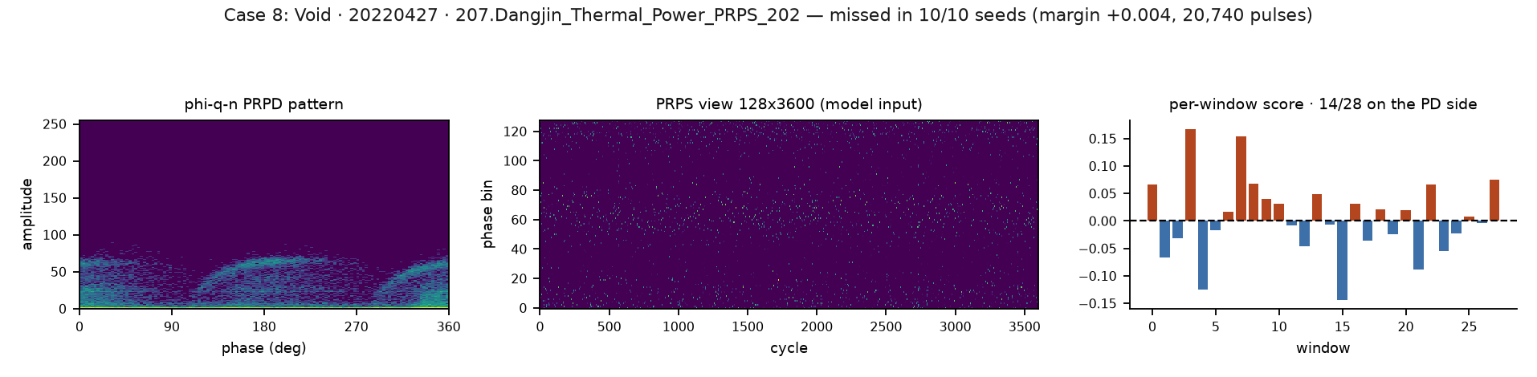

Case 9 — Void, 20220427
211.PD_04_Dangjin_Thermal_Power_PRPS_20220427_1359_DU0_LU17_CH1.dat
Missed in | Margin | Pulses | PD windows | Suspect | Lab match | Bank gap
10/10 seeds | +0.008 | 13,734 | 10/28 | 9 | 1.0 | 0.129

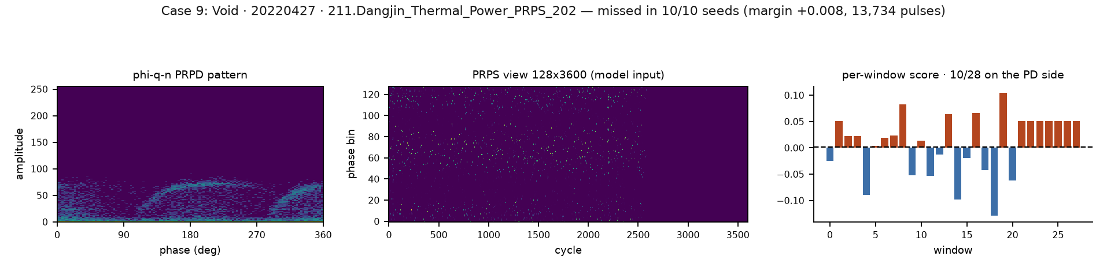

Case 10 — Void, 20220427
209.PD_04_Dangjin_Thermal_Power_PRPS_20220427_1219_DU0_LU17_CH1.dat
Missed in | Margin | Pulses | PD windows | Suspect | Lab match | Bank gap
10/10 seeds | +0.012 | 19,428 | 10/28 | 8 | 0.8 | 0.149

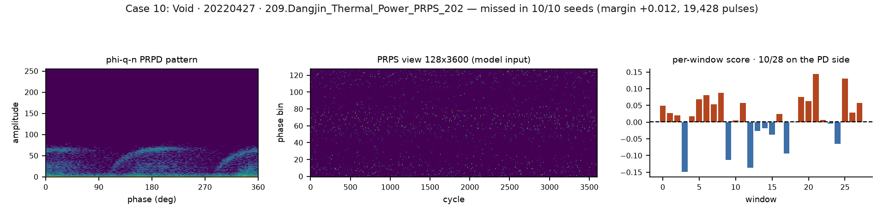

Case 11 — Void, 20220427
208.PD_04_Dangjin_Thermal_Power_PRPS_20220427_1154_DU0_LU17_CH1.dat
Missed in | Margin | Pulses | PD windows | Suspect | Lab match | Bank gap
10/10 seeds | +0.042 | 19,106 | 8/28 | 10 | 0.8 | 0.129

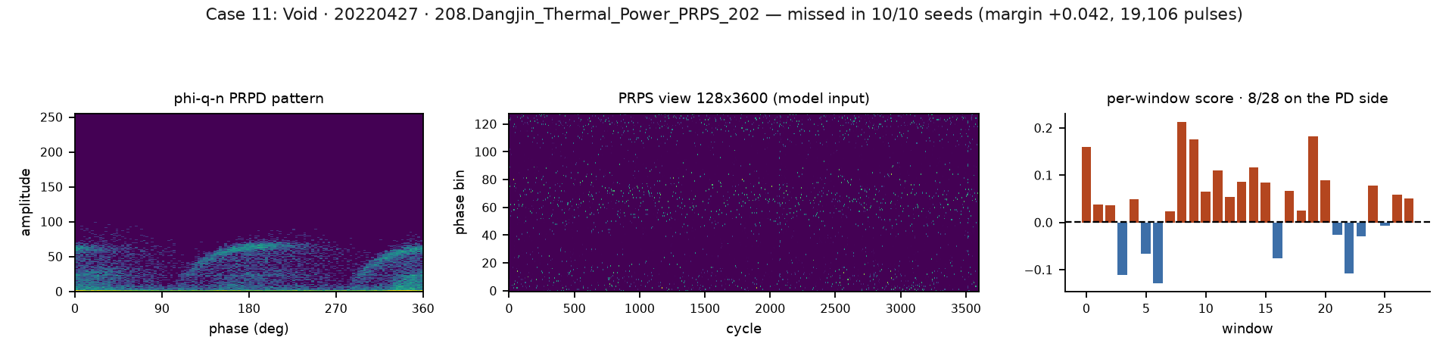

Case 12 — Void, 20220427
206.PD_04_Dangjin_Thermal_Power_PRPS_20220427_1145_DU0_LU17_CH1.dat
Missed in | Margin | Pulses | PD windows | Suspect | Lab match | Bank gap
9/10 seeds | +0.043 | 9,698 | 3/28 | 9 | 0.0 | 0.105

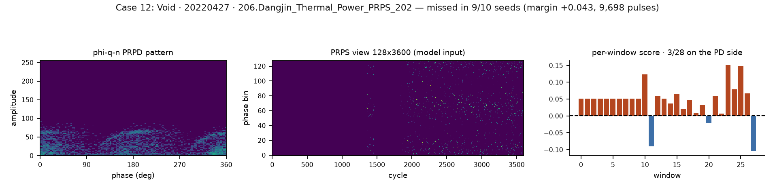

Case 13 — Void, 20220427
205.PD_04_Dangjin_Thermal_Power_PRPS_20220427_1023_DU0_LU17_CH1.dat
Missed in | Margin | Pulses | PD windows | Suspect | Lab match | Bank gap
9/10 seeds | +0.047 | 2,590 | 2/28 | 17 | 0.4 | 0.035

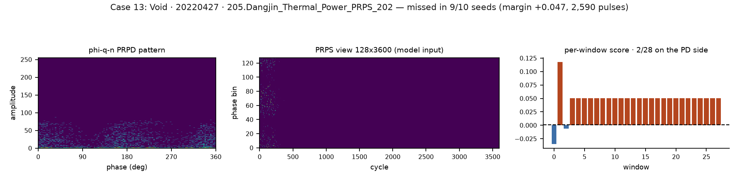

Group B — Asan Corona: a label-quality question
Five Corona measurements from 20231023, recorded after noise mitigation ("Noise_Removal_After_Improvement" in the filename). Suspect scores of 358-453 are the highest in the test set, the activity sits in a single polarity (half-cycle correlation 0.39 against 0.84 for detected PD), and the model leans clearly toward noise. These need expert review before counting as model errors.

Case 14 — Corona, 20231023
20231023_AsanSS_cell Energization_Noise_Removal_After_Improvement_Yuho76.dat
Missed in | Margin | Pulses | PD windows | Suspect | Lab match | Bank gap
6/10 seeds | +0.019 | 3,568 | 10/28 | 426 | 0.8 | 0.641

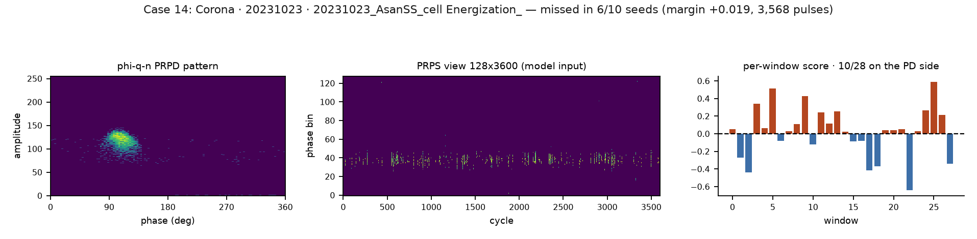

Case 15 — Corona, 20231023
20231023_AsanSS_cell Energization_Noise_Removal_After_Improvement_Yuho74.dat
Missed in | Margin | Pulses | PD windows | Suspect | Lab match | Bank gap
4/10 seeds | +0.048 | 2,510 | 8/28 | 453 | 1.0 | 0.380

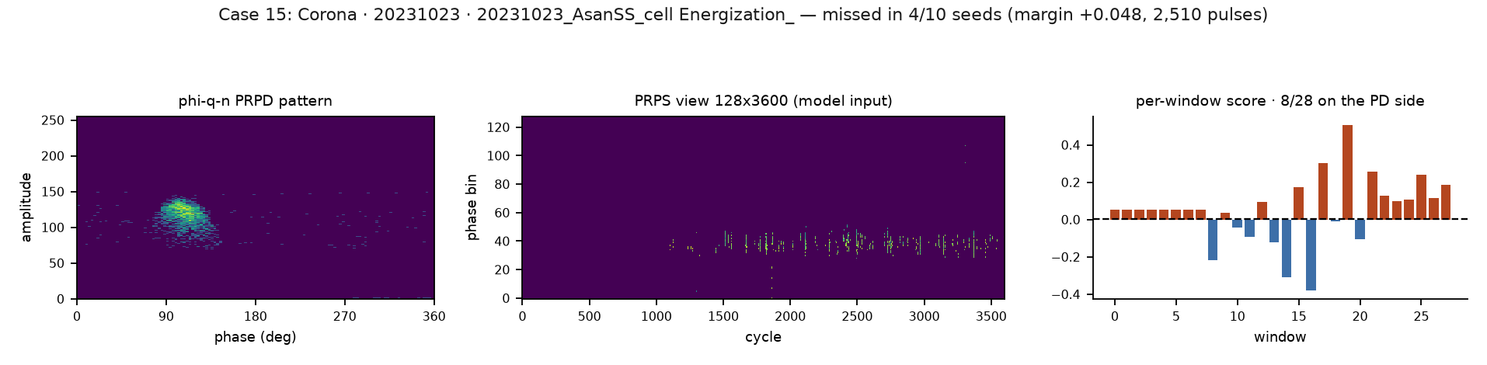

Case 16 — Corona, 20231023
20231023_AsanSS_cell Energization_Noise_Removal_After_Improvement_Yuho78.dat
Missed in | Margin | Pulses | PD windows | Suspect | Lab match | Bank gap
7/10 seeds | +0.083 | 3,706 | 9/28 | 375 | 1.0 | 0.566

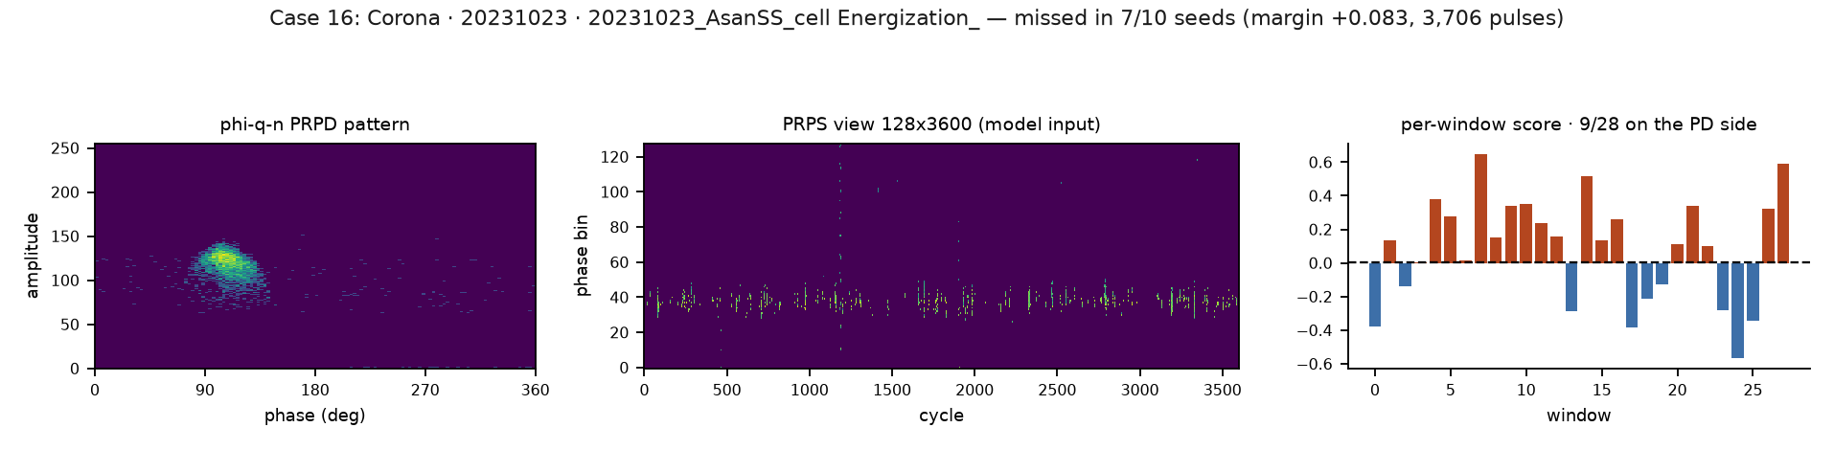

Case 17 — Corona, 20231023
20231023_AsanSS_cell Energization_Noise_Removal_After_Improvement_Yuho73.dat
Missed in | Margin | Pulses | PD windows | Suspect | Lab match | Bank gap
9/10 seeds | +0.087 | 3,131 | 4/28 | 434 | 1.0 | 0.345

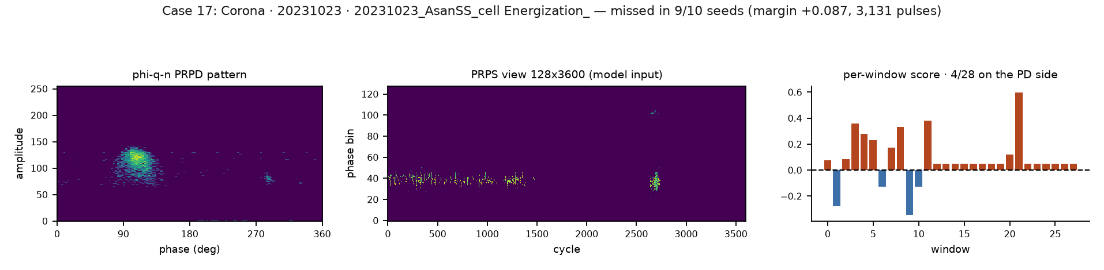

Case 18 — Corona, 20231023
20231023_AsanSS_cell Energization_Noise_Removal_After_Improvement_Yuho77.dat
Missed in | Margin | Pulses | PD windows | Suspect | Lab match | Bank gap
9/10 seeds | +0.118 | 3,868 | 7/28 | 358 | 1.0 | 0.505

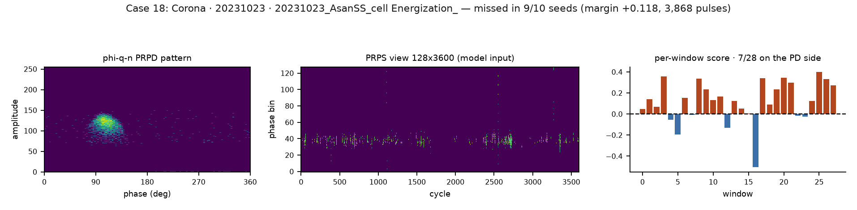

Group C — sparse measurements: too little evidence
Six files across four dates with a median of 569 pulses, against 34,086 for detected PD. Near-empty windows are well represented in both memory banks, so the two distances collapse together and the file lands on the decision threshold.

Case 1 — Floating, 20190327
139.PD_01_Sinjungbu_20190327_1018_DU1_LU19_CH255.dat
Missed in | Margin | Pulses | PD windows | Suspect | Lab match | Bank gap
7/10 seeds | +0.036 | 14,131 | 6/28 | 14 | 0.8 | 0.379

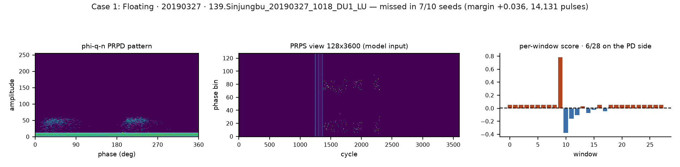

Case 2 — Floating, 20190403
123.PD_01_Sinjungbu_20190403_2011_DU1_LU19_CH255.dat
Missed in | Margin | Pulses | PD windows | Suspect | Lab match | Bank gap
5/10 seeds | +0.027 | 4,625 | 4/28 | 133 | 0.6 | 0.339

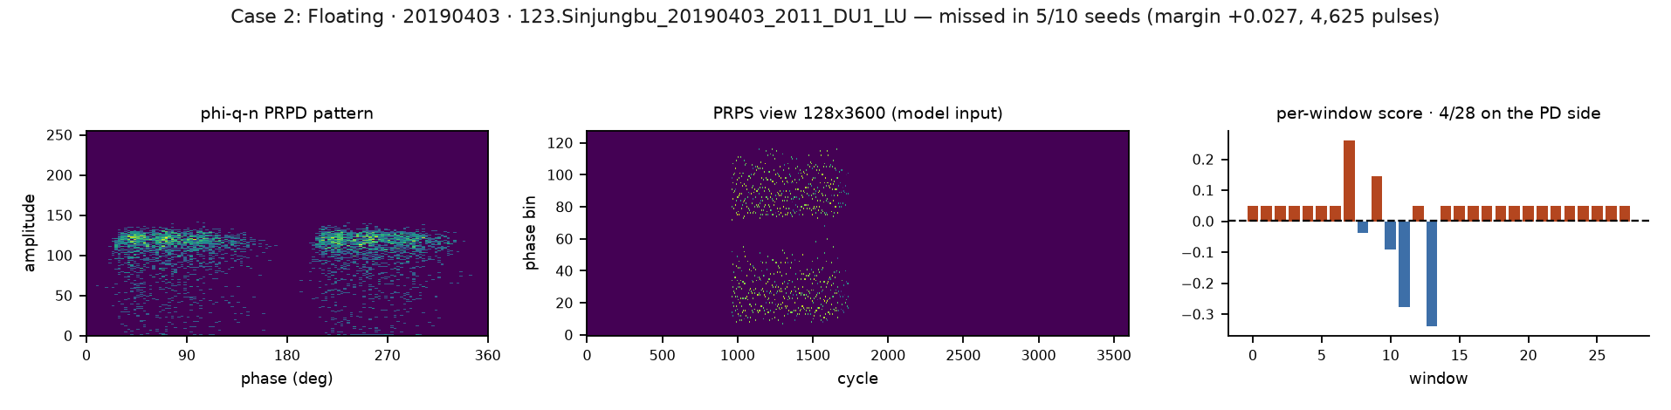

Case 3 — Void, 20210221
242.PD_08_Haenam_Converter_Station_K_2688_GLU104_CH04_SWPD_20210221_134502.dat
Missed in | Margin | Pulses | PD windows | Suspect | Lab match | Bank gap
8/10 seeds | +0.045 | 698 | 3/28 | 101 | 1.0 | 0.060

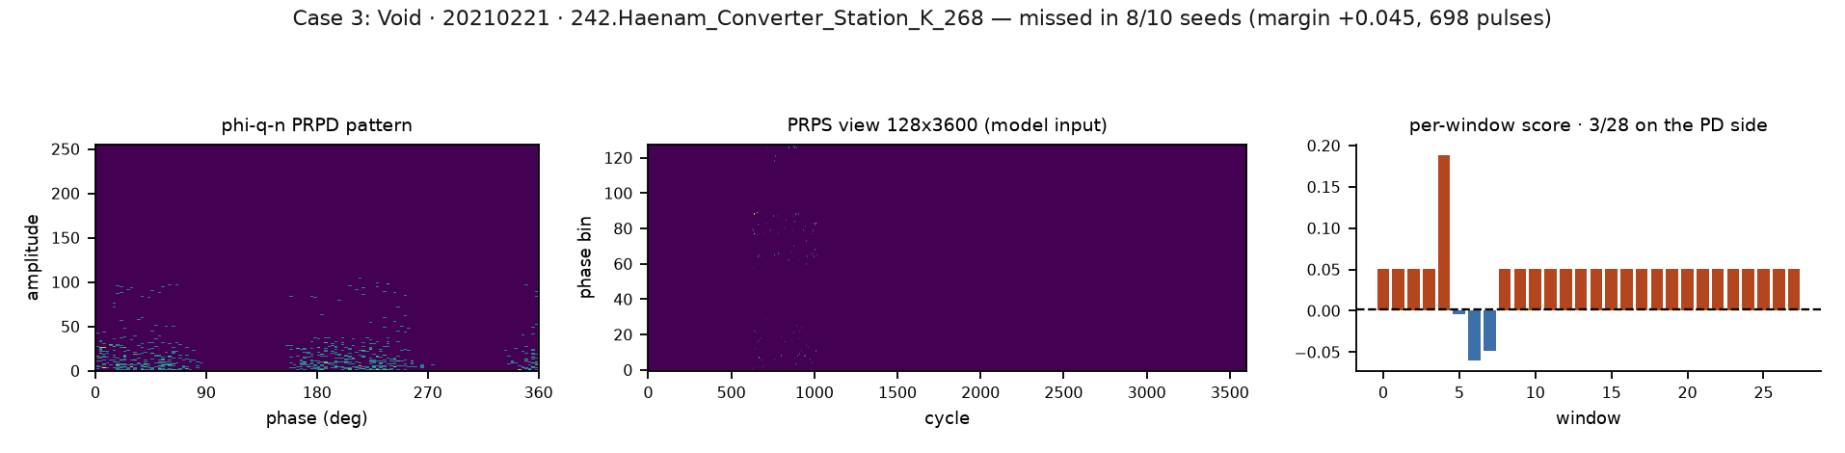

Case 4 — Void, 20210605
202.PD_05_Anin_Switchyard_PRPS_20210605_1013_DU1_LU4_CH164.dat
Missed in | Margin | Pulses | PD windows | Suspect | Lab match | Bank gap
8/10 seeds | +0.003 | 261 | 9/28 | 161 | 0.6 | 0.219

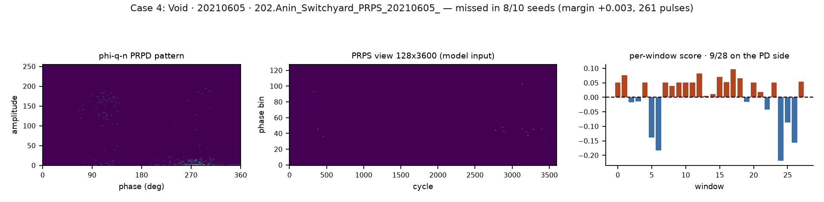

Case 5 — Void, 20210605
257.PD_05_Anin_Switchyard_PRPS_20210605_0700_DU1_LU4_CH164.dat
Missed in | Margin | Pulses | PD windows | Suspect | Lab match | Bank gap
6/10 seeds | +0.014 | 380 | 7/28 | 153 | 0.2 | 0.156

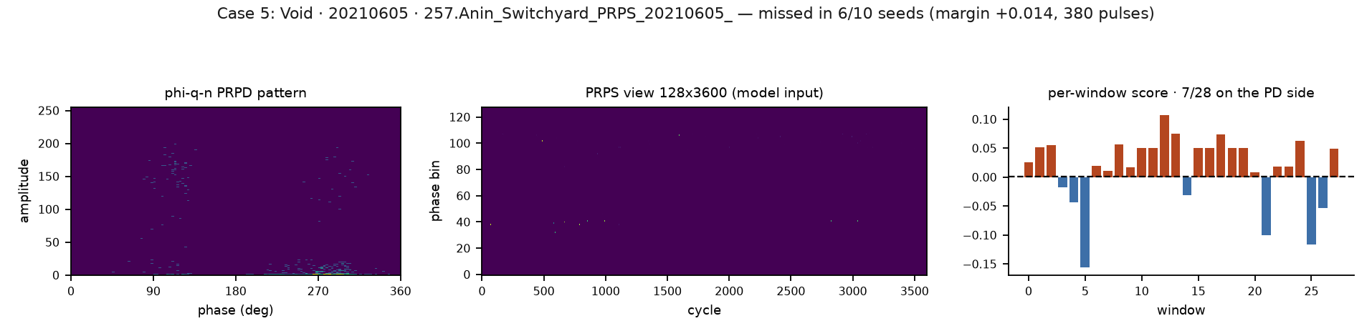

Case 6 — Void, 20210605
200.PD_05_Anin_Switchyard_PRPS_20210605_0705_DU1_LU4_CH164.dat
Missed in | Margin | Pulses | PD windows | Suspect | Lab match | Bank gap
6/10 seeds | +0.022 | 440 | 8/28 | 154 | 0.6 | 0.089

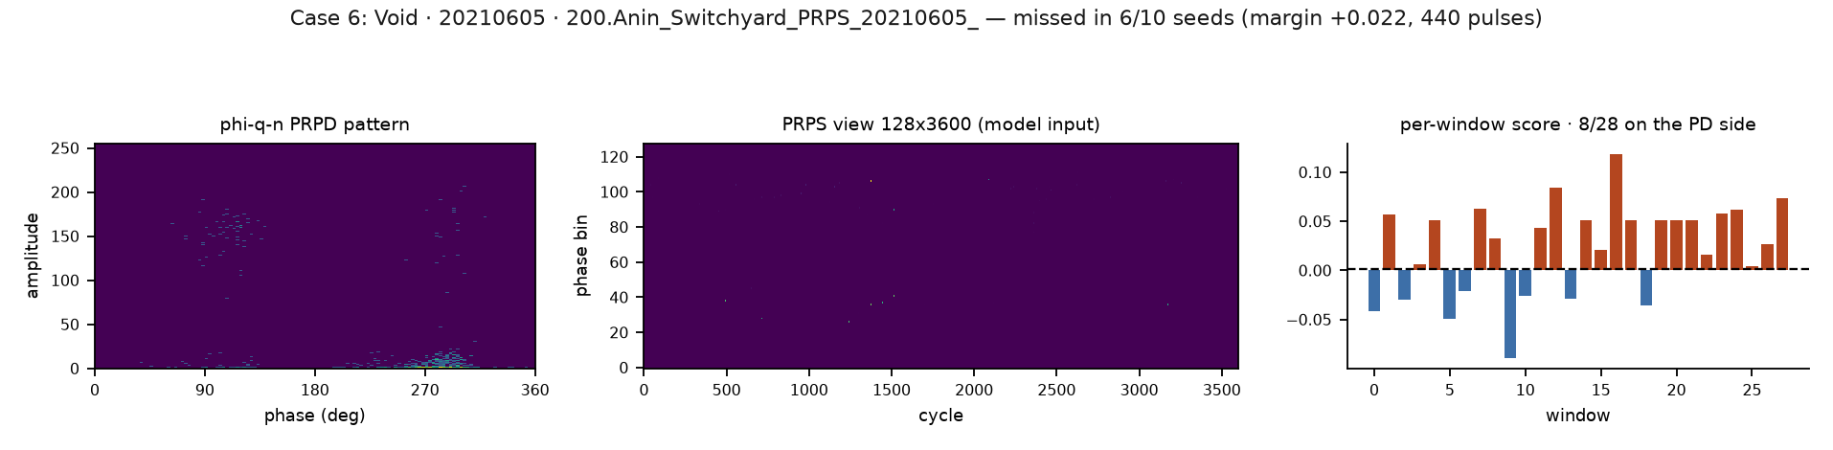

Source files
File | Contents
missed_pd_cases.csv | One row per missed file: decision, φ-q-n descriptors, bank audit, label quality
missed_pd_groups.csv | The three-group summary shown above
overview_phi_q_n.png | Figure 1
reference_detected.png | Figure 2
case_01…case_18_*.png | The 18 per-case figures in this atlas
Comparison/missed_pd_table.py | Rebuilds the CSV from the run artifacts
Comparison/missed_pd_figures.py | Rebuilds every figure from the CSV

