The 18 Missed PD Cases: Detailed Analysis
Companion to the PatchCore error-analysis report · seed 42, validation-selected threshold · 1 October 2026

Summary
Of the 75 Field PD measurements in the test set, PatchCore misses 18 at the validation-selected threshold. They are not a uniform group: the φ-q-n patterns separate them into three causes that call for three different responses.
Group | n | Dates | What the 2D pattern shows | Reading
A. Dangjin Void | 7 | 20220427 | Textbook Void: paired clusters in both half cycles | Genuine model failure
B. Asan Corona | 5 | 20231023 | Single dense cluster near 90–120°, one polarity only | Label quality — review
C. Sparse | 6 | 4 dates | Almost empty; a few hundred scattered pulses | Too little evidence

The decisive observation: group A carries clear, well-formed discharge patterns that any PD engineer would call Void, yet the model misses all seven in 8–10 of 10 random seeds. Group B is flagged as atypical by an independent label-quality check, and the filenames themselves say the measurements were taken after noise mitigation. Group C simply contains too few pulses to decide anything.

1. The 18 files
Sorted by date. “Missed in n/10” counts how many of the ten training seeds misclassify the file — the single most useful column, because it separates systematic failures from borderline cases. “Margin” is the distance past the decision threshold (larger = more confidently wrong). “Windows on PD side” counts how many of the file's 28 time windows individually scored as PD.
# | Measurement | Type | Date | Missed | Margin | Pulses | PD win.
1 | 139 Sinjungbu 1018 | Floating | 20190327 | 7/10 | +0.036 | 14,131 | 6/28
2 | 123 Sinjungbu 2011 | Floating | 20190403 | 5/10 | +0.027 | 4,625 | 4/28
3 | 242 Haenam 2688 | Void | 20210221 | 8/10 | +0.045 | 698 | 3/28
4 | 202 Anin 1013 | Void | 20210605 | 8/10 | +0.003 | 261 | 9/28
5 | 257 Anin 0700 | Void | 20210605 | 6/10 | +0.014 | 380 | 7/28
6 | 200 Anin 0705 | Void | 20210605 | 6/10 | +0.022 | 440 | 8/28
7 | 217 Dangjin 1710 | Void | 20220427 | 8/10 | +0.002 | 17,970 | 15/28
8 | 207 Dangjin 1146 | Void | 20220427 | 10/10 | +0.004 | 20,740 | 14/28
9 | 211 Dangjin 1359 | Void | 20220427 | 10/10 | +0.008 | 13,734 | 10/28
10 | 209 Dangjin 1219 | Void | 20220427 | 10/10 | +0.012 | 19,428 | 10/28
11 | 208 Dangjin 1154 | Void | 20220427 | 10/10 | +0.042 | 19,106 | 8/28
12 | 206 Dangjin 1145 | Void | 20220427 | 9/10 | +0.043 | 9,698 | 3/28
13 | 205 Dangjin 1023 | Void | 20220427 | 9/10 | +0.047 | 2,590 | 2/28
14 | AsanSS Yuho76 | Corona | 20231023 | 6/10 | +0.019 | 3,568 | 10/28
15 | AsanSS Yuho74 | Corona | 20231023 | 4/10 | +0.048 | 2,510 | 8/28
16 | AsanSS Yuho78 | Corona | 20231023 | 7/10 | +0.083 | 3,706 | 9/28
17 | AsanSS Yuho73 | Corona | 20231023 | 9/10 | +0.087 | 3,131 | 4/28
18 | AsanSS Yuho77 | Corona | 20231023 | 9/10 | +0.118 | 3,868 | 7/28

2. What distinguishes the three groups
Measure | A. Dangjin Void (7) | B. Asan Corona (5) | C. Sparse (6) | Detected PD (57)
Total pulses (median) | 17,970 | 3,568 | 569 | 34,086
Half-cycle correlation | 0.71 | 0.39 | 0.82 | 0.84
Analyzer suspect score | 8.9 | 426 | 143 | —
Matches from Lab data | 0.8 | 1.0 | 0.6 | 0.2
Gap between banks | 0.13 | 0.51 | 0.19 | 0.93
Missed in n/10 seeds | 10 | 7 | 6.5 | —

- Suspect score is the Analyzer's independent label-quality measure (pooled shrinkage Mahalanobis on the 256-D feature). The 95th-percentile cut is 210 and the 99th is 306. Group B sits at 358–453; group A sits at 7.8–17.2, i.e. entirely typical for Void.
- Gap between banks is distance to the Noise bank minus distance to the PD bank. Correctly detected PD files average 0.93; every missed group is far lower, meaning the two memory banks look almost equally close and the decision is effectively a coin flip.

3. The 2D patterns
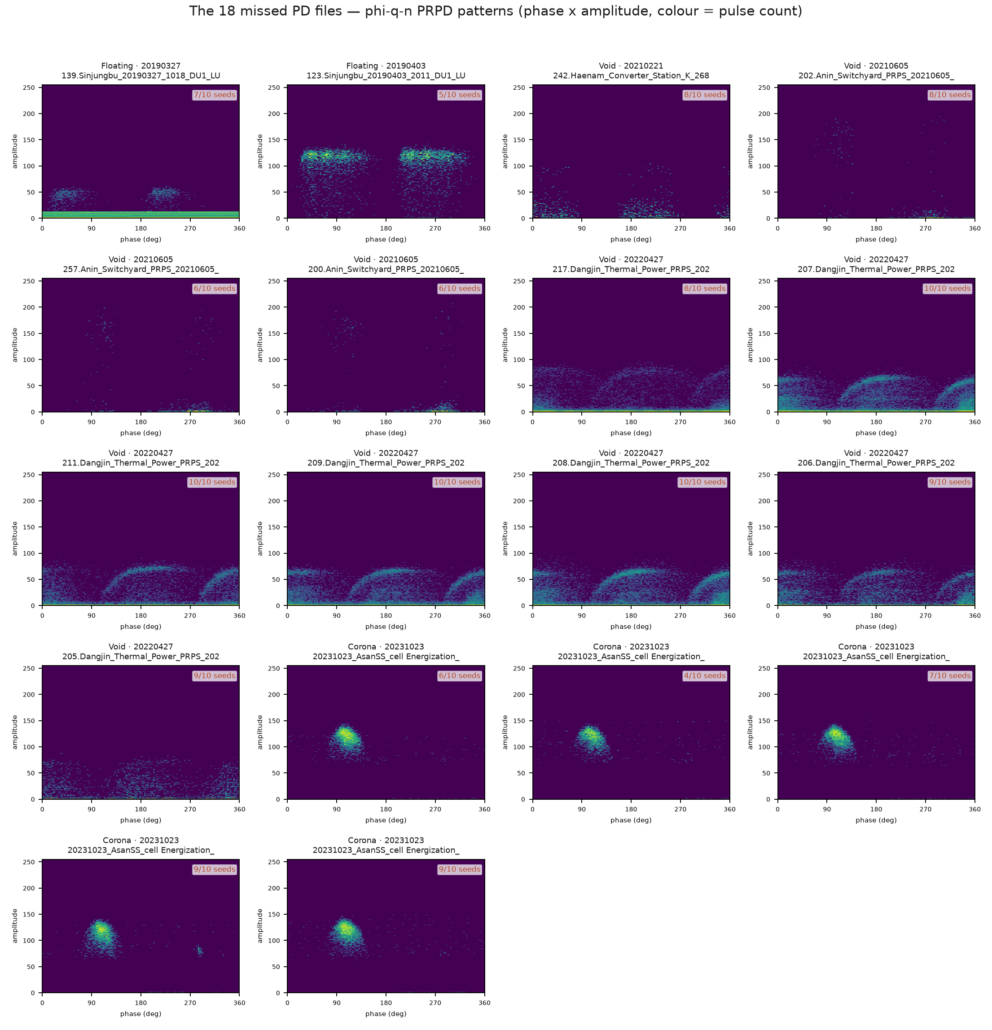
Figure 1. All 18 missed files as φ-q-n PRPD patterns (phase on x, amplitude on y, colour = pulse count — the conventional representation in the PD literature). The three groups are visually distinct: rows 2–4 left (Dangjin) show the paired half-cycle clusters typical of Void; the Asan Corona files show one dense single-polarity cluster; the remaining files are nearly empty.
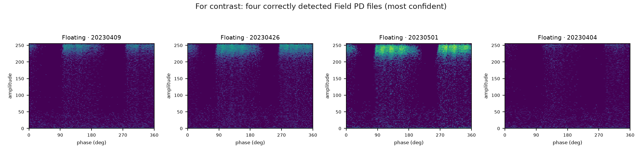
Figure 2. For contrast: the four Field PD files PatchCore detects most confidently. Note the much denser, structured activity across both half cycles.

4. Group A — Dangjin Void: a genuine model failure
Seven Void measurements from 20220427 (Dangjin thermal power station), all missed in 8–10 of 10 seeds — the most systematic failure in the test set. These are not ambiguous measurements. The φ-q-n patterns show the paired, phase-symmetric clusters in both half cycles that characterise void discharge, with 13,700–20,700 pulses. The Analyzer's label-quality check places them in the 0.6th–20th percentile of their class, i.e. more typical of Void than most Void files.
The model nevertheless scores them on the noise side, with the smallest bank gap of any group (0.13 against 0.93 for detected PD). Their nearest matches in the PD memory bank are predominantly laboratory windows (0.8), which supports the domain-gap explanation: field void discharge of this shape is under-represented in a bank that is 80% laboratory data.
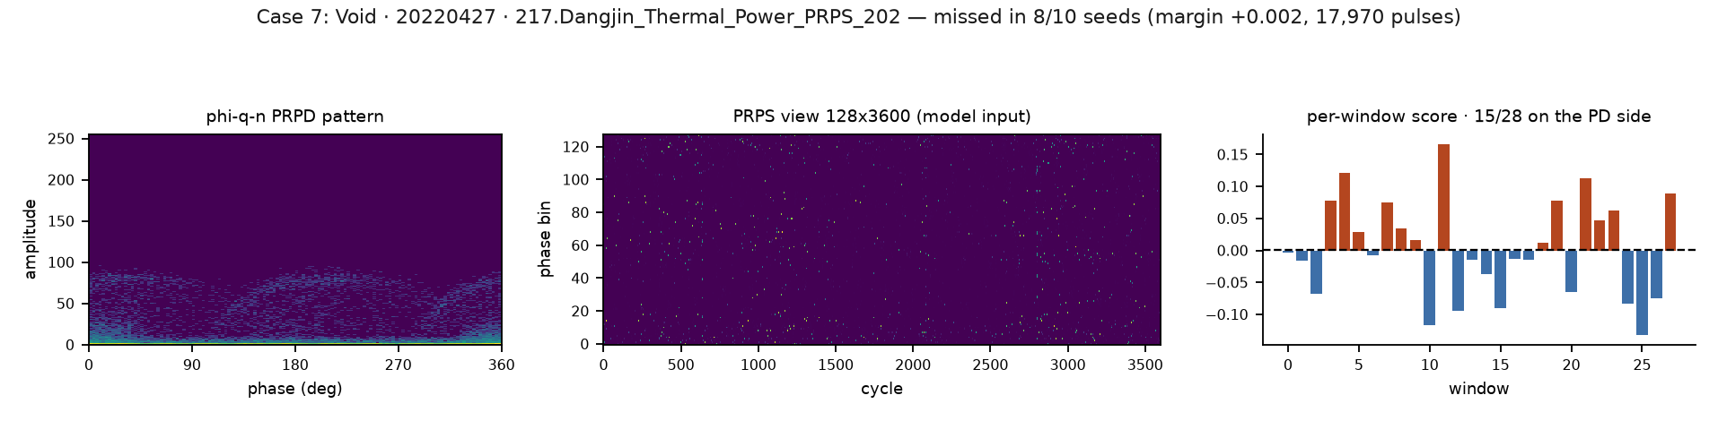
Figure 3. Case 7 — Void, 20220427, missed in 8/10 seeds. Left: φ-q-n pattern. Middle: the pulse-sequence view the model consumes. Right: the 28 window scores, of which 15 fall on the PD side.
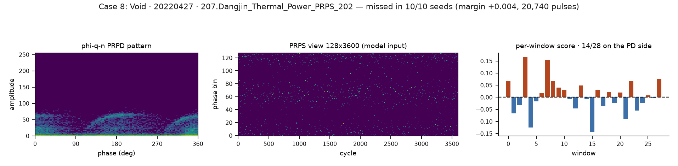
Figure 4. Case 8 — Void, 20220427, missed in 10/10 seeds. Left: φ-q-n pattern. Middle: the pulse-sequence view the model consumes. Right: the 28 window scores, of which 14 fall on the PD side.
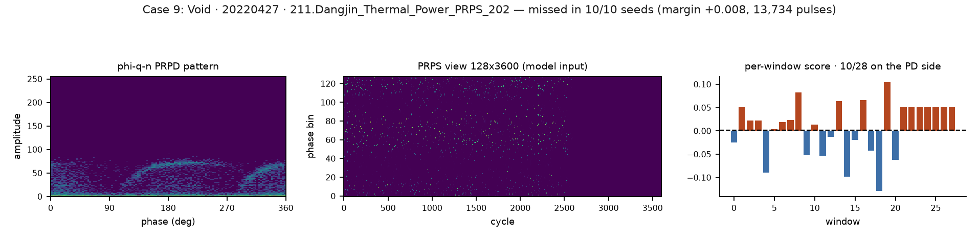
Figure 5. Case 9 — Void, 20220427, missed in 10/10 seeds. Left: φ-q-n pattern. Middle: the pulse-sequence view the model consumes. Right: the 28 window scores, of which 10 fall on the PD side.

5. Group B — Asan Corona: a label-quality question
Five Corona measurements from 20231023, all from the same site and series. Their filenames read “Noise_Removal_After_Improvement”, i.e. they were recorded after noise mitigation work. Three facts point the same way:
- Their suspect scores (358–453) are the highest in the test set, far above the 95th-percentile cut of 210.
- Their half-cycle correlation is 0.39, against 0.84 for detected PD — the activity sits in one polarity only.
- Four of the five match laboratory training windows exclusively (median 1.0), and their bank gap (0.51) is the largest among the missed groups, so the model is not merely undecided here — it leans toward noise.
Recommendation: these five files should be re-examined by a domain expert before they are counted as model errors. If the measurements capture residual interference rather than corona discharge, the label is wrong and the model is right. No labels were changed in this analysis.
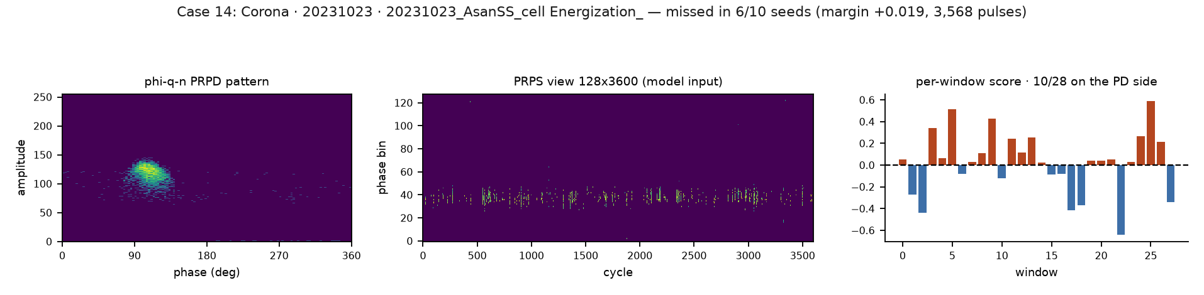
Figure 6. Case 14 — Corona, 20231023, suspect score 426, missed in 6/10 seeds. The single-polarity cluster is visible in the φ-q-n pattern at left.
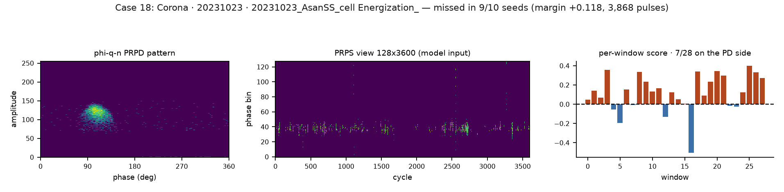
Figure 7. Case 18 — Corona, 20231023, suspect score 358, missed in 9/10 seeds. The single-polarity cluster is visible in the φ-q-n pattern at left.

6. Group C — sparse measurements: too little evidence
Six files spread over four dates (Sinjungbu 2019, Haenam 2021, Anin 2021), with a median of 569 pulses against 34,086 for detected PD — roughly sixty times fewer. The three Anin files contain 261, 380 and 440 pulses in a whole minute of recording.
With this little activity the 128×128 windows are almost empty, and near-empty windows are well represented in both memory banks. Both distances shrink, their difference collapses, and the file lands on the threshold. This is the general mechanism identified in the main error analysis, in its most extreme form. These files are also the least stable across seeds (missed in 5–8 of 10).
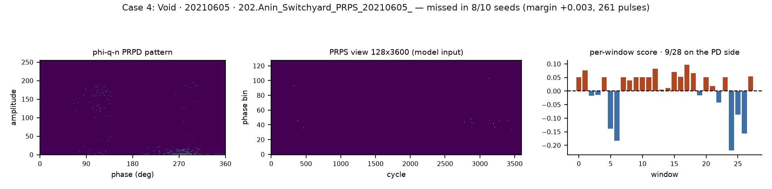
Figure 8. Case 4 — Void, 20210605, only 261 pulses in the whole measurement.
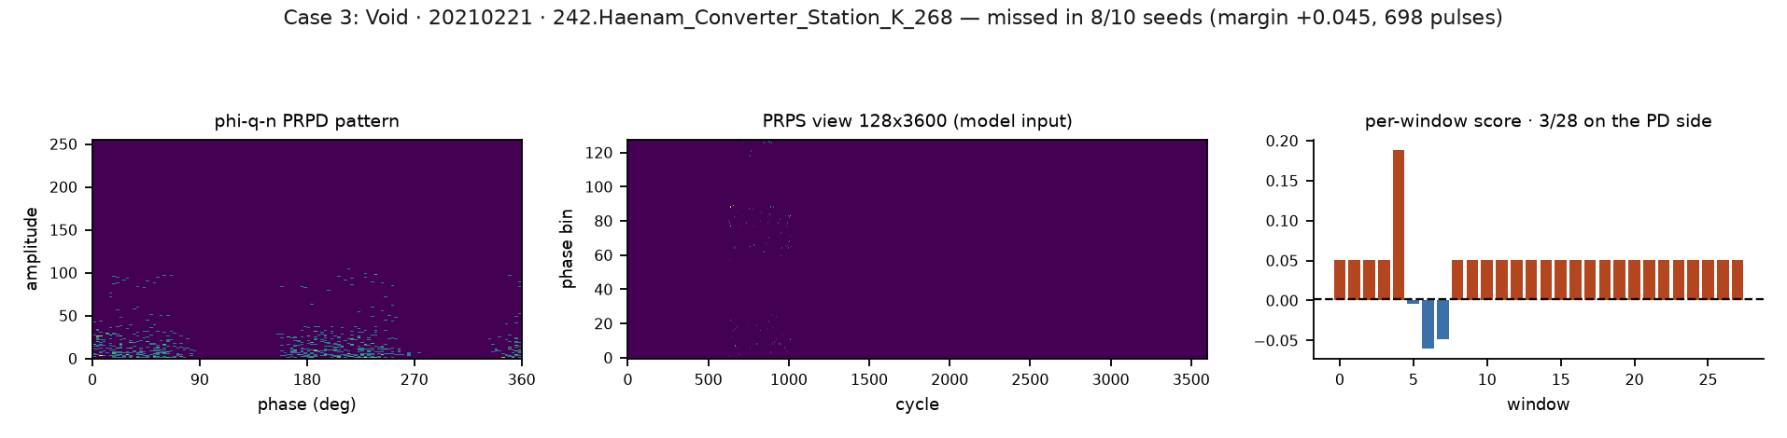
Figure 9. Case 3 — Void, 20210221, only 698 pulses in the whole measurement.

7. Conclusions
- Only 7 of the 18 are clear model failures. The Dangjin Void group carries textbook patterns and is missed almost every seed. These should be the target of any further model work and the case study in the paper.
- 5 of the 18 are label-quality candidates. The Asan Corona group is flagged independently by the Analyzer, shows single-polarity activity, and was recorded after noise mitigation. Expert review should settle whether they are discharge at all.
- 6 of the 18 cannot be decided from the data. With a few hundred pulses per minute there is too little evidence for any method. Reporting a minimum-activity criterion alongside the detector would be more honest than counting these as errors.
- The domain gap is visible throughout. Missed files match laboratory training windows 0.6–1.0 of the time, while detected files match them only 0.2. Rebalancing the PD memory bank toward field data remains the best-supported model change.
Taken together: of 75 Field PD measurements, the honest count of unexplained model failures is 7, not 18 — about 9%. The remaining 11 are a labelling question and a data-quality limit, and should be reported as such.

Appendix: how to read the figures
- φ-q-n PRPD pattern — phase angle (0–360°) on x, pulse amplitude on y, colour = number of pulses on a log scale. This is the conventional diagnostic view.
- PRPS view (128×3,600) — the raw matrix the model consumes: phase bin on y, AC cycle on x, colour = peak amplitude. One minute of recording.
- Per-window scores — the file is tiled into 28 windows of 128 cycles; each is scored separately and the mean becomes the file score. Bars below the dashed line are PD-like.
- All figures and the underlying table: Results/patchcore/error_analysis/missed18/ and Comparison/missed_pd_figures.py in the repository.

