Thrust:
$$T=\dot{m}U_{e}+A_{e}\left(P_{e}-P_{a}\right)$$

Thrust Coefficient:
$$C_{f}≡\frac{T}{P_{c}A_{t}}$$
Then:
$$T=C_{f}P_{c}A_{t}$$
And also:
$$T=C_{f}P_{c}A_{t}=\dot{m}U_{e}+A_{e}\left(P_{e}-P_{a}\right)$$
In reality:
$$T_{real}=\underset{{C_{f}}_{real}}{\underbrace{η_{C_{f}}\overset{{C_{f}}_{ideal}}{\overbrace{C_{f}}}}}P_{c}A_{t}$$
$$T_{real}=η_{C_{f}}\left(\dot{m}U_{e}+A_{e}\left(P_{e}-P_{a}\right)\right)$$
But, in addition to the nozzle efficiency, we have the combustion efficiency!. This one is defined as:
$$η_{c}=\frac{C_{real}^{*}}{C_{ideal}^{*}}→ C_{real}^{*}=η_{c}C_{ideal}^{*}$$
So, now, we have to effects: (1) reduction in pressure, (2) influence in $U_{e}$.
- Reduction in pressure
$$C^{*}=\frac{P_{c}A_{t}}{\dot{m}} → \dot{m}=\frac{P_{c}A_{t}}{C^{*}} → P_{c}=\frac{\dot{m}C^{*}}{A_{t}}$$
So, for a given mass flow rate (because we put a venturi to make the $\dot{m}$ be an independent variable), and for a given nozzle (i.e., a given $A_{t}$), we will get:
$$P_{c,real}=\frac{{\dot{m}}_{real}C_{real}^{*}}{A_{t}}=\frac{{\dot{m}}_{real}η_{c}C_{ideal}^{*}}{A_{t}}=η_{c}\frac{{\dot{m}}_{real}C_{ideal}^{*}}{A_{t}}=η_{c}\frac{\dot{m}C_{ideal}^{*}}{A_{t}}=η_{c}P_{c,ideal}$$
So we got that, the combustion efficiency influences the actual engine pressure:
$$P_{c,real}=η_{c}P_{c,ideal}$$
- influence in $U_{e}$
The exit velocity is defined as:
$$U_{e}=\sqrt{\frac{2γ}{γ-1}RT_{0}\left[1-{\left(\frac{P_{e}}{P_{c}}\right)}^{\frac{γ-1}{γ}}\right]}$$
In addition, the theoretical definition of the characteristic velocity ($C^{*}$) is:
$$C^{*}=\sqrt{\frac{1}{γ}{\left(\frac{γ+1}{2}\right)}^{\frac{γ+1}{γ-1}}\frac{R}{MW}T_{0}}$$
So, the theoretical $T_{0}$ is:
$$T_{0,ideal}=\frac{{C_{ideal}^{*}}^{2}}{\frac{1}{γ}{\left(\frac{γ+1}{2}\right)}^{\frac{γ+1}{γ-1}}\frac{R}{MW}}$$
So, the real $T_{0,real}$
$$T_{0,real}=\frac{{C_{real}^{*}}^{2}}{\frac{1}{γ}{\left(\frac{γ+1}{2}\right)}^{\frac{γ+1}{γ-1}}\frac{R}{MW}}=\frac{{\left(η_{c}C_{ideal}^{*}\right)}^{2}}{\frac{1}{γ}{\left(\frac{γ+1}{2}\right)}^{\frac{γ+1}{γ-1}}\frac{R}{MW}}=η_{c}^{2}\frac{{C_{ideal}^{*}}^{2}}{\frac{1}{γ}{\left(\frac{γ+1}{2}\right)}^{\frac{γ+1}{γ-1}}\frac{R}{MW}}=η_{c}^{2}T_{0,ideal}$$
So, the temperature, change with the squared of the combustion efficiency:
$$T_{0,real}=η_{c}^{2}T_{0,ideal}$$
Finally the exit velocity:
$$U_{e,ideal}=\sqrt{\frac{2γ}{γ-1}RT_{0,ideal}\left[1-{\left(\frac{P_{e}}{P_{c}}\right)}^{\frac{γ-1}{γ}}\right]}$$
And
$$U_{e,real}=\sqrt{\frac{2γ}{γ-1}RT_{0,real}\left[1-{\left(\frac{P_{e}}{P_{c}}\right)}^{\frac{γ-1}{γ}}\right]}=\sqrt{\frac{2γ}{γ-1}Rη_{c}^{2}T_{0,ideal}\left[1-{\left(\frac{P_{e}}{P_{c}}\right)}^{\frac{γ-1}{γ}}\right]}=η_{c}\sqrt{\frac{2γ}{γ-1}RT_{0,ideal}\left[1-{\left(\frac{P_{e}}{P_{c}}\right)}^{\frac{γ-1}{γ}}\right]}=η_{c}U_{e,ideal}$$
So, going back to the thrust, we have:
$$T_{real}=η_{C_{f}}\left(\dot{m}U_{e}+A_{e}\left(P_{e}-P_{a}\right)\right)=η_{C_{f}}\left(η_{c}\dot{m}U_{e,ideal}+A_{e}\left(P_{e}-P_{a}\right)\right)$$
And so:
$$T_{real}=η_{C_{f}}\left(η_{c}\dot{m}U_{e,ideal}+A_{e}\left(P_{e}-P_{a}\right)\right)$$
With:
$$P_{c,real}=η_{c}P_{c,ideal}$$

Chamber dimensions:
We have two engine parameters: (1) characteristic Length (2) contraction ratio
$$L^{*}=\frac{V_{c}}{A_{t}} ε_{c}=\frac{A_{c}}{A_{t}}$$
So, ss
$$L^{*}=\frac{V_{c}}{A_{t}}=\frac{A_{c}L_{c}}{A_{t}}=ε_{c}L_{c} → L_{c}=\frac{L^{*}}{ε_{c}}$$
$$A_{c}=ε_{c}A_{t}$$
We choose the $L^{*}$ and the $ε_{c}$

Contraction ratio theory:
The velocity of the flow at the entrance of the chamber is calculated using the subsonic solution for:
$$\frac{A_{c}}{A_{t}}={\left(\frac{γ+1}{2}\right)}^{-\frac{γ+1}{2\left(γ-1\right)} }\frac{{\left(1+\frac{γ-1}{2}M^{2}\right)}^{\frac{γ+1}{2\left(γ-1\right)}}}{M}$$
Solving for the Mach, we know the velocity of the Mach at the entrance of the nozzle.
Then, by using Rayleigh flow, we can calculate the stagnation pressure at the entrance of the nozzle. First, the ratio between static and stagnation pressure from Rayleigh flow is given by:
$$\frac{P_{o,nozzle}}{P_{0}^{*}}=\frac{γ+1}{1+γM^{2}}{\left[\left(\frac{2}{γ+1}\right)\left(1+\frac{γ-1}{2}M^{2}\right)\right]}^{\frac{γ}{γ-1}}$$
For the injection head, and assuming that at the injection head the flow is in stagnation, then
$$\frac{P_{o,inj}}{P_{0}^{*}}=\left(γ+1\right){\left[\left(\frac{2}{γ+1}\right)\right]}^{\frac{γ}{γ-1}}$$
Dividing both:
$$\frac{P_{o,inj}}{P_{o,nozzle}}=\frac{1+γM^{2}}{{\left(1+\frac{γ-1}{2}M^{2}\right)}^{\frac{γ}{γ-1}}}$$
And so we get the following figure. We want a contraction ratio to have the flow slow enough at the nozzle inlet. However, we want the stagnation pressure at the inlet of the nozzle to be the maximum. So we look for a tradeoff.
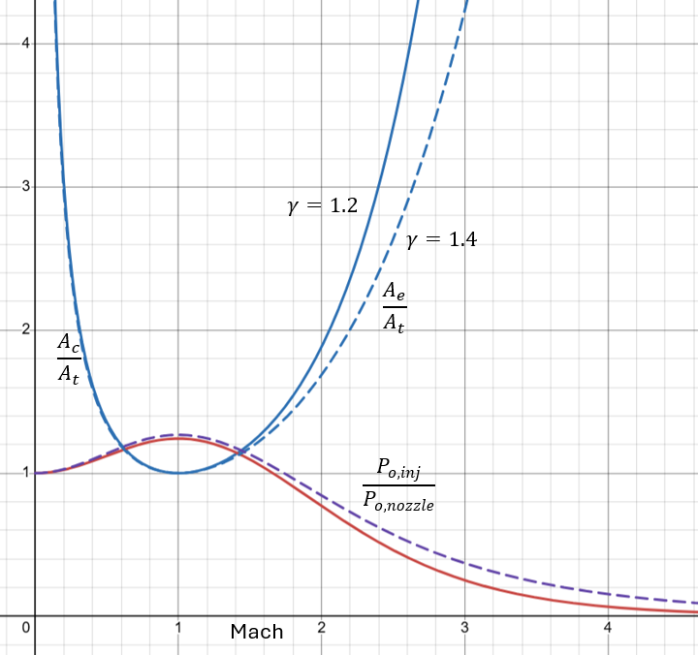
https://www.desmos.com/calculator/smrwvjpke2

