**CSCI240 – Computer Organization and Assembly Language Programming**

**Name:**  Jonathan Limpus

**Student ID:** 1429394

**Assignment:** Homework 3

6.

|  |  |  |  |  |
| --- | --- | --- | --- | --- |
| A | B | C | D | Z |
| 0 | 0 | 1 | 1 | 1 |
| 0 | 1 | 0 | 1 | 1 |
| 1 | 0 | 1 | 0 | 1 |
| 1 | 1 | 0 | 0 | 0 |

7. TODO

9.

|  |  |  |
| --- | --- | --- |
| A | B | NOT(NOT(A) OR NOT(B)) |
| 0 | 0 | 0 |
| 0 | 1 | 0 |
| 1 | 0 | 0 |
| 1 | 1 | 1 |

|  |  |  |
| --- | --- | --- |
| A | B | A NOR B |
| 0 | 0 | 1 |
| 0 | 1 | 0 |
| 1 | 0 | 0 |
| 1 | 1 | 0 |

10.

12.

3-input decoder created in Logicly

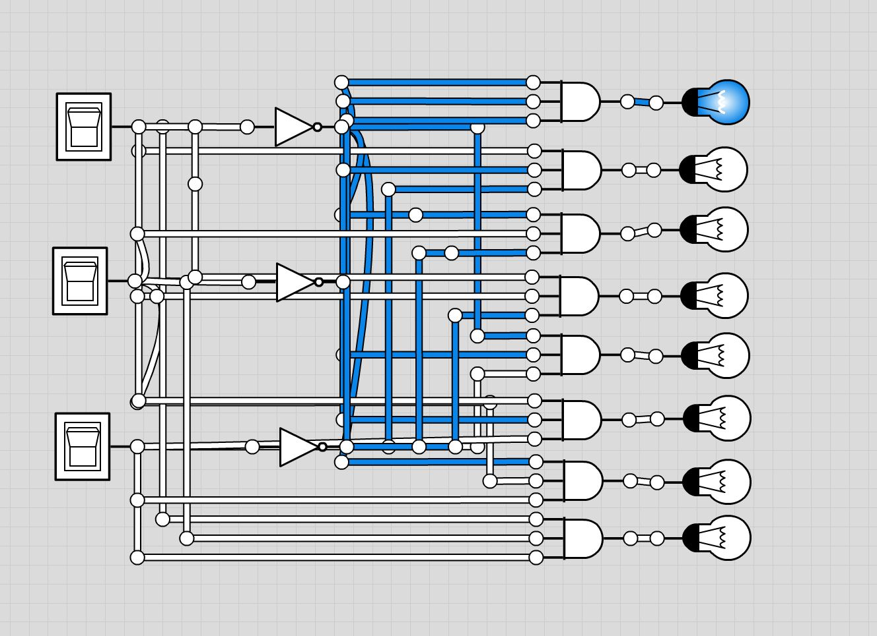

15.

|  |  |  |  |  |
| --- | --- | --- | --- | --- |
| C in |  |  |  | 0 |
| A | 0 | 1 | 1 | 1 |
| B | 1 | 0 | 1 | 1 |
| S | 1 | 1 | 0 | 0 |
| C out | 0 | 0 | 1 | 1 |

18. a. NOT(A) AND B

b. A AND NOT(B)

c. TODO

19. The first circuit is a straightforward circuit that will produce the same output with the same inputs every time. The second circuit may have different outputs for D for the same inputs, depending on previous states .

21. There are 4096 nibbles of storage. A 14 bit address means there are 2 to the 14th power locations in memory, which is 16384, divided by 4 to represent in nibbles.

23.

|  |  |  |  |
| --- | --- | --- | --- |
| A | B | C | Z |
| 0 | 0 | 0 | 0 |
| 0 | 0 | 1 | 0 |
| 0 | 1 | 0 | 0 |
| 0 | 1 | 1 | 0 |
| 1 | 0 | 0 | 0 |
| 1 | 0 | 1 | 0 |
| 1 | 1 | 0 | 0 |
| 1 | 1 | 1 | 0 |

27. a. When the select line is 0:

- When A is 0, Z is 0

-When A is 1, Z is 1

b. When the select line is switched to 1 while A is 0:

-When A is 0, Z is 0

-When A is 1, Z is 0

When the select line is switched to 1 while A is 1

-When A is 0, Z is 1

-When A is 1, Z is 1

c. TODO

|  |  |  |  |  |
| --- | --- | --- | --- | --- |
| A | B | G | E | L |
| 0 | 0 | 0 | 1 | 0 |
| 0 | 1 | 0 | 0 | 1 |
| 1 | 0 | 1 | 0 | 0 |
| 1 | 1 | 0 | 1 | 0 |

30. a.

b. 1 bit comparator:

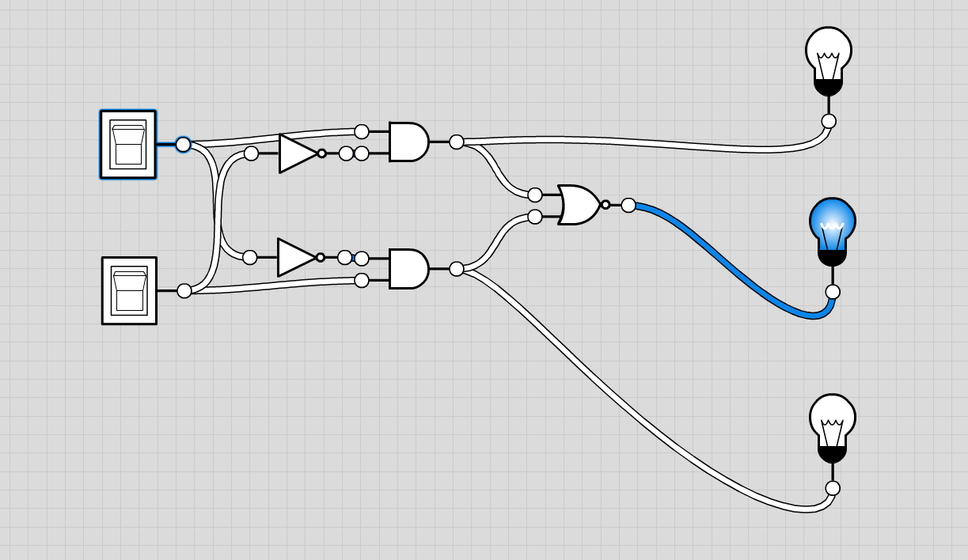

c.