**CSCI240 – Computer Organization and Assembly Language Programming**

**Name:**  Jonathan Limpus

**Student ID:** 1429394

**Assignment:** Project 1: Machine Language

## Program Flowcharts:

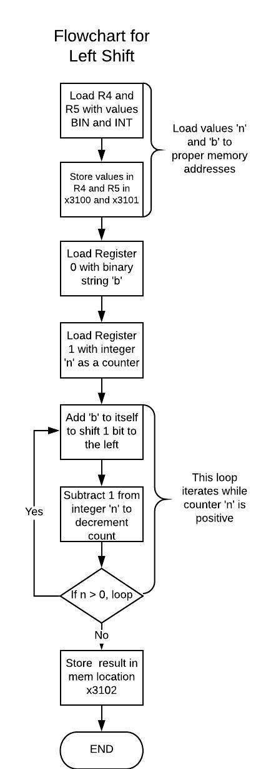

Flowchart for Left Rotation

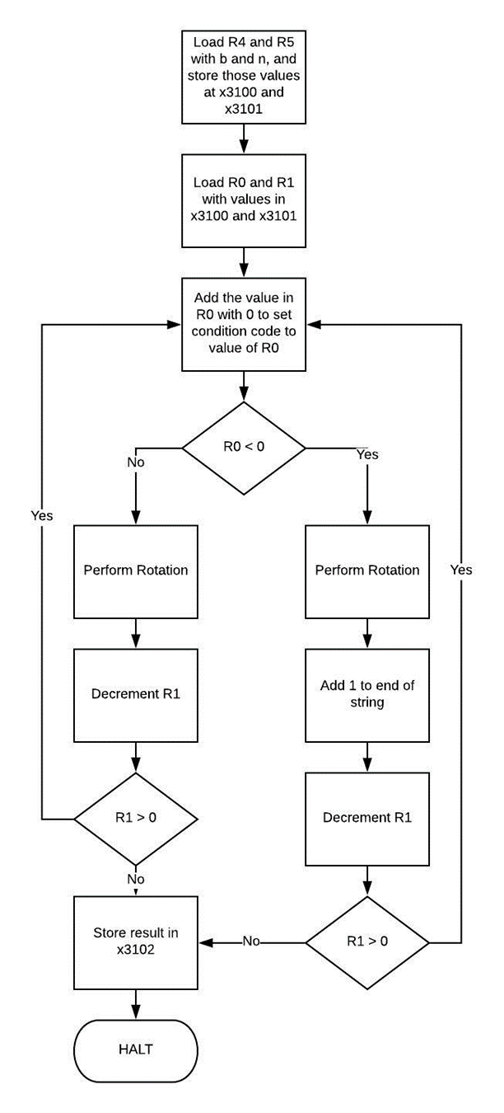

## Test Cases:

**Problem 1 – Left Shift:**

Test Case 1:

Inputs: Binary string initialized to 1111111111111010 at x3100 & integer n initialized to x0004 at x3101

Outputs: Binary string 1111111110100000 stored in x3102



Test Case 2:

Inputs: Binary string initialized to 0000000000100001 at x3100 & integer n initialized to x0009 at x3101

Outputs: Binary string 0100001000000000 stored in x3102



Test Case 3:

Inputs: Binary string initialized to 0000000001010000 at x3100 & integer n initialized to x0006 at x3101

Outputs: Binary string 0001010000000000 stored in x3102



Test Case 4:

Inputs: Binary string initialized to 1111111111111111 at x3100 & integer n initialized to x0011 at x3101

Outputs: Binary string 0000000000000000 stored in x3102



**Problem 2 – Left Rotation:**

Test Case 1:

Inputs: Binary String initialized to 1111111111111010 at x3100 and integer n initialized to x0004 at x3101

Outputs: Binary string 1111111110101111 stored in x3102



Test Case 2:

Inputs: Binary String initialized to 0000001110110011 at x3100 and integer n initialized to x0005 at x3101

Outputs: Binary string 011101101100000 stored in x3102



Test Case 3:

Inputs: Binary String initialized to 1000100010001000 at x3100 and integer n initialized to x0002 at x3101

Outputs: Binary string 0010001000100010 stored in x3102



Test Case 4:

Inputs: Binary String initialized to 1111000011111111 at x3100 and integer n initialized to x0004 at x3101

Outputs: Binary string 0000111111111111 stored in x3102



## Report:

This project was very enjoyable. One of the problems I encountered with this project was figuring out how to implement the general control structure of my algorithm in LC3. This gave me good experience with control flows in LC3 Assembly. Overall, this project was somewhat difficult, but not excessively so. My main source of help with this project was brainstorming with my fellow classmates, as well as the LC3 Assembly Appendix in the book.