My First Reproducible Report

1. First quarto doc on git
I’m learning how to use Github

1.1 Now it has a subheading
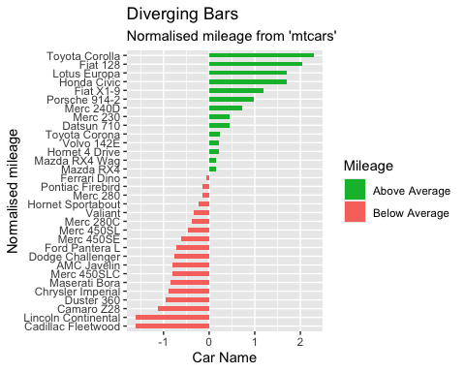
Figure 1: Normalised mileage of cars. Positive values represent above average mileage, negative values indicate negative mileage
In Figure 1 we can see some green and salmon bars.
Table 1: Summary of the dataset
 | mpg | cyl | disp | hp | drat | wt | qsec | vs | am | gear | carb | car name | mpg_z | mpg_type
Cadillac Fleetwood | 10.4 | 8 | 472 | 205 | 2.93 | 5.250 | 17.98 | 0 | 0 | 3 | 4 | Cadillac Fleetwood | -1.61 | below
Lincoln Continental | 10.4 | 8 | 460 | 215 | 3.00 | 5.424 | 17.82 | 0 | 0 | 3 | 4 | Lincoln Continental | -1.61 | below
Camaro Z28 | 13.3 | 8 | 350 | 245 | 3.73 | 3.840 | 15.41 | 0 | 0 | 3 | 4 | Camaro Z28 | -1.13 | below
Duster 360 | 14.3 | 8 | 360 | 245 | 3.21 | 3.570 | 15.84 | 0 | 0 | 3 | 4 | Duster 360 | -0.96 | below
Chrysler Imperial | 14.7 | 8 | 440 | 230 | 3.23 | 5.345 | 17.42 | 0 | 0 | 3 | 4 | Chrysler Imperial | -0.89 | below
Maserati Bora | 15.0 | 8 | 301 | 335 | 3.54 | 3.570 | 14.60 | 0 | 1 | 5 | 8 | Maserati Bora | -0.84 | below

