KejaLink
User Manual
For clients, agents and administrators · Version 2.0 (React web app)

KejaLink Realty Solutions Ltd · support@kejalink.co.ke

Contents

In Word, right-click the table and choose Update Field to show page numbers.

1. Getting started

1.1 What KejaLink does
KejaLink brings Kenyan property search into one place. Clients find verified listings and book viewings online; licensed agents list properties and manage inquiries and viewing requests; administrators keep the platform trustworthy.
Account type | Can do
Visitor (not logged in) | Browse and search listings, view details, read help
Client | Everything a visitor can, plus save listings, ask agents questions, book and cancel viewings, report suspicious listings
Agent | After admin approval: add, edit and delete listings; confirm, reschedule or decline viewings; reply to inquiries; feature listings with M-Pesa; run reports on own data
Admin | Verify agents; register, edit, suspend, reinstate and delete users; reset passwords; remove listings; see all viewings and payments; reports; activity log
Super admin | Everything an admin can do, plus create administrators and remove admin rights

1.2 Opening and installing the system
If KejaLink is already hosted online, just open its address in any modern browser (Chrome, Edge, Firefox or Safari) on a computer or phone. Nothing needs installing.
To run it on your own computer (for example for the presentation), you need Node.js 18 or newer and a free Supabase account:
- In Supabase, create a project, open SQL Editor › New query, and paste and Run the three files in the database folder in order: 01_schema.sql, 02_security_and_storage.sql, 03_demo_data.sql. The last one shows users 14, properties 15, viewings 18, property_images 43.
- In the backend folder, copy .env.example to .env and fill in DATABASE_URL (Supabase › Connect › Session pooler), SUPABASE_URL and SUPABASE_SERVICE_ROLE_KEY (Project Settings › API), and two random values for JWT_SECRET and APP_KEY. Keep this file private: never share it or paste it into chat.
- Open a terminal in the main KejaLink-JS folder and run npm run install:all, then npm run build.
- Run npm start. The terminal shows Database connected (14 users).
- Open http://localhost:5000 in the browser.
The full technical steps, including putting the site online with Render, are in README.md and DEPLOYMENT.md.

1.3 Creating an account
- Click Register at the top right of any page.
- Choose Client (looking to rent or buy) or Agent (licensed real estate agent).
- Fill in your full name, email, Kenyan phone number (e.g. 0712345678) and a password with at least 8 characters including an upper-case letter, a lower-case letter and a number. The bar under the password shows its strength.
- Agents also enter their EARB licence number and, optionally, the agency name.
- Tick the terms box and click Create account. You are logged in straight away.
If a field is wrong, it turns red with a message explaining what to fix. What you typed is kept, so you only correct that field.
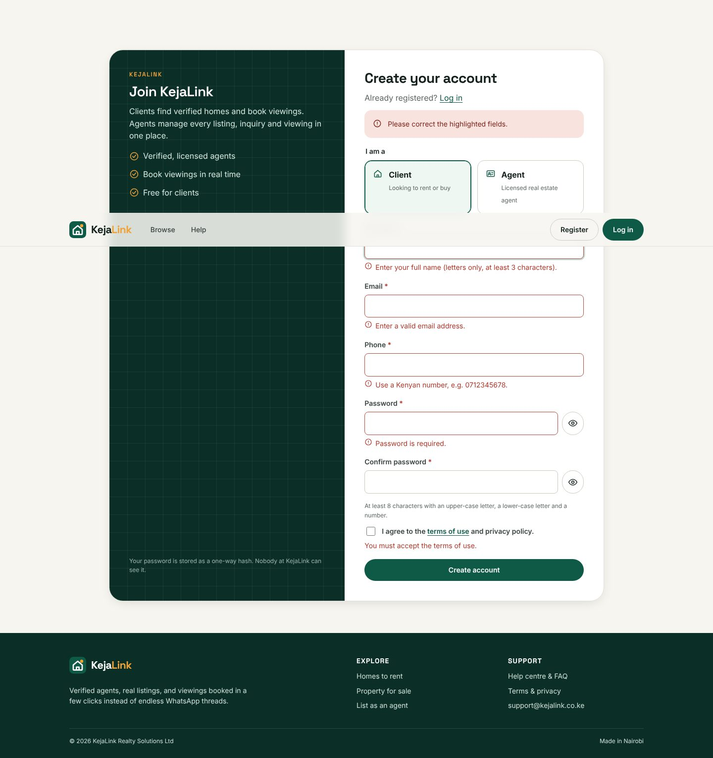
Figure 1: Registration form showing validation messages

1.4 Logging in and out
- Click Log in, enter your email and password, and click Log in. You go to the right home page for your account type.
- To log out, open the menu under your name (top right) and choose Log out. Agents and admins also have Log out at the bottom of the side menu.
- For your safety you are logged out automatically after 30 minutes without activity.
- After 5 wrong passwords in a row the account is locked for 15 minutes. Use Forgot password? to unlock it sooner.
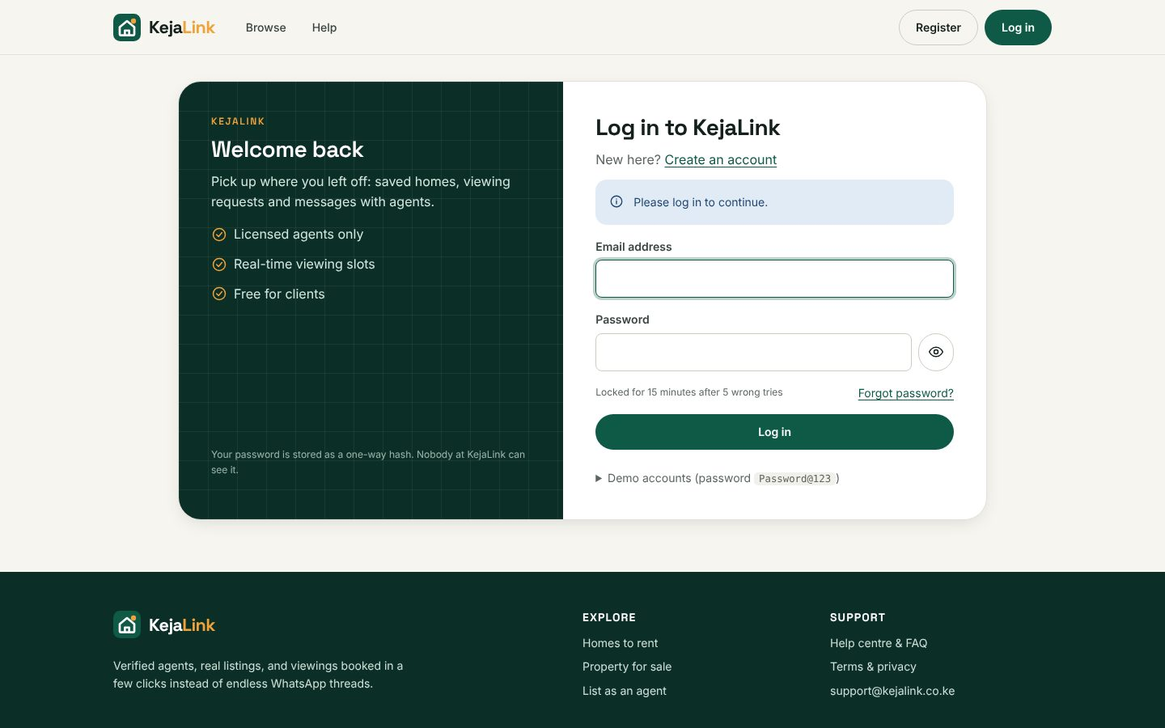
Figure 2: Login page

1.5 Forgot password
- On the login page click Forgot password?
- Enter your email and click Send reset link.
- Open the e-mail from KejaLink and click Reset my password. The link works once and expires after 30 minutes.
- Choose and confirm a new password, then log in with it.
In demonstration mode, e-mails are not sent; the reset link is shown on screen instead.

2. Using KejaLink as a client

2.1 Searching for a property
- Click Browse in the top menu, or search from the home page.
- Type an area such as Kilimani.
- Optionally choose rent or sale, property type, minimum and maximum price (digits only) and minimum bedrooms.
- Click Search. The number of results is shown above the list.
- Use Sort by to order by newest, price (low to high or high to low) or most viewed. Featured listings (star badge) appear first.
- Use the page numbers at the bottom to see more results. Clear all filters starts again.
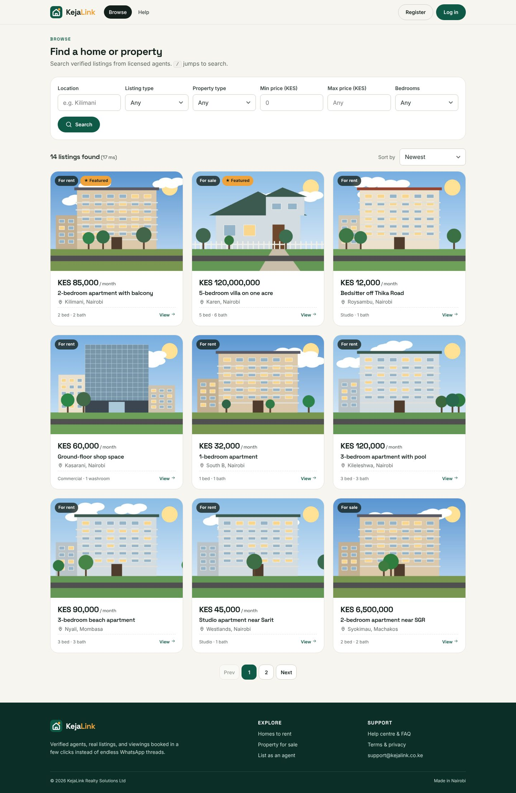
Figure 3: Search results with filters

2.2 Viewing a listing
Click View details on any card. The listing page shows photos (click a thumbnail to enlarge it), price, specifications, description, a map of the area, an affordability guide, and the agent's card with their verified licence number. Log in to see the agent's phone number.
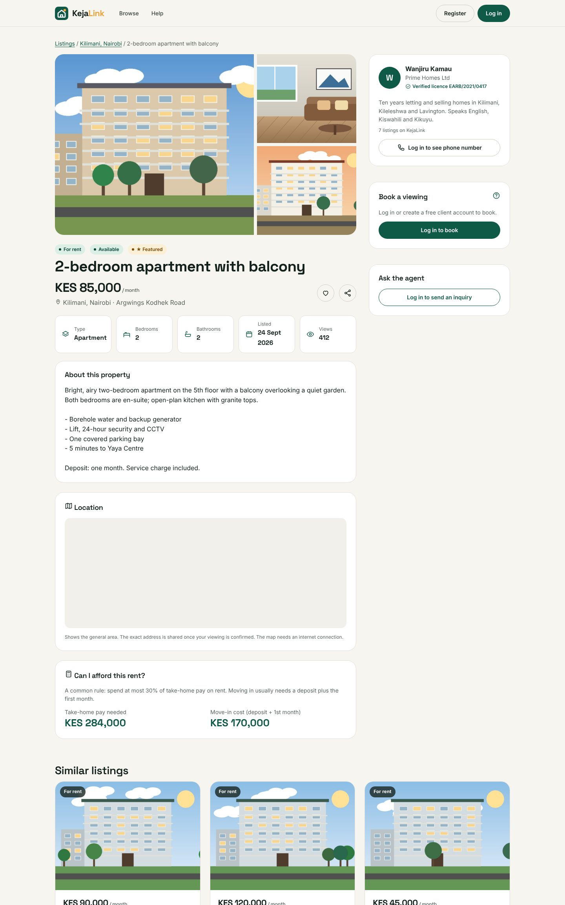
Figure 4: Listing details

2.3 Saving listings
Click the heart icon on a card or listing page. It turns red and the listing is added to Saved in the top menu. Click it again to remove it.

2.4 Booking a viewing
- On the listing page, find Book a viewing on the right.
- Choose a date. Viewings are Monday to Saturday, from tomorrow up to 30 days ahead.
- Free times appear as buttons. Crossed-out times are already taken.
- Click a time, then click Request viewing at …
- A green message confirms the request. The agent is notified and will confirm, reschedule or decline it.
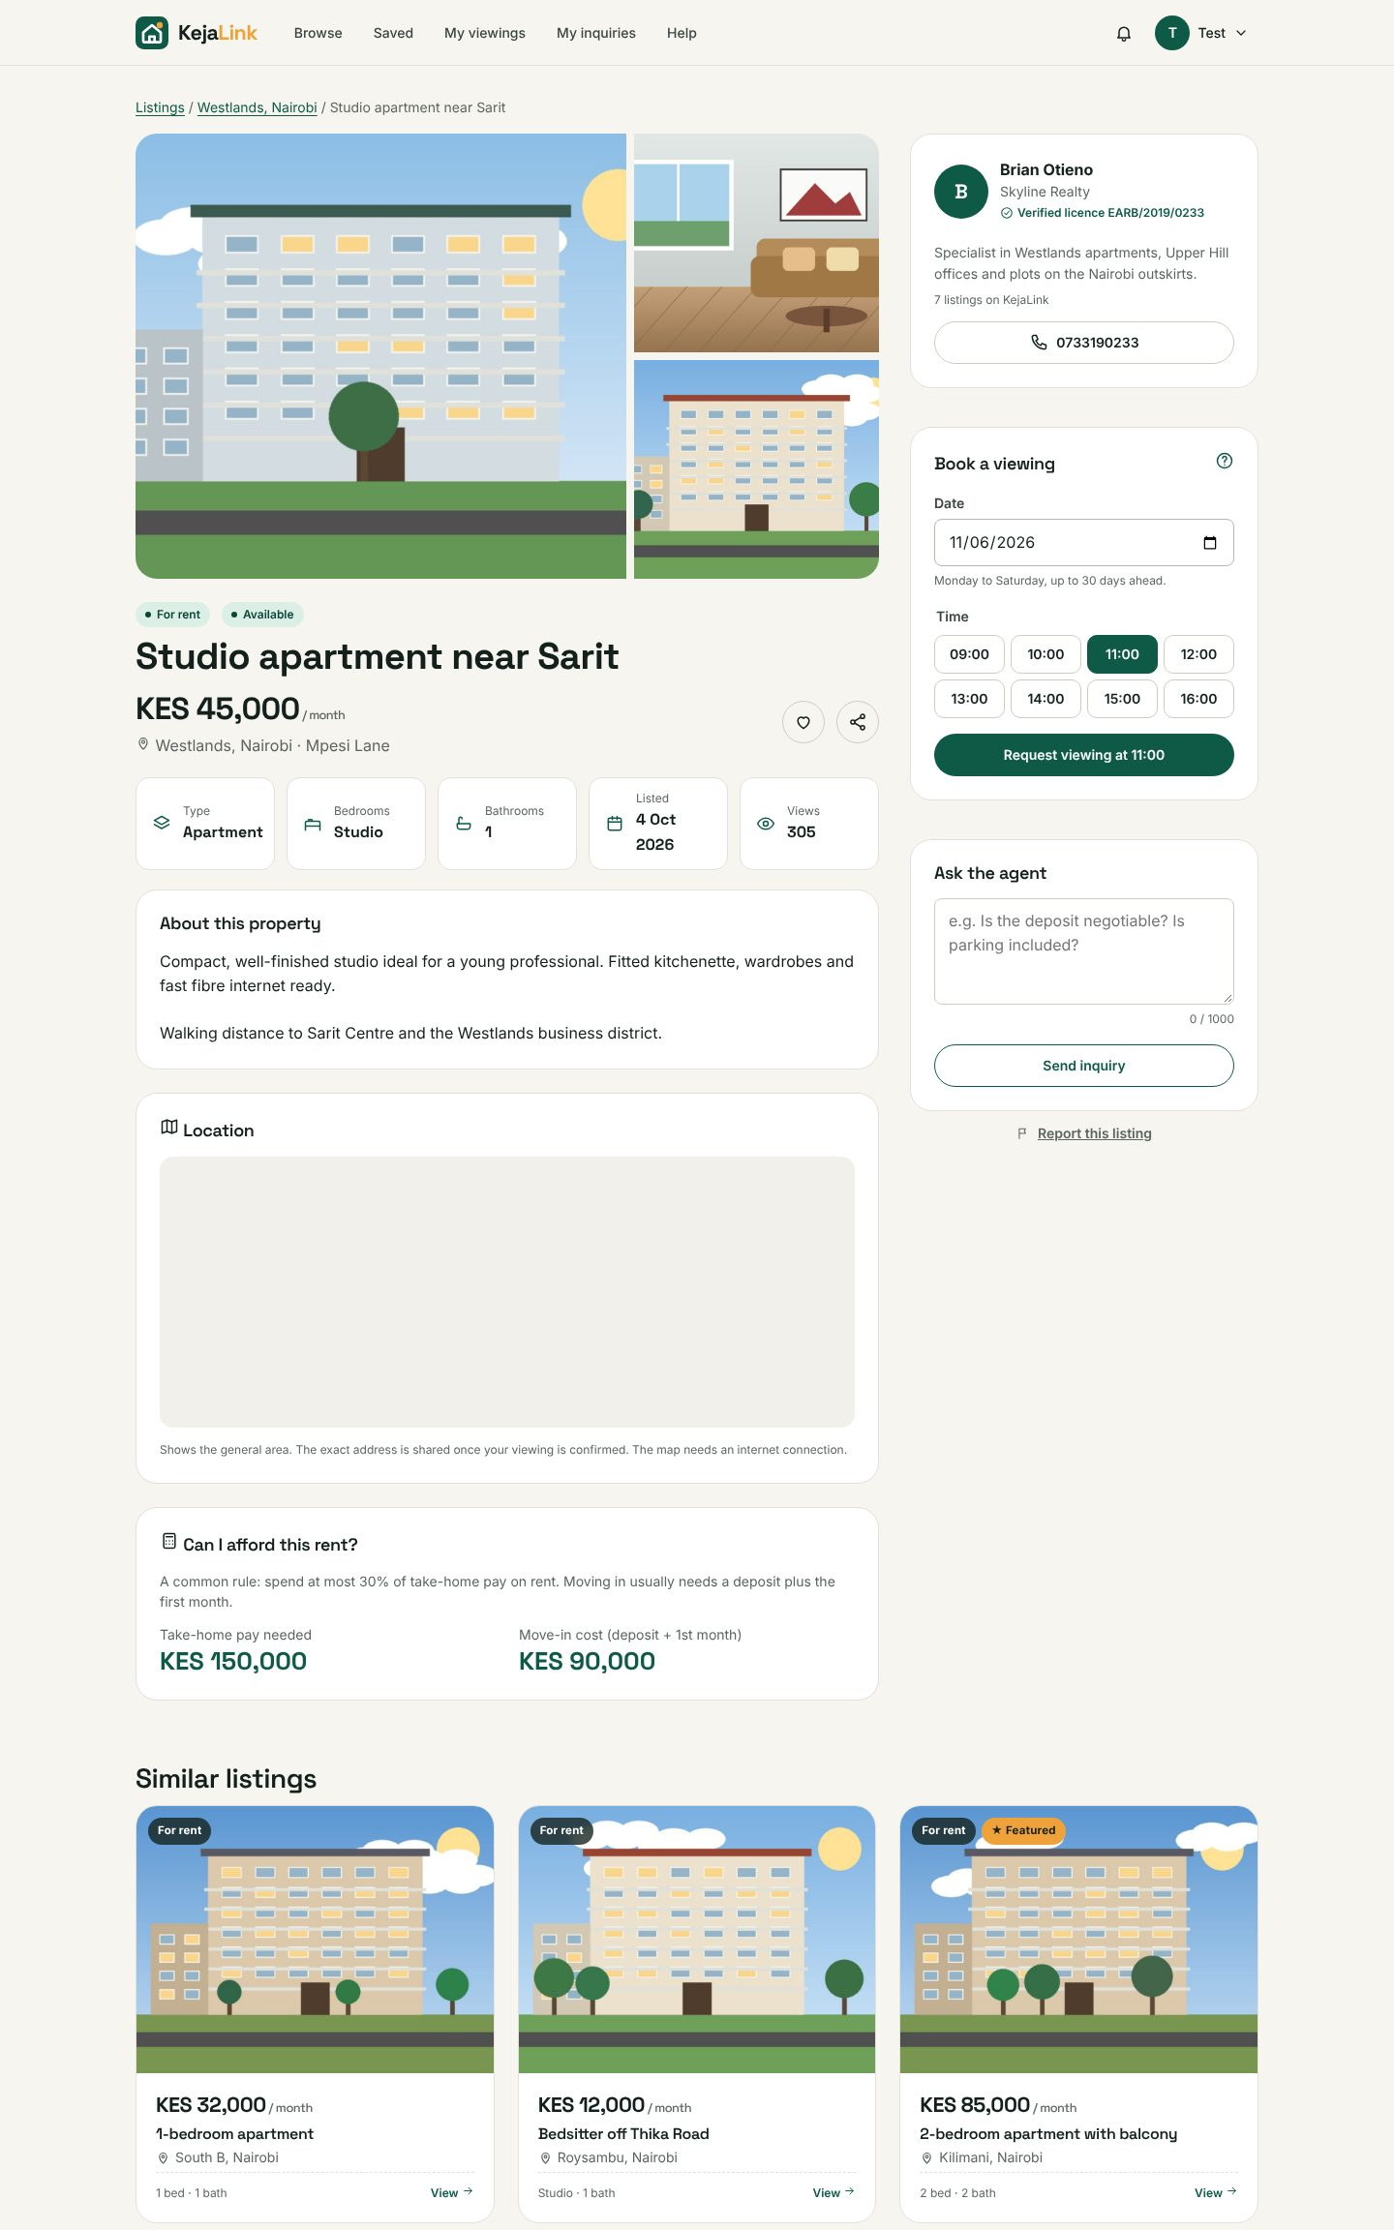
Figure 5: Choosing a date and time

2.5 Managing your viewings
Open My viewings. The Upcoming tab shows live bookings with their status; Past & closed shows the rest. Once a viewing is confirmed, the street address appears. To cancel, click Cancel and confirm. The agent is told, and the slot becomes free for others.
Status | Meaning
Requested | Waiting for the agent to respond
Confirmed | The agent will meet you at the time shown
Rescheduled | The agent moved it to a new time (see their note); cancel if it does not suit you
Declined | The agent cannot do this viewing; their reason is shown
Completed | The viewing took place
Cancelled | You cancelled it
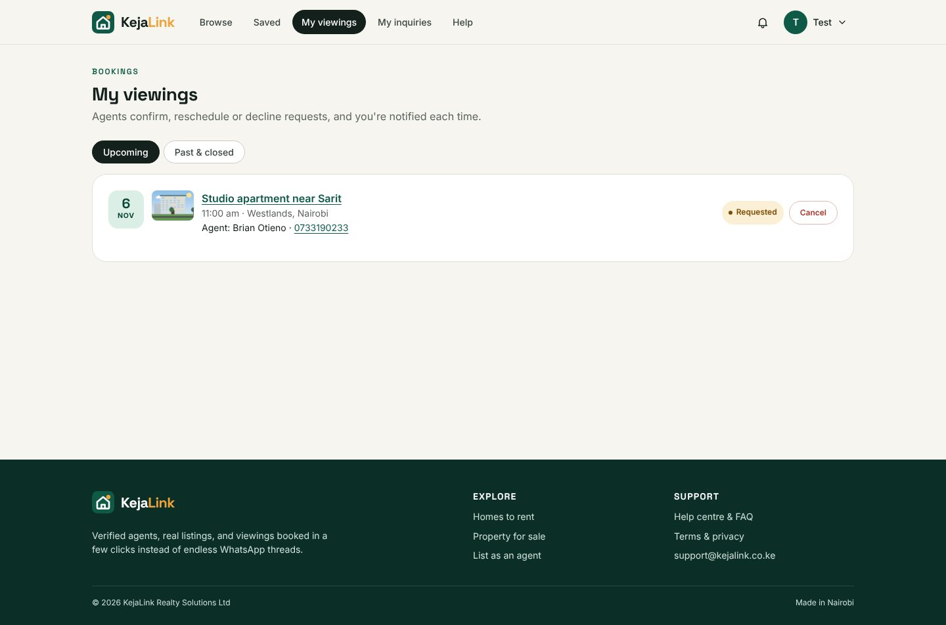
Figure 6: My viewings

2.6 Asking the agent a question
On the listing page, type at least 10 characters under Ask the agent and click Send inquiry. Replies appear on the listing page and under My inquiries, and the bell icon shows a notification.
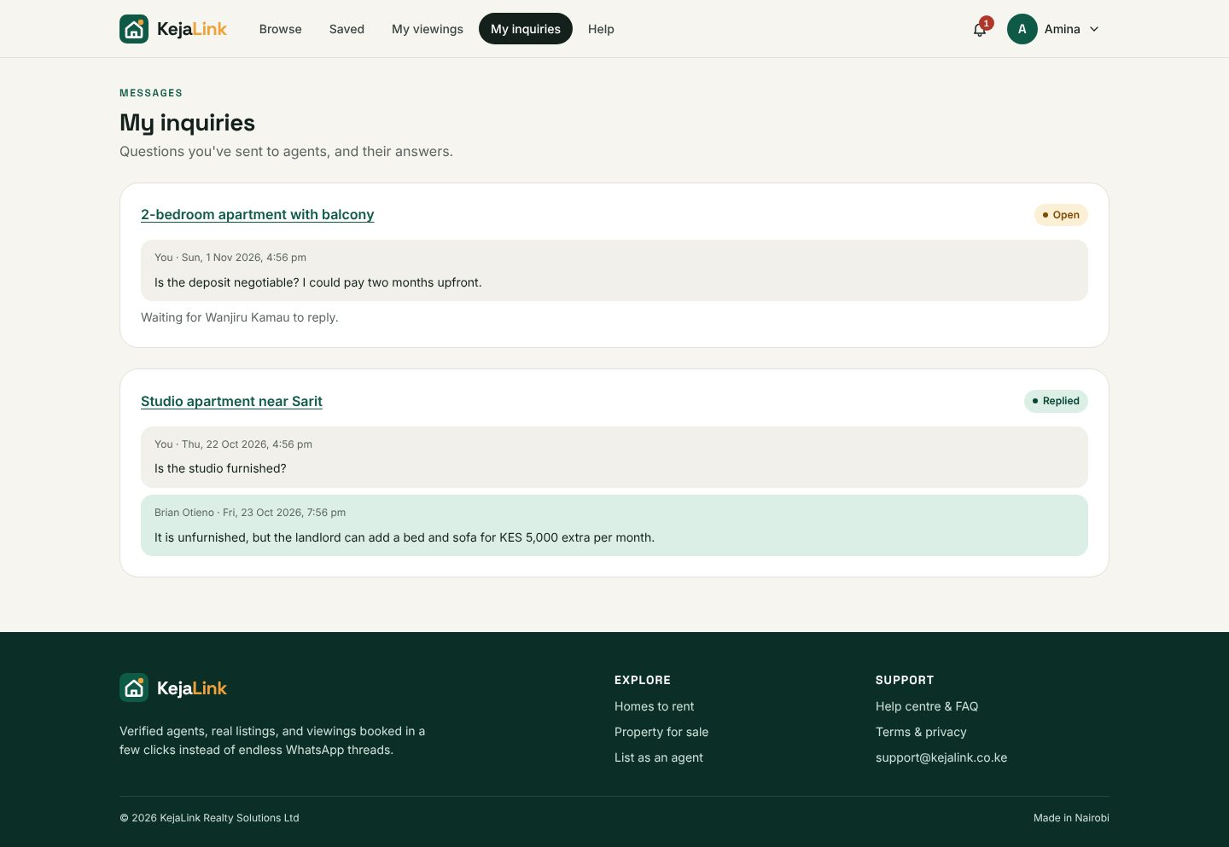
Figure 7: My inquiries with an agent reply

2.7 Reporting a suspicious listing
If a listing looks fake, or the agent asks for money before a viewing, click Report this listing at the bottom of the right-hand column, describe the problem and click Send report. An administrator will review it.

2.8 Notifications
The bell icon at the top shows a red number when you have unread updates. Click it to see the latest ones, or See all notifications for the full list. Clicking a notification opens the related page.

3. Using KejaLink as an agent

3.1 Verification
After registering as an agent you can log in immediately, but a yellow banner says Awaiting verification until an administrator checks your licence. You will get a notification and an e-mail once approved. If verification is rejected, the reason is shown on your dashboard.

3.2 The dashboard
The four boxes show your active listings, open inquiries, viewings awaiting your reply (orange border when there are any) and confirmed viewings this week. Click a box to open the matching page. Below them you can act on viewing requests and reply to the latest inquiry directly. Orange numbers in the side menu show items waiting for you.
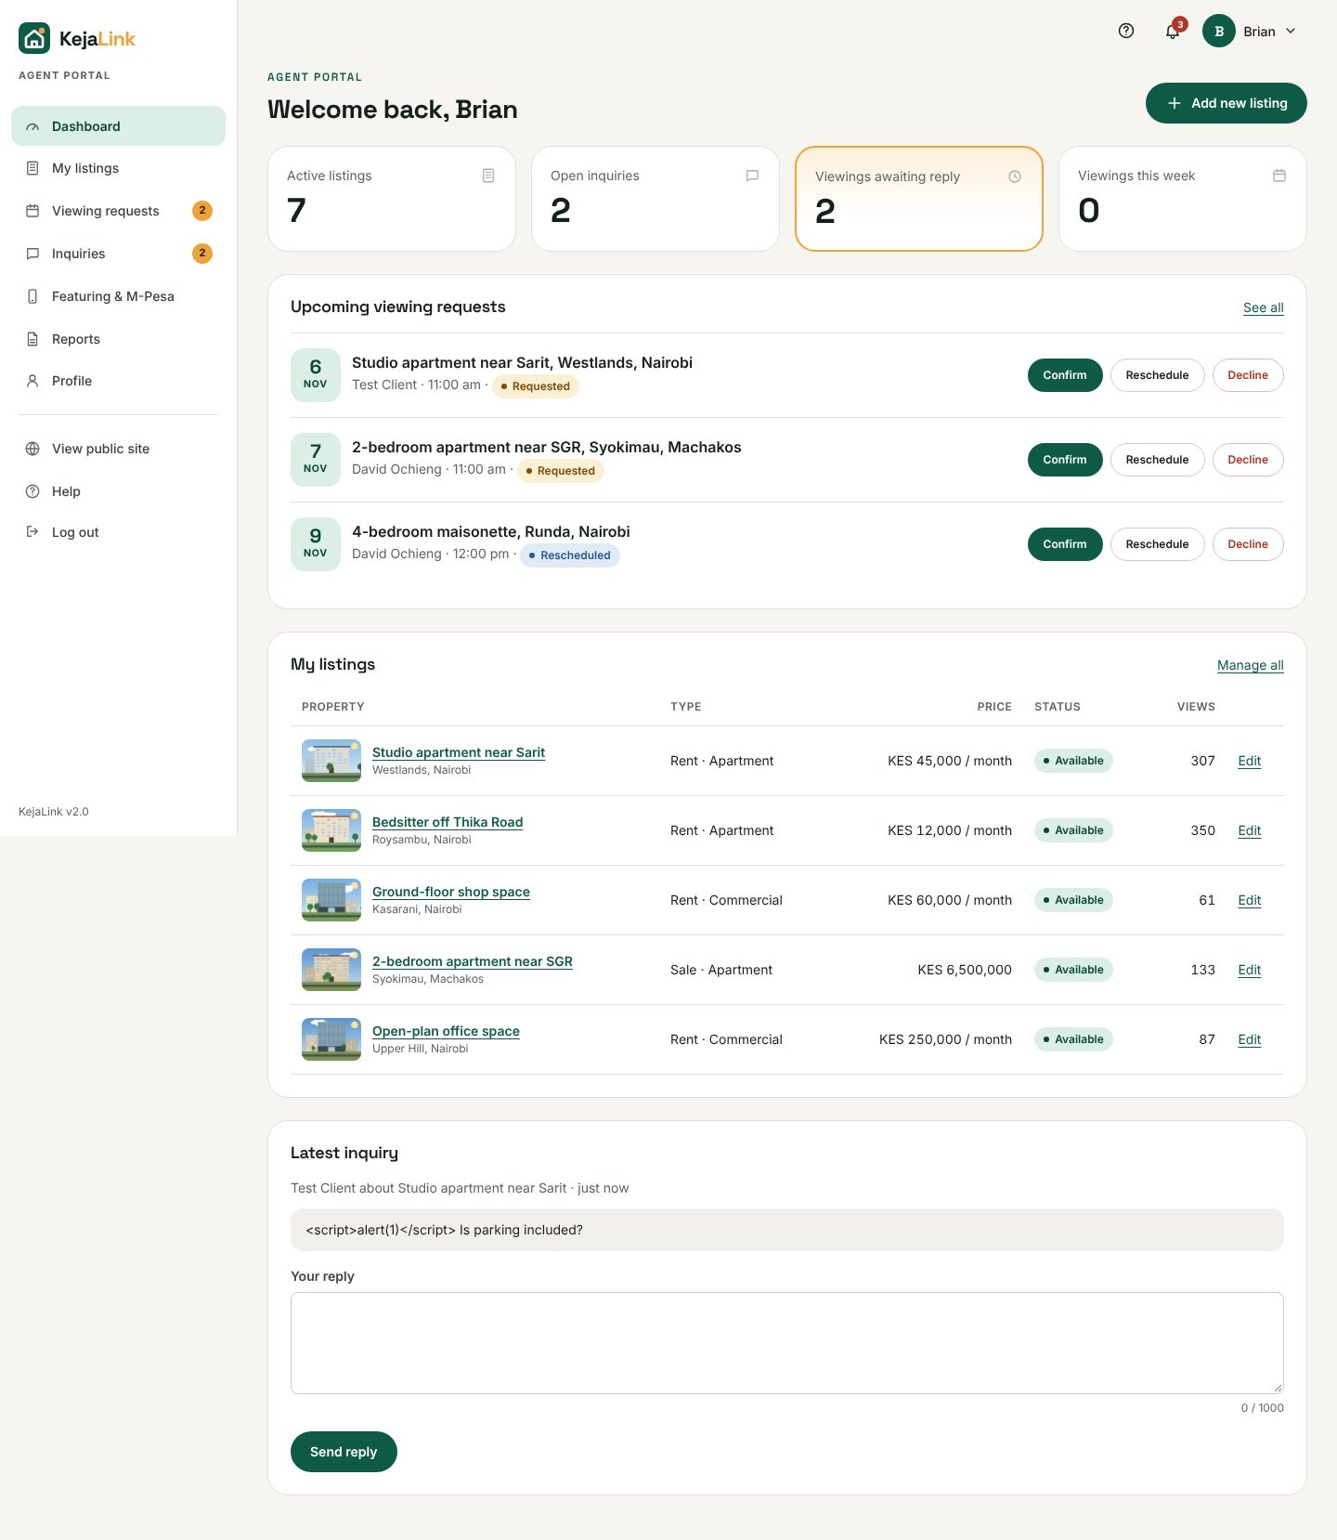
Figure 8: Agent dashboard

3.3 Adding a listing
- Click Add new listing.
- Enter a clear title (5–150 characters), choose rent or sale and the property type.
- Type the price in digits only (e.g. 85000). The formatted price appears under the box. For rentals this is the monthly rent.
- Enter bedrooms (0 for a studio) and bathrooms. These are hidden for land.
- Enter the location as "Area, Town" (e.g. Kilimani, Nairobi) because clients search by it. The street address is optional.
- Write a description: size, parking, water, security, deposit terms.
- Drag 1 to 10 photos onto the box, or click it to choose them (JPG, PNG or WebP, up to 3 MB each). Previews appear below.
- Click Publish listing. It appears in search straight away.
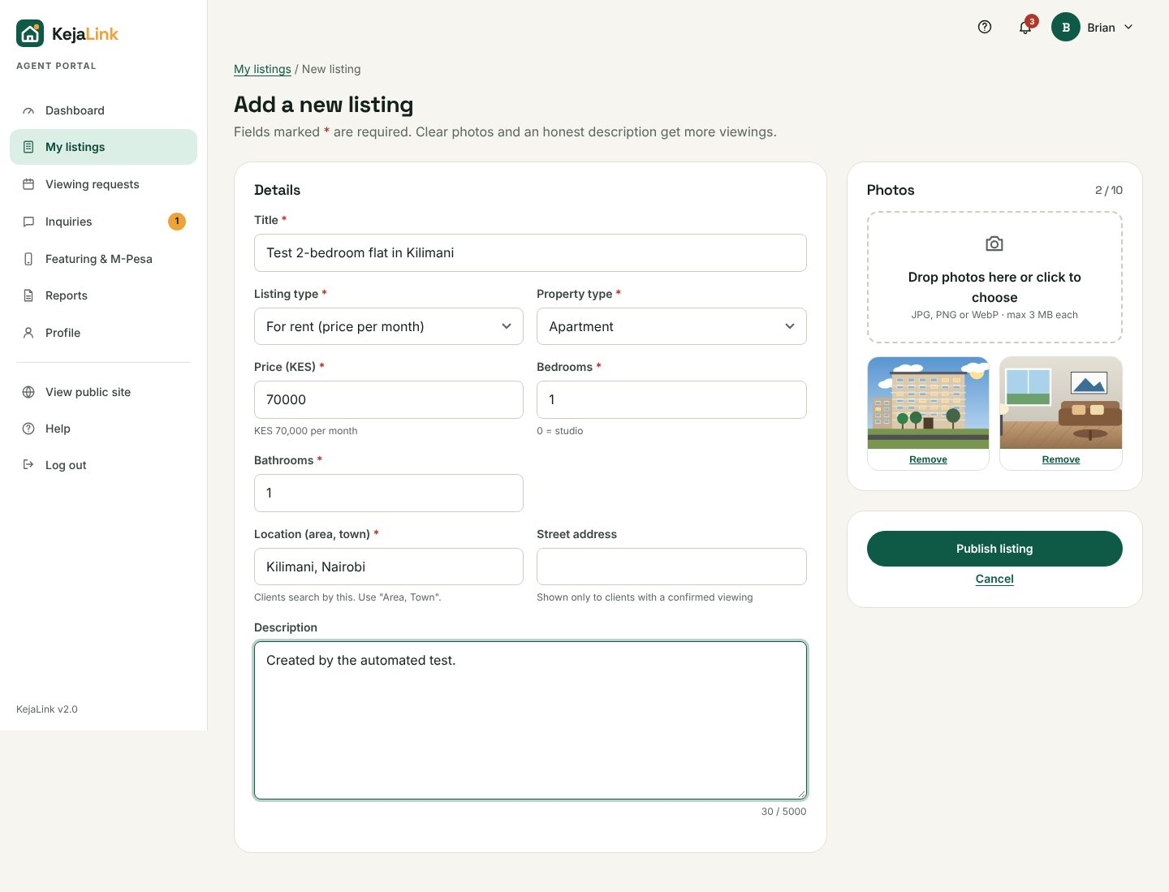
Figure 9: Add listing form

3.4 Editing, status and deleting
- Open My listings. Search by title or location, filter by status, and click a column heading to sort.
- Edit: change any detail, add photos, choose the cover photo, or tick photos to delete them.
- Status drop-down: Available, Under offer, Sold or Rented. Choosing Sold or Rented cancels upcoming viewings and notifies the clients.
- Delete: removes the listing with its photos, viewings and inquiries, after you confirm. This cannot be undone.
- If you leave a half-filled form, the browser warns you about unsaved changes.
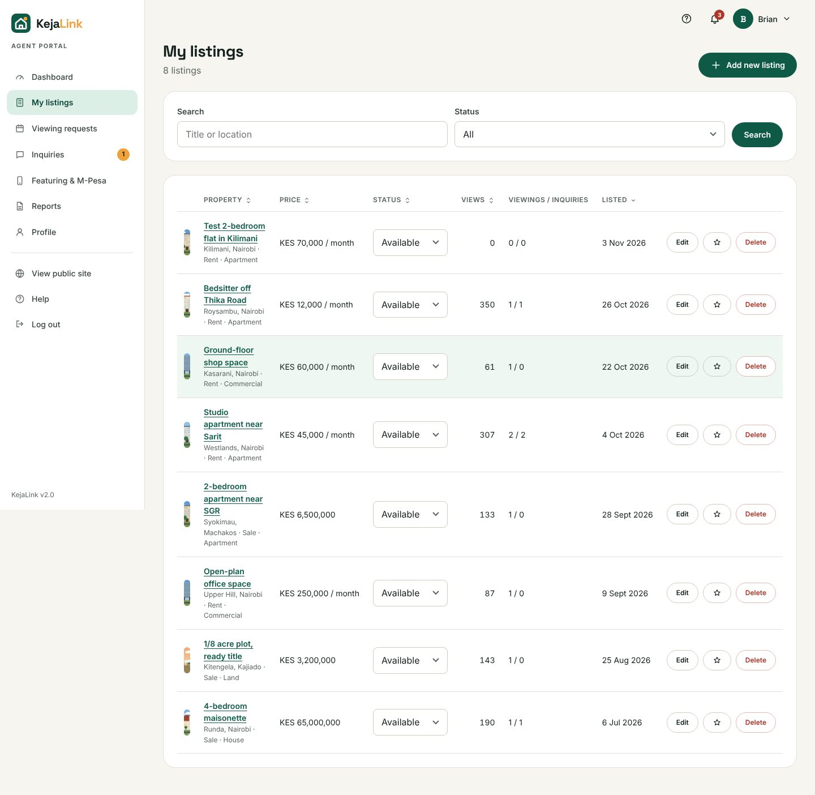
Figure 10: My listings

3.5 Handling viewing requests
- Confirm: accept the requested time.
- Reschedule: pick a new date and time and add an optional note for the client.
- Decline: give a short reason, which is sent to the client.
- Mark completed: appears after the viewing time has passed.
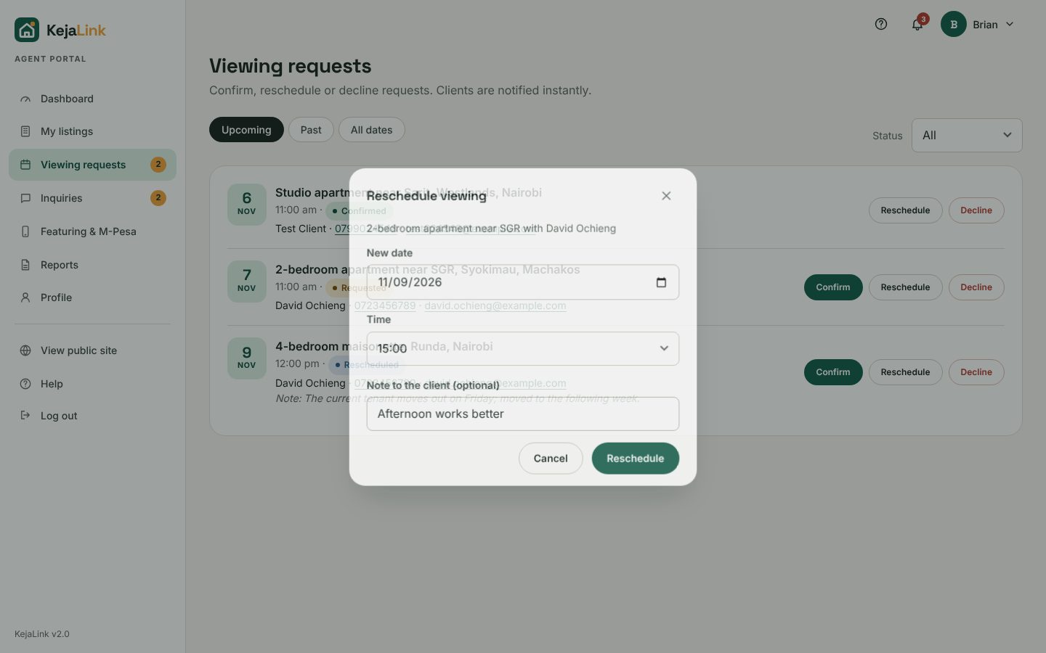
Figure 11: Rescheduling a viewing

3.6 Replying to inquiries
Open Inquiries. The Open tab lists unanswered questions. Type your answer and click Send reply; click Close when the conversation is finished.

3.7 Featuring a listing with M-Pesa
- Open Featuring & M-Pesa, or click the star next to a listing.
- Choose the listing and a package: 7 days for KES 500 or 30 days for KES 1,500.
- Check the Safaricom number that will pay and click Pay with M-Pesa.
- Enter your M-Pesa PIN in the prompt on your phone.
- The page updates automatically. The payment appears in the history with its M-Pesa receipt, and the listing gets a Featured badge at the top of search results.
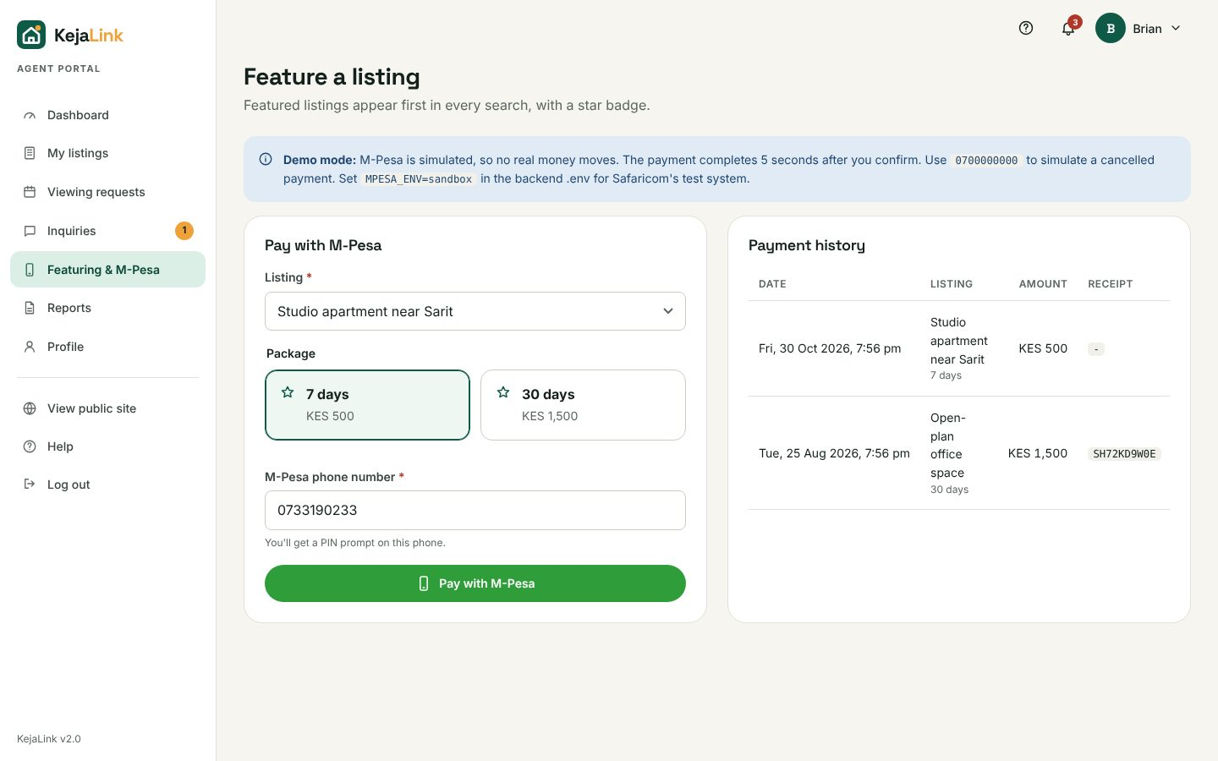
Figure 12: Paying with M-Pesa

3.8 Reports
Open Reports to produce listings, viewings, inquiries or payments reports for your own listings. See section 4.6 for how to use the report builder.

4. Using the admin panel

4.1 Overview
The overview shows total users, agents awaiting verification (orange border), active listings and viewings this month. Below are pending verifications, a moderation search, a report shortcut, charts and the latest activity. A yellow bar appears when clients have reported listings.
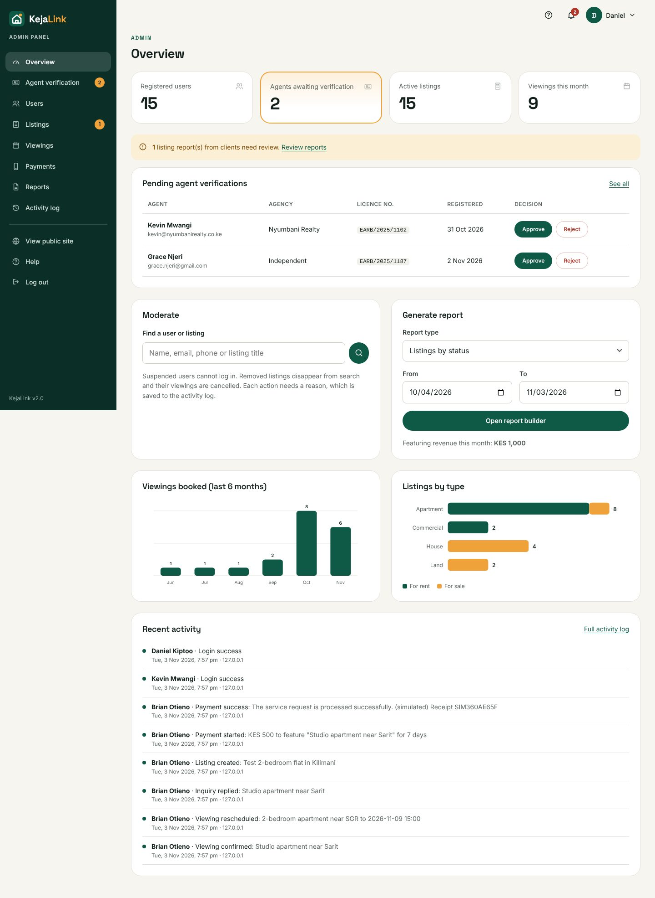
Figure 13: Admin overview

4.2 Verifying agents
- Open Agent verification. The Pending tab lists new agents with their licence numbers.
- Check the licence number with the Estate Agents Registration Board.
- Click Approve and confirm, or click Reject and give a reason.
- Approved agents can be revoked later from the Approved tab.

4.3 Managing users
Open Users. Search by name, email or phone and filter by role or status. Each row has buttons for the actions below.
- Register user: create a client or agent account (super admins can also create admins). A temporary password is shown once and e-mailed; the user must change it at first login. Agents created this way are approved automatically.
- Edit (pencil): change name, email, phone, licence or agency.
- Reset password (key): issues a new temporary password, e.g. for a locked-out user.
- 2FA off: for users who lost their phone. Confirm their identity first. The shield next to a name shows 2FA is on.
- Suspend / Reinstate: suspended users cannot log in, and are logged out on their next click. A reason is required.
- Delete (bin): permanently removes the user and their data, after you confirm.
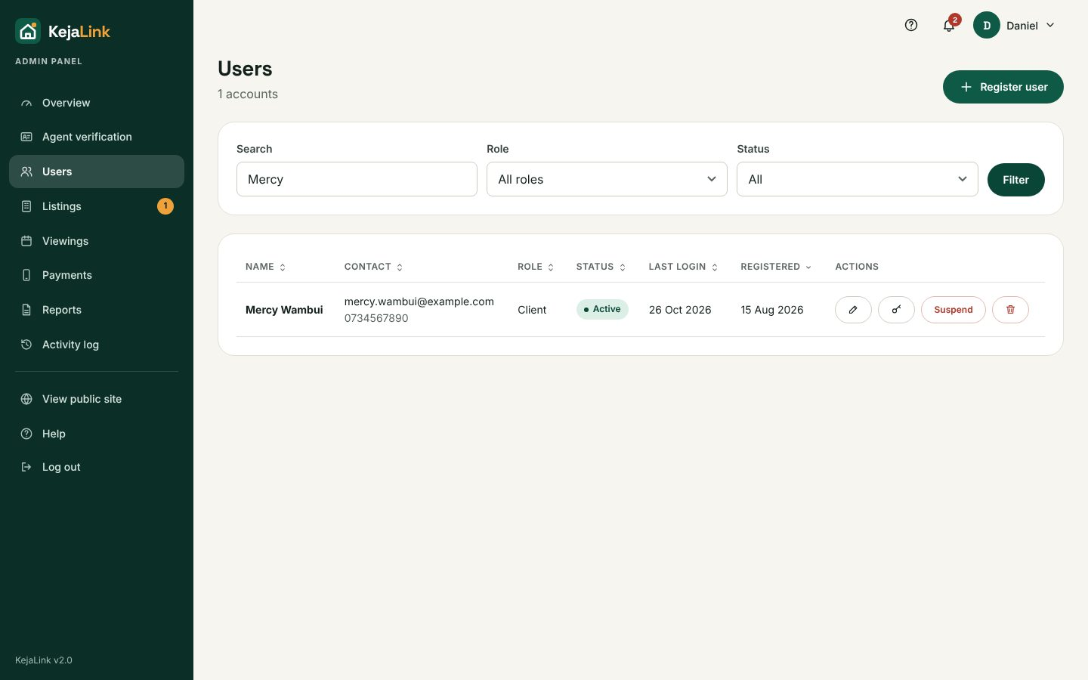
Figure 14: Users

4.4 Moderating listings
Open Listings. Tick Reported only to see listings clients have flagged; the reasons appear under each title. Remove hides a listing, cancels its upcoming viewings and notifies the agent with your reason. Restore reverses it. Dismiss closes a report without action.
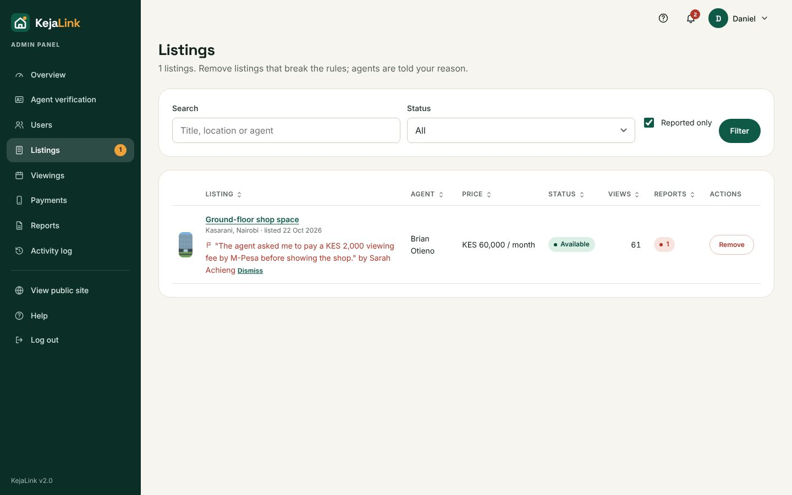
Figure 15: Reported listings

4.5 Viewings and payments
Viewings lists every booking on the platform with search, status and date filters, for oversight. Payments lists all M-Pesa payments with their receipts and the total revenue.

4.6 Generating reports
- Open Reports and choose a report type.
- Set From and To dates, and a status, location or role if needed.
- Click Generate report to preview it. Change Sort by and the direction, then generate again.
- Click PDF to download a printable report with the company name, logo, date and page numbers; Excel (CSV) to open the data in Excel; or Print.
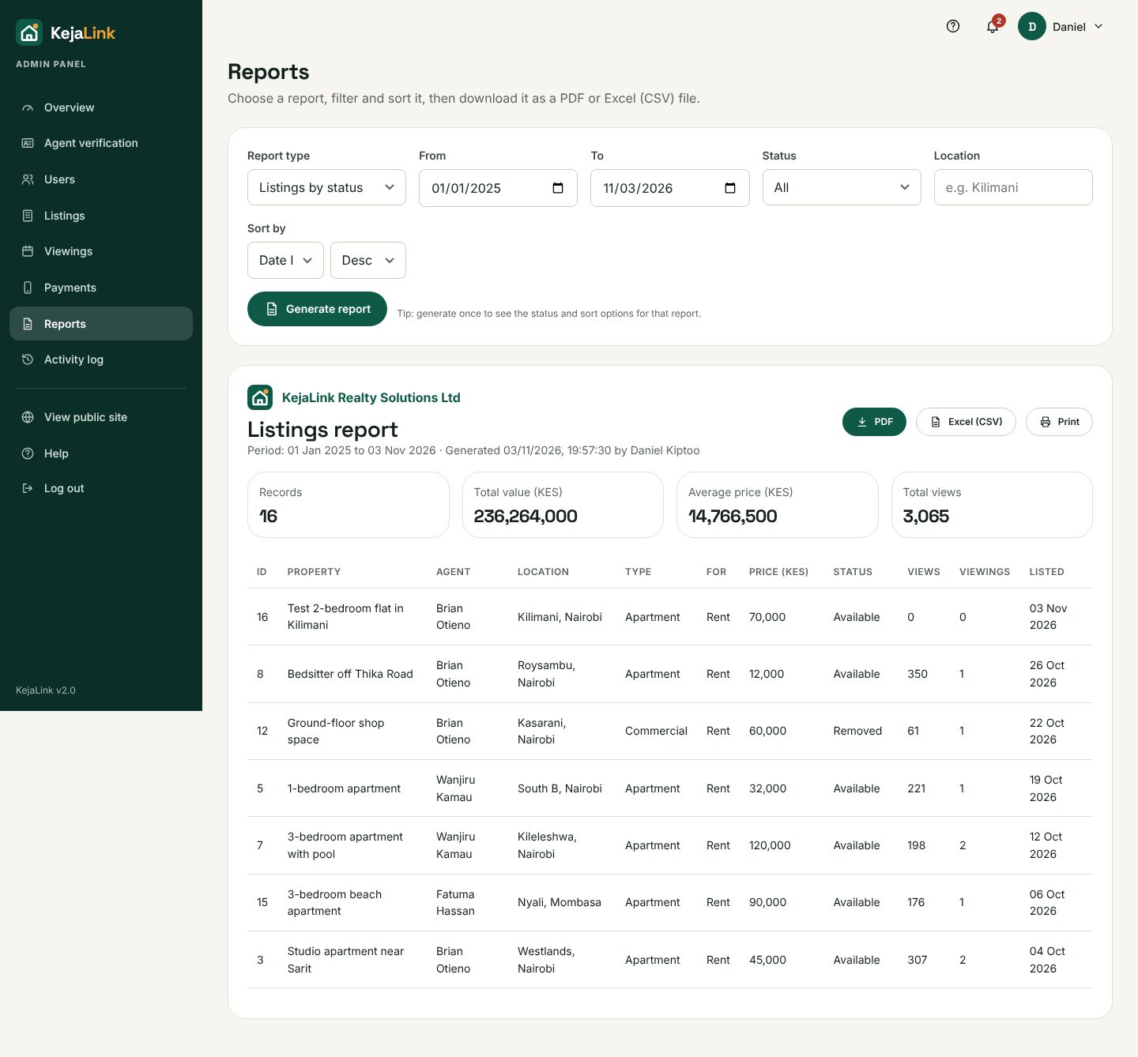
Figure 16: Report builder

4.7 Activity log
Activity log shows who did what and when, from which IP address: logins and failed logins, listing changes, bookings, payments and every admin decision. Filter by action, date or text, and click Export as report for a PDF. Failed or blocked actions are shown in red.
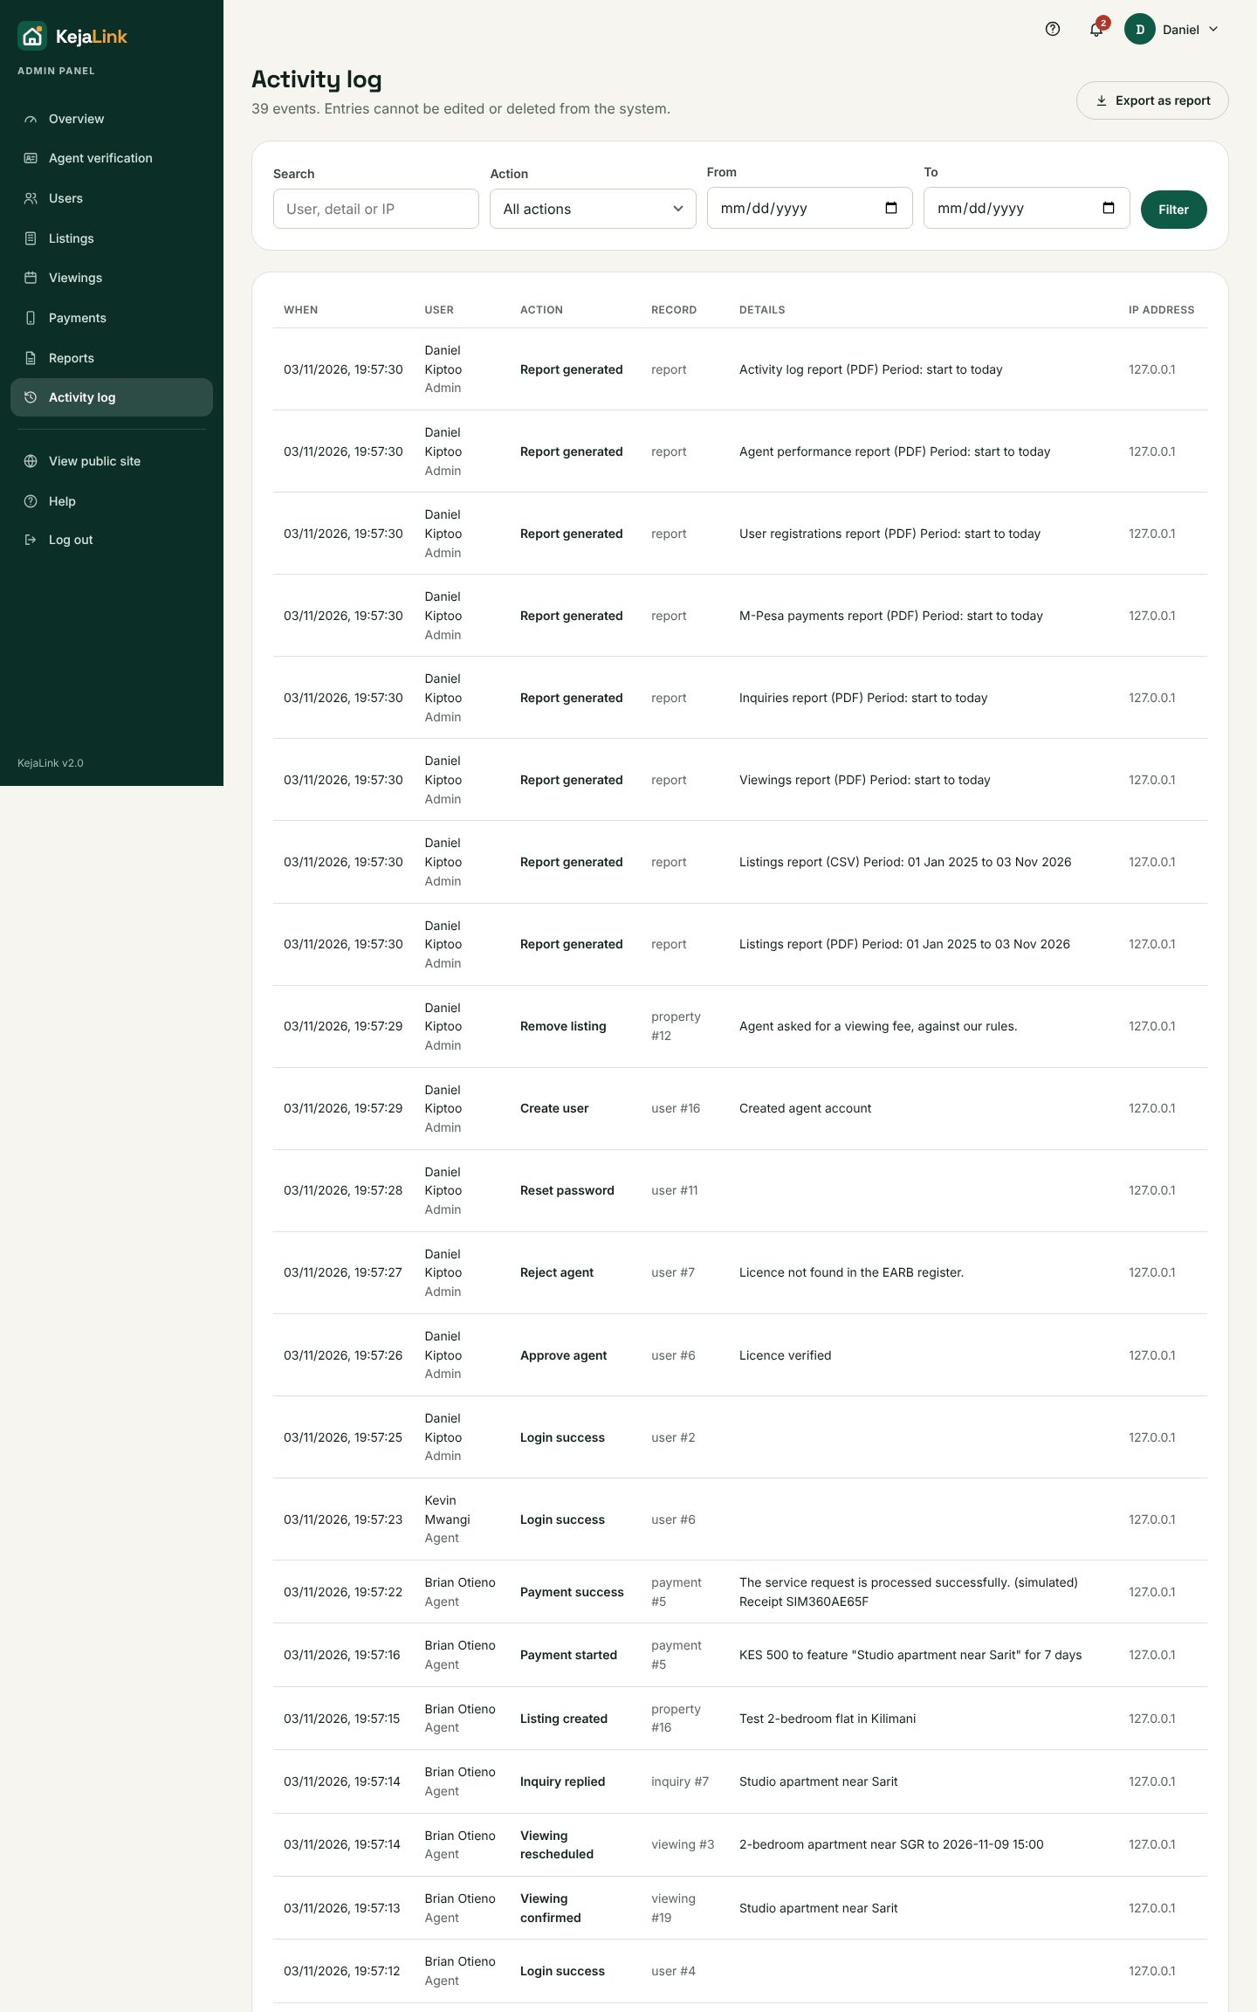
Figure 17: Activity log

4.8 Administrators (super admin only)
Super admins see Administrators in the side menu. From there they can add an administrator, promote an existing client, remove admin rights, or suspend an admin. Ordinary admins cannot change administrator accounts.

5. Account security

5.1 Changing your password
Open the menu under your name → Password & 2FA. Enter your current password and the new one twice, then click Update password.

5.2 Two-factor authentication (2FA)
- Install Google Authenticator, Authy or Microsoft Authenticator on your phone.
- Open Password & 2FA and scan the QR code with the app (or type the key shown beside it).
- Type the 6-digit code from the app and click Turn on 2FA.
- From now on, after your password, KejaLink asks for the current code from the app. Codes change every 30 seconds.
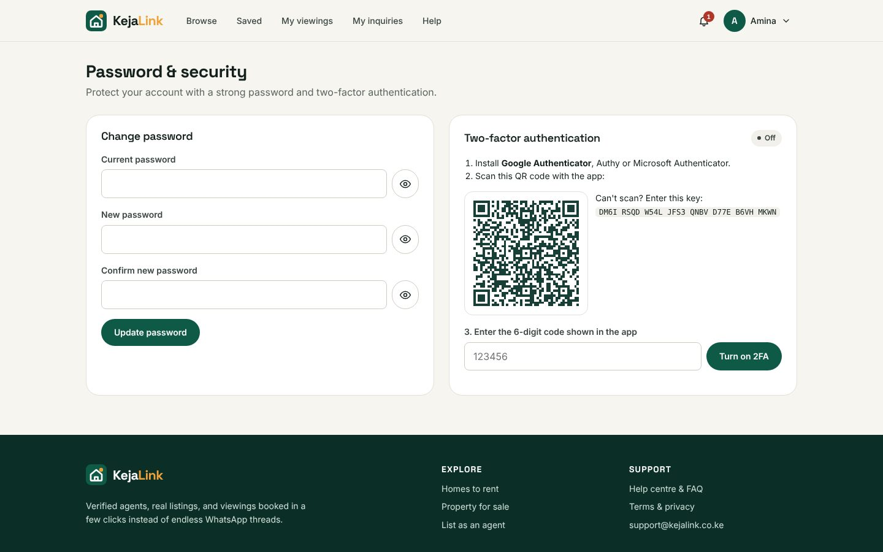
Figure 18: Setting up two-factor authentication
To turn 2FA off, enter your password on the same page and click Turn off 2FA. If you lose your phone, ask an administrator to turn it off for you.

6. Troubleshooting
Problem or message | What to do
"Incorrect email or password." | Check spelling and Caps Lock. After 5 tries the account locks for 15 minutes; use Forgot password? to unlock it sooner.
"This account has been suspended." | Contact support@kejalink.co.ke. An admin can reinstate the account.
"Please correct the highlighted fields." | Read the red message under each highlighted field, fix it and submit again.
"Please log in to continue." | You were logged out after 30 minutes without activity. Log in again; you return to the page you were on.
"Request blocked for security reasons. Refresh the page and try again." | Refresh the page (Ctrl+R) and repeat the action.
"Cannot reach the server. Check your internet connection and try again." | Check your connection. If the site is hosted on a free plan it may take about 30 seconds to wake up; wait and try again.
"Sorry, that time slot was just taken." | Someone booked it moments before you. Pick another time.
"Agents do not hold viewings on Sundays." | Choose a date from Monday to Saturday.
No "Book a viewing" button | Log in with a client account. Listings that are under offer, sold or rented cannot be booked.
Agent cannot add listings | The account is still awaiting admin verification.
"A photo is larger than 3 MB" / "not a JPG, PNG or WebP image" | Resize the photo or save it as JPG, then upload again.
"Something went wrong on our side. Nothing was half-saved. Reference: …" | Nothing was half-saved. Try again; if it repeats, send the reference code to support.
Map is grey | The map needs an internet connection.
Server says it cannot connect to the database (local install) | Check DATABASE_URL in backend/.env: use the Session pooler address and your real database password.

7. Demo accounts
When the demo data is loaded, all of these accounts use the password Password@123:
Role | Email
Super admin | superadmin@kejalink.co.ke
Admin | admin@kejalink.co.ke
Agent | wanjiru@primehomes.co.ke
Agent | brian@skylinerealty.co.ke
Agent (pending verification) | kevin@nyumbanirealty.co.ke
Client | amina@example.com
Client (suspended) | john.kariuki@example.com

