KejaLink
A Property Listing and Viewing Management System for Real Estate Agents

Software Engineering Group Project
Deliverable 3: Development & Debugging
Deliverable 4: Testing, Deployment & Maintenance
Implementation: React · Node.js/Express · Supabase PostgreSQL

Member | Admission no.
Dagane Abdirahman | 220498
Michael Maina | 174483
Mike Malcolm | 220964
Bridget Mutachu | 175228
Morgan Masila | 220986
Strathmore University · 2026

Contents

Right-click the table above and choose Update Field in Word to refresh page numbers.

1. Introduction
Deliverables 1 and 2 defined KejaLink: a web application where licensed agents list properties for sale or rent, clients search, save and inquire about listings and book viewings, and administrators verify agents, moderate the platform and run reports. They also produced the flowchart, use case, class and ER diagrams, the database schema and five UI mock-ups.
This document covers the remaining two deliverables:
- Deliverable 3 (development & debugging): the database created in a DBMS (PostgreSQL on Supabase), the React client front-end, the agent portal and admin panel, and the Node.js/Express API that connects them to the database.
- Deliverable 4 (testing, deployment & maintenance): every feature in the final marking scheme, the test results, how the system is deployed, and the maintenance plan.
The earlier recorded browser run reported 76 of 76 checks passing. The current suite contains 81 checks after the payment and recovery updates; it was not rerun in this validation because it changes seeded database records. The frontend build, 9 backend tests and local health, login, registration, Swagger and properties checks passed.

1.1 Objectives met
Requirement (Deliverable 1) | Status | Where in the system
FR1 Agent registration and verification | Done | Register page (agent role + licence); Admin › Agent verification
FR2 Listing management with photos | Done | Agent › My listings, Add/Edit listing (1–10 photos, drag and drop, cover photo)
FR3 Search and filter | Done | Listings page: location, listing type, property type, price range, bedrooms, sorting, pagination
FR4 Inquiries and viewings | Done | Property page (ask / book); Agent › Inquiries, Viewing requests (confirm, reschedule, decline, complete)
FR5 Administration and reports | Done | Admin › Users, Listings (suspend, remove with reason), Reports (7 types, PDF/CSV)
NFR1 Security: hashing and role-based access | Done | bcrypt hashes; four roles checked by the API on every request; plus 2FA, CSRF guard, lockout, RLS
NFR2 Performance: search under 3 seconds | Done | Filtered search API answered in 3–21 ms on the demo data
NFR3 Usability on phones and desktops | Done | Responsive custom CSS layout; tested at 390 px width with no horizontal scroll

2. Deliverable 3: Development

2.1 Technology stack
Layer | Technology | Why we chose it
Database | PostgreSQL 15 on Supabase | Hosted, backed up, SSL by default, free tier; supports transactions, CHECK constraints, partial indexes and Row Level Security
Back-end | Node.js 18+ with Express 4 | JavaScript on both sides; Express is small enough that every line can be explained in the presentation
Database access | pg driver with parameterised queries | Prevents SQL injection; one shared pool and a transaction helper in config/db.js
Front-end | React 18 + React Router 6 | Component-based single-page app; only the parts of a page that change are redrawn
Build | webpack 5 + Babel | Turns modern JSX into browser code. Vite was not allowed by the brief
Styling | Hand-written CSS (no framework) | The brief banned Tailwind and Bootstrap; a design-token file keeps colours, spacing and type consistent
Auth | bcryptjs, jsonwebtoken, cookie-parser | Password hashing and signed session tokens in httpOnly cookies
Uploads and storage | multer + Supabase Storage | Photos are checked in memory, then stored in the property-images bucket
PDF reports | pdfkit | Builds A4 reports with logo, header, summary boxes and page numbers
Password recovery | In-app admin notifications | An admin issues a temporary password; the user must change it at first login.
Payments API | Safaricom M-Pesa Daraja (STK Push + Query) | Agents can feature a listing with M-Pesa or submit a manual payment reference for administrator review.
2FA | TOTP (RFC 6238) + qrcode | Works with Google Authenticator, Authy, Microsoft Authenticator
Charts and icons are drawn with our own SVG components, so the front-end has only two runtime libraries: React and React Router.

2.2 Architecture
KejaLink is split into two programs that talk over HTTP with JSON:
- frontend/: the React app the user sees. It never connects to the database. Every network call goes through one file, src/api/client.js.
- backend/: the Express REST API under /api/.... It checks who the user is and what they may do, validates input, runs the SQL and returns JSON. In production it also serves the built React files, so the whole system runs as one web service.
Every API request passes through the same chain of middleware in server.js:
- securityHeaders: tells the browser to block framing and MIME sniffing.
- express.json / cookieParser: read the body and cookies.
- loadUser: verifies the kl_session JWT cookie and loads the user into req.user.
- csrfGuard: any request that changes data must carry the header X-KejaLink: 1.
- Route guard: requireLogin('agent'), requireAdmin or requireApprovedAgent on each route.
- Controller → service: validates the input with the Validator class, runs the business logic (for example bookViewing()), writes the audit log and notifications.
- errorHandler: turns any thrown AppError into a JSON message with the right status code; unexpected errors are logged with a reference code.
Folder | Contents
database/ | Fresh setup: 01_schema.sql, 02_security_and_storage.sql, 03_demo_data.sql. Existing databases: run 04_manual_payments.sql, then 05_mpesa_payments.sql.
backend/src/config | env.js (all settings from .env), db.js (connection pool, query helpers, transactions)
backend/src/middleware | auth.js (sessions and roles), security.js (headers, CSRF, rate limit), errors.js
backend/src/routes, controllers | auth, properties, me (client), agent, admin, reports, payments
backend/src/services | viewingService.js: the main transaction and its rules
backend/src/utils | validator, audit + notifications, crypto (2FA), storage, mpesa
frontend/src/api, context, hooks | API client; AuthContext and ToastContext; useApi, useForm, useTitle
frontend/src/components | Layouts, form fields, modals, listing card, SVG icons and charts
frontend/src/pages | Public, auth, client, account, agent and admin pages (about 40)
frontend/src/styles | tokens.css (design tokens), base, layout, components, pages
tests/ | e2e.test.js: 81 browser checks; use a disposable seeded database
In total the application is about 6,600 lines of JavaScript in 86 files, plus about 570 lines of CSS and 520 lines of SQL.

2.3 Database implementation
A fresh PostgreSQL database on Supabase is initialized with 01_schema.sql (tables, constraints, indexes, trigger), 02_security_and_storage.sql (Row Level Security and photo bucket) and 03_demo_data.sql. For an existing database, apply 04_manual_payments.sql followed by 05_mpesa_payments.sql to add manual review and restore M-Pesa fields.
# | Table | Purpose | Key relationships
1 | users | Every account (client, agent, admin, super admin) | 1:1 agent_profiles; 1:N almost every other table
2 | agent_profiles | Licence, agency, verification status | PK is also FK → users (1:1, ON DELETE CASCADE)
3 | properties | Listings | N:1 agent_profiles
4 | property_images | Photos (composition) | N:1 properties, cascade delete; one cover per property
5 | favourites | Saved listings (M:N associative) | Composite PK (client_id, property_id)
6 | inquiries | Client questions and agent replies | N:1 users, N:1 properties
7 | viewings | Bookings: the main transaction | N:1 users, N:1 properties; one live booking per slot
8 | admin_actions | Formal moderation record | N:1 users (admin, target), N:1 properties
9 | audit_logs | Audit trail of all activity | N:1 users (NULL for anonymous events)
10 | payments | M-Pesa and manual payments to feature listings | N:1 agent_profiles, N:1 properties
11 | notifications | In-app alerts (bell icon) | N:1 users
12 | listing_reports | Clients flag suspicious listings | N:1 properties, N:1 users

Changes from the Deliverable 2 schema
Change | Reason
MySQL → PostgreSQL: AUTO_INCREMENT → identity columns, ENUM → varchar + CHECK, DATETIME → timestamptz | Supabase runs PostgreSQL. CHECK constraints are easier to change than enum types, and timestamptz stores times correctly across time zones.
viewings: UNIQUE(property_id, scheduled_at) replaced by a partial unique index on live bookings only | The original constraint blocked a slot forever, even after the viewing was declined or cancelled. The partial index ignores dead bookings.
viewings: second partial unique index (client_id, property_id) | A client may hold only one live booking per property; the database enforces it, not just the code.
property_images: partial unique index on is_cover | Exactly one cover photo per property.
viewings.viewing_status: added "cancelled"; users.role: added "super_admin" | Clients cancel their own bookings; only a super admin can create or remove admins.
users: must_change_password, twofa_enabled, twofa_secret, failed_logins, locked_until, last_login_at | Forced password change, two-factor authentication, brute-force lockout, activity reporting.
properties: featured_until, views_count; inquiries: replied_at | Paid featuring, popularity sorting, response-time reports.
Trigger set_updated_at | Fills updated_at automatically on every edit.
Row Level Security on all tables, no policies | Supabase's public API key cannot read any table; only our backend can.
New tables 9–12 | Audit trail, payments, notifications and listing reports. Password recovery uses admin notifications and temporary passwords, not reset tokens.

Normalisation
- 1NF: every column holds a single value; photos are a separate table rather than a list in one column; favourites are rows, not a comma-separated field.
- 2NF: the only composite key is favourites (client_id, property_id), and its one non-key column (saved_at) depends on the whole key.
- 3NF: no non-key column depends on another non-key column. Agent details (licence, agency) live in agent_profiles, not repeated on each property; client and agent names are joined from users, not copied into viewings or inquiries.
- Reports are SQL queries over these tables, so no derived totals are stored.

Constraints enforced by the database
- Primary keys on every table; foreign keys with deliberate rules: CASCADE where the child cannot exist alone (images, viewings, inquiries), SET NULL where history must survive (audit logs, moderation targets).
- UNIQUE: user email, user phone and agent licence number; partial UNIQUE: M-Pesa CheckoutRequestID, live viewing slot, live client booking and cover photo.
- CHECK: allowed values for every status and role column, property price > 0, payment amount > 0.
- Indexes on columns used by search and joins (status/type/price, lower(location), agent, schedule, audit dates).

2.4 Final entity-relationship diagram
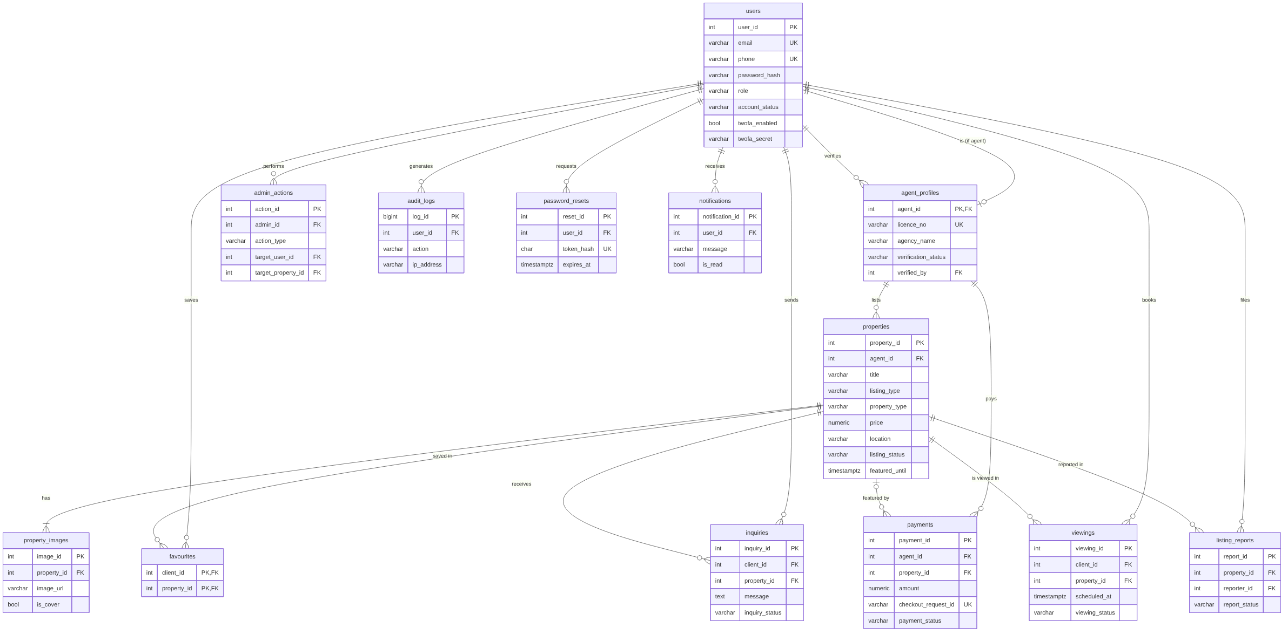
Figure 1: ER diagram of the final 12-table PostgreSQL database (crow's-foot notation; key columns shown, full columns in 01_schema.sql)

2.5 Connecting the front-end and admin panel to the database
The React pages (client, agent and admin alike) call the Express API; only the API connects to PostgreSQL. It does so through one pool in backend/src/config/db.js. Values are sent to PostgreSQL separately from the SQL text as numbered parameters, so user input can never change the command:
const pool = new Pool({ connectionString: config.databaseUrl, ssl: { rejectUnauthorized: false }, max: 10 });

async function query(sql, params = []) {
return (await pool.query(sql, params)).rows;
}
// Example from adminController: the search text is a parameter, never part of the SQL
const users = await query('select ... from users where full_name ilike $1 or email ilike $1 or phone ilike $1 limit 5', [q]);
Multi-step changes use transaction(async (tx) => { ... }), which runs begin, the caller's queries and commit on one borrowed connection, and rollback if anything throws. Column names used for sorting cannot be parameters, so they come from a whitelist in each controller.
On the front-end, api/client.js wraps fetch: it adds the CSRF header, sends the session cookie, and turns error responses into an ApiError carrying the message and field errors. The useApi hook loads data with loading and error states; useForm submits forms and shows each server message under its own field.

2.6 Client front-end
The front-end uses a custom design system: deep emerald and amber on warm paper-white, Space Grotesk headings and Inter text, white cards, and the same navigation on every page (Listings, Saved, My viewings, My inquiries).
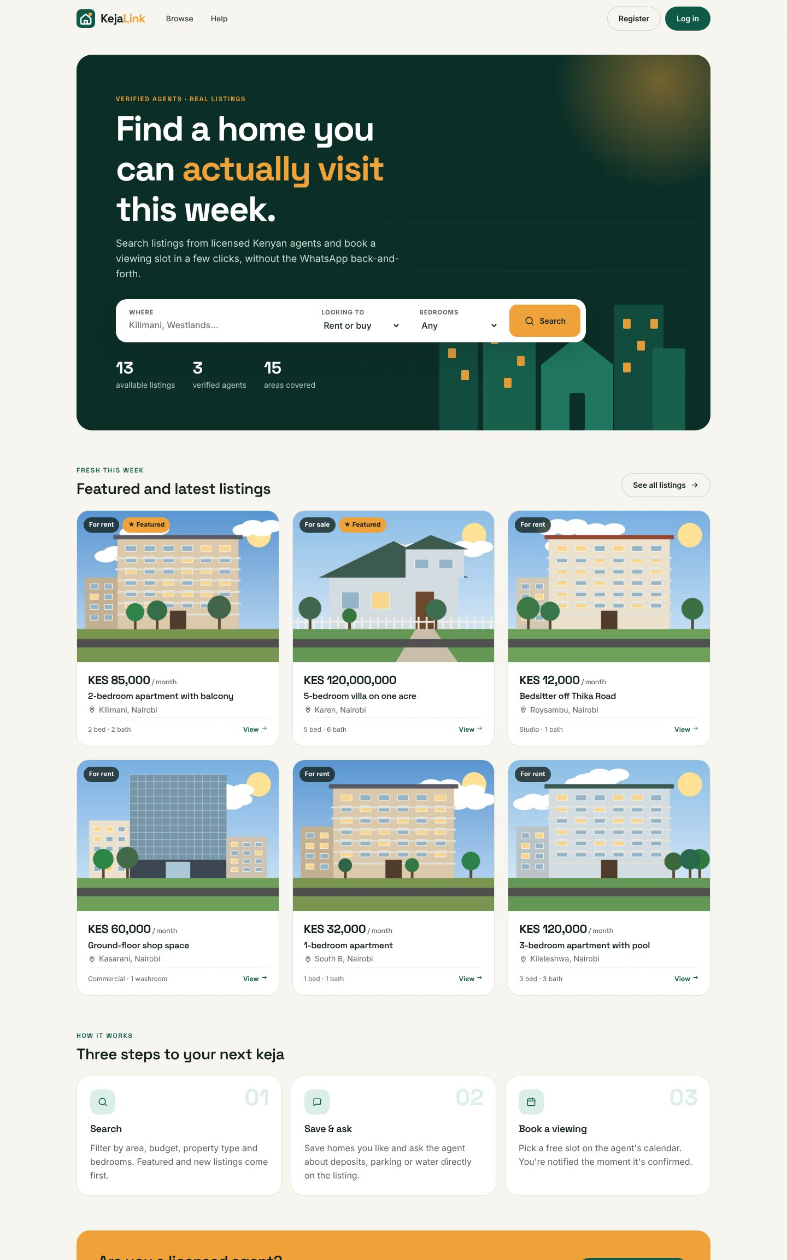
Figure 2: Home page with quick search and featured listings
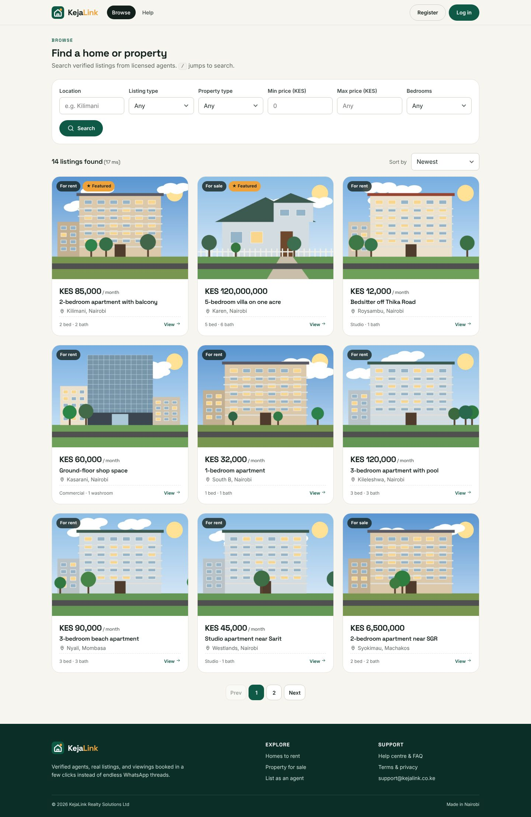
Figure 3: Search and filter listings (FR3)
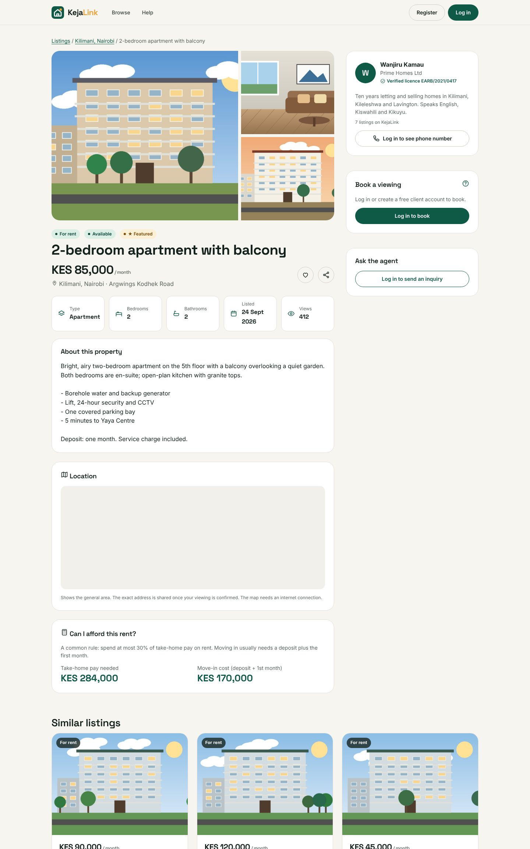
Figure 4: Property details with gallery, agent card, booking and inquiry panels and affordability calculator
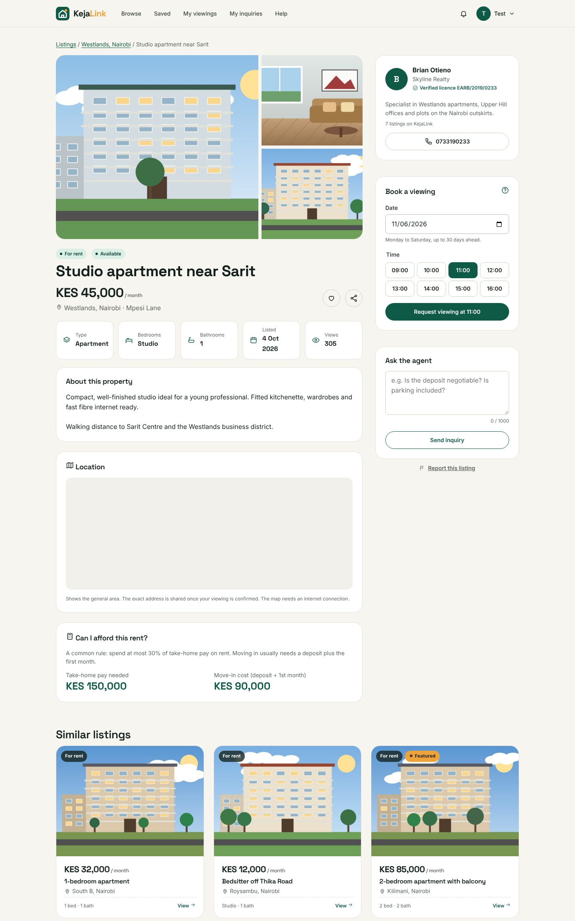
Figure 5: Choosing a viewing slot; taken slots are disabled
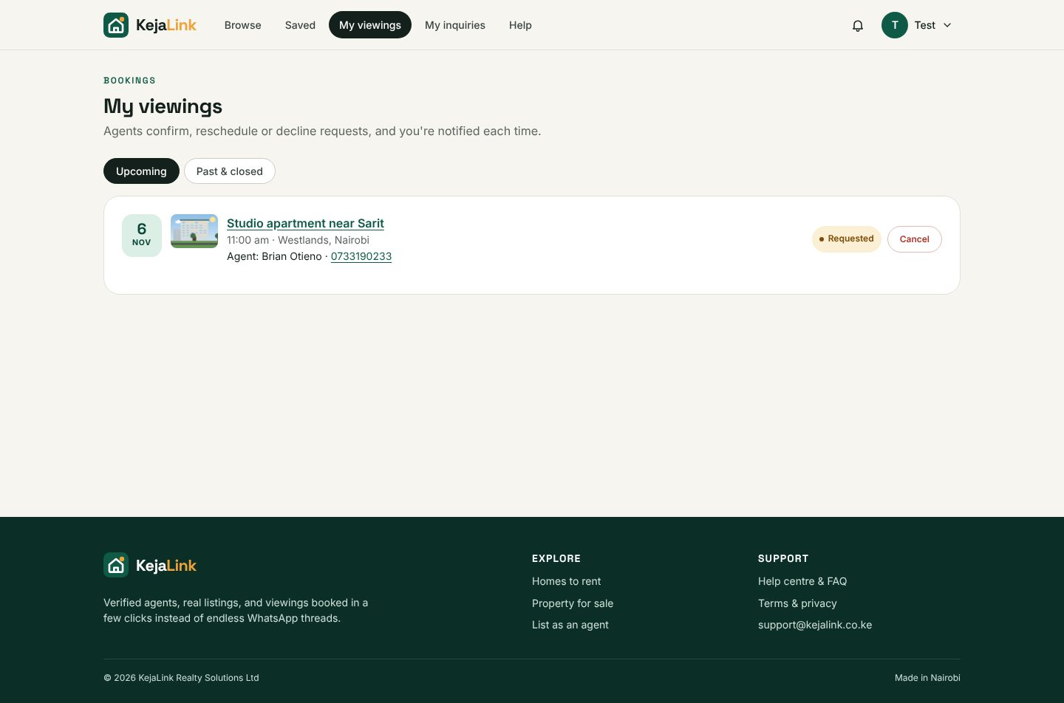
Figure 6: Client "My viewings" with status and cancel

2.7 Agent portal
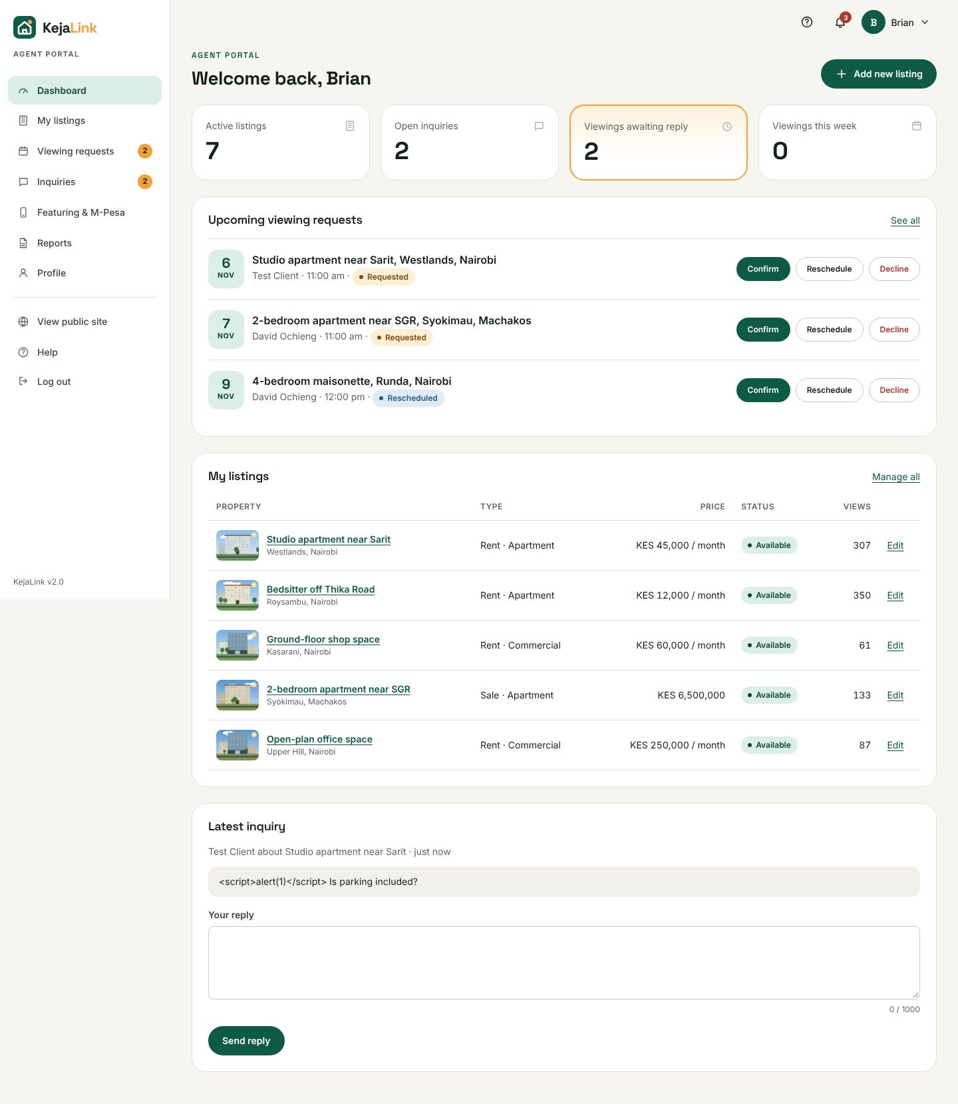
Figure 7: Agent dashboard with statistics and SVG charts
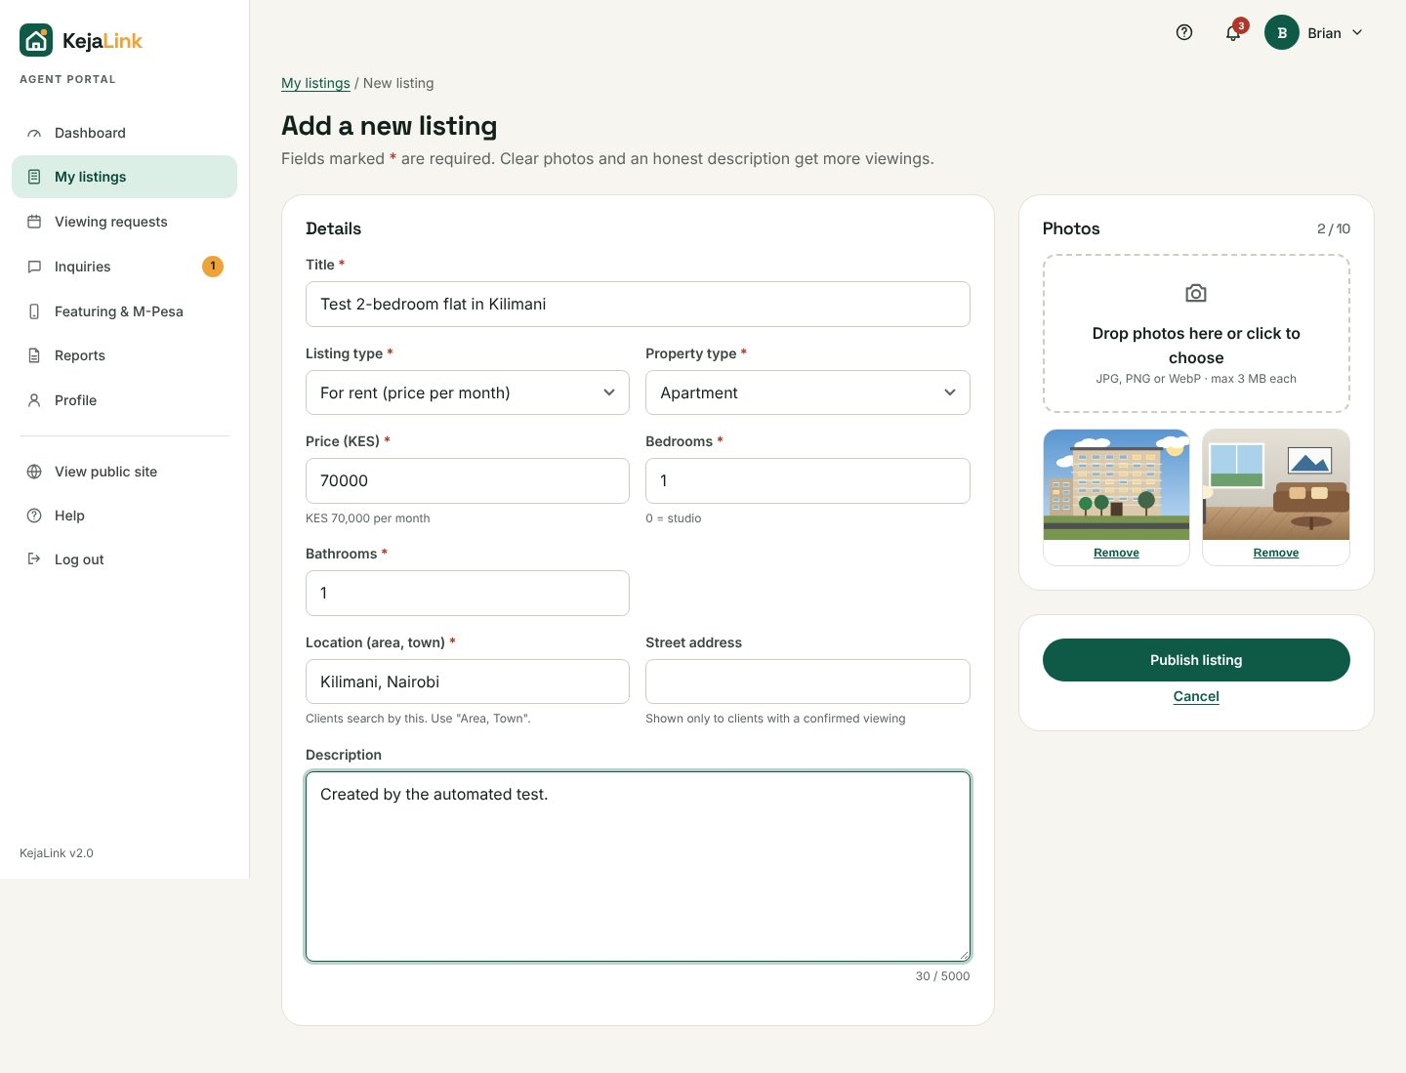
Figure 8: Add listing form with drag-and-drop photos, price formatting and validation
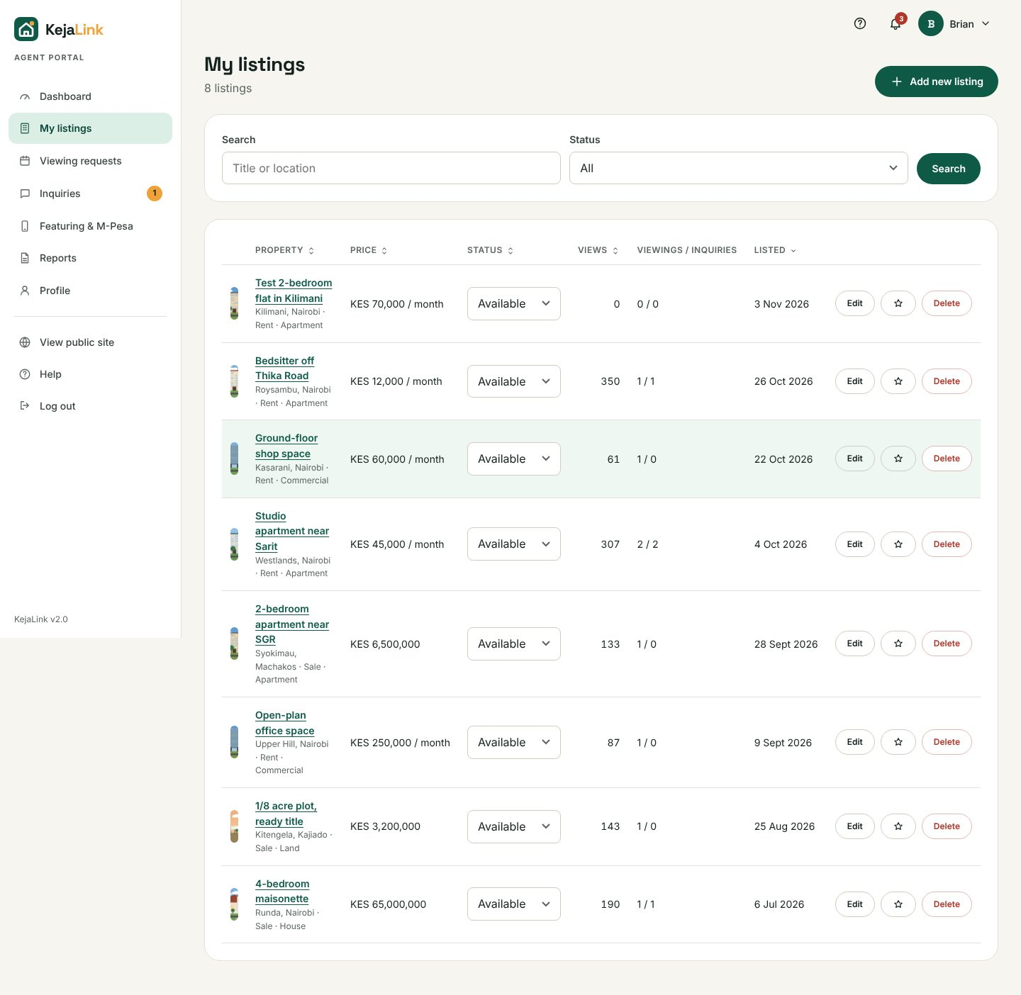
Figure 9: My listings: search, sort, change status, edit, feature, delete
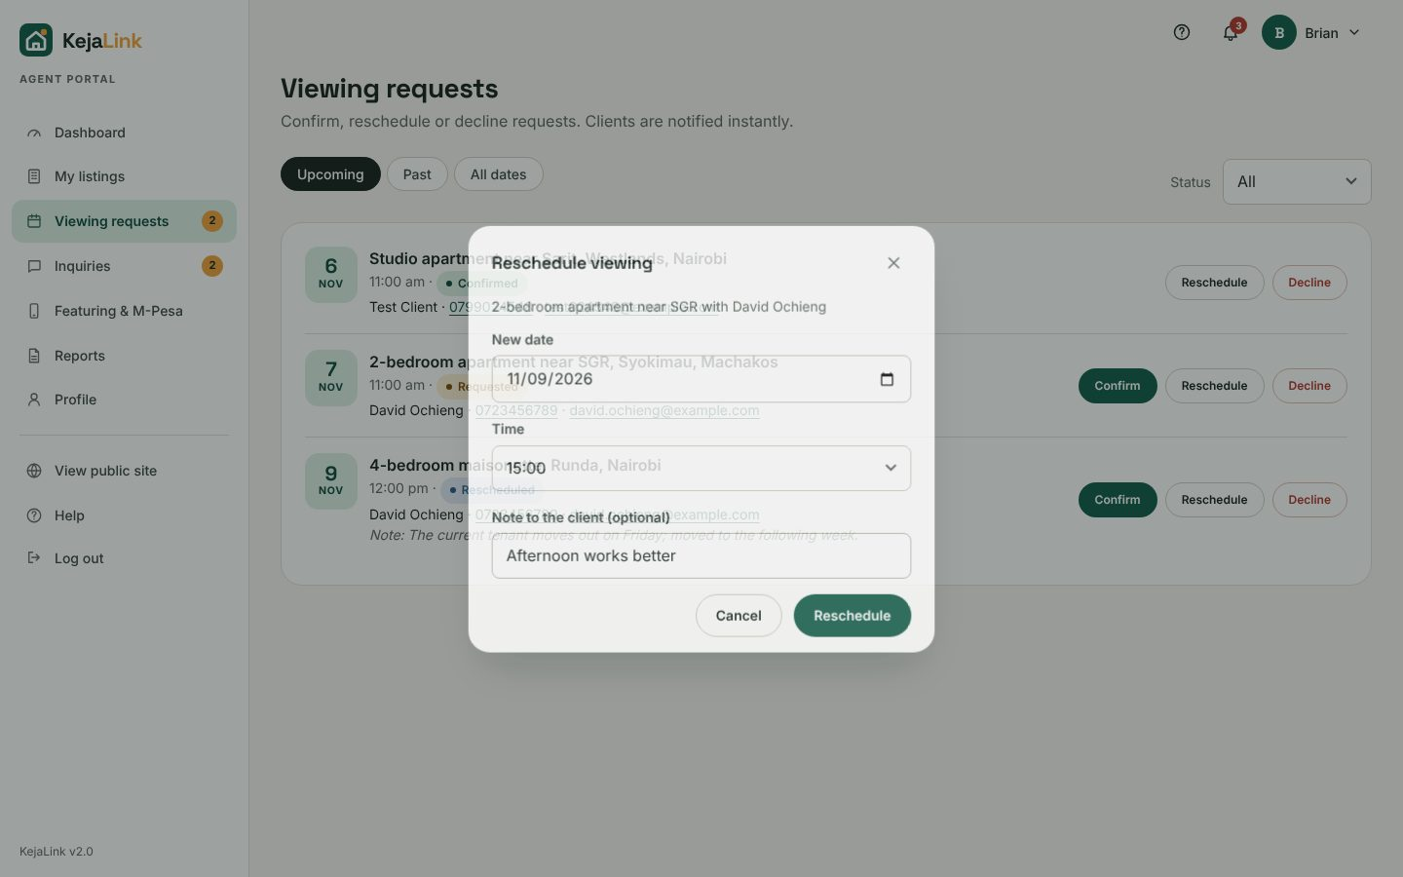
Figure 10: Rescheduling a viewing request

2.8 Admin panel
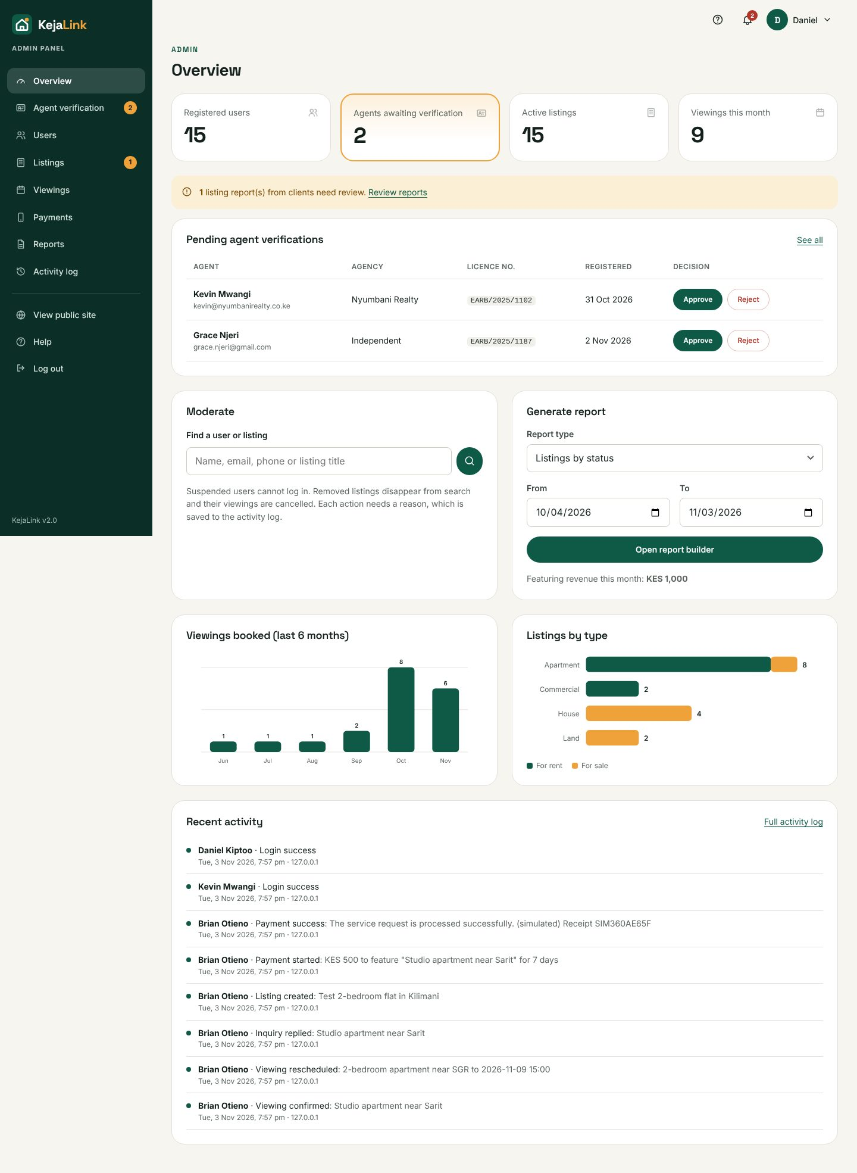
Figure 11: Admin overview with statistics, pending work and charts
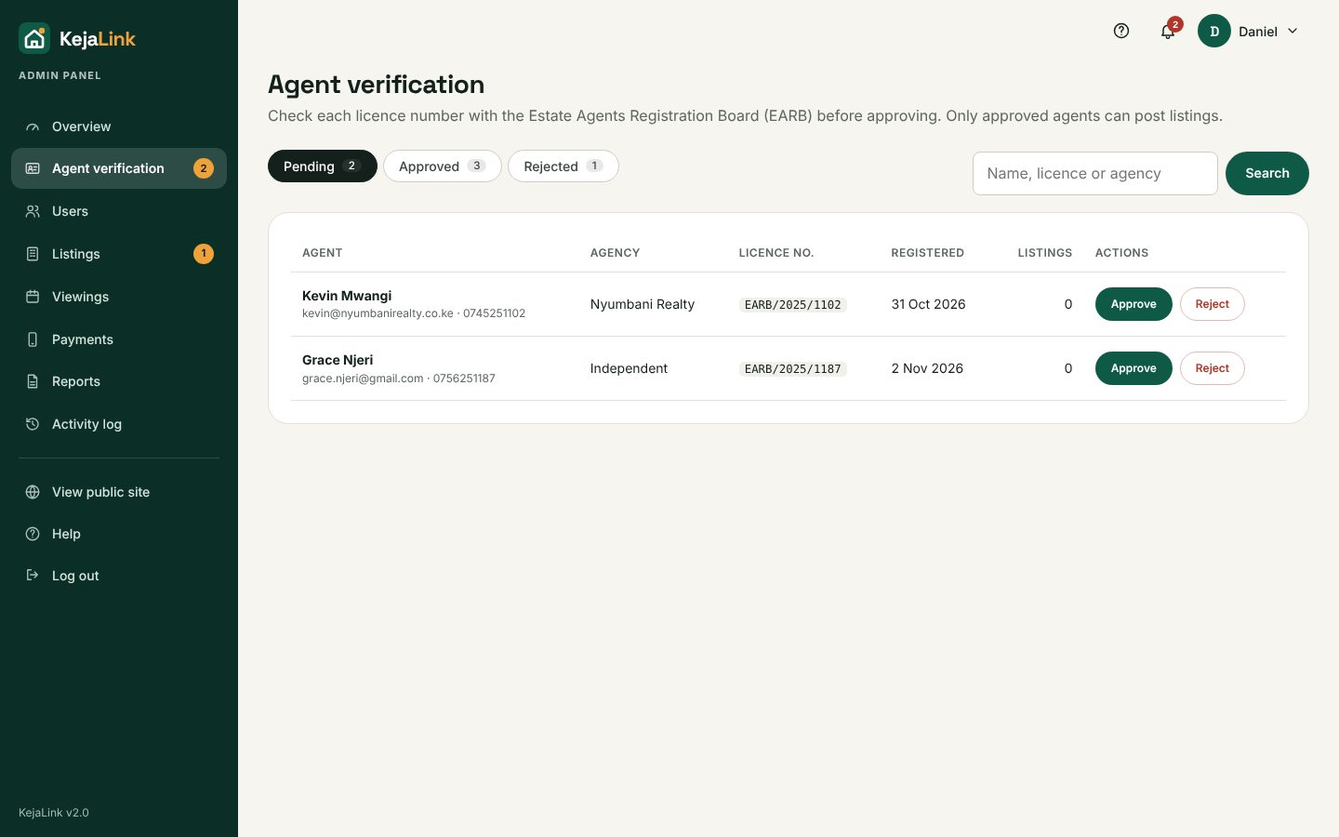
Figure 12: Agent verification queue
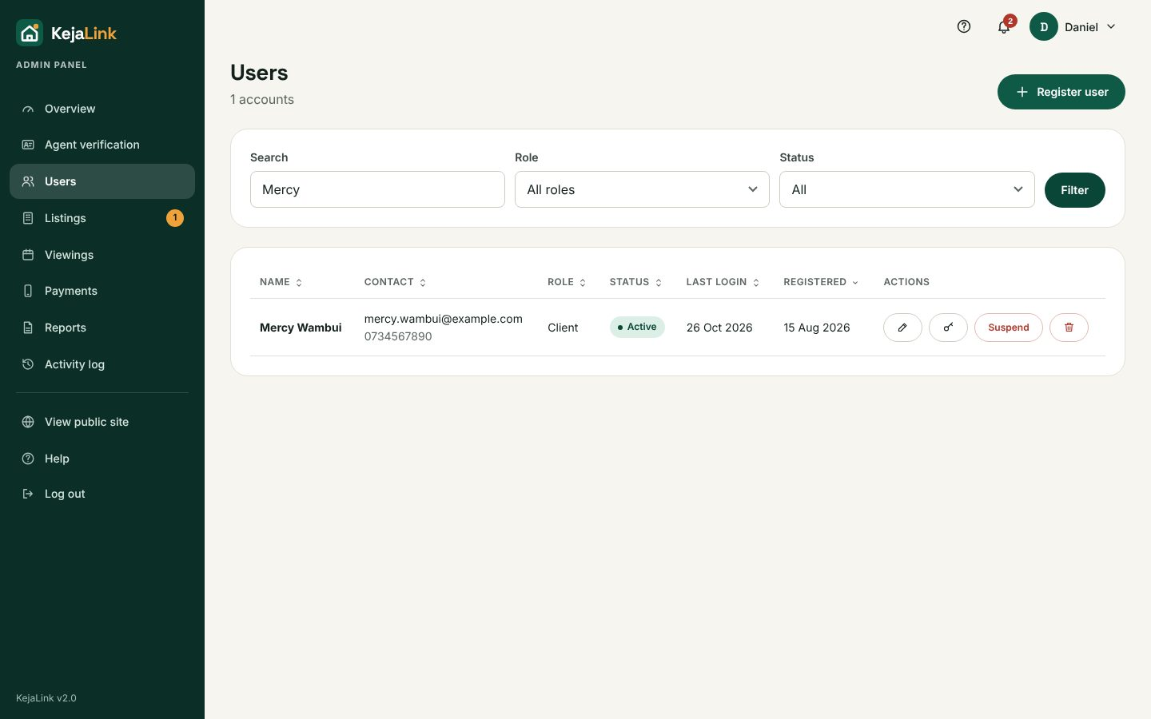
Figure 13: User management: create user, reset password, turn off 2FA, suspend, delete
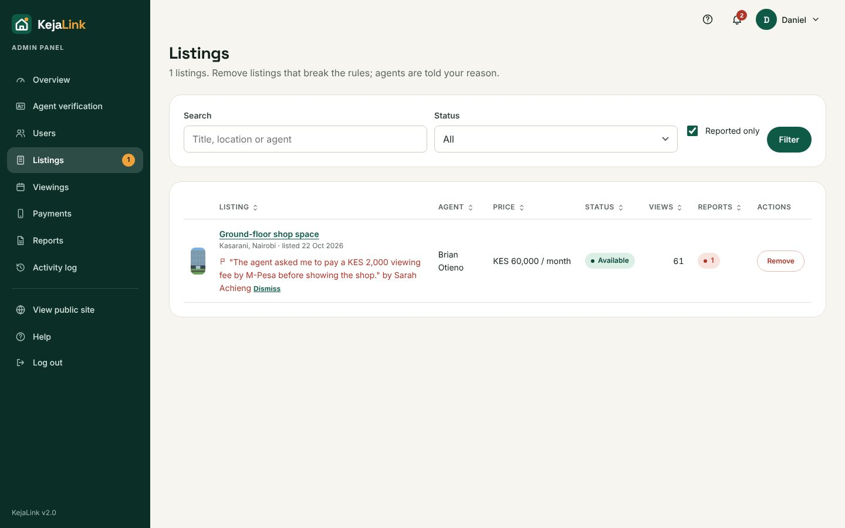
Figure 14: Listings reported by clients, with remove and dismiss actions

2.9 Debugging log
These defects were found while building and testing the JavaScript version, and fixed before submission:
# | Defect found | Cause | Fix
1 | A declined or cancelled viewing slot could never be booked again | UNIQUE(property_id, scheduled_at) from Deliverable 2 counted dead bookings | Partial unique index on live statuses only (section 2.3)
2 | Login for unknown emails crashed instead of returning "Incorrect email or password" | The placeholder bcrypt hash used to equalise timing was not a valid hash | Generate it at start-up with bcrypt.hashSync()
3 | Typing in a modal dialog lost focus after every key | The modal's effect re-ran on every render and moved focus back to the first field | Keep the close handler in a ref and run the focus effect once
4 | The change-password page showed a React warning and sometimes a blank screen | navigate() was called while the page was still rendering | Return a <Navigate> element instead
5 | After a successful login the page jumped back to the login form | The "already logged in" redirect effect raced with the form submit | Skip the effect while the form is submitting
6 | An agent awaiting verification could open the Add listing page | Only the API blocked it; the page itself had no guard | Redirect unapproved agents to the dashboard (the API check stays)
7 | Mobile menu button showed on desktop; admin sidebar label sat beside the logo; card rows misaligned | A general .icon-btn rule overrode the media query; inline display; card top margin | More specific CSS selectors and display:block
8 | Two textareas on the agent Inquiries page shared one id | Copied markup | Unique ids per inquiry, so labels and errors match
9 | Automated tests were locked out halfway through | The login rate limit (20 per 15 minutes) is shared by all test logins | Made the limit a setting, LOGIN_RATE_LIMIT, raised only in the test environment

3. Deliverable 4: Complete system features
This section follows the order of the Deliverable 4 marking scheme.

3.1 Database
See section 2.3: 12 tables, including four added tables for audit logs, payments, notifications and listing reports, normalised to 3NF, with foreign keys, cardinalities, UNIQUE, partial UNIQUE and CHECK constraints, indexes, a trigger and Row Level Security.

3.2 Data processing: add, delete, update, browse, search
Entity | Add | Edit | Delete | Browse / search / sort
Listings | Agent | Agent; status by agent, remove/restore by admin | Agent (cascades photos, viewings, inquiries) | Public search with 6 filters and 4 sort orders; agent and admin tables with search, filter, sortable columns, pagination
Photos | Agent (drag-and-drop, up to 10) | Choose cover | Agent | Gallery with lightbox on listing page
Users | Self-registration; admin "Create user" | Profile; admin edit | Admin (with confirmation) | Admin users table: search, role/status filter, sorting
Viewings | Client books | Agent confirms/reschedules/declines/completes; client cancels | Cascades with listing | Client, agent and admin lists with filters
Inquiries | Client | Agent replies/closes | Cascades with listing | Agent tabs by status; client list
Favourites | Heart icon | — | Heart icon | Saved page

3.3 Main transaction: booking a viewing
Booking a viewing is KejaLink's core business transaction. The logic lives in backend/src/services/viewingService.js.

Business rules
- Viewings run Monday to Saturday in one-hour slots from 09:00 to 16:00 (Nairobi time), from tomorrow up to 30 days ahead.
- Only properties with status Available can be booked.
- A property can have only one live booking per slot; a client can hold only one live booking per property.
- Status flow (the TRANSITIONS map): requested → confirmed / rescheduled / declined; confirmed or rescheduled → completed (only after the time has passed); the client may cancel any live booking. Declined, completed and cancelled are final.
- An agent may only change viewings on their own listings, and must give a reason to decline.
- When an agent marks a property Sold or Rented, or an admin removes it, its upcoming viewings are declined automatically and the clients are notified.

How double-booking is prevented
Two clients could click "Request viewing" for the same slot at the same instant. Three layers stop this:
- The slot picker loads taken slots from the API and disables them.
- The booking runs in a database transaction that locks the property row (select … for update), so concurrent bookings for the same property are processed one after another.
- The partial unique index uq_viewings_live_slot is the final guard. If it is violated PostgreSQL raises error 23505, the transaction rolls back, and the client sees "Sorry, that time slot was just taken."
return await transaction(async (tx) => {
const p = await tx.queryOne('select ... from properties where property_id = $1 for update', [propertyId]);
if (p.listing_status !== 'available') throw new AppError(409, '... cannot be booked.');
// one live booking per client per property
...
const v = await tx.queryOne('insert into viewings (client_id, property_id, scheduled_at) values ($1, $2, $3) returning viewing_id', [...]);
await notify(tx, p.agent_id, 'New viewing request: ...', '/agent/viewings');
await audit(req, 'viewing_booked', 'viewing', v.viewing_id, ...);
return v.viewing_id;
}); // any error → rollback; err.code 23505 → 409 "that time slot was just taken"
Test T23 sends a second booking for a taken slot straight to the API, bypassing the user interface, and confirms it is rejected with 409.

3.4 Levels of access
Capability | Guest | Client | Agent | Admin | Super admin
Browse, search, view listings | ✓ | ✓ | ✓ | ✓ | ✓
Save, inquire, book, cancel, report a listing |  | ✓
Manage own listings, viewings, inquiries; feature with M-Pesa or manual payment |  |  | ✓ (once approved)
Verify agents, moderate users and listings |  |  |  | ✓ | ✓
Reports |  |  | Own data (4) | All (7) | All (7)
Activity log, payments overview |  |  |  | ✓ | ✓
Create/remove administrators, act on admin accounts |  |  |  |  | ✓
Account functions: registration (client or agent), login, logout, administrator-assisted password recovery (a request notifies admins, who issue a temporary password that must be changed at login), and profile editing. Roles are enforced twice: RequireAuth in React decides which pages to show, and requireLogin(...roles) on the API refuses the request itself. A wrong role gets a 403 page and the attempt is written to the audit log.
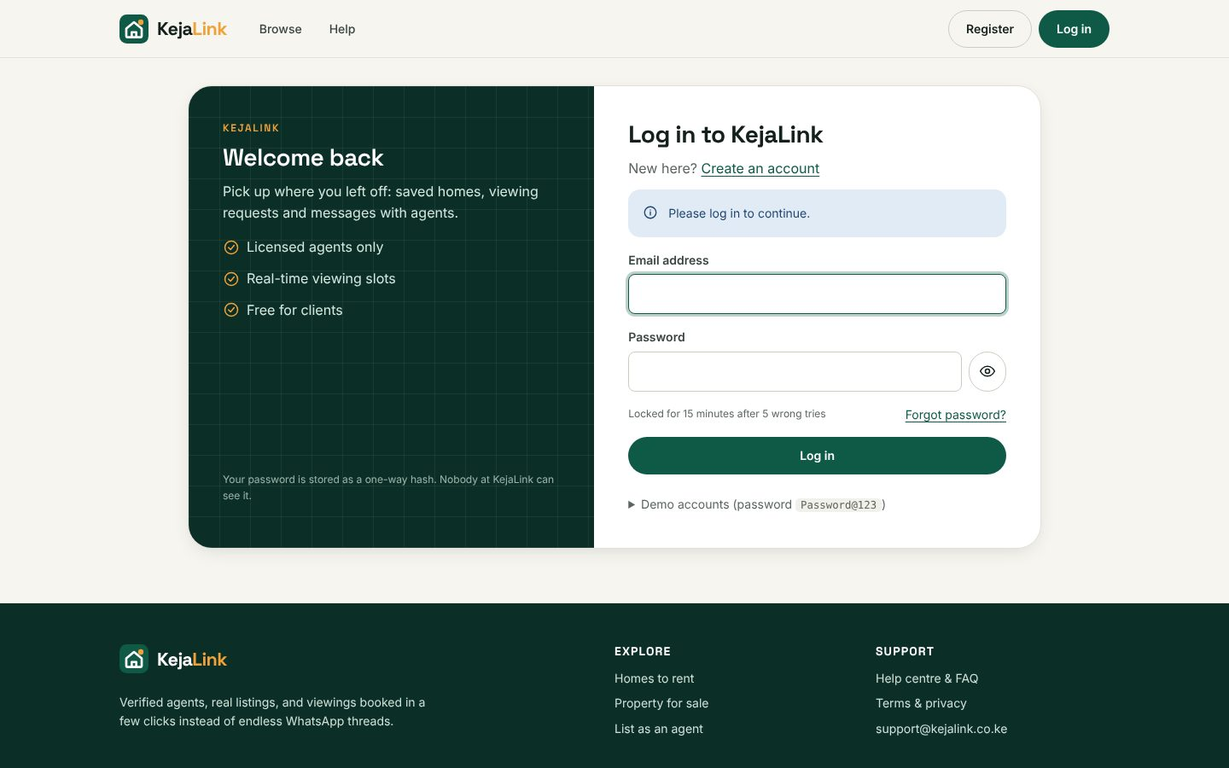
Figure 15: Login page with the demo-accounts list

3.5 Reports
Admins run seven reports and agents run four (limited to their own data) from the Reports page:
Report | Filters | Sort options | Summary figures
Listings by status | Date listed, status, location | Date, price, views, location, status | Count, total and average price, total views
Viewings (bookings) | Viewing date, status, location | Viewing date, status, property, date booked | Confirmed, completed, declined, cancelled
Inquiries & response times | Date sent, status | Date, response time, status | Average reply time, still open
Payments (M-Pesa and manual) | Date, status | Date, amount, status | Successful payments, revenue
User registrations | Date, status, role | Registered, name, role, last login | Users per role
Agent performance | Activity date range | Listings, viewings, completed, reply rate, name | Count
Activity log | Date, search text | Date, user, action | Count
Each report can be previewed on screen, downloaded as a PDF built with pdfkit (company name and logo, report title, date and time generated, who generated it, filters applied, summary boxes, table and "Page X of Y" footer) or exported to Excel (CSV). Report generation is itself recorded in the audit log. A sample is in docs/sample-listings-report.pdf.
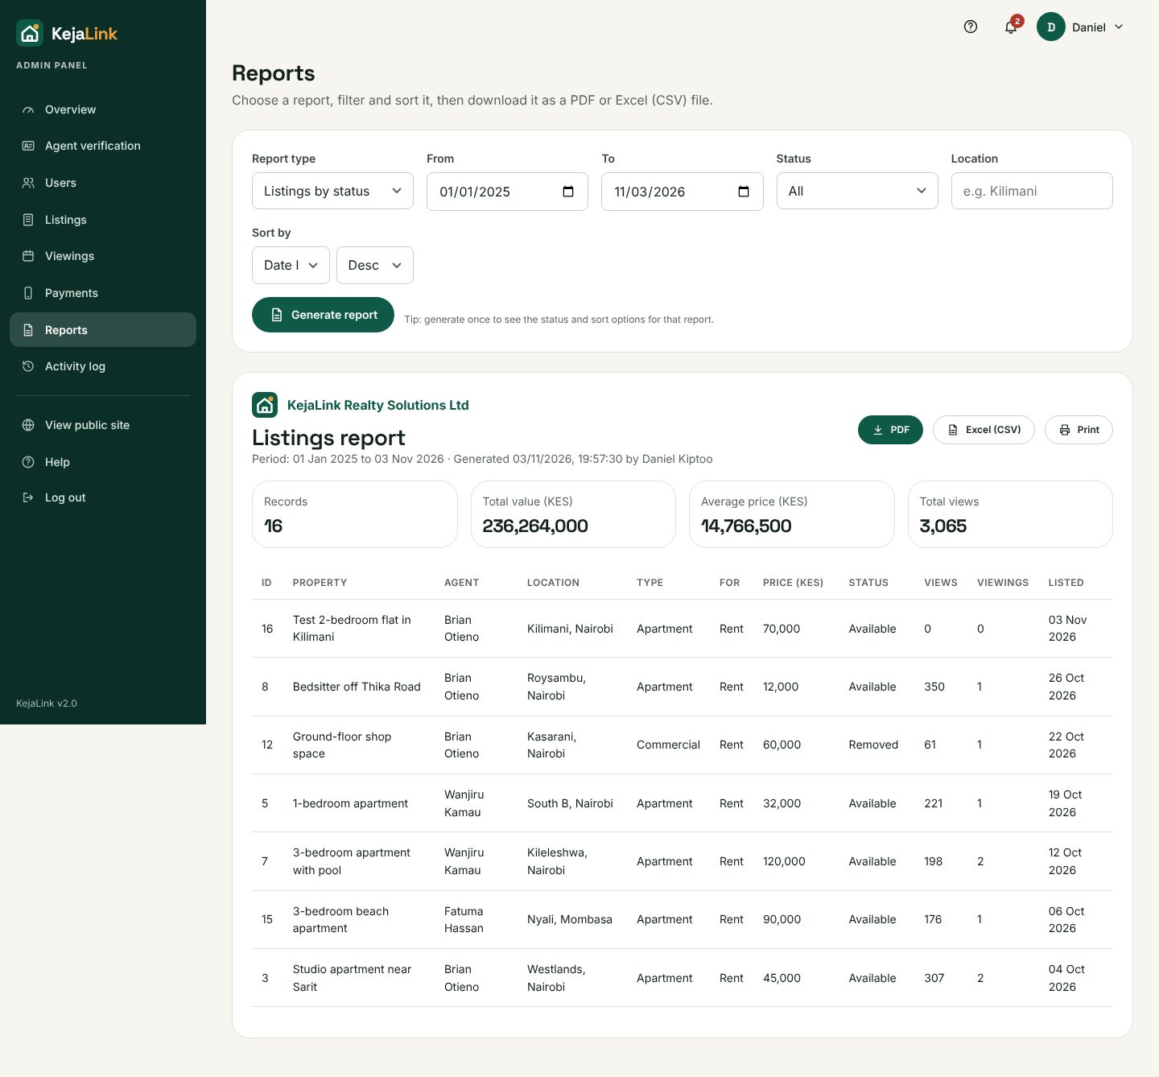
Figure 16: Report builder with filters, sorting, preview and export buttons
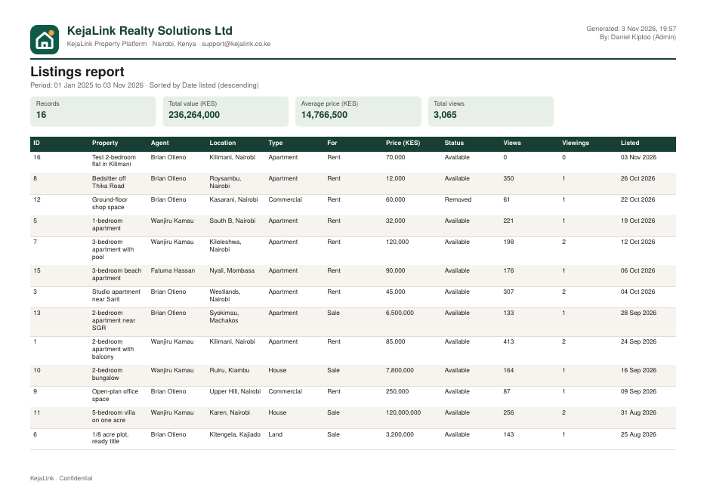
Figure 17: Generated PDF report with logo, company name, date and page numbers

3.6 Frameworks, libraries and APIs
- React 18 and React Router 6: components, hooks, context and client-side routing for about 40 pages.
- Express 4: REST API, middleware chain and static hosting of the built app.
- pg: PostgreSQL driver with a connection pool. bcryptjs, jsonwebtoken, cookie-parser: authentication.
- multer: photo uploads; Supabase Storage API: photo hosting.
- pdfkit builds PDF reports; qrcode generates the 2FA set-up QR code. Password recovery uses in-app administrator notifications and does not send email.
- Safaricom M-Pesa Daraja API: OAuth, STK Push, STK Query and callback handling (utils/mpesa.js, paymentController.js). MPESA_ENV=simulate works offline; sandbox/live require backend-only Daraja credentials and a public HTTPS callback URL.
- webpack 5 and Babel: build tools for the React app.
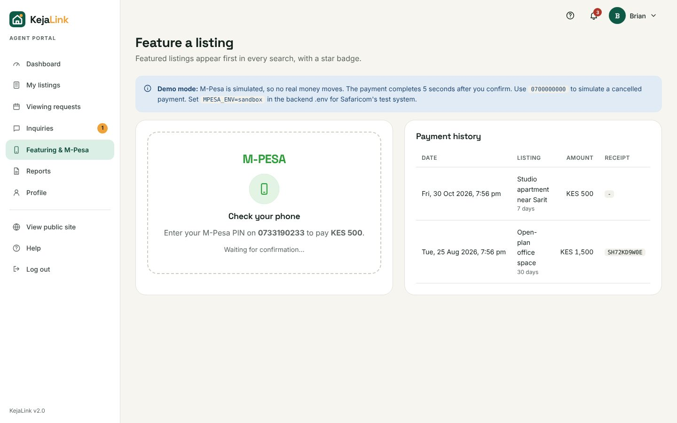
Figure 18: M-Pesa STK Push in progress; the page checks for the result and updates itself

3.7 Validation, error handling, key trapping and recovery
Technique | Implementation
Client-side validation | Each form has a validate() function run by useForm before sending; errors appear under each field and the first invalid field is focused
Server-side validation | Validator class (required, email, Kenyan phone, name, length, password policy, numeric range, allowed values, uniqueness in the database). Errors return as 422 with one message per field; the form keeps the user's input.
Exception handling | Every route is wrapped in asyncHandler; errorHandler returns friendly JSON. Unexpected errors are written to storage/logs/app.log with a reference code that the user sees. React has an ErrorBoundary with a crash page.
Recovery | Multi-step changes run in transactions with automatic rollback (registration, booking, listing + photos, moderation, payments). Uploaded photos are deleted again if the save fails. A slot taken during booking returns a clear message. An expired session returns the user to login.
Key trapping | Numeric fields (price, bedrooms, phone, 2FA code) block non-digit keys and clean pasted text; Enter submits; Esc closes dialogs; dropzone works with Enter and Space
Mistake prevention | Confirmation dialog for every destructive action; "unsaved changes" warning on long forms; buttons disable while saving to prevent double submission; reasons required for suspensions, rejections and declines
Error messages | Plain-language, specific messages (e.g. "Agents do not hold viewings on Sundays. Please pick another day."); 403, 404 and crash pages; the help centre explains common messages
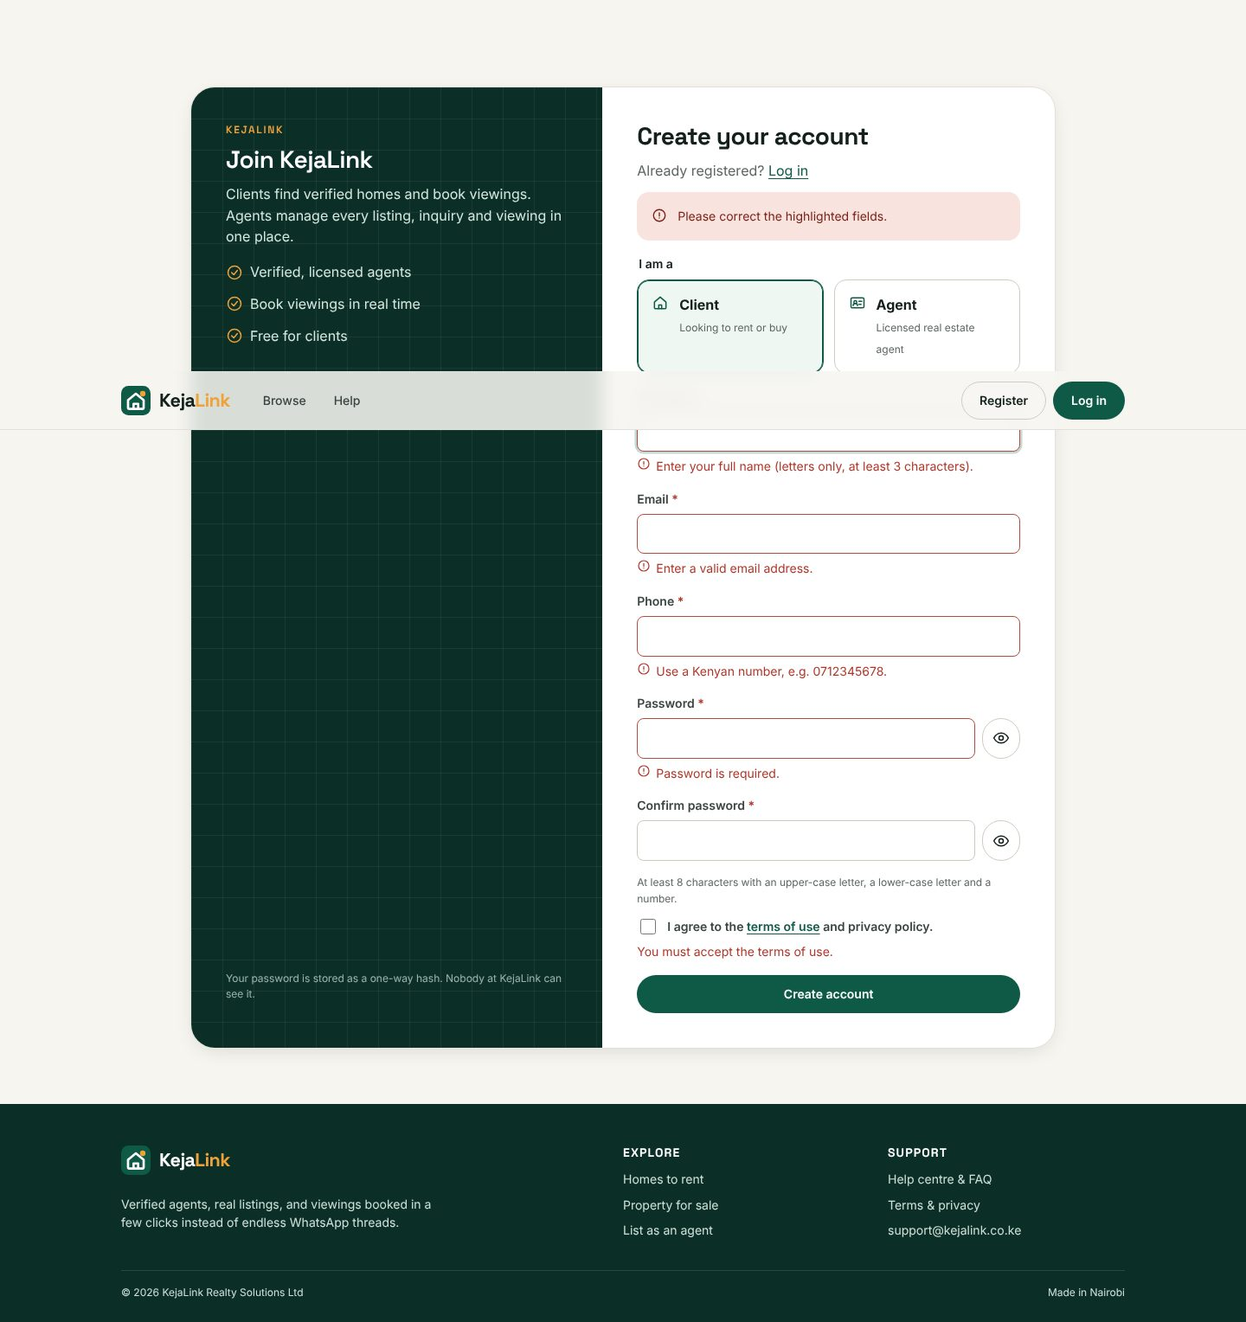
Figure 19: Field-level validation messages on registration

3.8 Security
Threat | Control in KejaLink
Password theft from the database | bcrypt hashing (cost 10, salted); strong password policy
SQL injection | Parameterised queries ($1, $2) everywhere; whitelisted sort columns
Cross-site scripting (XSS) | React escapes every value it displays; the session cookie is httpOnly, so scripts cannot read it
Cross-site request forgery (CSRF) | Every request that changes data must carry the custom header X-KejaLink: 1, which other websites cannot add; SameSite=Lax cookie
Brute-force login | Rate limit per IP; 5 wrong passwords lock the account for 15 minutes; the same message and timing whether or not the email exists
Stolen password | Optional two-factor authentication (TOTP); the 2FA secret is encrypted with AES-256-GCM using APP_KEY
Session hijacking | Signed JWT in an httpOnly, SameSite=Lax cookie, Secure on HTTPS; 30-minute idle timeout; suspension takes effect on the next request
Malicious uploads | File type checked from its first bytes (JPEG, PNG, WebP), 3 MB and 10-file limits, random file names
Unauthorised access | Role checks on every API route; ownership checks in queries (an agent can only touch their own listings and viewings)
Direct database access | Row Level Security on all 13 tables with no policies: Supabase's public key reads nothing
Password reset abuse | Rate-limited generic response; admin-issued temporary password must be changed at first login
Information leakage | Secrets only in backend/.env (never in the browser bundle); users see reference codes, not stack traces; security headers
CSV injection | Cells starting with = + - @ are neutralised in exports
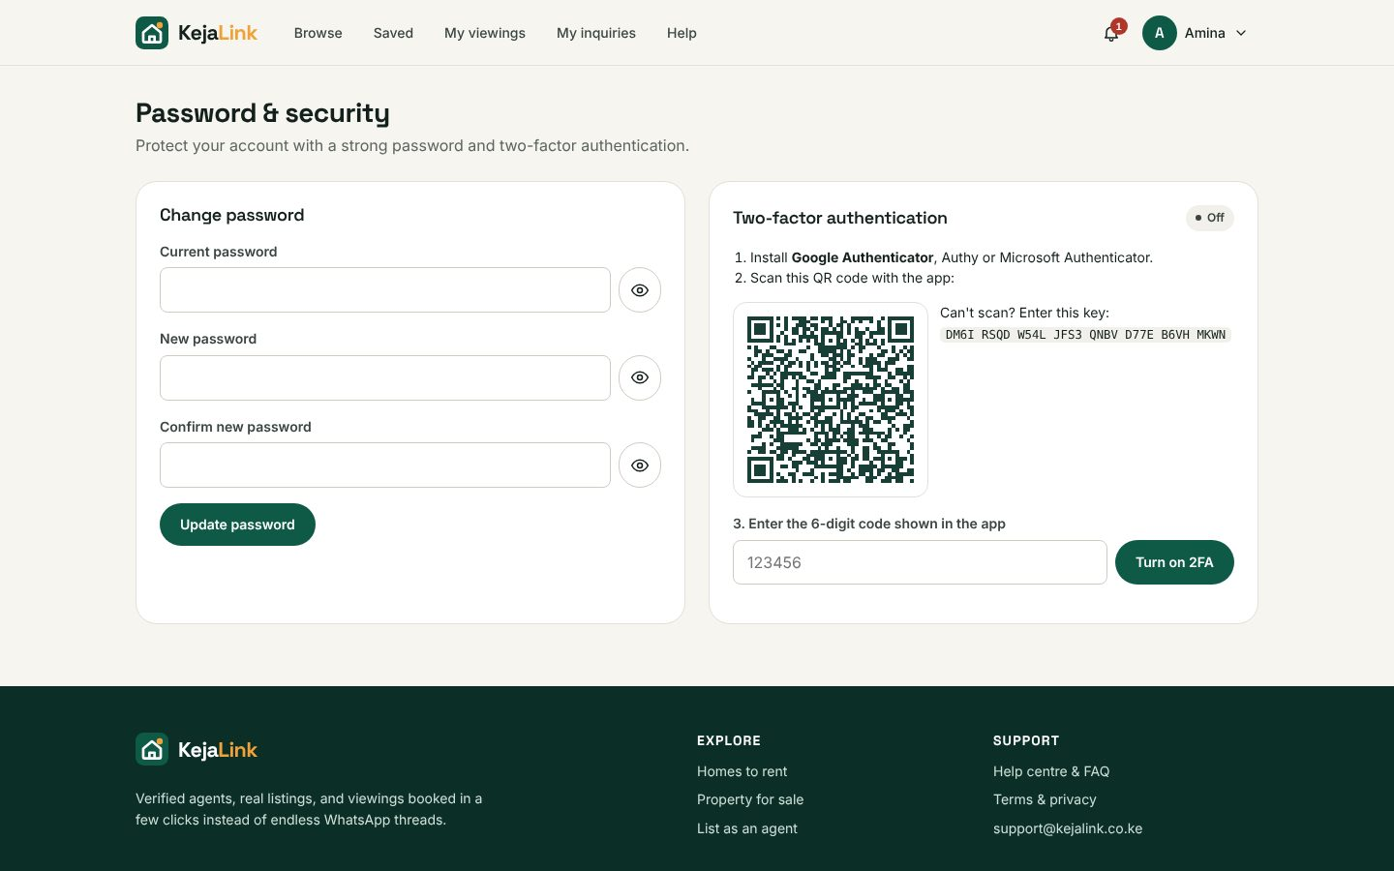
Figure 20: Two-factor authentication set-up with QR code

3.9 Audit trail
audit() in utils/audit.js records the user, action, record affected, details, IP address, browser and time for logins (successful and failed), lockouts, registrations, password and 2FA changes, listing create/edit/delete/status changes, bookings and every viewing status change, inquiries, favourites, listing reports, payments, every admin decision, generated reports and access-denied attempts. Admins search and filter it under Activity log and can export it as a report. There is no screen for editing or deleting log entries.
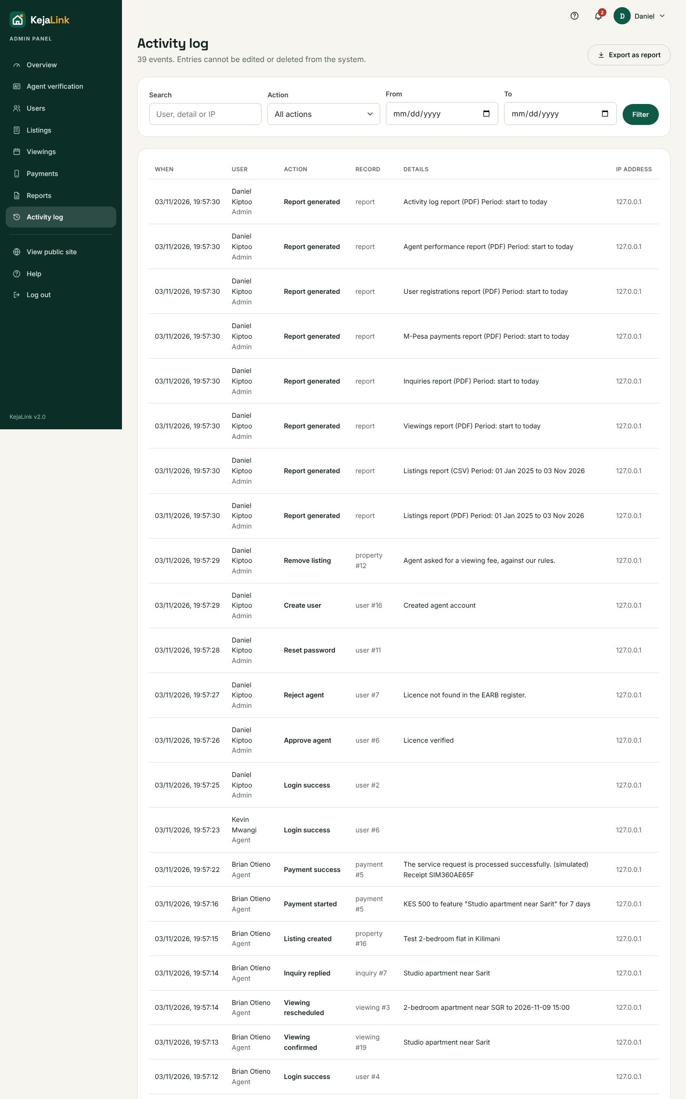
Figure 21: Activity log (audit trail)

3.10 Help facilities
The /help page is a searchable help centre with step-by-step guides for each role, an FAQ, and an explanation of common error messages. Every agent and admin page has a "?" button that opens the matching help section; form fields carry hint text; and the full user manual is supplied as a separate document.
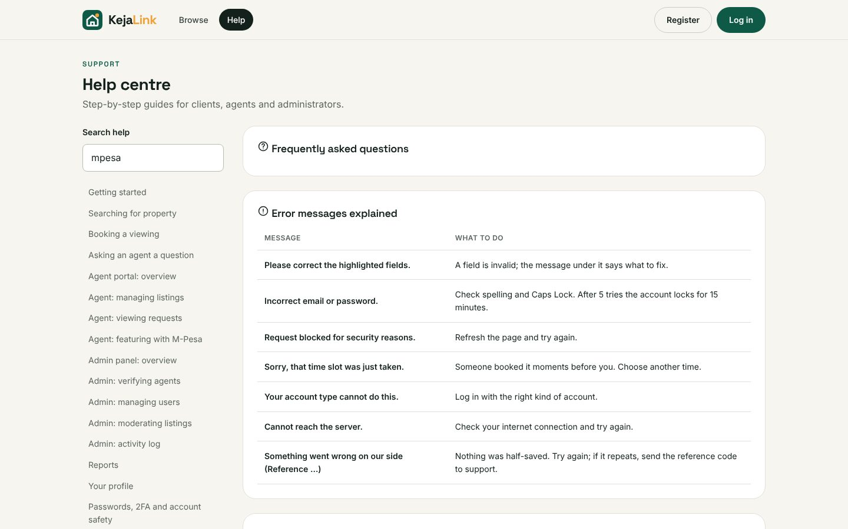
Figure 22: Help centre

3.11 Creativity: unique features
- Featured listings paid with M-Pesa: a real revenue model for the platform, with a simulation mode for demonstrations.
- Live slot picker: free and taken times load from the server as the client chooses a date.
- Affordability tools: rent-to-income guide for rentals and a mortgage calculator for sales.
- Notifications bell: every status change reaches the other party.
- Listing reports: clients flag scams, and admins see them highlighted.
- Automatic viewing cancellation when a property is sold, rented or removed.
- Custom design system with our own SVG icons and charts, photo lightbox and drag-and-drop uploads.

3.12 GUI design and usability
All styling is hand-written CSS built on design tokens (styles/tokens.css): one emerald accent with an amber highlight, generous white space, consistent cards, coloured status pills with text labels, and the same navigation on every page. Agents and admins share a sidebar layout. Empty lists explain what to do next, toasts confirm actions, and every page works at phone width. Accessibility basics are covered: labelled fields, aria-invalid and aria-describedby on errors, keyboard focus, alt text and colour plus text for statuses.
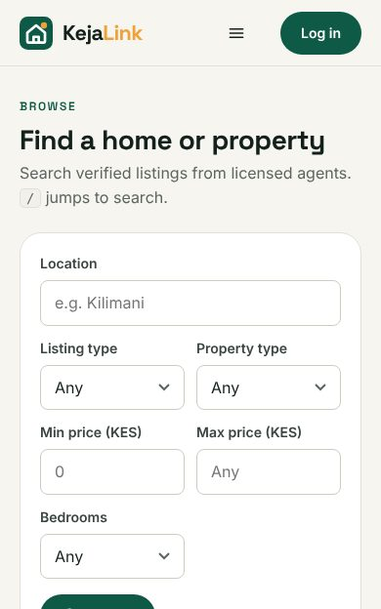
Figure 23: Mobile view (390 px)

3.13 Coding best practices
- Comments: every file opens with a block explaining its purpose; complex logic (transactions, TOTP, M-Pesa, security) is explained inline.
- Naming: camelCase functions, PascalCase components, snake_case database columns, descriptive names (bookViewing, declineOpenViewings, requireApprovedAgent).
- Separation of concerns: routes map URLs, controllers handle requests, services hold business rules, utils hold shared helpers; pages use shared hooks and components.
- Configuration: every setting in one documented .env file read only by config/env.js; the server refuses to start in production without real secrets.

4. Testing

4.1 Approach
- Automated end-to-end tests (tests/e2e.test.js, Playwright with a real Chromium browser) drive the system the way users do: filling forms, clicking buttons, downloading reports. They cover all four roles, the main transaction, security controls and reports.
- Negative tests deliberately attack the system: double booking sent straight to the API, a client calling admin API routes, wrong passwords until lockout, invalid form input, and pending agents trying to post listings.
- Database tests: all three SQL scripts were run twice on PostgreSQL 16 to prove they can be re-run, and the CHECK and unique constraints were tested with invalid rows.
- Each run starts from freshly loaded demo data so results are repeatable.

4.2 Results
The earlier recorded run reported 76 of 76 checks passing. The current suite has 81 checks; payment and recovery paths marked Not rerun below were not rerun because the browser suite mutates the database. Current validation passed the frontend build, all 9 backend tests and local health, login, registration, Swagger and properties checks.
ID | Test case | Result
T1 | Home shows listing cards | Pass
T2 | Search lists results with timing | Pass
T3 | Filter by location + rent | Pass
T4 | Active filters show as removable chips | Pass
T5 | Key trapping blocks letters in price | Pass
T6 | SQL injection attempt handled safely | Pass
T7 | Property page shows verified agent | Pass
T8 | Guest cannot see agent phone | Pass
T9 | Missing listing shows 404 page | Pass
T10 | Help search filters topics | Pass
T11 | Guest is sent to login from admin panel | Pass
T12 | Client-side validation blocks empty form | Pass
T13 | Client registers and is logged in | Pass
T14 | Server rejects duplicate email | Pass
T15 | Session cookie is httpOnly (invisible to JavaScript) | Pass
T16 | Client books a viewing | Pass
T17 | Booking panel shows the existing viewing | Pass
T18 | Inquiry sent | Pass
T19 | XSS payload shown as text, not run | Pass
T20 | Favourite saved | Pass
T21 | Client sees the booking under My viewings | Pass
T22 | Taken slot is disabled for other clients | Pass
T23 | Server blocks double booking (409) | Pass
T24 | Sunday viewings rejected | Pass
T25 | Past dates rejected | Pass
T26 | Client gets 403 page on admin route | Pass
T27 | API also refuses (403) for client | Pass
T28 | Request without CSRF header is blocked | Pass
T29 | Agent lands on the dashboard | Pass
T30 | Agent confirms a viewing | Pass
T31 | Agent reschedules a viewing | Pass
T32 | Agent replies to an inquiry | Pass
T33 | Listing form validates an empty submit | Pass
T34 | Agent publishes a listing with photos | Pass
T35 | Fake image upload rejected by content check | Pass
T36 | Agent submits a manual payment for review | Not rerun
T36b | Agent completes a simulated M-Pesa payment | Not rerun
T36c | Admin confirms a manual payment | Not rerun
T36d | Confirmed manual payment is marked successful | Not rerun
T37 | Agent report shows only own listings | Pass
T38 | Agent cannot run admin-only reports | Pass
T39 | Pending agent sees verification banner | Pass
T40 | Pending agent cannot open the listing form | Pass
T41 | API refuses listings from pending agents | Pass
T42 | Admin overview with charts | Pass
T43 | Admin approves an agent | Pass
T44 | Reason is required to reject | Pass
T45 | Admin rejects an agent with a reason | Pass
T46 | Admin resets a password (temporary password shown) | Pass
T47 | Admin registers a user | Pass
T48 | Admin removes a reported listing | Pass
T49 | Report preview renders rows | Pass
T50 | PDF report downloads | Pass
T51 | CSV report downloads | Pass
T52 | PDF viewings report | Pass
T53 | PDF inquiries report | Pass
T54 | PDF payments report | Pass
T55 | PDF users report | Pass
T56 | PDF agents report | Pass
T57 | PDF audit report | Pass
T58 | Activity log records admin actions | Pass
T59 | Plain admin cannot open the super-admin page | Pass
T60 | Super admin manages administrators | Pass
T61 | Temporary password forces a change | Pass
T62 | Forced change cannot be skipped (API refuses) | Pass
T63 | User sets a new password | Pass
T64 | Account locks after 5 wrong passwords | Pass
T65 | Locked account refuses the right password | Pass
T66 | Unknown address gets a non-enumerating reset response | Not rerun
T67 | Registered address gets the same reset response | Not rerun
T67b | Active reset request notifies administrators | Not rerun
T68 | Admin reset issues a temporary password | Not rerun
T68b | Temporary password requires a change at login | Not rerun
T69 | Suspended user cannot log in | Pass
T70 | 2FA turned on with an authenticator code | Pass
T71 | Login asks for the 2FA code | Pass
T72 | Wrong 2FA code rejected | Pass
T73 | Correct 2FA code logs in | Pass
T74 | Notifications page lists updates | Pass
T75 | No horizontal scrolling at phone width | Pass
T76 | Mobile menu opens | Pass

4.3 Non-functional requirements
NFR | Target | Measured
Performance | Search under 3 seconds | Filtered search API (location, type, price range, bedrooms, sort) answered in 3–21 ms over five runs on the demo data
Usability | Works on mobile and desktop | No horizontal scrolling at 390 px; slide-out menus on small screens (tests on mobile layout)
Security | Hashed passwords, role-based access | bcrypt hashes in the database; role and ownership checks verified by earlier tests T23, T26 and T27. The current payment and recovery checks are marked Not rerun in section 4.2.

5. Packaging and deployment
Option | For | How
Local (development) | Presenting from a laptop | Fresh setup: run 01_schema.sql, 02_security_and_storage.sql and 03_demo_data.sql. For an existing database, apply 04_manual_payments.sql then 05_mpesa_payments.sql; configure backend/.env, install dependencies and start the services.
Local (single server) | Presentation without two terminals | npm run build once, then npm start in backend: the whole site runs at http://localhost:5000
Live hosting | Render free tier + Supabase | Push to GitHub, create a Render web service with build npm run build and start npm start, add the .env values; check /api/health shows "database": "connected" (DEPLOYMENT.md)

6. Maintenance plan
- Corrective: users quote the reference code shown on error messages; the matching entry in storage/logs/app.log (or the Render logs) has the full technical details.
- Backups: Supabase daily backups on paid plans, or CSV export of the tables; photos are kept in Supabase Storage, not on the server.
- Security: run npm audit and update dependencies each term; rotate JWT_SECRET to log everyone out and the database password if leaked; review failed logins and lockouts in the activity log.
- Adaptive: switch M-Pesa from simulate to sandbox or live by configuring backend-only credentials and the HTTPS callback URL. Password-recovery requests notify administrators in-app; no SMTP transport is used.
- Perfective (future work): SMS notifications, a calendar export (.ics) for viewings, map-based search, agent ratings after completed viewings, and a mobile app reusing the same REST API.

7. Conclusion
KejaLink meets every functional and non-functional requirement set in Deliverable 1, keeps the design from Deliverable 2 (with the documented changes), and covers each item in the Deliverable 4 marking scheme. Rebuilt with React, Express and Supabase PostgreSQL, it is a working information system for a real problem: Kenyan property search scattered across WhatsApp and social media, with no verification of agents and no structured way to book viewings.

Appendix A: Demo accounts
Role | Email | Password
Super admin | superadmin@kejalink.co.ke | Password@123
Admin | admin@kejalink.co.ke | Password@123
Agent (approved) | wanjiru@primehomes.co.ke | Password@123
Agent (approved) | brian@skylinerealty.co.ke | Password@123
Agent (pending) | kevin@nyumbanirealty.co.ke | Password@123
Client | amina@example.com | Password@123
Client (suspended) | john.kariuki@example.com | Password@123

