Burke Porter Machinery
Test Result Document Description

The test result document contains all the vehicle information gathered during the test as well as the results of each test step performed during the test sequence. The document is stored in XML format. Viewers are freely available to format the document and make it easy to view. One such program is XML Notepad.

The test result document has 2 main sections (see Figure 1), the VehicleBuild section and the TestResult section.
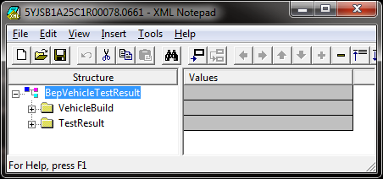
Figure 1

Vehicle Build Section:
The vehicle build section contains all the build data that was gathered in order to test the vehicle. Typically this node will contain the brake type, drive axle and the VIN. Other data may also be available.
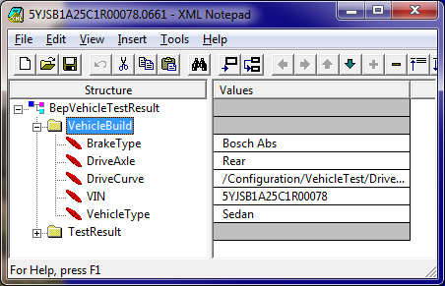
Figure 2

Test Result Section:
The TestResult section contains the results of each test that was performed during the testing sequence. There are some special nodes under this section:
- AllFailures: Contains a copy of all the test steps that have failed.
- DTC: Contains a list of each module DTC that was detected during the test sequence.
- TestStats: Statistics concerning the test sequence, such as number of tests performed and percentage of tests passed.
- ErrorCodeTest: Contains the error code from each failed test. This is mainly used for reporting purposes in some customer installations.
- BrakeForceData: Force data collected from each roller during the test sequence. The data can be imported into Excel and graphed.
- SpeedData: Speed data collected from each roller during the test sequence. The data can be ported into Excel and graphed.
Each test result node is formatted similarly. The name of the test step node is comprised of the vehicle subsystem that was tested as well as the name of the test step. For example, BrakeLFSensorTest is a test result from the Brake test component and the test step was for the Left Front ABS Wheel Speed Sensor. Additionally, each test step result will contain the following attributes:
- Description: Description of the test step.
- Process: The test component name that performed the test.
- Result: The result of the test step. Valid values are:
  - Pass
  - Fail
  - Abort
  - Timeout
  - TestNotRequired
  - Skip
- TestResultCode: The result code for the test step in the event a code needs to be reported to the customer’s reporting system.
There may be additional nodes under each test result node. These additional nodes provide more information about the test step result. For example, Figure 3 shows the Left Front Brake Force result.
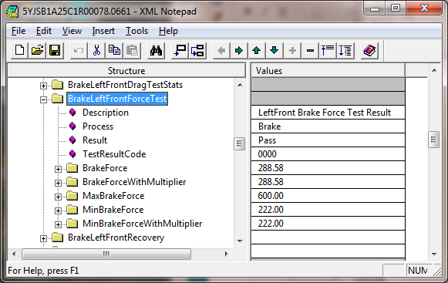
Figure 3

In this example, you can see there is a BrakeForce node that contains the measured brake force for the Left Front wheel. The MinBrakeForce node is the minimum required brake force parameter. Any measured force below this value will cause the test to fail. There is also a MaxBrakeForce node that contains the maximum brake force allowed parameter. Any measured brake force higher than this value will cause the test to fail as well.
Typically, any test step result that measures a value will contain the measured value as a child node of the test step result node. It will typically also contain the parameters used to determine the pass/fail result of the test step.

