Toyota Vehicle Parameter Editor

Introduction:
On the desktop of each PC/Machine, there is a parameter editor application icon. This program makes it easy to change the testing parameters for each vehicle type or even to add new vehicle types to be tested. Look for an icon labeled Toyota Parameter Editor.

Using the Parameter Editor:
When the parameter editor is started, you should see a screen similar to Figure 1. Using the File menu, you can choose open an existing parameter file, create a new parameter file or import/export parameter files.

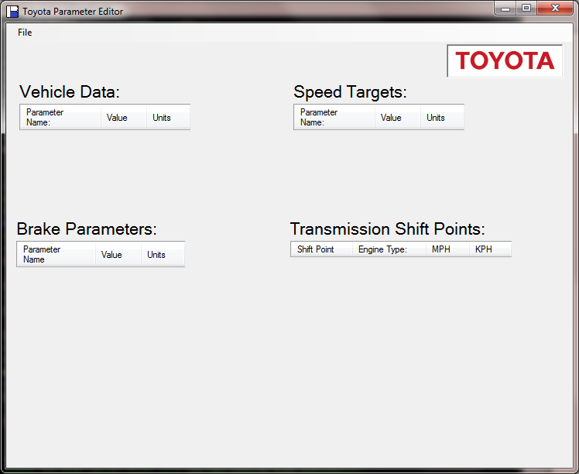
Figure 1

Figure 2 shows the parameter editor after opening the Camry parameter file. The Brake Parameters section is only used on the brake test machines. The Speed Targets and Transmission Shift Points parameters are only used on the roller drum machines.

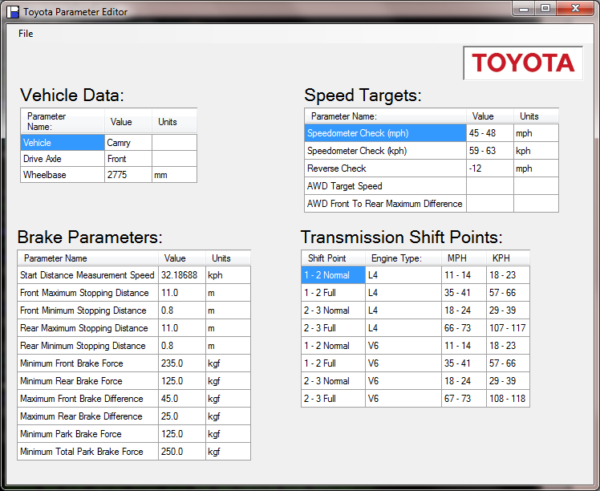
Figure 2

After making any changes, select Save Updates from the File menu. You can also choose to export the parameter files to a memory stick for installation on the other machines. The import and export items can be found under the File menu.

