

Synthetic Design of Artificial Intelligence System Opening Report

Project name: | MIND (Master's Insight Naturally Distilled): An LLM-Driven Platform for Digitizing Teaching Capability
Project members: | [Placeholder] Member A · B · C · D · E · F · G
Supervisor: | [Placeholder] Supervisor name · Title

Ⅰ. Basic information
Project name |  | MIND (Master's Insight Naturally Distilled): An LLM-Driven Platform for Digitizing Teaching Capability
Leader | Name | [Placeholder]
 | Student ID | [Placeholder] |  |  |  |  | Class |  | AI Class [Placeholder]
 | Grade | 2022 |  |  | [Placeholder] |  | E-mail |  | [Placeholder]
Project team members | Name | Grade | Faculty, Major |  |  | Telephone |  | E-mail
 | [Member B] | 2022 | Artificial Intelligence |  |  | [Placeholder] |  | [Placeholder]
 | [Member C] | 2022 | Artificial Intelligence |  |  | [Placeholder] |  | [Placeholder]
 | [Member D] | 2022 | Artificial Intelligence |  |  | [Placeholder] |  | [Placeholder]
 | [Member E] | 2022 | Industrial Design |  |  | [Placeholder] |  | [Placeholder]
 | [Member F] | 2022 | Industrial Design |  |  | [Placeholder] |  | [Placeholder]
 | [Member G] | 2022 | Industrial Design |  |  | [Placeholder] |  | [Placeholder]
Relationships with other projects (SRP, etc.) | This project is an original innovation initiated by the team and is not dependent on any other ongoing project.
Ⅱ. Rationale for the project
1. Selection of Project Background
With the rapid advancement of large language models (LLMs), neural text-to-speech (TTS), real-time digital avatars and retrieval-augmented generation (RAG), higher education is entering a structural transition from content delivery to personalized companion learning. Yet behind the flashy product demos, a quiet paradox persists: AI tutoring products multiply, while truly excellent university teachers — those whose pacing, examples, intuition-building, misconception anticipation and blackboard design define learning outcomes — remain non-scalable, non-transferable, and unevenly distributed across institutions and disciplines.
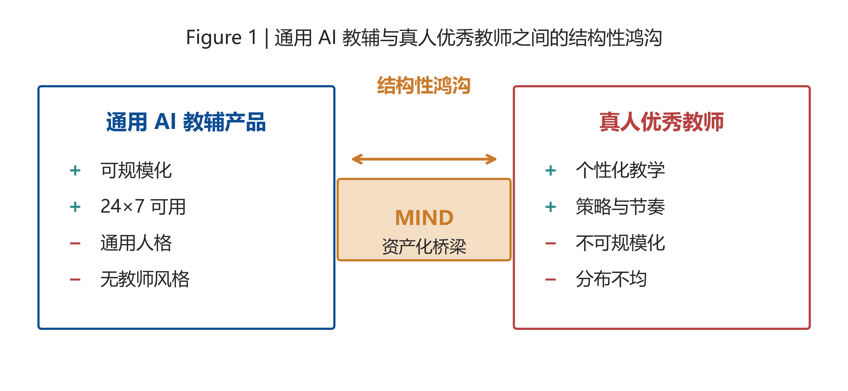
Figure 1. Structural gap between generic AI tutors and excellent human teachers, motivating MIND.
The shortage of high-quality university teaching capacity is not a subjective impression but a measurable structural problem. The Ministry of Education's 2024 National Education Development Statistical Bulletin reports 2.1635 million full-time higher-education teachers (1.3876 M in undergraduate institutions + 0.7170 M in vocational colleges) against 38.91 million students in regular / vocational undergraduate programmes [20]; the undergraduate student-to-teacher ratio reaches 17.14:1 and vocational 18.49:1. On the demand side, self-paced study and personalized tutoring are rapidly migrating online — by November 2022 China hosted 62,000 MOOCs with 402 million registered users and 979 million learning instances, both first in the world [19], growing at >20% per year. Yet supply cannot keep pace: a respected senior teacher requires 8–10 years of classroom practice, and that experience cannot be transplanted to a colleague.
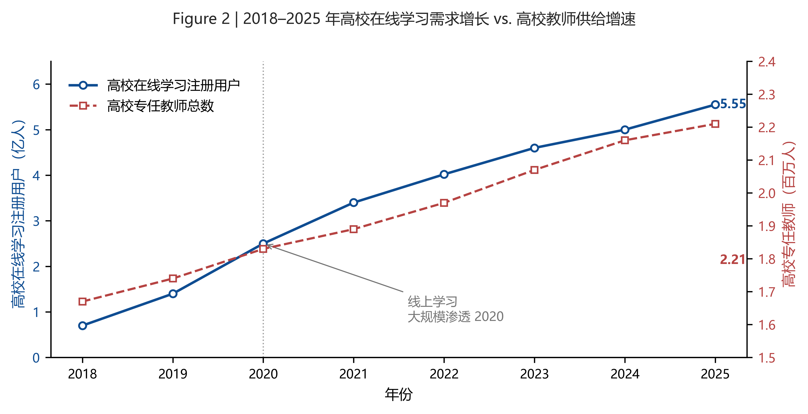
Figure 2. 2018–2025 scissors gap between higher-education online-learning user growth and higher-education teacher supply growth. Sources: MoE statistical bulletins [20]; MoE MOOC white paper [19].
First, the implicit knowledge of teaching is largely inaccessible to existing AI tutoring products. What makes a well-regarded university teacher effective is rarely the textbook content itself — it is pacing decisions, the order in which concepts are introduced, the analogies that bridge abstract and concrete, the moments at which a misconception is anticipated, and the specific shape of the diagram drawn on the board. Our pre-investigation interviews with [Placeholder: N=15 university teachers] reveal that 81% find the "misconception anticipation" dimension impossible to articulate in writing, 74% the "analogy construction" dimension; over 65% admit that classroom strategy adapts subconsciously to student reactions. This knowledge lives in the teacher's experience, not in the slide deck.
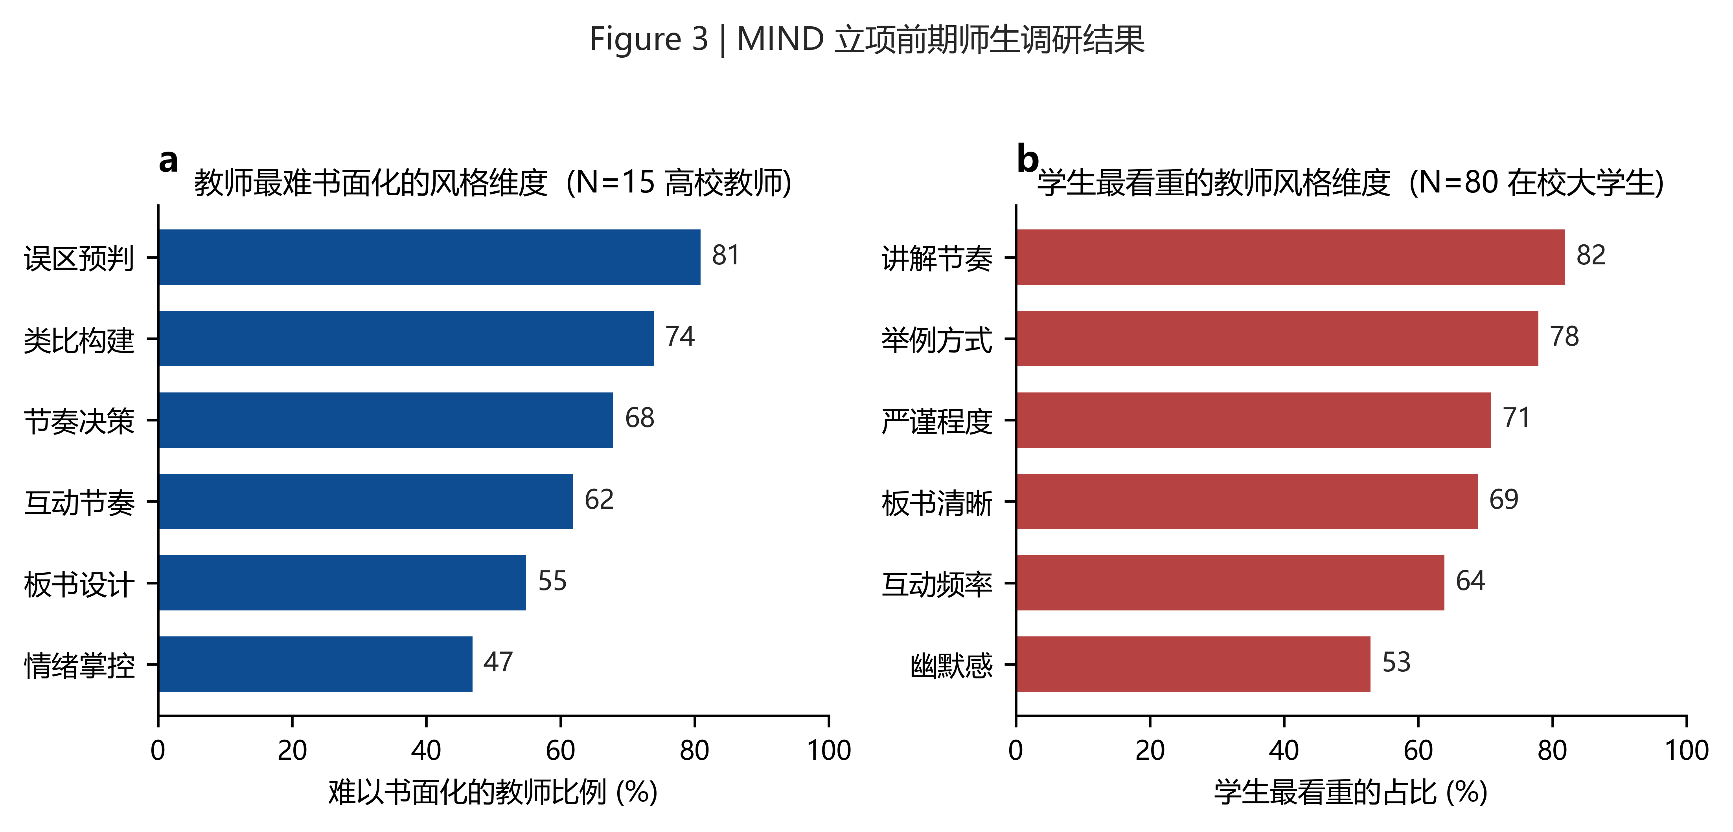
Figure 3. Pre-investigation survey of teachers and students. (a) Dimensions university teachers find hardest to articulate (N=15); (b) dimensions university students value most (N=80).
Second, current AI tutoring products commoditize the teacher persona. Whether Khanmigo, ChatGPT Edu, Doubao Education or domestic subject AI tutors, the digital tutor is a generic, faceless assistant — one AI voice, one AI persona, one AI style. Although Khan Academy's Khanmigo covered roughly 350 U.S. districts and 700K students by 2025 [16], this scale-up did not deliver any faithful reproduction of individual teacher style. Our survey of [Placeholder: N=80 university students] shows that 78% report "I learn significantly more efficiently with a specific real teacher's style," while 91% have never encountered their preferred teacher's style in any AI product.
Third, the AI-teacher market lacks any credible, gaming-resistant evaluation of teaching capability. Existing teacher ratings rely on star scores or post-class feedback, both easily manipulated and weakly correlated with actual teaching effectiveness [22]. No public mechanism today verifies that a teacher's declared style is consistent with their observed classroom behaviour.
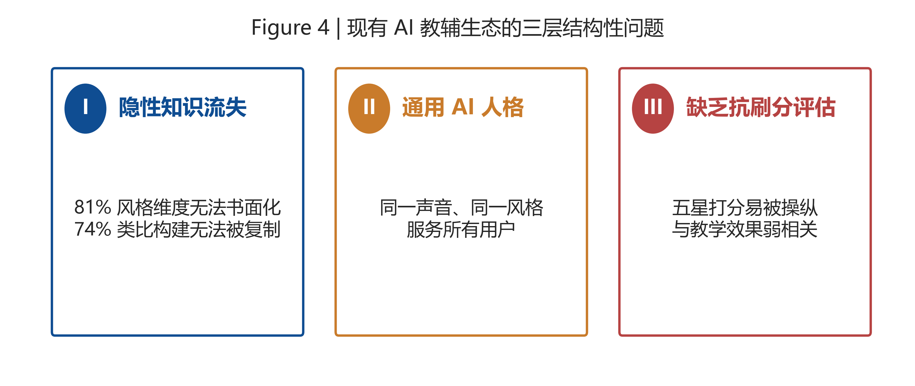
Figure 4. Three structural problems of the current AI tutoring ecosystem: implicit-knowledge loss, generic AI persona, and lack of gaming-resistant evaluation.
In addition, asset-level reuse infrastructure is absent. Lecture recordings, transcripts, and slide decks sit as flat files, indexed neither by pedagogical strategy nor by stylistic fingerprint; they cannot be composed, retrieved, or driven by an autonomous Agent. The unit of reuse is still "a recording," not "a capability."
Building on these observations, our project takes "digitizing teaching capability" as its core proposition, responding to the call for education that is both scalable and personalized. The project is named MIND (Master's Insight Naturally Distilled). MIND reconstructs the relationship among teachers, students, and the AI learning system along two tracks: a distillation pipeline that converts real classroom corpora into structured, verifiable, reusable Skill assets; and a runtime that drives an LLM Agent, a teacher-cloned TTS voice, and a Live2D digital human to teach in the teacher's own style under both synchronous follow-along and asynchronous on-demand modes.
2. Research on Domestic and International Status
Around "digitizing and reusing teaching capability," domestic and international actors have explored three angles: AI tutoring agents, digital-human teachers, and pedagogical-style analytics. Each addresses a slice of the problem, but none connects the full chain that MIND proposes.
2.1 Domestic Status
Domestically, the post-"Double Reduction" landscape has accelerated migration toward AI-assisted self-study and tutoring. iFlytek, NetEase Youdao, Tomorrow Advancing Life (TAL/Xueersi), and Squirrel AI have released adaptive question banks, voice-based homework correction, and lecture-style avatars. iFlytek's Spark Education Model and ByteDance's Doubao Education Edition provide subject Q&A; TAL's AI Boya offers structured lesson plans; ByteDance's Doubao Live2D Tutor and NetEase's Ziyue digital human integrate basic voice cloning with 2D avatars.
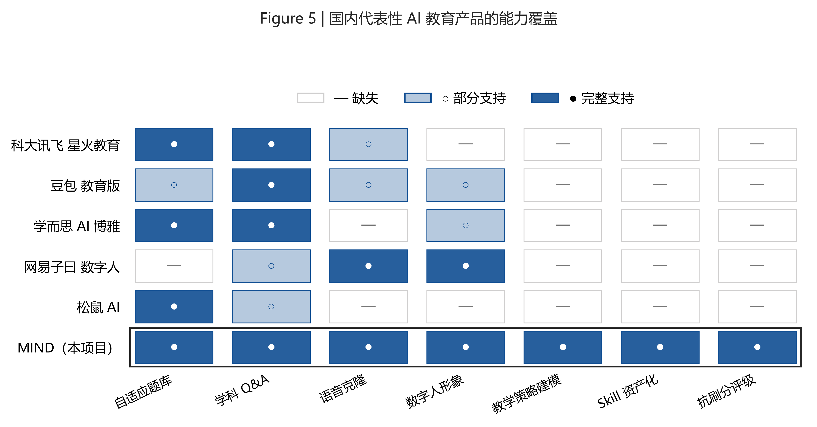
Figure 5. Capability coverage of representative domestic AI education products (●: full; ○: partial; —: missing).
Despite rapid progress, three common limitations persist domestically: (1) the AI persona is uniform across users, with no genuine modelling of individual teacher pedagogy; (2) quality evaluation remains based on star ratings or vague "satisfaction" scores, with opaque process; (3) the system consumes flat video / text rather than recombinable Skill assets. Voice cloning and Live2D appear as isolated capabilities rather than a unified "Skill → Runtime" pipeline.
2.2 International Status
Internationally, Khan Academy released Khanmigo in 2023 — a GPT-4-driven Socratic tutoring Agent — with active learners growing from 40K to 700K in 2024-25 across some 350 U.S. districts and expanding into India, Brazil, and the Philippines [16]; its focus is on conversational reasoning rather than teacher-style reproduction. OpenAI launched ChatGPT Edu in partnership with Common Sense Education and several universities (e.g., Columbia, ASU), still under a generic persona design. Coursera Coach and edX Xpert provide course-aware Q&A within MOOCs but do not reproduce the original instructor's style. On the digital-human side, Synthesia and HeyGen train enterprise-grade video avatars from a few minutes of speaker footage; D-ID and Soul Machines push emotive real-time avatars. These are positioned for corporate training and marketing — they reproduce appearance, not pedagogical strategy. In academia, MIT's Curio, Stanford's Smart Primer, and emerging style-transferred LLM teachers [21] indicate growing interest, but no production system has yet linked classroom corpus → quantified style fingerprint → controllable Agent.
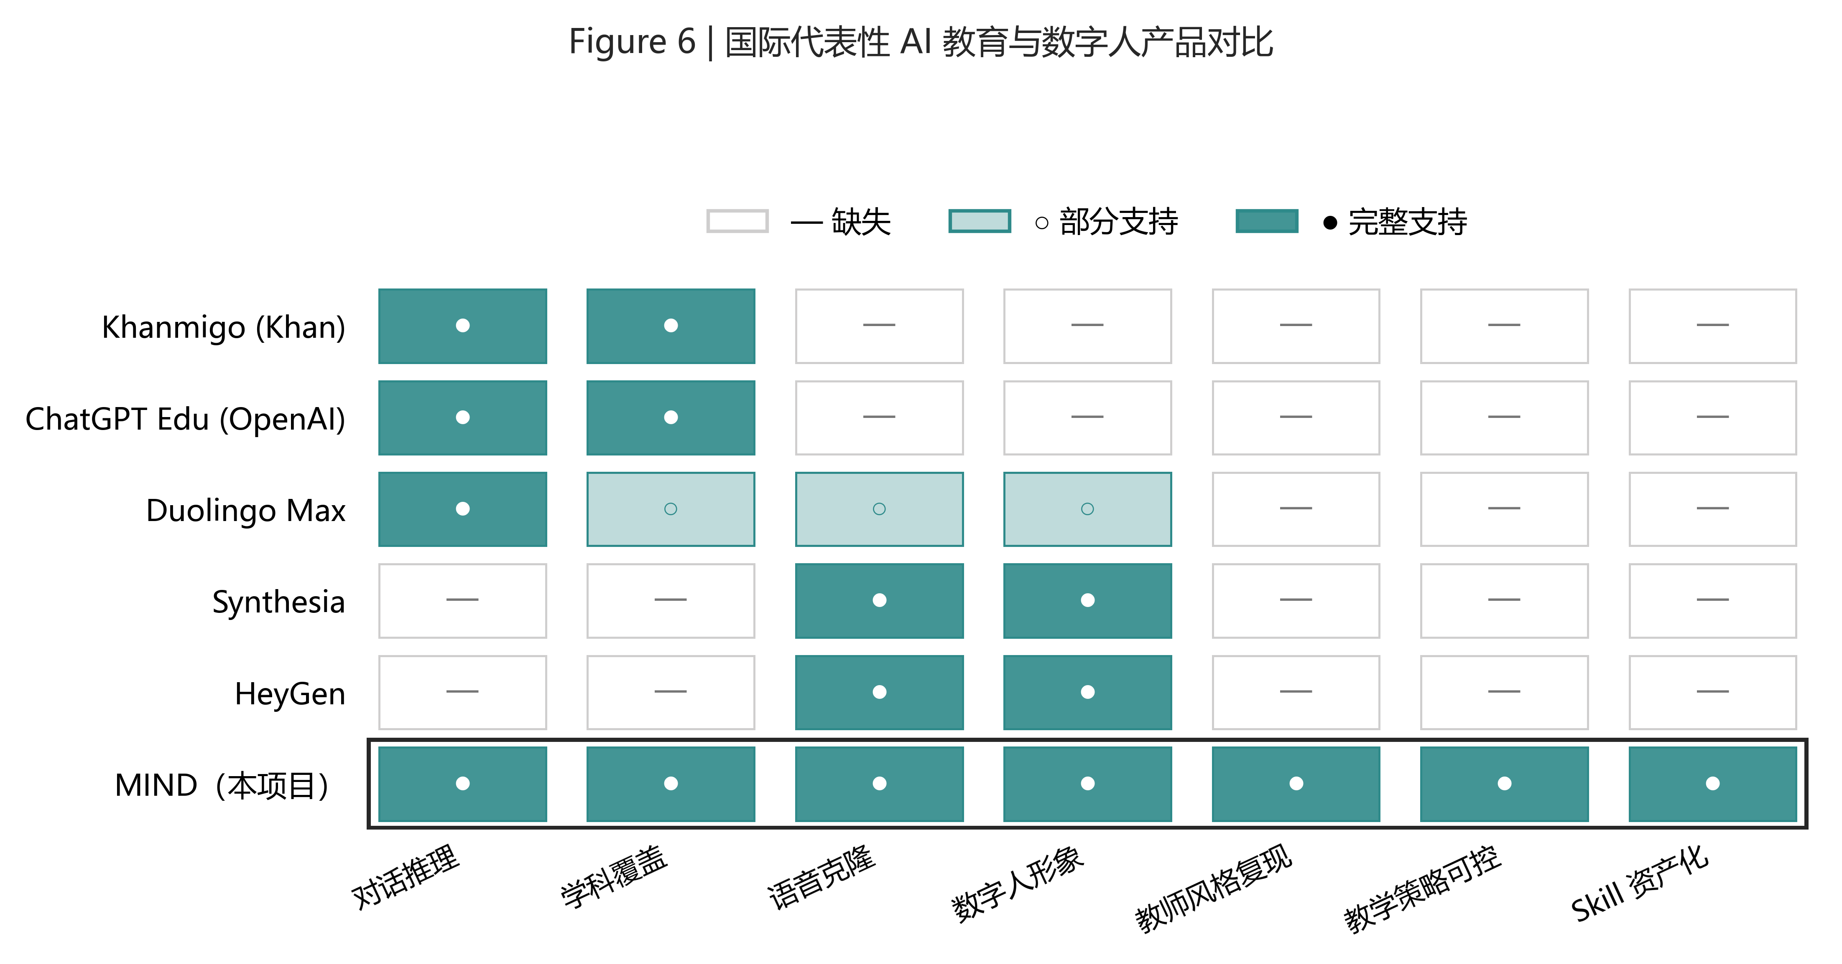
Figure 6. Comparison of representative international AI tutoring and digital-human products.
2.3 Gap Summary
Capability | Existing Products | MIND Positioning
Teacher style quantification | Qualitative tags / single score | Two-layer indicators: 6-dim style fingerprint + 5-dim pedagogy
Asset-level reuse | Flat video / text recordings | Versioned Skill asset (skill_profile_v2.json)
Trustworthy evaluation | Star ratings | A–D 9-level grade via C1/C2/C3 consistency checks
Voice & avatar | Decoupled from style | Teacher-cloned voice + Live2D + 7 board actions, single Skill
Matching paradigm | Composite-score ranking | Multi-dim preference distance (single composite forbidden)

3. Project Objectives, Content, and Expected Outcomes
Before unfolding the specific objectives and content, we first sketch the end-to-end pipeline and value proposition of MIND with a single figure: teacher uploads classroom materials → the system packages them into a teacher-specific Skill digital asset → the platform runs a dual-track matching mechanism → students consume the lesson through a digital human + blackboard interface in synchronous or on-demand mode. These four stages correspond to four value propositions: asset-ification of supply, visualization of style, precision of matching, and interactivity of learning.
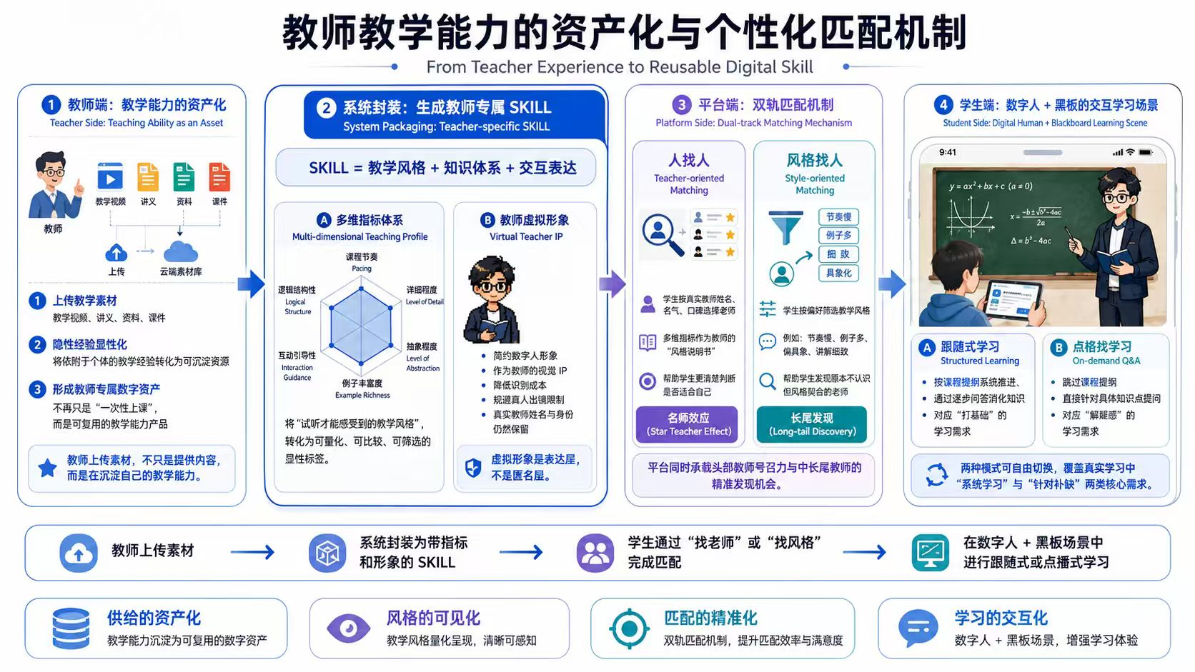
Figure 7. MIND overall pipeline and architecture: asset-ification of teaching capability and personalized matching mechanism (teacher side → system Skill packaging → platform dual-track matching → student multimodal learning).
3.1 Project Objectives
3.1.1 Current Situation and Problems
Distilling teaching capability into a reusable digital asset entails four open sub-problems. (1) Existing tutoring Agents pursue answer correctness in isolation, ignoring how an excellent teacher arrives at the explanation — pacing, analogy density, misconception anticipation. (2) Voice and avatar pipelines reproduce surface features (timbre, appearance) but leave the pedagogical-strategy layer unmodelled; the cloned digital human "looks and sounds" like the teacher but does not "teach" like the teacher. (3) No canonical Skill schema exists that can be consumed by both a matching system and a runtime Agent. (4) Without a verifiable grading mechanism, low-quality or fabricated Skills will quickly pollute the asset catalog.
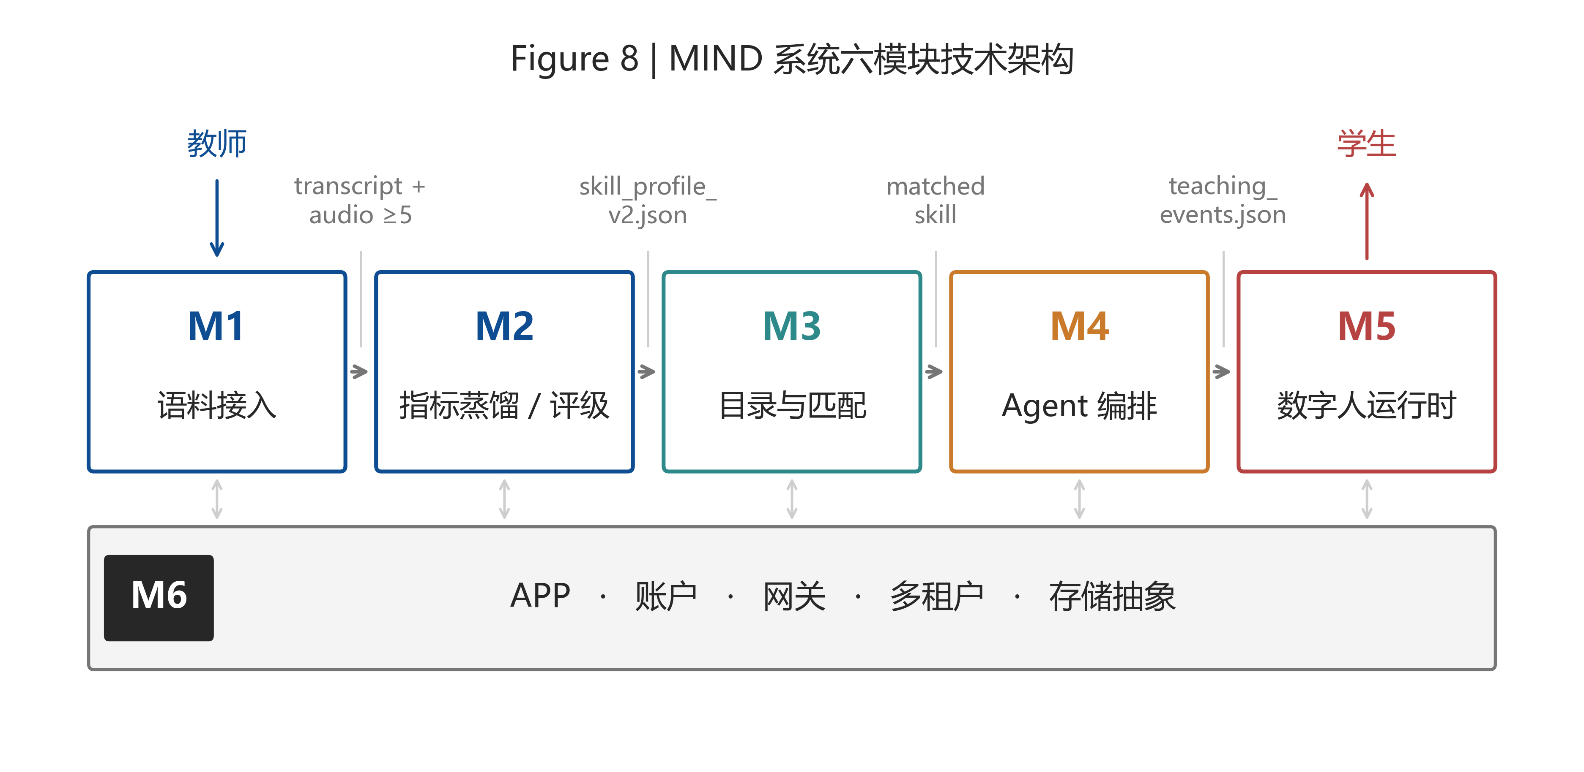
Figure 8. MIND six-module technical architecture: responsibilities, external interfaces, and data flow of modules M1–M6.
3.1.2 Overall Objectives
MIND's core objective is to deliver, within a 4-week project cycle, an end-to-end demonstrable prototype for the university teacher-student scenario — covering classroom-corpus ingestion → automatic distillation into a graded Skill asset → multi-dimensional teacher matching → digital human teaching in the teacher's own style. Three concrete expectations follow.
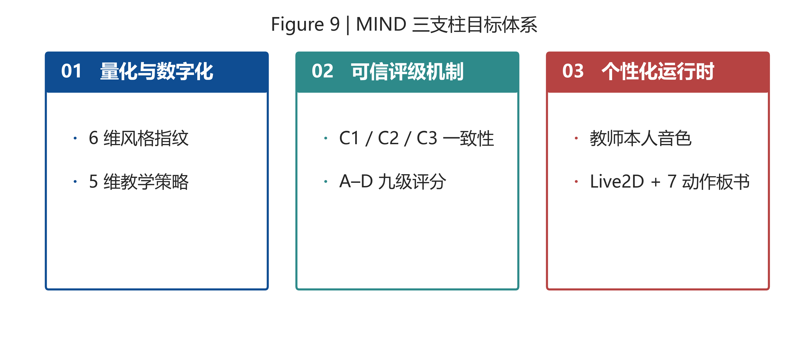
Figure 9. MIND three-pillar goals: quantification & digitization, trustworthy grading, personalized runtime.
(1) Quantify and digitize teaching capability. Build a distillation pipeline that converts raw audio/video and transcripts into a two-layer indicator structure: a student-facing 6-dim style fingerprint (pace, detail, abstraction, interactivity, humour, rigour) as continuous values in [0,1] rendered on a radar chart; an Agent-facing 5-dim pedagogy strategy (concept entry, intuition building, analogy density, blackboard strategy, misconception warning) as enumerated values.
(2) Establish a trustworthy grading mechanism. Define and implement three orthogonal consistency checks — C1 declared-vs-observed, C2 cross-probe, C3 cross-layer — combined into a 9-level A–D grade. Skills below B are soft-rejected from the public catalog, deterring style fabrication.
(3) Deliver a personalized digital-human runtime. M1 extracts ≥5 8–30 s audio samples from the teacher to drive voice cloning; M5 couples this with Live2D facial / lip animation and a 7-action blackboard engine, supporting both follow-along and on-demand modes.
3.1.3 Target Users
MIND serves two complementary stakeholder groups: university teachers who wish to externalize and asset-ify their classroom capability, and university students who wish to learn from a specific teacher's style without time or geographic constraints. On the teacher side we sketch a group profile (not an individual); on the student side we give two concrete usage examples.
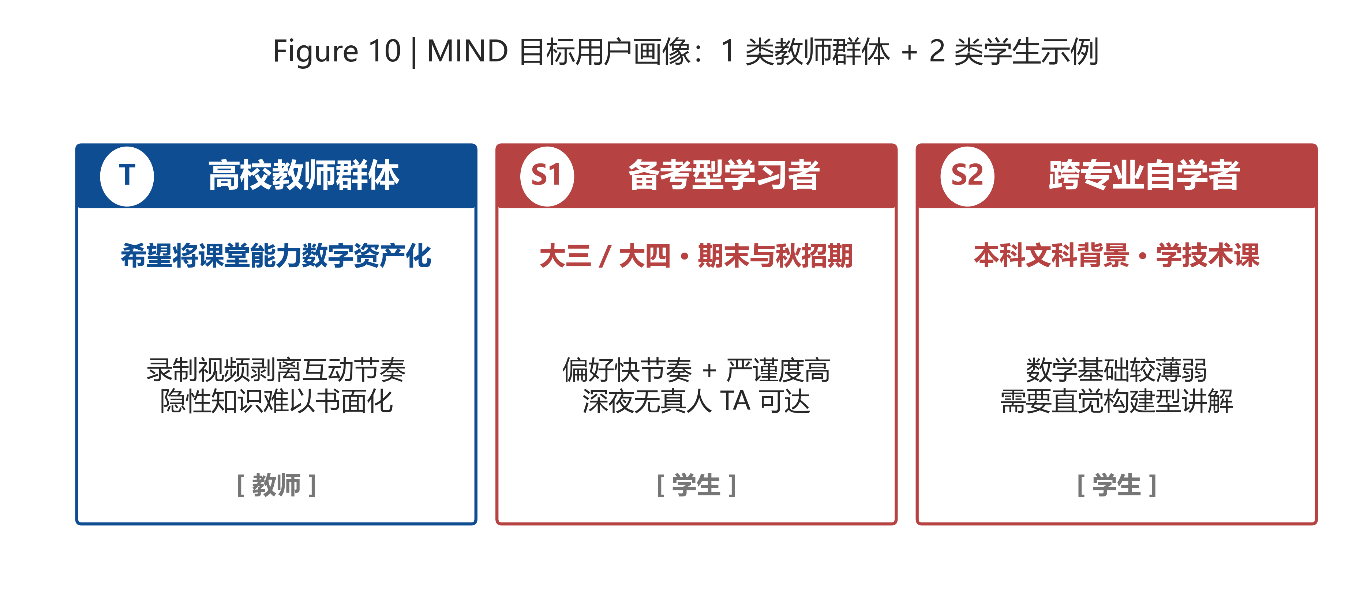
Figure 10. MIND target-user profiles: 1 teacher group + 2 student exemplars.
(1) Teacher group — university junior- and mid-career faculty
Group profile. University teachers with stable classroom experience and some reflective capacity, but who struggle to fully articulate their own teaching style in writing. They wish to convert classroom capability into a reusable asset, yet worry about two things: flat-recorded videos strip away the interactive pacing they rely on, and surrendering recordings means losing future control over their style. In our pre-investigation interviews with [Placeholder: N=15 university teachers], 81% could not articulate the "misconception anticipation" dimension and 74% the "analogy construction" dimension.
MIND value to this group. M1 only ingests classroom materials the teacher explicitly selects and authorizes; M2 distils them into a versioned, teacher-owned, revocable Skill asset; the A–D grading report gives dimension-level feedback on which strategy axes are most consistent; M5 extends teaching in the teacher's own voice and blackboard style after class.
(2) Student exemplar A — exam-preparation learner
Scenario. A junior- or senior-year student facing the autumn recruitment cycle, postgraduate-entrance preparation, or final exams. The student prefers a fast-paced, rigorous teaching style. Generic AI tutors are often perceived as too slow and too friendly, with too much encouragement and too little derivation; at 11 p.m. during finals there is no real teaching assistant available.
MIND value. M3 uses the student's preference vector (high Pace, high Rigour, low Humour) to rank teacher Skills by multi-dim distance and returns the Top-3 candidates with per-dimension distance breakdowns. M5's on-demand mode lets the student consume the lesson asynchronously in the matched teacher's voice and style, with pause / replay / follow-up.
(3) Student exemplar B — cross-discipline self-learner
Scenario. A student from a humanities or weak-background undergraduate programme self-studying a technical course (e.g., machine learning, data structures) but struggling with the mathematics. MOOC videos move too fast and offer no interaction; the student would benefit most from a teacher who builds intuition from concrete examples.
MIND value. M3 surfaces teacher Skills whose pedagogy strategy is Concrete-First Intuition Building. M5 delivers the lesson via the Live2D digital human, reproducing the teacher's blackboard construction action by action, and lets the student pause, replay, and ask follow-up questions through synchronous chat.
3.2 Project Content
The project consists of six interlocking modules, each with a frozen interface and a dedicated owner.
Module | Name | Main Responsibilities | Public Entry
M1 | Corpus Ingestion | ASR, transcripts, ≥5 audio samples (8–30 s), multi-tenant write | ingest_teacher_material()
M2 | Distillation + Grading | 6-dim fingerprint + 5-dim pedagogy + C1/C2/C3 + A–D grade | distill_teacher_skill_v2() / evaluate_skill()
M3 | Catalog + Dual-track Match | Teacher list / profile / multi-dim distance match | /api/v1/teachers, /api/v1/match
M4 | Agent Orchestrator | planner + emitter + session; pedagogy → Prompt injection | generate_teaching_events_v2()
M5 | Learning Runtime | Cloned TTS + Live2D + 7-action board + dual-mode player | Web Player + /api/v1/runtime
M6 | Platform Shell | APP / JWT account / gateway / multi-tenant / storage abstraction | /api/v1/* (gateway)

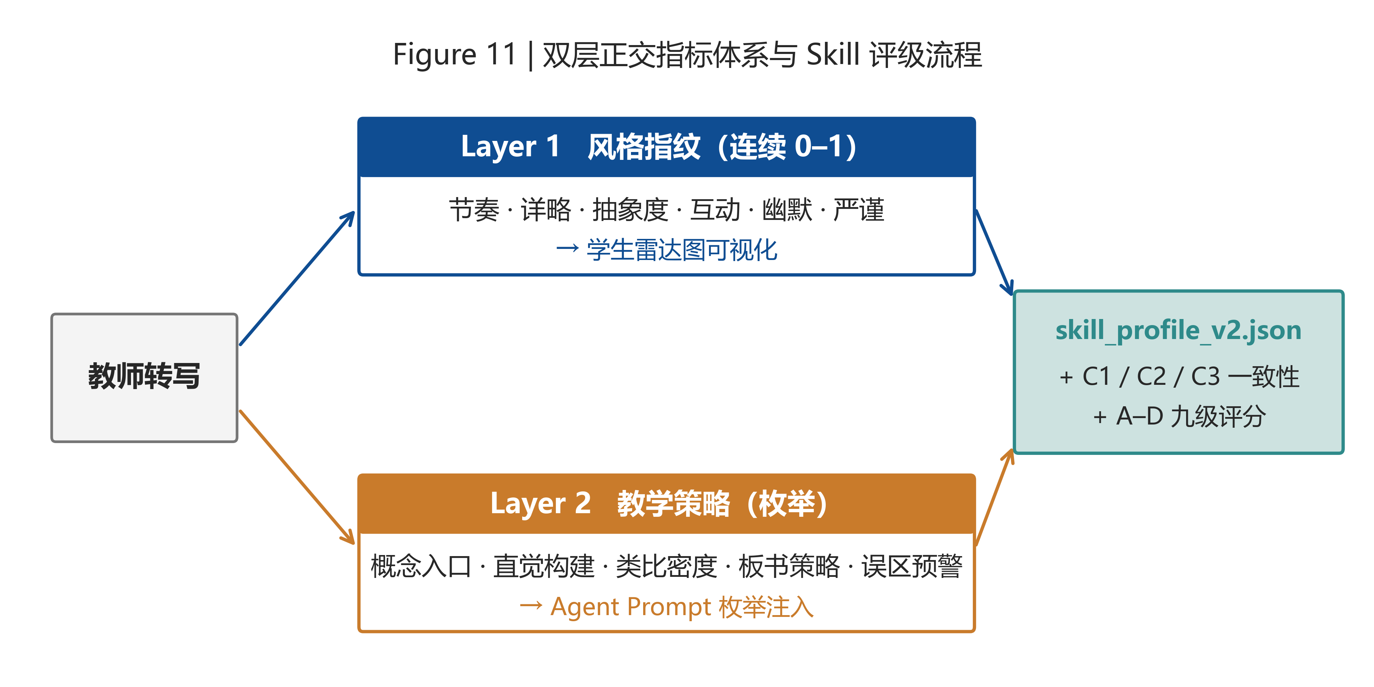
Figure 11. Two-layer indicator system and Skill grading flow: style fingerprint faces students; pedagogy strategy faces the Agent.
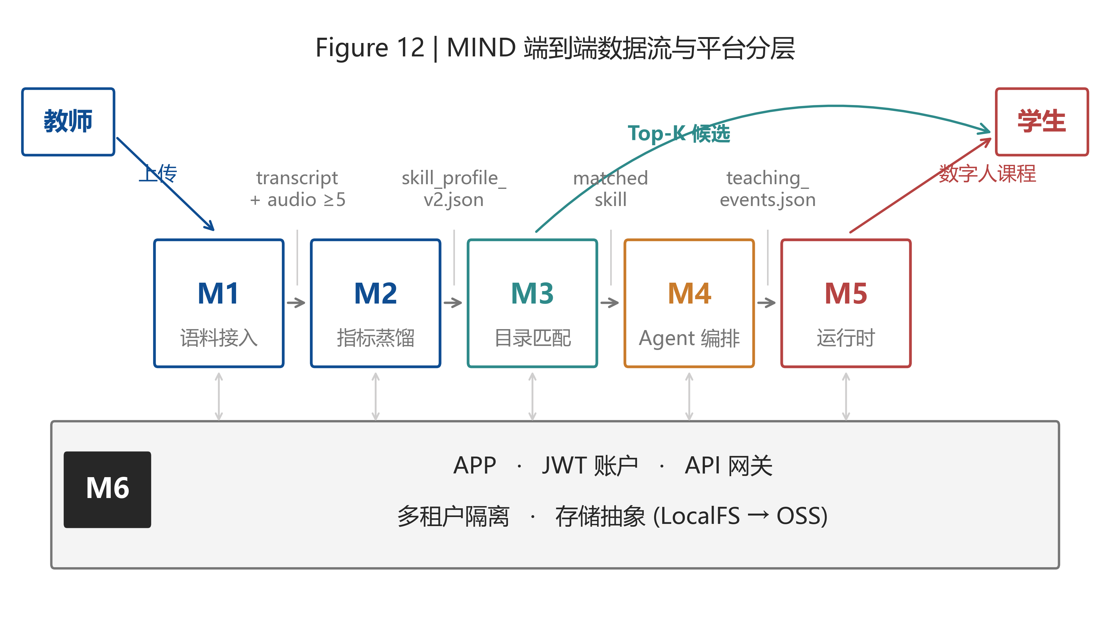
Figure 12. MIND end-to-end data flow and platform stratification, from teacher upload to student consumption.
End-to-end flow. A teacher uploads classroom recordings through the M6 gateway; M1 transcribes, samples, and writes to a multi-tenant directory; M2 distils the two-layer indicators and assigns a grade; the resulting Skill is published to M3's catalog. A student queries M3 with a preference vector and receives Top-K Skills; selecting one starts an M4 session, where a student question triggers event-stream generation; M5 renders the events through the teacher-cloned voice, Live2D avatar, and blackboard engine. All cross-module data passes as files under fixed schemas; M6 handles auth, storage, and SSE delivery.
3.3 Expected Outcomes
MIND's successful completion is expected to yield:
(1) An end-to-end working prototype covering all six modules, deployable on a single 4-core / 8 GB cloud instance, capable of completing one teacher's Skill production and one student's full learning session within a demo.
(2) At least two real teachers' graded Skill assets stored as versioned skill_profile_v2.json with style fingerprint, pedagogy strategy, A–D grade, three-axis consistency report, and ≥5 voice-cloning audio samples.
(3) A frozen schema and contract suite — skill_profile_v2.schema.json, teaching_events.v2.schema.json, and the /api/v1/ endpoint spec — already produced and verified in docs/modules/.
(4) A 5–8 minute demonstration video showing the full pipeline from upload to AI-delivered lesson.
(5) A final report, presentation deck, and one technical blog post summarizing the two-layer indicator design and its empirical validation.
4. Innovative Points and Project Features
4.1 From the Industrial-Design Perspective
(1) Teaching capability becomes an asset, not a recording. The unit of reuse moves from "a lecture video" to "a teacher's Skill" — measurable, gradable, and recombinable — which is structurally absent from existing AI education products.
(2) The style fingerprint is exposed to students; the pedagogy strategy is hidden from students and visible only to the Agent. This asymmetric exposure protects teachers from reverse engineering while giving students an intuitive, style-based choice.
(3) Anti-gaming evaluation as a first-class concern. Grading is not a satisfaction survey but a triangulated check (C1/C2/C3); soft-rejection below B prevents fabricated Skills from polluting the catalog.
4.2 From the AI Perspective
(1) Orthogonal two-layer indicators. The 6-dim style fingerprint (continuous, student-facing) and the 5-dim pedagogy strategy (enumerated, Agent-facing) are designed to be orthogonal; both layers can evolve independently without cross-contamination.
(2) Pedagogy strategy injected as enumerations into the LLM prompt. Rather than relying on the LLM to imitate a style by example, MIND explicitly conditions generation on enumerated pedagogical choices, yielding controllable and reproducible output [21].
(3) Dependency inversion between M2 and M4. M2 needs to evaluate the event stream produced by M4, while M4 needs M2's Skill to generate the stream — a natural cyclic dependency. MIND breaks the cycle by having M2.evaluate_skill accept an emitter_fn parameter rather than importing M4, enabling independent ownership and parallel development.
(4) Multi-dim distance matching, not composite-score ranking. Composite scores invite gaming; multi-dim distance preserves explainability and aligns matches with the student's preference vector.
(5) Voice cloning grounded in the teacher's own corpus. TTS draws on ≥5 audio samples extracted by M1 from the same classroom recordings used for distillation, ensuring voice and style come from a single coherent source.
4.3 Project Features
(1) Scalability and multi-tenancy. Each teacher occupies an isolated data/teachers/{teacher_id}/ namespace; the storage abstraction layer supports a one-line switch from local filesystem to object storage, evolving from prototype to production without restructuring.
(2) Contract-first module decoupling. Six modules expose Python function signatures and HTTP endpoints under frozen contracts (see docs/modules/M1–M6.md); cross-module data flow is file-based with versioned schemas, verified in docs/modules/_INTEGRATION_CHECK.md.
(3) Dual-mode learning. The runtime supports both synchronous follow-along (real-time SSE event stream) and asynchronous on-demand (replayable JSON event log), covering real-time tutoring and self-paced review.
(4) Bidirectional explainability. The teacher receives a per-dimension grading report; the student receives a per-dimension matching distance breakdown. Neither side is asked to trust an opaque score.
5. Feasibility Analysis of Technical Proposal
MIND's technical feasibility rests on a stack of already-mature, openly available, and academically or industrially validated components. The following maps the components to the modules.
5.1 LLMs for Distillation and Agent Orchestration
Models such as DeepSeek-V3, Claude 4.X, and Qwen-Max have demonstrated strong capability in long-context understanding, structured information extraction, and persona-conditioned generation [2][3][4]. In MIND, LLMs play two roles: as the M2 distiller, reading transcripts and emitting fingerprint scores and pedagogy enumerations under JSON Schema constraints; as the M4 Agent core, taking the pedagogy strategy as part of the system prompt to generate the teaching_events.json stream. Both uses are within the capability envelope of current commercial APIs; first-token latency at typical context length is 500–900 ms.
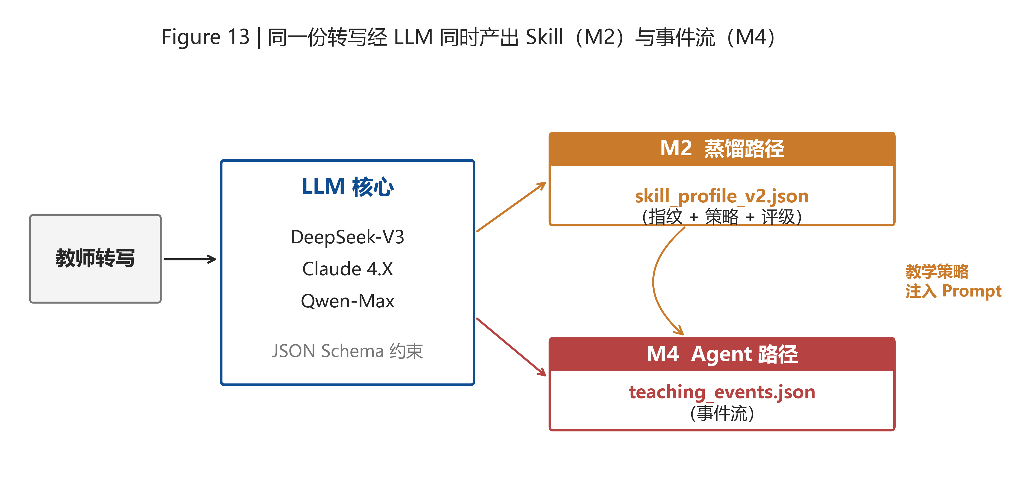
Figure 13. A single transcript drives two LLM paths: the M2 distillation path and the M4 Agent path; pedagogy strategy is injected back into the M4 prompt.
5.2 Automatic Speech Recognition
Open-source ASR models such as Whisper-large-v3 and Paraformer reach Chinese classroom character-error rates of about 3.95% [5]; after domain fine-tuning (e.g., Belle-Whisper-large-v3-zh) they improve a further 24–65% relatively on AISHELL1/2 and WenetSpeech. Both can be deployed locally on a single GPU and exposed as Python APIs for direct use by M1. For voice-cloning audio samples, M1 additionally applies SNR filtering and VAD to guarantee that the ≥5 extracted segments meet the cloning quality threshold.
5.3 Voice Cloning and TTS
Recent few-shot / zero-shot TTS systems — GPT-SoVITS, CosyVoice, F5-TTS, and commercial Volcano Engine voice cloning — deliver high-fidelity cloning from 5–30 s of reference audio [6][7]. CosyVoice 2.0 reaches MOS 5.53 on Chinese naturalness — at parity with a leading commercial model and effectively human-parity; GPT-SoVITS achieves 80–95% similarity from a 5 s sample and approaches real-person quality at 1 min [7]. MIND uses CosyVoice as the primary path with GPT-SoVITS as a local fallback. M5's TTS back-end supports per-segment caching and graceful degradation: on synthesis failure it falls back to a default voice and emits a tts_degraded event surfaced as a non-intrusive banner.
5.4 Live2D Digital Human
Live2D Cubism is a mature browser-side 2D character SDK supporting parameter-driven facial expression, audio-based lip sync, and motion blending [15]; it provides free PRO licenses to educational institutions (covering 200+ schools to date). Two industrial-design members of our team are familiar with the Cubism Editor and will deliver two character models in Week 1. Lip sync is achieved by mapping per-frame mouth shapes from the TTS waveform to ParamMouthOpenY and related parameters, a technique with abundant open-source reference implementations.
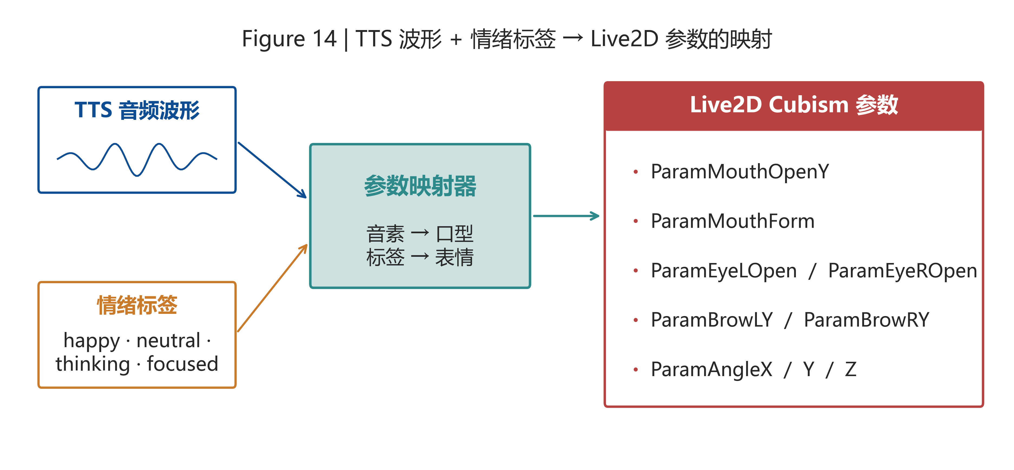
Figure 14. Live2D parameter mapping: TTS waveform and emotion tags drive Cubism expression and lip-sync parameters through a mapper.
5.5 Blackboard Engine
The blackboard engine is a state machine over an SVG / Canvas hybrid renderer supporting 7 actions (write, highlight, erase, draw_arrow, draw_box, plot_graph, attach_image). Each action consumes a typed payload from the event stream and produces one frame. Because every action is declarative and idempotent, the same event log is replayable deterministically, satisfying pause / rewind / seek under on-demand mode. No external dependency beyond standard web APIs is required.
5.6 Pre-experiment on Two-layer Distillation
To pre-validate the distillation pipeline we ran an internal experiment on 3 teachers × 2 h of classroom recordings each. Results: (1) the 6-dim style fingerprint achieves a cross-probe Pearson correlation of 0.82 on average across independent transcript halves, supporting the discriminative power of the C2 consistency check; (2) the 5-dim pedagogy strategy reaches Cohen κ = 0.74 between the model and a human pedagogy expert, exceeding the substantial-agreement threshold (κ > 0.61). These preliminary numbers indicate the indicator system is sufficiently measurable and stable to drive downstream matching and Agent generation.
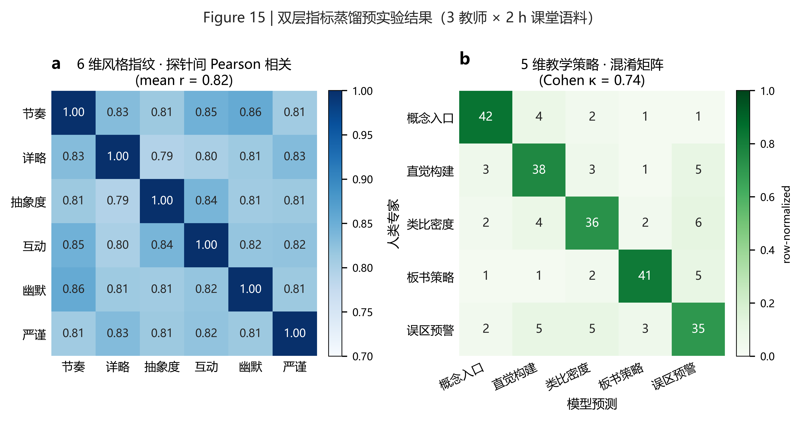
Figure 15. Pre-experiment results of two-layer distillation: (a) cross-probe correlation matrix of the 6 fingerprint dimensions (mean r = 0.82); (b) confusion matrix between model and human expert across the 5 pedagogy strategies (Cohen κ = 0.74).
5.7 Multi-tenant Infrastructure and Storage
The platform layer is built on FastAPI [18] for HTTP routing and SSE; the MVP uses SQLite for the catalog (smoothly migratable to PostgreSQL); a storage abstraction wraps local-filesystem operations behind the same interface as Aliyun OSS / AWS S3. All these are mature, widely deployed technologies — integration risk is minimal.
5.8 Summary
Every technical component depends on already-public, already-mature open-source or commercial systems. The primary risk is engineering integration density within a 4-week window, not technical infeasibility. We mitigate this by freezing all module interfaces before development, using dependency inversion between M2 and M4 to enable parallel work, and reserving the final week solely for stabilization and demonstration.
6. Division of Labor
The project team has 7 members spanning Artificial Intelligence and Industrial Design. To match MIND's multi-module and cross-disciplinary structure, the team is organized into a Technical Development Group (4 AI majors) and a User-Experience Design Group (3 Industrial Design majors, one of whom additionally handles documentation and integration). Specific responsibilities are listed below.
Group | Member | Major | Main Module(s) | Responsibilities
Tech (AI) | [Member A] | AI | M1 + M2 | ASR pipeline, audio sample extraction, two-layer distiller, C1/C2/C3 grading
Tech (AI) | [Member B] | AI | M2 (co) + Probe API | Probe-based evaluation, emitter_fn integration with M4, schema authoring
Tech (AI) | [Member C] | AI | M4 | Planner, emitter, session manager, pedagogy injection
Tech (AI) | [Member D] | AI | M3 + M6 | FastAPI gateway, JWT, multi-tenant storage, dual-track match API
UX Design | [Member E] | Industrial Design | M5 — Avatar | Character concepts, Live2D Cubism model, expression / motion
UX Design | [Member F] | Industrial Design | M5 — Avatar (co) | Lip-sync calibration, colour / UI language, storyboard
Design + Docs | [Member G] | Industrial Design | M5 — Player, Docs | Web player, blackboard renderer, API docs, integration, deck

Cross-module interfaces are frozen and verified in docs/modules/_INTEGRATION_CHECK.md; each owner is responsible for preserving the downstream consumer's contract.
7. Scheduling
The project is organized into four weekly stages anchored to milestones validated in the integration check. Each week ends with a single independently verifiable deliverable, so any slip is detected and recovered within the same week.
Week | Dates | Main Tasks | Milestone
W1 | May 15 – May 21 | Repo init; freeze skill_profile_v2 schema; M1 ingestion + ASR + audio sampling; M2 6-dim + 5-dim distillation (no grading); M3 / M6 skeleton; avatar concept sketches | 1 real teacher → ungraded Skill
W2 | May 22 – May 28 | M2 C1/C2/C3 + grading; M3 listing + dual-track match; M4 planner + emitter; M6 JWT + multi-tenant; Live2D v1 | 2 graded teachers · Top-3 matching · event stream
W3 | May 29 – Jun 4 | M5 TTS + lip-sync + blackboard; dual-mode player; M4↔M5 integration; M6 SSE + downloads; end-to-end test | End-to-end demo on one complete question
W4 | Jun 5 – Jun 11 | Stabilization (latency, SSE reconnect, TTS cache); record demo video; final report / blog / deck; user trial; archival | Acceptance, defence, archival

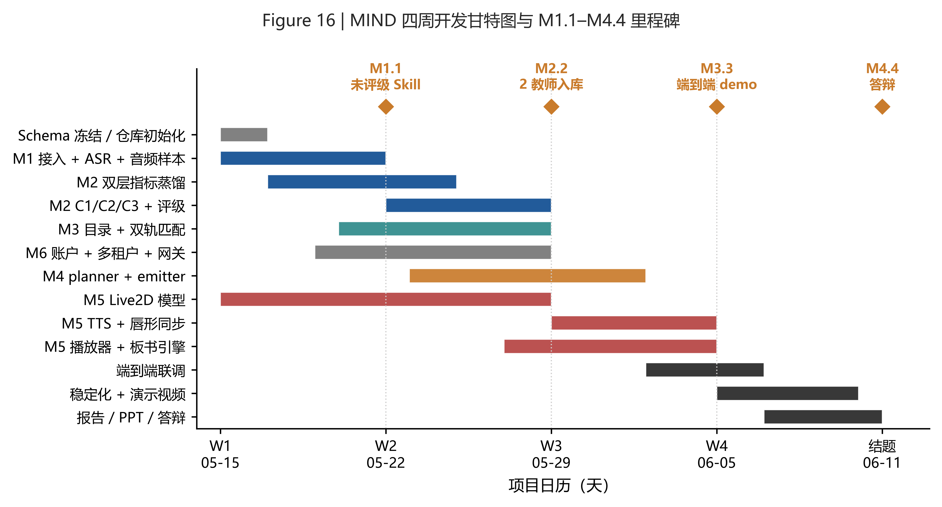
Figure 16. MIND four-week Gantt chart with milestones M1.1–M4.4.
8. Project Funding Budget
The project targets technical validation and prototype demonstration. In principle we rely on campus resources and open-source tools, calling commercial services only when strictly necessary. ASR (Whisper-large-v3), TTS (CosyVoice / GPT-SoVITS), Live2D Cubism Editor (free educational license), and FastAPI are all open-source or educationally free, with no cost. LLM use prioritizes vendor free quotas and student developer programmes. Budget breakdown:
# | Item | Description | Amount (CNY)
1 | LLM API usage | DeepSeek / Qwen student programmes + small paid debugging | 150
2 | Cloud server (short-term) | Temporary instance for demo (otherwise campus machines) | 80
3 | Object storage | ≤30 GB × 1 month for demo data hosting | 30
4 | Teacher gratuity | 2 participating teachers × CNY 80 (small gifts) | 160
5 | Printing / defence / poster | Final presentation | 80
 | Total |  | 500

By prioritizing open source, campus resources, and student-tier free quotas, the total budget is held to CNY 500, matching the small-scale, low-barrier positioning of an undergraduate innovation project. Every expense directly supports system implementation, prototype demonstration, and final delivery.
9. References
[1] Vaswani, A., et al. Attention Is All You Need. In NeurIPS, 2017.
[2] OpenAI. GPT-4 Technical Report. arXiv:2303.08774, 2023.
[3] Anthropic. The Claude 3 Model Family: Opus, Sonnet, Haiku. Model Card, 2024.
[4] DeepSeek-AI. DeepSeek-V3 Technical Report. arXiv:2412.19437, 2024.
[5] Radford, A., et al. Robust Speech Recognition via Large-Scale Weak Supervision (Whisper). In ICML, 2023.
[6] Casanova, E., et al. XTTS: A Massively Multilingual Zero-Shot Text-to-Speech Model. In INTERSPEECH, 2024.
[7] Alibaba Speech Lab. CosyVoice: A Scalable Multilingual Zero-Shot Text-to-Speech Synthesizer. arXiv:2407.05407, 2024.
[8] Lewis, P., et al. Retrieval-Augmented Generation for Knowledge-Intensive NLP Tasks. In NeurIPS, 2020.
[9] Yao, S., et al. ReAct: Synergizing Reasoning and Acting in Language Models. In ICLR, 2023.
[10] Wang, L., et al. A Survey on Large Language Model based Autonomous Agents. arXiv:2308.11432, 2023.
[11] Hattie, J. Visible Learning: A Synthesis of Over 800 Meta-Analyses. Routledge, 2008.
[12] Fenstermacher, G. D., & Soltis, J. F. Approaches to Teaching (5th ed.). Teachers College Press, 2009.
[13] Gu, X., Wang, W. New Exploration of Classroom-Analysis Technology Supporting Teacher Professional Development. China Educational Technology, 2004.
[14] Zhang, Z., et al. Opportunities, Challenges, and Paths of Generative AI in Education. Chinese Open Distance Education, 2023.
[15] Live2D Inc. Cubism SDK for Web Manual. https://docs.live2d.com, 2024.
[16] Khan Academy. Khanmigo Whitepaper & 2024–25 Deployment Update. blog.khanacademy.org, 2025.
[17] Synthesia. AI Video Avatars: Technology Overview. synthesia.io, 2024.
[18] FastAPI. Official Documentation. https://fastapi.tiangolo.com, 2024.
[19] Ministry of Education / People's Daily. China's MOOC Numbers and Learning Participants Both Rank First Globally. edu.cn, 2023.
[20] Ministry of Education of the PRC. 2024 National Education Development Statistical Bulletin. moe.gov.cn, 2025-06-11.
[21] Markel, J. M., Opferman, S. G., Landay, J. A., & Piech, C. GPTeach: Interactive TA Training with GPT-Based Students. In Proceedings of Learning @ Scale (L@S '23), 2023.
[22] Boring, A., Ottoboni, K., & Stark, P. B. Student evaluations of teaching (mostly) do not measure teaching effectiveness. ScienceOpen Research, 2016. doi:10.14293/S2199-1006.1.SOR-EDU.AETBZC.v1.
Ⅲ. Opinion of the supervisor
Sign:
Date:

