The “Matching Task”

In this task, you need to match, the shape-color-number combination described to you to one of four choices that are at the right of the screen.

In particular at each trial you will get simultaneously three different types of instructions.
- Audio
- Textual
- Visual

All the instructions combined describe a unique combination of shape-color-number

Click one of the four buttons that match the combination that was described to you. Follow your selection, you will get feedback. If your match was not correct, you need to try a different rule.

Rules:
- match according to visual stimuli
- match according to textual stimuli
- match according to audio stimuli

Example:
a) If you match according to visual stimuli you would click the third button. If you match according to textual stimuli, you would click the second button. If you match according to audio stimuli, you would click the first button.
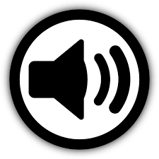
Voice Command: “Circle”
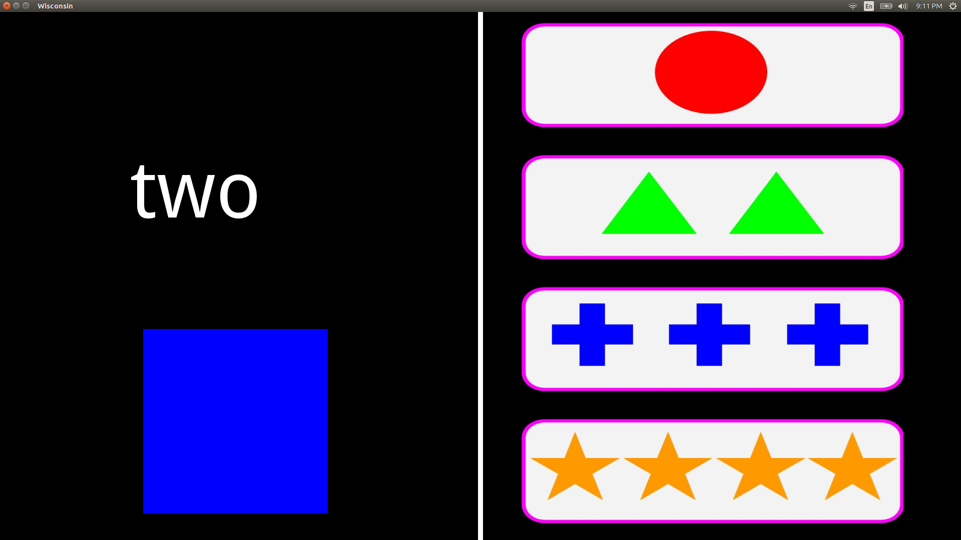
Button
1
Audio Stimuli

Textual Stimuli
Button
2

Button
3
Visual Stimuli

Button
4

You will need to find out whether to match according to audio, text, or image. Once you have figured out what rule to use, you can relax for a while. But, that is not all. The matching rule changes now and then! You need to carefully monitor the feedback. If the computer gives you error message, you need to change the rule! At each trial you have 8 seconds to respond!

If a match is correct the robotic-arm will grab one cube either from bucket “A” or bucket “B” and place it to bucket “C”. Your goal is to place as many cubes as possible in bucket “C” .
That is all!

In total there are 60 trials!

