# OSU Quadruped

## Summary

The team will be building and programming a 3D printed, quadruped robot using C++ and the Arduino Mega microcontroller. The quadruped will have 3 degrees of freedom on each leg and be capable of walking, rotation and tilt. The robot will interface with a controller (either PC or Android device) via Bluetooth. The project will allow team members solve unique problems involving inverse kinematics, walking gaits, Arduino hardware and wireless control systems.

## Build Materials

* 1x Arduino microcontroller (Uno/Mega)
* 1x Adafruit servo shield
* 1x 2S 1000 MaH Lipo
* 1x 3A 5V UBEC
* 12x MG90 servos
* 1x Bluetooth module
* 2x Upper and lower plates body plate assemblies
* 8x Servo brackets
* 4x Femur assemblies
* 4x Tibia assemblies
* M2 screws, washers, nuts

## Frame Design

A preliminary frame design was created using Autodesk Inventor and a Monoprice Mini Delta 3D printer. Below is a screenshot from Inventor displaying the frame components. This frame is a work in progress. Modifications and refinements to this design will occur throughout the development.

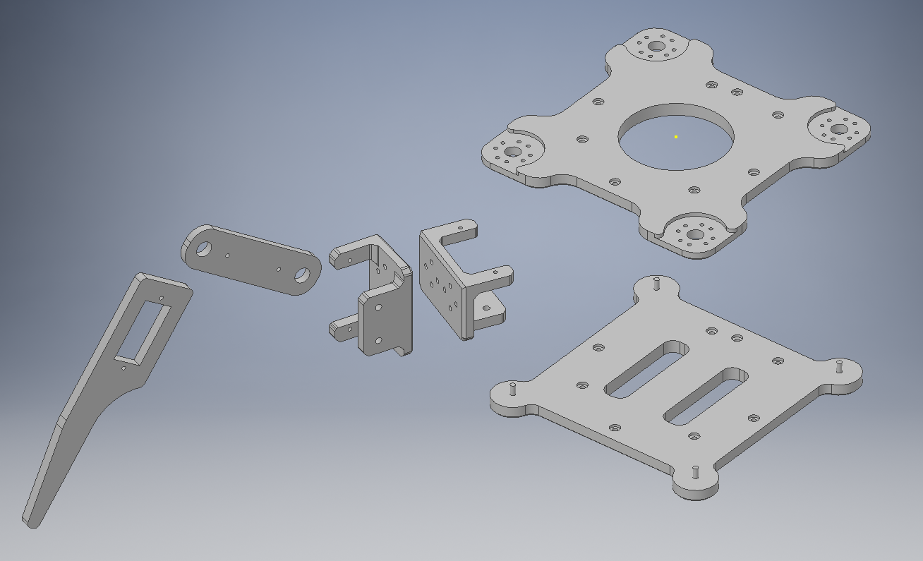

## Movement System Design

The movement for the quadruped will be written using the Arduino IDE using C++ and open source Arduino libraries. The body and leg movement algorithms will need to utilize Inverse Kinematics. Initially, the following capabilities will be developed:

* Tilt body in place
* Rotate in place
* Translate/walk in joystick direction

If these primary movement mode goals are met, additional movement gaits and functionality will be added, possibility including additional walking gaits, scripted sequences/dances, simple obstacle detection (requires ultrasonic rangefinder sensor to be added).

## Control System Design

Depending on the client and team consensus, the quadruped control system may be designed for PC or android device and connect via Bluetooth. The software will consist of a single screen interface with the following functionality:

* Connect Button – connect to Arduino/robot
* Tilt Mode Button – Selects tilt state
* Move Mode Button – Selects move state
* Joystick Interface – Moves/tilts depending on selected state

## Technology

The [Arduino IDE](https://www.arduino.cc/en/Main/Software) will be used for developing quadruped movement algorithms. [Qt Creator](https://www.qt.io/download) or [Android Studio](https://developer.android.com/studio/) will be used to develop the control software.

## Plan

Below is a high-level plan of the steps required to complete the project. Note, as of December 30, 2018 the preliminary frame design is complete. Parts are currently in the process of being printed and tested.

1. Initial frame design and print
2. Servo alignment and initial build
3. Tilt feature code
4. Rotate feature code
5. Move feature code
6. Control software code
7. Bluetooth module integration
8. Iteratively improvements to frame, software, algorithms

## Team Members

1. Daniel Jarc
2. TBD
3. TBD

## Individual Task Assignments

|  |  |  |  |
| --- | --- | --- | --- |
|  | Daniel Jarc | Team Member 2 | Team Member 3 |
| Week 1 | TBD | TBD | TBD |
| Week 2 | TBD | TBD | TBD |
| Week 3 | TBD | TBD | TBD |
| Week 4 | TBD | TBD | TBD |
| Week 5 | TBD | TBD | TBD |
| Week 6 | TBD | TBD | TBD |
| Week 7 | TBD | TBD | TBD |
| Week 8 | TBD | TBD | TBD |
| Week 9 | TBD | TBD | TBD |
| Week 10 | TBD | TBD | TBD |

### Summary

Develop a quadruped robot capable of basic walking, rotation and tilt using C++ and an Arduino microcontroller. The user will control the robot wirelessly via PC or android device.

### Breakdown

1. Initial frame design and print
2. Servo alignment and initial build
3. Tilt feature code
4. Rotate feature code
5. Move feature code
6. Control/GUI code
7. Bluetooth module integration
8. Iteratively improvements to frame, software, algorithms as time permits

### Frame Design

A preliminary frame design was created using Autodesk Inventor and a Monoprice Mini Delta 3D printer.  Below is a screenshot from Inventor displaying the proposed frame components. This frame is a work in progress. Modifications and refinements to the design will occur throughout the development. Part files will available and printed as necessary for team members wishing to do a parallel build of the project.

### Movement System Design

Movement algorithms for the quadruped will be written using C++ and the Arduino IDE. The following capabilities will be developed:

* Tilt body in place
* Rotate in place
* Translate/walk in joystick direction

If these goals are met, additional movement modes, scripted sequences and/or simple obstacle detection could be added.

### Control System Design

Depending on the client and team consensus, the quadruped control system may be designed for PC or android device and connect via Bluetooth. The software will consist of a single screen user interface with the following functionality:

* Connect Button – connect to Arduino
* Tilt Mode Button – Selects tilt state
* Move Mode Button – Selects move state
* Joystick Interface – Moves/tilts depending on selected state

## Technology

The [Arduino IDE](https://www.arduino.cc/en/Main/Software) will be used for developing quadruped movement algorithms. [Qt Creator](https://www.qt.io/download) or [Android Studio](https://developer.android.com/studio/) will be used to develop the control software.

### Materials

* 1x Arduino microcontroller (Uno or Mega)
* 1x Adafruit servo shield
* 1x 2S 1000 mAh lipo battery
* 1x 3A 5V UBEC
* 12x MG90 servos
* 1x Bluetooth module
* 2x Upper and lower body plate assemblies
* 8x Servo brackets (shoulder joints)
* 4x Femur assemblies
* 4x Tibia assemblies
* M2 screws, washers, nuts

### Division of Labor

* Frame and initial build
* Movement code
* Control/GUI code
* Additional features

Note: I think it's feasible for all team members to participate with each phase of the project, except possibly the intial build (if other group members opt to only work on the code). I have all the materials listed above and a 3D printer available for prototyping. My goal is to have the wiring, servo alignment and frame assembly done by the end of week 1, when we pick projects. I think this would be a really cool project to work on - our updates could include videos of the build, movement tests, etc.. and it would be awesome to demo.