The Bill of Rights
Know Your Rights
Your Rights
Fit the Bill Nicely
Playgrounds
Rules and Your Rights
Your Voice Matters
Speak Up & Help Out
Lesson 3
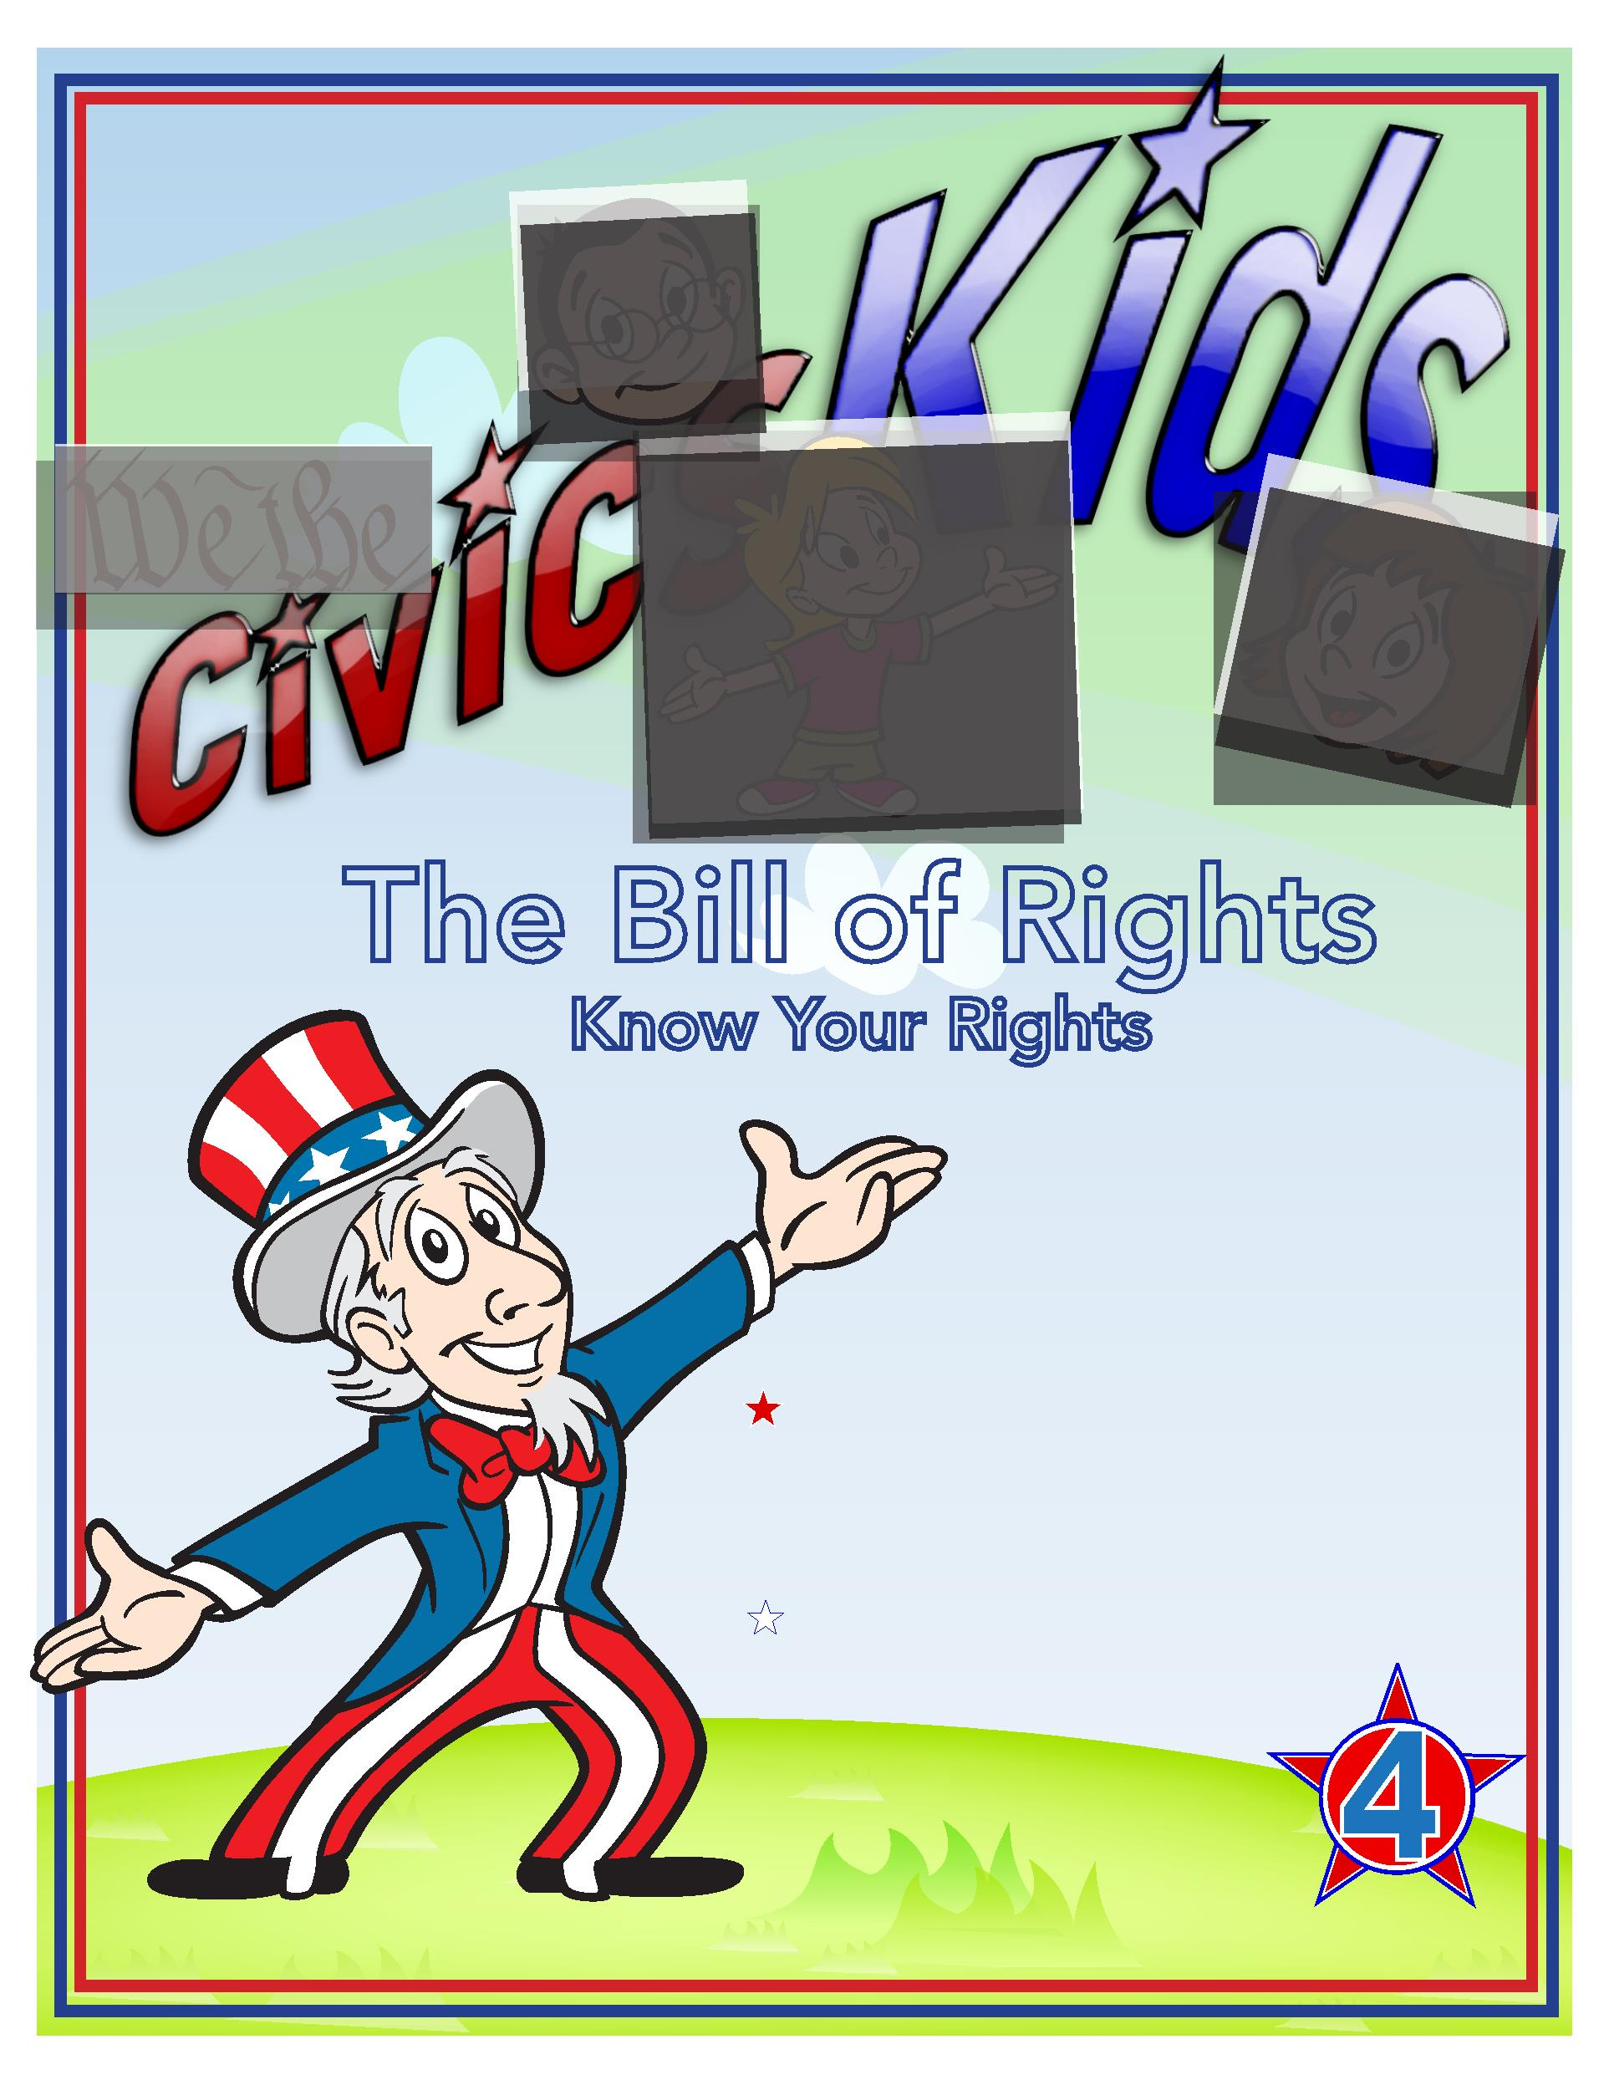

Lesson 3: Bill of Rights
The Constitution established a strong national government and the rights of
the states, but there was no mention of the rights of its citizens. Some of the
delegates refused to sign the Constitution until a bill of rights was written to
protect the freedom and rights of the individual. It was promised that a bill
of rights would be attached to the Constitution. These would be the ﬁrst
changes, or amendments, to the document.
James Madison proposed twelve amendments. Only ten were approved
by the States. These ﬁrst ten amendments to the Constitution are our
Bill of Rights.
Let’s look at the rights and freedoms provided by each of the amendments:
Amendment 1: Freedom of Religion, Speech and the Press: The Right to
Assemble and Petition
The First Amendment might be one of the best known. It allows people to establish and
practice their religion freely, and to speak their ideas and opinions. It protects the rights of
its citizens to hold meetings and to petition the government. It gives the press (newspapers,
magazines) the right to publish the news and ideas.
Amendment 2: The Right to Bear Arms
The Second Amendment gives all citizens the right to own guns. You have probably heard
news stories about this recently. There has been much discussion about whether to limit the
kinds of guns that can be sold. Also, many people want to require a background check for
anyone purchasing a gun.
Amendment 3: Housing of Soldiers
When the colonies were ruled by England, people were forced to house soldiers in their
homes. They would have to give them a place to sleep and meals. This amendment made it
unlawful for a government to make a private citizen house its soldiers.
Amendment 4: Searches, Seizure and Warrants
This amendment protects people from law enforcement entering their
home without their permission or an order from the court called
a search warrant.
Lesson 3


Amendment 5: Rights in Criminal Trials and the Rights of Property
Persons cannot be made to testify against themselves in a criminal trial. A person cannot be
tried more than once for that same crime. People’s property cannot be taken away without
their being paid for it.
Amendment 6: Rights to a Fair Trial
This amendment requires a person accused of a crime to receive a speedy public trial by a
jury. This did not happen in England during this time. People were held in jail for years before
their trial and often the trial was held in secret.
Amendment 7: Rights in a Civil Trial
A civil case is brought by a person to get back property, to have a contract enforced, or to
protect a person’s rights. The Seventh Amendment allows a civil case to be decided by a jury
trial when the amount of money involved is over $20.
Amendment 8: Bail, Fines and Punishment
The Eighth Amendment does not allow for unfair bail or ﬁnes and the use of cruel or unusual
punishments. The framers wanted to eliminate the use of torture on suspected criminals or as
a punishment for a crime.
Amendment 9: Rights Kept by the People
Some of the delegates thought that if a right was not listed in their Bill of Rights, it might be
interpreted to mean that the people did not have that right. The Ninth Amendment protects
the rights people have though not listed in the Constitution.
Amendment 10: Powers Kept by the States and the People
The rights not given to the national government are rights kept by the states or the people.
Sticky Situation
It is recess time and you and your friends head out to the playground.
You approach a group of friends from another class and notice a group of boys
have joined them. Teams need to be chosen for your game and one of the boys
who you normally don’t play with is selected as captain. This boy insists that his
team has NO girls on
What would
you do?
Why?
Lesson 3


Civic Literacy Links
The Bill of Rights: Read More on Your Rights
• More Than Anything Else by Maria Bradby and Chris Soentpiet
• Carl the Complainer
• Bill of Rights Match Game:
http://www.Texaslre.org/BOR/billofrights.html
• Bill of Rights: Protecting Our Freedom Then and Now by Syl Sobel
• Library of Congress Word Search:
http://myloc.gov/Education/OnlineActivities/Pages/onlineactivities/wordsearch/index2.html
Time to look at our classroom or school rules and maybe make
some changes or amendments.
Is there a rule you would like added?
Maybe there is a rule that you think should be changed in
some way.
H Write your idea on one of the index cards and post it on the Student Voices Bulletin Board.
H We will take a look at everyone’s ideas at a class meeting!
Lesson 3
