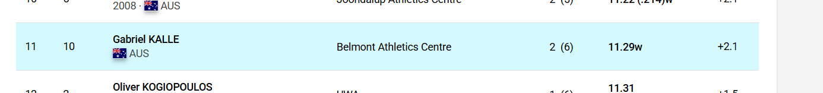
Kalle – no year of birth

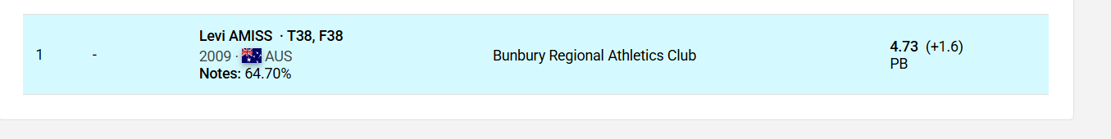
T38,F38 at end of name (should drop based on current code given dot after name
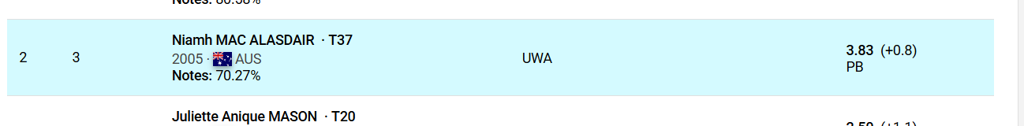
As above – T37 should be removed by regex or similar
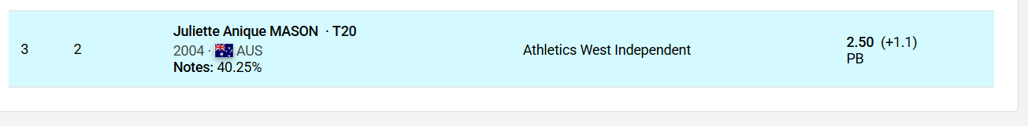
As above

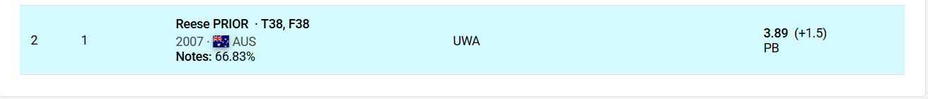
Track events parsing OK – consider for field events

