ENTWA Project Ideas

*User interaction design*

Table of Contents

Organisation structure diagrams (Sitemap) 1

Wireframes 2

Main frame 2

Homepage 2

Add an Idea 3

View idea 3

Sign Up 4

Use Cases 4

Searching & applying for an idea 4

Adding an idea 4

Approving an idea 5

Joining the site 5

Login into site 5

Logout of site 5

# Organisation structure diagrams (Sitemap)

The application will be split into two main sections. App will offer a simple CRUD for users to manage their ideas and for users to sign up and manage their account.

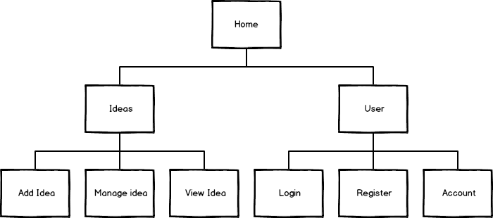

# Wireframes

## Main frame

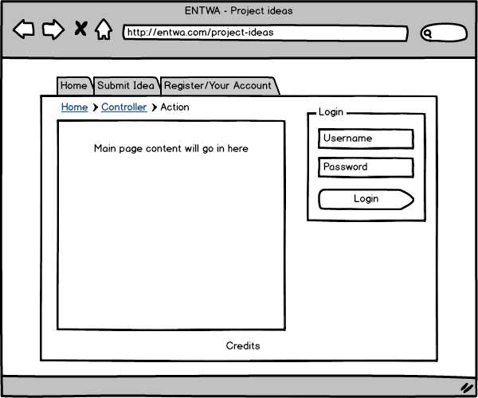

The main frame of the website will be consistent across the entire website to make sure users can easily find the page to preform the main actions of the application. The “Main page content” section will contain the sections below.

The links on the top of the site will change based on the type of users (for example, students will not be able to submit ideas).

## Homepage

The homepage will consistent of recent ideas & a search bar.

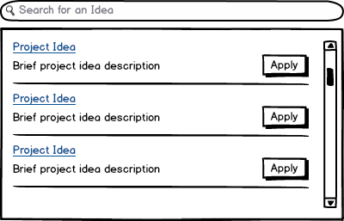

When the search bar contains a value, the project ideas in the box will update via AJAX.

## Add an Idea

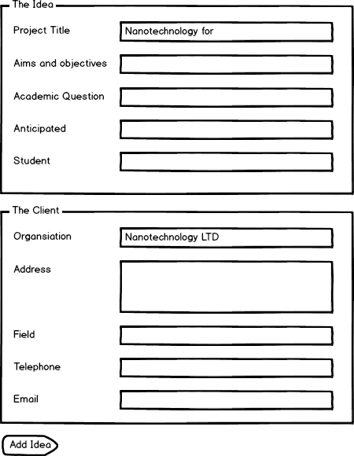

The idea page is split into two main sections, the idea and the client. If the client is adding the idea, the client is blank.

## View idea

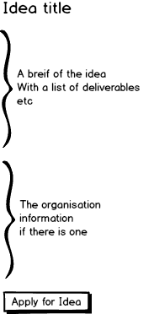  
  
This is a simple view of the view idea page; it will pretty much just contain a list of information (like the current site) but with the ability for users to apply with just one click.

## Sign Up

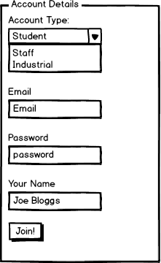

Upon pressing “Join!”, the user is then redirected to their user account. The sign up page is as minimal as possible; this is to make the sign up process as simple as possible.

# Use Cases

## Searching & applying for an idea

1. The user searches for an idea via the homepage using the search box. When they find a suitable idea they click the “apply”. If the user created the idea, the “apply” button will be a “edit” button, which leads them to an edit page.
2. The system then displays more information about the idea & a confirmation button.
3. Assuming the user is a student, they can apply for an idea & will be shown a success page.

## Adding an idea

1. To add an idea, the user must either be an organisation or staff member. To navigate to the “submit an idea” page, the user clicks the “Submit Idea” link.
2. Once the “Submit an idea” page has loaded, the user fills out the idea portion of the form they have the option to input an organisational details.
3. Once the user is happy with their idea form, they can click “save” to add it to the website.

## Approving an idea

1. When a student applies for an idea, it’s logged against an idea.
2. Ideas with a student applying for them are listed in a staff members account page in a similar way to the homepage.
3. The staff member can click the idea to view which student is applying for it & approve a single student to an idea.

## Joining the site

1. The user clicks the “register” link on the homepage. This takes to a registration page.
2. The registration page contains a few details required to make an account, which are required by the user to have an account.
3. When the user is done completing the field, the user clicks the “Join now” button & goes to a confirmation page.

## Login into site

1. On the right hand side of the website there is a login box.
2. The user fills in the form & presses “login”
3. They are then taken to their account management page

## Logout of site

1. Where the login box was, there is now a logout link.
2. When a user clicks “logout”, it takes them to the homepage & logs them out.