**Instruction for running InnoCalendarBotapplication:**

1. Installjava 8 on your computer
2. Install IDE: Intellij Idea ultimate
3. Unzip files from zip archive
4. Run Intellij Idea Import project on welcome screen (fig .1)
5. Choose folder with project
6. Import project from external model
7. Press Enter
8. Press Enter
9. Press Enter
10. Press Enter
11. Press Enter
12. Press Enter
13. Wait until all maven dependencies will be downloaded
14. In project tree section (fig.2) run \innoElectiveBot\src\main\java\Bot.java

*Be aware of blocking of telegram IPs by some internet providers in Russia (Use University network)

1. Open Telegram application

2. Project tree

1. Find by alias @InnoElectiveBot and start it

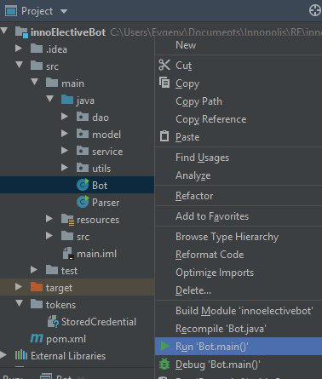

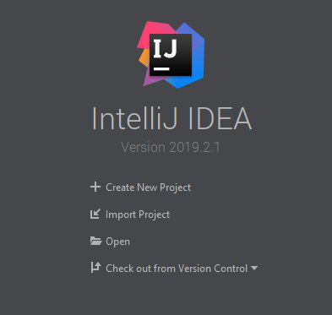

. Welcome screen