Particle Tracking Guide

Creating a minimalist project:

-To track a bunch of objects you need a movie in a recognised format e.g .mp4, .avi, .m4v. In order to follow the motion of objects through a movie the objects must move only a small distance between frames. “small” depends on the density of other objects, the predictability of how they move etc. Generally speaking if you can’t track them by eye the computer has no chance!

-Create a tracking project. To do this create a new python file and create a carbon copy of the contents of ParticleTracking>project>workflow.py.

-There are multiple steps to a project:

preprocess: Getting images ready for tracking
→ Can involve multiple operations such Cropping, Blurring, Thresholding

track: This uses a single method to locate the position of the particles

link: This is a sorting algorithm that links particle A etc in frame i with particle A in frame i + 1. This is necessary if you want to calculate any property (eg velocity) that represents a change in position of a specific particle.

Postprocess: Once the raw data has been extracted there are additional properties you could calculate

Annotate: This involves various visualisation methods which are superimposed on the video to work out how good your tracking is or simply to visualise a property eg a deformation

In addition to the input movie the other key file for a project is what is called a DataStore. This file type ends in .hdf5. This file contains:
1. A Dataframe – which is a container a bit like a spreadsheet with all the information about your particles in various columns. A basic dataframe contains x and y coordinates for all particles in all frames as well as additional information calculated during the tracking. Link will modify this dataframe so that a single particle has the same id in all frames. Postprocess will add additional columns with calculated results based on the original data. The dataframe or parts of it are the basic unit by which information is passed to different parts of the program.
2. Metadata – This is additional information about the experiment for example the parameter dictionaries used to process the movie are stored here.

How the dictionary works:
The entire process from start to finish is controlled via a PARAMETERS dictionary.
This dictionary is made up of a series of sub dictionaries. There is one dictionary for each stage in the process. Each sub dictionary starts with a tuple of methods which is the list of methods that will be applied and also the order in which they will be applied. In the case of track you can only apply one method but preprocess, annotate etc allow multiple operations.

In order for the method to work you must supply the list of parameters required by that particular method. You can look that up in the manual pages. For each parameter there is a parameter name which is to the left of the colons. This should be in single quotes. To the right of the colon are the actual parameter values. If one sees a list with 4 numbers e.g [1,0,10,1] this means that when you use the TrackingGUI (see later) a slider will appear that will allow you to adjust the parameter value. The values mean [Start Value, Min Value, Max Value, Step]. Usually step will be 1 but some parameters must be odd and so here you’ll see a Step value of 2. Once you are happy with a parameter value you can fix this value by replacing the list with a single numeric value. Then when you run the script this value will not produce a slider.

Getting the correct parameters in the dictionary for the method along with their min and max and step values can be found by looking them up in the guide. Usually it is easiest to simply comment the list out so that the line in the dictionary looks like this:

‘param’:2,#[2,0,10,1]

This enables you to easily switch sliders on and off.

Setting up a particle tracking workflow:

1. You need to decide what tracking method to use and what preprocessing operations will be required or will improve this.

2. Add the necessary methods and parameters to the preprocess sub dictionary

3. In PTProject set all parameters except preprocess to False.

4. Below if __name__ == ‘__main__’:
write:

from ParticleTracking.tracking.tracking_gui import TrackingGui

track = PTProject(video_filename='/home/mike/Documents/HydrogelTest.m4v')
#track.process()
TrackingGui(track)
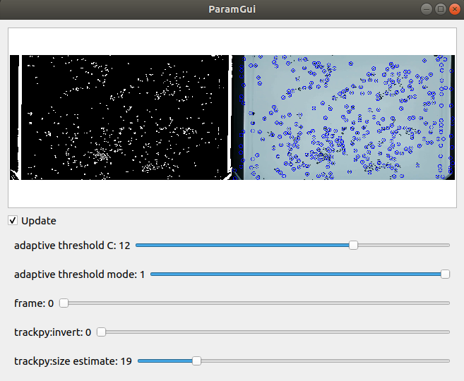
Run the script: If you have all the right params a window should open with a frame from your movie. Check and uncheck the update checkbox.

In your preprocess dictionary it is a good idea to start with only 1 method listed and gradually add a method at a time so you can see the steps being taken. Each time run the script and adjust the parameters on the sliders until you are vaguely happy. This is an iterative process. Every time you close the window the complete set of parameters is printed out in the command window. It is worth copying those you’ve changed into your parameters lists so you don’t have to readjust these every time.

Next step is to add a track method and parameters to the track sub dictionary and a simple annotate method such as circles to the annotate sub dictionary. In your script set the track_select property in your script to true and the annotate_select to true. Run again and hopefully a bunch of circles will appear. Adjust the track parameters and also readjust the preprocess params to get the circles on your objects. Update the numbers in your dictionary upon closing.

If it works well for a frame, move the frame slider and check for a range of frames. If that works change the script below if __name__ == ‘__main__’:

from ParticleTracking.tracking.tracking_gui import TrackingGui

track = PTProject(video_filename='/home/mike/Documents/HydrogelTest.m4v')
track.process()
#TrackingGui(track)

Now when you run the script it will display nothing but you should see a progress bar telling you what is happening. When it finishes, you should get a movie with the called originalmoviename_annotated.mp4 and a Datastore called originalmoviename.hdf5

Check the originalmoviename_annotated.mp4 to see how good your tracking is.

If it is all working you can start to add in other more complicated postprocessing / analysis / annotation methods.

The PTProject is designed so that one can miss out any stage. For example you may want to annotate a video using a given method. Provided you have already created a dataframe and it still has the name of originalvideo.hdf5 and is still stored in the same folder as the video you can simply run this section. Be warned it will overwrite.

Program Structure:

The structure of ParticleTracking Suite is that each step in the project workflow has a corresponding directory within ParticleTracking which all follow the same basic pattern:

1. __init__.py file. This contains parent classes which do not need to be accessed directly
2. “process”_methods.py. This is a module of functions. These function names are the methods you are calling in the appropriate parameters subdictionary. If you want to increase the functionality you add a method to the appropriate section.

These methods are all structured as follows

Preprocess_methods:
def method(frame, parameters=None):
code to preprocess
return preprocessed_frame

track_methods:
def method(frame, parameters=None):
tracking code
return dataframe

annotation_methods:
def method(frame, data, f, parameters=None):
Code to perform annotation
return annotated_frame

Annotation Notes

Working with colours:
There are a few different types of colouring system that can be used with annotation methods:
Some methods use static colours for example labels which can be set with 3 colour channel tuple: (B,G,R). For other methods you have decisions to make.
Alternatively you can apply a continous colour map.
A continuous colour map will change continuously according to some property. For example you might want the colour of the circles to be mapped to the speed of the particles.
What if you want to set some particles red and some particles green?
Firstly, you should create a classifier column and specify the name which gives each particle a label. Then you should specify one of these labels as the ‘classifier’. So for example you have a column in your dataframe with 1 (for red) or 2 (for green) next to each particle. You then put 1 in the classifier. This by itself would colour all the ones in red. However, you can create a second circles dictionary called circles*2. The 2 is irrelevant it must just be unique, the * tells the software this is a repeated call. Having made this dictionary with ‘classifier’:2 in this case, add ‘circles*2’ to the annotate_method’ : (‘circles’, ‘circles*2’). This will give you red and green coded particles. To create the classifier you should use the postprocessor method classify where you can classify with bin edges according to some property.

