The skeletal reconstruction of Barosaurus lentus in the American Museum of Natural History

Michael P. Taylor. Department of Earth Sciences, University of Bristol, Bristol BS8 1RJ, UK. dino@miketaylor.org.uk (corresponding author)
Peter May. Research Casting International, 15 Dufferin Ave, Trenton, Ontario K8V 5C8, Canada. pmay@rescast.com
Lowell Dingus. Division of Paleontology, American Museum of Natural History, New York, New York, USA. dinglowell@gmail.com
Eugene S. Gaffney. Division of Paleontology, American Museum of Natural History, New York, New York, USA. genegaffney373@comcast.net
John S. McIntosh. Wesleyan University, Science Tower, Middle Town, Connecticut 06457, USA. (Deceased 2015)
Mark A. Norell. Division of Paleontology, American Museum of Natural History, New York, New York, USA. (Deceased 2025).

Abstract
The rearing mounted skeleton of Barosaurus lentus in the Roosevelt Memorial Hall of the American Museum of Natural History (AMNH) is among the most culturally influential of all dinosaur exhibits. We review the history of the genus and of AMNH 6341, the specimen on which the mount is principally based. Excavated by Earl Douglass from the Carnegie Quarry at what is now Dinosaur National Monument, this skeleton was divided between three institutions before Barnum Brown reunited it at the AMNH around 1930. It was then largely neglected for six decades. We document the conception of the rearing mount during the 1986–1991 renovation of the fossil halls, when Lowell Dingus and Eugene Gaffney independently arrived at the idea of a rearing sauropod inspired in part by Gregory S. Paul’s painting Ambush at Como Creek, and the construction of the cast by Research Casting International. At about 15 m, it is the tallest free-standing mounted skeleton in the world. Crucially, the mount’s purpose was not to assert that Barosaurus habitually reared, but to provoke visitors to think about what fossils can and cannot tell us about extinct animals. About 80% of the material in the mount was cast from AMNH 6341. Almost all of the rest was cast from second-generation molds of the Carnegie Diplodocus, including a third of the neck and some residual camarasaurid material in the manus. We summarise the controversy the pose provoked, trace the longer history of rearing sauropods in science and art, and assess the mount’s substantial impact on popular culture.
Keywords: Barosaurus, sauropod, neck, rearing, skeletal mount, cast
Table of Contents
Introduction 2
Anatomical nomenclature 5
Institutional abbreviations 6
Historical background 6
Early discoveries of Barosaurus 6
The AMNH specimen of Barosaurus 7
The Carnegie Quarry at Dinosaur National Monument 7
USNM work at Dinosaur National Monument 9
The skeleton reunited 11
The AMNH mounted Barosaurus 13
The conception of the mount 13
The purpose of the mount 16
The creation of the mount 16
Photography of the mount 25
The composition of the mount 25
Overview 25
Barosaurus material in the mount 26
Non-Barosaurus material in the mount 28
Skull 28
Neck 29
Torso, sacrum and tail 31
Forelimbs and girdles 32
Hindlimbs and girdles 32
Discussion 32
Size of the AMNH 6341 animal 32
Rearing pose 33
A short history of rearing sauropods 36
Cultural impact 38
Conclusion 40
Acknowledgements 40
References 41

Introduction
Barosaurus is a diplodocid sauropod from the Late Jurassic of North America, found in the extensive Morrison Formation of the American West. It closely resembles its relative Diplodocus in most respects but is characterised by an extremely long neck, even by sauropod standards. In the popular imagination, it is typified by the iconic rearing mount in the Roosevelt Memorial Hall of the American Museum of Natural History (Figure 1).
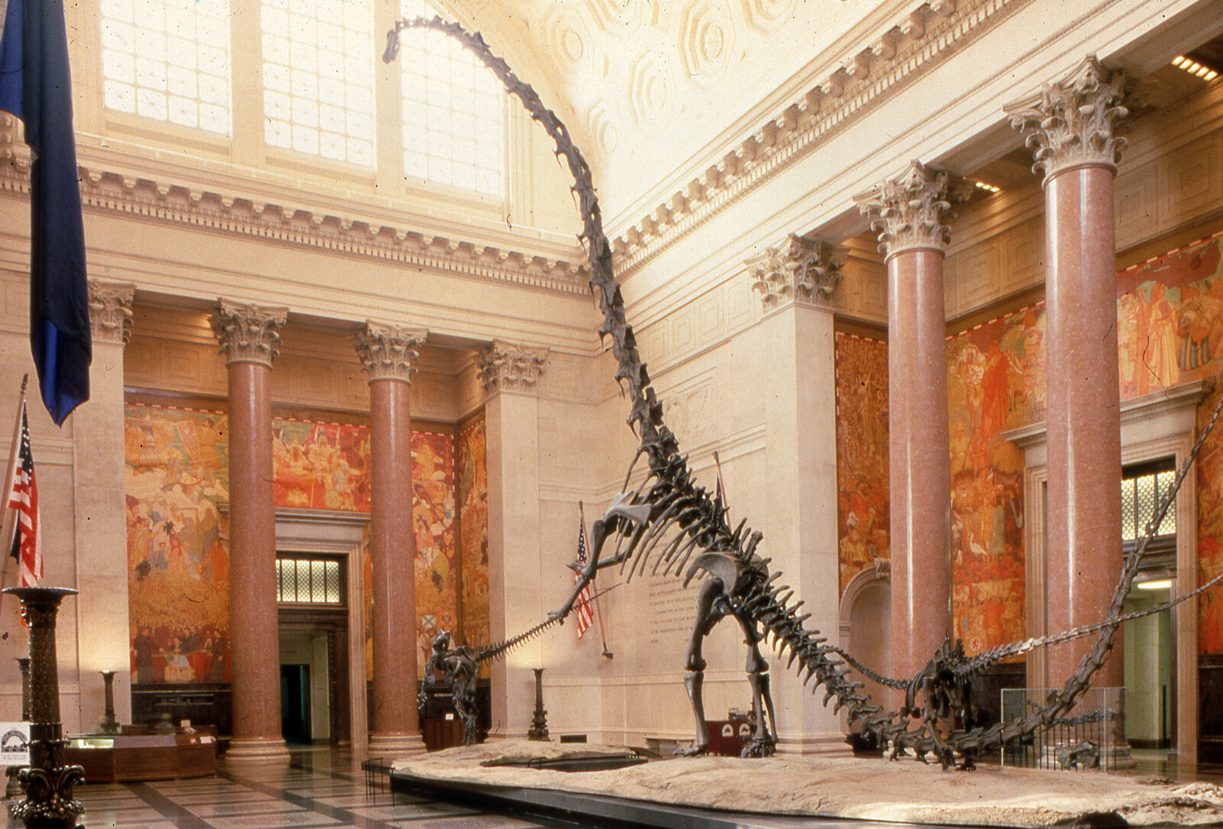
Figure 1. The mounted skeleton of Barosaurus lentus AMNH 6341 in the Theodore Roosevelt Rotunda of the American Museum of Natural History, New York, as it appeared after the initial mounting and before repairs to the middle of the neck (see text). Photograph provided by Department of Vertebrate Paleontology Archive, Copyright © AMNH.
Although the material that the mount is based on (the partial skeleton AMNH 6341) has never been described in monographic detail, the mounted skeleton has been enormously significant culturally, and it is due to this that Barosaurus is universally recognised as proportionally long necked in popular books (e.g. Bartram et al. 1983, Lindsay 1992, Lambert 2000). Along with the Carnegie Diplodocus CM 84 and Apatosaurus CM 3018, and the Berlin Giraffatitan MB.R.2181, it has been one of the keystone specimens in establishing the perception of sauropods by the general public.
There are two popular accounts of the Barosaurus mount (Norell et al. 1991, Dingus 1996:21–26) but as yet no scientific account has been published. In this paper, we will review the history of Barosaurus (Table 1). We will consider the composition of the mounted Barosaurus skeleton in the spirit of Janensch’s (1950) review of the original Berlin mounting of Giraffatitan (= “Brachiosaurus” of his usage) brancai. We will determine which parts are cast from the main specimen AMNH 6341, and which from other specimens. We will discuss how the pose was decided on, summarize the controversy generated by the mount, survey the history of rearing sauropods, and consider the cultural impact of the AMNH exhibit.
Date | Event
1880s | The first fossils of what is now Barosaurus were discovered in the 1880s by Mrs. E. R. Ellerman on land owned by Mrs. Rachel Hatch half a mile east of Piedmont on the eastern rim of the Black Hills of South Dakota.
Summer 1889 | O. C. Marsh visited the site with J. B. Hatcher, and collected part of the tail for the Yale Peabody Museum (YPM).
1890 | Marsh (1890) very briefly described and named the new genus and species Barosaurus lentus based on six caudal vertebrae and a chevron from the initial excavation.
Late August 1898 | Marsh sent George Wieland to collect the rest of the skeleton.
1899 | First published scientific support for the plausibility of rearing: Osborn (1899:213) wrote that the tail of Diplodocus “functioned as a lever to […] raise the entire forward portion of the body upwards.”
1907 | Charles R. Knight painted a rearing Diplodocus.
Late 1916 | The Barosaurus lentus holotype YPM 429 was fully prepared; Richard S. Lull gave a presentation of the specimen at the eighth annual meeting of the Paleontological Society in Albany, NY.
1917 | Lull’s published abstract very briefly described the type specimen.
1919 | Lull’s detailed monographic description of the type specimen.
1922 | Janensch (1922:464) erroneously referred diplodocid material from the Tendaguru Formation of Tanzania to Barosaurus as the new species B. africanus (now Tornieria africana).
1922–1923 | Two diplodocine skeletons were partially excavated from the Carnegie quarry (now Dinosaur National Monument). One of these, designated #340 was thought at that time to be Diplodocus. Earl Douglass took most of it to the University of Utah, but parts of its tail were sent to the Carnegie Museum.
1923 | The neck of #340 was sent to the USNM to provide material for a Diplodocus skeletal mount based on the other diplodocine #355 (USNM 10865). When prepared, the neck sent to the USNM proved to belong not to Diplodocus but to Barosaurus.
1929 | Barnum Brown realised that the USNM neck and the Carnegie tail belonged to the same individual as the partial skeleton at the University of Utah. He negotiated to acquire all three portions of this skeleton for the American Museum of Natural History (AMNH) in New York.
1931 | Work began on the Roosevelt Memorial Hall that is the main entrance to the AMNH. It was completed in 1936.
9 February 1933 | The portion of the skeleton held by USNM was belatedly shipped to AMNH. The reunited skeleton was given the specimen number AMNH 6341.
17 April 1939 | The presacral vertebrae, scapulocoracoid and humerus of AMNH 6341 were exhibited in the Hall of Early Dinosaurs.
Early 1950s | The AMNH 6341 elements were removed from display as part of Edwin H. Colbert’s renovation of the galleries.
1952 | The original Carnegie Diplodocus molds, having been used ten times by the Carnegie museum to create plaster casts from museums around the world, were donated to the Utah Field House of Natural History in Vernal, Utah.
8 June, 1957 | A concrete Diplodocus cast made from these molds was unveiled outside the Utah Field House.
1970 | Eugene S. Gaffney succeeded Colbert as curator of the fossil reptile collection at the AMNH.
1977 | Peter May began working with skeletal mounts at the Royal Ontario Museum.
1978 | Gregory S. Paul painted Ambush at Como Creek, a widely reproduced piece that depicts rearing Diplodocus individuals under attack from Allosaurus.
1986 | The AMNH began planning an extensive renovation of its fossil halls.
1989 | Jim Madsen’s company Dinolab unmounted the concrete Diplodocus of Vernal, used it to create second-generation molds, and created a new, lightweight cast for the Utah Field House.
1990 | Peter May went full time with his company Research Casting International (RCI).
28 March 1990 | A formal agreement was made between AMNH and RCI for the project to mount a cast of Barosaurus AMNH 6341 along with a juvenile Barosaurus and an Allosaurus.
Fall 1990 | RCI took the repaired and cleaned Barosaurus fossils from New York to Toronto.
Late 1990/early 1991 | RCI created casts of the Barosaurus elements and filled in the gaps with second generation Carnegie Diplodocus casts from Dinolab.
Spring 1991 | A test erection of the rearing Barosaurus mount was carried out in Toronto.
Summer 1991 | Gene Gaffney and Peter May found a site in northeastern Montana that could be molded and cast to provide a base for the skeletons.
November 1991 | The work in Toronto was complete, and the completed exhibit was transported to New York.
29 November 1991 | The John Gurche painting of a rearing Barosaurus, prepared for the exhibit, appeared on the front cover of New York Newsday.
3 December 1991 | The completed exhibit — rearing adult and hiding juvenile Barosaurus, and running Allosaurus — was unveiled to select guests.
4 December 1991 | The exhibit was opened to the public.

Table 1. Summarised history of the genus Barosaurus and the rearing skeleton mount AMNH 6341.

Anatomical nomenclature
Cn indicates the nth cervical vertebra, Can indicates the nth caudal vertebra.
We follow McIntosh’s (2005) interpretation of the presacral vertebrae of Barosaurus consisting of 16 cervicals and nine dorsals, rather than 15 and 10 as in Diplodocus (although see discussion below).

Institutional abbreviations
- AMNH — American Museum of Natural History, New York, New York, USA.
- CM — Carnegie Museum of Natural History, Pittsburgh, Pennsylvania, USA.
- HMNS — Houston Museum of Nature and Science, Houston, Texas, USA.
- MB — Museum für Naturkunde Berlin, Berlin, Germany; specimen numbers for fossil reptiles take the form MB.R.nnnn.
- ROM — Royal Ontario Museum, Toronto, Ontario, Canada.
- USNM – United States National Museum, Washington, D.C., USA.
- YPM — Yale Peabody Museum, New Haven, Connecticut, USA.

Historical background

Early discoveries of Barosaurus
As recounted in McIntosh (2005:40–41), the first fossils of what is now Barosaurus were discovered in the 1880s by Mrs. E. R. Ellerman on land owned by Mrs. Rachel Hatch half a mile east of Piedmont on the eastern rim of the Black Hills of South Dakota. In the summer of 1889, O. C. Marsh visited the site with J. B. Hatcher, and collected part of the tail, obtaining a promise from Ellerman and Hatch that they would protect the rest of the specimen until it could be collected. Based on six caudal vertebrae and a chevron from this initial excavation, Marsh (1890) very briefly described and named the new genus and species Barosaurus lentus in a six-page paper in which he also cursorily described the theropod Ornithomimus and two new species of Triceratops. The only Barosaurus elements mentioned in Marsh’s description were caudal vertebrae, and a single mid-caudal centrum was illustrated (Marsh 1890: figures 1–2). Marsh’s diagnosis noted only that the caudals resembled those of Diplodocus but varied from them in several ways that subsequently turned out to be errors brought about by comparing more anterior Barosaurus caudals with more posterior Diplodocus caudals.
It was not until eight years later that Marsh attempted to have the rest of the skeleton collected, sending George Wieland in late August 1898. In the intervening time, Mrs. Ellerman had died and parts of the skeleton had been taken by locals, but Wieland was able to reunite much of this material and excavate what remained underground, apparently working alone (Wieland 1920:529). All the material was shipped to Yale and added to the holotype under the specimen number YPM 429.
However, Marsh died the next year, and work on the specimen stalled. Almost two further decades passed before YPM 429 was fully prepared and Richard S. Lull was able to make a presentation on the specimen at the end of 1916 at the eighth annual meeting of the Paleontological Society in Albany, NY. Unfortunately, his abstract (Lull 1917), at only 74 words in length, is largely uninformative. Subsequently he described the specimen in detail in a significant monograph (Lull 1919), which remained the definitive publication on Barosaurus until McIntosh’s (2005) revision.
Since Lull’s monograph, Barosaurus has become known from several additional specimens. These include several excavated by Earl Douglass, working for the Carnegie Museum, at what is now Dinosaur National Monument, north of Jensen, Utah. One of these specimens was broken up into a cervical sequence CM 1198 (consisting of cervicals ?12, ?13 and ?16) and the postcervical skeleton ROM 3670 — now reunited at the Royal Ontario Museum in Canada under the specimen number ROM 3670. Also excavated by Douglass from Dinosaur National Monument was CM 11984, another partial cervical sequence consisting of C7–C15 but still not fully prepared, residing the collections of the Carnegie Museum.
Diplodocid material from the Tendaguru Formation of Tanzania was rather casually referred to the new species Barosaurus africanus by Janensch (1922:464), but the complex nomenclatural history of this species can be ignored for our present purposes, as it is now regarded as belonging to the separate diplodocine genus Tornieria as the species Tornieria africana.
The most complete and informative Barosaurus specimen to date is AMNH 6341, the individual that provided most of the material for the AMNH mount. It was briefly described as part of McIntosh’s (2005) revision of the genus Barosaurus, but has yet to be described in monographic detail (and will not be so described herein). For the remainder of this paper, we will focus on this specimen.

The AMNH specimen of Barosaurus

The Carnegie Quarry at Dinosaur National Monument
The fossil material of AMNH 6341 comes from the Carnegie Quarry at Dinosaur National Monument, in the north-east corner of Utah. Earl Douglass, a fossil hunter employed by the Carnegie Museum, received a letter on 6 August 1909 from the museum Director William J. Holland saying that “he wished me to dig up Dinosaur bones east of Vernal”. (This and other quotes in this section are from correspondence collection Douglass 1879–1953.) He and Holland had seen a good Diplodocus femur on an earlier visit to the area but, arriving on 10 August, he found that “someone had taken the best of the bones that were exposed”. On August 16 he wrote “The bones were terribly broken up and it seemed as if they had been churned up … Felt rather discouraged.”
However, the very next day — the 17th and not the 19th as stated by Gilmore (1936:178) — Douglass switched to another area and made an important find: “At last, in the top of the ledge where the softer overlying beds form a divide, a kind of saddle, I saw eight of the tail bones of a Brontosaurus in exact position. It was a beautiful sight … several of the vertebrae had weathered out and the beautifully petrified centra lay on the ground. It is by far the best looking Dinosaur prospect I have ever found.” This skeleton, once excavated, would be mounted in the Carnegie Museum in 1913. It would be described by Holland (1915) as CM 3018, the holotype of the new species Apatosaurus (= Brontosaurus of Douglass’s usage) louisae, and described in detail by Gilmore (1936).
As Douglass and his colleagues excavated, it quickly became apparent that there were many more dinosaurs in the rock. Excavating these fossils now became Douglass’s full-time job (Figure 2). The Carnegie Quarry, as it was named, would become one of the most fruitful in palaeontological history. The Museum funded the excavations for 13 years, shipping 700,000 lb of material to Pittsburgh (Gilmore 1936:170) — 318 tonnes.
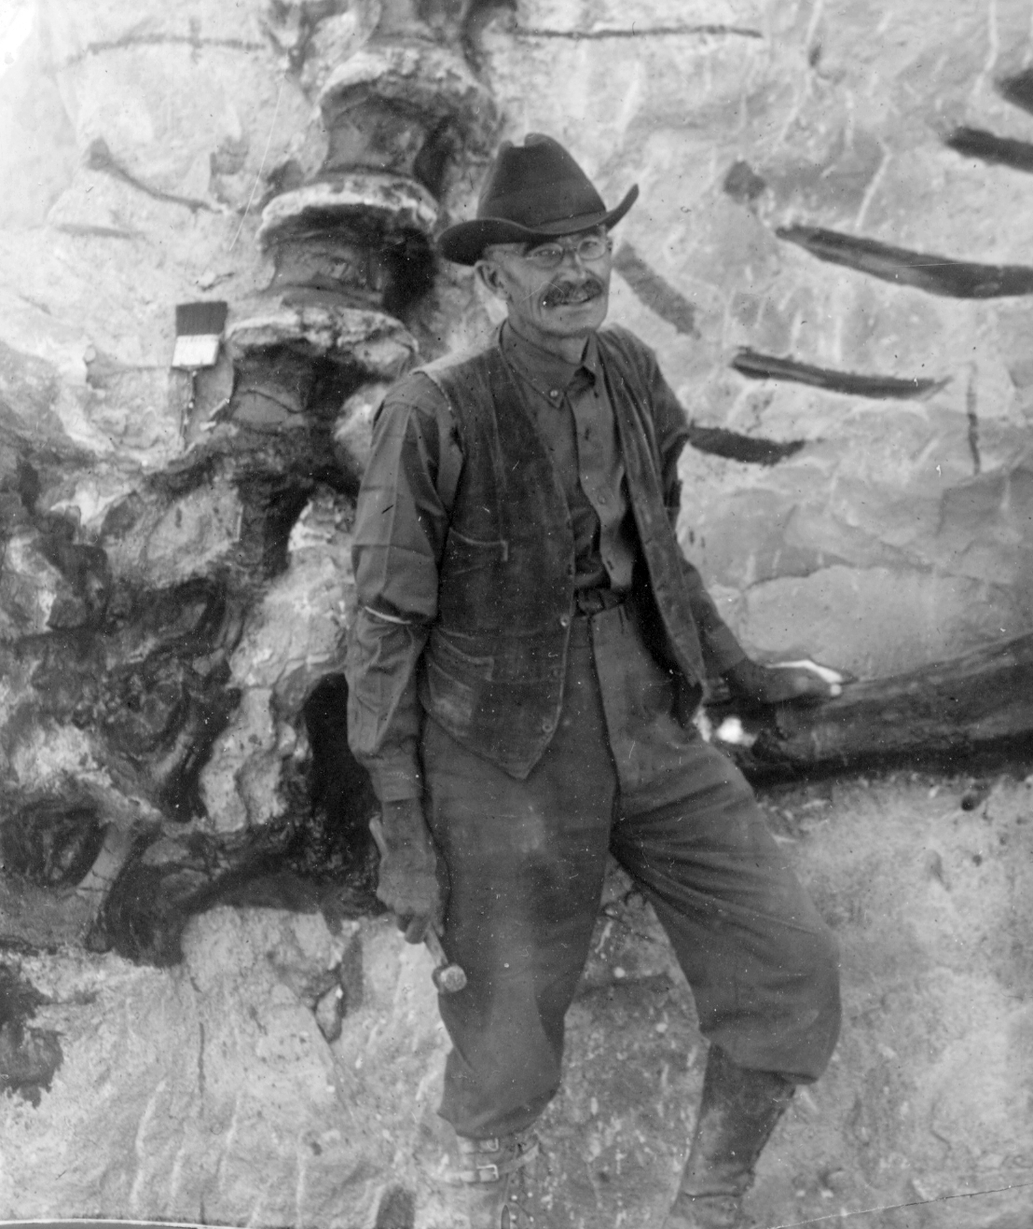
Figure 2. Earl Douglass, aged 60, at the Carnegie Quarry in August 1922. He is seen here standing in front of the left femur of Diplodocus specimen #355 (now USNM 10865), with the sacrum, partial left ilium, last five dorsal vertebral centra and some ribs also in view (compare Figure 3, in which the femur is labelled 23, the ilium 24 and the last five dorsals 7–11). The Diplodocus is seen in ventral view with anterior to the top. Photograph uploaded to Wikimedia Commons by Ken Carpenter.

USNM work at Dinosaur National Monument
By 1922 the Carnegie Museum had more fossils from this locality than it could use. Douglas Stewart, Holland’s successor as Director of the museum, evidently favoured turning the quarry over to the USNM, writing to Arthur S. Coggeshall on 6 September, 1922 to acknowledge the latter’s recommendation that Douglass finish the excavation of a Stegosaurus and a small dinosaur skeleton, but to leave two partially exposed specimens of Diplodocus to the USNM to excavate (Stewart 1922a).
George Perkins Merrill, Head Curator of the Department of Geology at the USNM, learned from Stewart that the Carnegie Museum was ready to relinquish its claim, and wrote on 6 November 1922 to William de Chastignier Ravenel, Secretary of the USNM, urging him to take on the quarry as “There are few objects that would yield greater attractiveness to the main hall of this department than the restored skeleton of one of the monsters of the dinosaur group that these beds yield” (Merrill 1922). [By coincidence, the next day Stewart wrote to Merrill to confirm the offer and provide details (Stewart 1922b).]
In a brief telegram on 10 November, Douglass reported to Merrill the existence of two sauropods in the quarry (Douglass 1922a). The next day, Merrill wrote to Douglass requesting technical and logistical information. Douglass replied on 22 November (Douglass 1922b) with a long and helpful letter explaining how the two sauropod skeletons, both thought to be Diplodocus, were positioned — #355 and #340, the former lying partly above the latter (Figure 3) — and stating that blocks containing most of the neck of #340 had been taken out of the quarry.
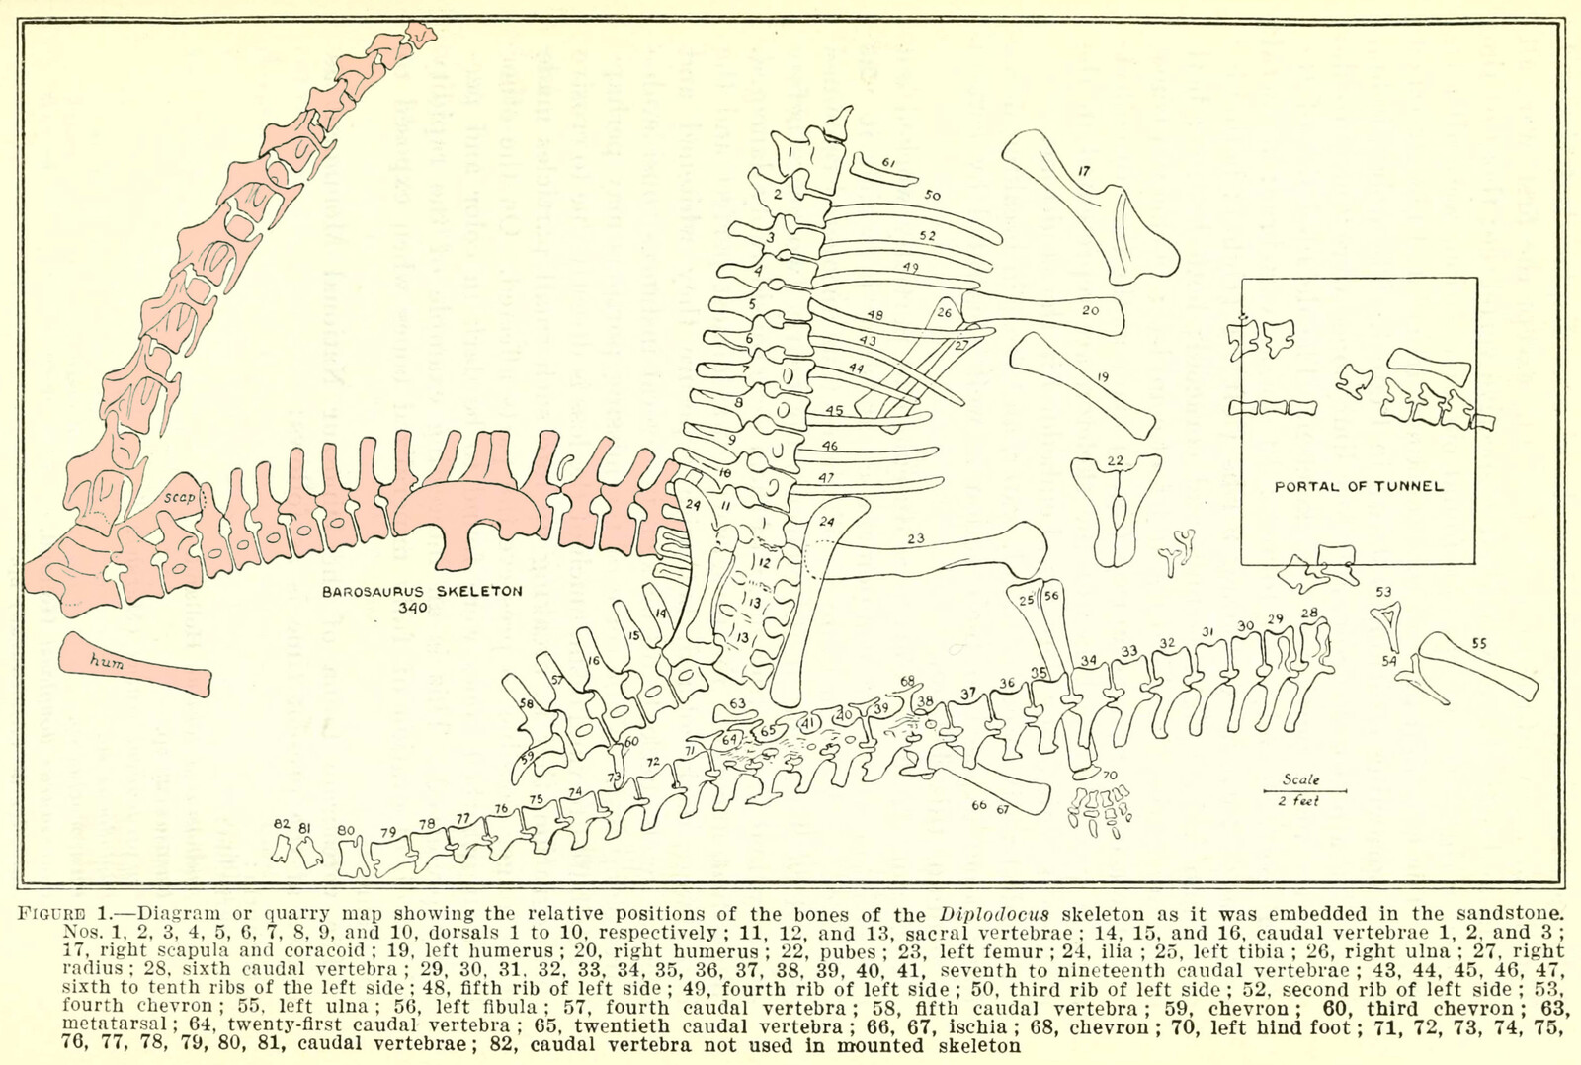
Figure 3. Carnegie Quarry map showing the relative positions of two iconic sauropod specimens: #355 (Diplodocus, right) and #340 (Barosaurus, left, highlighted in pink, initially thought to be be a second Diplodocus). Modified from Gilmore (1932:figure 1). The Diplodocus specimen would become USNM 10865, and the Barosaurus would become AMNH 6341. Note that in this map the cervical vertebrae of Barosaurus #340 are drawn to look like those of Diplodocus, which they were originally assumed to represent. Note also that the number of cervical vertebrae illustrated is ten, compared with the preserved count of nine, weakly corroborating the possibility that there was originally an additional, more anterior vertebra (C7 of present usage).
Douglass listed 10 skeletons that had been partly or completely taken out during the year. Among those listed was “No. 340 — Diplodocus. Apparently nearly complete skeleton but only neck taken out. The remainder still in the ledge” (Douglass 1922c). By the end of the 1922 season, “all but two skeletons — those of Diplodocus — were removed” (Douglass 1923). Work by the Carnegie crew finished on 1 January 1923 (Osborn 1923).
Charles W. Gilmore arrived at the quarry on 14 May 1923 to work it for the USNM and was shown around by Douglass, who was about to leave for Colorado (Gilmore 1923b). Gilmore inherited the two partially uncovered skeletons, both then thought to be Diplodocus: #340, as mentioned in Douglass’s report, and #355, presumably one of the two Diplodocus skeletons that Douglass had referred to as not having been removed.
Douglass also handed over to Gilmore four large blocks and several smaller ones containing much of the neck of #340, which as noted above had been extracted from the quarry but not prepared out. It was Gilmore’s intention to extract #355 (the more complete of the two) for the USNM, then secure the parts of #340 necessary to complete the skeleton (Gilmore 1923b). Skeleton #355 was subsequently accessioned as USNM 10865 and mounted in Washington D.C. (Gilmore 1932), where it remains in the public gallery to this day.
On 8 August 1923, Gilmore wrote briefly to Ravenel to say that work in the quarry was complete and the extracted blocks would be shipped to the USNM soon after 19 August (Gilmore 1923a), and sent a more comprehensive report in 30 August (Gilmore 1923b). In 1924, all excavation at the quarry ended.
USNM’s only interest in #340 was apparently in using elements of the skeleton to complete #355 for a gallery mount (Gilmore 1923b:1), so only the cervicals, three anterior dorsals, right scapula, humerus and radius and a sternal plate were sent there (Gilmore 1923b:3). Some material of #340 went to the Carnegie Museum: Gilmore (1923b:1) wrote that “One block belonging to this specimen was shipped to Pittsburgh, but will, I understand, be turned over to the National Museum as soon as certain bones of another individual are extracted from it”. It seems however that at least three blocks went to Pittsburgh. One, containing part of the neck, was shipped from there to the USNM in October 1924 (Coggeshall 1924); but there were also caudals, which would still be at the Carnegie at the end of 1929: “nine or ten vertebrae in the Carnegie Museum are preserved in two blocks 348/A and 348/B” (Brown 1929).
In April 1924, Earl Douglass was offered a position at the University of Utah and resigned his position with Carnegie Museum (Douglass 1879–1953). He excavated the remainder of #340 and sent it to the University of Utah. This left the skeleton now spread across three institutions in Salt Lake City, Pittsburgh, and Washington, D.C. It is perhaps for this reason that, although the portion of the skeleton at the University of Utah was prepared, it was never mounted.
The material of #340 in Washington was accessioned as USNM 11647 on 11 April 1927 (Abby Telfer, pers. comm., 2025). When it was prepared, what had been thought in the field to be two cervicals proved to be a single long cervical (McIntosh 2005:43). It was then apparent that the cervicals (and the rest of #340) did not belong to Diplodocus after all but to Barosaurus (Gilmore 1932:4). This material could therefore not be used in the mount of USNM 10865, which was instead completed with casts of the Carnegie Diplodocus CM 84 and unveiled in 1932 (Gilmore 1932).

The skeleton reunited
In 1929, Barnum Brown, acting for the American Museum of Natural History, visited most of the nation’s major natural history museums to assess their collections. He realised that the neck, anterior torso and forelimb material at the USNM, and the tail segment still at the Carnegie, belonged to the same individual as the partial skeleton at the University of Utah. Brown negotiated separately with representatives of all three museums to acquire the three portions of this skeleton, and was able to reunite the whole of Douglass’s skeleton in New York at the AMNH, a museum that had had no part in its excavation or early history. Brown arranged complex multipart deals: while the USNM accepted a straight swap for their part of the Barosaurus with a skeleton of the tyrannosaurid Gorgosaurus (AMNH 5428, now USNM 12814), the University of Utah made a cash-plus-fossils deal in which they were paid $2,500 cash plus the equivalent value in fossil mammal specimens (Brown 1929). The process of bringing the skeleton back together dragged on: the thirteen crates of material at the USNM were transported to the AMNH only in February 1933 (Wetmore 1933), perhaps because Wetmore himself — Secretary of the USNM — did “not favour disposal of this Barosaurus neck” (Gilmore, reported in Brown 1929). The reunited specimen was given the specimen number AMNH 6341. (See Norell et al. 1991:36–38, Dingus 1996:21–22, McIntosh 2005:42–43).
Brown’s (1929) memorandum on the trading he did for fossils provided a list of Barosaurus material at the USNM rather different than that which Gilmore (1923b:3) had specified when sending the fossils there. Where Gilmore had listed 13 cervicals, three dorsals, right scapula, humerus and radius and a sternal plate, Brown listed 10 cervicals, three anterior dorsals, left scapula and humerus. The left/right differences for the appendicular material are simply errors on Brown’s part (see below). The radius and sternal plate mentioned by Gilmore seem to have gone missing: they are not included in the material list below. They may still lurk unrecognised in the USNM collections. Matt Caranno (pers. comm., 2026) thinks it is possible they are in the oversized collection at the remote storage facility, but a detailed search would be laborious.
The issue of the number of cervicals is complex. Gilmore’s count of 13 cervicals is compatible with Douglass’s (1922b:3) report that “the skull and two or three of the anterior cervicals of no. 340 had been detached and were not in place” — an absence that would leave 13 cervicals remaining in an animal with 15 of 16 neck vertebrae. The reduction to 10 in Brown’s list, made after the material had been prepared at USNM, can be explained as a consequence of supposed pairs turning out to be single long vertebrae. This lower count is also in accord with the quarry map of Gilmore (1932:figure 1; Figure 3). This shows nine dorsals and ten cervicals belonging to the Barosaurus skeleton (although the line-drawings of the cervicals do not at all resemble the actual vertebrae: compare Figure 4).
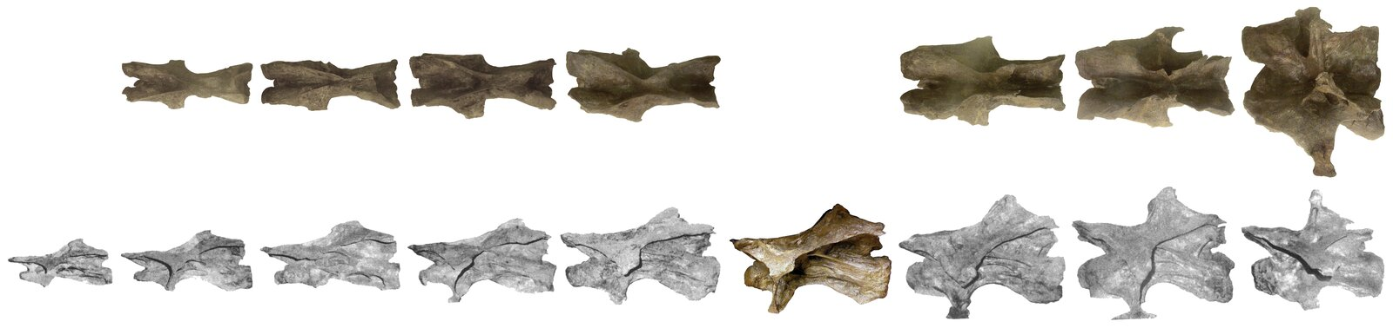
Figure 4. Barosaurus AMNH 6341, cervical vertebrae C8–C16 in dorsal (where available) and lateral views, to scale. Lateral views from McIntosh (2005: fig. 2.1) except except C13, which we were able to photograph in collections. Extensive image manipulation was necessary to bring out the information in the dorsal view photographs, due to to poor photography conditions. C16 is sheered to the right, so the aspect is slightly left dorsolateral rather than true dorsal. C8 is on display in the gallery with these vertebrae, but the structure of the display makes it impossible to photograph in dorsal view. C13 is on a shelf in collections, apart from the other cervicals, and we were not able to photograph it in dorsal view.
If the cervical count of ten in the quarry map and Brown’s memo is correct, the most anterior of the cervicals (C7) seems to have been lost or destroyed some time in the next 30 years, since McIntosh’s unpublished 1962 notes, his published account (McIntosh 2005) and the present fossil holdings at the AMNH all include only nine cervical vertebrae, C8–16. Carl Mehling (pers. comm., 2022) has searched in collections for the missing C7 and been unable to locate it. In fact, the C7, if it ever existed, was likely lost or destroyed prior to the 1939 renovation: photographs from that time (Figure 5B) show the anteriormost cervical vertebra on display, and it is recognizable as the C8 that is the anteriormost currently preserved vertebra; and the signage that accompanied the exhibit (Figure 6) indicates that nine cervicals were present.
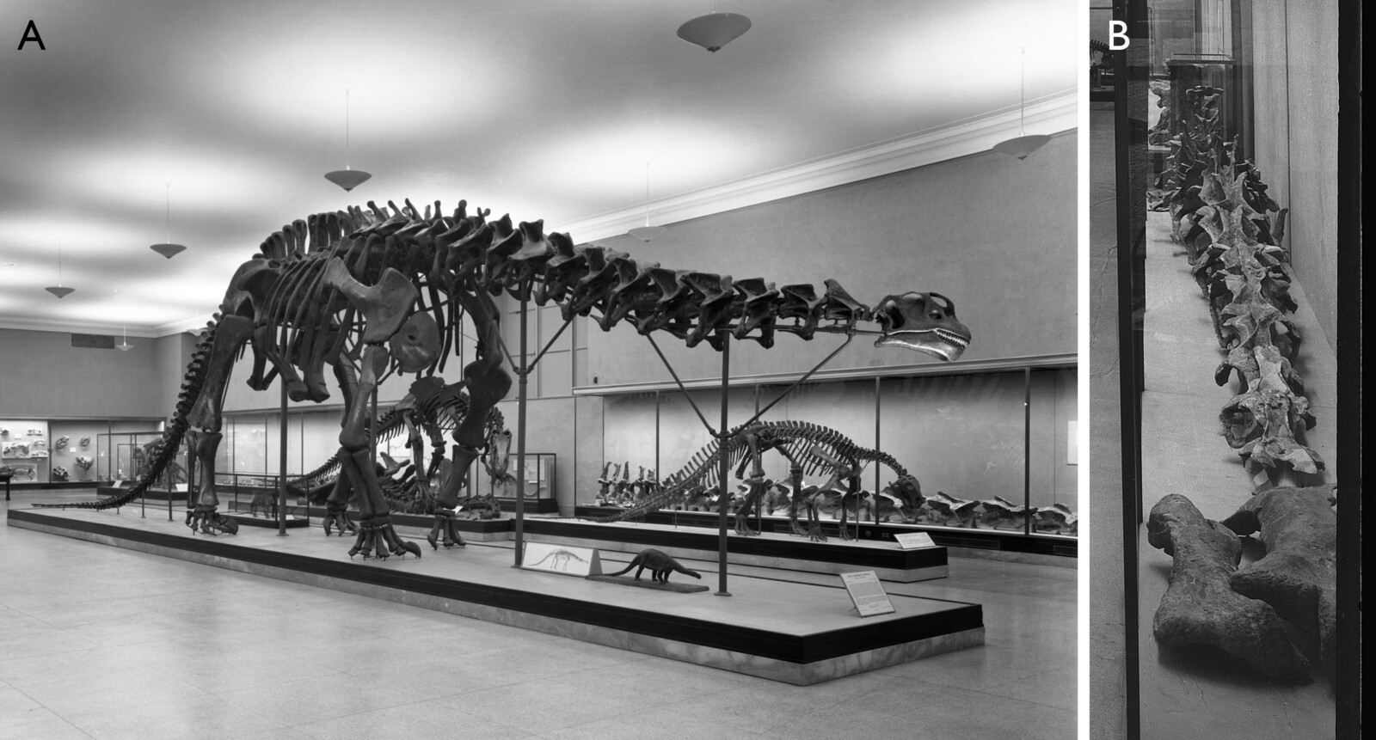
Figure 5. The Jurassic Hall in April 1939, photographs taken during or shortly after the renovations. A. The mounted skeleton of “Brontosaurus” (now thought to be Apatosaurus); in cabinets behind it the presacral vertebrae of Barosaurus AMNH 6341 can be seen in right lateral view. Note that the Brontosaurus mount has only thirteen cervicals, perhaps following Marsh’s (1891: plate XVI) skeletal reconstruction. B. The cabinets from the background of part A, showing the presacral sequence in anterodorsal view. In front of the vertebrae lie the right humerus, its posterior face uppermost and its proximal end facing the camera (left); and the right scapulocoracoid, its lateral face uppermost and its humeral glenoid roughly articulating with the humerus (right). Cropped from photographs 315932 (part A) and 315930 (part B) from the AMNH Research Library Digital Special Collections, by Charles H. Cole.

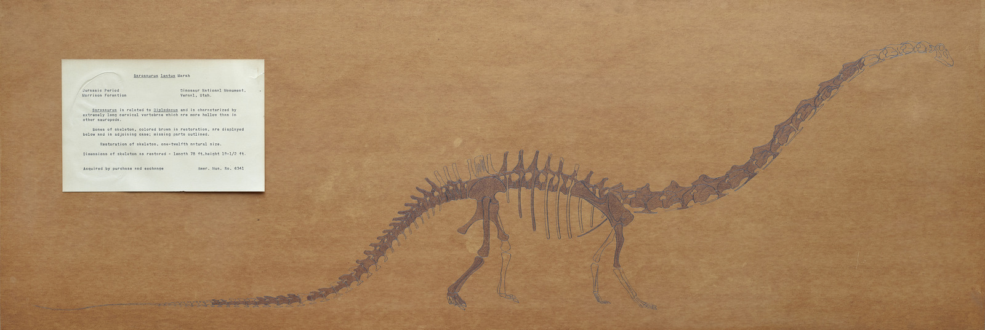
Figure 6. Public gallery exhibit panel for AMNH 6341, prepared around 1939 to accompany the vertebral sequence, scapulocoracoid and humerus depicted in Figure 5. Photographed by Mick Ellison, AMNH. Original caption reads:
Jurassic Period, Morrison Formation. Dinosaur National Monument, Vernal, Utah. Barosaurus is related to Diplodocus and is characterized by extremely long cervical vertebrae which are more hollow than in other sauropods. Bones of skeleton, colored brown in restoration, are displayed below and in adjoining case; missing parts outlined. Restoration of skeleton, one-twelfth natural size. Dimensions of skeleton as restored — length 78 ft., height 19–1/2 ft. Acquired by purchase and exchange. Amer. Mus. No. 6341.
The representation of which bones are included in the specimen is a good match for our modern reconstruction (Figure 15), but there are some differences in the reconstruction. Most notably, only 14 cervical vertebrae are depicted, with the nine preserved cervicals interpreted as C6–C14. This is surprising as the closely related Diplodocus had been known with some confidence since Hatcher’s (1901) monograph to have 15 cervicals. Also surprisingly, the 1939 reconstruction shows only nine dorsal vertebrae, compared with the ten described by Holland (1906:251–252) for Diplodocus. While McIntosh’s catalogue of material indicates that the first 29 caudals are preserved, the 1939 diagram shows 30 caudals, of which the neural spines of Ca1–3 and Ca26–28 are absent and Ca21 is represented only by the anterior portion of its centrum. Finally, the 1939 diagram suggests that of the right dorsal ribs, only those of D7 and D8 are present, which contradicts McIntosh’s (2005:57) assessment that two of the six preserved ribs are the left and right ribs of D1 or D2.

The AMNH mounted Barosaurus

The conception of the mount
The three parts of AMNH 6341 had been reunited from their layovers in the USNM, Utah University and Carnegie Museum by 1933 or shortly thereafter. However, having acquired their Barosaurus skeleton, the AMNH seemed at a loss to know what to do with it. It lay dormant for a decade until the presacral vertebrae and some limb bones were exhibited in glass cabinets alongside the mounted Apatosaurus in the Hall of Early Dinosaurs on 17 April 1939 (Figure 5, Figure 6). Plans were made at that time to mount the skeleton in place of Apatosaurus (Anonymous 1939), but these came to nothing. The Barosaurus elements remained here until the renovation supervised by Edwin H. Colbert in the early 1950s. At this point, tentative plans were made once more to mount the Barosaurus skeleton in the Hall of Early Dinosaurs, but it was felt that the mount would take up too much space and these plans were abandoned. Instead, the entire specimen was moved into collections. Four more decades were to pass before the skeleton (or at least a cast based on it) was finally mounted.
In 1986, the museum began planning what would become an extensive renovation of its fossil halls, which had become significantly outdated since the previous update more than thirty years previously. The initial plan was to renovate only the Osborn Hall of Late Mammals, but a change of museum leadership meant that by 1988 the project had become much more extensive, now encompassing all four existing vertebrate fossil halls covering 65,000 square feet, and expanding into new spaces at a total cost of $38 million. Ralph Appelbaum Associates were hired as the designers.
As part of this broader initiative, paleontological staff were asked whether they had any specimens suitable for mounting in the Roosevelt Memorial Hall that is the main entrance to the museum on Central Park West. The hall, begun in 1931 and completed in 1936, is a majestic space in its own right, with its impressive, barrel-vaulted ceiling. But it was puzzlingly empty as late as 1990 (see illustration in Dingus 1996:20). It was the perfect space for a truly spectacular dinosaur mount that could introduce new visitors to dinosaurs, draw them in to the main galleries, and provoke them to think about paleobiological issues.
It occurred to Lowell Dingus, then project director of the fossil halls renovation project, that the most spectacular exhibit would be a gigantic sauropod rearing up on its hind legs. Jack McIntosh told Dingus about the long-neglected Barosaurus specimen in the collections, and it occurred to Dingus that this could provide the basis for the mount. But he thought there was little chance of persuading Eugene S. Gaffney, then the curator in charge of the dinosaur collections in the Department of Vertebrate Paleontology, to undertake such a project. In fact, both Dingus and Gaffney were known for their disdain of such speculative “dinomania”: the possibility of both consenting to a rearing mount would have been considered very unlikely.
The iconoclastic palaeontologist Robert T. Bakker had in 1971 included a skeletal reconstruction of a rearing Apatosaurus in an entry in the McGraw-Hill Yearbook of Science and Technology (Bakker 1971:figure 7f). This was provocative to the palaeoartist Gregory S. Paul, who incorporated the idea in his 1978 painting Ambush at Como Creek. In this, only his third dinosaur painting (Gregory S. Paul, pers. comm. 2022), he depicted a herd of Diplodocus surprised by an Allosaurus. As the carnivore attacks, one Diplodocus provides cover for its retreating allies by facing down the predator in a rearing threat display. This initial version of the painting was reproduced in Bird (1985:59), but Paul became dissatisfied with it and painted over parts of the original in 1983 and 1985 to produce the better known final version (Figure 7) in which the attack is by a whole pack of Allosaurus. This version was reproduced in the influential book Dinosaurs Past and Present as Paul (1987:figure 16).
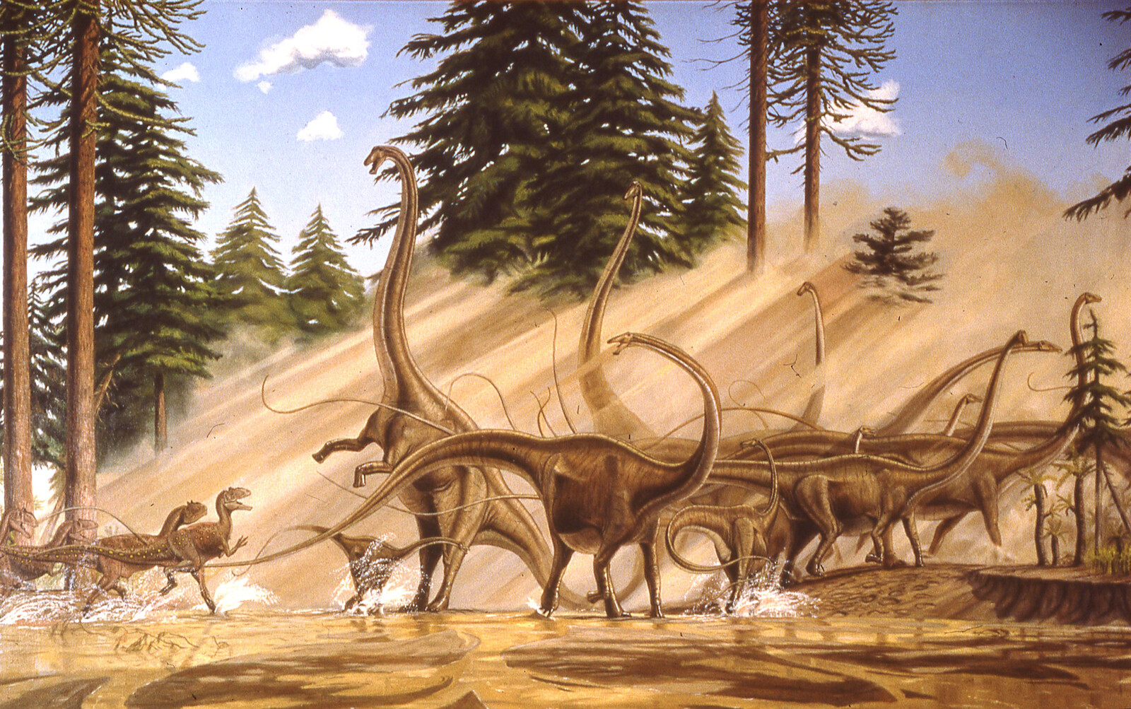
Figure 7. Ambush at Como Creek, painted by Gregory S. Paul in the late 1970s or early 1980s. In this revised version, completed in 1985, a pack of Allosaurus menace a herd of Diplodocus. While most of them, including a juvenile and two subadults, try to escape, one adult faces the attacking allosaurs in a threatening rearing posture. This painting was part of the inspiration for the AMNH’s rearing Barosaurus mount. Copyright © Gregory S. Paul, 2022. Reproduced by kind permission.
Knowing nothing of Dingus’s independently arrived-at plan, Gaffney found Paul’s painting intriguing. Inspired by this artwork, he conceived for the Roosevelt Memorial Hall exhibit the very ambitious idea of mounting a group of Barosaurus skeletons under attack from a group of Allosaurus. Dingus was astonished to discover that Gaffney had come up with essentially the same plan as himself — and both were further astonished when incoming dinosaur curator Mark Norell also approved of the proposal, despite his own distaste for behavioural speculation about dinosaurs.
The original suggestion, using half a dozen or more skeletal casts, was deemed impractical, in part because it would have taken up too much space even in the huge Roosevelt Memorial Hall. So while the basic idea was adopted, it was scaled back to one erect Barosaurus adult and one juvenile, under attack from a single Allosaurus — ironically, a scene corresponding more nearly to the original version of Paul’s painting.
Dr. John (Jack) S. McIntosh, a professor of theoretical physics at Wesleyan University in Connecticut, was an avocational palaeontologist specialising in sauropods, and through work done in his spare time became the world’s leading expert on the group. Gaffney knew him from his undergraduate days and when he succeeded Colbert as curator of the AMNH fossil reptile collection in 1970, McIntosh had provided a great deal of information about the AMNH dinosaurs. He had told Gaffney that the museum had one of the best preserved sauropod skeletons in its collection and that he thought it was the then poorly known Barosaurus. It would be the perfect specimen to use as the basis of the rearing mount. Early in the design of the exhibit, Dingus and Gaffney asked McIntosh what he thought about the pose. When he gave an enthusiastic “Yes, I do think it was possible”, the die was cast. Against their usual inclinations, Dingus and Gaffney had become accomplices in the perpetuation of speculative dinosaur paleobiology, albeit for a specifically limited purpose, as discussed in the next section. McIntosh was to have second thoughts about the rearing pose, though. When interviewed a year later he observed “I’ll just say this — I am not responsible for the pose of the Barosaurus, and as a matter of fact, I would have been chicken and would never have mounted it that way if it were my responsibility” (Psihoyos 1994:74), although he did go on in the same interview to reaffirm that he thought the posture possible.

The purpose of the mount
While providing a breathtaking first impression of the museum for new visitors, the purpose of the mount extended well beyond the visual power of viewing the tallest free-standing dinosaur mount ever constructed. More importantly, the mount would introduce a major scientific theme that would be integrated into all the fossil halls encompassed in the renovation project: what can we actually know about extinct animals, and what can’t we know based on the limited kinds of data preserved in their fossils? The exhibition label for the mount clearly stated this conundrum in a section entitled “Did this really happen?” (Figure 8):
No one knows for sure. Our only evidence of the lives of extinct dinosaurs comes from such fossils as bones and footprints. Fossils tell us about the size and shape of the animals and whether they stood on four legs (like Barosaurus) or on their two hind legs (like Allosaurus). They do not tell us, however, if Barosaurus could rear up or if Allosaurus hunted alone or in groups.
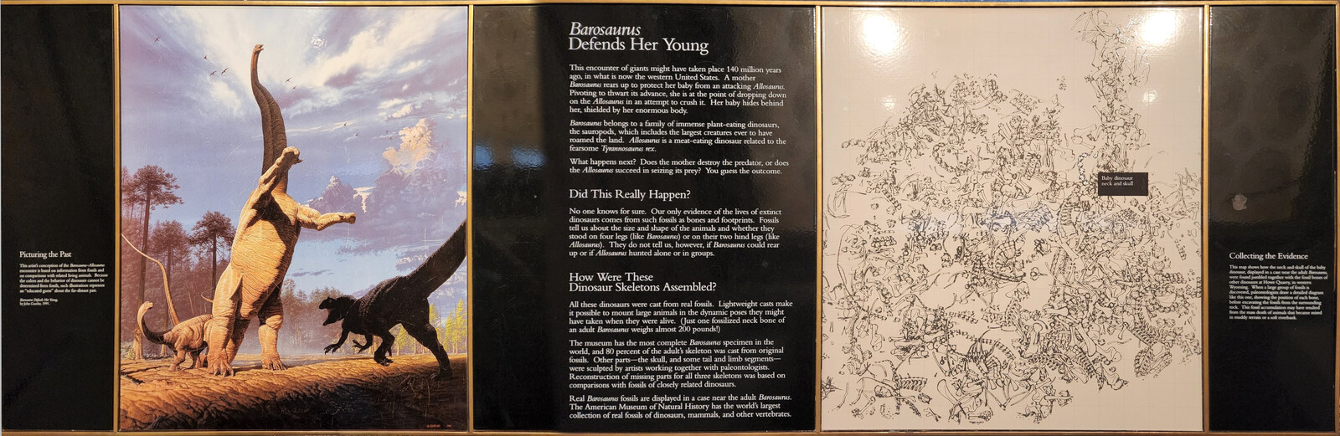
Figure 8. The signage for the exhibit as it currently appears in the Roosevelt Memorial Hall. The headings read “Picturing the Past”, “Barosaurus Defends Her Young”, “Did This Really Happen?”, “How Were These Dinosaur Skeletons Assembled?” and “Collecting the Evidence”. See text for full transcription of the “Did This Really Happen?” section.

The creation of the mount
At the time of the casting-and-mounting project, the process was well documented with contracts, architectural drawings, inventories, shipping notes and other documents. But with the passage of more than three decades, nearly all this paperwork has been lost. The retirement of key individuals at the AMNH, including several authors of the present work, resulted in records being moved between offices and ultimately misplaced; and an extensive search of RCI’s archives has turned up little. As a result, nearly all that follows has been assembled from the memories of the individuals involved, supplemented by information from contemporary and near-contemporary accounts such as those of Norell et al. (1991) and Dingus (1996), and the relatively few documents that were recovered from AMNH archives.
Early in the process, around March 1990, a prototype model at about 1/16 full size was commissioned at a cost of $3,980 (Galiano 1990), to allow the scene to be created and manipulated at a workable scale (Figure 9). This was created by a model-maker at Maxilla and Mandible, a nearby fossil shop owned by Henry Galiano, which was one block north of the museum. It served as a general guide for the poses of the three animals, as well as a prop for raising funds for the renovation project. The model remains intact at the time of writing and was recently conserved. Comparing it with the finished mount, it is apparent that the torso is too long (it has one too many vertebrae and they are too elongate), the limbs are proportionally short, and there is a downward kink in the tail after the 7th caudal. The pose also differs from that of finished model in having a much more strongly S-curved neck. Apart from these minor issues, however, it is an excellent representation of the mounted skeleton.
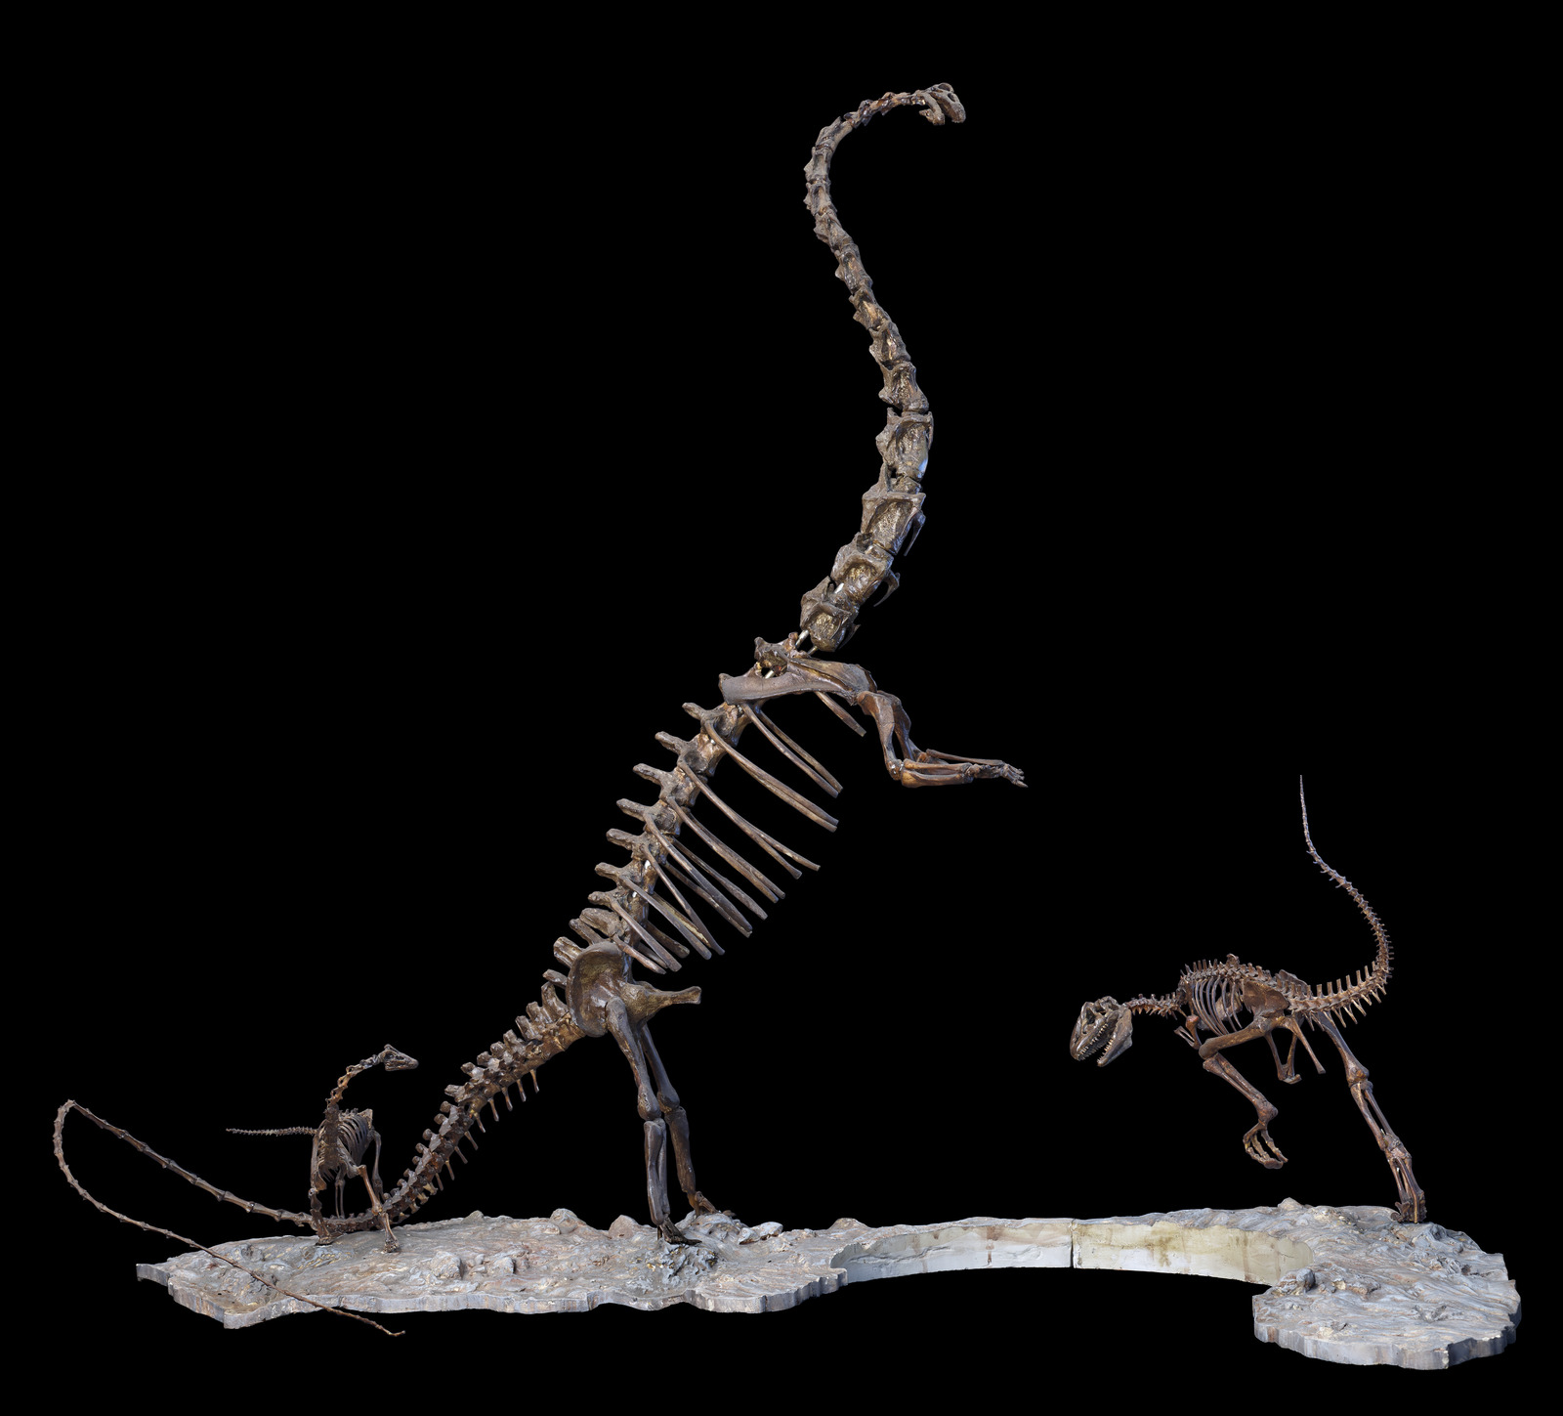
Figure 9. Prototype model of the proposed display. This model is three feet (91 cm) tall from the bottom of the base to the top of the rearing Barosaurus, and the base is 44 inches (112 cm) long (Mick Ellison, pers. comm, 2022). Despite some notable differences — for example, the model has a much more strongly S-curved neck than the full-size mount, and its forefeet lack digits — the model seems to have been followed fairly closely in composing the final mount, and remains a beautiful object in its own right. Photograph by Mick Ellison (AMNH).
Individual fossilized cervical vertebrae of Barosaurus can mass well over 100 kg, and supporting them in the rearing pose would have required a prohibitively strong armature. Furthermore, permanently mounting these scientifically significant fossils 10 m above ground level, even if logistically feasible, would effectively make them unavailable for study. For these reasons, while the mounted skeletons in the main Fossil Halls of the AMNH are mostly real bone, the Roosevelt Memorial Hall display consists entirely of replicas. (The real presacral vertebrae are on display under the glass walkway behind the mounted Apatosaurus in the Hall of Saurischian Dinosaurs, and have been since the Hall opened in June 1995: see the photo in Dingus 1996:71.)
The bones of AMNH 6341, the Barosaurus specimen that was to provide most of the mount, were in poor condition by 1990. The presacral vertebrae, scapulocoracoid and humerus had been in collections for the best part of 40 years, since Colbert’s early-1950s renovation; the rest of the bones had been there for 60 years, ever since being reunited by Barnum Brown in 1930. Bones in collections can degrade with time, especially the complex and delicate presacral vertebrae, and it is not unknown for broken-off parts to become separated from the elements they belong to. A program of repair and cleaning was required. As outlined below, about 80% of the skeleton was present. These available Barosaurus elements were cast, and most of the remainder of the skeleton was taken from a cast of the closely related Diplodocus carnegii with a few elements sculpted (details below).
All casting and sculpting was done by Research Casting International (RCI), a recently established organization specializing in mounting prehistoric animals. Founder Peter May had started working with fossil mounts at the Royal Ontario Museum, beginning in 1977, where he learned the techniques from paleontology technician Gordon Gyrmov and former WW2 Luftwaffe rocket-plane test pilot Rudy Zimmermann. May rose to become the head technician at the ROM. Having worked for a while at the Royal Tyrrell Paleontology Museum in Alberta, he found on returning to the ROM that his expertise was in demand from other museums. Initially fitting this outside work into his spare time under the banner of RCI, he went full time with his company in 1990, and the AMNH Barosaurus was to become their most important early commission. May’s first meeting with Lowell Dingus, Gene Gaffney, Jack MacIntosh and Phil Currie was on 30 January 1990 at the AMNH.
On 28 March 1990, an agreement was made between Lowell Dingus, acting for the AMNH, and Peter May and Andrew Leitch, acting for RCI, to provide the fully mounted and painted cast skeletons of a rearing adult Barosaurus, a juvenile, and an Allosaurus (Dingus 1990). The total agreed cost was $184,675 (equivalent to $472,000 in 2026 according to usinflationcalculator.com). This amount was made up of $72,721 for the adult Barosaurus, $75,136 for the juvenile, $16,660 for the Allosaurus, $15,411 for a duplicate model of the juvenile Barosaurus for Dinosaur National Monument, and $4,748 for travel and transport. (Surprisingly, the small juvenile cost more than the adult!). The agreement was signed by Dingus on 28 March, by May and Leitch on 30 March, and by AMNH director William J, Moynihan on 3 April.
In the fall 1990, the RCI crew took the repaired and cleaned Barosaurus fossils in a semi truck from New York to Toronto, where they remained for the best part of a year. There, the bones were duplicated. First, they were coated with latex, which was then cured to form rubber molds (Figure 10). The bones were then cast, first with a layer of gel coat inside the molds, and then in various materials. As noted by Norell et al. (1991:38), “Those that would stand near the ground were cast in higher-density and more durable materials, while those higher up were made of lighter substances.” Specifically, the lower elements were cast in polyester resin and fiberglass with a substantial steel armature, while the dorsal series, ribs and cervicals were cast with a much lighter fiberglass mat and backfilled with polyurethane foam to keep the weight down as low as possible. (Due to the lightness of these elevated elements, the steel armature could be reduced too.)
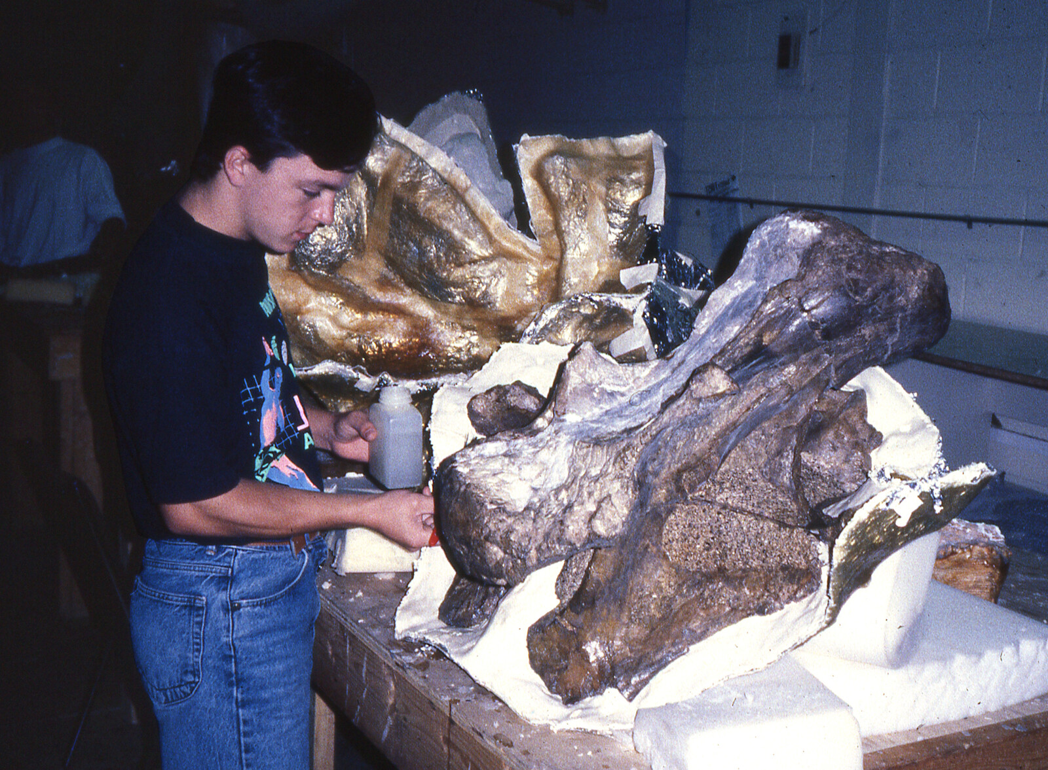
Figure 10. The mold creation process at RCI. Lazlo Eger paints separator on the mold wall surrounding a posterior cervical vertebra of Barosaurus lentus AMNH 6341, here seen upside-down in right ventrolateral view with anterior to the left. The separator on the mold wall allows the rubber latex for the next mold section to be applied without adhering to the first mold section, so that the mold sections will separate easily. Photograph provided by Department of Vertebrate Paleontology Archive.
These accurate replicas of the original fossils, when painted, were indistinguishable from real bone but weighed only a twentieth as much as the fragile and irreplaceable originals. The casts were not “corrected” to account for distortion in the original bones: they are faithful reproductions of what is preserved.
Most cervical ribs, however, were missing from the original cervical vertebrae. (These fragile projections are rarely preserved intact.) The missing parts of the skeleton were mostly replaced by elements cast from the Carnegie Diplodocus, though some were fabricated in Toronto. Records do not show exactly which bones were sculpted but Peter May was the only sculptor at RCI at the time the skeleton was being prepared, and he does not recall sculpting any elements other than the metacarpals discussed below and possibly some cervical ribs.
In spring of 1991, a test erection of the rearing Barosaurus mount was carried out with the aid of a hired crane and 15 m scissor lift (Figure 11). This had to be done in the parking lot behind the RCI workshop, as the completed mount would be too tall to fit inside the workshop. The event was attended by a group from the AMNH, and Jack McIntosh, who had been brought in as a consultant to ensure that the bones were articulated correctly in the mount (Figure 12). Also present were photographers including National Geographic’s Louie Psihoyos, a television crew, at least one observer from another museum, and a crowd of local workers on their lunch breaks. The skeleton was pieced together from prefabricated sections. The exercise began with the “tripod” of hindlimbs and tail, anchored together at the pelvis, providing a stable base. These were followed by the torso section, then the three sections of the neck and head, and finally the forelimbs. Dingus (1996:25–28) recalled that “the strangest thing was that the mount actually looked rather natural and graceful […] I had always been extremely skeptical about whether sauropods could rear up to such heights, but the grace of the mount almost erased my doubt”. Although the initial assembly of the rearing barosaur had proven successful, another six months would be required before the entire exhibit was ready to assemble in New York, as work was required not only on the main Barosaurus, but on the juvenile and the Allosaurus.
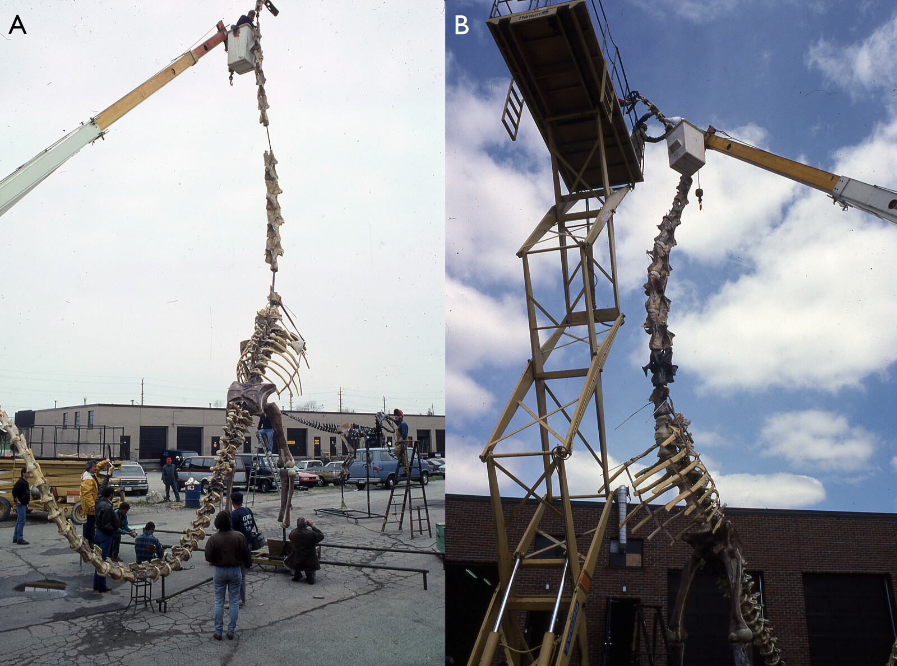
Figure 11. Two views of the trial mount executed in the parking lot behind the RCI workshop in Spring 1991. A. Right posterolateral view, with an RCI employee adjusting the anterior part of the neck. Note that two vertebrae — one very posterior, the other in the middle of the neck — are absent at this point. B. left anterolateral view, with three RCI employees working on the anterior part of the neck: one in a cherry-picker, the other two on a scissor lift. Note that the two missing cervical vertebra have been added, and that the posterior one is a different colour from the others. The ribs are a noticeably lighter colour than the rest of the skeleton, presumably because they had not been painted at this point. Photographs provided by Department of Vertebrate Paleontology Archive.
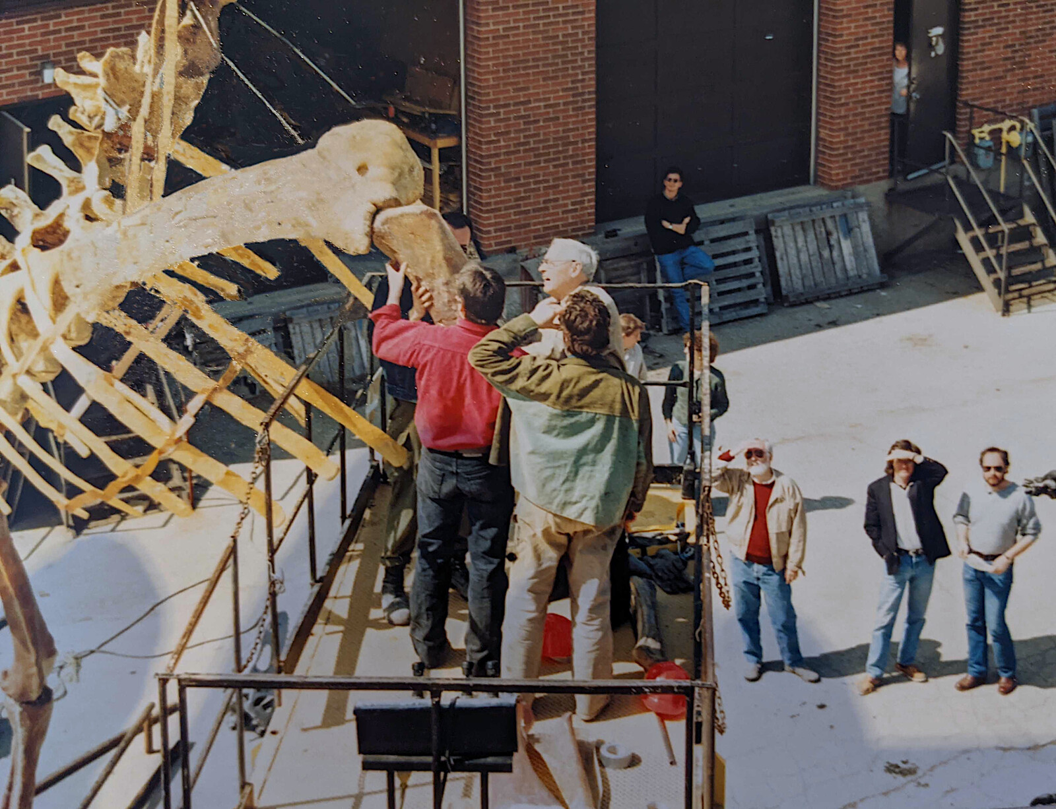
Figure 12. Part way through the trial mounting process in the parking lot behind the RCI workshop in Spring 1991. In the lift platform, Peter May sets the humerus in place while Jack McIntosh advises on its articulation and Rick Eyre (back to the camera) looks on. At ground level, Gene Gaffney, Mark Norell and Lowell Dingus (left to right) observe. Photographs provided by Department of Vertebrate Paleontology Archive.
To provide the base that the skeletons would be mounted on, fossil-bearing rock was considered appropriate. During the summer of 1991, Gene Gaffney and Peter May searched for a suitable site, finally finding an area that Gaffney was satisfied with by the road just outside the Fort Peck Reservation in northeastern Montana. May and his crew later returned to the site and created peels by spraying a thin layer of latex rubber across the rocks. They returned these to RCI, and used them to make and paint a cast. Ironically, the exposures in this area are from the early Paleocene Fort Union Formation (then the Tullock Formation), about 65 Mya, meaning that the ground that the mounted Barosaurus stands on dates from after the extinction of the dinosaurs, about 90 million years after the time Barosaurus lived.
In November 1991, the work in Toronto was complete, and Blakelock Moving were contracted to ship the completed exhibit in sections for mounting to New York on 7 November (Clark 1991; Figure 13).
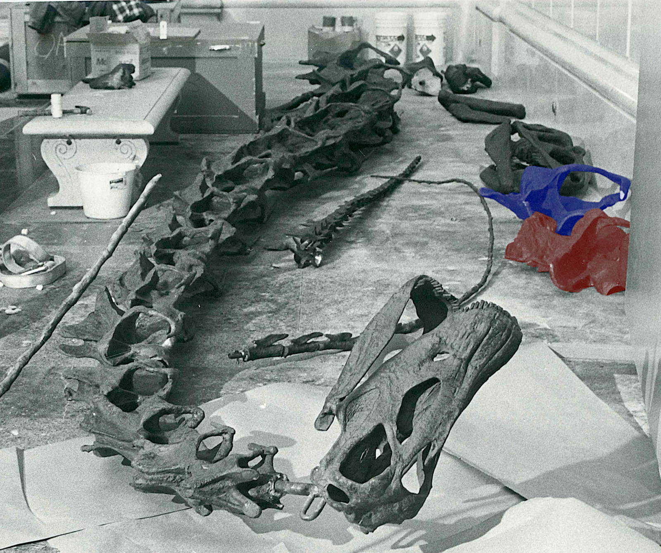
Figure 13. Elements of the cast Barosaurus skeleton on the floor of the Roosevelt Memorial Hall of the American Museum of Natural History before mounting. Centrally, the skull and cervical vertebrae 3–16, all articulated in a single piece, with the atlas an axis still to be fitted behind the skull. By the wall to the right are the two halves of the 17th cervical vertebrae: the left half, highlighted in red, with anterior towards the camera; and the right half, highlighted in blue, with anterior facing away. Between these and the neck is the distal (whiplash) portion of a tail: possibly that of the main Barosaurus, but more likely that of the juvenile based on the small size of the most proximal caudals. Between this and the neck is a section that is probably the proximal part of the Allosaurus tail. Finally, intruding on the image from the left is the distal (whiplash) portion of the other Barosaurus tail, probably that of the adult. Photograph provided by Department of Vertebrate Paleontology Archive, Copyright © AMNH.
Unlike the trial mounting in Toronto, when the head and neck were attached in three sections, in New York the three sections were first joined together and then fitted as a unit. This large unit, about nine meters in length, proved awkward to manoeuvre, and it was difficult to raise it to a sufficient height to slide into its slot (Figure 14). It took nearly two hours to wrestle it into place at the front of the rearing torso. Worse, when the mount was finally completed it was imperfect because, when the whole neck had been hanging horizontally, it had bent in the middle at the point of suspension. The resulting kink in the neck can be seen between C11 and C13 in Figures 1 and 14B and in other contemporary photos such as those of Dingus (1996:26) and Lindsay (1992:18–20). It was soon corrected, however, in a near-disastrous but ultimately successful late-night operation (Dingus 1996:28), and the resulting line of the neck is smooth and elegant.
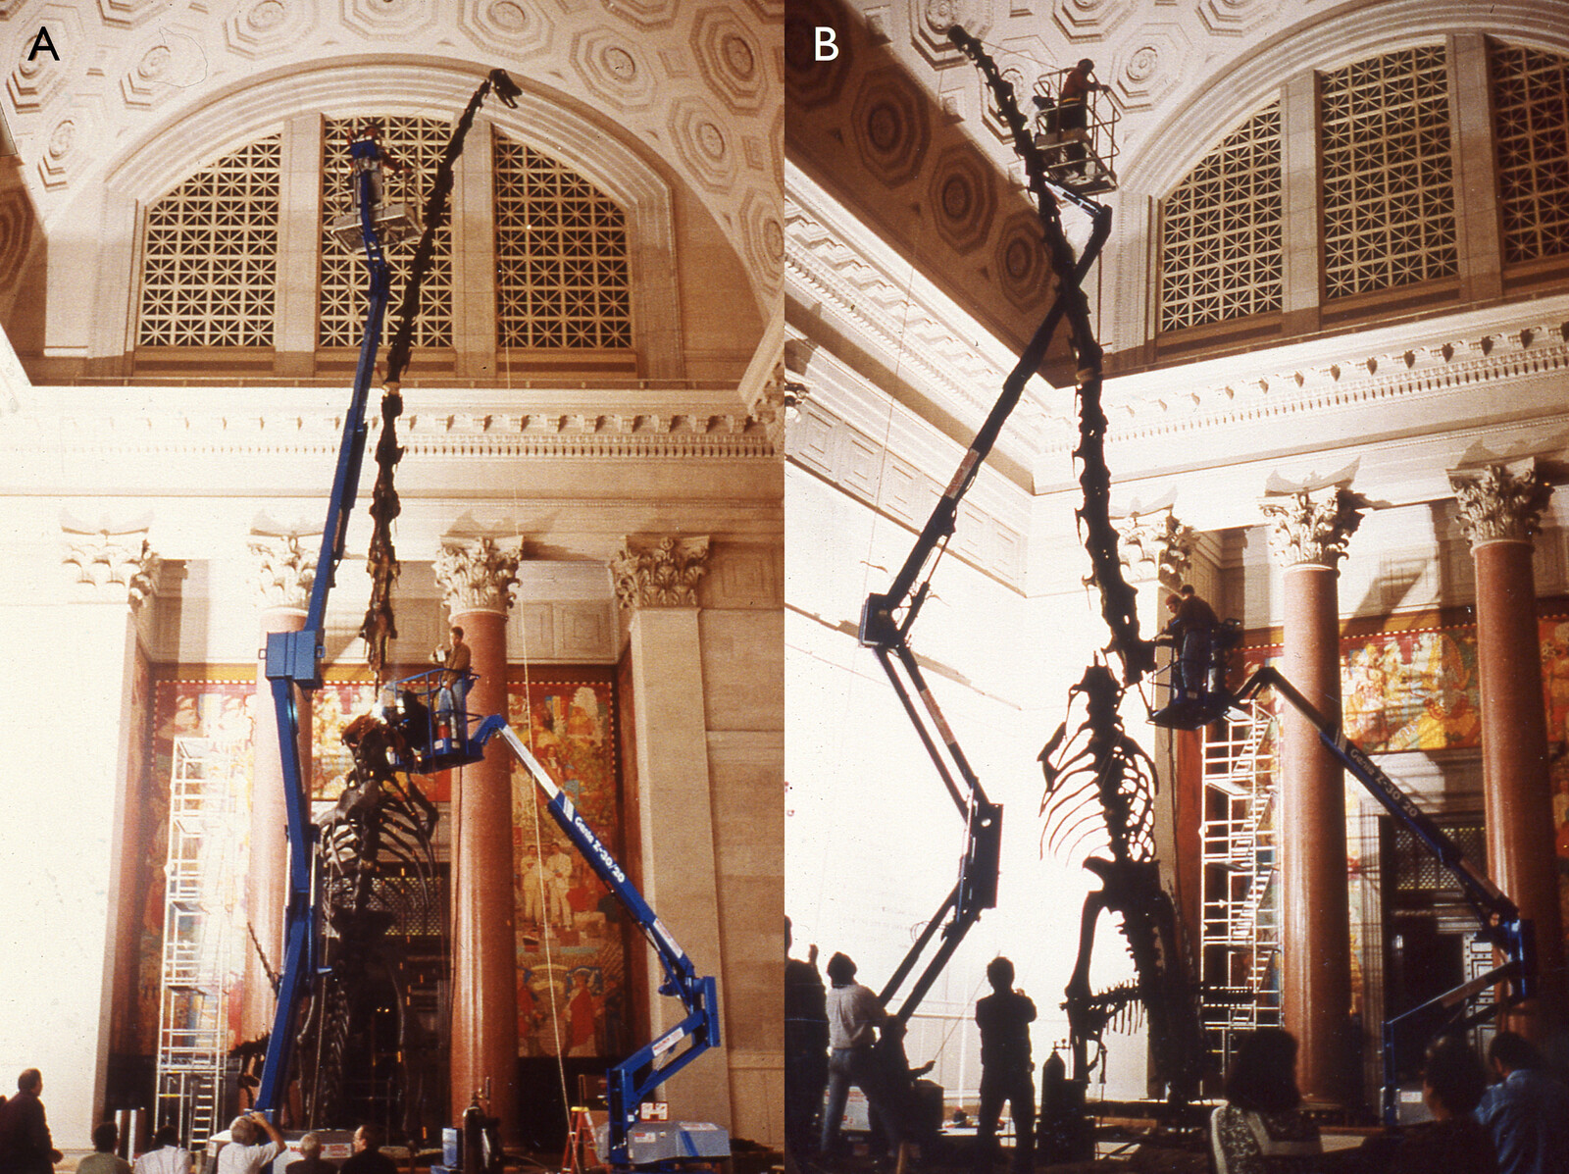
Figure 14. Two views of the final mounting in the Roosevelt Memorial Hall of the American Museum of Natural History, both showing the use of two frighteningly unstable-looking cherry-picker cranes. The RCI employees in the higher crane are moving the head-and-neck assembly into place, while the two in the lower crane attempt to fit it to the anterior torso. Photographs provided by Department of Vertebrate Paleontology Archive, Copyright © AMNH.
In a non-technical children’s book simply titled, “Barosaurus”, Lindsay (1992:14–19) provides a vivid illustrated account of the molding, casting and mounting of the skeleton, with photographs by Lynton Gardiner (see below). This book also contains the best published photographs of some of the fossil material, e.g. a posterior cervical vertebra in left lateral view (p11), posterior cervical and posterior dorsal vertebrae in anterior views and right pubis in lateral view (p12), articulated sequence of cast dorsals and posterior cervicals in right lateral view (p18–19).
The exhibit — rearing adult and hiding juvenile Barosaurus, and running Allosaurus — was unveiled to select guests on Tuesday 3 December 1991 (Anonymous 1991) and opened to the public on Wednesday 4 December 1991 (Gordy 1991, Collins 1991). Press coverage was extensive, not only in local publications such as New York Newsday (Gordy 1991) but also in national publications such as the Washington Post (Associated Press 1991) and Newsweek (Begley and Yoffe 1991), and abroad in countries including Germany and Japan.
It was at that time the only publicly exhibited Barosaurus in the world (Norell et al. 1991:36), although additional mounts have since been erected at the Royal Ontario Museum in Toronto, Canada, and the Natural History Museum of Utah in Salt Lake City. Also included in the exhibit, in a case next to the mounted skeletons, were the real 13th cervical of AMNH 6341, and the partial skull and neck AMNH 7530, which the juvenile mounted skeleton had been partially based on. (That skull and neck, thought in the 1990s to belong to Barosaurus, were referred to the closely related diplodocine Kaatedocus siberi by Tschopp et al. 2015:220). The juvenile skull and neck are, at the time of writing, on exhibit in the Miriam and Ira D. Wallach Orientation Hall.
Since the mount of Barosaurus and Allosaurus opened to the public, tens of millions of visitors have begun their visit to AMNH by sizing up this iconic, if somewhat controversial, skeletal scene.

Photography of the mount
During the mounting process at the AMNH, and after the unveiling, many photographs were taken. But the rearing mount is a very difficult object to photograph well, climbing high into a gloomy hall with bright windows. Among the photographers was Lynton Gardiner, who had been contracted by Dorling Kindersley to provide photographs for the children’s book Barosaurus: On the Trail of the Gigantic Plant-Eating Dinosaur (Lindsay 1992) in their Dinosaur Spotter’s Guides series, as part of a broader contract to photograph dinosaurs at the AMNH and the USNM. Gardiner recalls (pers. comm., 2022):
The main hall at the AMNH is huge, unevenly and dimly lit, so to get clear bright shots I placed several 2400 and 5000 watt second Comet strobe packs and bare-bulb heads around the hall, synchronizing them with slaves and an infrared sender on the camera. With ISO 200 film we had a consistent f/11 aperture [enabling fine details to be captured and light/shadow contrasts to be adequately depicted] from any vantage point in the hall. I used a Hasselblad camera with a Distagon lens of about 40 mm. Except for using digital cameras now, if I had the same assignment again I’d use a similar approach with synced strobe packs around the hall. Available light with high ISO recording doesn’t produce the crisp detailed results you get with updated traditional electronic flash lighting.

The composition of the mount

Overview
Norell et al. (1991:38) wrote that “only about a fifth of the skeleton was missing, but each of these pieces, including the skull, several limb bones, and part of the tail, had to be modeled to complete the skeleton […] the technicians at Research Casting sculpted each individual missing bone in clay, basing the shapes on the remains of more completely known close relatives of Barosaurus, in particular, its contemporary Diplodocus.” However, this account seems to be in error regarding numerous elements being modeled from scratch. A complete list of the elements of AMNH 6341 itself can be assembled from the published works and notes of McIntosh, old signage, and letters between Gilmore and the USNM (see below). Peter May recalls that with some exceptions discussed below, the missing bones were filled in with casts taken from molds made from the Utah Field House’s concrete copy of the Carnegie Diplodocus. That copy was made from the original Carnegie molds (Taylor et al. 2023), and the composition of the elements from which those molds were taken is well understood (Taylor et al. 2025), so it is possible to determine the sources of most of the bones in the Barosaurus mount. The details follow.

Barosaurus material in the mount
McIntosh’s (2005:43) catalogue of elements in the referred specimen AMNH 6341 is incomplete and contains multiple errors. However, by reading it in context of the more detailed descriptions of the elements later in the same paper, and with his unpublished 1962 notes on the specimen, with observations of materials on exhibition in the past and present, and in light of historical correspondence, it is possible to arrive at a complete list of material as follows:
- the posterior part of the neck (cervicals 8–16)
- all nine dorsal vertebrae (dorsals 1–9)
- the complete sacrum (sacral vertebrae 1–5)
- the anterior part of the tail (caudals 1–29)
- six partial ribs, of which one is the first or possibly second on the left side, and another is probably its counterpart
- a single chevron, from further back than Ca13 and likely in the region Ca22–Ca28.
- right (not left as in McIntosh 2005:43) scapulocoracoid, fully fused together; distal end of left scapula; left coracoid
- right (not left as in McIntosh 2005:43) humerus
- right ilium complete except small part of the upper border; acetabular portion and “distal ends” of left ilium
- both pubes and ischia complete except parts of the proximal ends of both pubes and the right ischium
- complete right hindlimb (femur, tibia, fibula, astragalus)
- elements of the right pes: metatarsals I, II and V, phalanges I-I and V-I, two 2nd phalanges, one ungual
- three “ossicles” (McIntosh’s unpublished 1962 notes) — the meaning is unclear.
The sternal plates, clavicles and lower forelimb (ulna, radius, carpals and manus) are the only parts of the skeleton missing from both sides. Figure 15 shows a skeletal inventory of Barosaurus lentus with the portions of the skeleton preserved by AMNH 6341 in white and the missing bones in grey.
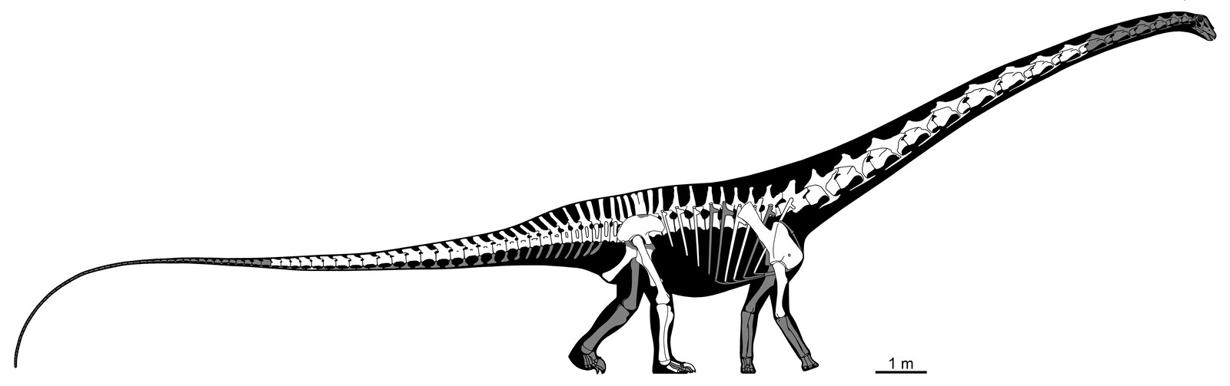
Figure 15. Skeletal reconstruction of Barosaurus lentus based primarily on AMNH 6341. Modified to show bones preserved in AMNH 6341 in white, and bones absent from this specimen (which had to be cast or modelled from other specimens for the mount) in grey. Some guesswork was involved here: for example, McIntosh (2005:43) says that six ribs are present, but it is not possible to say which six ribs. Base image copyright © 2022 Scott Harman, all rights reserved. Used by kind permission.
This list of material is gratifyingly congruent with that depicted in the 1939 exhibition panel (Figure 6). This panel provides the additional detail that the neural spines were missing from all five sacral vertebrae and caudals 1–3 and 26–28, and that only the anterior portion of caudal 21 remains. The panel shows 30 rather than 29 caudals: it is possible that some time after this illustration was prepared, the very fragmentary caudal 21 was lost or discarded, and that the caudals identified as 21–29 by McIntosh (2005) were in fact 22–30. The panel further suggests that two of the six preserved ribs may be those of the right side of dorsals 8 and 9. The only contradiction with the material list above is that the pes elements are interpreted differently: the panel shows metatarsals I, II and III, phalanges I-I, II-I and III-I, and ungual I. We consider McIntosh’s assignments more likely trustworthy.
This list of material of AMNH 6341 is mostly a superset of that listed as belonging to what was then the USNM’s part of the specimen in Brown’s (1929) account of reuniting the parts of the skeleton. The only additional element in Brown’s account is his statement that “the last ten cervical vertebrae” (not just the last nine) were at that time present — see above. But Brown stated wrongly that the left rather than right scapulocoracoid and humerus are present (and the material list of McIntosh 2005:43 followed this error, contradicting his description and illustration later in the same chapter, McIntosh 2005:59–62). The girdle element that was on display in 1939 (Figure 5B) is clearly a complete and well preserved right scapulocoracoid, based on the location of the glenoid fossa in combination with the curvature of the shaft. Similarly the humerus that was on display in 1939 is the right, not the left, based on the shape of the proximal end and the anterior projections at the distal end. It is possible that Brown carelessly misidentified the elements in his letter and McIntosh transcribed the error in his 2005 paper. McIntosh’s unpublished 1962 notes further confirm the presence of these elements from the right (correct) side.
In preparing the mounted skeleton, casts of all the elements of AMNH 6341 were used. Little or no reconstruction was done, so distortion in the preserved cervical vertebrae is retained in the mounted copies; however, missing cervical ribs were added as necessary to the cervicals (Taylor, pers. obs.).

Non-Barosaurus material in the mount
So far as we have been able to determine, no casts of Barosaurus elements from specimens other than AMNH 6341 were used. The missing elements were filled in with Diplodocus casts that have a curious provenance. As recounted in detail by Taylor et al. (2023), the original Carnegie Diplodocus molds, having been used ten times by the Carnegie museum to create plaster casts from museums around the world, were donated in 1952 to the Utah Field House of Natural History in Vernal, Utah, and there used to create a concrete cast that was mounted outdoors (Untermann 1959). In 1989, Jim Madsen’s company Dinolab unmounted this concrete cast and used it to create second-generation molds with the immediate goal of providing the Field House with a new, lightweight cast to be exhibited indoors. These new molds were then used to create several additional Diplodocus casts. Jack McIntosh inventoried the AMNH 6341 Barosaurus material and ordered the missing bones from Dinolab, as casts made from these molds, but we have not been able to find details of this order in McIntosh's notes.
With this in mind, we will now consider the source of specific elements of the cast.

Skull
The skull in the mounted Barosaurus skeleton was cast from the corresponding elements in the Carnegie Diplodocus. However, CM 84, the specimen from which the Carnegie mount is mostly assembled, does not itself include a skull. As documented in Taylor et al. (2025:69), Holland (1906:227) explained that the skull supplied to British Museum (now the Natural History Museum) as part of the Diplodocus cast presented to it in May 1905 was a composite sculpture based on several specimens. The posterior portion was modelled on material from CM 662 (now HMNS 175). The remainder of the skull was based on USNM 2673, the skull on which Marsh (1896:175–179) had primarily based his description of the skull of Diplodocus.
The skull used in the Barosaurus mount, cast from molds taken from this composite, is shown in a 1991 photograph (Figure 16A–B). It can be confidently confirmed as the same composite illustrated by Holland (1906:figure 1) “as placed in the restoration at the British Museum”, and by Nieuwland (2019:figure 5.3) in a photograph of a worker at the Muséum Nationale d’Histoire Naturelle, Paris, France, with the plaster skull of their Diplodocus cast in 1908 (Figure 16C).
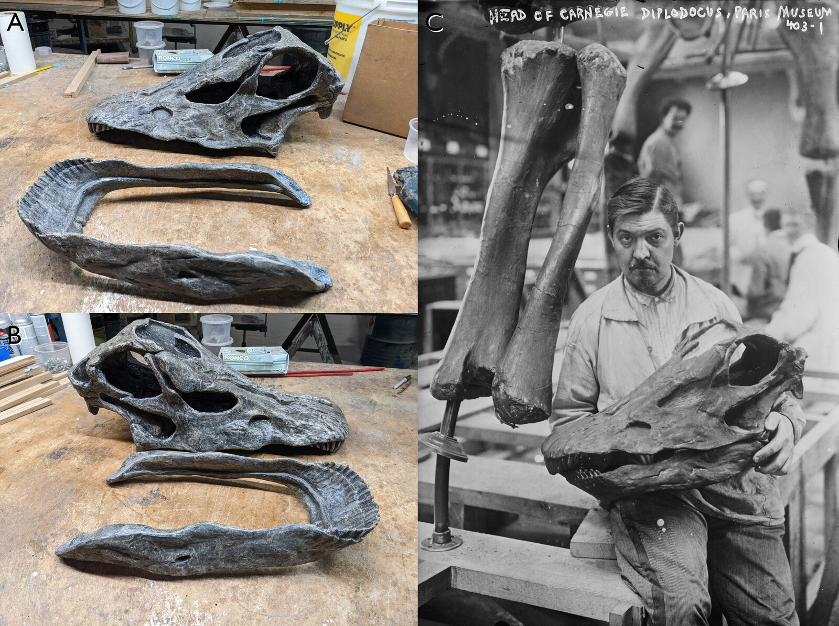
Figure 16. The skull used in the mounted Barosaurus. A. Cranium to rear, mandible to the front, both in left dorsolateral view, photographed in 1991. B. Cranium to rear, mandible to the front, both in right dorsolateral view, photographed in 1991. This skull was copied from that of the mounted Carnegie Diplodocus. Note its similarity to the skull “as placed in the restoration at the British Museum” in Holland (1906:figure 1). C. The skull used in the Paris mount of Diplodocus, held by an unnamed worker, in left lateral view, photographed in 1908. That of the Barosaurus mount is identical.

Neck
McIntosh (2005:45) considered the number of cervicals in Barosaurus to be 16 on the basis that there are only nine dorsals, compared with ten in the closely related Diplodocus, and the most likely reason is that the first dorsal was recruited into the neck. McIntosh’s inference has been widely considered correct, and 16 is now the accepted cervical count for Barosaurus. (The earliest mention of the sixteen-cervicals hypothesis in print appears in a caption in a children’s book, Lindsay 1992:20.) Whether or not the AMNH 6341 material may at some point have included an additional cervical vertebra (C7), at present it preserves the last nine cervical vertebrae. These are therefore considered to be C8–C16.
The anterior part of the neck of the mount was completed using seven casts of anterior vertebrae from the Carnegie Diplodocus, but the anteriormost seven Diplodocus cervicals were not used as that would have resulted in an abrupt transition in length between the Diplodocus C7 (485 mm, Hatcher 1901:38) and the Barosaurus C8 (618 mm, McIntosh 2005:46). Instead, a non-contiguous sequence of Carnegie Diplodocus cervicals was used to obtain a smoother transition. By comparison of Barosaurus-mounting photos (Figure 17) with Hatcher (1901:plate III) and photographs of various Carnegie Diplodocus mounts, the anterior cervicals cast from Diplodocus can be seen to be C3–6 and C8 (512 mm) — and presumably the atlas and axis, though these are not in place in Figures 13 and 17.
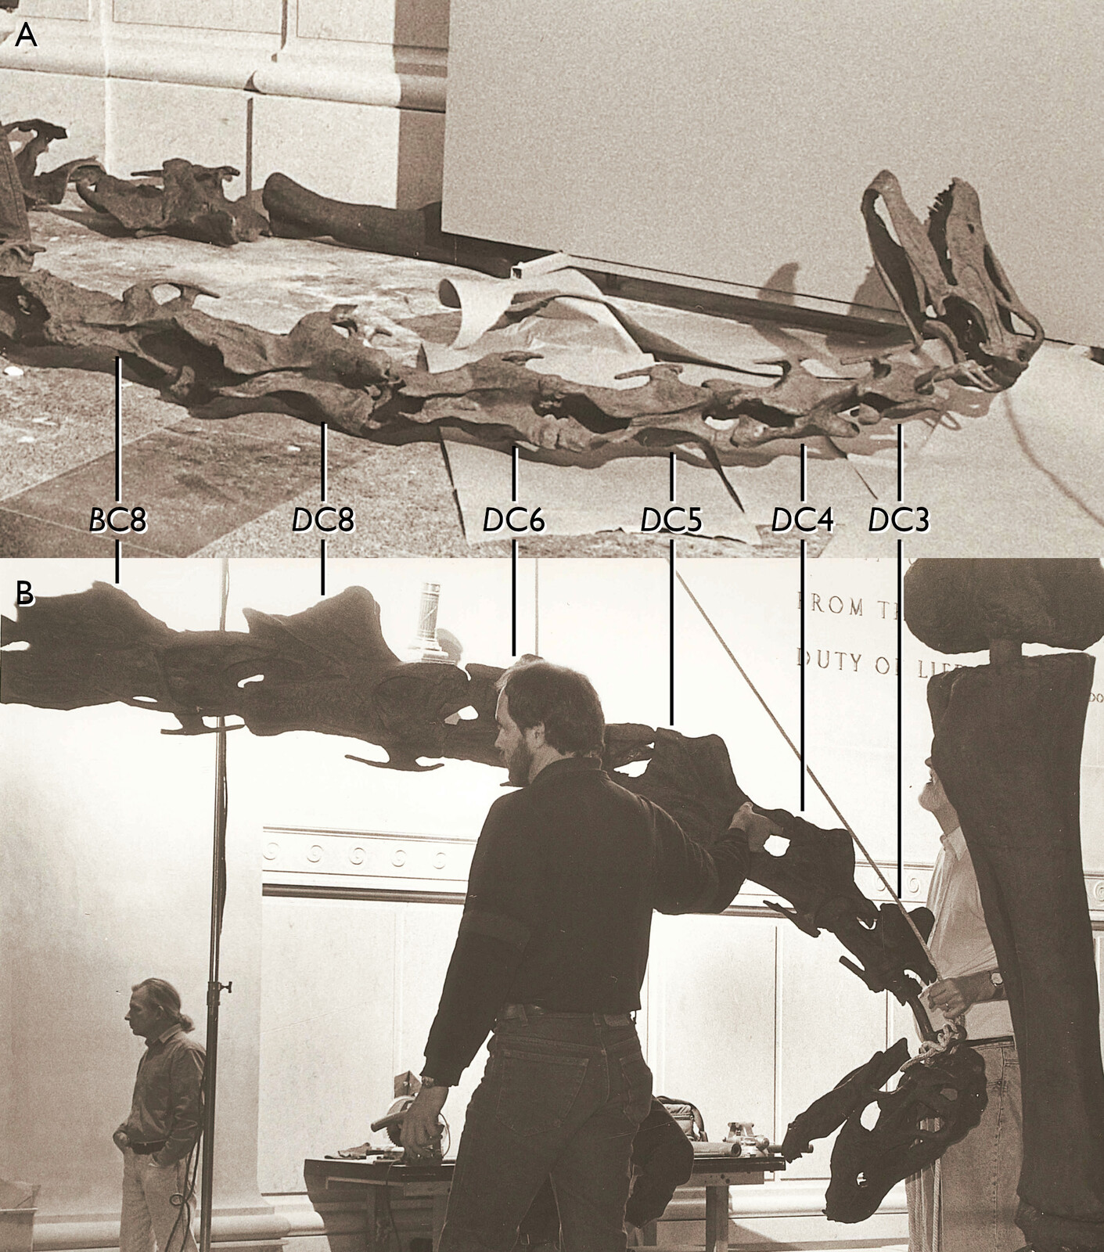
Figure 17. The anterior part of the AMNH Barosaurus neck (skull and first eight cervicals, though the atlas and axis are absent at this point) during the mounting process. A. lying on the floor, seen in roughly dorsal view. B. held upright, seen in right lateral view. Note that the vertebrae in positions 3–7 are those of Diplodocus, with relatively high bifurcated neural spines, while the vertebra in position 8 is that of Barosaurus, with a low and unbifurcated spine. Comparison with the Carnegie Diplodocus shows that those in positions 3–6 are C3–C6 of Diplodocus, but that the 8th cervical vertebra of Diplodocus is used in position 7 to give a more even progression of increasing length. Photographs provided by Department of Vertebrate Paleontology Archive, Copyright © AMNH.
To make matters more complicated, photographs show that the completed mount actually has 17 cervicals rather than 16 (e.g. Figure 1; Lindsay 1992:20–21; Taylor and Wedel 2016:figure 1). McIntosh (2005:45) implicitly left open the possibility that Barosaurus had 17 cervicals, due to his uncertainty about the correct interpretation of the 9th presacral, which he tentatively designated as the first dorsal vertebra but considered possibly the last cervical. However, the existence of a 17th cervical on this basis is predicated on a reduced dorsal count of eight, and the mounted skeleton has nine dorsals with free ribs. The additional cervical therefore appears to be an insert not warranted by the evidence available at the time of mounting.
However, photos of the mounting process in the AMNH (e.g. Figure 13) show that the neck section used in the mount had only 14 cervical vertebrae — C3–16, not counting the atlas and axis which were not in place at that time but which, when added, would bring the total to 16. The assembly process was complex. The neck section containing the head and C1–16 was welded to the torso leaving a stretch of bare armature. The two halves of the seventeenth vertebra (visible on the right side of Figure 13) were then glued together around the armature, bridging the gap between the bones of the neck section and the torso. The special 17th vertebra can be seen in Figure 11B, distinctly darker than the cervicals above it and the dorsals below. Since there are no duplicate vertebrae in the neck, the special C17 must have come from elsewhere. Careful comparisons between photographs of the 17th cervical and 3D models of the Carnegie Diplodocus provided by Heinrich Mallison (for the Berlin cast) and Paul Barrett (for the London cast) show that the former is not a replica of any of the posterior cervicals of the latter. Since the Carnegie Diplodocus was the only source of cast elements (other than the metacarpals discussed below), the 17th cervical of the mounted skeleton must be a sculpture, crafted as an intermediate between C16 and D1.
(Note: it is quite possible that Barosaurus did indeed have 17 cervicals — or even more, as in the 18 of Mamenchisaurus youngi (Ouyang and Ye 2002:24–30) or the 19 of Mamenchisaurus hochuanensis (Young and Zhao 1972). Currently available Barosaurus fossils are not complete enough to determine the point.)
CM 84, the specimen that forms most of the Carnegie mount, includes C2–8 (and the subsequent cervicals), but not the atlas (C1). As discussed by Taylor et al. (2025:71–72), it is not clear which specimen supplied the atlas in the Carnegie mount, and it seems most likely that this element was a sculpture not based on any specific fossil specimen — and so the same would be true in the mounted Barosaurus.

Torso, sacrum and tail
The complete dorsal sequence (of nine vertebrae) and complete sacrum (of five vertebrae) are present in AMNH 6341. However, McIntosh’s (2005:43) account says that only “six ribs and fragments” were included from a total of 18 (two per dorsal vertebra), and as noted above the identification of these ribs is uncertain.
AMNH 6341 includes the first 29 caudals (or perhaps caudals 1–20 and 22–30, see above) but only one chevron. The missing caudals and chevrons were most likely provided once more by casts of the Carnegie Diplodocus.

Forelimbs and girdles
The bones of the forelimb are not only absent from CM 84 (as noted by Hatcher 1901:45) but were completely unknown in the Carnegie collection at the time the mount was constructed. Holland (1906) made no comment on how the forelimbs were obtained for the skeletal mount sent to England. As detailed by Taylor et al. (2025:84), both humeri, radii and ulnae of the casts produced by the Carnegie Museum were sculpted based on the slightly smaller diplodocine individual CM 662 (now HMNS 175), which also provided the rear part of the skull (see above). The forefeet however were sculpted from those of AMNH 965, now recognized as camarasaurid, and were given three manual unguals instead of one, as well as too many phalanges. These errors were well understood by the 1990s: to address them in the Barosaurus mount, a set of metacarpals from a left manus assigned to Diplodocus (DINO 2568) was loaned from Dinosaur National Monument, cast and returned. Corresponding sculptures were created for the metacarpals of the right manus (this predated the use of scanning and 3D printing, which would have allowed a perfect reflection), and the cast and sculptures were used in place of the camarasaurid metacarpals. Other elements of the forefeet were taken from the Carnegie Diplodocus molds, but the unguals were removed from digits II and III to correctly leave a single manual ungual. It follows that a small amount of camarasurid-derived material (the phalanges and surviving unguals) remains in the AMNH Barosaurus mount.

Hindlimbs and girdles
As noted by Taylor et al. (2025:84–85), the Carnegie Museum’s own mounted Diplodocus carnegii, uses the left fibula and partial pes of the referred specimen CM 33985, but for unknown reasons the casts do not use this material. No documentation survives indicating what material was used to create the left fibula and metatarsals III–V used in the casts. Most likely, these bones were mirror-imaged sculptures of the right-side elements preserved in the D. carnegii paratype CM 94 (which also furnished these bones on the right side of both the original mounted Diplodocus and the casts). And the Barosaurus cast probably used second-generation casts of these sculptures.

Discussion

Size of the AMNH 6341 animal
The exact length of the neck of Barosaurus is difficult to determine as no complete neck is known. Only one known specimen referred to Barosaurus preserves the anterior cervicals: AMNH 7535 is a juvenile, consisting of cervicals 2–8, referred by Tschopp et al. (2015:220) to Barosaurus sp. Wedel (2007:207) scaled these vertebrae up to match those of AMNH 6341 (C8 is preserved in both specimens), to arrive at his total neck length estimate of 8.5 m. It seems that someone performed a similar scaling operation using these vertebrae during the period of the mounting, as shown by notes hand-written around 1990 on a printed draft of what would become the table of measurements in McIntosh’s (2005) Barosaurus paper (Peter May, pers. comm. 2022). The identity of the note-taker is not known, but the handwriting does not match that of McIntosh himself. Summing the known centrum lengths of AMNH 6341 cervicals 8–16 from this table (McIntosh 2005:table 2.1) yield a total of 6993 mm. The scaled-up centrum lengths of AMNH 7535 cervicals 2–7 written onto the manuscript are 125, 174, 234, 299, 355 and 467, for a total of 1654 mm. Together these sums add to 8587 mm, a good match for Wedel’s (2007) estimate of 8.5 m, which is currently the generally accepted figure. However, see Taylor and Wedel (in prep.) for alternative estimates.
The height of the mounted Barosaurus is usually given rather inexactly as “fifty feet above the Rotunda floor” (Norell et al. 1991:39), “almost fifty feet” (Dingus 1996:25), “five-storey-high” (Gordy 1991:3) or “over 50 feet (15 m) from ground to head-level” (Lindsay 1992:26). Although vague, these measurements are enough to establish it as the tallest mounted skeleton of any animal anywhere in the world, about two meters taller than the Berlin brachiosaur which has “a skull located more than 13 m above the level of the feet” (Remes et al. 2011:309). (The Berlin brachiosaur was also mounted by RCI — or rather, remounted in 2005–2007, following the original mounting in 1938 under the direction of Werner Janensch.)
The mass of Barosaurus AMNH 6341 is generally considered to be similar to that of Diplodocus carnegii, as its torso is about the same size and the longer neck is balanced by Diplodocus’s longer tail. Seebacher (2001) gave a mass estimate of 20,040 kg based on graphic double integration (compared with 19,655 kg for Diplodocus carnegii). Henderson (2013) estimated 15,800 kg by slicing a digital model (compared with 11,900 kg for Diplodocus carnegii). Benson et al. (2014), in supplementary information S1, gave an estimate of 13,164 kg for AMNH 6341 based on limb-bone measurements (compared with 13,801 kg for Diplodocus carnegii).

Rearing pose
The mounted Barosaurus is in a spectacular rearing pose, as though to defend its offspring against a threatening Allosaurus individual. The exhibit was illustrated by a specially commissioned John Gurche painting (Figure 18), which was used in gallery signage and in numerous publications (e.g. the cover of New York Newsday for 29 November 1991; the cover of the AMNH’s own magazine Natural History for December 1991).
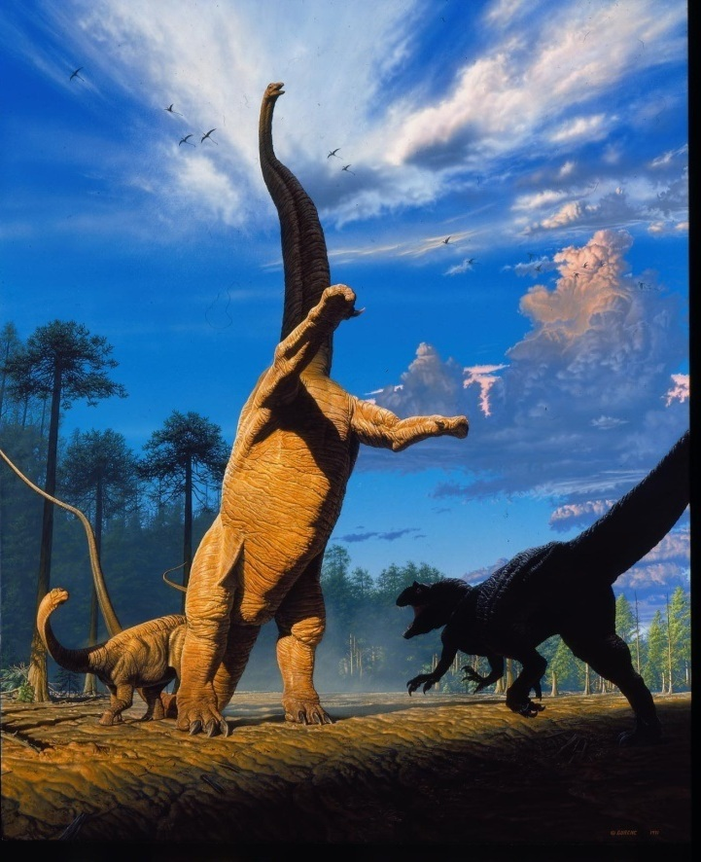
Figure 18. Barosaurus Defends Her Young, John Gurche’s painting of a rearing Barosaurus confronting an Allosaurus and protecting a juvenile, created especially for the publicity materials for the mount when unveiled in 1991. This painting was used in gallery signage and in numerous publications (e.g. the cover of New York Newsday for 29 November 1991; the cover of the AMNH’s own magazine Natural History for December 1991).
The unveiling of the Berlin cast of the Carnegie Diplodocus in 1908 had provoked controversy: Hay (1908, 1910) and Tornier (1909) argued that its erect-legged posture was incorrect, and it should sprawl like a lizard; and Holland (1910) emphatically rebutted these suggestions. In the same way, the AMNH Barosaurus mount started discussions. From the moment of its unveiling this exhibit was controversial for two reasons.
First, there is no direct evidence that Barosaurus, or any sauropod, practiced parental care (Sander et al. 2008). However, it is well established from both trackways (e.g. Day et al. 2004) and death assemblages (e.g. Coria 1994) that sauropods did live and move in herds of different-sized individuals, whether genetically related or not. It is not unreasonable to assume that larger individuals defended the smaller from attack on occasion.
Second, and more seriously, some paleontologists felt that Barosaurus could not or would not have adopted the rearing pose — something which, as noted above, Dingus, Gaffney and McIntosh all had their own reservations about. In a newspaper report published five days before the exhibit was publicly unveiled, it was claimed that “of six leading paleontologists interviewed for this article, all but one questioned how a behemoth weighing in excess of 25 tons could be accurately depicted in an upright position. Most thought it physically impossible” (Gordy 1991:3) — although since the article also wrongly claims that the posture was chosen “over the objections of Gene Gaffney”, it should not be assumed to be accurate in other matters. While Kevin Padian was quoted supporting the posture, Paul Sereno, Jack Horner and Phil Currie all expressed reservations — though none of them went on to express their criticisms in scientific publications. Thirty years on, Sereno comments “I still think it's ridiculous” (Paul Sereno, pers. comm., 2022), but Horner has mellowed: “I had opposed the idea originally but have since come to the conclusion that at least the males had to have been able to rear up to at least the back of the female. I think it took me about a decade to figure that out. […] I like the mount now, it may have been the way the males displayed. Would have been spectacular!” (Jack Horner, pers. comm., 2022).
More specific criticisms and comments were to follow in published articles. Surprisingly, much of the published discussion was in the medical journal The Lancet. First, provoked by Lillywhite’s (1991) brief account of the high blood pressure required to circulate blood to the head of Barosaurus, Choy and Altmann (1992) argued that the great size required of the Barosaurus heart to perfuse an erect neck would have meant that it beat very slowly. Check valves would therefore have been necessary in the neck arteries to prevent the column of blood from falling back to the heart during diastole. They suggested that these valves may have been active pumps — three pairs of “secondary hearts” — though they admitted that in the absence of soft-tissue fossils this is pure conjecture. Millard et al. (1992) dismissed this proposal as unsupported by evidence, noted the absence of check valves in the neck of the giraffe, and argued that the multiple-heart scheme would probably create non-continuous blood flow at the brain. They considered amphibious habits a more likely adaptation for supporting the neck, despite the discrediting of that notion (e.g. Coombs 1975). In a letter published simultaneously, Rewell (1992) noted based on dissection that while there are no valves in the giraffe jugular vein, “specialised seried valves prevented reflux into tributaries running from below into large veins”, a system also seen in the Bactrian camel and by implication also possible in sauropods.
Dennis (1992) claimed to have independently reached the same multiple-hearts conclusion as Choy and Altmann (1992), and noted that hagfish, the giant Brazilian earthworm and some insects have multiple perfusion organs. He also considered and discarded the idea that the blood flow to the head operated as a siphon. In a letter published simultaneously, Taylor (1992) pointed out the evidence for sauropod terrestriality, contra Millard et al.’s proposed amphibious habits, and that breathing would have been impossible when the lungs were far below the surface (see Kermack 1951). And in a third letter, Hicks and Badeer (1992) argued that the circulatory system was closed, i.e. not exposed to ambient pressure, reducing the need for high blood pressure. (Badeer and Hicks (1996) would revisit their ideas in more detail four years later, proposing a siphon loop circulating blood to the head and arguing that blood pressure in the head was negative.)
Separately from the Lancet discussion, Landry (1992) argued briefly that Barosaurus would not have had the necessary muscle mass to rear up, that compressive stresses in a vertical spine would exceed the bending stresses in a horizontal spine, and that dropping down from a rearing posture would create too much kinetic energy to disperse.
All discussion of this nature was welcome to the AMNH team. As noted above, the most important purpose of the mount as originally conceived was not to argue in favour of rearing as a habitual behaviour, but to set out the issue of what we can and cannot know. Dingus (1996:28) noted that he actively welcomed the controversy — not only because all publicity is good publicity, but because the mount’s critics were encouraging the public to think about the controversy for themselves.

A short history of rearing sauropods
The notion of rearing sauropods has a long heritage. One of earliest life restorations featuring sauropods is Charles R. Knight’s 1897 drawing, created under the supervision of E. D. Cope, appearing in Ballou (1897:20) and reproduced in Osborn and Mook (1921:figure 127). This shows several Amphicoelias individuals in mostly submerged rearing postures.
Scientific support for the plausibility of rearing on land goes back at least to Osborn (1899:213), who wrote that the tail of Diplodocus “functioned as a lever to balance the weight of the dorsals, anterior limbs, neck, and head, and to raise the entire forward portion of the body upwards. […] Thus the quadrupedal Dinosaurs occasionally assumed the position characteristic of the bipedal Dinosaurs — namely, a tripodal position, the body supported upon the hind feet and the tail”.
In his classic monograph of Diplodocus carnegii, Hatcher (1901:58) strongly implied, without quite explicitly stating, that Diplodocus habitually reared: “the modified nature of the chevrons of the mid-caudal region indicate the point of contact of the tail with the earth attending the different positions habitually assumed during the life of the individual”.
Riggs (1904:245–246), contrasting his new dinosaur Brachiosaurus with the then-known diplodocids wrote: “We may well assume, with other writers, that the heavier forms, such as Apatosaurus and Diplodocus, which are provided with long spines in the sacral and posterior dorsal region, were adapted to rearing up on the hind legs as is represented in the conventional mounted skeleton of Megatherium. In these forms we find that the body is short and therefore well adapted to this habit.”
Knight was painting rearing diplodocids as early as 1907 (reproduced in Taylor 2010:figure 6B).
Huene (1929:497) provided what was probably the first life restoration of a titanosaur, “Titanosaurus” (= Neuquensaurus) australis. As well as the foreground individual, depicted in a classic four-square pose, two more individuals are shown fighting in the background, one of them rearing on its hind legs.
Borsuk-Bialynicka (1977:51) proposed that the robust titanosaur Opisthocoelicaudia occasionally stood on its hind limbs: “the tail working as a prop seems […] probable. […] Occasional bipedality is therefore strongly suggested. It is, however, not a matter of briefly assuming a bipedal stance as is possible in most of the tetrapods. […] The animal must have been stable in this position; otherwise this posture would not have left such distinct traces in the skeleton architecture.”
In 1984, Gregory S. Paul drew an assemblage of four Jurassic sauropods: Camarasaurus, two Barosaurus and Apatosaurus, all but the first of which were shown rearing to near-vertical postures. This drawing, possibly the first artwork to show rearing Barosaurus, was reproduced by Bird (1985:14).
In a landmark paper on dinosaur biomechanics, R. McNeill Alexander (1985:9) took the first steps towards numerically modelling the ability of sauropods, including Diplodocus, to rear. These early calculations were concerned only with the location of the centre of mass, and the ability of the dinosaurs in question to shift it backwards to the location of the hips.
Robert T. Bakker had been arguing for some time that at least some sauropods reared (e.g. Bakker 1971, 1978). In his widely read popular-science book The Dinosaur Heresies, Bakker (1986:190–192) reiterated and expanded his own argument that diplodocids, including Barosaurus itself, not only could rear but habitually did so when feeding and at other times. The frontispiece of the book illustrated this idea with a striking drawing of two apatosaurines fighting in tripodal posture. While the idea of rearing sauropods had been growing among researchers, The Dinosaur Heresies probably marked the point where the idea began to impinge on non-specialists.
Paul (1987:31), in the article containing his influential painting Ambush at Como Creek (see above), argued that habitual rearing into tripodal stance is the only explanation for diplodocids’ massive hips and vertebrae, larger than those of otherwise bigger sauropods, and for their relatively straight necks, short forelimbs and sledlike chevrons. The next year, his book Predatory Dinosaurs of the World contained a drawing a Mamenchisaurus hochuanensis rearing to fight theropods (Paul 1988:88) in a composition reminiscent of Ambush but rather more extreme due to the extraordinarily long neck of Mamenchisaurus.
Jensen (1988) described a new camarasaurid species Cathetosaurus lewisi (considered by McIntosh et al. (1996) to be a species of Camarasaurus but regarded as its own genus by Tschopp et al. 2014). Jensen (1988:124–128) considered several characters of the C. lewisi holotype BYU 9047 as specializations for rearing and bipedal locomotion: bifurcated neural spines through the entire presacral series, elongated chevrons, a strong system of ossified diagonal intervertebral ligaments in the dorsal vertebrae, supracostal plates in the sacral vertebrae, and 20-degree forward rotation of the ilia relative to the sacrum. While some of these features do not seem directly related to rearing and others are likely age-related, the rotation of the ilium remains unique and is difficult to interpret as anything other than a rearing adaptation.
In more recent times, biomechanical modelling has been used to establish the feasibility of elevated postures such as that of the AMNH Barosaurus. Mallison (2011) argued compellingly from kinetic–dynamic modelling that diplodocines such as Barosaurus were particularly well adapted to bipedal rearing and sustained tripodal (tail-supported) standing. So the pose selected for the AMNH mount seems biomechanically justified.

Cultural impact
As well as catalyzing a scientific debate on the mechanical difficulties of rearing, the AMNH Barosaurus mount has significantly influenced the depiction of sauropods in popular culture.
Pre-production of Steven Spielberg’s Jurassic Park (1993) began in July 1990, and filming begin in August 1992, so the AMNH Barosaurus was unveiled about two thirds of the way through pre-production, in time to influence decisions about the film’s content. Notably, the first dinosaur seen in the film is a rearing sauropod — but it is a Brachiosaurus rather than a Barosaurus. The choice of a rearing Brachiosaurus in Jurassic Park is surprising because brachiosaurs were the most front-heavy of all sauropods, and so the least well adapted to rearing. It must be possible that from early versions, the script called for a Brachiosaurus, but the rearing was added only relatively late in the process, in response to the AMNH exhibit.
If Jurassic Park was the most important representation of dinosaurs in film, the BBC documentary Walking With Dinosaurs (1999) was certainly the most influential depiction on the small screen. The second of the six episodes, Time of the Titans (broadcast in the USA as Jurassic Giants) traces the life of a female Diplodocus, and spends much of its time with the herd of different-aged Diplodocus individuals. Two passages of this episode show several individuals rearing onto their hind limbs: 15 minutes in, to push over trees; and 26 minutes in, to confront an Allosaurus, in a scene that can only be a tribute to the AMNH exhibit. In this latter sequence, the rearing Diplodocus is even seen taking several bipedal steps. More than 20 years later, Apple TV+ provided a spiritual successor to Walking with Dinosaurs in Prehistoric Planet (2022). Episode 2 (Deserts) included a lengthy scene beginning at four minutes, in which Dreadnoughtus titanosaurs reared into bipedal poses, initially for sexual display, then for intraspecific combat.
The Dinosaur World park in Plant City, Florida, contains a life-sized sculpture of a rearing Barosaurus.
Some dinosaur toys have been influenced by the AMNH mount: for example, the Collecta Diplodocus is in a rearing pose. However, toys of Barosaurus itself are for some reason extraordinarily rare. The Dinosaur Toy Blog (Smith 2007) has reviewed well over 2,500 dinosaur toys (Adam Smith, pers. comm., 2024), including 50 versions of Brachiosaurus, 38 of Apatosaurus and 22 of Diplodocus — but not a single Barosaurus toy. The only Barosaurus “toys” on the market at the time of writing seem to be large museum-quality maquettes costing $500 or more. A Lego model of the rearing AMNH Barosaurus has been created by Ambrosino (a pseudonym) and its instructions made freely available (Ambrosino 2023; Figure 19).
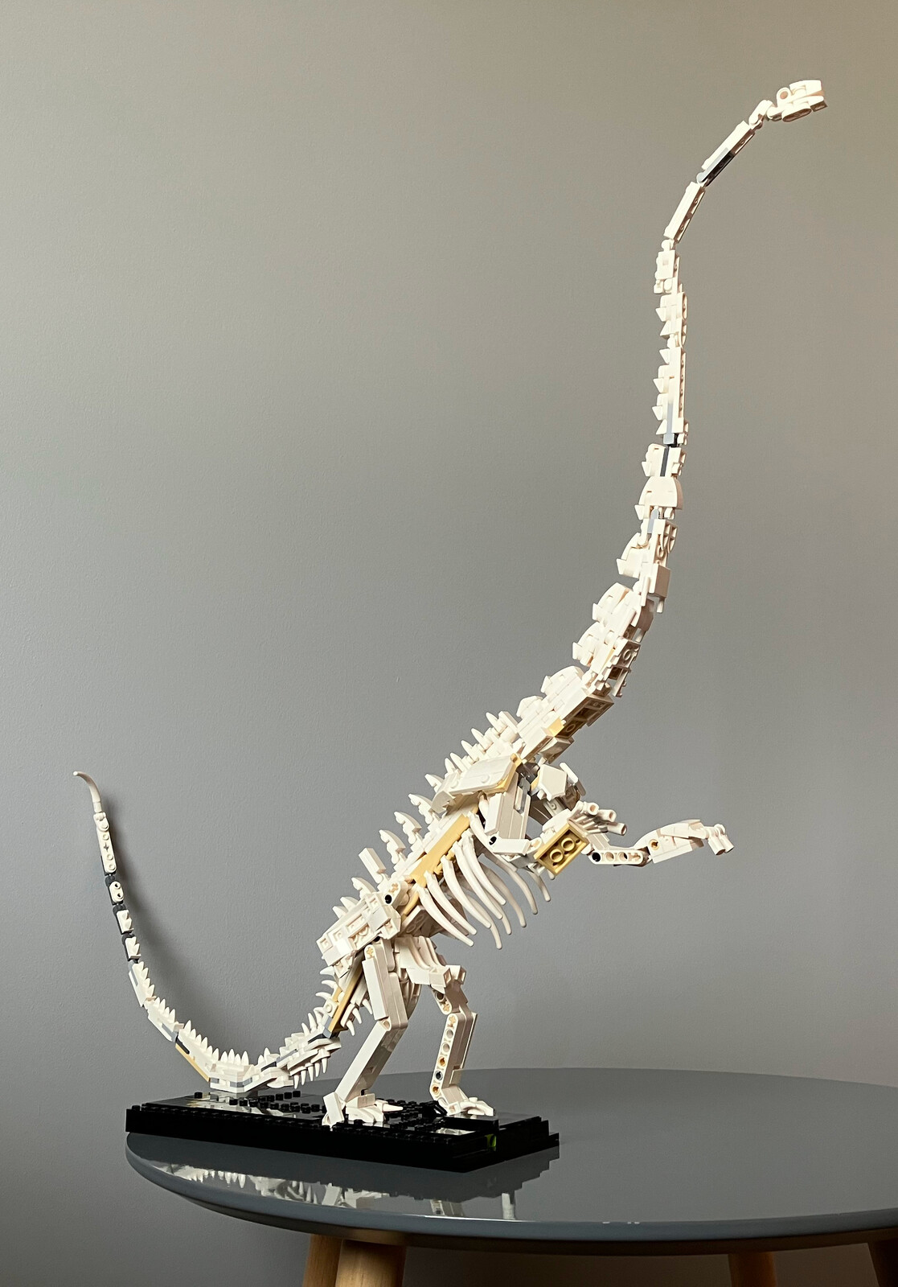
Figure 19. Lego model of the rearing AMNH Barosaurus, created by Ambrosino (a pseudonym). Reproduced with permission. This model is built from the pieces of Lego’s official Dinosaur Fossils kit (number 21320) and its instructions are freely available (Ambrosino 2023). These instructions have been used as the basis for a commercially available, but unauthorized, kit.

Conclusion
It is ironic that the AMNH had no part in the excavation or preparation of what is arguably its most iconic fossil specimen, Barnum Brown having reunited it after a diaspora to three different museums. It doubly ironic that, having acquired the skeleton, the museum did not even display it for several years, then removed it from display after little more than a decade. Subsequent developments show the value of palaeoart as a hypothesis-generating machine: there would be no rearing Barosaurus mount without Greg Paul’s painting Ambush at Como Creek. It is striking that Dingus and Gaffney independently had the idea for a rearing mount, despite their distaste for speculative palaeobiology, each of them expecting the other to object — and that Norell, who they both expected to veto the idea, was also on board. And it is satisfying that the biomechanical feasibility of rearing diplodocines has subsequently been demonstrated mathematically. The mount certainly achieved its stated goals of provoking not just public discussion, but much further scientific work.

Acknowledgements
We are grateful to Gregory S. Paul for permission to reproduce his artwork Ambush at Como Creek (Figure 7), to Scott Hartman (University of Wisconsin-Madison) for allowing us to use his Barosaurus lentus skeletal reconstruction in Figure 15, to John Gurche for permission to reproduce his life restoration of the rearing Barosaurus (Figure 18), and to Ambrosino for permission to use a photograph of his Lego Barosaurus model (Figure 19). Jarrod Davis created the high-quality image of Paul’s Ambush painting by combining several scans created by Mathew J. Wedel (Western University of Health Sciences); we thank them both. Mick Ellison (AMNH) kindly photographed for us both the 1939 public gallery exhibit panel (Figure 6) and the prototype model (Figure 9), having had the model repaired. Photography of the model was courtesy of the AMNH Main Archives.
Melissa Posen, Dingus’s administrative assistant on the Barosaurus mounting project, took most of the photographs of the initial assembly in Toronto. Denis Finnin, the Museum Photographer, took most of the photos of the assembly in the Rotunda. It is likely that their work is included in one or more of our illustrations, but individual photo credits have been lost.
Mai Reitmeyer (Department of Library Services, AMNH) helped us to obtain historical photographs. Kiana Clark (AMNH Vertebrate Paleontology Archives), provided numerous historical documents and photographs. Abby Telfer (United States National Museum), provided helpful documents in establish the early history of the AMNH 6341 material. ReBecca Hunt-Forster (Dinosaur National Monument) provided an invaluable archive of correspondence relating to the early years of the quarry. Amelia Zietlow (Richard Gilder Graduate School at the AMNH) provided helpful photographs and information about the present public exhibits (Figure 8). We thank Ray Wilhite (Auburn University College of Veterinary Medicine) and Brooks Britt and Rod Scheetz (both Brigham Young University) for help in accessing the archived notebooks of John S. McIntosh. Matt Wedel helped with the interpretation and identification of some vertebrae, and provided valuable feedback on the manuscript.
Heinrich Mallison (Palaeo3D) and Paul M. Barrett (Natural History Museum) provided 3D scans of two casts of the Carnegie Diplodocus. Carl Mehling (AMNH) searched collections for the missing C7 and concluded it was absent. Matt Caranno (USNM), Mick Ellison, Lynton Gardiner, Jack Horner (Chapman University), Carl Mehling, Gregory S. Paul. Paul Sereno (University of Chicago), Adam Smith (Nottingham Natural History Museum) and Abby Telfer (USNM) allowed us to cite personal communications.

References
Alexander, R. McNeill. 1985. Mechanics of posture and gait of some large dinosaurs: Zoological Journal of the Linnean Society 83:1–25.
Ambrosino. 2023. 21320: Barosaurus skeleton. https://rebrickable.com/mocs/MOC-154998/Ambrosino/21320-barosaurus-skeleton/ archived at https://web.archive.org/web/20241109174605/https://rebrickable.com/mocs/MOC-154998/Ambrosino/21320-barosaurus-skeleton/#details
Anonymous. 1939. Museum monster loses by 14 feet; Brontosaurus, size champion, to be replaced by a much larger Barosaurus. New York Times, 18 April 1939, page 25.
Anonymous. 1991. They say even Barosaurus danced. New York Times, 8 December 1991, section 1, page 75.
Associated Press. 1991. Dinosaur gets legs up on a controversy. Washington Post, 30 November, 1991.
Badeer, Henry S., and James W. Hicks, 1996. Circulation to the head of Barosaurus revisited: theoretical considerations. Comparative Biochemistry & Physiology A114:197–203.
Bakker, Robert T. 1971. Brontosaurs. pp. 178–181 in: McGraw-Hill Yearbook of Science and Technology, 1971. McGraw-Hill, New York, New York.
Bakker, Robert T. 1978. Dinosaur feeding behaviour and the origin of flowering plants. Nature 274:661–663.
Bakker, Robert T. 1986. The Dinosaur Heresies: New Theories Unlocking The Mystery of the Dinosaurs and Their Extinction. Morrow, New York. 481 pages.
Ballou, William H. 1897. Strange creatures of the past: gigantic saurians of the reptilian age. Century Illustrated Magazine 55(1):15–23. https://babel.hathitrust.org/cgi/pt?id=coo.31924080776994
Bartram, Alan, B. Booth, M. Chinery, E. N. K. Clarkson, B. Cox, D. Edwards, C. Maynard and W. D. I. Rolfe. 1983. The Prehistoric World. Galley Press (London).
Begley, Sharon, and Emily Yoffe. 1991. New theories and old bones reveal the lifestyles of the Dinosaur. Newsweek, 28 October 1991, pp. 52–58.
Benson Roger B. J., Nicolás E. Campione, Matthew T. Carrano, Philip D. Mannion, Corwin Sullivan, Paul Upchurch and David C. Evans. 2014. Rates of dinosaur body mass evolution indicate 170 million years of sustained ecological innovation on the avian stem lineage. PLoS Biology 12(5):e1001853. doi:10.1371/journal.pbio.1001853
Bird, Roland T. 1985. Bones for Barnum Brown. Texas Christian University Press, Fort Worth, Texas.
Borsuk-Bialynicka, Magdalena. 1977. A new camarasaurid sauropod Opisthocoelicaudia skarzynskii gen. n., sp. n. from the Upper Cretaceous of Mongolia. Palaeontologica Polonica 37:4–64 and plates 1–14.
Brown, 1929. Report on Barosaurus (letter to the American Museum of Natural History, 31 December 1929. Reproduced on page 21 in: Dingus, Lowell. 1996. Next of Kin: Great Fossils at the American Museum of Natural History. Rizzoli, New York.
Choy, Daniel S. J., and P. Altmann. 1992. The cardiovascular system of Barosaurus: an educated guess. The Lancet 340:534–536.
Clark, Robert J. 1991. Letter to Peter May, Research Casting International. 28 October 1991. Department of Vertebrate Paleontology building and exhibit records, VPA 100, Series 3, Box 28, Folder 35, American Museum of Natural History Vertebrate Paleontology Archive.
Coggeshall, Arthur S. 1924. Letter to Charles W. Gilmore reporting that neck section is ready to be shipped from Caregie Museum to USNM. About 21 October 1924.
Collins, Glenn. 1991. Clearing a new path for T. Rex and company. New York Times, 1 December 1991, page 2038.
Coombs, W. 1975. Sauropod habits and habitats. Palaeogeography, Palaeoclimatology, Palaeoecology 17:1–33. doi:10.1016/0031-0182(75)90027-9
Coria, Rodolfo A. 1994. On a monospecific assemblage of sauropod dinosaurs from Patagonia: implication for gregarious behaviour. Gaia 10:209–213.
Day, Julia J., David B. Norman, Andrew S. Gale, Paul Upchurch and H. Philip Powell. 2004. A Middle Jurassic dinosaur trackway site from Oxfordshire, UK. Palaeontology 47:319–348. doi:10.1111/j.0031-0239.2004.00366.x
Dennis, James M. 1992. Barosaurus and its circulation. The Lancet 340:1228.
Dingus, Lowell. 1990. Letter of agreement to Peter May and Andrew Leitch, Research Casting International. 28 March 1990. Department of Vertebrate Paleontology building and exhibit records, VPA 100, Series 3, Box 28, Folder 35, American Museum of Natural History Vertebrate Paleontology Archive.
Dingus, Lowell. 1996. Next of Kin: Great Fossils at the American Museum of Natural History. Rizzoli, New York.
Douglass, Earl. 1879–1953. Earl Douglass papers, 1879–1953. Collected by University of Utah Libraries, Special Collections; Excepted by Archives West. https://archiveswest.orbiscascade.org/ark:80444/xv14910
Douglass, Earl. 1922a. Telegram to George P. Merrill estimating cost and time to extract two Diplodocus skeletons from the Dinosaur National Monument quarry. 10 November 1922 or shortly before.
Douglass, Earl. 1922b. Letter to George P. Merrill expanding on cost and time to extract two Diplodocus skeletons from the Dinosaur National Monument quarry. 22 November 1922.
Douglass, Earl. 1922c. Report of Work Done by the Carnegie Museum at the Dinosaur National Monument in Uinta County, Utah, under the Supervision of Earl Douglass, in the year 1922. 24 March 1923.
Douglass, Earl. 1923. Report of Work Done by the Carnegie Museum at the Dinosaur National Monument in Uinta County, Utah, under the Supervision of Earl Douglass, in the year 1922. 24 March 1923. 2 pages.
Galiano, Henry. 1990. Letter to James “Chip” Jeffries, Ralph Appelbaum Associates. 22 March 1990. Department of Vertebrate Paleontology building and exhibit records, VPA 100, Series 3, Box 28, Folder 35, American Museum of Natural History Vertebrate Paleontology Archive.
Gilmore, Charles W. 1923a. Handwritten letter to William de C. Ravenel briefly summarising the outcome of the field season at the Dinosaur National Monument quarry. 8 August 1923.
Gilmore, Charles W. 1923b. Letter to William de Chastignier Ravenel, “I herewith submit my report on the expedition to the Dinosaur National Monument”. 30 August 1923. 3 pages.
Gilmore, Charles W. 1932. On a newly mounted skeleton of Diplodocus in the United States National Museum. Proceedings of the United States National Museum 81:1–21.
Gilmore, Charles W. 1936. Osteology of Apatosaurus with special reference to specimens in the Carnegie Museum. Memoirs of the Carnegie Museum 11:175–300 and plates XXI–XXXIV.
Gordy, Molly. Dinosaur’s Last Stand? Exhibit’s pose is all wrong, experts assert. 1991. New York Newsday 52(88) for 29 November 1991:3, 27.
Hatcher, John B. 1901. Diplodocus (Marsh): its osteology, taxonomy and probable habits, with a restoration of the skeleton. Memoirs of the Carnegie Museum 1:1–63 and plates I–XIII.
Hay, Oliver P. 1908. On the habits and the pose of the sauropodous dinosaurs, especially of Diplodocus. The American Naturalist 42:672–681.
Hay, Oliver P. 1910. On the manner of locomotion of the dinosaurs, especially Diplodocus, with remarks on the origin of birds. Proceedings of the Washington Academy of Sciences 12:1–25.
Henderson, Donald M. 2013. Sauropod necks: are they really for heat loss? PLoS ONE 8(10): e77108. doi:10.1371/journal.pone.0077108
Hicks, James W., and Henry S. Badeer. 1992. Barosaurus and its circulation. The Lancet 340:1229.
Holland, William J. 1906. Osteology of Diplodocus Marsh with special reference to the restoration of the skeleton of Diplodocus carnegiei [sic] Hatcher presented by Mr. Andrew Carnegie to the British Museum, May 12 1905. Memoirs of the Carnegie Museum 2(6):225–278.
Holland, William J. 1910. A review of some recent criticisms of the restorations of sauropod dinosaurs existing in the museums of the United States, with special reference to that of Diplodocus carnegiei [sic] in the Carnegie museum. American Naturalist 44:259–283.
Holland, William J. 1915. A new species of Apatosaurus. Annals of the Carnegie Museum 10:143–145.
Huene, Friedrich von. 1929. Die Besonderheit der Titanosaurier [The characteristics of titanosaurs]. Centralblatt für Mineralogie, Geologie und Palaontologie 1929(B):493–499.
Janensch, Werner. 1922. Das Handskelett von Gigantosaurus robustus u. Brachiosaurus brancai aus den Tendaguru-Schichten Deutsch-Ostafrikas. Centralblatt für Mineralogie, Geologie und Palaontologie 1922(15): 464–480.
Janensch, Werner. 1950. Die Skelettrekonstruktion von Brachiosaurus brancai. Palaeontographica (Supplement 7) 3:97–103, and plates VI–VIII.
Jensen, James A. 1988. A fourth new sauropod dinosaur from the Upper Jurassic of the Colorado Plateau and sauropod bipedalism. Great Basin Naturalist 48(2):121–145.
Kermack, Kenneth A. 1951. A note on the habits of sauropods. Annals and Magazine of Natural History, series 12, 4:830–832. doi:10.1080/00222935108654213
Lambert, David. 2000. DK Guide: Dinosaurs. Dorling Kindersley (London). 64 pages.
Landry, Stuart O. 1992. Untitled abstract on rearing Barosaurus. American Zoologist 32:5, Abstracts for annual meeting of the American Society of Zoologists, 26–30 December 1992, page 147A.
Lillywhite, Harvey B., 1991. Sauropods and gravity. Natural History 100(12):33
Lindsay, William. 1992. Barosaurus: On the Trail of the Gigantic Plant-Eating Dinosaur (Dinosaur Spotter’s Guides series). Dorling Kindersley (London). 32 pages.
Lull, Richard S. 1917. Barosaurus: a gigantic sauropod dinosaur. Bulletin of the Geological Society of America 28 (Proceedings of the eigth annual meeting of the Paleontological Society, held at Albany, New York, December 27, 28, and 29, 1916), pages 214–215.
Lull, Richard S. 1919. The sauropod dinosaur Barosaurus Marsh. Memoirs of the Connecticut Academy of Arts and Sciences 6:1–42 and plates I–VII.
Mallison, Heinrich. 2011. Rearing giants: kinetic-dynamic modeling of sauropod bipedal and tripodal poses. pp. 237–250 in: Nicole Klein, Kristian Remes, Carole T. Gee and Martin P. Sander (eds.), Biology of the Sauropod Dinosaurs: Understanding the Life of Giants. Indiana University Press, Bloomington, Indiana.
Marsh, Othniel C. 1890. Description of new dinosaurian reptiles. American Journal of Science, third series, 39:81–86. doi:10.2475/ajs.s3-39.229.81
Marsh, Othniel C. 1891. Restoration of Triceratops (with plates XV and XVI). American Journal of Science, 3rd series, 41(244):339–342.
Marsh, Othniel C. 1896. The dinosaurs of North America. Extract from the 16th annual report of the U. S. Geological Survey, 1894–95, part I. doi:10.5962/bhl.title.60562
McIntosh, John S. 2005. The Genus Barosaurus Marsh (Sauropoda, Diplodocidae). pp. 38–77 in Virginia Tidwell and Ken Carpenter (eds.), Thunder Lizards: the Sauropodomorph Dinosaurs. Indiana University Press, Bloomington, Indiana. 495 pp.
McIntosh, John S, Wade E. Miller, Kenneth L. Stadtman and David D. Gillette. 1996. The osteology of Camarasaurus lewisi (Jensen, 1988). Brigham Young University Geology Studies 41:73–115.
Merrill, George P. 1922. Letter to William de C. Ravenel on the Carnegie Museum's readiness to release the Dinosaur National Monument quarry. 6 November 1922.
Millard, Ronald W., Harvey B. Lillywhite and Alan R. Hargens. 1992. Cardiovascular system design and Barosaurus. The Lancet 340:914.
Nieuwland, Ilja. 2019. American dinosaur abroad: a cultural history of Carnegie’s plaster Diplodocus. University of Pittsburgh Press. ISBN: 978-0822945574. doi:10.2307/j.ctvh4zh5n
Norell, Mark A., Lowell W. Dingus and Eugene S. Gaffney. 1991. Barosaurus on Central Park West. Natural History 100(12):36–41. http://hdl.handle.net/2246/6497
Osborn, Henry F. 1899. A skeleton of Diplodocus. Memoirs of the American Museum of Natural History, 1:189–214 and plates 24–28.
Osborn, Henry F. 1923. Letter to Charles D. Walcott with vague but ominous contents. 14 April 1923.
Osborn, Henry F., and Charles C. Mook. 1921. Camarasaurus, Amphicoelias and other sauropods of Cope. Memoirs of the American Museum of Natural History, n.s. 3:247–387 and plates LX–LXXXV. doi:10.1130/GSAB-30-379
Ouyang Hui and Ye Yong. 2002. The first mamenchisaurian skeleton with complete skull: Mamenchisaurus youngi. 111 pages + 20 plates. Sichuan Science and Technology Press, Chengdu.
Paul, Gregory S. 1987. The science and art of restoring the life appearance of dinosaurs and their relatives. pp. 4–49 in: Sylvia J. Czerkas and Everett C. Olson (eds.), Dinosaurs Past and Present, Volume II . Natural History Museum of Los Angeles County in association with University of Washington Press, Los Angeles. 150 pp.
Paul, Gregory S. 1988. Predatory Dinosaurs of the World. Simon and Schuster Inc., New York. 446 pp.
Psihoyos, Louie (with John Knoebber). 1994. Hunting dinosaurs. Random House, New York. 267 pp.
Remes, Kristian, David M. Unwin, Nicole Klein, Wolf-Dieter Heinrich and Oliver Hampe. 2011. Skeletal Reconstruction of Brachiosaur brancai in the Museum für Naturkunde, Berlin: summarizing 70 years of sauropod research. pp. 305–316 in: Nicole Klein, Kristian Remes, Carole T. Gee and Martin P. Sander (eds.), Biology of the Sauropod Dinosaurs: Understanding the Life of Giants. Indiana University Press, Bloomington, Indiana.
Rewell, R. E. 1992. Cardiovascular system design and Barosaurus. The Lancet 340(8824):914.
Riggs, Elmer S. 1904. Structure and relationships of opisthocoelian dinosaurs. Part II, the Brachiosauridae. Field Columbian Museum, Geological Series 2(6):229–247, plus plates LXXI–LXXV.
Sander, P. Martin, Christian Peitz, Frankie D. Jackson and Luis M. Chiappe. 2008. Upper Cretaceous titanosaur nesting sites and their implications for sauropod dinosaur reproductive biology. Palaeontographica Abteilung A 284:69–107. doi:10.1127/pala/284/2008/69
Seebacher, Frank. 2001. A new method to calculate allometric length-mass relationships of dinosaurs. Journal of Vertebrate Paleontology 21:51–60. doi:10.1671/0272-4634(2001)021[0051:ANMTCA]2.0.CO;2
Smith, Adam S. (with contributions from 20 other authors). 2007. Dinosaur Toy Blog. https://dinotoyblog.com/
Stewart, Douglas. 1922a. Letter to Arthur S. Coggeshall offering to turn over the two Diplodocus skeletons at Dinosaur National Monument quarry to USNM. 6 September 1922.
Stewart, Douglas. 1922b. Letter to George P. Merrill offering to turn over the Dinosaur National Monument quarry to USNM. 7 November 1922.
Taylor, Michael A. 1992. Barosaurus and its circulation. The Lancet 340:1228.
Taylor, Michael P. 2010. Sauropod dinosaur research: a historical review. pp. 361–386 in: Richard T. J. Moody, Eric Buffetaut, Darren Naish and David M. Martill (eds.), Dinosaurs and Other Extinct Saurians: a Historical Perspective. Geological Society of London, Special Publication 343. doi: 10.1144/SP343.22
Taylor, Michael P., and Mathew J. Wedel. 2016. The neck of Barosaurus: longer, wider and weirder than those of Diplodocus and other diplodocines. PeerJ PrePrints 1:e67v2. doi:10.7287/peerj.preprints.67v2
Taylor, Michael P., and Mathew J. Wedel. In prep. Giant specimens of the sauropod dinosaur Barosaurus from Utah and Colorado, USA. https://github.com/miketaylor/palaeo-superbaro
Taylor, Michael P., Steven Sroka and Kenneth Carpenter. 2023. The concrete Diplodocus of Vernal — a Cultural Icon of Utah. Geology of the Intermountain West 10:65–91. doi: 10.31711/giw.v10.pp65-91.
Taylor, Michael P., Matthew C. Lamanna, Amy Henrici, Linsly Church and Ilja Nieuwland. 2025. The history and composition of the Carnegie Diplodocus. Annals of the Carnegie Museum 91(1):55–91. doi:10.2992/007.091.0104
Tornier, Gustav. 1909. Wie war der Diplodocus carnegii wirklich gebaut? Sitzungsbericht der Gesellschaft naturforschender Freunde zu Berlin 4:193–209.
Tschopp, Emanuel, Octávio Mateus and Roger B. J. Benson. 2015. A specimen-level phylogenetic analysis and taxonomic revision of Diplodocidae (Dinosauria, Sauropoda). PeerJ 2:e857. doi:10.7717/peerj.857
Tschopp, Emanuel, Octávio Mateus, Ralf Kosma, P. Martin Sander, Ulrich. Joger and Oliver W. M. Wings. 2014. A specimen-level cladistic analysis of Camarasaurus (Dinosauria, Sauropoda) and a revision of camarasaurid taxonomy. 74th Annual Meeting of the Society of Vertebrate Paleontology, Program and Abstracts, 241. XXXXX is this right?
Untermann, G. Ernest. 1959. A replica of Diplodocus. Curator 2(4):364–369. doi:10.1111/j.2151-6952.1959.tb00520.x
Wedel, Mathew J. 2007. Postcranial pneumaticity in dinosaurs and the origin of the avian lung. Ph.D dissertation, Integrative Biology, University of California, Berkeley, CA. Advisors: Kevin Padian and Bill Clemens. 290 pages.
Wetmore, F. Alexander. 1933. Letter to George H. Sherwood stating that Barosaurus material had been sent to the AMNH.
Wieland, George R. 1920. The Longneck sauropod Barosaurus. Science, New Series 51(1326):528–530.
Young, Chung-Chien, and X. Zhao. 1972. [Chinese title. Paper is a description of the type material of Mamenchisaurus hochuanensis]. Institute of Vertebrate Paleontology and Paleoanthropology Monograph Series I, No. 8:1–30. English translation by W. Downs. https://naturalhistory.si.edu/sites/default/files/media/translated_publications/Young%26amp%3BZhao_72.pdf

