ANNEX I. REGISTRATION FORM

Paleonturology 26

24th INTERNATIONAL AWARD IN PALAEONTOLOGICAL RESEARCH

A) PAPER ENTERED BY THE AUTHOR/S

-Title of the publication: The history and composition of the Carnegie Diplodocus

-Names of all authors: Michael P. Taylor, Amy C. Henrici, Linsly J. Church, Ilja Nieuwland and Matthew C. Lamanna.

-Contact information of all authors (postal addresses, telephone numbers and email addresses of all of them): I do not have phone numbers for the authors other than myself, but here is the rest of the information:

MICHAEL P. TAYLOR
Department of Earth Sciences, University of Bristol, Bristol BS8 1RJ, United Kingdom
Phone +44 1594 550 507
dino@miketaylor.org.uk (corresponding author)

AMY C. HENRICI
Collection Manager (retired), Section of Vertebrate Paleontology,
Carnegie Museum of Natural History
4400 Forbes Avenue, Pittsburgh, Pennsylvania
HenriciA@carnegiemnh.org

LINSLY J. CHURCH
Curatorial Assistant, Section of Vertebrate Paleontology,
Carnegie Museum of Natural History
4400 Forbes Avenue, Pittsburgh, Pennsylvania
ChurchL@carnegiemnh.org

ILJA NIEUWLAND
Huygens Institute, Royal Netherlands Academy of Arts and Sciences, Netherlands
ilja@mac.com

MATTHEW C. LAMANNA
Mary R. Dawson Curator, Section of Vertebrate Paleontology,
Carnegie Museum of Natural History
4400 Forbes Avenue, Pittsburgh, Pennsylvania
LamannaM@carnegiemnh.org

-Signatures of all authors, all of them sign accepting to be represented to all intents and purposes of this award by the first author or the corresponding author:
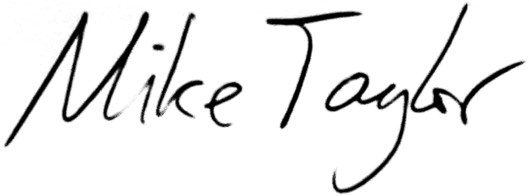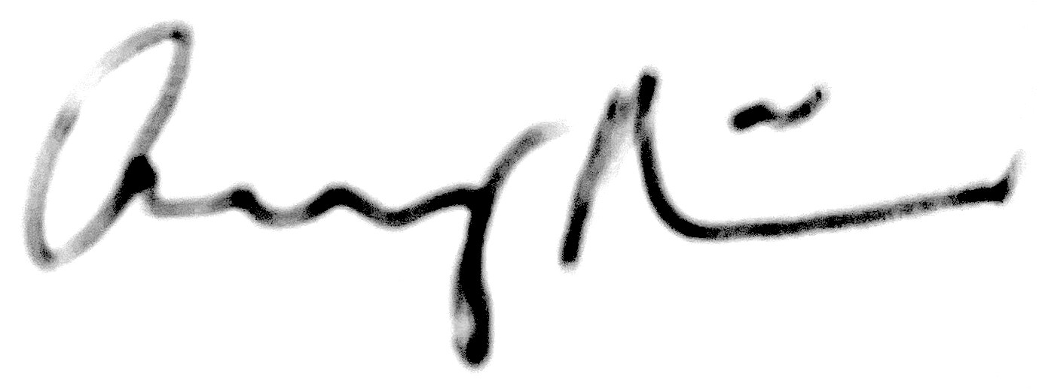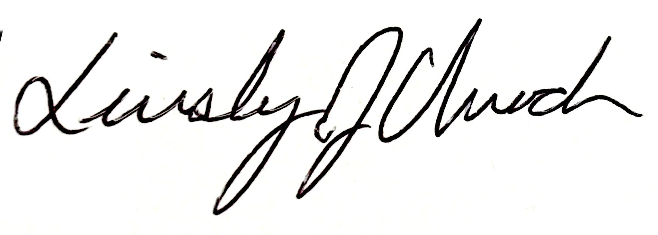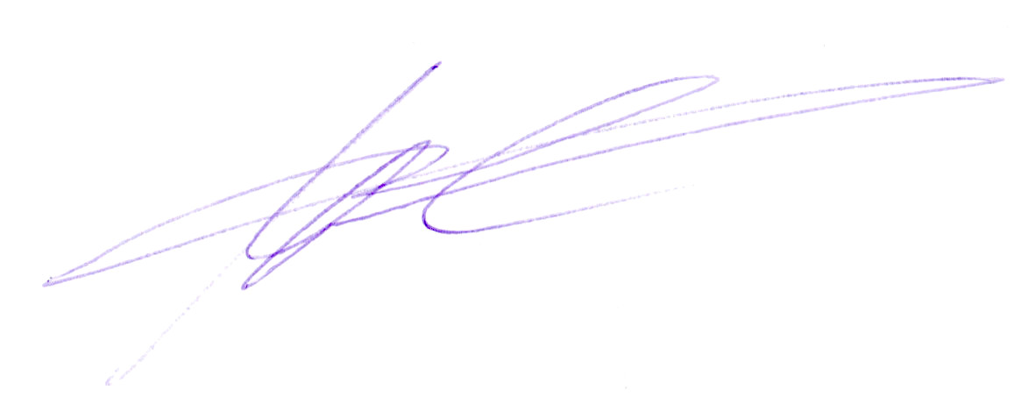

-The first author or the corresponding author will certify that all the others accept to be represented by him/her: Yes.

-Date of submission: 14 September 2026

The author/s of this paper accepts the Requirements of the award, specifically, the 7th: The Twenty-fourth International Award in Palaeontological Research Paleonturology 26 is endowed with a Two Thousand Five Hundred Euros (2,500 €) prize, indivisible and subject to the current fiscal legislation, and, prior to its acceptance, the author will be committed to writing a brief version to popularise the awarded paper (PALEOguide), paying special attention to additional graphics that may be required. It has to be sent to the organisation within a period of four months from the notification of the award and to relinquish the publication rights to the organisation. The organisation will use it to publish a popular version –guide- whose authors will be the same as those of the awarded paper (it will be translated, if necessary), and will collaborate with the author to reach the required didactic level (students between 15 and 17 years of age). The mentioned right has to be exercised within a year from the date of the decision. The amount of the award will be paid in its 25% within a period of two months from the notification of the award and the remaining 75% when the popular version is handed in.

B) PAPERS ENTERED BY A PERSON OR ORGANIZATION DIFFERENT FROM THEIR AUTHOR

Title of the publication:

Author/s:

Author/s’ contact address (postal address, telephone, fax, e-mail):

Paper entered by:

Contact address (postal address, telephone, fax, e-mail):

Signature of the person who enters the paper and date:

