What do we mean by the directions “cranial” and “caudal” on a vertebra?
Mike Taylor. Department of Earth Sciences, University of Bristol, Bristol BS8 1RJ, UK. dino@miketaylor.org.uk (corresponding author)
Mathew J. Wedel. College of Osteopathic Medicine of the Pacific and College of Podiatric Medicine, Western University of Health Sciences, Pomona, California, USA. mathew.wedel@gmail.com
XXX Abstract
Keywords: vertebra, orientation, cranial, caudal, nomenclature, well-defined.
Table of Contents
Introduction 2
Anatomical nomenclature 6
Institutional abbreviations 6
Four definitions of “horizontal” 6
1. Long axis of centrum is horizontal 7
2. Articular surfaces of centrum are vertical 9
3. Neural canal is horizontal 12
4. Similarity in articulation 15
Comparison of definitions 16
Recommendations 19
Discussion 22
Applications of this work 22
Open peer review 24
Open composition 24
Acknowledgements 25
References 25

Introduction
In late 2017, one of us submitted a paper (Taylor 2018b) redescribing the sauropod dinosaur Xenoposeidon and assigning it to the group Rebbachisauridae, based on the holotype and only specimen NHMUK PV R2095. Among the five diagnostic characters given for Xenoposeidon was #2, “Neural arch slopes anteriorly 30°–35° relative to the vertical” (Taylor 2018b:5). In a helpful and detailed peer review, Phil Mannion (2018a) commented:
The strong anterior slant of the neural arch appears to be dependent on how you've chosen to orientate the vertebra, but there doesn't appear to be any need to orientate it in this way.
I (Taylor) carelessly failed to directly address this criticism in my response letter, although I did add a brief discussion of the orientation. Consequently Mannion raised the matter again in the second round of review (Mannion 2018b):
I'm still unconvinced by the proposed anterior slant of the vertebra and don't think that there's any evidence for orientating it in this way. I went into the NHM to re-look at this. No aspect of the posterior articular surface of the centrum leads me to orient the vertebra in the same way of shown in your figures. In addition, as currently orientated, the floor of the neural canal is strongly tilted - it seems more conservative to assume that this is horizontal. Similarly, by following that orientation, this would then make the long-axis of the lateral pneumatic opening closer to horizontal. By orientating the vertebra this way, the anterior margin is sub-vertical, with a very gentle anterior deflection (i.e. fairly normal for a sauropod), and the M-lamina is much closer in orientation to that of Rebbachisaurus.
I responded (Taylor 2018a):
Phil remains convinced that the proper orientation of the vertebra gives it a lesser forward slope than as described in the manuscript. Having once more revisited my photos and 3D models, I remain convinced that the present orientation is essentially correct. It could be out by five degrees or so, so I have changed “35 degrees” to “30-35 degrees” throughout.
Mannion was gracious enough to accept this, and the paper proceeded to publication with the relevant section (Taylor 2018b:5) essentially unchanged. But the question he had raised continued to play on both of our minds: what exactly is the “correct” orientation of the vertebra, relative to which we can measure the angle of the sloping neural arch? And what do we even mean by “correct”? Figure 1 shows the difference between the slope as published (part A), and as interpreted by Mannion (part B).
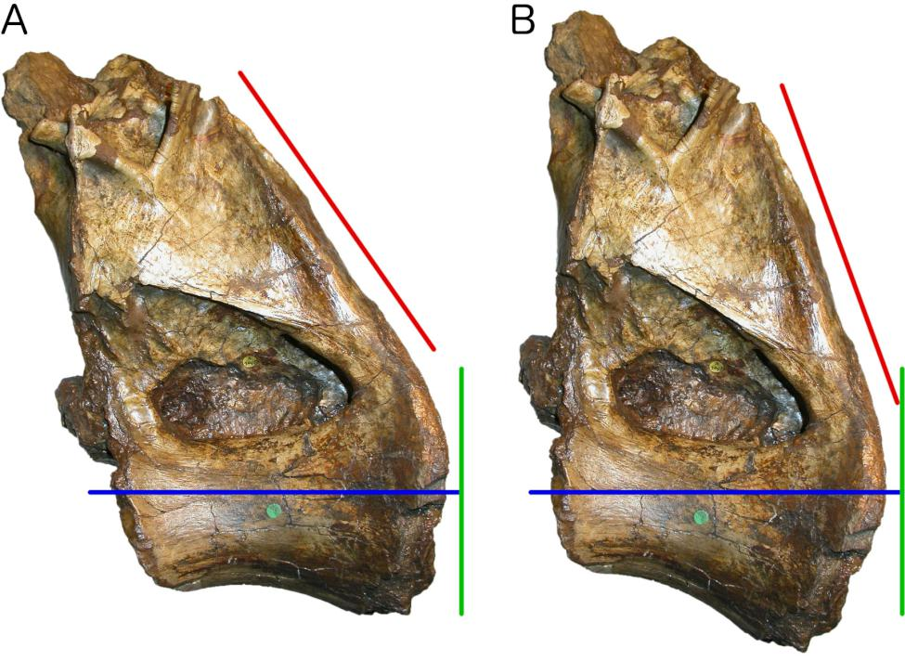
Figure 1. NHMUK PV R2095, the holotype dorsal vertebra of Xenoposeidon proneneukos in left lateral view. A. In the canonical orientation that has been used in illustrations in published papers (Taylor and Naish 2007, Taylor 2018b), in blog-posts and even on mugs (Taylor 2017). B. Rotated 15° “backwards” (i.e. clockwise, with the dorsal portion displaced caudally), yielding a sub-vertical cranial margin in accordance the recommendation of Mannion (2018b). In both parts, the blue line indicates the horizontal axis, the green line indicates the vertical axis, and the red line indicates the slope of the neural arch as in Taylor (2018b: figure 3B, part 2). In part A, the slope (i.e. the angle between the red and green lines) is 35°; in part B, it is 20°.
The neural arch slopes relative to the vertical. Vertical is defined as being orthogonal to the horizontal. That in turn is defined by the cranial–caudal (= anterior–posterior) axis. But what do those directions mean? How can we define them for a given vertebra?
In the present paper, we aim to answer that question. We will propose and discuss four candidate criteria, recommend the one we consider most practical and informative, and determine the slope of Xenoposeidon's neural arch more precisely. In the absence of such criteria, it is perhaps inevitable that we will continue to see inconsistency such as that in Saegusa and Ikeda's (2014: figure 8) illustration of the caudal vertebrae of Tambatitanis amicitiae (reproduced here as Figure 2).
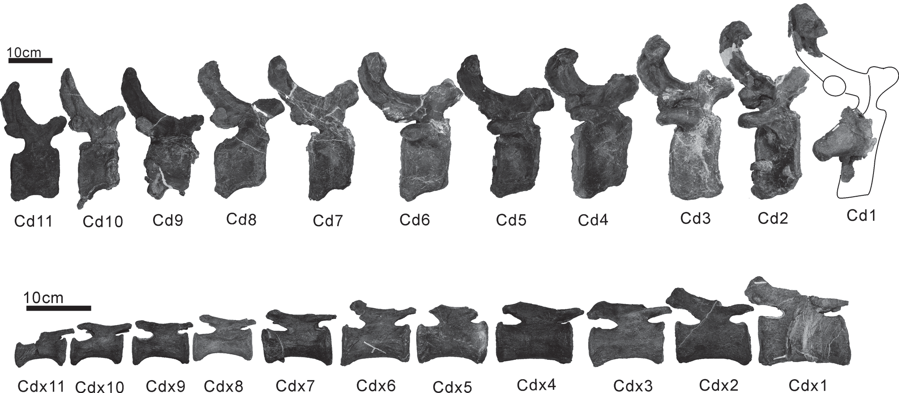
Figure 2. Tambatitanis amicitiae holotype MNHAH D-1029280, caudal vertebrae in right lateral view. Top row, caudals 1–11; bottom row, a set of more caudal caudals, not necessarily contiguous, designated x1–x11. Note the more cranial caudals are oriented such that their articular surfaces are vertical, even when this means that the long axis of the vertebra is steeply inclined as in caudals 4–7 and especially 8; while the more distal caudals are oriented such that their long axis is horizontal, even when this means that the articular surfaces are inclined as in caudals x7 and x10, which slope in opposite directions. Reproduced from Saegusa and Ikeda (2014: figure 8) under the CC By 3.0 licence.
We have been similarly inconsistent in our own previous papers, sometimes figuring vertebrae with the neural canal horizontal even if that meant the centrum ends were tilted (e.g., Wedel and Taylor 2013:figure 7), but at other times figuring vertebrae with the posterior articular surface vertical, even if that meant that the neural canal or centrum long axis was inclined (e.g., Wedel 2009:figure 7). Where we have been consistent, it has been through blind luck rather than careful consideration or deliberate choice; we did not perceive that there was a problem to be solved until the aforementioned discussion of the Xenoposeidon holotype dorsal.
Note that the present question is nothing to do with life posture, which is a much more difficult problem, subject to many more degrees of uncertainty. Animals do not hold their vertebral columns at anything close to true horizontal (Taylor et al. 2009) — not even those that we characterise as having horizontal posture — and we do not want to tie the meaning of our very nomenclature to something so variable and unpredictable. Otherwise we would have to define “horizontal” for the mid-cervical vertebrae of parrots as upside-down (Figure 3).
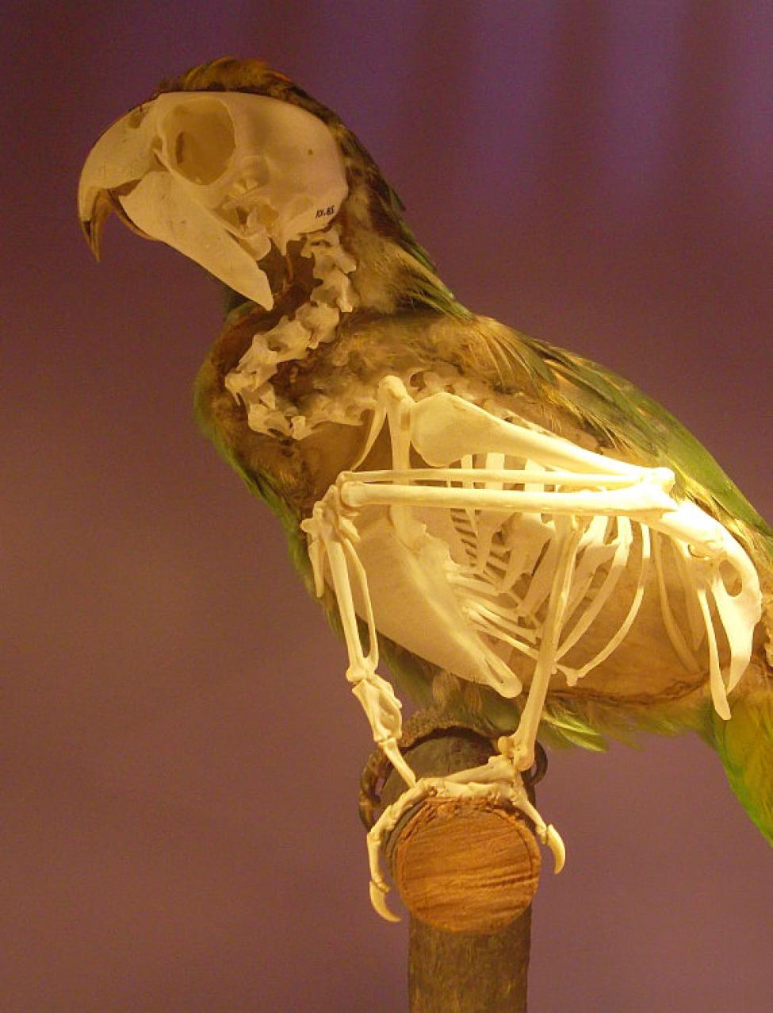
Figure 3. Parrot skeleton with hemisected integument (probably Amazona ochrocephala) in left lateral view, in the Natuurhistorisch Museum of Rotterdam. Photograph by Marc Vincent, used with permission. Note the very strong 'S'-curve of the neck, such that the most caudal cervical vertebrae are inclined downwards, then more cranial vertebrae are, progressively, inclined upwards, near vertical, sloping backwards, then vertical again, and finally sloping upwards to the skull.
Instead, we seek abstract notions of “horizontal”, “cranial” and “caudal” that apply irrespective of the specific posture adopted by an animal — something that is especially important for the study of extinct animals for which habitual posture cannot be known with certainty and remains controversial (e.g. sauropod neck posture: Stevens and Parrish 1999 vs. Taylor et al. 2009). Our goal is to have an objective standard by which to assess properties such as the slope of a neural arch.

Anatomical nomenclature
As dinosaur palaeontologists, we generally use and prefer the Owenian system of anatomical directions, with anterior and posterior indicating the forward and backward directions accordingly (Owen 1854) — hence the use of these terms in the Xenoposeidon paper, its reviews, and the associated discussion. However, for the present paper, we seek directional definitions that are unambiguous for all vertebrates: not only those like dinosaurs, dogs and fish, which hold their vertebral columns essentially horizontal; but also those like humans, penguins and alert meerkats, which hold their vertebral columns essentially vertical. For this reason, avoiding ambiguity in humans, where “anterior” means ventral (towards the belly) rather than cranial (towards the head), we will use terms cranial and caudal, and derived terms such as craniodorsal.

Institutional abbreviations
- CM — Carnegie Museum of Natural History, Pittsburgh, Pennsylvania, USA.
- FMNH — Field Museum of Natural History, Chicago, Illinois, USA.
- LACM — Natural History Museum of Los Angeles County, Los Angeles, California, USA.
- MB.R — Museum für Naturkunde Berlin, Berlin, Germany; fossil reptile collection.
- MWC — Museum of Western Colorado, Fruita, Colorado.
- MNHAH — Museum of Nature and Human Activities, Hyogo, Japan.
- NHMUK PV — Natural History Museum, London, UK; vertebrate palaeontology collection.
- WRAZL — The William R. Adams Zooarchaeology Laboratory, Indiana University Bloomington, Indiana, USA.
- ZPAL — Institute of Paleobiology, Polish Academy of Sciences, Warsaw, Poland.

Four definitions of “horizontal”
We have conceived four candidate definitions of what it might mean for a vertebra to be horizontal — and therefore what the directions cranial and caudal (and dorsal and ventral) might mean. We will now consider them in turn.

1. Long axis of centrum is horizontal
The default approach for most illustrations, especially for elongate vertebrae such as sauropod cervicals, has been to orient them more or less by eye. In practice, this means to draw a line between the cranial and caudal articular surfaces of the centrum at half height, and orient that line horizontally (Figure 4).
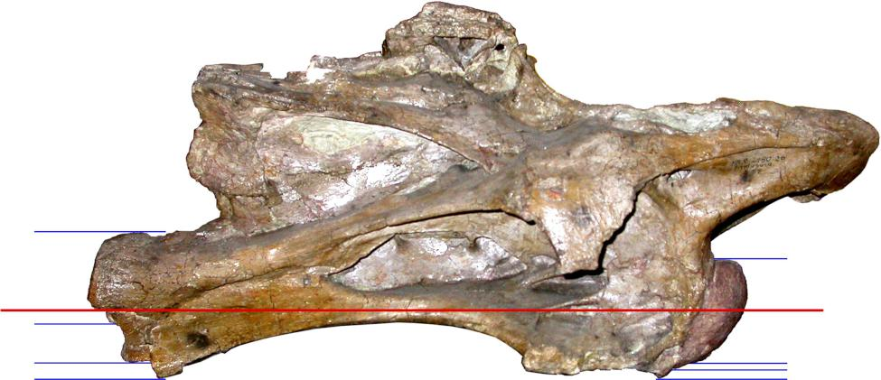
Figure 4. Giraffatitan brancai lectotype MB.R.2180 (formerly HMN SI), fifth cervical vertebra in right lateral view, oriented horizontally according to the long axis of the vertebra (red line). The long axis may be defined as the line between the vertical midpoints of the cranial and caudal articular surfaces — but the height of those midpoints depend on the selection of dorsal and ventral extremities of those surfaces, and these are not always obvious. The blue lines at each end of the vertebra show candidate margins. In both cases, the dorsal margin is more or less uncontroversial; but there are several candidates for the ventral margin, especially for the caudal articular surface, which are impossible to resolve using only lateral-view photos and potentially even with the complete fossil to hand.
However, this approach cannot be meaningfully used for craniocaudally short vertebrae such as most caudals, in which there is no unambiguous long axis (Figure 5A).
And even for elongate vertebrae, this immediately intuitive approach breaks down when considered in detail. A line between the cranial and caudal articular surfaces at half height sounds simple, but to determine half-height we need to establish the dorsal and ventral margins of the articular surfaces, and this is not always clear, especially for fossil vertebrae. In Figure 4, the upper blue lines at each end of the vertebra mark the dorsalmost extent of the two articular surfaces, and are not difficult to determine. But the ventralmost extent of both surfaces is much more ambiguous. Candidate ventral extents are shown by the other blue lines. Cranially (to the right), the ventralmost line is aligned with the ventralmost point on the cranial part of the vertebra, but it is not certain that this is part of the articular condyle rather than some other process; the two lines immediately above show two other points on the curvature of the condyle that could be interpreted as its ventralmost extent. The same problem is more extreme with respect to the ventral margin of the caudal articular surface (left side of figure D). Only with the benefit of a caudal view does it become apparent that the upper two lines mark breakages in the cotyle rim rather than a legitimate ventral margin, and that even the lowest line represents a point of breakage rather than for example, a separate ventrolateral process. In fact, the true ventral extent of this articular surface would have been located some way below the preserved portion of the bone — as is shown in Janensch's (1950: figures 23, 25) reconstruction of this vertebra.
All this shows that relying on the eye to determine horizontal orientation can be very misleading, and that a more objective approach is needed. We will now consider three such methods (Figure 5).
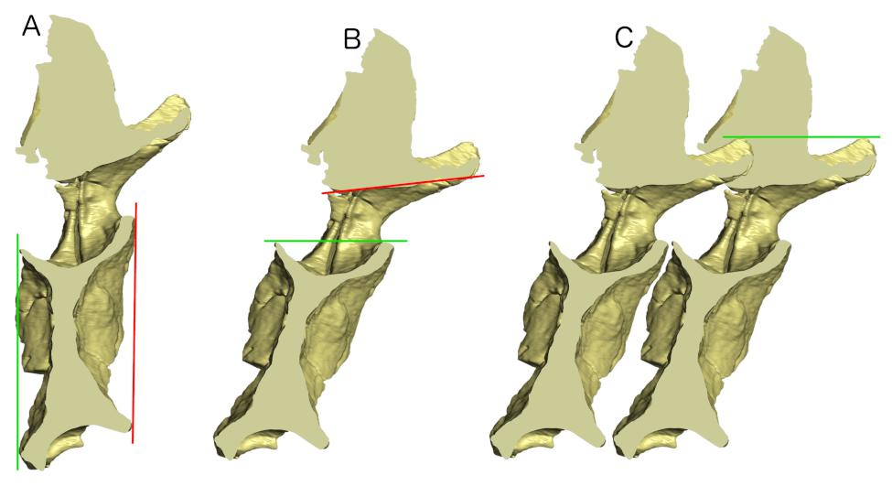
Figure 5. Haplocanthosaurus sp. MWC 8028, caudal vertebra ?3, in cross section, showing medial aspect of left side, in three orientations. A. In “articular surfaces vertical” orientation (method 2 of this paper). The green line joins the dorsal and ventral margins of the caudal articular surface, and is oriented vertically; the red line joins the dorsal and ventral margins of the cranial articular surface, and is nearly but not exactly vertical, instead inclining slightly forwards. B. In “neural canal horizontal” orientation (method 3 of this paper). The green line joins the cranial and caudal margins of the floor of the neural canal, and is oriented horizontally; the red line joins the cranial and caudal margins of the roof of the neural canal, and is close to horizontal but inclined upwards. C. In “similarity in articulation” orientation (method 4 of this paper). Two copies of the same vertebra, held in the same orientation, are articulated optimally, then the group is rotated until the two are level. The green line connects the uppermost point of the prezygapophyseal rami of the two copies, and is horizontal; but a horizontal line could join the two copies of any point. It happens that for this vertebra methods 3 and 4 (parts B and C of this illustration) give very similar results, but this is accidental.

2. Articular surfaces of centrum are vertical
In this approach, we define horizontal as that orientation in which the cranial and caudal articular surfaces of the centrum are vertical. (Figure 5A). This is appealing when dealing with short, tall vertebrae, but less so for long, slender vertebrae such as the Giraffatitan cervical of Figure 4.
For the Haplocanthosaurus caudal shown here, the method gives a nearly unambiguous result as the cranial and caudal articular surfaces are very close to parallel: in Figure 5A, where the green line showing the orientation of the caudal surface is vertical, the red line showing the orientation of the cranial surface is cranially inclined by less than one degree. However, its meaning is ambiguous for “keystoned” vertebrae in which the cranial and caudal surfaces are not parallel, as for example the giraffe C7 shown in Figure 6; or the Sauroposeidon C5 illustrated by Taylor and Wedel (2013:figure 8.1) in which the caudal surface is vertical but the margin of the cranial condyle is inclined about 16°.
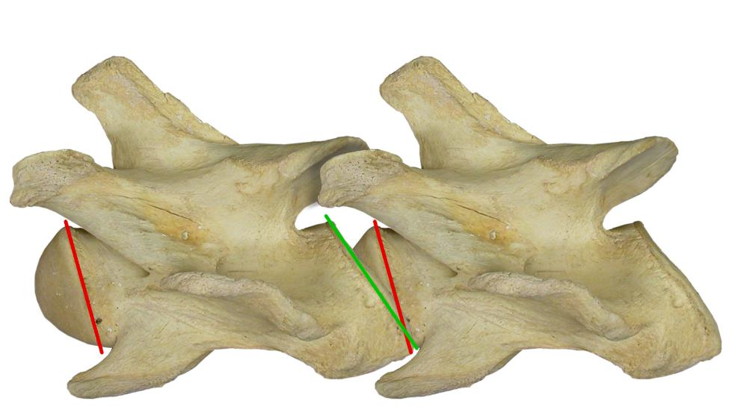
Figure 6. Giraffe Giraffa camelopardalis FMNH 34426, two copies of cervical 7 in left lateral view, articulated, both horizontal according to the “similarity in articulation” orientation (method 4 of this paper). The 7th cervical vertebra of the giraffe is strongly “keystoned”, with the centrum (excluding the articular condyle) forming a parallelogram whose dorsal length is less than its ventral length. The red lines indicate the orientation of the cranial articular surfaces, following the lines of ligament attachment immediately behind the articular condyle; the green line indicates the orientation of the margin of the caudal articular surface. The angle between the red and green lines is about 19 degrees, meaning that if the two copies of the vertebra were oriented such that the cranial and caudal articular surfaces were optimally articulated, there would be a 19 degree angle between the vertebrae.
Strongly opisthocoelous vertebrae such as giraffe cervicals, and strongly procoelous vertebra such as monitor lizard caudals (Figure 7A) and crocodilian cervicals (Figure 7B) exemplify another difficulty of this method: how does one even determine the orientation of an articular surface that is not flat? For concave surfaces such as the caudal articulation of the giraffe cervical and the cranial articulations of the monitor caudals and crocodile cervicals, the best solution is probably to project a straight line between the caudalmost extremities of the dorsal and ventral surfaces, as shown by the green line in Figure 6. However, these points are not always easy to determine: in the Xenoposeidon dorsal vertebra (Figure 1), the caudal margin of the neural arch appears in lateral view to blend into that of the centrum, so that there is no obvious point that is the caudalmost extremity of the dorsal surface of the centrum; and in the Giraffatitan cervical vertebra (Figure 4), parts of the caudoventral margin of the vertebra are broken off, so it is not possible to determine the caudalmost extremity of the ventral surface. Convex surfaces such as the cranial articulation of the giraffe cervical and the caudal articulations of the crocodile cervicals and monitor caudals present an even more difficult problem: what can be defined to be the orientation of a surface that is curved in lateral view? For some vertebrae, there is a clear ridge projecting outward from the concave articular extremity, and the orientation of that ridge can be used, as shown by the red lines in Figure 6. But this is not present in all opisthocoelous and procoelous vertebrae: and even when it is, the ridge is often somewhat ill-defined, so that superimposing an orientation line is more an art than a science.
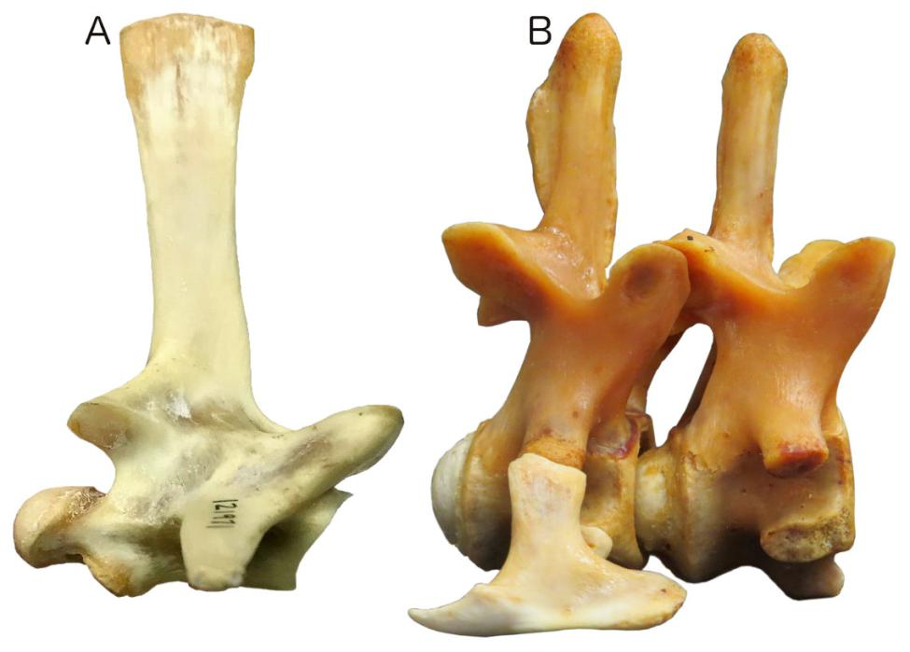
Figure 7. Proceoelous vertebrae for which it is difficult to determine the orientation of the articular surfaces, scaled to the same vertebral height. A. Komodo dragon Varanus komodoensis, LACM Herpetology specimen 121971, cranial caudal vertebra in right lateral view. Note the extremely convex and strongly inclined caudal articular surface to the left; the cranial articular surface to the right is correspondingly convex and inclined. B. Alligator mississippiensis WRAZL 9840044, seventh cervical vertebra (with cervical rib attached) and sixth cervical vertebra (without rib) in articulation, in right lateral view. Photograph kindly provided by Jess Miller-Camp. While the caudal articular surfaces are strongly convex, the orientation of each can be interpreted as that of the well-defined “collar” that surrounds it.
Finally, the giraffe C7 also illustrates yet another difficulty with this definition of horizontality: if the vertebra were oriented such that either the cranial (red line) or caudal (green line) articular surface were vertical, the resulting orientation, with a very obvious diagonal slope to the long axis of the vertebra, would immediately strike us as “wrong”. That in itself is not a fatal strike against the method, but its violation of what strikes us intuitively as correct must weigh against it.

3. Neural canal is horizontal
An alternative to this method is to fix the orientation of the neural canal as “horizontal”, as shown in Figure 5B. For a given vertebra, this can yield extremely different results from method 2, as seen in the contrast between the two orientations shown of the Haplocanthosaurus caudal in parts A and B of Figure 5. It can also be seen that the giraffe C7 in figure F and the Komodo dragon caudal in Figure 7A, both which are here depicted with the neural canal close to horizontal, would be oriented very differently according to method 2.
However, this method, too, is subject to some ambiguity.
First, just as Method 2 can yield a different orientation depending on whether the orientation of the cranial or caudal articular surface is used, so the present method can yield a different orientation depending on whether the orientation of roof or the floor of the neural canal is used: compare the green and red lines approximating the floor and roof of the Haplocanthosaurus caudal in Figure 5B. For a tubular neural canal of constant diameter, this problem does not arise, but not all neural canals are this regular, and “trumpet-shaped” canals can yield widely divergent orientations of roof and floor.
Secondly, as again shown by the Haplocanthosaurus caudal of Figure 5, the individual margins of the neural canal may not be straight. This is particularly apparent for the floor of the canal, which is deeply dished. However, it is easy in this case to define the orientation of the neural canal floor as that of a straight line joining its cranialmost and caudalmost extent. A less obvious but more profound difficulty is presented by the roof of this vertebra's neural canal, in which it is not apparent where the cranialmost point is: two equally credible alternatives, points a and b, yield “horizontal” lines whose inclinations differ by 3.8 degrees (Figure 8).
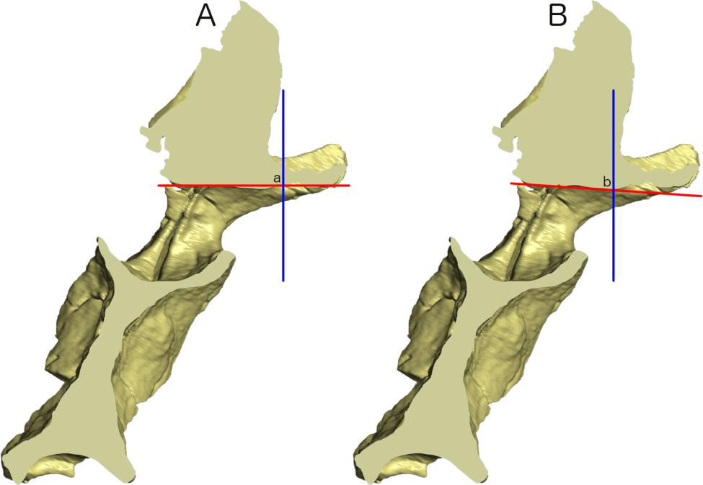
Figure 8. Haplocanthosaurus sp. MWC 8028, caudal vertebra ?3, in cross section, showing the ambiguous interpretation of the roof of the neural canal. A. The vertebra oriented according to a long interpretation of neural canal extent. The vertical blue line indicates the position identified as the cranialmost extent of the roof of the neural canal (point a), and the red line shows the interpretation of “horizontal” based on that location. B. The same vertebra, but with a different choice of cranialmost extent of the roof of the neural canal (point b), again marked with a vertical blue line. When a line is projected from here to the same caudalmost extent as in part A, the resulting notion of “horizontal” differs by 3.8 degrees.
Even worse, when one or both of the margins of the neural canal is convex in cross-section, there is no cranialmost or caudalmost margin, and therefore no straight line to project between them (Figure 9).
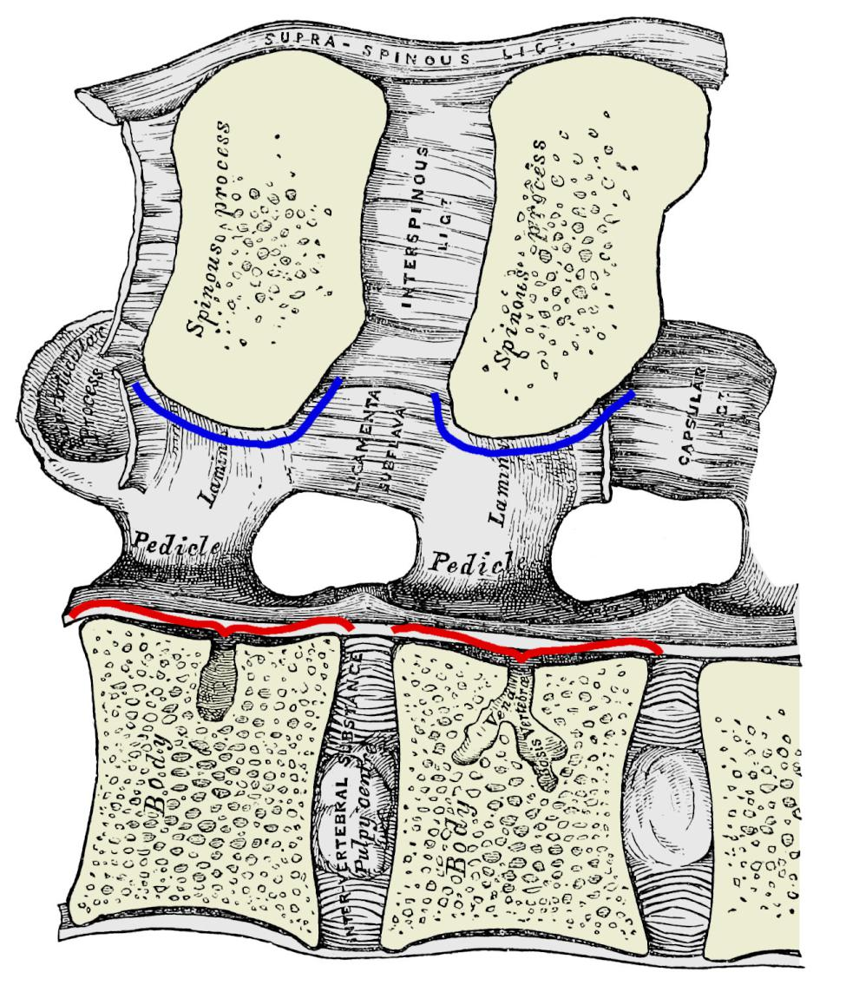
Figure 9. Right halves of two vertebrae from the lumbar (caudal dorsal) region of a human Homo sapiens in sagittal cross-section (cranial to left). Modified from Gray (1858: figure 99). Pale yellow indicates bone in cross-section, grey indicates both bone further from the midline and soft tissue. The red lines mark the floor of the neural canal: since the cranial and caudal ends of the floor of the canal are slightly elevated dorsally relative to the middle part of the canal, it is easy to project a line between these eminences and designate this as the trajectory of the canal. The blue lines mark the roof of the neural canal, but this is convex throughout its length for each vertebra. There is therefore no way to designate any single tangent to it as the trajectory of the neural canal roof of the vertebra as a whole.
A further difficulty with this method is that, unlike the articular surfaces, the neural canals of vertebrae can be difficult to examine and measure. In fossil vertebrae, they are frequently not prepared out of matrix. But even when a complete and completely prepared vertebra is available, a physical or virtual sagittal hemisection is required to fully depict and determine the neural canal trajectory, and this is only rarely available.

4. Similarity in articulation
Definition method 1 is based on the centrum of the vertebra; method 2 is based on the cranial and caudal articular surfaces; and method 3 is based on the neural canal. But is it possible to arrive at a definition that takes the whole vertebra into account?
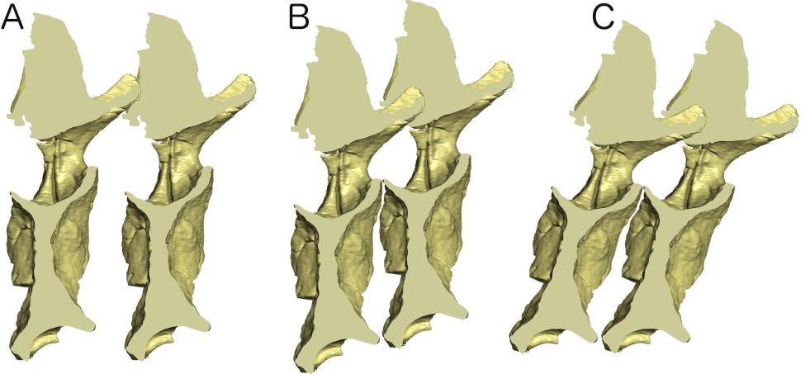
Figure 10. The steps of the similarity-in-articulation method of determining horizontal orientation of a vertebra, illustrated using Haplocanthosaurus sp. MWC 8028, caudal vertebra ?3. A. Two identical copies of the same vertebra depicted in the same orientation. B. The two copies brought into optimal whole-vertebra articulation without rotating either. C. The articulated pair rotated into that orientation in which they are at the same height. This is orientation is designated as horizontal according to the present method.
The method that we call “similarity in articulation” (Figure 10) does this. It consists of four steps as follows:
- Depict the vertebra in any orientation. (It doesn't matter which orientation is chosen at this stage, as it will be changed in step 4.)
- Add another copy of the same vertebra in the same orientation (Figure 10A).
- without rotating either copy, move them into the relative position that gives the best articulation, based on both the centrum articulations and the zygapophyses (Figure 10B.)
- Rotate the articulated grouping of both copies into the orientation where they are at same height (Figure 10C). The resulting orientation is deemed to be horizontal according to this method.
Note that this method does not require two vertebrae: it uses two copies of the same vertebra to determine the orientation of that vertebra in isolation.
Figure 6 shows the method applied to a giraffe Giraffa camelopardalis FMNH 34426, cervical 7. Note that the intercentral joint shows a strong divergence between the planes of the two articular surfaces: a “better” articulation might be achieved between the two copies of the vertebra is one were allowed to rotate relative to the other, but that would not yield a single orientation and so would violate the mechanism of method 4.
This definition of “horizontal” is less intuitive than definitions 1–3, but has some advantages. First, it can be determined for any more or less complete vertebra, irrespective of whether or not the articular faces are parallel or the neural canal is tubular. Second we may hope that, since it uses the whole shape of the vertebra, this method is less vulnerable to yielding a distorted result when the vertebra is damaged. Third, it constrains subjectivity to a single well-defined judgement which can be reviewed and revised as needed: that of how the two similarly-oriented copies of the vertebra best articulate together.

Comparison of definitions
Each of the candidate definitions of “horizontal” has appealing qualities, and indeed when we floated these notions on our blog, all the methods had adherents (comments to Taylor 2018c). No one method can satisfy all desiderata.
Definition 1 (Long axis of centrum is horizontal) is perhaps the least satisfactory of the methods presented here, as it is the most dependent on a judgement “by eye”. It is also not really applicable at all to craniocaudally short vertebrae.
While definition 2 (articular surfaces of centrum are vertical) is perhaps the most frequently used orientation when illustrating craniocaudally short vertebra, it has the undesirable property that when a sequence of consecutive vertebrae are illustrated in this orientation, the neural canal can be jagged (Figure 11).
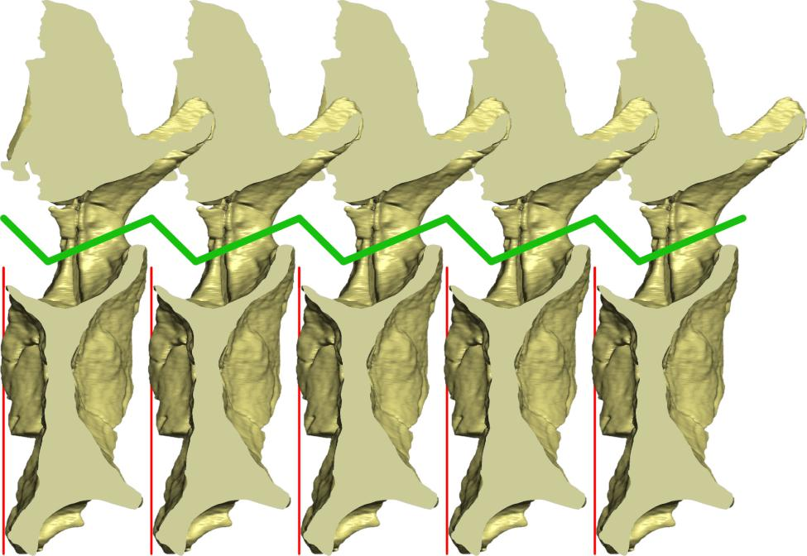
Figure 11. Five instances of Haplocanthosaurus sp. MWC 8028, caudal vertebra ?3, all oriented according to candidate method 2. Since the orientation of the neural canal in this vertebra is inclined 20–30 degrees to perpendicular with the articular surfaces, the result is a kinked spinal cord — something that never happens in life.
This never happens in life: the spinal cord can curve but never kink: see for example Figure 12.
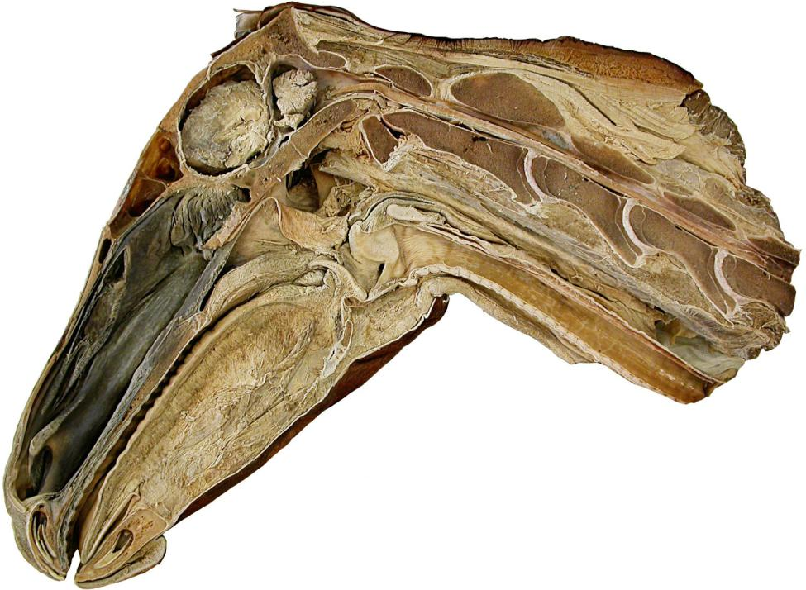
Figure 12. Sagittally bisected head and cranial neck of a horse. The first four cervical vertebrae are complete, but the caudal part of the fifth is absent. Note that the neural canal runs in a nearly straight line, and is not kinked.
By contrast, definition 3 (“neural canal is horizontal”) is anatomically informative, corresponding to the reality of the how consecutive vertebrae articulate in life, and to how they originate. Vertebrae may be found in isolation (e.g., NHMUK PV R2095, Figure 1), but they do not develop in isolation. Early in the embryological development of vertebrates, the notochord is the primary body axis, defining not only craniocaudal orientation but also dorso–ventral and left–right (Stemple 2005 and references therein). The notochord induces the formation of the neural plate, which rolls up to become the neural tube, and eventually the brain and spinal cord (Spemann and Mangold 1924). From that point forward, the spinal cord lies dorsal to — and parallel to — the notochord, or to the articulated vertebral centra that replace the notochord. In some vertebrae, the intervertebral joints form orthogonal to the notochord axis, so that the trajectory of the notochord can be reconstructed from the vertebral centrum (for example, Cdx4 in Figure 2). As we have demonstrated, however, in other vertebrae the intervertebral joints are not orthogonal to the notochord axis on which the vertebral column is patterned. If the long axis of the centrum is difficult or impossible to define, and if the intervertebral joints are not orthogonal to the trajectory of the vertebral column, then the only aspect of a vertebra that faithfully preserves the original axis of the parallel notochord and spinal cord is the neural canal. Furthermore, in such cases the geometry of the centrum is actively misleading with respect to the original notochordal/vertebral axis.
This orientation is used in the illustration of caudals 6–8 of the Opisthocoelicaudia skarzynskyii holotype ZPAL MgD-I/48 in Borsuk-Bialynicka (1977: plate 5: figure 2a), but this was not necessarily a choice consciously made by the author. These three vertebrae were preserved in articulation in this orientation, suggesting this was the relative orientation in life.
Definition 4 (similarity in articulation) was initially appealing because it takes the whole vertebra into account, rather than only the articular surfaces of the centrum (as in method 2) or only the neural canal (as in method 3). In practice, however, this means that the method cannot be used at all unless the vertebra is sufficiently well preserved to have well-formed articular surfaces both at the centrum and at the pre- and post-zygapophyses. This rules out its use for many fossil vertebrae — ironically, including NHMUK PV R2095, the Xenoposeidon proneneukos holotype dorsal vertebra which was the catalyst for this whole project. We are therefore not able to recommend the use of this method, at least not when dealing with fossils.

Recommendations
In discussing the angles of inclination of parts of vertebrae, it is essential to have a rigorously defined baseline: a concept of what is meant by the directions cranial and caudal, and therefore what axis is defined as horizontal, and therefore what is vertical. In this paper, we have proposed four candidate definitions.
At minimum, we advocate that each paper that discusses vertebral shape and the inclination of parts should explicitly adopt some specific definition of “horizontal”, and use it consistently.
We recommend that the base-of-the-neural-canal-is-horizontal method should be used in most cases, for the following reasons:
- It is well defined for both long and short vertebrae.
- It corresponds to the physical reality of the unkinked spinal cord.
- It reflects the developmental reality of how vertebra are formed.
- It requires only a relatively small part of the vertebra to be preserved.
Orientation by this method can best be achieved by the use of CT scans or physical cross-sections. However, it can often by approximated using low-tech means such as a roll of paper pushed through the neural canal (Figure 13), yielding “good enough” results.
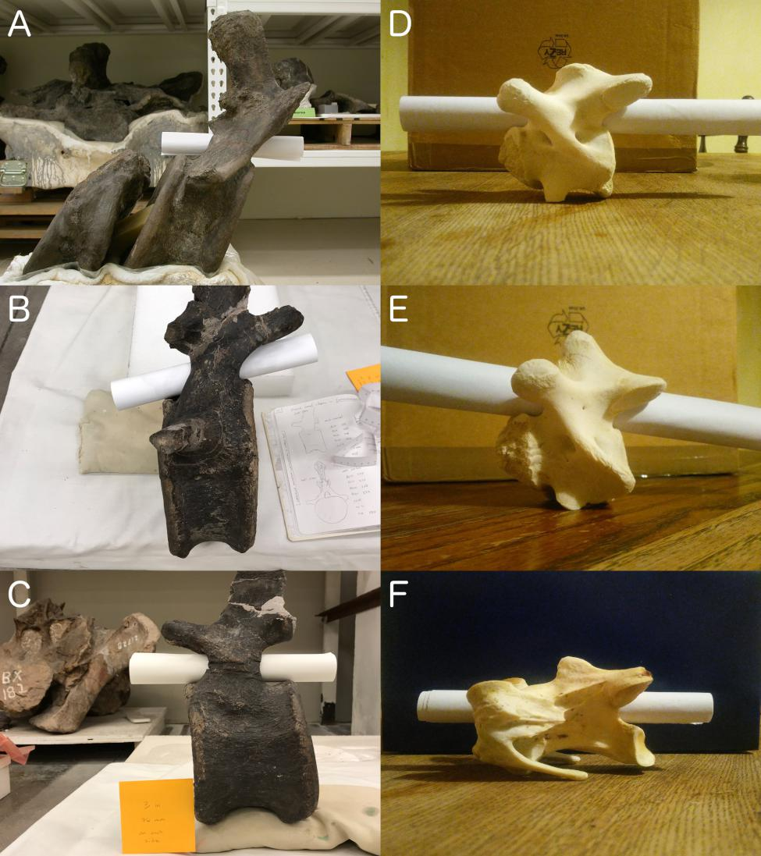
Figure 13. A selection of vertebrae with the approximate trajectory of their neural canals determined by the simple method of pushing a rolled-up piece of paper through their neural canals. A. Brachiosaurus altithorax holotype FMNH P 25107, first and partial second caudal vertebrae in right lateral view. B. Camarasaurus sp. CM 584, cranial caudal vertebra ?4 in right lateral view. C. Camarasaurus sp. CM 584, mid-caudal vertebra ?12 in left lateral view. D. Juvenile giraffe Giraffa camelopardalis, cervical vertebra 6 in left lateral view. E. Juvenile giraffe Giraffa camelopardalis, cervical vertebra 7 in left lateral view. Note the much stronger inclination than in C6. F. Ostrich Struthio camelus, cervical vertebra 16 in left lateral view.
This is a case where an unsophisticated method gives surprisingly informative and reliable results. As the rolled-up paper naturally uncoils, it fills as much of the space of the neural canal as possible, giving a good sense of the trajectory of the roof and floor of the canal. In a “trumpet shaped” neural canal that is wider at one end than at the other, the paper uncurls further at the wider end, giving a visual indication of the variation in width. This can be seen to a minor degree in Figure 13E, in which the neural canal of cervical vertebra 7 in a juvenile giraffe is slightly wider cranially than it is caudally.
Finally, we return to the Xenoposeidon proneneukos holotype dorsal vertebra NHMUK PV R2095 that motivated this entire project. This vertebra cannot be oriented by the rolled-up paper method, as its neural canal has not been prepared out, and is filled with matrix. However, the use of another low-tech method can give us the result (Figure 14). We used Blu-Tack to attach two toothpicks to the cranial and caudal ends of the neural canal floor, and manipulated the toothpicks so that they formed a straight line. We then oriented the vertebra such that this straight line was horizontal, as indicated by a spirit level held parallel to it. Using this method we were able to determine from photos that that the slope of the neural arch is about 29°: just outside the 30°–35° range specified as character #2 in the revised diagnosis of Taylor (2018b:5).
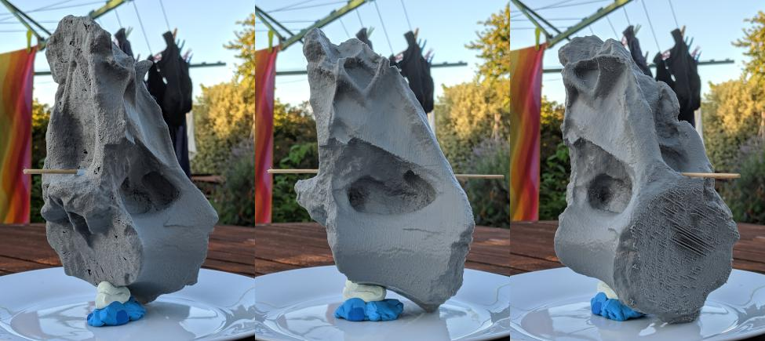
Figure 14. 3D print of the Xenoposeidon proneneukos holotype dorsal vertebra NHMUK PV R2095, oriented horizontally according to method 3 (neural canal is horizontal) by the toothpicks method. From left to right: anterolateral, left lateral and posterolateral views. The camera is at the same level as the floor of the neural canal, so that the toothpicks appear horizontal in the oblique views as well as in the lateral view. This procedure was carried out using a 3D print of the vertebra from the scan data published as the supplementary file to Taylor (2018b), as the fossil was not readily available.
We therefore recognise that Mannion (2018a, 2018b) was correct that the orientation depicted by Taylor (2018b) was not horizontal and that the slope was therefore exaggerated (according to method 2). However, the initially stated slope of 35° was exaggerated only by 6° rather than the 15° suggested by Mannion (2018b). The slope as stated in the final published version of the paper (30°–35°) is a better representation of the true morphology when using the neural canal as the determinant of horizontality.

Discussion

Applications of this work
Beyond the simple need to measure angles of inclinations against an objectively defined baseline, there are biological questions for which we cannot give a well-defined answer except in the context of a well-defined vertebral orientation. For example, although the spinal cord does not completely fill the neural canal in most vertebrates, the cross-sectional area of the neural canal does vary in concert with the cross-sectional area of the spinal cord. This allows us to estimate serial variation in spinal cord diameter, and to make inferences regarding gross patterns of limb use in extinct animals, including dinosaurs (Giffin 1990, 1992, 1995a, b). These estimates and inferences depend on the cross-sectional area of the neural canal — but this varies depending on how a vertebra is oriented when the measurement is taken. In most cases, the “neural canal is horizontal” approach will also be the approach that maximizes the cross-sectional area of the neural canal as seen from cranial or caudal. If the neural canal and long axis of the centrum are not orthogonal, orienting the vertebra according to the long axis of the centrum or verticality of the articular faces will result in a decreased apparent diameter of the neural canal. This is true even in vertebrae with craniocaudally short centra, such as the proximal caudals of many sauropod dinosaurs (Figure 15).
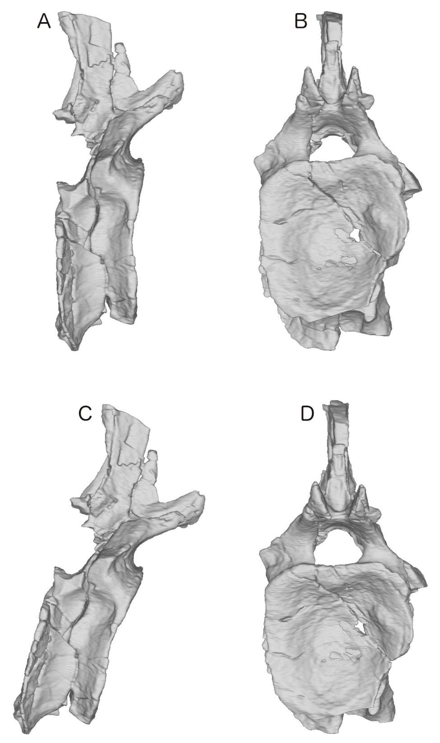
Figure 15. Varying apparent cross-sectional area of the neural canal of Haplocanthosaurus sp. MWC 8028, caudal vertebra ?3, depending on the orientation of a vertebra. A and C. Right lateral view in different orientations. B and D. Cranial views in different orientations. Parts A and B depict the vertebra oriented according to method 2 (Articular surfaces of centrum are vertical), and show a neural canal that is small (5870 pixels) in cross-sectional area; parts C and D depict the vertebra oriented according to method 3 (Neural canal is horizontal), and show a neural canal that is 61% larger (9458 pixels) in cross-sectional area.
For determining neural canal cross-section to estimate spinal cord size, we would prefer to orient the vertebra according to the long axis of the neural canal, as in Figure 15C–D. For other purposes, such as measuring the articular surface area of the centrum to estimate biomechanical loading or intervertebral cartilage properties, we might prefer to orient the vertebra with the articular surfaces vertical, as in Figure 15A–B. More generally, the complexity of vertebral geometry requires careful thought as to which definition of horizontality is appropriate in each analytical context: while we recommend method 3 (neural canal is horizontal) for most purposes, other definitions may be more appropriate in specific circumstances.

Open peer review
In publishing the Xenoposeidon revision (Taylor 2018b) in the journal PeerJ, I (Taylor) was pleased to take advantage of the journal's policy of allowing submitted drafts, peer-reviews, response letters and handling editors' comments to be published alongside the final paper. It is because these materials are published (Young et al. 2018) that the sequence of discussion is preserved, and Mannion's helpful and gracious comments are available to be read — not only as the extracts in the present paper, but in their full context.
We endorse the publication of peer reviews, and both take this option whenever it is offered. Aside from their value as part of the scholarly record, published peer-reviews are visible evidence of the reviewers’ broader contribution to science, and can be taken into account in evaluating researchers for jobs, promotions, tenure and grants. Sets of reviews, accompanied by the corresponding versions of the manuscript, can be an important pedagogical tool for teaching students in practical terms how peer-review works: for example, Andy Farke (Raymond M. Alf Museum) writes “I use those published reviews when we are talking about the process of scientific publication. I have the students read the reviews and read the responses, and then talk about how the paper changed as a result” (pers. comm. 2018). Crucially, reviews can also play an important role in the origination of new research questions, and should be acknowledged: the present work on defining vertebral orientation arises directly from Phil Mannion's peer-review comments (Mannion 2018a, 2018b).

Open composition
This work first began to take shape as a series of blog-posts (Taylor 2018c, Taylor 2018d, Wedel 2018a, Wedel 2018b, Wedel 2018c) which were drawn together in a talk (Taylor and Wedel 2018) presented by Taylor as part of the 1st Palaeontological Virtual Congress (http://palaeovc.uv.es/) and announced online (Wedel 2018d). This manuscript was developed in the open, in a public GitHub repository (https://github.com/MikeTaylor/palaeo-vo; see Taylor 2018e). We commend this approach as valuable for soliciting informal feedback early in the process, and in making the research itself available quickly.

Acknowledgements
First, we thank Phil Mannion (Imperial College London) both for his multiple rounds of review of the Xenoposeidon manuscript and for giving us permission to quote relevant excepts in the current paper. We also thank Marc Vincent for permission to reproduce his photograph in Figure 3, Jess Miller-Camp for responding to a cry for help on Twitter and providing the alligator cervical photograph in Figure 7, and Andy Farke for permission to cite a personal communication.
We are deeply grateful to the curators and collection managers for access to specimens used in this study, including
- Daniela Schwarz (Museum für Naturukunde Berlin) for Giraffatitan.
- Julia McHugh (Dinosaur Journey) for Haplocanthosaurus.
- Bill Simpson (Field Museum of Natural History, Chicago, IL) for Brachiosaurus and the mature giraffe.
- Neftali Camacho (Los Angeles County Museum of Natural History) for the Komodo dragon.
- Sandra Chapman (Natural History Museum, London, UK) for Xenoposeidon.
- Ken Noriega (Western University of Health Sciences) for the horse head.
We thank John Hutchinson (Royal Veterinary College, UK) for the juvenile giraffe neck from which we prepared the vertebra used in Figure 13D–E, and Matt Cobley (Judge Memorial Catholic High School, Salt Lake City UT) for the ostrich neck skeleton whose vertebra appears in Figure 13F.
Finally, we thank John Yasmer and Thierra Nalley (Western University of Health Sciences) for their assistance in CT scanning and 3D modelling the Haplocanthosaurus caudal vertebra.

References
Borsuk-Bialynicka, Magdalena. 1977. A new camarasaurid sauropod Opisthocoelicaudia skarzynskii, gen. n., sp. n. from the Upper Cretaceous of Mongolia. Palaeontologia Polonica 37:5–64 and plates 1–14.
Giffin, Emily B. 1990. Gross spinal anatomy and limb use in living and fossil reptiles. Paleobiology 16(4):448–458.
Giffin, Emily B. 1992. Functional implications of neural canal anatomy in recent and fossil marine carnivores. Journal of Morphology 214(3):357–374.
Giffin, Emily B. 1995a. Functional interpretation of spinal anatomy in living and fossil amniotes. pp. 235–248 in: Jeffrey J. Thomason (ed.), Functional morphology in vertebrate paleontology. Cambridge University Press, Cambridge, UK.
Giffin, Emily B. 1995b. Postcranial paleoneurology of the Diapsida. Journal of Zoology 235(3):389–410.
Gray, Henry. 1858. Anatomy: descriptive and surgical, 1st edition. J.W. Parker, London, UK.
Janensch, Werner. 1950. Die Wirbelsaule von Brachiosaurus brancai. Palaeontographica (Suppl. 7) 3:27–93.
Mannion, Philip D. 2018a. Peer Review #3 (1st round) of “Xenoposeidon is the earliest known rebbachisaurid sauropod dinosaur (v0.1)”. PeerJ. https://doi.org/10.7287/peerj.5212v0.1/reviews/3
Mannion, Philip D. 2018b. Peer Review #3 (2nd round) of “Xenoposeidon is the earliest known rebbachisaurid sauropod dinosaur (v0.2)”. PeerJ. https://doi.org/10.7287/peerj.5212v0.1/reviews/3
Owen, Richard. 1854. The principal forms of the skeleton and of the teeth. Blanchard and Lea, Philadelphia.
Saegusa, Haruo, and Tadahiro Ikeda. 2014. A new titanosauriform sauropod (Dinosauria: Saurischia) from the Lower Cretaceous of Hyogo, Japan. Zootaxa 3848(1):1–66. doi:10.11646/zootaxa.3848.1.1.
Spemann, H., and Hilde Mangold. 1924. Über Induktion von Embryonalanlagen durch Implantation artfremder Organisatoren [On induction of embryo anlagen by implantation of organizers of other species]. Development Genes and Evolution 100:599–638.
Stemple, Derek L. 2005. Structure and function of the notochord: an essential organ for chordate development. Development 132(11):2503–2512.
Stevens, Kent A., and J. Michael Parrish. 1999. Neck posture and feeding habits of two Jurassic sauropod dinosaurs. Science 8284:798–800.
Taylor, Michael P. 2017. My collection of sauropod-themed mugs (or at least five sixths of it). Sauropod Vertebra Picture of the Week 4 June 2017. https://svpow.com/2017/06/04/my-collection-of-sauropod-themed-mugs-or-at-least-five-sixths-of-it/
Taylor, Michael P. 2018a. Untitled rebuttal letter to 2nd round of reviews of “Xenoposeidon is the earliest known rebbachisaurid sauropod dinosaur (v0.2)”. PeerJ. https://peerj.com/articles/5212v0.3/rebuttal
Taylor, Michael P. 2018b. Xenoposeidon is the earliest known rebbachisaurid sauropod dinosaur. PeerJ 6:e5212. doi:10.7717/peerj.5212
Taylor, Michael P. 2018c. What does it mean for a vertebra to be “horizontal”? Sauropod Vertebra Picture of the Week 28 August 2018. https://svpow.com/2018/08/28/what-does-it-mean-for-a-vertebra-to-be-horizontal/
Taylor, Michael P. 2018d. When is a vertebra “horizontal”, part 2. Sauropod Vertebra Picture of the Week 28 August 2018. https://svpow.com/2018/08/28/when-is-a-vertebra-horizontal-part-2/
Taylor, Michael P. 2018e. Writing the vertebral-orientation paper in the open. Sauropod Vertebra Picture of the Week 14 December 2018. https://svpow.com/2018/12/14/writing-the-vertebral-orientation-paper-in-the-open/
Taylor, Michael P., and Darren Naish. 2007. An unusual new neosauropod dinosaur from the Lower Cretaceous Hastings Beds Group of East Sussex, England. Palaeontology 50(6):1547–1564. doi:10.1111/j.1475-4983.2007.00728.x
Taylor, Michael P., and Mathew J. Wedel. 2013. Why sauropods had long necks; and why giraffes have short necks. PeerJ 1:e36. doi:10.7717/peerj.36
Taylor, Michael P., and Mathew J. Wedel. 2018. What do we mean by the directions “cranial” and “caudal” on a vertebra? PeerJ Preprints 6:e27437v1. doi:10.7287/peerj.preprints.27437v1
Taylor, Michael P., Mathew J. Wedel and Darren Naish. 2009. Head and neck posture in sauropod dinosaurs inferred from extant animals. Acta Palaeontologica Polonica 54(2):213–230.
Wedel, Mathew J. 2009. Evidence for bird-like air sacs in saurischian dinosaurs. Journal of Experimental Zoology 311A(8):611–628.
Wedel, Mathew J. 2018a. The proximal caudals of Brachiosaurus altithorax, FMNH P25107. Sauropod Vertebra Picture of the Week 11 September 2018. https://svpow.com/2018/09/11/the-proximal-caudals-of-brachiosaurus-altithorax-fmnh-p25107/
Wedel, Mathew J. 2018b. Vertebral orientation: Varanus komodoensis would like a word. Sauropod Vertebra Picture of the Week 25 September 2018. https://svpow.com/2018/09/25/vertebral-orientation-varanus-komodoensis-would-like-a-word/
Wedel, Mathew J. 2018c. Vertebral orientation, part 3: Matt weighs in. Sauropod Vertebra Picture of the Week 5 October 2018. https://svpow.com/2018/10/05/vertebral-orientation-part-3-matt-weighs-in/
Wedel, Mathew J. 2018d. Our presentations are up at the 1st Palaeo Virtual Congress. Sauropod Vertebra Picture of the Week 5 December 2018. https://svpow.com/2018/12/05/our-presentations-are-up-at-the-1st-palaeo-virtual-congress/
Wedel, Mathew J., and Michael P. Taylor. 2013. Neural spine bifurcation in sauropod dinosaurs of the Morrison Formation: ontogenetic and phylogenetic implications. PalArch's Journal of Vertebrate Palaeontology 10(1):1–34.
Young, Mark, anonymous, Daniela Schwarz, Philip Mannion, Lucio Manuel Ibiricu and Michael P. Taylor. 2018. Review History: Xenoposeidon is the earliest known rebbachisaurid sauropod dinosaur. https://peerj.com/articles/5212/reviews/

